# 选择分校年级班级界面设计开发文档

|  |  |  |  |
| --- | --- | --- | --- |
| ***版本*** | ***日期*** | ***作者*** | ***更新内容*** |
| V0 | 2018.11.16 | 孙传奎 | 创建文档 |
|  |  |  |  |

## 效果图

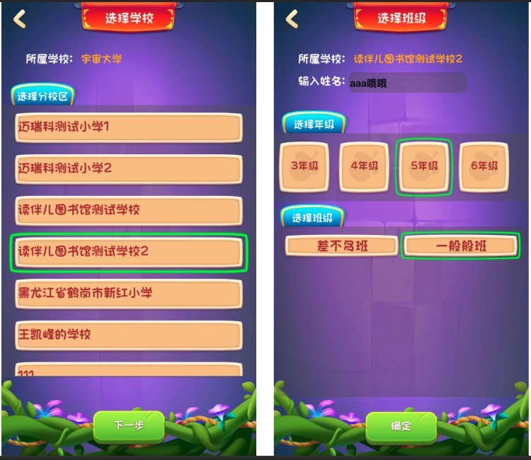

## 协议tag

此界面涉及到与服务器通信的协议如下：

|  |  |
| --- | --- |
| ***协议tag*** | ***含义*** |
| eHttpType::getBranchSchoolList | 获取分校列表 |
| eHttpType::setBranchSchoolID | 设置分校ID |
| eHttpType::classListV2 | 获取班级列表 |
| eHttpType::applyclass | 申请加入班级 |

## 流程图

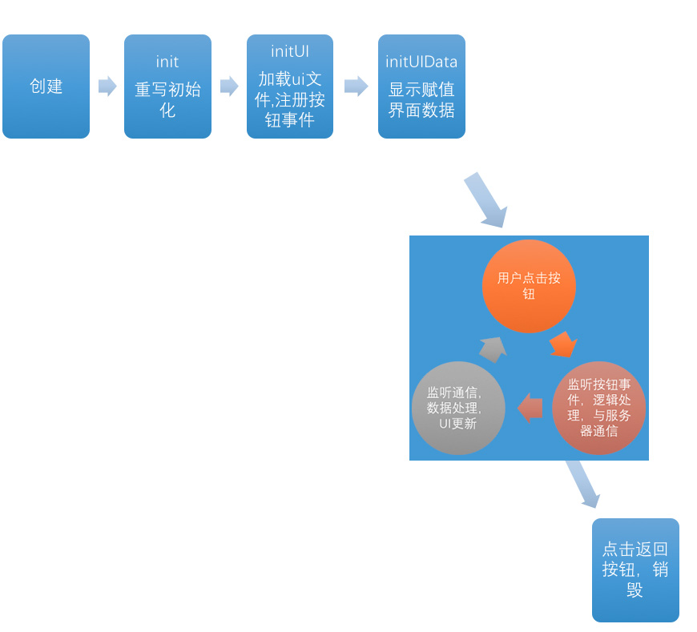

## 头文件重要方法

#include "stdafx.h"

class BindSchool : public Layer, public CDataHttpDelegate

{

public:

BindSchool();

virtual ~BindSchool();

virtual void onEnter() override;

virtual void onExit() override;

virtual bool init() override;

virtual void endWithHttpData(eHttpType nOp,bool bSuccess,const stuJson& json) override;

CREATE_FUNC(BindSchool);

private:

void initUI();

void initUIData();

void btnClickHandle(Ref* pSender);

void listCellTouchEvent(Ref* pSender, Widget::TouchEventType eventType);

void handleItemSchool(ImageView* img);

Layout* createItem(string schoolName);

void createItem(int schoolID,string schoolName);

std::unordered_map<string, Widget*> mapWidget;

std::unordered_map<int, Layout*> mapWidgetSchool;

};

#include "stdafx.h"

class BindClassV3 : public Layer, public CDataHttpDelegate,public cocos2d::ui::EditBoxDelegate

{

public:

BindClassV3();

virtual ~BindClassV3();

virtual void onEnter() override;

virtual void onExit() override;

virtual bool init() override;

virtual void endWithHttpData(eHttpType nOp,bool bSuccess,const stuJson& json) override;

private:

void initUI();

void initUIData();

void btnClickHandle(Ref* pSender);

void listCellTouchEvent(Ref* pSender, Widget::TouchEventType eventType);

void listCellClassTouchEvent(Ref* pSender, Widget::TouchEventType eventType);

};