**已知直角三角形两点坐标和一边长,求另一点坐标**

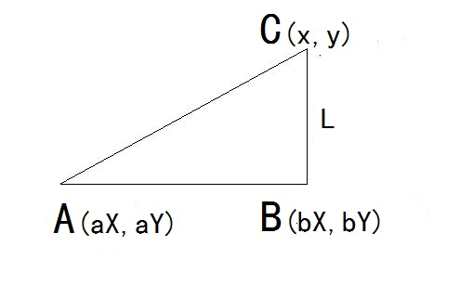

**如图：**A(aX, aY)，B(bX, bY)，BC=L，求C点坐标(x, y)

**思路：**

(1)

1-1 kAB * kCB = -1 // 互相垂直两直线斜率的乘积 = -1  
1-2 [(aY - bY) / (aX - bX)] * [(y - bY) / (x - bX)] = -1  
1-3 (aY - bY) * (y – bY) = -(aX – bX) * (x - bX)  
1-4 (y – bY) = - [(aX - bX) * (x - bX)] / (aY - bY)

1-5 y = bY - [(aX - bX) * (x - bX)] / (aY - bY)

(2)

2-1 CB = L

2-2 CB² = L²

2-3 (x – bX)² + (y – bY)² = L²

(3)

把1-4带入2-3

3-1 (x – bX)² + {-[(aX – bX) * (x – bX)] / (aY – bY)}² = L²

3-2 (x – bX)² + [(aX – bX)² * (x – bX)²] / (aY – bY)² = L²

3-3 (x – bX)² + [1 + (aX – bX)² / (aY – bY)²] = L²

3-4 (x – bX)² + {[aY - bY]² + (aX – bX)² * (aY - bY)²} / (aY – bY)²} = L²

3-5 (x - bX)² = [L² * (aY – bY)²] / [(aX – bX)² + (aY – bY)²]

3-6 x – bX = ±√{[L² * (aY - bY)²] / [(aX - bX)² + (aY – bY)²]}

3-7 x – bX = ±[L * (aY - bY)] / √[(aX - bX)² + (aY – bY)²]

3-8 x = bX ± [L * (aY - bY)] / √[(aX - bX)² + (aY – bY)²]

(4)

把3-8带入1-5

4-1 y = bY – {(aX - bX) * (bX ± [L * (aY – bY)] / √[(aX - bX)² + (aY – bY)²] – bX)} / (aY – bY)

4-2 y = bY – {(aX - bX) * (±[L * (aY – bY)] / √[(aX - bX)² + (aY – bY)²])} / (aY – bY)

4-3 y = bY ± [L * (aX - bX)] / √[(aX - bX)² + (aY – bY)²]

**结果：**

x1 = bX + [L * (aY - bY)] / √[(aX - bX)² + (aY – bY)²]

y1 = bY + [L * (aX - bX)] / √[(aX - bX)² + (aY – bY)²]

和

x1 = bX - [L * (aY - bY)] / √[(aX - bX)² + (aY – bY)²]

y1 = bY - [L * (aX - bX)] / √[(aX - bX)² + (aY – bY)²]