PIXELFORGE
Conditional GAN for Pixel Art Sprite Generation
Vandan Agrawal · GitHub: https://github.com/atom218/Pixel-art-generation-

1. Project Overview
PixelForge is a Conditional WGAN-GP trained from scratch in PyTorch to generate 64×64 pixel art character sprites conditioned on view angle (front, back, left, right). Using the TinyHero dataset (3,648 sprites, Kaggle), the model learns novel, class-conditioned sprite generation and supports smooth latent-space rotation between viewing angles via a Gradio GUI.

2. Model Architecture

Generator
Noise (100-dim) + one-hot label (4-dim) → Linear projection → reshape (512, 4, 4) → 4× ConvTranspose2d (4→64px) → Sigmoid. Sigmoid over Tanh: preserves hard pixel art color boundaries. BatchNorm2d + ReLU after each upsampling layer.

Critic (Discriminator)
Image (3, 64, 64) + class embedding map (1, 64, 64) → 4× strided Conv2d → raw scalar score (no Sigmoid). InstanceNorm2d over BatchNorm2d: required so the gradient penalty’s second-order gradients are not corrupted by inter-sample batch statistics.

WGAN-GP Loss & Key Hyperparameters
WGAN-GP replaces BCE with Wasserstein distance: Lᴇ = E[D(fake)]−E[D(real)]+10·GP, L၇=−E[D(fake)]. Gradient penalty enforces 1-Lipschitz on the critic, providing non-vanishing gradient to G regardless of critic confidence — directly fixing the collapse seen in v1.
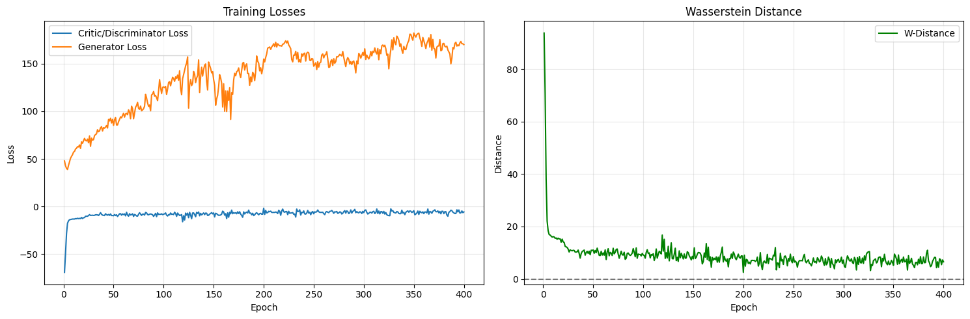

Epochs | Batch | LR | Adam β1/β2 | D_STEPS | GP_λ | Grad Clip
400 | 64 | 1e-4 → 5e-5 (ep.200) | 0.0 / 0.9 | 5 | 10 | max_norm=1.0

3. Extra Criteria

Gradio GUI — Character Angle Explorer
Users enter a character number (0–900) — mapped deterministically to a noise seed — and all four view angles are generated as thumbnails. A rotation slider (0–300, three 100-step segments) SLERP-interpolates conditioning vectors between adjacent angles (front→left→back→right), producing smooth angular transitions while keeping character identity fixed. Sprites are upscaled 4×5× with nearest-neighbour for crisp pixel art. Runs in Colab via demo.launch(share=True).

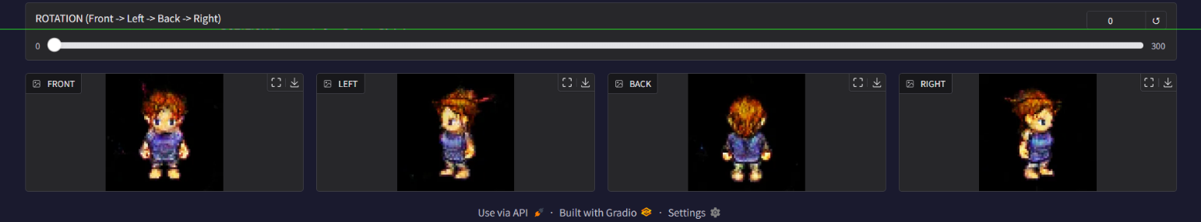
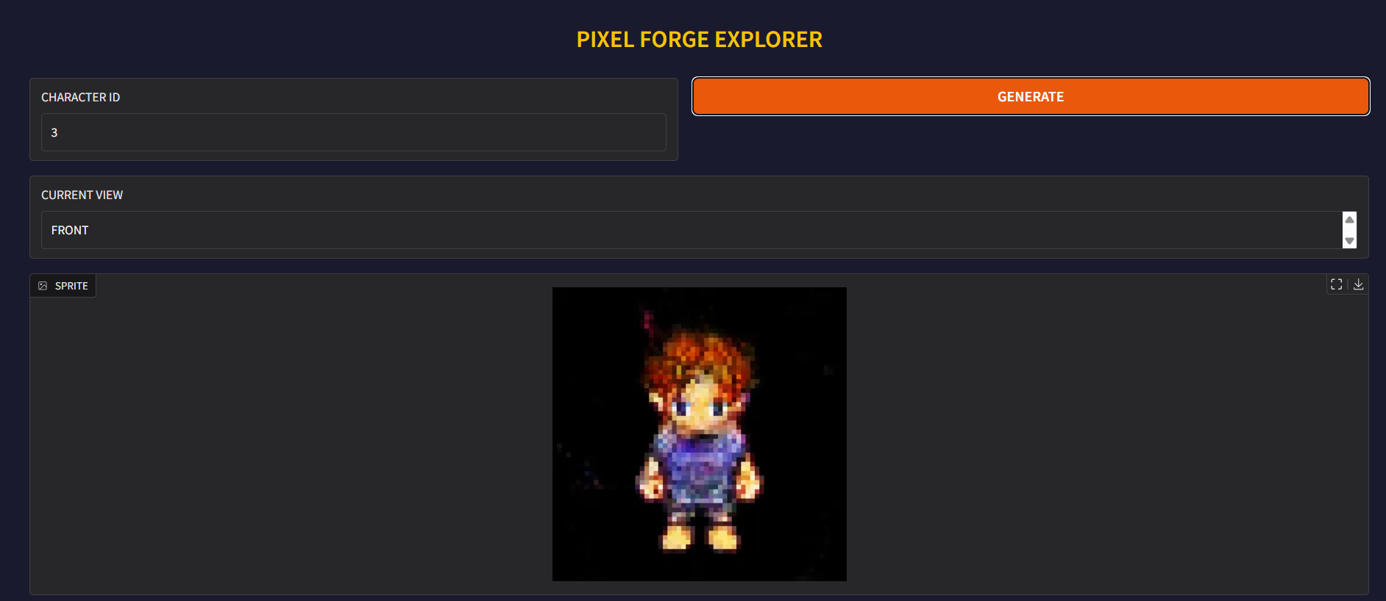

Hyperparameter Sweep (hyperparameter_tuning.py)
12 configurations across lr ∈ {1e-4, 2e-4}, batch_size ∈ {32, 64}, noise_dim ∈ {50, 100, 200}, each trained for 25 epochs. Scored by a lightweight FID approximation using discriminator conv features rather than InceptionV3, which is inappropriate for 64×64 pixel art (trained on natural photos).

4. Difficulties & Solutions
- Discriminator collapse (v1): BCE loss saturated by epoch 50 (lossᴇ=0.007, loss၇=6–13). Switched to WGAN-GP — provides non-saturating gradient regardless of critic confidence.
- Dataset pivot: Custom sprite-sheet slicer for OpenGameArt produced unusable pixel fragments. Adopted TinyHero (pre-sliced), repurposing conditioning from character class to view angle.
- AMP incompatibility (v3): float16 silently violated the Lipschitz constraint, producing neon noise blobs. Removed AMP; full float32 is required for gradient penalty correctness.
- Training speed: D_STEPS=5 means 5 critic backward passes per generator step. Mitigated with DataLoader pin_memory, num_workers=4, and LR halving at epoch 200.

