1) How many pennies could you put on the Golden Gate Bridge without any of them overlapping? For this question, please write out each step in your thought process.

Steps:
1) After raiding the change jar I found 87 pennies. So I could personally put 87 pennies on the Golden Gate Bridge. Knowing the Code Foo challenge isn't that easy, unless it was a trick question, I went ahead and did the math with an unlimited supply of pennies. First I calculated the area of the bridge. I am treating the bridge as a flat object and ignoring the curbs, cables, cars, etc.

Bridge Dimensions
Length: 8981 ft x Width: 90 ft = 808290 square feet

2) Then I decided to see how many pennies I could actually fit in to a small square (6x6 inches). Fortunately I had many pennies handy :D. For the penny placement I tried two approaches, a square grid of pennies, and a honeycomb pattern of pennies.

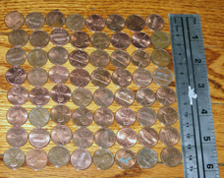Illustration 3: Grid 8 x 8 Pennies
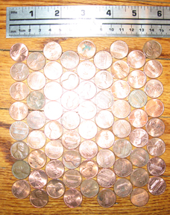Illustration 2: Honeycomb 8 x 9 Pennies
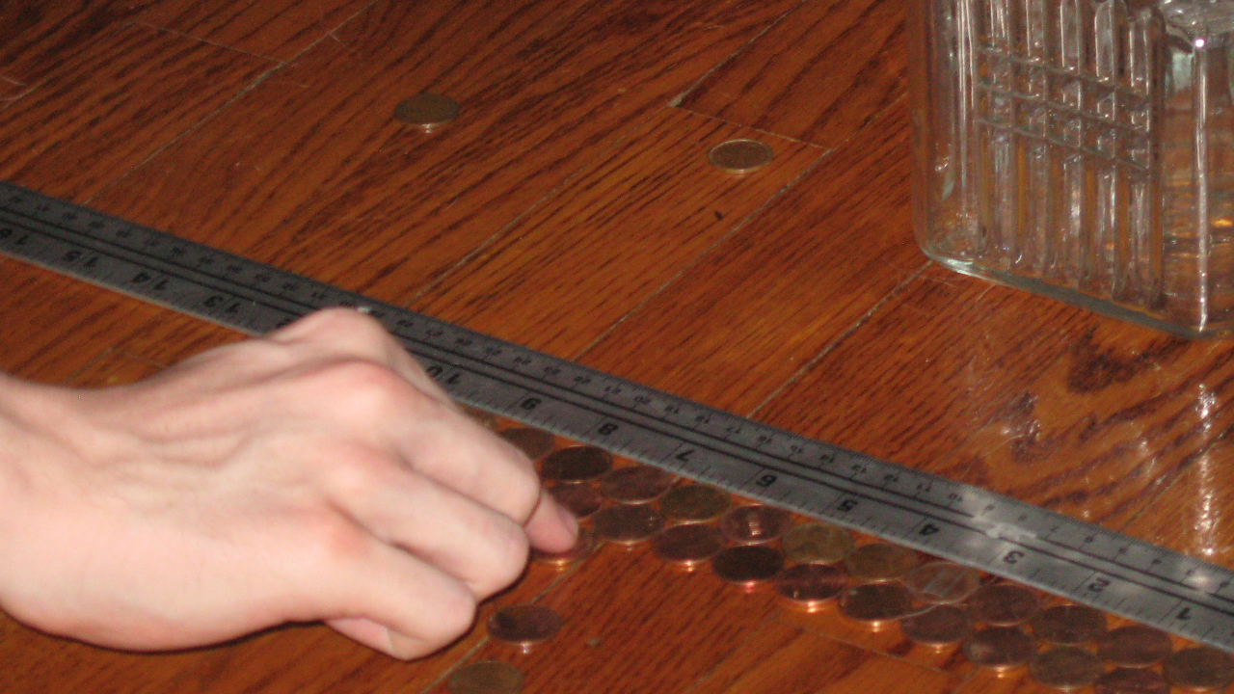Illustration 1: Easy Does It...

Side Note: Another option (if you wanted get crazy with it) you could roll the pennies in to tubes and put the rolled coins on the bridge. This would be a smaller penny footprint, allowing for more pennies. However the little ridges would probably overlap and not meet the requirements.

8x8 (16x6) Grid – 64 (256) pennies
First I arranged the pennies in an 8x8 penny grid within the 6 inch square. Adding 4 of these grids will complete a square foot which results in 256 pennies in a 16x16 grid per square foot.

8x9 (16x18) Honeycomb – 72 (288) pennies
Next option I arranged the pennies in to a repeating 8x9 honeycomb pattern within the 6 inch square. Adding 4 of these grids will also complete a square foot. However this square the top five pennies will interlock with bottom of the next tile. However at the end of the bridge some pennies will be half off of the bridge. To compensate for this I remove the 10 pennies per foot times the 90ft width of the bridge. That's 900 pennies extra we must remove.

3) Take the area of the bridge and multiply it by our pennies per square foot. For the honeycomb remember to subtract the 900 extra pennies hanging halfway off the end of the bridge.

16x16 Grid
808290 x 256 = 206,922,240 pennies

16x18 Honeycomb
(808290 x 288) – 900 = 232,786,620 pennies

