3) What is the minimum number of moves required for a knight to cover the entire chessboard? Write a program to prove it. Provide a graph with the move number on the x axis and the number of squares covered on the y axis.

Please extract ChessFoo.zip and open index.htm to view my dynamic chess program! Lots of love was put in to ChessFoo so I hope you enjoy it!

Assumptions – A “move” is a legal move of the knight. Meaning that initial placement of the knight on the board does not count as a “move”.

The minimum number of total moves for a knight to cover each square on the chessboard is 63.
189 total crossed squares
91 vertically
98 horizontally
The vertical & horizontal # shifts depending on where you place the knight.

Luke Auto-Walker uses Warnsdorff's rule to decide the next move square.
In the event of a tie the “newest” move set will take precedence.
The move set is the standard 0-7 possible knight moves rotating clockwise.

My graph is generated with each move. Here is one I generated -

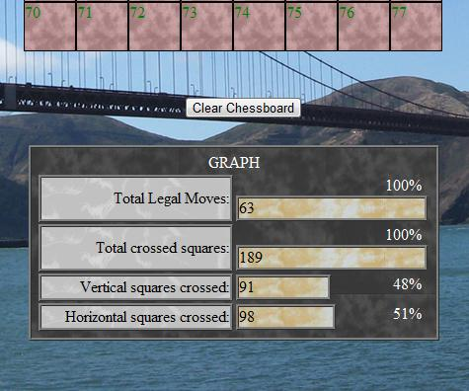

For my chess program I decided to use JavaScript, HTML, and CSS. To view and play with the chessboard please extract the zip file and open index.htm in a browser window. Best viewed with Google Chrome or Firefox web browsers, but should display/work well on everything. Slight CSS issue with IE when placing the first knight.

Thought process-
Essentially I created a “square” object to represent each square on the chessboard. Clicking a square places a “horse” object down displaying every possible move from the position. Clicking on a possible move will “move” the knight to the position, increment its move properties, display the new possible moves, and updated the graph. When you reach the other side of the board the win function will execute displaying total moves.

These objects are attached to our HTML elements. The great part of this is that with these objects we can now easily operate on the square & horse object properties & HTML in a variety of ways. We can also attach more properties to the squares or horses easily. Creating new objects is a snap with our constructors.

My code is separated in to “modules” to keep things clean & for easy debugging.

HTML
index.htm – Our test ground for the chessboard. Contains -
- Window onload JavaScript function to initilize the chessboard
- Creates an 8 by 8 matrix used to represent the chessboard
- Populates the matrix with div elements
- And finally creates and attaches a “square” object instrument each div

JavaScript
board.js – Used to create our chessboard. Contains -
- makeGrid (x, y) - A function to create and return a y by x matrix. We use 8x8 to represent the chessboard
- drawDivs (elementName, matrix) function – Insert an HTML div in to each element in our matrix
- populateMatrix (matrix) function – For each object (now also a div) in the matrix { create a new square object }
- The square object attaches to the div and instruments it by adding methods and properties

horse.js – A horse object to represent the knight on the chessboard. Contains -
- Horse (elementName, options) object constructor – Creates a horse object with our options and attaches it to elementName
- Horse.move (object, square) method – Moves horse to goal (set in options) and attaches the parent square element the horse came from.

square.js – A object used to represent one unit on the chessboard. It contains -
- Square(elementName,options) object constructor – Creates a square object which attaches to and instruments elementName.
- Square.removeFriends() method – Delete all possible moves from Square
- Square.occupy() method – Set squares status to occupied and change CSS
- Square.unoccupy() method – Set squares status to unoccupied and change CSS
- Square.setHorse() method – place a knight HTML div in the square
- Square.removeHorse() method – remove the knight HTML div from the square

common.js – Functions that are operate both with the square object and horse object or DOM
- squishThis(element) function – Squish or unsquish CSS settings for element
- swapThis(checkbox) function – Toggle for option checkbox + divs
- toggleSquare(square) function – The click function for a square on the chessboard. Makes calls to square.removeFriends and makemoves(knight,square)
- makeMoves(knight, square) function– Get all possible moves from square (using decideFate(knight)) and display
- decideFate(knight) function– Return option sets for making moves. Calculate and add to xy positions to option sets for return
- throwBones(knight) function- Return the “one correct” option set for Auto-Walker
- castRunes(fate) function – Return number of possible moves from passed option position
- readPalms(options) – Return true if square from option position is available

CSS

common.css – CSS used for main page and common items
horse.css – Knight image size rules
square.css – Styles used for occupied squares & chessboard
table.css – Bar graph style rules

