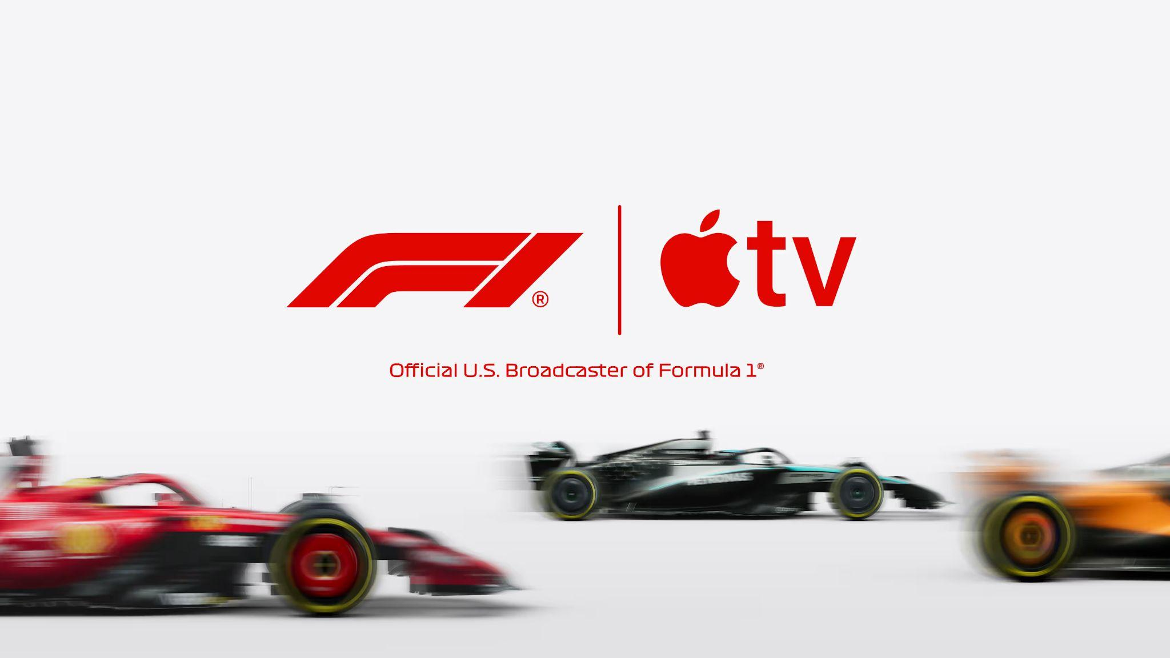
Formula 1 has announced a five-year partnership with Apple to become the sport’s exclusive U.S. broadcast partner from 2026, bringing together two global brands with a shared passion for innovation, excellence, and entertainment.
The news follows on from the hugely successful F1 The Movie, the Apple Original Film, which was released internationally in cinemas and IMAX venues in June and will make its global streaming debut date on Apple TV on Friday, December 12 2025.
Apple invested significantly in the project and worked with the F1 community in an unprecedented collaboration over three years to deliver a truly authentic and immersive racing movie for new and established F1 fans.
Critically acclaimed worldwide, F1 The Movie has grossed nearly $630 million globally to date, making it the most successful sports movie in history.
Importantly, as demonstrated by F1 The Movie, Apple’s ability to reach a diverse range of consumers across its powerful ecosystem presents a groundbreaking opportunity to engage new fans.
The 2025 Global F1 Fan Survey found that 47% of new U.S. F1 fans, who have been following the sport for five years or less, are aged 18-24, while over half are female, underlining the partnership’s huge potential to expand the sport’s younger and more diverse audience.

In addition to showing F1 on Apple TV, Apple will amplify the sport across Apple News, Apple Maps, Apple Music, Apple Sports, and Apple Fitness+.
This new broadcast agreement will see Apple TV host all Free Practice, Qualifying, Sprint sessions, and Grands Prix. Select races and all Free Practice sessions throughout the season will also be available to watch for free in the Apple TV app.
F1 TV Premium, F1’s own premier content offering, will continue to be available in the U.S. via an Apple TV subscription only and will be free for those who subscribe.
Additional information, including production and product details, and all the ways fans will be able to enjoy F1 content across their favourite Apple products and services, will be announced in the coming months.
“This is an incredibly exciting partnership for both Formula 1 and Apple that will ensure we can continue to maximise our growth potential in the U.S. with the right content and innovative distribution channels,” said Stefano Domenicali, President and CEO of Formula 1.
“We are no strangers to each other, having spent the past three years working together to create F1 The Movie, which has already proven to be a huge hit around the world.
“We have a shared vision to bring this amazing sport to our fans in the U.S. and entice new fans through live broadcasts, engaging content, and a year-round approach to keep them hooked.
“I want to thank Tim Cook [Apple’s CEO], Eddy Cue [Apple’s Senior Vice President of Services], and the entire Apple team for their vision, enthusiasm and passionate approach to delivering this partnership, and we are looking forward to the next five years together.”
Cue said: “We’re thrilled to expand our relationship with Formula 1 and offer Apple TV subscribers in the U.S. front row access to one of the most exciting and fastest-growing sports on the planet.
“2026 marks a transformative new era for Formula 1 from new teams to new regulations and cars with the best drivers in the world, and we look forward to delivering premium and innovative fan-first coverage to our customers in a way that only Apple can.”

