DATAPREPROCESSING

Total Monsoon Rainfall (TMRF) time series (𝑋𝑖) from the year 1993 to 2011 has been constructed for Mainpar region of Chhattisgarh, India. Since, transfer function sigmoid axon is used in the BPN model. The output of sigmoid axon has in close interval 0 to 1. Therefore, TMRF data time
series is normalized by using following equation 1 and obtained new normalized TMRF data time series (𝑅𝑖). The equation 2 is used to de-normalize thereafter for actual representation 𝑋𝑖. Data time series (𝑋𝑖) for the first 19 years (1993-2011) are used for developing the model. Remaining 11 years
(2012-2022) data time series (𝑋𝑖) is used to test the model independently for its acceptance. And
finally model is verified and operated for the year of 2023.

𝑅𝑖 = 𝑋𝑖 + min(𝑋𝑖)
𝑋𝑖 + max(𝑋𝑖)

𝑋𝑖 = (min(𝑋𝑖)− 𝑅𝑖 .max(𝑋𝑖))
(𝑅𝑖−1)

…(1)

…(2)
The MPS in parametric forecast is designed with twelve identified meteorological parameters. Most of those parameters have shown a very strong correlation with the TMRF. All these twelve parameters have different patterns, few of the current years parameters affecting the rainfall of same year wherein few previous years parameters affecting current years monsoon rainfall. MPS in parametric forecast is illustrated in [Figure 1], where 12 parameters (p1…p12) as depicted in Table 2 is used as input to input layer, three neurons in hidden layer (z1…z3) and one neuron in output unit are used to observe TMRF. Thus a total of 43 trainable weights including biases have been used in the network. Output target value for the network is actual TMRF data. The model parameters are given in the following Table 1. The list of identified meteorological parameters for forecasting of monsoon rainfall is depicted in Table 2 along with requisite details.

MPS IN PARAMETRIC FORECAST
MPS in parametric forecast is illustrated in [Figure 2], where 12 parameters (p1…p12) as depicted in Table 2 is used as input to input layer, three neurons in hidden layer (z1…z3) and one neuron Yk in output unit are used to observe current year TMRF. The model parameters are given in the following Table 1. The list of identified meteorological parameters for forecasting of monsoon rainfall is depicted in Table 2 along with requisite details.
Thus a total of 43 trainable weights including biases have been used in the network. Output target value for the network is actual current year TMRF data. In fact, it has been found that MAD (% of mean) between actual and model predicted value is directly proportional to number of hidden neuron (p).
These networks have input layer at the bottom, one hidden layer at the middle, and one output layer at the top. It has been observed that one hidden layer is sufficient, using two hidden layer rarely improves the model, and it may introduce a greater risk of converging to a local minima. However it has been identified that the three neuron in hidden layer and twelve input vectors provided satisfactory result for all meteorological data. Increase in number of neurons in hidden layer increases MAD between actual and predicted value Karmakar et al. [14].



Figure 1. Mainpat region, geographically located at 22.8199°N longitude to 83.2828°E latitude.

It is found that, a high learning rate ‘α’ leads to rapid learning but the weights may oscillate, while a lower learning rate leads to slower learning, Kumar (2007). If the momentum is added to the weight update formula, the convergence is faster. The main purpose of the momentum is to accelerate the convergence of error propagation algorithm. It is found that, if initial weight is too large the initial input signals to each hidden or output unit will fall in the saturation region where the derivative of sigmoid has very small value (f (network) = 0). If initial weights are too small, the network output to a hidden or output unit will approach zero, which then causes extremely slow learning. To get the best result the initial weights (and biases) are set to random number between 0 and 1. Rumelhart et al.(1986) first introduced BPN based on gradient descent method [16]. Being a gradient descent method, it minimizes the mean square error (MSE) of the output computed by the network during the feed-forward and back-propagation process.
As a result, three neurons in hidden layer have been selected and it provides most desirable result. Output target value for the network is actual data to be predicted. The neurons output can be obtained as f (xj). The neurons output is obtained as f (xj) where f is a transfer function typically the sigmoid function is used i.e.
1
(𝑥) = 1 + 𝑒−𝛿𝑥+𝑛

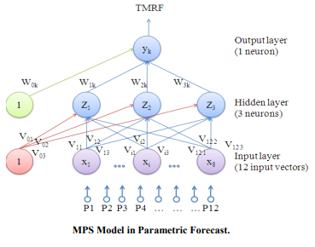
Figure 2: MPS Model in Parameteric Forecast
where δ determines the slope and η is the threshold. In the proposed model δ =1, η =0, the output of the neuron will be in close interval [0, 1] as shown in [Figure 3]. Learning rate α = 0.0364438 is used. It is found that, α = 0.0364438 is suitable for almost all of the cases and in this study. It is also observed that, for nearly all problems, one hidden layer is sufficient. Using two hidden layers rarely improves the model, and it may introduce a greater risk of converging to local minima and also there is no theoretical reason for using more than two hidden layers.
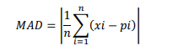
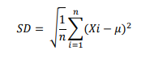
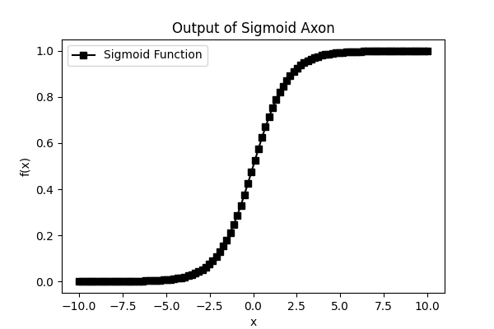
Figure 3: Output of Sigmoid Axon
DESCRIPTION:
This graph illustrates the sigmoid activation function, which maps input values into an output range between 0 and 1. This is crucial in neural networks for introducing non-linearity and ensuring output values are bounded. The sigmoid function's characteristic "S" shape is useful for binary classification tasks and helps in gradient-based optimization during training.

Table 1. Parameters of MPS Model

Name of the model MPS in Parametric Forecast
1. Number of layer | 03
2. Input vector (n) | 12 parameters + 1Dependant parameter
3. Input data (independent parameter)  year | 12 parameters of current and previous
4. Output neurons | One neuron
5. Target (Dependent parameter) | TMRF
6. Hidden layer | 01
7. Neurons in hidden layer (p) | 03
8. Transfer function (f) | Sigmoid.
9. Learning rate (α) | 0.0364438
10. Momentum factor (μ) | 1.0
11. Weight optimization rule | Delta learning rule (Back Propogation )
12. Number of weights (wi) | 43 (Including biases).
13. Epochs | 5000
16. Trained weights | Table 1.
17. Performance | Excellent in training period, and good in the independent period .

Table 2 List of Identified Meterological Parameters
Sl.  No. | Parameters

Highest Maximum Temperature
Lowest Minimum Temperature
Mean Maximum Temperature
Mean Minimum Temperature
Mean Relative Humidity
Mean Wind Speed
Mean Station Level Pressure
Mean Dew
Mean Wet Bulb
Mean Vapour Pressure
Heaviest Rainfall in 24 hour
Cloud Amt

Table 3. Initial Random Weights for MPS in Parametric forecast

Weights
Hidden Layer Weights:
0.863792 | 0.483292 | 0.782414
0.539032 | 0.428871 | 0.175198
0.98087 | 0.134237 | 0.895696
0.918302 | 0.376361 | 0.11424
0.16682 | 0.862062 | 0.866989
0.624043 | 0.010861 | 0.143803
0.836227 | 0.339984 | 0.203833
0.088325 | 0.574381 | 0.362452
0.806964 | 0.488113 | 0.606796
0.879906 | 0.026557 | 0.106788
0.275506 | 0.710538 | 0.522044
0.835395 | 0.281752 | 0.858415

Hidden Layer Bias
0.135504
0.915212
0.578844

Output Layer Weights
0.623661
0.739239
0.854091

Output Layer Bias
0.876588

Normalization

Denormalization
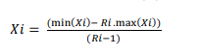
Activation Function
The neurons output is obtained as f (xj) where f is a transfer function typically the sigmoid function is used i.e
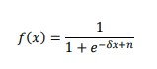
MAD,SD Formula
[3] RESULTS & DISCUSSIONS
To check the accuracy of the experiments and analyze the performances of MPS during training period, it is trained with 19 years (1993-2011) training dataset in parametric forecast.
While training of the network in parametric forecast it has shown a very high compatibility between the actual and predicted rainfall, in course of training the final CC between the actual and predicted rainfall was very high i.e. 0.830029 CC.
In order to check the performance of MPS during the testing / independent period with new data, it was tested with the 10 years (2012- 2022) of the test data and verified for 2023.

Table 4 TMRF (Total Monsoon Rainfall) data for training period
YEAR | Predicted TMRF | Actual TMRF
1993 | 282.2228 | 171.09
1994 | 207.1296 | 172.18
1995 | 235.5964 | 158.02
1996 | 201.3776 | 162.78
1997 | 306.1561 | 161.55
1998 | 63.86442 | 119.61
1999 | 147.5526 | 125.12
2000 | 183.1023 | 160
2001 | 150.2657 | 138.7
2002 | 202.6334 | 162.36
2003 | 247.2671 | 160.41
2004 | 115.5908 | 130.91
2005 | 169.6282 | 166.44
2006 | 116.5974 | 188.44
2007 | 120.2133 | 135.25
2008 | 142.1412 | 143.7
2009 | 173.4022 | 168.62
2010 | 182.0057 | 150.2
2011 | 86.18304 | 177.81

Table 5: TMRF (Total Monsoon Rainfall ) data for testing period
YEAR | Predicted TMRF | Actual TMRF
2012 | 106.8722 | 95.15
2013 | 158.8957 | 157.33
2014 | 184.8759 | 140.83
2015 | 201.5846 | 174.17
2016 | 219.8377 | 192.54
2017 | 249.6307 | 165.97
2018 | 111.8397 | 100.61
2019 | 132.5282 | 147.93
2020 | 237.3531 | 200.57
2021 | 193.8086 | 113.9
2022 | 134.9287 | 108.43

Table 6: TMRF(Total Monsoon Rainfall) for Verification Period 2023
YEAR | Predicted TMRF | Actual TMRF
2023 | 130.5977 | 136.74

Table 9. Statistics of Performance of MPS.

Model | Training Period |  |  | Independent Period
Model | SD | MAD | CC | SD | MAD | CC
Parametric  forecast | 0.047373 | 0.027862 | 0.830029 | 0.017321 | 0.005128 | 0.80

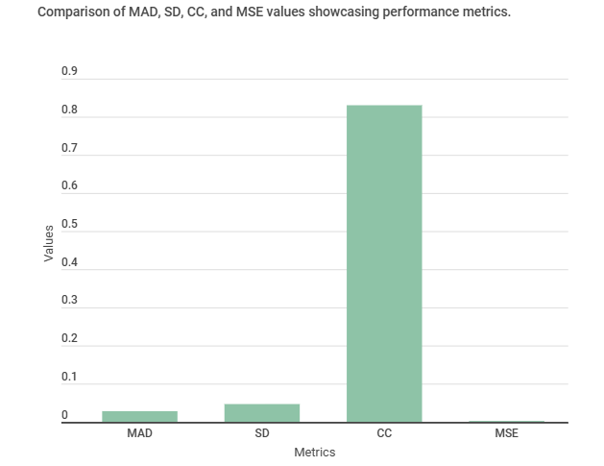
Figure 4: Metrics for the performance of model
Description:
The graph illustrates the performance of a neural network model during its training period, using key metrics: Standard Deviation (SD), Mean Absolute Deviation (MAD), and Correlation Coefficient (CC). The SD of 0.047373 indicates the variation in prediction errors, the MAD of 0.027862 shows the average absolute errors, and a CC of 0.830029 suggests a strong positive correlation between the predicted and actual values, highlighting the model's predictive accuracy.

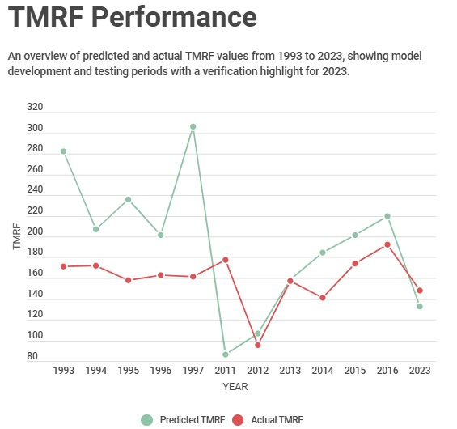

Figure 5: Performance of MPS in Parametric forecast on 5000 epochs of training and testing period

Description: The graph plotted by this program illustrates the model's input and target data from 1993 to 2023. The input data, represented by a sample set for each year, is displayed alongside the target data, which represents the dependent parameter (TMRF). This visualization helps in understanding the variations and trends in the input parameters over the 31-year period and their relationship with the target output, providing insights into the model's behavior and performance over time.

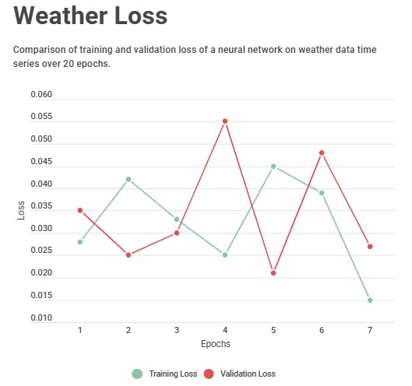
Graph depicting Training and Validation loss occurred.

IMD’s operational model is appropriate for LRF of monsoon rainfall over whole Central India. However it is inadequate in case of LRF over a very smaller region like Mainpat which is allocated in Central India. The IMD’s operational model is based on statistical power regression analysis which uses few global dynamic parameters (i.e., predictors). These similar parameters are not useful for prediction over this region. It is concluded that impact of global parameters (i.e., independent) on the monsoon rainfall (i.e., dependent) over the smaller region is irrelevant. Identification of physically connected global meteorological parameters for monsoon rainfall over smaller region is also extremely difficult. The ANN techniques are capable in identification of internal dynamics of chaotic time series data. Thus, MPS in parametric forecast is recommended for this type of study.

References:
- Rumelhart, D., Hinton, G. E., Williams, R. J., Learning Internal Representation By Error Propagation, R J Parallel Distributed Processing: Exploration in the Microstructure of Cognition, MIT Press Cambridge, 1, 318-362, (1986).

- Karmakar, S., et al., “Development of Artificial Neural Network Models for Long-Range Meteorological Parameters Pattern Recognition over the Smaller Scale Geographical Region”, IEEE Computer Society, Washington, DC, USA., 8-10 Dec., pp.1 – 6, (2008).

- Kumar, S., Neural Network Computer Engineering Serie, The McGraw-Hill, New Delhi, , 104-152, (2007).

- A Pragmatic Study Based on Neural Network for Forecasting Long-range Monsoon Rainfall over Smaller Geographical Region by Gyanesh Shrivastava

