Software Requirement Specification

Diabetes Care

By

**Jirayu Chinpongsuwan 552115011**

Department of Software Engineering

College of Arts, Media and Technology

Chiang Mai University

_________________________________________________

**Project Advisor**

Dr. Prompong Sugunnasil

**Document History**

|  |  |  |  |  |  |  |
| --- | --- | --- | --- | --- | --- | --- |
| **Document Name** | **Version** | **Status** | **Date** | **Viewable** | **Reviewer** | **Responsible** |
| Document |  | | | | | |
| diabetes -SRS-V.0.1.docx | V0.1 | Draft | February  29, 2016 | JC, PS | JC, PS | JC, PS |
| diabetes -SRS-V.0.1.docx | V0.2 | Draft | April 25,2016 | JC, PS | JC, PS | JC, PS |
|  |  |  |  |  |  |  |

*PS: Dr. Prompong Sugunnasil

*JC: Mr. Jirayu Chinpongsuwan

**___________________**

**Dr. Prompong Sugunnasil**

Senior Project Advisor

**Table of Contents**

**Chapter One | Introduction**

* 1. **Objective**

The objective of the Software Requirement Specification document is out line overall requirement of “Diabetes Web application” project. This document has described clearly and accurately descriptively. About detail in Software Requirement Specification is included by function, performance, design consistency, and external interface. This document is based on the project proposal and project plan. It also constraint the general description of user type who is involved with the system.

The Software Requirement Specification document is also a guideline of design the “Diabetes Web application” system

* 1. **Intended Audience and Reading Suggestions**

This Software Requirement Specification is created for everyone who is involved with this “Diabetes web application” project. It will make convenience for those people as follow

**1.2.1 Development Team**

**-** To help the developer understand the requirement and plan how to work together.

**1.2.2 Customer**

**-** Help the customer to know the basic requirement of the “Diabetes Web application”

**1.3 Project Scope**

The main feature of “Diabetes Web application” are as follows:

* Authentication system.
* Account management.
* Nutritionists management.
* Admin management nutritionists.
* Health plan system.
* Statistics glycemic.
* Analyze diabetes.

**1.4 Acronyms and Definitions**

**1.4.1 Acronyms**

SRS: Software Requirement Specification

URS: User Requirement Specification

UC: Use Case

AD: Activity Diagram

**1.4.2 Definitions**

**Feature** Transformation of input parameters to output parameters based on a specified algorithm. It describes the functionality of a product in the language of the product. Used for requirements analysis, design, coding, testing or maintenance.

**User Interface** User interface (UI) is everything designed into an information device with which a human being may interact including display screen, keyboard, mouse, light pen, the appearance of a desktop, illuminated characters, help messages, and how an application program or a Web site invites interaction and responds to it. [1]

**UML** The Unified Modeling Language (UML) is a general -purpose modeling language in the field of software engineering, which is designed to provide a standard way to visualize the design of a system. [2]

**Activity Diagram** Activity diagrams are graphical representations of the workflows of stepwise activities and actions with support for choice, iteration and concurrency. Activity diagrams show the overall flow of control. [3]

**Use Case** A use case is a methodology used in system analysis to identify, clarify, and organize system requirements. The use case is made up of a set of possible sequences of interactions between systems and users in a particular environment and related to a particular goal. It consists of a group of elements (for example, classes and interfaces) that can be used together in a way that will have an effect larger than the sum of the separate elements combined. [4]

**Use Case Diagram** A use case diagram at its simplest is a representation of a user’s interaction with the system and depicting the specifications of a use case. A use case diagram can portray the different types of users of a system and the various ways that they interact with the system. [5]

**Chapter Two | Overall Description**

**2.1 Product Perspective**

“Diabetes Care Web application” is web application to help customer to take care the diabetic. Customer will be convenient to protect complication from diabetes. This system will help customer to be more convenient to organize because the customer will get info to be analyzed from system. In term of visitor, they can search for the information and detail about diabetes. This system will be much more helpful for patient diabetes.

**2.2 Product Feature**

Diabetes project has separated the whole project to one processors. The description is shown below:

Progress I: Feature#1: Authentication system.

Feature#2: Account management.

Feature#3: Nutritionists management.

Feature#4: Admin management nutritionists.

Feature#5: Health plan system.

Feature#6: Statistics glycemic.

Feature#7: Analyze diabetes.

**2.3 User Characteristics**

User: User can direct access an application via their desktop, tablets, and phones to every part of this application by requesting internet connection. The patient is the person who can create a health plan and monitor nutrition behavior for preventing theirs from the complications disease. Admin is the person who can manage the account of doctor, nurse, and nutritionists. Doctor/Nurse is the person who can enter patient information into the system and management the activity in a part of insert/update/delete. And the nutritionist is the person who can control the nutrition in part of insert/update/delete.

**2.4 Development Environment**

Laptops

- DELL

Processor: Intel(R) Core(TM) i5-6200U CPU @ 2.30GHz 2.14 GHz

Memory: 4.00 GB (3.90 GB usable)

System type: 64-bit Operating System.x64-based processor

**Chapter Three | Functional Requirement**

**3.1 User Requirement Specification**

**Feature#1: Authentication system.**

URS-01: The user can log in to a web application.

URS-02: Use can log out from a web application.

**Feature#2: Account management.**

URS-03: The nurse can enter patient (username, password, name, age, gender, weight, height, diabetes type and date that start treatment) to the database server on a web application.

URS-04: Patient can view information of his on profile page.

URS-05: Patient can edit information on profile page.

URS-06: Patient can change the password for login.

URS-07: Admin can manage user account on administrator page.

**Feature#3: Nutrition management.**

URS-08: Nutritionists can manage food on nutrition management page.

**Feature#4: Activity management**

URS-09: Nurse or Doctor can manage activity on activity management page.

**Feature#5: Activity plan and recommend system**.

URS-10: Patient can select the symptoms on health plan page.

URS-11: Patient can get the suggestion about exercise from the system.

**Feature#6: Nutrition plan system.**

URS-12: Patient can add food from the database to record in a health plan.

URS-13: Patient can view the average of glycemic index and calorie of food in the selected plan.

URS-14: Patient can delete a food from the health plan.

**Feature#7: Health monitor system.**

URS-15: Patient can record blood sugar value to the database.

URS-16: Patient can view body mass value that calculated by using BMI = weight (Kg) / (height (m) * height (m)).

URS-17: Patient can view the statistic line graph of blood sugar and body mass.

URS-18: Patient can view interpretation about blood sugar level from the system.

**Feature#8: Behavior monitors system.**

URS-19: Patient can select food name from the database.

URS-20: Patient can check the list of medicine.

URS-21: Patient can get analyze of nutrition behavior in each day.

URS-22: Patient can view the daily graph of the glycemic level.

**3.2 User Requirement specification and Software Requirement Specification**

**Feature#1: Authentication system.**

**URS-01: The user can log in to a web application.**

**Requirement**

SRS-01: The system shall provide the login UI to receive username and password.

SRS-02: The system shall provide button “login”.

SRS-03: The system shall validate username and password.

SRS-04: The system shall display error message “Invalid login attempt”, when user input wrong username and password

SRS-05: The system shall display error message the “Please input Username”, when the user does not input username.

SRS-06: The system shall display error message the “Please input Password”, when the user does not input password.

SRS-07: The system shall redirect to behavior page, when the patient login to the web application.

SRS-08: The system shall redirect to home page, when the doctor or nurse login to the web application.

SRS-09: The system shall redirect to administrator page, when admin login to the web application

**URS-02: The user can log out from web application.**

**Requirement**

SRS-10: The system shall provide button “Log out”.

SRS-11: The system shall redirect to home page.

**Feature#2: Account management.**

**URS-03: The nurse can be registration patient on a Web Application.**

**Requirement**

SRS-12: The system provides the register UI which includes input fields to input username, password, confirm Password, e-mail, first name, last name, a select box to select gender of patient, age, address, a select box to select diabetes type of patient, height, weight, and start treatment

SRS-13: The system shall provide button “Submit”.

SRS-14: The system shall redirect to home page, when nurse registers patient success.

SRS-15: The system shall validate input field username, password, confirm Password, e-mail, first name, last name, gender, age, address, diabetes type, height, weight, and start treatment.

SRS-16: The system shall provide error message the “email is already taken”, when the user input email is already in the database.

SRS-17: The system shall provide error message the “email is invalid”, when user input wrong format e-mail.

SRS-18: The system shall provide error message the “Username is already taken”, when the user input username is already in the database.

SRS-19: The system shall provide error message the “Username field is required”, when the user does not input username.

SRS-20: The system shall provide error message the “Password field is required”, when the user does not input password.

SRS-21: The system shall provide UI to user input again.

SRS-22: The system shall provide error message the “First Name field is required”, when the user does not input the first name.

SRS-21: The system shall provide UI to user input again.

SRS-23: The system shall provide error message the “Last Name field is required”, when user does not input the last name.

SRS-21: The system shall provide UI to user input again.

SRS-24: The system shall provide two select options male and female in the select box gender of the user.

SRS-25: The system shall provide error message the “Age field is required”, when the user does not input age.

SRS-26: The system shall provide error message “age is invalid”, when user input wrong format age.

SRS-21: The system shall provide UI to user input again.

SRS-27: The system shall provide error message the “Address field is required”, when the user does not input address.

SRS-21: The system shall provide UI to user input again.

SRS-28: The system shall provide two select options diabetes type 1 and diabetes type 2 in the select box diabetes type of user.

SRS-29: The system shall provide error message “height is invalid”, when user input wrong format height.

SRS-30: The system shall provide error message the “Height field” is required, when the user does not input height.

SRS-21: The system shall provide UI to user input again.

SRS-31: The system shall provide error message “weight is invalid”, when user wrong input format weight.

SRS-32: The system shall provide error message the “Weight field” is required, when the user does not input weight.

SRS-21: The system shall provide UI to user input again.

SRS-33: The system shall provide error message the “Start Treatment field” is required. When the user does not input, start treatment.

SRS-21: The system shall provide UI to user input again.

SRS-34: The system shall save user information to database, when user input data success.

SRS-35: The system shall redirect to home page, when registration is a success.

**URS-04: The patient can view information of his on profile page.**

**Requirement**

SRS-36: The system shall provide link redirect to profile page.

SRS-37: The system shall redirect to the profile page.

SRS-38: The system shall display the information of the user.

**URS-05: The patient can edit information on the profile page.**

**Requirement**

SRS-39: The system shall provide UI, which includes input fields to input username, password, confirm Password, e-mail, first name, last name, a select box to choose gender, age, address, a select box to select diabetes type, height, weight, and start treatment for edit patient info.

SRS-13: The system shall provide button “Submit”.

SRS-40: The system shall redirect to a profile page, when patient edit information success.

SRS-40: The system shall validate input field Username, Password, Confirm Password, E-mail, First Name, Last Name, Gender, Age, Address, Diabetes Type, Height, Weight, Start treatment

SRS-41: The system shall provide error message “e-mail is invalid”, when user input wrong format phone number.

SRS-42: The system shall provide error message “age is invalid”, when user input wrong format age.

SRS-43: The system shall provide error message “height is invalid”, when user input wrong format height.

SRS-44: The system shall provide error message “Weight is invalid”, when user wrong input format weight.

SRS-45: The system shall save change in the database.

**URS-06: The patient can change the password for login.**

**Requirement**

SRS-46: The system shall provide input fields to current input password, new password, confirm the password.

SRS-13: The system shall provide button “Submit”.

SRS-47: The system shall redirect to the profile page, when user change password success.

SRS-48: The system shall validate the input fields current password, new password, confirm the password.

SRS-49: The system shall provide error massage “current password is field”, when the current password not correct.

SRS-50: The system shall provide error massage “new password is field”, when new password not same confirm the password.

SRS-51: The system shall provide error massage “new password and confirm password does not match”, when user input a new password and confirm password does not match.

**URS-07: Admin can manage the account on administrator page.**

**Requirement**

SRS-52: The system shall provide UI to create new account include input fields to input username, password, first name, last name, and selection box to select the role of the user.

SRS-53: The system shall provide three select options doctor, nurse, and nutritionists in the select role of the user.

SRS-13: The system shall provide “Submit” button.

SRS-54: The system shall save data in the database, when admin click button “Submit”.

SRS-55: The system shall redirect to the home page of account management, when admin creates new account success.

SRS-56: The system shall provide UI to edit include input fields to input username, password, first name, last name, and selection box to select the role of the user.

SRS-53: The system shall provide three select options doctor, nurse, and nutritionists in the select role of the user.

SRS-13: The system shall provide “Submit” button.

SRS-57: The system shall save change data in the database, when admin click button “Submit”.

SRS-58: The system shall redirect to a home page of account management, when edit accounts success.

SRS-59: The system shall provide “Delete” button.

SRS-60: The system shall delete the account from the database, when admin click button “Delete”.

**Feature#3: Nutrition management.**

**URS-08: Nutritionists can manage food on nutrition management page.**

**Requirement**

SRS-59: The system shall provide UI to create new foods which include input field to input food name, glycemic index, and calorie.

SRS-60: The system shall validate input field food name, glycemic index, and calorie.

SRS-61: The system shall provide error message “glycemic index is invalid”, when user wrong input format.

SRS-62: The system shall provide error message “calorie is invalid”, when user wrong input format.

SRS-13: The system shall provide “Submit” button.

SRS-63: The system shall save data in the database, when nutritionists click button “Submit”.

SRS-64: The system shall redirect to the home page of nutrition management, when to create new foods success.

SRS-65: The system shall provide UI to edit include input field to input food name, glycemic index, and calorie.

SRS-60: The system shall provide error message “glycemic index is invalid”, when user wrong input format.

SRS-61: The system shall provide error message “calorie is invalid”, when user wrong input format.

SRS-13: The system shall provide “Submit” button.

SRS-66: The system shall save change data in the database, when nutritionists click button “Submit”.

SRS-67: The system shall redirect to the home page of nutrition management, when to edit food success.

SRS-59: The system shall provide “Delete” button.

SRS-68: The system shall delete foods from the database, when nutritionists click button “Delete”.

**Feature#4: Activity management**.

**URS-09: Nurse or Doctor can manage activity on activity management page.**

**Requirement**

SRS-69: The system shall provide UI to create the new activity which includes input field patient symptom and exercise advice to a database.

SRS-13: The system shall provide “Submit” button.

SRS-70: The system shall save data in the database, when nurse/doctor clicks button “Submit”.

SRS-71: The system shall redirect to a home page of activity management, when to create new activity success.

SRS-72: The system shall provide UI to edit the data include input field patient symptom and exercise advice to a database.

SRS-13: The system shall provide “Submit” button.

SRS-73: The system shall save change data in the database, when nurse/doctor click button “Submit”.

SRS-74: The system shall redirect to the home page of activity management, when editing activity success.

SRS-59: The system shall provide “Delete” button.

SRS-75: The system shall delete an activity from the database, when nurse/doctor click button “Delete”.

**Feature#5: Activity plan and recommend system**.

**URS-10: The patient can select the symptoms on health plan page.**

**Requirement**

SRS-76: The system shall provide a select box to select symptoms of the patient.

SRS-77: The system shall provide five select option ที่มีปัญหาข้อเข่า ข้อเท้าหรือเท้า, ผู้ที่เป็นปลายประสาทอักเสบ มีอาการชาเท้า, ผู้ที่เบาหวานขึ้นตา, ผู้ที่มีโรคหัวใจ in the select box symptoms of patient.

SRS-78: The system shall provide “select” button.

**URS-11: The patient can get the suggestion about exercise from a system.**

**Requirement**

SRS-79: The system shall provide information which includes symptom detail, exercise appropriate, exercise inappropriate, and steps of exercise, when patient select the symptoms success.

**Feature#6: Nutrition plan system.**

**URS-12: The patient can select food from the database to record in the health plan.**

**Requirement**

SRS-80: The system shall provide a select box to select food name from the database.

SRS-81: The system shall provide select options list of food name.

SRS-82: The system shall provide “Add” button.

SRS-83: The system shall remember the food that selected to the database of user food.

SRS-84: The system shall review food to the user, when success process.

**URS-13:** **The patient can view the average of glycemic index and calorie of food in the selected plan.**

**Requirement**

SRS-85: The system shall provide text number of an average glycemic index.

SRS-86: The system shall provide text number of average calorie.

**URS-14: The patient can delete the food from the health plan.**

**Requirement**

SRS-87: The system shall provide a button to “delete” food from the list.

SRS-89: The system shall delete a food from the list of the health plan.

SRS-90: The system shall save change in the database of user food.

**Feature#7: Health monitors system.**

**URS-15: The patient can record blood sugar value to the database.**

**Requirement**

SRS-91: The system shall provide input field to input blood sugar.

SRS-92: The system shall provide button “add” to a user.

SRS-93: The system shall record the value in the database.

SRS-94: The system shall validate input field blood sugar.

SRS-95: The system shall provide error message “blood sugar is invalid”, when the user input wrong format blood sugar.

SRS-96: The system shall provide error message “blood sugar cannot be negative”, when the user input blood sugar minus value.

**URS-16: Patient can view body mass value that calculated by using BMI = weight (Kg) / (height (m) * height (m)).**

**Requirement**

SRS-97: The system shall calculate body mass from information (weight, height) of patientby using BMI = weight (Kg) / (height (m) * height (m)).

SRS-98: The system shall display body mass (BMI, BMR) on health plan page.

**URS-17: The patient can view the statistic line graph of blood sugar and body mass.**

**Requirement**

SRS-99: The system shall provide line graph.

SRS-100: The system shall request blood sugar value and BMI value from the database.

SRS-101: The system shall display blood sugar value and BMI value in the graph.

**URS-18: The patient can view interpretation about blood sugar level from the system.**

**Requirement**

SRS-102: The system shall provide UI for display recommend to the user include (levels of diabetes, Symptom, How to take care).

SRS-103: The system shall request the blood sugar value to analyze and find the levels of diabetes.

SRS-104: The system shall display the levels of diabetes and symptom and how to take care.

**Feature#8: Behavior monitors system.**

**URS-19: The patient can select food name from the database.**

**Requirement**

SRS-80: The system shall provide a select box to select food name from the database.

SRS-81: The system shall provide select options list of food name.

SRS-105: The system shall provide “select” button.

SRS-106: The system shall review food that selected to the user.

**URS-20: The patient can check the list of medicine.**

**Requirement**

SRS-107: The system shall provide a checkbox to check the list of medicine.

**URS-21: The patient can get analyze of nutrition behavior in each day.**

**Requirement**

SRS-108: The system shall provide image color to display result analyze.

SRS-109: The system shall provide three colors which include green, yellow, and red.

SRS-110: The system shall request data of food and medicine in each day to analyze.

SRS-111: The system shall display analyze result green color, when the user gets glycemic index value less than 120 and check all list of medicine.

SRS-112: The system shall display analyze result yellow color, when the user gets glycemic index value more than 120 and check all list of medicine or get glycemic index value less than 120 and not check all list of medicine.

SRS-113: The system shall display analyze result red color, when the user gets glycemic index value more than 120 and not check all list of medicine.

**URS-22: The patient can view the daily graph of the glycemic level.**

**Requirement**

SRS-114: The system shall provide line graph.

SRS-115: The system shall get glycemic index value from foods that selected.

SRS-116: The system shall calculate the glycemic index value.

SRS-117: The system shall display the glycemic value of foods that calculated on the graph.

**Chapter Four | Specification Requirement**

**4.1 Use Case Scenarios**

**4.1.1 Use Case Diagram All Feature**

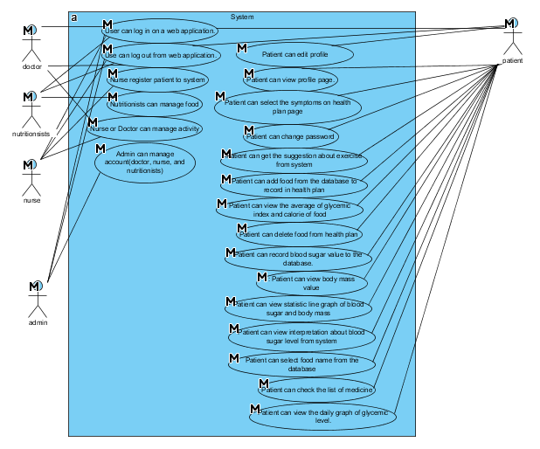

**Figure 1: Use Case diagram of Diabetes**

**Use Case Diagram: Authentication system.**

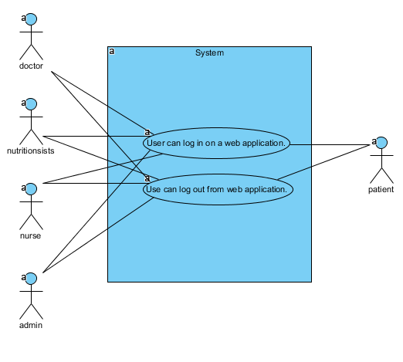

**Figure 2: Use Case diagram of Authentication system.**

**Use Case Diagram: Account management.**

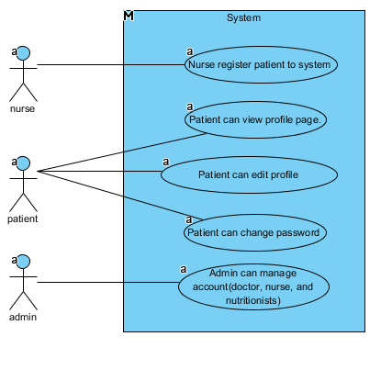

**Figure 3: Use Case diagram of Account management.**

**Use Case Diagram: Nutritionists management**

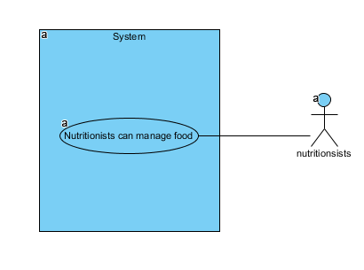

**Figure 4: Use Case diagram of Nutritionists management.**

**Use Case Diagram: Activity management**

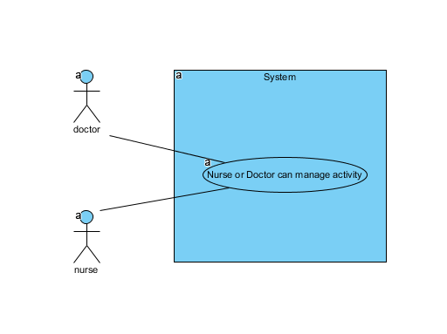

**Figure 5: Use Case diagram of Activity management.**

**Use Case Diagram: Activity plan and recommend system.**

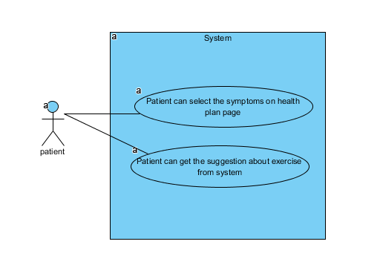

**Figure 6: Use Case diagram of Activity plan and recommend system.**

**Use Case Diagram: Nutrition plan system.**

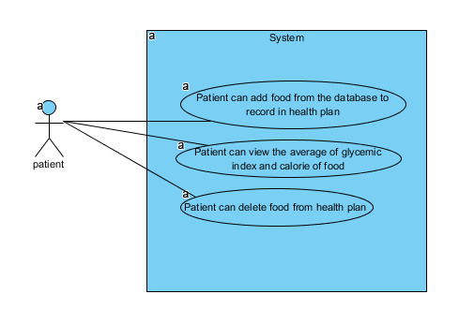

**Figure 7: Use Case diagram of Nutrition plan system.**

**Use Case Diagram: Health monitors system.**

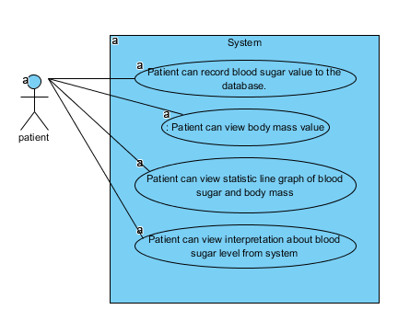

**Figure 8: Use Case diagram of Health monitors system.**

**Use Case Diagram: Behavior monitors system.**

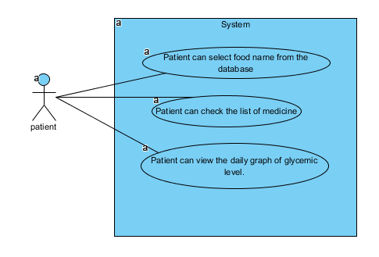

**Figure 9: Use Case diagram of Behavior monitors system.**

**Chapter Four | Specification Requirement**

**4.1 Use Case Scenarios**

|  |  |  |  |  |  |
| --- | --- | --- | --- | --- | --- |
| Use Case ID | UC01 | | | | |
| Use Case Name | User can log in on a Web Application. | | | | |
| Created By | Jiraayu Chinpongsuwan | | | Last Update By | Jiraayu Chinpongsuwan |
| Date Created | 25/4/2016 | | | Last Revision Date | 25/4/2016 |
| Actors | Patient, Nutritionists, Admin | | | | |
| Description | User login to web application by use username and password | | | | |
| Trigger | - User selects login button. | | | | |
| Preconditions | - User must register in the system | | | | |
| Use Case Input Specification | | | | | |
| Input | type | Constraint | | | Example |
| Username | string | Must not empty | | | usertest |
| Password | string | - Must not empty  - 6-12 characters of capital or small alphabet letters or number | | | - |
| Post conditions | - User login to system | | | | |
| Normal Flows | User | | System | | |
|  | 3. User must input data which includes (username and password).  5. User must click login. | | 1. The system shall provide UI which includes (username and password).  2. The system shall request user input data which includes (username and password).  4. The system shall provide “login” button | | |
| Alternative Flow | In step of 3 of Normal Flow, if users input wrong username or password.  1. System shall provide the user interface to display the error message.  2. Users can view the error message.  3. Users input again  4. The system shall resume to step 3 of normal flow | | | | |
| Exception Flow | - | | | | |
| Assumption | 1. Users understand English.  2. Users must have username and password in system | | | | |

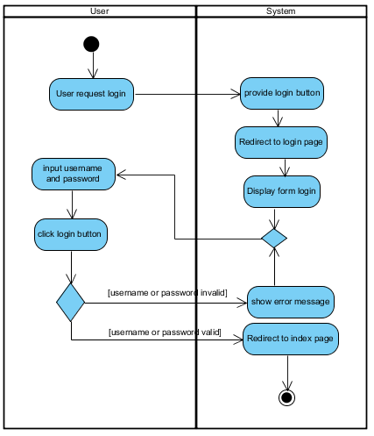

**Figure 9:** **AD: 01:** login.

|  |  |  |  |  |  |
| --- | --- | --- | --- | --- | --- |
| Use Case ID | UC02 | | | | |
| Use Case Name | User can log out from system. | | | | |
| Created By | Jiraayu Chinpongsuwan | | | Last Update By | Jiraayu Chinpongsuwan |
| Date Created | 25/4/2016 | | | Last Revision Date | 25/4/2016 |
| Actors | Patient, Nutritionists, Admin | | | | |
| Description | User logout from web application. | | | | |
| Trigger | - User selects logout button. | | | | |
| Preconditions | - User login to the Diabetes web application. | | | | |
| Use Case Input Specification | | | | | |
| Input | type | Constraint | | | Example |
| - | - | - | | | - |
| Post conditions | - User logout from system | | | | |
| Normal Flows | User | | System | | |
|  | 2. User must click logout button. | | 1. The system shall provide “logout” button | | |
| Alternative Flow | - | | | | |
| Exception Flow | - | | | | |
| Assumption | 1. Users understand English. | | | | |

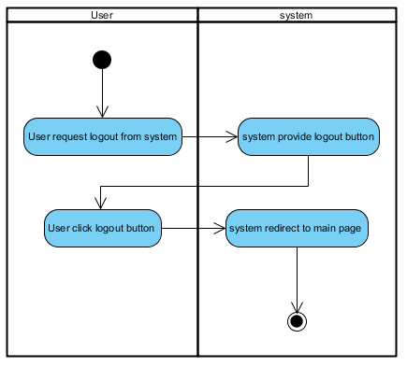

**Figure 10:** **AD: 02:** Patient logout.

|  |  |  |  |  |  |
| --- | --- | --- | --- | --- | --- |
| Use Case ID | UC03 | | | | |
| Use Case Name | Nurse can register patient to the web application | | | | |
| Created By | Jiraayu Chinpongsuwan | | | Last Update By | Jiraayu Chinpongsuwan |
| Date Created | 25/4/2016 | | | Last Revision Date | 25/4/2016 |
| Actors | Nurse, Patient | | | | |
| Description | The nurse can enter patient (username, password, confirm password, email, first name, last name, age, gender, weight, height, diabetes type and date that start treatment) to the database server on a web application. | | | | |
| Trigger | - Nurse or Patient selects register button on navigation. | | | | |
| Preconditions | - | | | | |
| Use Case Input Specification | | | | | |
| Input | type | Constraint | | | Example |
| username | string | Must not empty | | | usertest |
| password | string | - Must not empty  - 6-12 characters of capital or small alphabet letters or number | | | Mkog0k86o |
| Confirm password | string | Must be same with password | | | - |
| e-mail | string | - email address format (made up of a local part, an @ symbol, than a domain part)  - Must not empty | | | example@email.com |
| First name | string | Must not empty | | | Jirayu |
| Last name | string | Must not empty | | | Chinpongsuwan |
| age | Int | - Must input to be number  - Must not empty | | | 20 |
| weight | int | - Must input to be number  - Must not empty | | | 60 |
| height | int | - Must input to be number  - Must not empty | | | 175 |
| Post conditions | - Registration success. | | | | |
| Normal Flows | User | | System | | |
|  | 1. User must select “register” button.  3. User must input information which includes (Username, Password, Confirm Password, E-mail, First Name, Last Name, Gender, Age, Address, Diabetes Type, Height, Weight, Start treatment)  5. User must click “Submit” button. | | 2. The system shall provide UI which includes (Username, Password, Confirm Password, E-mail, First Name, Last Name, Gender, Age, Address, Diabetes Type, Height, Weight, Start treatment)  4. The system shall provide “Submit” button | | |
| Alternative Flow | In step of 3 of Normal Flow, if users forget to input the information that the system request  1. System shall provide the user interface to display the error message.  2. Users can view the error message.  3. Users input again | | | | |
| Exception Flow | - | | | | |
| Assumption | 1. Users understand English. | | | | |

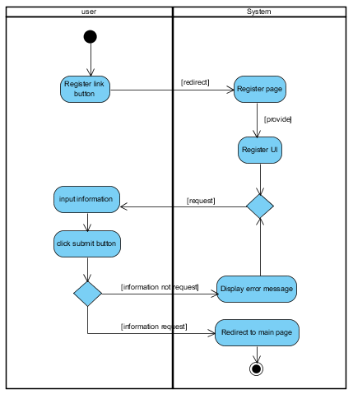

**Figure 11:** **AD: 03:** Register patient.

|  |  |  |  |  |  |
| --- | --- | --- | --- | --- | --- |
| Use Case ID | UC04 | | | | |
| Use Case Name | Profile. | | | | |
| Created By | Jiraayu Chinpongsuwan | | | Last Update By | Jiraayu Chinpongsuwan |
| Date Created | 25/4/2016 | | | Last Revision Date | 25/4/2016 |
| Actors | Patient | | | | |
| Description | Patient can view the information of his on profile page. | | | | |
| Trigger | - User selects profile link button. | | | | |
| Preconditions | - User login to the Diabetes web application.. | | | | |
| Use Case Input Specification | | | | | |
| Input | type | Constraint | | | Example |
| - | - | - | | | - |
| Post conditions | - User can view the information of user profile. | | | | |
| Normal Flows | User | | System | | |
|  | 1. User click button link to profile. | | 2. The system shall redirect to profile page.  3. The system shall display his profile on profile page. | | |
| Alternative Flow | - | | | | |
| Exception Flow | - | | | | |
| Assumption | 1. Users understand English. | | | | |

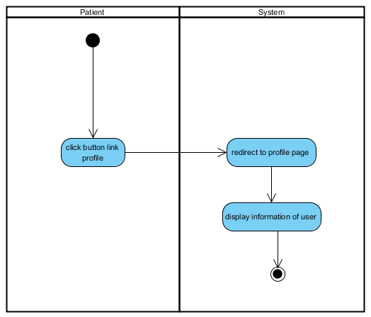

**Figure 12:** **AD: 04:** View information of his on profile page.

|  |  |  |  |  |  |
| --- | --- | --- | --- | --- | --- |
| Use Case ID | UC05 | | | | |
| Use Case Name | Edit profile | | | | |
| Created By | Jiraayu Chinpongsuwan | | | Last Update By | Jiraayu Chinpongsuwan |
| Date Created | 25/4/2016 | | | Last Revision Date | 25/4/2016 |
| Actors | Patient | | | | |
| Description | Patient can edit the information of his. | | | | |
| Trigger | - User selects profile link button. | | | | |
| Preconditions | - User login to the Diabetes web application. | | | | |
| Use Case Input Specification | | | | | |
| Input | type | Constraint | | | Example |
| First name | string | Must not empty | | | Jirayu |
| Last name | string | Must not empty | | | Chinpongsuwan |
| age | Int | - Must input to be number  - Must not empty | | | 20 |
| weight | int | - Must input to be number  - Must not empty | | | 60 |
| height | int | - Must input to be number  - Must not empty | | | 175 |
| Post conditions | - User can edit account success. | | | | |
| Normal Flows | User | | System | | |
|  | 2. Patient click profile button link.  5. Patient click “edit” button  7. Patient input new information which includes (Username, Password, Confirm Password, E-mail, First Name, Last Name, Gender, Age, Address, Diabetes Type, Height, Weight, Start treatment)  9. User click save. | | 1. The system shall provide “profile link” button.  3. The system shall redirect to profile page.  4. The system provide “edit” button.  6. The system provides UI to edit information which includes (Username, Password, Confirm Password, E-mail, First Name, Last Name, Gender, Age, Address, Diabetes Type, Height, Weight, Start treatment).  8. The system provide “save” button.  10. The system shall save change in data base | | |
| Alternative Flow | In step of 7 of Normal Flow, if users input wrong format age, height, and weight.  1. System shall provide the user interface to display the error message “… is invalid”.  2. Users can view the error message.  3. Users input again  4. The system shall resume to step 7 of normal flow | | | | |
| Exception Flow | - | | | | |
| Assumption | 1. Users understand English. | | | | |

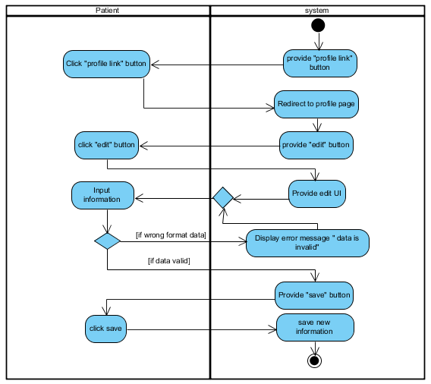

**Figure 13:** **AD: 05:** Edit account .

|  |  |  |  |  |  |
| --- | --- | --- | --- | --- | --- |
| Use Case ID | UC06 | | | | |
| Use Case Name | Chang password | | | | |
| Created By | Jiraayu Chinpongsuwan | | | Last Update By | Jiraayu Chinpongsuwan |
| Date Created | 25/4/2016 | | | Last Revision Date | 25/4/2016 |
| Actors | Patient | | | | |
| Description | Patient can change password for login. | | | | |
| Trigger | - User selects profile link button. | | | | |
| Preconditions | - Patient login to the Diabetes web application. | | | | |
| Use Case Input Specification | | | | | |
| Input | type | Constraint | | | Example |
| Current password | string | - Must have in the database  - Must not empty  - 6-12 characters of capital or small alphabet letters or number | | | - |
| New password | string | - Must not empty  - 6-12 characters of capital or small alphabet letters or number | | | - |
| Confirm password | string | Must be same with password | | | - |
| Post conditions | - Patient can change password success | | | | |
| Normal Flows | User | | System | | |
|  | 2. Patient click profile button link.  5. Patient click “change password” button  7. Patient input data which include (current password, new password)  9. Patient click “submit”. | | 1. The system shall provide “profile link” button.  3. The system shall redirect to profile page.  4. The system provide “change password” button.  6. The system shall provide UI for change password which includes (current password, new password )  8. The system shall provide “submit” button. | | |
| Alternative Flow | In normal flow step 7. If the patient input wrong current and not input data.   1. the system shall display error message “current password is not valid” 2. The patient must input current password again. 3. The system shall resume to step 7 of normal flow 4. The system shall display error message “field is required.” 5. The patient must input data again. 6. The system shall resume to step 7 of normal flow | | | | |
| Exception Flow | - | | | | |
| Assumption | 1. Users understand English. | | | | |

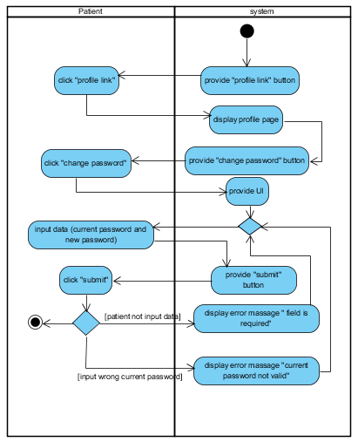

**Figure 14:** **AD: 06:** Chang password.

|  |  |  |  |  |  |
| --- | --- | --- | --- | --- | --- |
| Use Case ID | UC07 | | | | |
| Use Case Name | Admin manage account | | | | |
| Created By | Jiraayu Chinpongsuwan | | | Last Update By | Jiraayu Chinpongsuwan |
| Date Created | 25/4/2016 | | | Last Revision Date | 25/4/2016 |
| Actors | Admin | | | | |
| Description | * Admin can add nutritionists, nurse, and doctor to the system by input username, password, first name, last name and select role. * Admin can edit username, password, first name, last name and role. * Admin can nutritionists, nurse, and doctor from the system. | | | | |
| Trigger | - Admin clicks account management. | | | | |
| Preconditions | - Admin login to the administration system. | | | | |
| Use Case Input Specification | | | | | |
| Input | type | Constraint | | | Example |
| username | string | Must not empty | | | username |
| password | string | - Must not empty  - 6-12 characters of capital or small alphabet letters or number | | | - |
| name | string | Must not empty | | | admin |
| Post conditions | - Admin manages account success. | | | | |
| Normal Flows | User | | System | | |
|  | 2. Admin click “create new”  4. Admin input info which includes (username, password, first name, last name and role).  6. Admin click “submit” button.  8. Admin click “edit”.  10. Admin input new info which includes (username, password, first name, last name and role).  12. Admin click “submit” button.  14. Admin click “delete” button. | | 1.The system provide “create new” button    3. The system provides UI which include (username, password, first name, last name and role).  5. The system provide “submit” button  7. The system provide “edit” button  9. The system provides UI for edit which include (username, password, first name, last name and role).  11. The system provide “submit” button  13. The system provide “delete” button  15. The shall delete account that selected. | | |
| Alternative Flow | In normal flow step 4. If the admin don’t input data.   1. The system shall display error message “field is required.” 2. The admin must input data again. 3. The system shall resume to step 4 of normal flow | | | | |
| Exception Flow | - | | | | |
| Assumption | 1. Users understand English. | | | | |

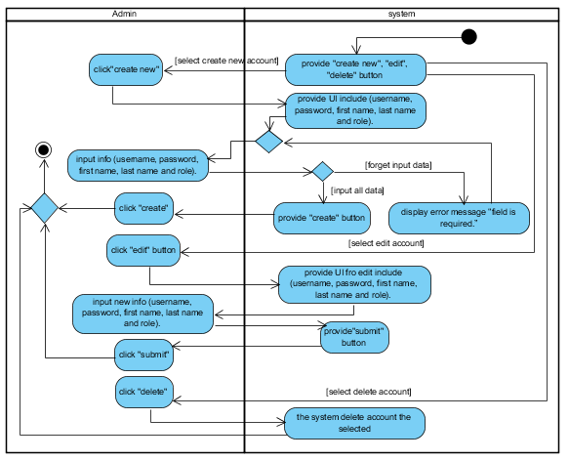

**Figure 15:** **AD: 07:** Admin manages account.

|  |  |  |  |  |  |
| --- | --- | --- | --- | --- | --- |
| Use Case ID | UC08 | | | | |
| Use Case Name | Manage nutrition | | | | |
| Created By | Jiraayu Chinpongsuwan | | | Last Update By | Jiraayu Chinpongsuwan |
| Date Created | 25/4/2016 | | | Last Revision Date | 25/4/2016 |
| Actors | Nutritionists | | | | |
| Description | Nutritionists can manage food on nutrition management page. | | | | |
| Trigger | - Nutritionists click manage foods. | | | | |
| Preconditions | - Nutritionists login to the Diabetes web application. | | | | |
| Use Case Input Specification | | | | | |
| Input | type | Constraint | | | Example |
| - | - | - | | | - |
| Post conditions | - Nutritionists can manage nutrition success. | | | | |
| Normal Flows | User | | System | | |
|  | 2. Nutritionists click “create new”  4. Nutritionists input info which includes (food name, the glycemic index of food, and food calorie).  6. Nutritionists click “submit” button.  8. Nutritionists click “edit”.  10. Nutritionists input new info which includes (food name, the glycemic index of food, and food calorie).  12. Nutritionists click “submit” button.  14. Nutritionists click “delete” button. | | 1.The system provide “create new” button    3. The system provides UI which include (food name, the glycemic index of food, and food calorie).  5. The system provide “submit” button  7. The system provide “edit” button  9. The system provides UI for edit which include (food name, the glycemic index of food, and food calorie).  11. The system provide “submit” button  13. The system provide “delete” button  15. The system shall delete food that selected. | | |
| Alternative Flow | In normal flow step 4. If the admin don’t input data.   1. The system shall display error message “field is required.” 2. The nutritionists must input data again. 3. The system shall resume to step 4 of normal flow | | | | |
| Exception Flow | - | | | | |
| Assumption | 1. Users understand English. | | | | |

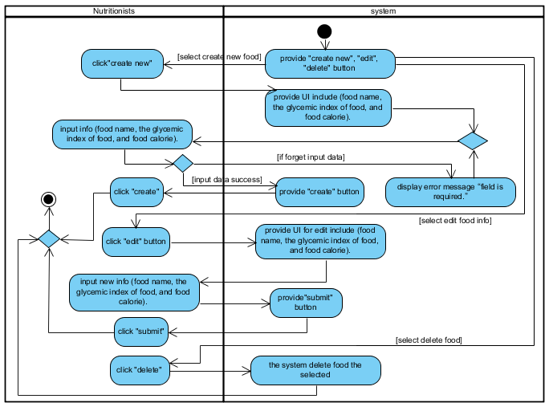

**Figure 16:** **AD: 08:** Add food list to system.

|  |  |  |  |  |  |
| --- | --- | --- | --- | --- | --- |
| Use Case ID | UC09 | | | | |
| Use Case Name | Manage activity | | | | |
| Created By | Jiraayu Chinpongsuwan | | | Last Update By | Jiraayu Chinpongsuwan |
| Date Created | 25/4/2016 | | | Last Revision Date | 25/4/2016 |
| Actors | Nurse, Doctor | | | | |
| Description | Nurse or Doctor can manage activity on activity management page. | | | | |
| Trigger | - Nurse or Doctor click manage activity. | | | | |
| Preconditions | - Nurse or Doctor login to the Diabetes web application. | | | | |
| Use Case Input Specification | | | | | |
| Input | type | Constraint | | | Example |
| - | - | - | | | - |
| Post conditions | - Nurse or Doctor can manage activity success. | | | | |
| Normal Flows | User | | System | | |
|  | 2. Nurse or Doctor click “create new”  4. Nurse or Doctor input info which includes (symptom and exercise advice).  6. Nurse or Doctor click “submit” button.  8. Nurse or Doctor click “edit”.  10. Nurse or Doctor input new info which includes (symptom and exercise advice).  12. Nurse or Doctor click “submit” button.  14. Nurse or Doctor click “delete” button. | | 1.The system provide “create new” button    3. The system provides UI which include (symptom and exercise advice).  5. The system provide “submit” button  7. The system provide “edit” button  9. The system provides UI for edit which include (symptom and exercise advice).  11. The system provide “submit” button  13. The system provide “delete” button  15. The system shall delete activity that selected. | | |
| Alternative Flow | In normal flow step 4. If the admin don’t input data.   1. The system shall display error message “field is required.” 2. The doctor/nurse must input data again. 3. The system shall resume to step 4 of normal flow | | | | |
| Exception Flow | - | | | | |
| Assumption | 1. Users understand English. | | | | |

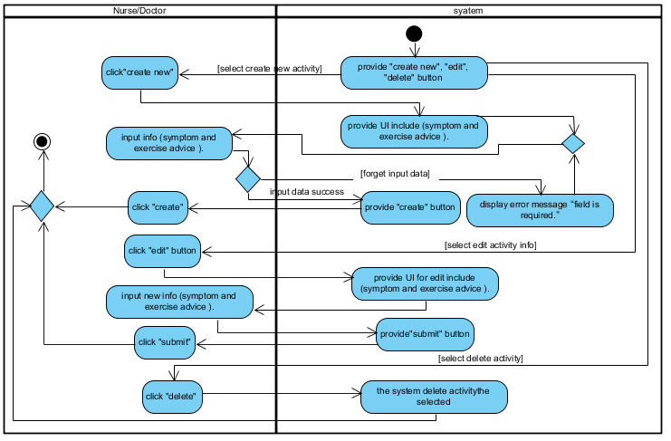

**Figure 17:** **AD: 09:** Manage activity.

|  |  |  |  |  |  |
| --- | --- | --- | --- | --- | --- |
| Use Case ID | UC10 | | | | |
| Use Case Name | Select the symptoms | | | | |
| Created By | Jiraayu Chinpongsuwan | | | Last Update By | Jiraayu Chinpongsuwan |
| Date Created | 25/4/2016 | | | Last Revision Date | 25/4/2016 |
| Actors | Patient | | | | |
| Description | Patient can select the symptoms on health plan page. | | | | |
| Trigger | - Patient selects health plan link button. | | | | |
| Preconditions | - Patient login to the web application. | | | | |
| Use Case Input Specification | | | | | |
| Input | type | Constraint | | | Example |
| - | - | - | | | - |
| Post conditions | - Patient can select the symptoms success. | | | | |
| Normal Flows | User | | System | | |
|  | 2. Patient must select symptoms from drop down list.  4. Patient click “select”. | | 1. The system shall provide drop down list on health plan page.  3. The system provide “select button” | | |
| Alternative Flow | - | | | | |
| Exception Flow | - | | | | |
| Assumption | 1. Users understand English. 2. Patient must be member of web application. | | | | |

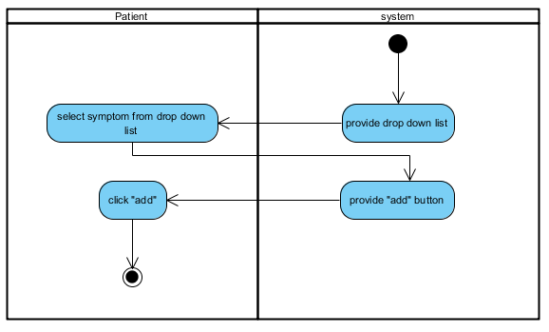

**Figure 18:** **AD: 10:** Select the symptoms.

|  |  |  |  |  |  |
| --- | --- | --- | --- | --- | --- |
| Use Case ID | UC11 | | | | |
| Use Case Name | Get exercise suggestion. | | | | |
| Created By | Jiraayu Chinpongsuwan | | | Last Update By | Jiraayu Chinpongsuwan |
| Date Created | 25/4/2016 | | | Last Revision Date | 25/4/2016 |
| Actors | Patient | | | | |
| Description | Patient can get the suggestion about exercise from system. | | | | |
| Trigger | - Patient selects health plan link button. | | | | |
| Preconditions | - Patient login to the web application. | | | | |
| Use Case Input Specification | | | | | |
| Input | type | Constraint | | | Example |
| - | - | - | | | - |
| Post conditions | - Patient gets the suggestion about exercise from system. | | | | |
| Normal Flows | User | | System | | |
|  | 2. Patient must select symptoms from drop down list.  4. Patient click “select”. | | 1. The system shall provide drop down list on health plan page.  3. The system provide “select button”  5. The system displays the exercise suggestion to patient. | | |
| Alternative Flow | - | | | | |
| Exception Flow | - | | | | |
| Assumption | 1. Users understand English. 2. Patient must be member of web application. | | | | |

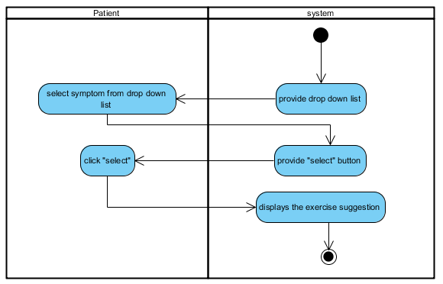

**Figure 19:** **AD: 11:** Get exercise suggestion.

|  |  |  |  |  |  |
| --- | --- | --- | --- | --- | --- |
| Use Case ID | UC12 | | | | |
| Use Case Name | Add food to record health plan. | | | | |
| Created By | Jiraayu Chinpongsuwan | | | Last Update By | Jiraayu Chinpongsuwan |
| Date Created | 25/4/2016 | | | Last Revision Date | 25/4/2016 |
| Actors | Patient | | | | |
| Description | Patient can add food from the database to record in health plan. | | | | |
| Trigger | - Patient selects health plan link button. | | | | |
| Preconditions | - Patient login to the Diabetes web application. | | | | |
| Use Case Input Specification | | | | | |
| Input | type | Constraint | | | Example |
| - | - | - | | | - |
| Post conditions | - Patient can record the foods to health plan success. | | | | |
| Normal Flows | User | | System | | |
|  | 2. Patient must select.  4. Patient must click add. | | 1. The system shall provide drop down list of food.  3. The system shall provide add food button. | | |
| Alternative Flow | - | | | | |
| Exception Flow | - | | | | |
| Assumption | 1. Users understand English. 2. Users must be member of web application. | | | | |

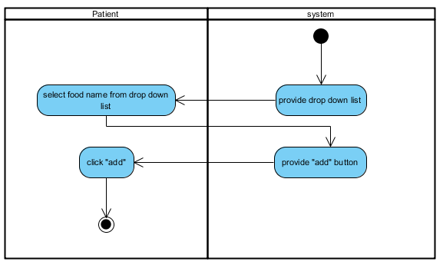

**Figure 20:** **AD: 12:** Add food to record health plan.

|  |  |  |  |  |  |
| --- | --- | --- | --- | --- | --- |
| Use Case ID | UC13 | | | | |
| Use Case Name | View the average of glycemic index and calorie. | | | | |
| Created By | Jiraayu Chinpongsuwan | | | Last Update By | Jiraayu Chinpongsuwan |
| Date Created | 25/4/2016 | | | Last Revision Date | 25/4/2016 |
| Actors | Patient | | | | |
| Description | Patient can view the average of glycemic index and calorie of food in the selected plan. | | | | |
| Trigger | - Patient selects health plan link button. | | | | |
| Preconditions | - Patient login to system. | | | | |
| Use Case Input Specification | | | | | |
| Input | type | Constraint | | | Example |
| - | - | - | | | - |
| Post conditions | - The system displays the average of glycemic index and calorie of food in the selected plan. | | | | |
| Normal Flows | User | | System | | |
|  | 4. Patient views the result average of glycemic index and calorie of food. | | 1. The system request data of food from food plan the database.  2. The system shall calculate the average of average of glycemic index and calorie of food.  3. The system provides text for display result. | | |
| Alternative Flow | - | | | | |
| Exception Flow | - | | | | |
| Assumption | 1. Users understand English. 2. Users must be member of web application. | | | | |

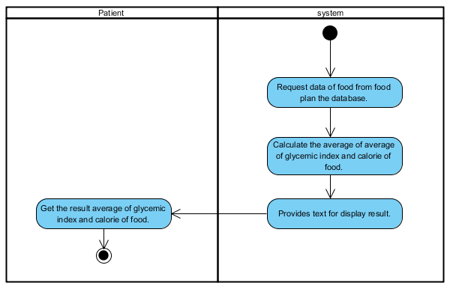

**Figure 21:** **AD: 13:** View the average of glycemic index and calorie.

|  |  |  |  |  |  |
| --- | --- | --- | --- | --- | --- |
| Use Case ID | UC14 | | | | |
| Use Case Name | Delete food from health plan | | | | |
| Created By | Jiraayu Chinpongsuwan | | | Last Update By | Jiraayu Chinpongsuwan |
| Date Created | 25/4/2016 | | | Last Revision Date | 25/4/2016 |
| Actors | Patient | | | | |
| Description | Patient can delete food from health plan. | | | | |
| Trigger | - Patient selects health plan link button. | | | | |
| Preconditions | - Patient login to system. | | | | |
| Use Case Input Specification | | | | | |
| Input | type | Constraint | | | Example |
| - | - | - | | | - |
| Post conditions | - Patient can delete food from his health plan success. | | | | |
| Normal Flows | User | | System | | |
|  | 2. Patient must select food.  3. Patient must click delete. | | 1. The system shall provide delete food button.  4. The system shall delete food from health plan. | | |
| Alternative Flow | - | | | | |
| Exception Flow | - | | | | |
| Assumption | 1. Users understand English. 2. Users must be Patient of web application. | | | | |

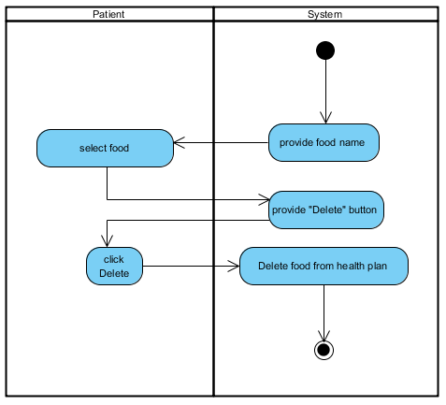

**Figure 22:** **AD: 14:** Delete food from health plan.

|  |  |  |  |  |  |
| --- | --- | --- | --- | --- | --- |
| Use Case ID | UC15 | | | | |
| Use Case Name | Add glycemic. | | | | |
| Created By | Jiraayu Chinpongsuwan | | | Last Update By | Jiraayu Chinpongsuwan |
| Date Created | 25/4/2016 | | | Last Revision Date | 25/4/2016 |
| Actors | Patient | | | | |
| Description | Patient can record blood sugar value to the database. | | | | |
| Trigger | - Patient selects health plan link button. | | | | |
| Preconditions | - Patient login to system. | | | | |
| Use Case Input Specification | | | | | |
| Input | type | Constraint | | | Example |
| Blood sugar | double | - Must not input minus value  - Must input to be number | | | 102 |
| Post conditions | - Patient can add the blood sugar value to the system success. | | | | |
| Normal Flows | User | | System | | |
|  | 2. Patient must input blood sugar value.  4. Patient must click add. | | 1. The system shall provide text field for add glycemic to user.  3. The system shall provide add button.  5. The system shall record data in the database | | |
| Alternative Flow | In normal flow step 2. If the patient input wrong format blood sugar. And The patient input blood sugar minus value.   1. The system display error message “blood sugar is invalid” 2. The patient must input data again. 3. The system shall resume to step 2 of normal flow 4. The system display error message “blood sugar cannot be negative”. 5. The patient must input data again. 6. The system shall resume to step 4 of normal flow | | | | |
| Exception Flow | - | | | | |
| Assumption | 1. Users understand English. 2. Users must be member of web application. | | | | |

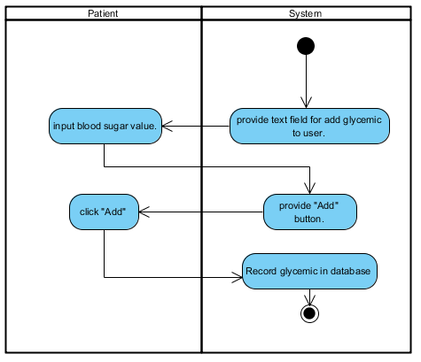

**Figure 23:** **AD: 15:** of Add glycemic.

|  |  |  |  |  |  |
| --- | --- | --- | --- | --- | --- |
| Use Case ID | UC16 | | | | |
| Use Case Name | View BMI. | | | | |
| Created By | Jiraayu Chinpongsuwan | | | Last Update By | Jiraayu Chinpongsuwan |
| Date Created | 25/4/2016 | | | Last Revision Date | 25/4/2016 |
| Actors | Patient | | | | |
| Description | Patient can view body mass value that calculated by using BMI = weight (Kg) / (height (m) * height (m)). | | | | |
| Trigger | - Patient selects health plan link button. | | | | |
| Preconditions | - Patient login to system. | | | | |
| Use Case Input Specification | | | | | |
| Input | type | Constraint | | | Example |
| - | - | - | | | - |
| Post conditions | Patient can view body mass value. | | | | |
| Normal Flows | User | | System | | |
|  | 4. Patient views the result BMI. | | 1. The system request data of patient (weight and height) from the database.  2. The system shall calculated by using BMI = weight (Kg) / (height (m) * height (m)).  3. The system provides text for display result. | | |
| Alternative Flow | - | | | | |
| Exception Flow | - | | | | |
| Assumption | 1. Users understand English. 2. Users must be member of web application. | | | | |

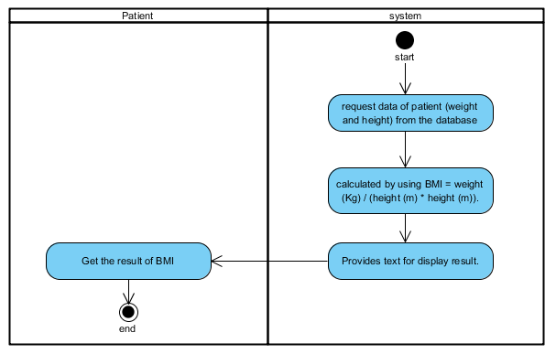

**Figure 24:** **AD: 16:** View BMI.

|  |  |  |  |  |  |
| --- | --- | --- | --- | --- | --- |
| Use Case ID | UC17 | | | | |
| Use Case Name | View blood sugar and body mass graph. | | | | |
| Created By | Jiraayu Chinpongsuwan | | | Last Update By | Jiraayu Chinpongsuwan |
| Date Created | 25/4/2016 | | | Last Revision Date | 25/4/2016 |
| Actors | Patient | | | | |
| Description | Patient can view statistic line graph of blood sugar and body mass. | | | | |
| Trigger | - Patient selects health plan link button. | | | | |
| Preconditions | - Patient login to system. | | | | |
| Use Case Input Specification | | | | | |
| Input | type | Constraint | | | Example |
| - | - | - | | | - |
| Post conditions | - Display blood sugar value and body mass value on graph. | | | | |
| Normal Flows | User | | System | | |
|  | 5. The patient view display graph. | | 1. The system shall provide line graph.  2. The system request data of blood sugar value from the database and BMI value from method code.  3. The system request the data value of blood sugar and body mass to using on graph  4. The system display line graph to patient. | | |
| Alternative Flow | - | | | | |
| Exception Flow | - | | | | |
| Assumption | 1. Users understand English. 2. Users must be Patient of web application. | | | | |

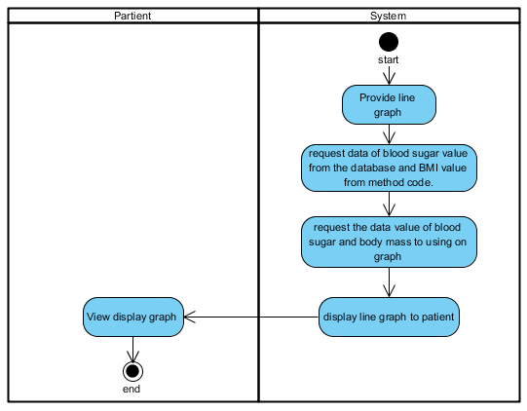

**Figure 27:** **AD: 17:** View glycemic graph.

|  |  |  |  |  |  |
| --- | --- | --- | --- | --- | --- |
| Use Case ID | UC18 | | | | |
| Use Case Name | View interpretation of blood sugar. | | | | |
| Created By | Jiraayu Chinpongsuwan | | | Last Update By | Jiraayu Chinpongsuwan |
| Date Created | 25/4/2016 | | | Last Revision Date | 25/4/2016 |
| Actors | Patient | | | | |
| Description | Patient can view interpretation about blood sugar level from system. | | | | |
| Trigger | - Patient selects health plan link button. | | | | |
| Preconditions | - Patient login to system. | | | | |
| Use Case Input Specification | | | | | |
| Input | type | Constraint | | | Example |
| - | - | - | | | - |
| Post conditions | - Patient gets interpretation about blood sugar level from system. | | | | |
| Normal Flows | User | | System | | |
|  | 4. The patient view display of interpretation about blood sugar level on text area. | | 1. The system shall provide text area.  2. The system request data for gets interpretation about blood sugar level from database.  3. The system display data on text area. | | |
| Alternative Flow | - | | | | |
| Exception Flow | - | | | | |
| Assumption | 1. Users understand English. 2. Users must be member of web application. | | | | |

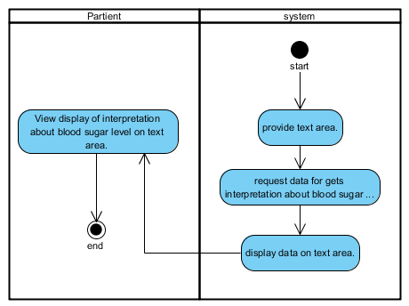

**Figure 28:** **AD: 18:** View interpretation of blood sugar.

|  |  |  |  |  |  |
| --- | --- | --- | --- | --- | --- |
| Use Case ID | UC19 | | | | |
| Use Case Name | Patient select food name from the database. | | | | |
| Created By | Jiraayu Chinpongsuwan | | | Last Update By | Jiraayu Chinpongsuwan |
| Date Created | 25/4/2016 | | | Last Revision Date | 25/4/2016 |
| Actors | Patient | | | | |
| Description | Patient can select food name eat in that day from the database. | | | | |
| Trigger | - Patient selects behavior monitor link button. | | | | |
| Preconditions | - Patient login to system. | | | | |
| Use Case Input Specification | | | | | |
| Input | type | Constraint | | | Example |
| - | - | - | | | - |
| Post conditions | - Patient select food success. | | | | |
| Normal Flows | User | | System | | |
|  | 2. Patient must select food.  4. Patient must click “select”. | | 1. The system shall provide drop down list of food.  3. The system shall provide “select” button.  4. The system shall provide text area to display food selected. | | |
| Alternative Flow | - | | | | |
| Exception Flow | - | | | | |
| Assumption | 1. Users understand English. 2. Users must be member of web application. | | | | |

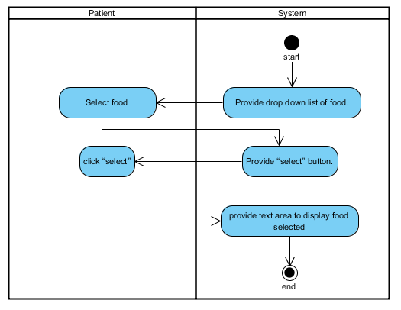

**Figure 29:** **AD: 19:** Patient select food name from the database.

|  |  |  |  |  |  |
| --- | --- | --- | --- | --- | --- |
| Use Case ID | UC20 | | | | |
| Use Case Name | Patient can check the list of medicine. | | | | |
| Created By | Jiraayu Chinpongsuwan | | | Last Update By | Jiraayu Chinpongsuwan |
| Date Created | 25/4/2016 | | | Last Revision Date | 25/4/2016 |
| Actors | Patient | | | | |
| Description | Patient can check the list of medicine on behavior monitor page. | | | | |
| Trigger | - Patient selects behavior monitor link button. | | | | |
| Preconditions | - Patient login to system. | | | | |
| Use Case Input Specification | | | | | |
| Input | type | Constraint | | | Example |
| - | - | - | | | - |
| Post conditions | - Patient check list medicine success. | | | | |
| Normal Flows | User | | System | | |
|  | 2. Patient must click “check button” follow list of medicine. | | 1. The system shall provide check button and list of medicine name to patient. | | |
| Alternative Flow | - | | | | |
| Exception Flow | - | | | | |
| Assumption | 1. Users understand English. 2. Users must be member of web application. | | | | |

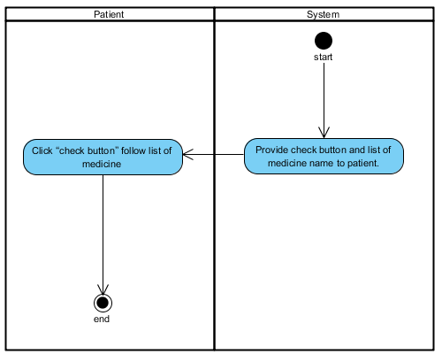

**Figure 30:** **AD: 20:** Patient can check the list of medicine.

|  |  |  |  |  |  |
| --- | --- | --- | --- | --- | --- |
| Use Case ID | UC21 | | | | |
| Use Case Name | Analyze. | | | | |
| Created By | Jiraayu Chinpongsuwan | | | Last Update By | Jiraayu Chinpongsuwan |
| Date Created | 25/4/2016 | | | Last Revision Date | 25/4/2016 |
| Actors | Patient | | | | |
| Description | Patient can get analyze of nutrition behavior in each day on behavior monitor page. | | | | |
| Trigger | - Patient selects behavior monitor link button. | | | | |
| Preconditions | - Patient login to system. | | | | |
| Use Case Input Specification | | | | | |
| Input | type | Constraint | | | Example |
| - | - | - | | | - |
| Post conditions | - Patient can get analyze of nutrition behavior from system. | | | | |
| Normal Flows | User | | System | | |
|  | 4. The patient get analyze result from the system. | | 1. The system shall provide UI to display analyze result  2. The system request data of food and medicine to analyze  3. The system display analyze result on UI (color red, color yellow, color green) | | |
| Alternative Flow | In normal flow step 3.   1. The system shall display analyze result green color, when the user gets glycemic index value less than 120 and check all list of medicine. 2. The system shall display analyze result yellow color, when the user gets glycemic index value more than 120 and check all list of medicine or get glycemic index value less than 120 and not check all list of medicine. 3. The system shall display analyze result red color, when the user gets glycemic index value more than 120 and not check all list of medicine. | | | | |
| Exception Flow | - | | | | |
| Assumption | 1. Users understand English. 2. Users must be member of web application. | | | | |

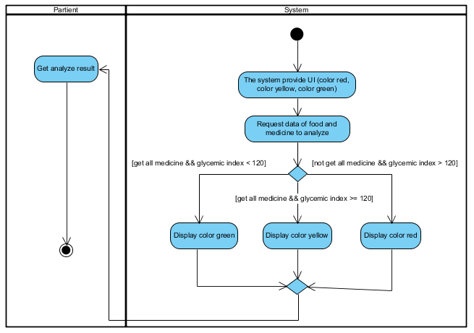

**Figure 31:** **AD: 21:** Analyze.

|  |  |  |  |  |  |
| --- | --- | --- | --- | --- | --- |
| Use Case ID | UC22 | | | | |
| Use Case Name | View the daily graph of glycemic level. | | | | |
| Created By | Jiraayu Chinpongsuwan | | | Last Update By | Jiraayu Chinpongsuwan |
| Date Created | 25/4/2016 | | | Last Revision Date | 25/4/2016 |
| Actors | Patient | | | | |
| Description | The patient can view the daily graph of glycemic level on behavior monitor page. | | | | |
| Trigger | - Patient selects behavior monitor link button. | | | | |
| Preconditions | - Patient login to system. | | | | |
| Use Case Input Specification | | | | | |
| Input | type | Constraint | | | Example |
| - | - | - | | | - |
| Post conditions | - Patient can view the daily graph of glycemic level. | | | | |
| Normal Flows | User | | System | | |
|  | 5. The patient view display graph. | | 1. The system shall provide line graph.  2. The system request data of glycemic index from food that selected in behavior monitor page  3. The system request the data of glycemic index to using on graph.  4. The system display line graph to patient. | | |
| Alternative Flow | - | | | | |
| Exception Flow | - | | | | |
| Assumption | 1. Users understand English. 2. Users must be member of web application. | | | | |

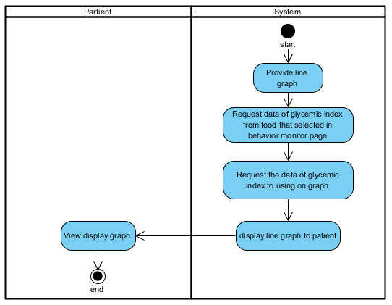

**Figure 32:** **AD: 22:** View the daily graph of glycemic level.