**Document History**

|  |  |  |  |  |  |  |
| --- | --- | --- | --- | --- | --- | --- |
| **Document Name** | **Version** | **Status** | **Date** | **Viewable** | **Reviewer** | **Responsible** |
| Document |  | | | | | |
| diabetes -SDD-V.0.1.docx | V0.1 | Draft | February  29, 2016 | JC, PS | JC, PS | JC, PS |

*PS: Dr. Prompong Sugunnasil

*JC: Mr. Jirayu Chinpongsuwan

**___________________**

**Dr. Prompong Sugunnasil**

Senior Project Advisor

Table Content

# Chapter One | 4.1 Introduction

## 4.1.1 Document Purpose

The Software Design Document (SDD) is a document used to establish architecture of Diabetes web application, compose of the high level of software design, system architecture, database system and graphic user interfaces. The document is purpose to describe the overall system design and detail in each part of functional design. The SDD is importance thing so that it is the blueprint of system that provided to be explicit understanding between developers.

## 4.1.2 Software Scope

Software Design Document is the document use to explain overall design architecture of the Diabetes web application. This document covers content about

**- User Characteristic**

The user characteristic is the information explaining about activity that user can interact and perform with the application.

**- Constrains**

The project constrains is the information describe about a limit of application that might have effect with user.

**- System Architecture**

The system Architecture is the information about overall architecture of an application system.

**- Detailed Design**

The detail design is the information describes each detail of design architecture within the application system.

**- Data Architecture**

The data architecture is the information about overall data property which use in the application.

**- User Interface Design**

The user interface design is the information about overall design interface of the application.

## 

## 4.1.3 Definitions, Acronyms, and Abbreviations

* **Key Definitions**

**Diabetes**  Name of this project

**System** “Computer programs, procedure and associated documentation and data pertain to the operation of a computer system” [IEEE90]

**Database** A collection of logically related data stored together in one or more computerized files. [IEEE90]

* **Key Acronyms and Abbreviation**

**SDD**  Software design document

**SD** Sequence diagram

**UI**  User interface

**ID** Identity number

**CD** Class diagram

## 4.1.4 User characteristic

User: User can direct access an application via their desktop, tablets, and phones to every part of this application by requesting internet connection. The patient is the person who can create a health plan and monitor nutrition behavior for preventing theirs from the complications disease. Admin is the person who can manage the account of doctor, nurse, and nutritionists. Doctor/Nurse is the person who can enter patient information into the system and management the activity in a part of insert/update/delete. And the nutritionist is the person who can control the nutrition in part of insert/update/delete.

## 4.1.5 Design Constraints

**Need PHP 5.5 platform or newer.**

Diabetes web application use MVC .Net platform on developing process. Therefore, user need any web browser for run this application.

# 

# Chapter Two | 4.2 System Architecture

1111

**Figure 1: The architecture system of "Diabetes Care" web application**.

The “Diabetes Care Web Application” can run on the different platform (mobile web browser, PC web browser). The first part, database server stores the data of Diabetes application about the information of Patient, nutritionists and data of foods and activity. Second, The user who can send the request via a web browser to “Diabetes Care web application”. The application will request information from the database and return to the user.

# Chapter Three | 4.3 Detailed Design

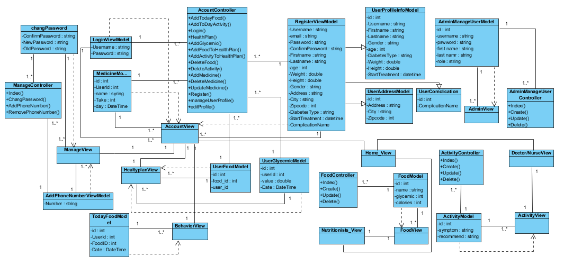

**Figure 2:** The High Level Design represents the relationship between UML Class Diagrams

## 

## 4.3.1 Class Diagram Description

### 4.3.1.1 CD01: AcountController

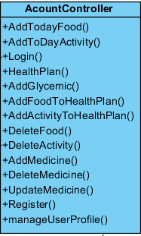

**Figure 3**: CD01: AccountController

**Description:** This class is a controller for the user to go to the login page for logging-in and logging-out, go to register page for registering, manage health plan, manage medicine of user, add glycemic for analyzing in a form of the graph, and user manage user profile.

**Method:**

|  |  |  |  |  |  |
| --- | --- | --- | --- | --- | --- |
| **ID** | **Name** | **Description** | **access modifiers** | **Parameter** | **Remark** |
| 1 | Index() | This method get the data include user profile, food, activity, medicine | public | - | Return: View( ) |
| 2 | Login() | For redirecting user to login page. | public | string returnUrl | Return: View( ) |
| 3 | Register() | This method records the user info to the database. | public | RegisterViewModel model | Return: View( ) |
| 4 | HealthPlan() | This method has to calculate BMI, BMR food glycemic, and food calorie. | public | - | Return: View( ) |
| 5 | AddGlycemic() | For user add value of glycemic index or blood sugar. | public | int value = 0 | Return: View( ) |
| 6 | AddFood () | For user can select and add food on health plan page. | public | int id = 0 | Return: View( ) |
| 7 | AddActivity () | For user can select and add activity on health plan page. | public | int id = 0 | Return: View( ) |
| 8 | DeletFood() | For user can delete food on health plan page. | public | int id = 0 | Return: View( ) |
| 9 | DeletActivity() | For user can delete activity on health plan page. | public | int id = 0 | Return: View( ) |
| 10 | AddMedicine | For user can add his medicine to the system. | public | string name = null) | Return: View( ) |
| 11 | DeleteMedicine | For user can delete his medicine. | public | int id = 0 | Return: View( ) |
| 12 | UpdateMedicine | For user can edit/update his medicine | public | int[] medicine = null | Return: View( ) |
| 13 | manageUserProfile | For user can edit/update user information | public | int[] userProfileInfo = null | Return: View( ) |

**Table 1**: Method of CD01: AccountController

### 4.3.1.2 CD02: ManageController

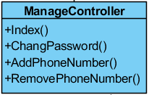

**Figure 4**: CD02: ManageController

**Description:** This class is controller for user to go to Index page that is first page of management page, change password is page for user need to change new password.

**Method:**

|  |  |  |  |  |  |
| --- | --- | --- | --- | --- | --- |
| **ID** | **Name** | **Description** | **Access modifiers** | **Parameter** | **Remark** |
| 1 | Index() | This method defines the error message. | public | ManageMessageId? message | Return: View( ) |
| 2 | Change Password() | For user can change or manage password for login to the system. | public | ChangePasswordViewModel model | Return: View(model) |
| 3 | AddPhoneNumber() | This method record phone number of user to system. | public | AddPhoneNumberViewModel model | Return: View() |
| 4 | RemoverPhoneNumber() | This method delete phone number of user from the database | public | - | Return: View() |

**Table 2**: Method of CD02: ManageController

### 4.3.1.3 CD 03: AdminManageUserController

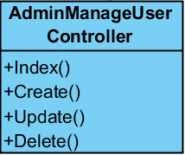

**Figure 5**: CD03: AdminManageUserController

**Description:** This class is controller for admin need to go to administration management page for manage the nutritionists. Such as create new user account, update account or delete account.

**Method:**

|  |  |  |  |  |  |
| --- | --- | --- | --- | --- | --- |
| **ID** | **Name** | **Description** | **Access modifiers** | **Parameter** | **Remark** |
| 1 | Index() | This method returns data from the database. | public | - | Return: View(database table) |
| 2 | Create() | For admin can create new doctor/nurse/nutritionists to the system. | public | - | Return: View( ) |
| 3 | Update() | For admin can update or edit user account in the system. | public | int? id | Return: View( ) |
| 4 | Delete() | For admin can delete nutritionists from the system. | public | int? id | Return: View( ) |

**Table 3**: Method of CD03: AdminManageUserController

### 4.3.1.4 CD04: FoodsController

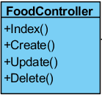

**Figure 6**: CD04: FoodsController

**Description:** This class is controller for nutritionists need to go to a nutritionists management page for manage the foods. Such as create new food, update food or delete food.

**Method:**

|  |  |  |  |  |  |
| --- | --- | --- | --- | --- | --- |
| **ID** | **Name** | **Description** | **Access modifiers** | **Parameter** | **Remark** |
| 1 | Index() | This method returns data from the database. | public | - | Return: View(database table) |
| 2 | Create() | For nutritionists can create new food to the system. | public | - | Return: View( ) |
| 3 | Update() | For nutritionists can update or edit food in the system. | public | int? id | Return: View( ) |
| 4 | Delete() | For nutritionists can delete food from the system. | public | int? id | Return: View( ) |

**Table 4**: Method of CD04: FoodsController

### 4.3.1.5 CD05: ActivityController

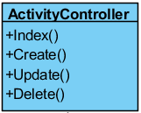

**Figure 7**: CD05: ActivityController

**Description:** This class is controller for doctor/nurse need to go to activity management page for manage the activity. Such as create new activity, update activity or delete activity.

**Method:**

|  |  |  |  |  |  |
| --- | --- | --- | --- | --- | --- |
| **ID** | **Name** | **Description** | **Access modifiers** | **Parameter** | **Remark** |
| 1 | Index() | This method returns data from the database. | public | - | Return: View(database table) |
| 2 | Create() | For nutritionists can create new activity to the system. | public | - | Return: View( ) |
| 3 | Update() | For nutritionists can update or edit activity in the system. | public | int? id | Return: View( ) |
| 4 | Delete() | For nutritionists can delete activity from the system. | public | int? id | Return: View( ) |

**Table 5**: Method of CD05: ActivityController

**4.3.1.6 CD06: RegisterViewModel**

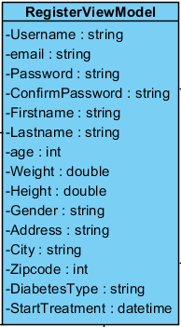

**Figure 8**: CD06: RegisterViewModel

**Description:** This class is class that inherits from class UserProfileInfoModel and class UserAddressModel. For extend model to correspond to table “Asp Net User” and “Address” in the database.

**Method:**

|  |  |  |  |  |
| --- | --- | --- | --- | --- |
| **ID** | **Name** | **Description** | **Access modifiers** | **Remark** |
| 1 | Username | The attribute “Username” can contain a get accessor, a set accessor the Usernamedata on table “Asp Net User” in the database. | Public | - |
| 2 | Email | The attribute “Email” can contain a get accessor, a set accessor the email data on table “Asp Net User” in the database. | Public | - |
| 3 | Password | The attribute “Password” can contain a get accessor, a set accessor the password data on table “Asp Net User” in the database. | public | - |
| 4 | ConfirmPassword | The attribute “ConfirmPassword” can contain a get accessor, a set accessor the confirm password data on table “Asp Net User” in the database. | Public | - |
| 5 | Firstname | The attribute “Firstname” can contain a get accessor, a set accessor the first name data on table “Asp Net User” in the database. | Public | - |
| 6 | Lastname | The attribute “Lastname” can contain a get accessor, a set accessor the last name data on table “Asp Net User” in the database. | Public | - |
| 7 | age | The attribute “age” can contain a get accessor, a set accessor the agedata on table “Asp Net User” in the database. | Public | - |
| 8 | weight | The attribute “weight” can contain a get accessor, a set accessor the weight data on table “Asp Net User” in the database. | Public | - |
| 9 | height | The attribute “height” can contain a get accessor, a set accessor the height data on table “Asp Net User” in the database. | Public | - |
| 10 | gender | The attribute “gender” can contain a get accessor, a set accessor the gender data on table “Asp Net User” in the database. | Public | - |
| 11 | address | The attribute “address” can contain a get accessor, a set accessor the address data on table “Address” in the database. | Public | - |
| 12 | city | The attribute “city” can contain a get accessor, a set accessor the city data on table “Address” in the database. | Public | - |
| 13 | Zipcode | The attribute “Zipcode” can contain a get accessor, a set accessor the city code data on table “Address” in the database. | Public | - |
| 14 | DiabetesType | The attribute “DiabetesType” can contain a get accessor, a set accessor the diabetes type data on table “Asp Net User” in the database. | Public | - |
| 15 | StartTreatment | The attribute “StartTreatment” can contain a get accessor, a set accessor the start treatment data on table “Asp Net User” in the database. | public | - |

**Table 6**: Method of CD06: RegisterViewModel

**4.3.1.7 CD07: UserProfileInfoModel**

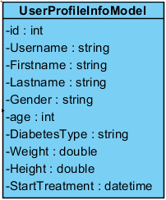

**Figure 9**: CD07:UserProfileInfoModel

**Description:** This class is extend model to correspond to table “Asp Net User” in the database

**Method:**

|  |  |  |  |  |
| --- | --- | --- | --- | --- |
| **ID** | **Name** | **Description** | **Access modifiers** | **Remark** |
| 1 | id | The attribute “id” can contain a get accessor, a set accessor the data id of user info on table “Asp Net User” in the database. | Public | - |
| 2 | Username | The attribute “Username” can contain a get accessor, a set accessor the Username data on table “Asp Net User” in the database. | Public | - |
| 3 | Firstname | The attribute “Firstname” can contain a get accessor, a set accessor the first name data on table “Asp Net User” in the database. | Public | - |
| 4 | Lastname | The attribute “Lastname” can contain a get accessor, a set accessor the last name data on table “Asp Net User” in the database. | Public | - |
| 5 | age | The attribute “age” can contain a get accessor, a set accessor the agedata on table “Asp Net User” in the database. | Public | - |
| 6 | weight | The attribute “weight” can contain a get accessor, a set accessor the weight data on table “Asp Net User” in the database. | Public | - |
| 7 | height | The attribute “height” can contain a get accessor, a set accessor the height data on table “Asp Net User” in the database. | Public | - |
| 8 | gender | The attribute “gender” can contain a get accessor, a set accessor the gender data on table “Asp Net User” in the database. | Public | - |
| 9 | DiabetesType | The attribute “DiabetesType” can contain a get accessor, a set accessor the diabetes type data on table “Asp Net User” in the database. | Public | - |
| 10 | StartTreatment | The attribute “StartTreatment” can contain a get accessor, a set accessor the start treatment data on table “Asp Net User” in the database. | public | - |

**Table 7**: Method of CD07: UserProfileInfoModel

**4.3.1.8 CD08: UserAddressModel**

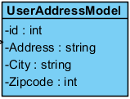

**Figure 10**: CD08:UserAddressModel

**Description:** This class is extend model to correspond to table “Address” in the database

**Method:**

|  |  |  |  |  |
| --- | --- | --- | --- | --- |
| **ID** | **Name** | **Description** | **Access modifiers** | **Remark** |
| 1 | id | The attribute “id” can contain a get accessor, a set accessor the data id of user address on table “Address” in the database. | Public | - |
| 2 | address | The attribute “address” can contain a get accessor, a set accessor the address data on table “Address” in the database. | Public | - |
| 3 | city | The attribute “city” can contain a get accessor, a set accessor the city data on table “Address” in the database. | Public | - |
| 4 | Zipcode | The attribute “Zipcode” can contain a get accessor, a set accessor the city code data on table “Address” in the database. | Public | - |

**Table 8**: Method of CD08: UserAddressModel

**4.3.1.9 CD09: AdminManagesUserModel**

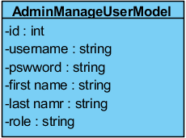

**Figure 11**: CD09:AdminManagesUserModel

**Description:** This class is extend model to correspond to table “AdminManageUser” in the database

**Method:**

|  |  |  |  |  |
| --- | --- | --- | --- | --- |
| **ID** | **Name** | **Description** | **Access modifiers** | **Remark** |
| 1 | id | The attribute “id” can contain a get accessor, a set accessor the data id of user on table “AdminManageUser” in the database. | Public | - |
| 2 | Username | The attribute “Username” can contain a get accessor, a set accessor the data of username of user on table “AdminManageUser” in the database. | Public | - |
| 3 | Password | The attribute “Password” can contain a get accessor, a set accessor the data of password of user on table “AdminManageUser” in the database. | Public | - |
| 4 | First name | The attribute “Password” can contain a get accessor, a set accessor the data of first name of user on table “AdminManageUser” in the database. | Public | - |
| 5 | Last name | The attribute “Password” can contain a get accessor, a set accessor the data of last name of user on table “AdminManageUser” in the database. | Public | - |
| 6 | role | The attribute “Password” can contain a get accessor, a set accessor the data of role of user on table “AdminManageUser” in the database. | Public | - |

**4.3.1.10 CD010: ChangePasswordModel**

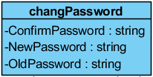

**Figure 12**: CD10:ChangePasswordModel

**Description:** This class is extend model to correspond to table “Asp Net User” in the database

**Method:**

|  |  |  |  |  |
| --- | --- | --- | --- | --- |
| **ID** | **Name** | **Description** | **Access modifiers** | **Remark** |
| 1 | ConfirmPassword | The attribute “ConfirmPassword” can contain a get accessor, a set accessor the data of new password of user on table “Asp Net User” in the database. For validate new password and confirm password is same. | Public | - |
| 2 | NewPassword | The attribute “NewPassword” can contain a get accessor, a set accessor the data of new password of user on table “Asp Net User” in the database. | Public | - |
| 3 | OldPassword | The attribute “OldPassword” can contain a get accessor and set validate the data of current password of user on table “Asp Net User” in the database. | Public | - |

**Table 10**: Method of CD10: ChangePasswordModel

**4.3.1.11 CD11: AddPhoneNumberViewModel**

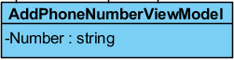

**Figure 13**: CD11:AddPhoneNumberViewModel

**Description:** This class is extend model to correspond to table “Asp Net User” in the database

**Method:**

|  |  |  |  |  |
| --- | --- | --- | --- | --- |
| **ID** | **Name** | **Description** | **Access modifiers** | **Remark** |
| 1 | Number | The attribute “Number” can contain a get accessor, a set accessor the data of phone number of user on table “Asp Net User” in the database. | Public | - |

**Table 11**: Method of CD11: AddPhoneNumberViewModel

**4.3.1.12 CD12: ActivityModel**

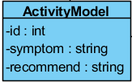

**Figure 14**: CD12:ActivityModel

**Description:** This class is extend model to correspond to table “Activity” in the database

**Method:**

|  |  |  |  |  |
| --- | --- | --- | --- | --- |
| **ID** | **Name** | **Description** | **Access modifiers** | **Remark** |
| 1 | id | The attribute “id” can contain a get accessor, a set accessor the data id of activity on table “Activity” in the database. | Public | - |
| 2 | symptom | The attribute “symptom” can contain a get accessor, a set accessor the symptom data on table “Activity” in the database. | Public | - |
| 3 | recommend | The attribute “recommend” can contain a get accessor, a set accessor the recommend data on table “Activity” in the database. | Public | - |

**Table 12**: Method of CD12: ActivityModel

**4.3.1.13CD13: FoodModel**

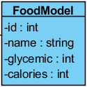

**Figure 15**: CD13:FoodModel

**Description:** This class is extend model to correspond to table “Food” in the database

**Method:**

|  |  |  |  |  |
| --- | --- | --- | --- | --- |
| **ID** | **Name** | **Description** | **Access modifiers** | **Remark** |
| 1 | id | The attribute “id” can contain a get accessor, a set accessor the data id of food on table “Food” in the database. | Public | - |
| 2 | name | The attribute “name” can contain a get accessor, a set accessor the data of name of food on table “Food” in the database. | Public | - |
| 3 | glycemic | The attribute “glycemic” can contain a get accessor, a set accessor the data of glycemic of food on table “Food” in the database. | Public | - |
| 4 | calories | The attribute “calories” can contain a get accessor, a set accessor the data of calories of food on table “Food” in the database. | Public | - |

**Table 13**: Method of CD13: FoodModel

**4.3.1.14 CD14: LoginViewModel**

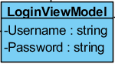

**Figure 16**: CD14:LoginViewModel

**Description:** This class is extend model to correspond to table “Asp Net User” in the database

**Method:**

|  |  |  |  |  |
| --- | --- | --- | --- | --- |
| **ID** | **Name** | **Description** | **Access modifiers** | **Remark** |
| 1 | Username | The attribute “Username” can contain a get accessor, a set accessor the Username data on table “Asp Net User” in the database. For validate username. | Public | - |
| 2 | Password | The attribute “Password” can contain a get accessor, a set accessor the data of password of user on table “Asp Net User” in the database. For validate password. | Public | - |

**Table 14**: Method of CD014: LoginViewModel

**4.3.1.15 CD15: MedicineModel**

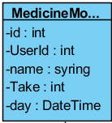

**Figure 17**: CD15:MedicineModel

**Description:** This class is extend model to correspond to table “Medicine” in the database

**Method:**

|  |  |  |  |  |
| --- | --- | --- | --- | --- |
| **ID** | **Name** | **Description** | **Access modifiers** | **Remark** |
| 1 | id | The attribute “id” can contain a get accessor, a set accessor the data id of medicine on table “Medicine” in the database. | Public | - |
| 2 | UserId | The attribute “UserId” can contain a get accessor, a set accessor the data id of user on table “Medicine” in the database. | Public | - |
| 3 | name | The attribute “name” can contain a get accessor, a set accessor the data of name of medicine on table “Medicine” in the database. | Public | - |
| 4 | Take | The attribute “Tale” can contain a get accessor, a set accessor the data on table “Medicine” in the database. | Public | - |
| 5 | day | The attribute “day” can contain a get accessor, a set accessor the data of date of medicine on table “Medicine” in the database. | Public | - |

**Table 15**: Method of CD15: MedicineModel

**4.3.1.16 CD16: TodayFoodModel**

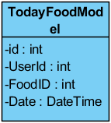

**Figure 18**: CD16:TodayFoodModel

**Description:** This class is extend model to correspond to table “TodayFood” in the database

**Method:**

|  |  |  |  |  |
| --- | --- | --- | --- | --- |
| **ID** | **Name** | **Description** | **Access modifiers** | **Remark** |
| 1 | id | The attribute “id” can contain a get accessor, a set accessor the data id of today food on table “TodayFood” in the database. | Public | - |
| 2 | UserId | The attribute “UserId” can contain a get accessor, a set accessor the data id of user on table “TodayFood” in the database. | Public | - |
| 3 | FoodID | The attribute “FoodID” can contain a get accessor, a set accessor the data id of food from the table “Food” to table “TodayFood” in the database. | Public | - |
| 4 | Date | The attribute “Date” can contain a get accessor, a set accessor the data of date on table “TodayFood” in the database. | Public | - |

**Table 16**: Method of CD16: TodayFoodModel

**4.3.1.17 CD17: UserFoodModel**

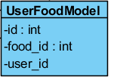

**Figure 19**: CD17:UserFoodModel

**Description:** This class is extend model to correspond to table “UserFood” in the database

**Method:**

|  |  |  |  |  |
| --- | --- | --- | --- | --- |
| **ID** | **Name** | **Description** | **Access modifiers** | **Remark** |
| 1 | Id | The attribute “id” can contain a get accessor, a set accessor the data id of today food on table “UserFood” in the database. | Public | - |
| 2 | user_id | The attribute “user_id” can contain a get accessor, a set accessor the data id of user on table “UserFood” in the database. | Public | - |
| 3 | food_id | The attribute “food_id” can contain a get accessor, a set accessor the data id of food from the table “Food” to table “UserFood” in the database. | Public | - |

**Table 17**: Method of CD17: UserFoodModel

**4.3.1.18 CD18: UserGlycemicModel**

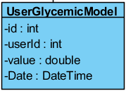

**Figure 20**: CD18: UserGlycemicModel

**Description:** This class is extend model to correspond to table “UserGlycemic” in the database

**Method:**

|  |  |  |  |  |
| --- | --- | --- | --- | --- |
| **ID** | **Name** | **Description** | **Access modifiers** | **Remark** |
| 1 | Id | The attribute “id” can contain a get accessor, a set accessor the data id of glycemic index of user on table “UserGlycemic” in the database. | Public | - |
| 2 | userId | The attribute “userId” can contain a get accessor, a set accessor the data id of user on table “UserGlycemic” in the database. | Public | - |
| 3 | value | The attribute “value” can contain a get accessor, a set accessor the data of glycemic value on table “UserGlycemic” in the database. | Public | - |
| 4 | Date | The attribute “Date” can contain a get accessor, a set accessor the data of date on table “UserGlycemic” in the database. | Public | - |

**Table 18**: Method of CD18: UserGlycemicModel

**4.3.1.19 CD19: UserComplicationn**

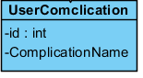

**Figure 21**: CD19: UserComplication

**Description:** This class is extend model to correspond to table “UserComplication” in the database

**Method:**

|  |  |  |  |  |
| --- | --- | --- | --- | --- |
| **ID** | **Name** | **Description** | **Access modifiers** | **Remark** |
| 1 | id | The attribute “id” can contain a get accessor, a set accessor the data id of complication disease of user on table “UserComplication” in the database. | Public | - |
| 4 | ComplicationName | The attribute “ComplicationName” can contain a get accessor, a set accessor the data name of complication disease on table “UserComplication” in the database. | Public | - |

**Table 19**: Method of CD19: UserComplication

# 4.3.2 Sequence Diagram

**4.3.2.1 SD01: Registration.**

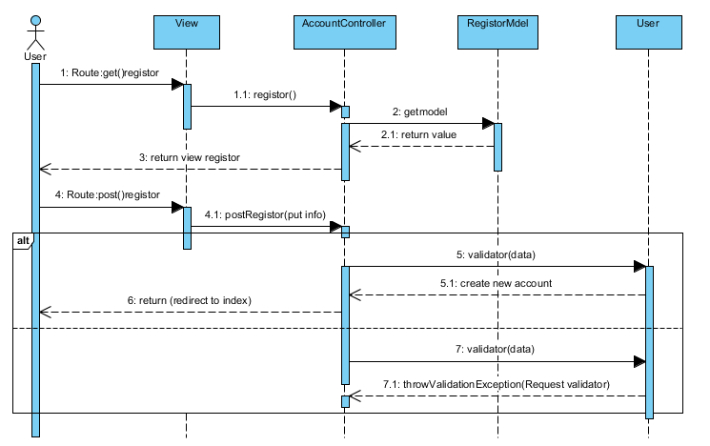

Figure 22: SD01: Registration.

# 4.3.2.2 SD02: Login.

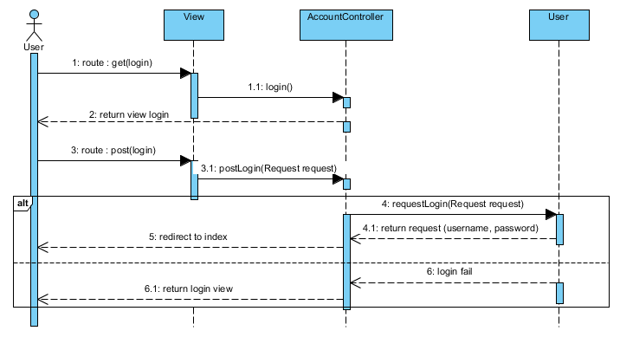 Figure 23: SD02: Login.

# 4.3.2.3 SD03: Logout.

# C:\Users\DELL\Desktop\project\diagram\sd\3 logount.PNG

Figure 23: SD03: Logout.

# 4.3.2.4 SD04: View user profile.

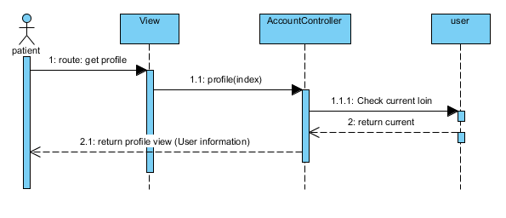

Figure 24: SD04: View user profile.

# 4.3.2.5 SD05: Edit user profile.

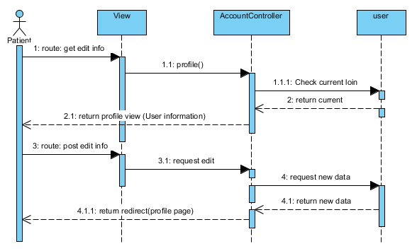

Figure 25: SD05: Edit user profile.

# 4.3.2.6 SD06: Change password

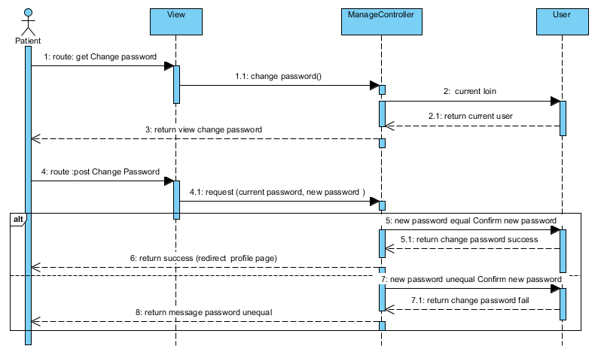

Figure 26: SD06: Change password

# 4.3.2.7 SD07: Create new food

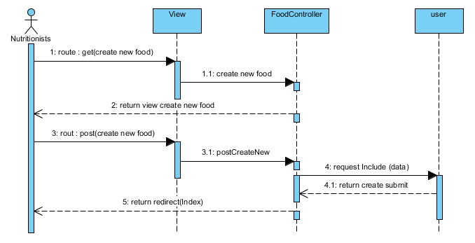

Figure 27: SD07: Create new food

# 4.3.2.8 SD08: Edit food info

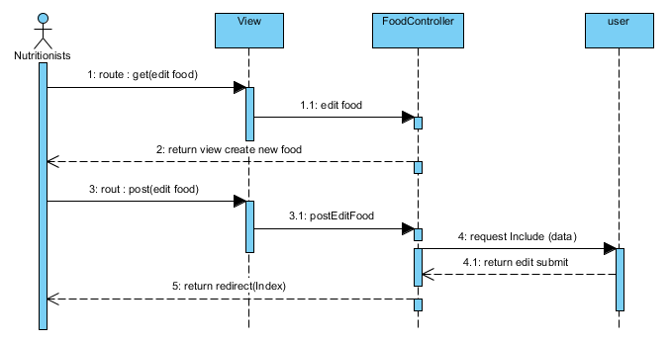

Figure 28: SD08: Edit food info

# 4.3.2.9 SD09: Delete food

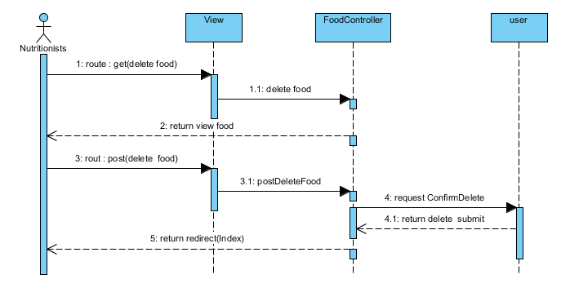

Figure 29: SD09: Delete food

# 4.3.2.10 SD10: Add activity

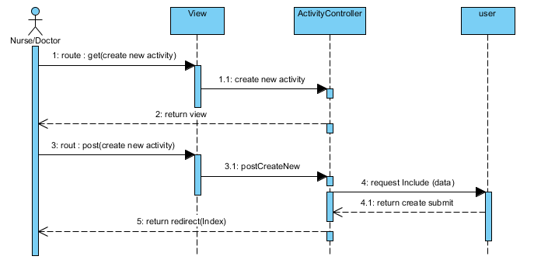

Figure 30: SD010: Add activity

# 4.3.2.11 SD11: Edit activity

# C:\Users\DELL\Desktop\project\diagram\sd\11 edit food.PNG

Figure 31: SD11: Edit activity

# 4.3.2.12 SD12: Delete activity

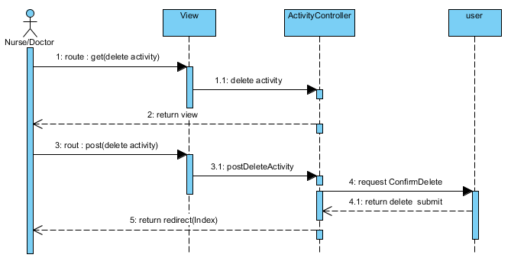

Figure 32: SD12: Delete activity

# 4.3.2.13 SD13: Admin create new user.

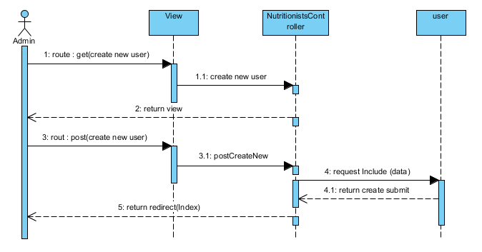

Figure 33: SD13: Admin create new user.

# 4.3.2.14 SD14: Admin edit user info.

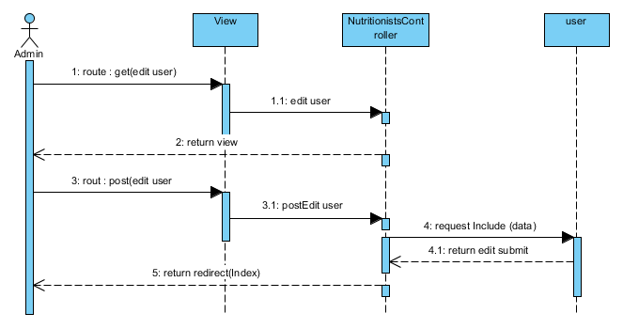

Figure 34: SD14: Admin edit user info.

# 4.3.2.15 SD15: Delete user

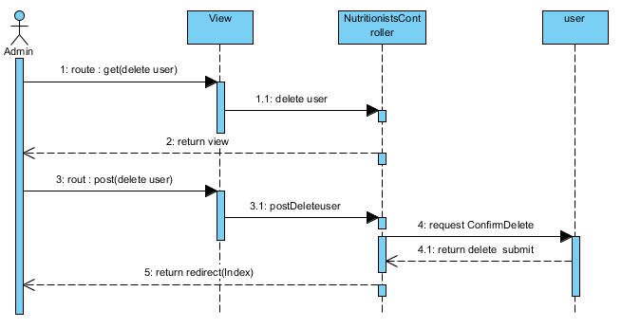

Figure 35: SD15: Delete user

# 4.3.2.16 SD16: Add food to health plan.

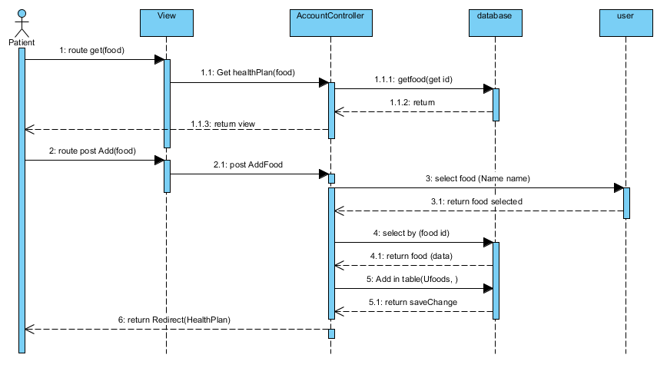

Figure 36: SD16: Add food to health plan.

# 4.3.2.17 SD17: Delete food from health plan.

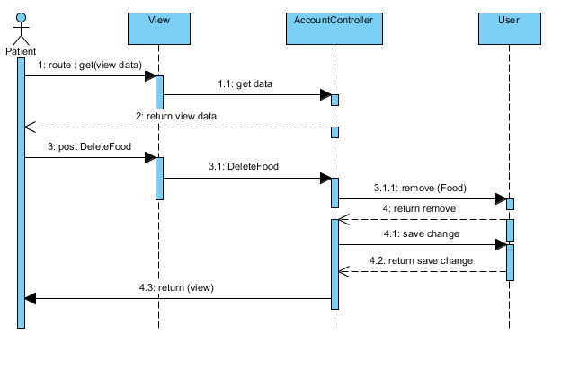

Figure 37: SD17: Delete food from health plan.

# 4.3.2.18 SD18: View BMI.

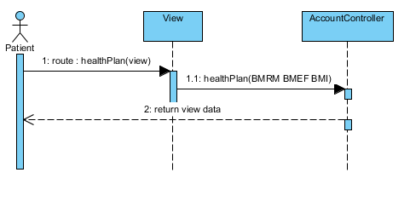

Figure 38: SD18: View BMI.

# 4.3.2.19 SD19: Add blood sugar.

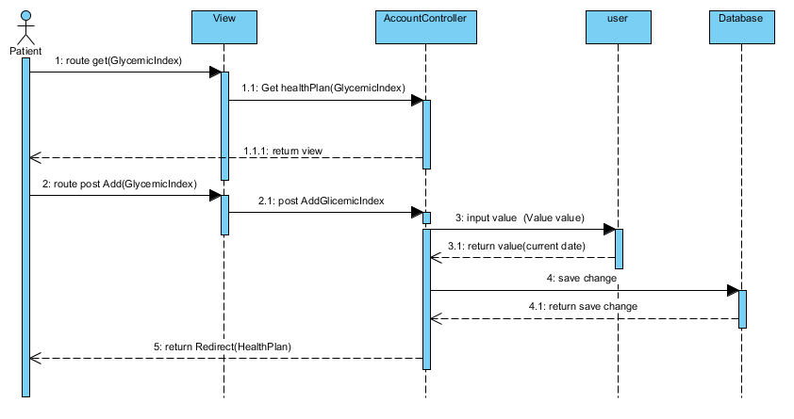

Figure 39: SD19: Add blood sugar.

# 4.3.2.20 SD20: View blood sugar on graph.

# C:\Users\DELL\Desktop\project\diagram\sd\20 View graph.PNG

# Figure 40:SD020: View blood sugar on graph.

# 4.3.2.21 SD21: Get recommend about blood sugar.

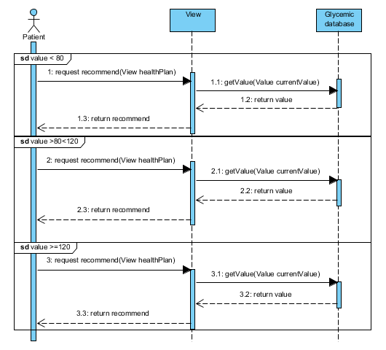Figure 41:SD021: Get recommend about blood sugar.

**4.3.3 User Interface.**

**4.3.3.1 Login**

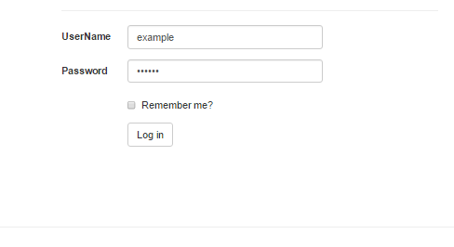

Figure 42:UI01: login.

**4.3.3.2 Logout**

**C:\Users\DELL\Desktop\project\diagram\logout.PNG**

Figure 43:UI02: logout.

**4.3.3.3 Registration**

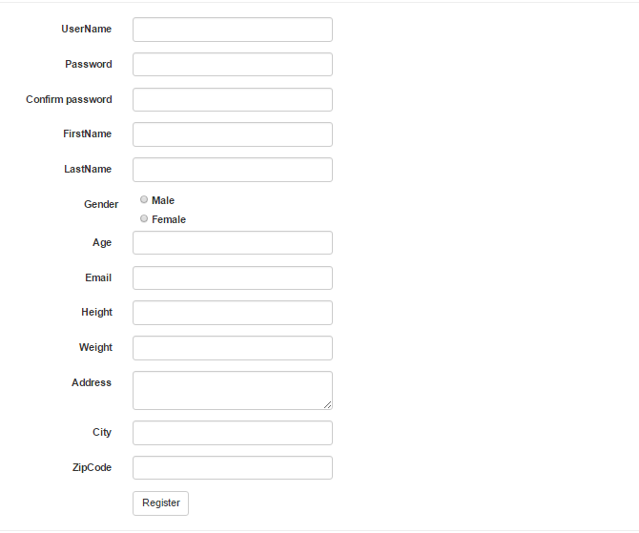

Figure 44:UI03: Registration.

**4.3.3.4 User profile.**

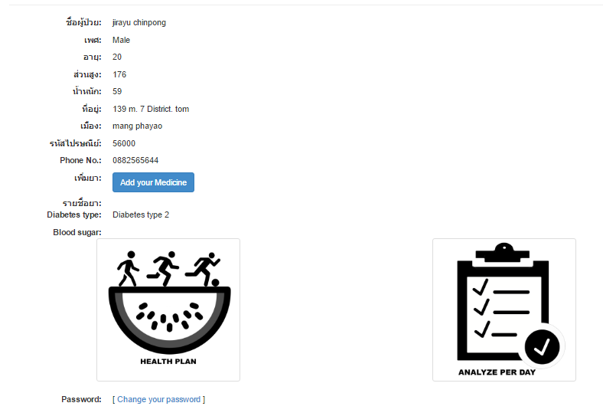

Figure 45:UI04: User profile.

**4.3.3.5 Change password.**

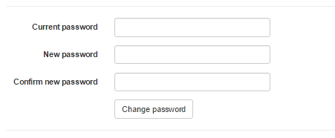

Figure 46:UI05: Chang password.

**4.3.3.6 Create new food.**

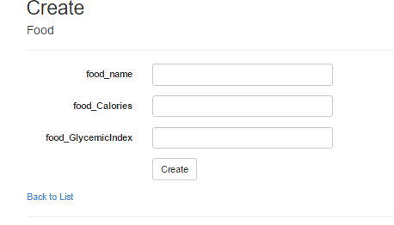

Figure 47:UI06: create new food.

**4.3.3.7 Edit food.**

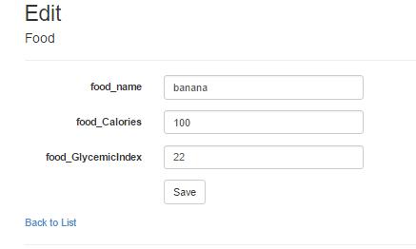

Figure 48:UI07: Edit food.

**4.3.3.8 Delete food.**

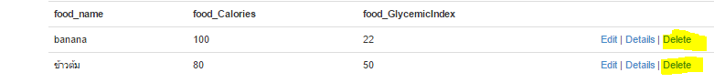

Figure 49:UI08: Delete food.

**4.3.3.9 Add food to health plan.**

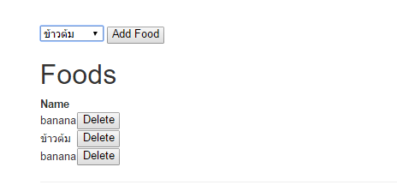

Figure 50:UI09: Add food to health plan.

**4.3.3.10 Delete food from health plan.**

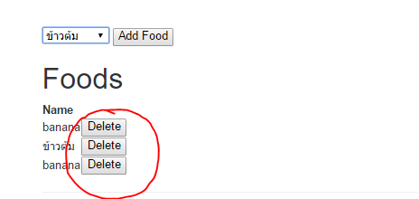

Figure 50:UI10: Delete food from health plan.

**4.3.3.11 Add blood sugar.**

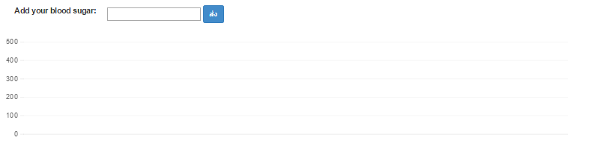

Figure 51:UI11: Add blood sugar.

**4.3.3.12 BMI.**

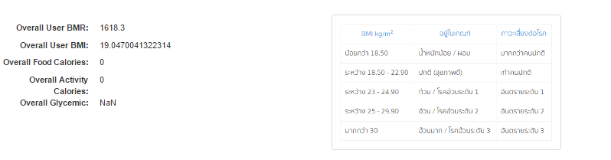

Figure 52:UI12: BMI.

# Chapter Four | 4.4 Data Architecture

## 4.4.1 Entity Relationship Diagram

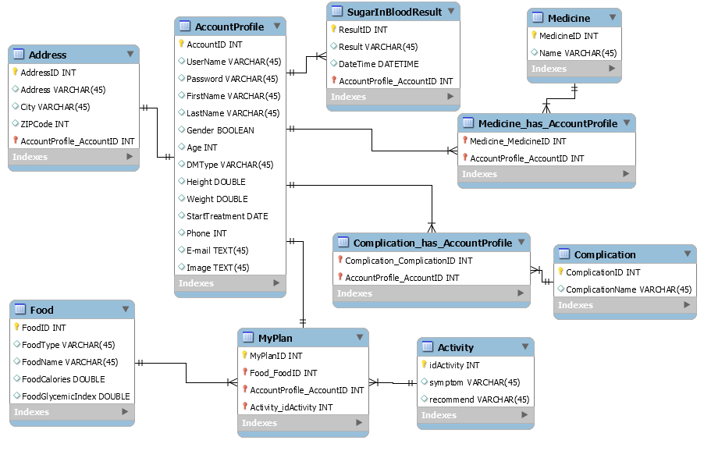

**Figure 53**: ER diagram

## 4.4.2 Database Design

### DB01 – AccountProfile

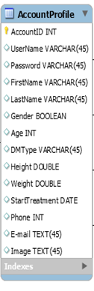

**Figure 54**: ER diagram: AccountProfile

**Class:** AccountProfile

**Description:** This class used for storing user’s information to the web application. **Attributes description:**

|  |  |  |  |
| --- | --- | --- | --- |
| **ID** | **Name** | **Description** | **Type** |
| 1 | AccountId | Stored user id number | int |
| 2 | username | Stored username of user | varchar |
| 3 | email | Stored user email | varchar |
| 4 | password | Stored user password | varchar |
| 5 | FirstName | Stored user first name | varchar |
| 6 | LastName | Stored user last name | varchar |
| 7 | Gender | Stored user gender | varchar |
| 8 | Age | Stored user age | int |
| 9 | DMType | Stored user diabetes type | varchar |
| 10 | Height | Stored user height | double |
| 11 | Weight | Stored user weight | double |
| 12 | StartTreatment | Stored user start treatment | DateTime |
| 13 | PhoneNo. | Stored user phone number | int |

**Table 20:** Description data of Class AccountProfile.

**DB02 – Address**

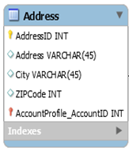

**Figure 55**: ER diagram: Address

**Class:** **Address**

**Description:** This class used for storing user’s address to the web application. **Attributes description:**

|  |  |  |  |
| --- | --- | --- | --- |
| **ID** | **Name** | **Description** | **Type** |
| 1 | AddressId | Stored user address id number | int |
| 2 | address | Stored address of user | varchar |
| 3 | city | Stored city of user | varchar |
| 4 | ZipCode | Stored the number of zip code | int |

**Table 21 :** Description data of Class Address.

**DB03 – Food**

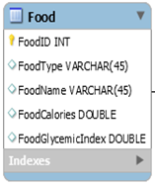

**Figure 56**: ER diagram: Food

**Class:** **Food**

**Description:** This class used for storing data of foods to the web application. **Attributes description:**

|  |  |  |  |
| --- | --- | --- | --- |
| **ID** | **Name** | **Description** | **Type** |
| 1 | foodID | Stored number of food id | int |
| 2 | FoodType | Stored the food type | varchar |
|  | FoodName | Stored the name of food | varchar |
| 3 | FoodCalories | Stored the calories of food | double |
| 4 | FoodGlycemicIndex | Stored the glycemic index of food | double |

**Table 22 :** Description data of Class Food.

**DB04 – Activity**

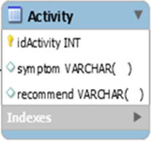

**Figure 57**: ER diagram: Activity

**Class:** **Activity**

**Description:** This class used for storing data of activity to the web application. **Attributes description:**

|  |  |  |  |
| --- | --- | --- | --- |
| **ID** | **Name** | **Description** | **Type** |
| 1 | idactivity | Stored number of activity id | int |
| 2 | symptom | Stored the symptom of the body | varchar |
| 3 | recommend | Stored the recommend from doctor about the exercise | varchar |

**Table 23:** Description data of Class Activity.

**DB05 – SugarInBloodResult**

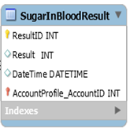

**Figure 58**: ER diagram: SugarInBloodResult

**Class:** **SugarInBloodResult**

**Description:** This class used for storing blood sugar value of user to the web application. **Attributes description:**

|  |  |  |  |
| --- | --- | --- | --- |
| **ID** | **Name** | **Description** | **Type** |
| 1 | ResultId | Stored id number of data | int |
| 2 | Result | Stored the value of blood sugar | int |
| 3 | DateTime | Stored date that user input data | DateTime |

**Table 24:** Description data of Class SugarInBloodResult.

**DB06 – Medicine**

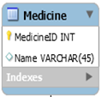

**Figure 59**: ER diagram:Medicine

**Class:** **Medicine**

**Description:** This class used for storing the medicine of user to the web application. **Attributes description:**

|  |  |  |  |
| --- | --- | --- | --- |
| **ID** | **Name** | **Description** | **Type** |
| 1 | MedicineID | Stored id number of data | int |
| 2 | Name | Stored the name of medicine | varchar |

**Table 25:** Description data of Class Medicine.

**DB07 – Complication**

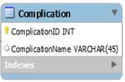

**Figure 60**: ER diagram: Complication

**Class:** **Medicine**

**Description:** This class used for storing the complication disease of user to the web application. **Attributes description:**

|  |  |  |  |
| --- | --- | --- | --- |
| **ID** | **Name** | **Description** | **Type** |
| 1 | ComplicationID | Stored id number of data | int |
| 2 | ComplicationName | Stored the name of complication | varchar |

**Table 26:** Description data of Class Medicine

**DB08 – Medicine_has_AccountProfile**

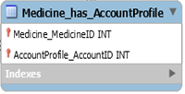

**Figure 61**: ER diagram: Medicine_has_AccountProfile

**Class:** **Medicine_has_AccountProfile**

**Description:** This class used for storing the id number of medicine from table “Medicine” and id number of account from table “AccountProfile” **Attributes description:**

|  |  |  |  |
| --- | --- | --- | --- |
| **ID** | **Name** | **Description** | **Type** |
| 1 | Medicine_Medicine | Stored id number of medicine from table “Medicine” | int |
| 2 | AccountProfile_AccountID | Stored id number of account from table “AccountProfile” | int |

**Table 27:** Description data of Class Medicine_has_AccountProfile

**DB09 – MyPlan**

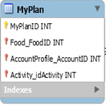

**Figure 62:** ER diagram : MyPlan

**Class:** **MyPlan**

**Description:** This class used for storing the id number of table food, accountProfile, and activity for syncing between class.

**Attributes description:**

|  |  |  |  |
| --- | --- | --- | --- |
| **ID** | **Name** | **Description** | **Type** |
| 1 | MyPlanID | Stored id number ofdata | int |
|  | Food_FoodID | Stored id number of account from table “Food” | int |
|  | AccountProfile_AccountID | Stored id number of account from table “AccountProfile” | int |
| 2 | Activity_idActivity | Stored id number of account from table “Activity” | int |

**Table 28:** Description data of Class Myplan

**DB08 – Complication_has_AccountProfile**

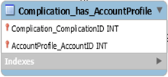

**Figure 63**: ER diagram : Complication_has_AccountProfile

**Class:** **Complication_has_AccountProfile**

**Description:** This class used for storing the id number of medicine from table “Complication” and id number of account from table “AccountProfile” **Attributes description:**

|  |  |  |  |
| --- | --- | --- | --- |
| **ID** | **Name** | **Description** | **Type** |
| 1 | Complication_ComplicationID | Stored id number of medicine from table “Complication” | int |
| 2 | AccountProfile_AccountID | Stored id number of account from table “AccountProfile” | int |

**Table 29:** Description data of Class Complication_has_AccountProfile