Web Service Home Work

实验目的
根据第8章内容，使用Axis或XFire编写一个简单的Web服务以及调用该Web服务的程序；
Web服务：编写一个查询学生成绩的Web服务，可根据学生的学号查询该生所修课程的成绩（要求使用数据库存储学生成绩）；
Web服务调用程序：编写一个学生成绩查询界面，可输入学生学号，调用Web服务，并将Web服务返回的成绩查询结果显示到界面上。

简述
本次实验，主要包含两个系统
- 学生成绩管理系统：
  - 学生信息维护
  - 课程信息录入
  - 学生成绩的维护
  - 学生成绩Web Service提供
- 客户端系统：
  - 学生成绩Web Service 调用

应用工具
- IDE:IntelliJIDEA
- Web Server:Tomcat 7.0
- JDK 7.0
- Grails 2.0.3

学生成绩管理系统

项目建立
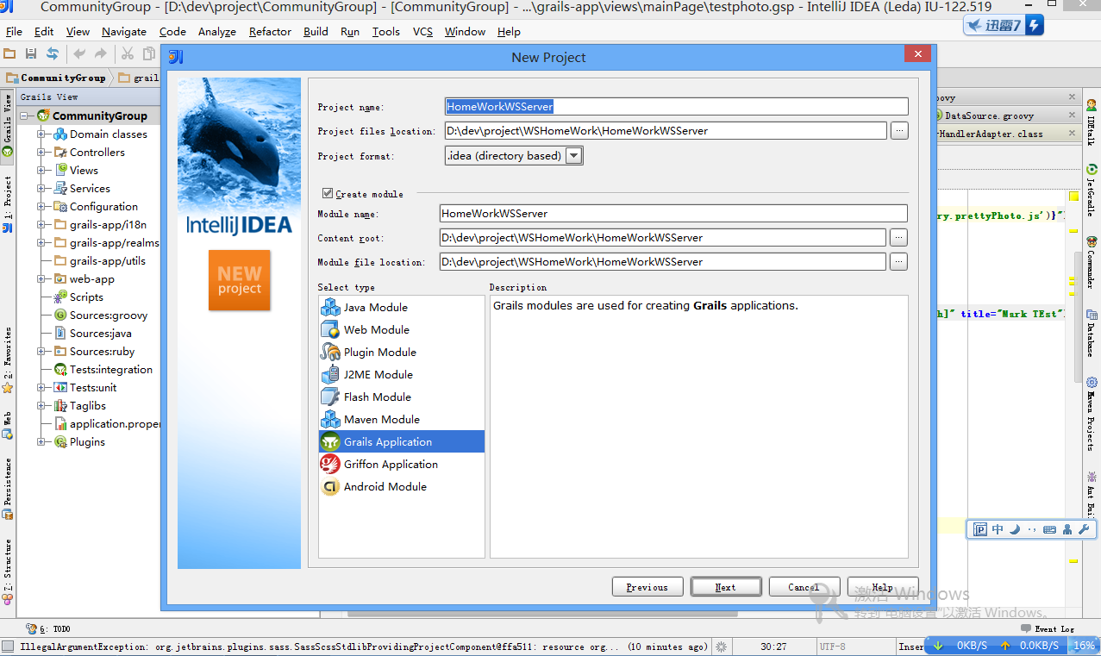
项目名称
应用框架

Plugin 安装
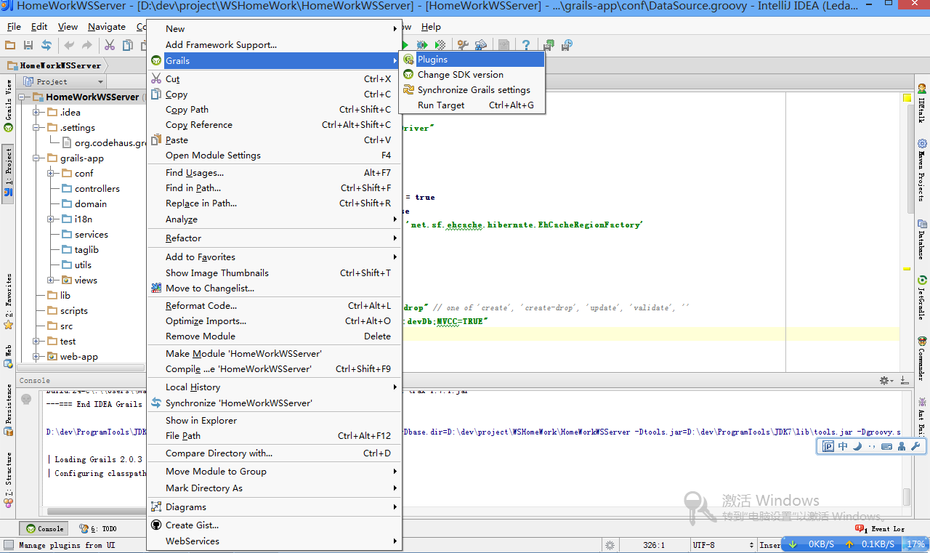
安装Plugin

mysql和XFire 插件安装
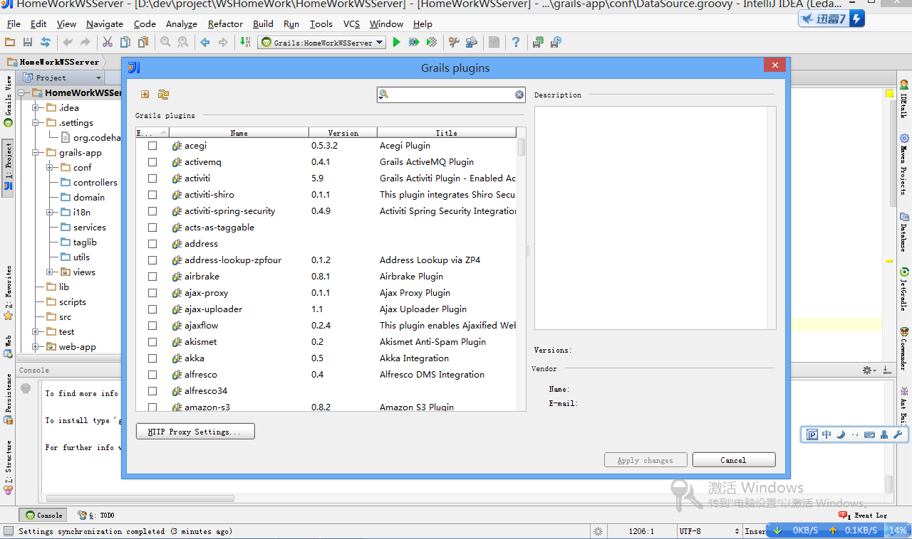
在这里分别查找mysql和XFire 插件并安装

Mysql DB准备-1创建Schema ：wsHomeWorkDB
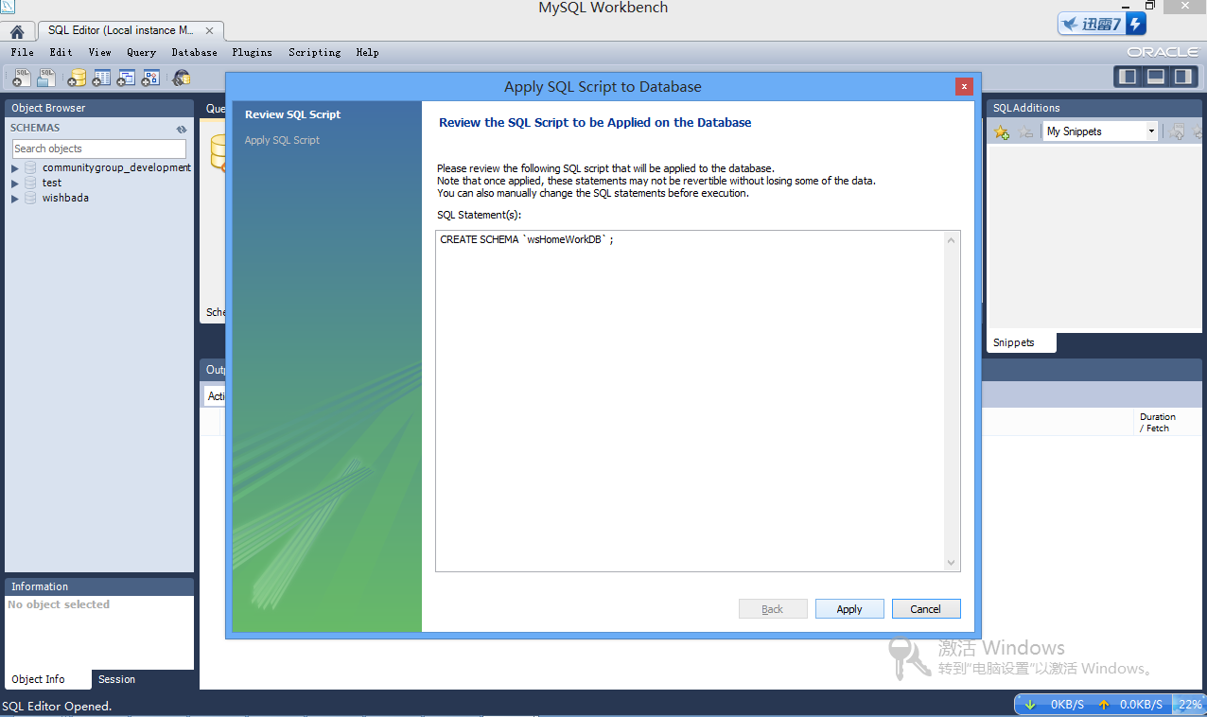
创建Schema ：wsHomeWorkDB collation： UTF-8

Mysql DB准备-2 修改DB Config 文件
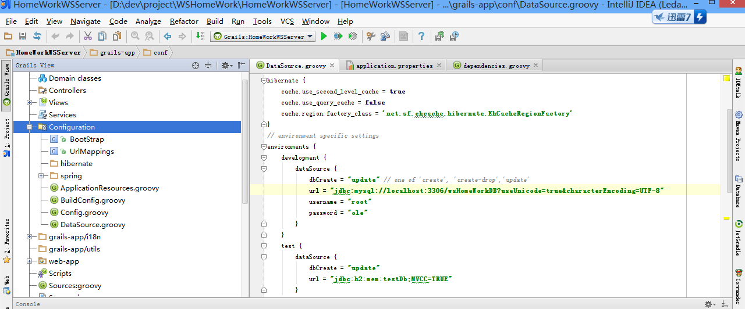
1. DB Config file
2. Mysql DB Url
3. Mysql DB User Name
4. Mysql DB Password

Domain Class建立
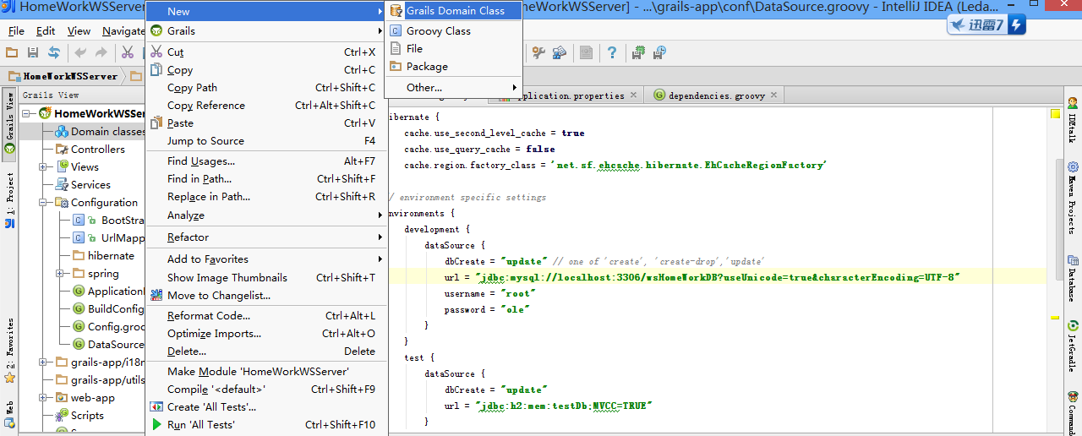
Domain Class 建立

Domain Class List
Student
属性 | 描述
Id | 学生ID
no | 学号
name | 学生姓名
address | 家庭住址
tel | 联系电话
Course
属性 | 描述
Id | 课程ID
no | 课程编号
name | 课程名称
teacher | 授课教师

Course Score
属性 | 描述
Course | 课程
Student | 学生
score | 分数

Domain Code
package homeworkwsserver
class Student implements Serializable {
String no
String name
String address
String tel
Date dateCreated
Date lastUpdated
static constraints = {
no()
name()
address()
tel()
dateCreated()
lastUpdated()
}
static mapping = {
sort lastUpdated: "asc"
}
String toString() {
no + "," + name
}
}
package homeworkwsserver

class Course implements Serializable {
String no
String name
String teacher
Date dateCreated
Date lastUpdated
static constraints = {
no()
name()
teacher()
dateCreated()
lastUpdated()
}
static mapping = {
sort lastUpdated: "asc"
}
String toString() {
no + "," + name
}
}

package homeworkwsserver

class CourseScore implements Serializable {
Student student
Course course
Integer score
Date dateCreated
Date lastUpdated
static constraints = {
student()
course()
score(nullable: false, range: 0..100)
dateCreated()
lastUpdated()
}
static mapping = {
sort lastUpdated: "asc"
}
String toString() {
student + "," + course + "=" + score
}
}

Controller 和Views 自动生成
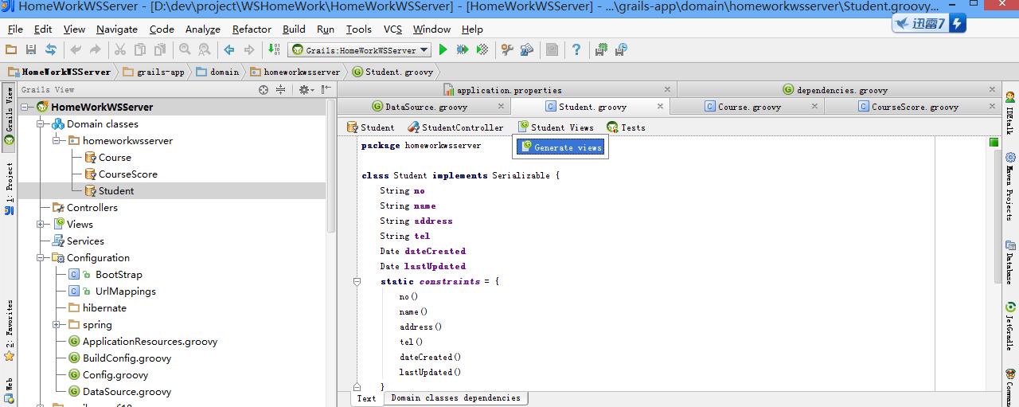
自动生成Views
自动生成 Controller

Web Service Class 编写
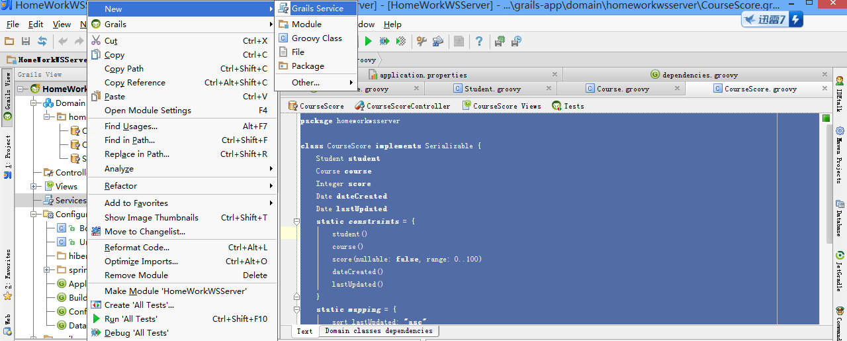
新建一个Web Service Class

Source Code
package homeworkwsserver

import com.mark.homework.CourseScoreBean

class WSService {
static expose = ['xfire'] //声明这是一个web service

CourseScore[] getScoresByStudentNo(String no) {
CourseScore.findAllByStudent(Student.findByNo(no)) as CourseScore[]
}

}

启动server服务
通过http://localhost:9080/HomeWorkWSServer/ 进入学生成绩管理系统。
可以添加学生，添加课程，添加课程成绩。如图：
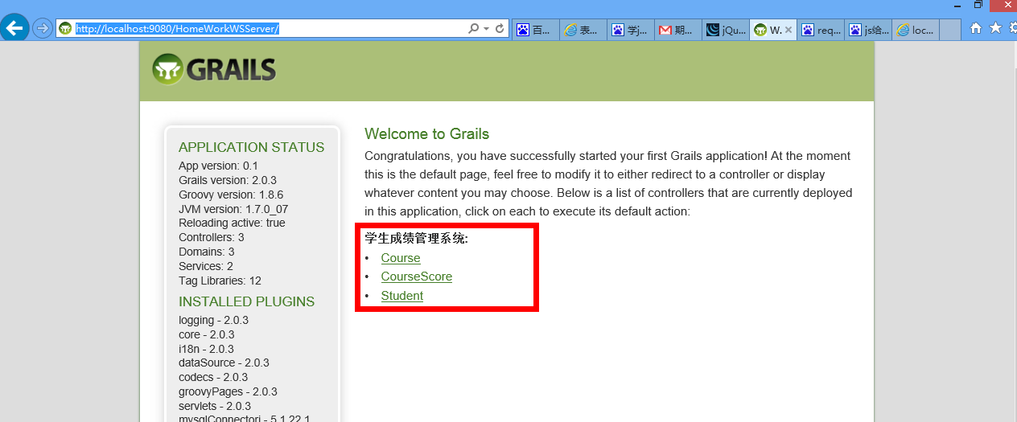
通过http://localhost:9080/HomeWorkWSServer/services/WS?wsdl 可以查看wsdl 文件，如下文件自动生成：
<?xml version="1.0" encoding="UTF-8"?>
<wsdl:definitions targetNamespace="http://homeworkwsserver" xmlns:ns1="http://validation.springframework.org" xmlns:soapenc12="http://www.w3.org/2003/05/soap-encoding" xmlns:tns="http://homeworkwsserver" xmlns:wsdl="http://schemas.xmlsoap.org/wsdl/" xmlns:xsd="http://www.w3.org/2001/XMLSchema" xmlns:soap11="http://schemas.xmlsoap.org/soap/envelope/" xmlns:wsdlsoap="http://schemas.xmlsoap.org/wsdl/soap/" xmlns:soapenc11="http://schemas.xmlsoap.org/soap/encoding/" xmlns:soap12="http://www.w3.org/2003/05/soap-envelope">
<wsdl:types>
<xsd:schema xmlns:xsd="http://www.w3.org/2001/XMLSchema" attributeFormDefault="qualified" elementFormDefault="qualified" targetNamespace="http://homeworkwsserver">
<xsd:element name="getScoresByStudentNo">
<xsd:complexType>
<xsd:sequence>
<xsd:element maxOccurs="1" minOccurs="1" name="in0" nillable="true" type="xsd:string"/>
</xsd:sequence>
</xsd:complexType>
</xsd:element>
<xsd:complexType name="ArrayOfCourseScore">
<xsd:sequence>
<xsd:element maxOccurs="unbounded" minOccurs="0" name="CourseScore" nillable="true" type="tns:CourseScore"/>
</xsd:sequence>
</xsd:complexType>
<xsd:complexType name="CourseScore">
<xsd:sequence>
<xsd:element minOccurs="0" name="attached" type="xsd:boolean"/>
<xsd:element minOccurs="0" name="course" nillable="true" type="tns:Course"/>
<xsd:element minOccurs="0" name="dateCreated" type="xsd:dateTime"/>
<xsd:element minOccurs="0" name="errors" nillable="true" type="ns1:Errors"/>
<xsd:element minOccurs="0" name="id" nillable="true" type="xsd:long"/>
<xsd:element minOccurs="0" name="lastUpdated" type="xsd:dateTime"/>
<xsd:element minOccurs="0" name="properties" nillable="true" type="tns:anyType2anyTypeMap"/>
<xsd:element minOccurs="0" name="score" nillable="true" type="xsd:int"/>
<xsd:element minOccurs="0" name="student" nillable="true" type="tns:Student"/>
<xsd:element minOccurs="0" name="version" nillable="true" type="xsd:long"/>
</xsd:sequence>
</xsd:complexType>
<xsd:complexType name="anyType2anyTypeMap">
<xsd:sequence>
<xsd:element maxOccurs="unbounded" minOccurs="0" name="entry">
<xsd:complexType>
<xsd:sequence>
<xsd:element maxOccurs="1" minOccurs="0" name="key" type="xsd:anyType"/>
<xsd:element maxOccurs="1" minOccurs="0" name="value" type="xsd:anyType"/>
</xsd:sequence>
</xsd:complexType>
</xsd:element>
</xsd:sequence>
</xsd:complexType>
<xsd:complexType name="ArrayOfString">
<xsd:sequence>
<xsd:element maxOccurs="unbounded" minOccurs="0" name="string" nillable="true" type="xsd:string"/>
</xsd:sequence>
</xsd:complexType>
<xsd:complexType name="Course">
<xsd:sequence>
<xsd:element minOccurs="0" name="attached" type="xsd:boolean"/>
<xsd:element minOccurs="0" name="dateCreated" type="xsd:dateTime"/>
<xsd:element minOccurs="0" name="errors" nillable="true" type="ns1:Errors"/>
<xsd:element minOccurs="0" name="id" nillable="true" type="xsd:long"/>
<xsd:element minOccurs="0" name="lastUpdated" type="xsd:dateTime"/>
<xsd:element minOccurs="0" name="name" nillable="true" type="xsd:string"/>
<xsd:element minOccurs="0" name="no" nillable="true" type="xsd:string"/>
<xsd:element minOccurs="0" name="properties" nillable="true" type="tns:anyType2anyTypeMap"/>
<xsd:element minOccurs="0" name="teacher" nillable="true" type="xsd:string"/>
<xsd:element minOccurs="0" name="version" nillable="true" type="xsd:long"/>
</xsd:sequence>
</xsd:complexType>
<xsd:complexType name="Student">
<xsd:sequence>
<xsd:element minOccurs="0" name="address" nillable="true" type="xsd:string"/>
<xsd:element minOccurs="0" name="attached" type="xsd:boolean"/>
<xsd:element minOccurs="0" name="dateCreated" type="xsd:dateTime"/>
<xsd:element minOccurs="0" name="errors" nillable="true" type="ns1:Errors"/>
<xsd:element minOccurs="0" name="id" nillable="true" type="xsd:long"/>
<xsd:element minOccurs="0" name="lastUpdated" type="xsd:dateTime"/>
<xsd:element minOccurs="0" name="name" nillable="true" type="xsd:string"/>
<xsd:element minOccurs="0" name="no" nillable="true" type="xsd:string"/>
<xsd:element minOccurs="0" name="properties" nillable="true" type="tns:anyType2anyTypeMap"/>
<xsd:element minOccurs="0" name="tel" nillable="true" type="xsd:string"/>
<xsd:element minOccurs="0" name="version" nillable="true" type="xsd:long"/>
</xsd:sequence>
</xsd:complexType>
<xsd:element name="getScoresByStudentNoResponse">
<xsd:complexType>
<xsd:sequence>
<xsd:element maxOccurs="1" minOccurs="1" name="out" nillable="true" type="tns:ArrayOfCourseScore"/>
</xsd:sequence>
</xsd:complexType>
</xsd:element>
</xsd:schema>
<xsd:schema xmlns:xsd="http://www.w3.org/2001/XMLSchema" attributeFormDefault="qualified" elementFormDefault="qualified" targetNamespace="http://www.w3.org/2001/XMLSchema">
<xsd:complexType name="ArrayOfAnyType">
<xsd:sequence>
<xsd:element maxOccurs="unbounded" minOccurs="0" name="anyType" nillable="true" type="xsd:anyType"/>
</xsd:sequence>
</xsd:complexType>
</xsd:schema>
<xsd:schema xmlns:xsd="http://www.w3.org/2001/XMLSchema" attributeFormDefault="qualified" elementFormDefault="qualified" targetNamespace="http://validation.springframework.org">
<xsd:complexType name="Errors">
<xsd:sequence>
<xsd:element minOccurs="0" name="allErrors" nillable="true" type="ns1:ArrayOfObjectError"/>
<xsd:element minOccurs="0" name="errorCount" type="xsd:int"/>
<xsd:element minOccurs="0" name="fieldError" nillable="true" type="ns1:FieldError"/>
<xsd:element minOccurs="0" name="fieldErrorCount" type="xsd:int"/>
<xsd:element minOccurs="0" name="fieldErrors" nillable="true" type="ns1:ArrayOfFieldError"/>
<xsd:element minOccurs="0" name="globalError" nillable="true" type="ns1:ObjectError"/>
<xsd:element minOccurs="0" name="globalErrorCount" type="xsd:int"/>
<xsd:element minOccurs="0" name="globalErrors" nillable="true" type="ns1:ArrayOfObjectError"/>
<xsd:element minOccurs="0" name="nestedPath" nillable="true" type="xsd:string"/>
<xsd:element minOccurs="0" name="objectName" nillable="true" type="xsd:string"/>
</xsd:sequence>
</xsd:complexType>
<xsd:complexType name="ArrayOfObjectError">
<xsd:sequence>
<xsd:element maxOccurs="unbounded" minOccurs="0" name="ObjectError" nillable="true" type="ns1:ObjectError"/>
</xsd:sequence>
</xsd:complexType>
<xsd:complexType name="ObjectError">
<xsd:sequence>
<xsd:element minOccurs="0" name="arguments" nillable="true" type="xsd:ArrayOfAnyType"/>
<xsd:element minOccurs="0" name="code" nillable="true" type="xsd:string"/>
<xsd:element minOccurs="0" name="codes" nillable="true" type="tns:ArrayOfString"/>
<xsd:element minOccurs="0" name="defaultMessage" nillable="true" type="xsd:string"/>
<xsd:element minOccurs="0" name="objectName" nillable="true" type="xsd:string"/>
</xsd:sequence>
</xsd:complexType>
<xsd:complexType name="FieldError">
<xsd:sequence>
<xsd:element minOccurs="0" name="arguments" nillable="true" type="xsd:ArrayOfAnyType"/>
<xsd:element minOccurs="0" name="bindingFailure" type="xsd:boolean"/>
<xsd:element minOccurs="0" name="code" nillable="true" type="xsd:string"/>
<xsd:element minOccurs="0" name="codes" nillable="true" type="tns:ArrayOfString"/>
<xsd:element minOccurs="0" name="defaultMessage" nillable="true" type="xsd:string"/>
<xsd:element minOccurs="0" name="field" nillable="true" type="xsd:string"/>
<xsd:element minOccurs="0" name="objectName" nillable="true" type="xsd:string"/>
<xsd:element minOccurs="0" name="rejectedValue" nillable="true" type="xsd:anyType"/>
</xsd:sequence>
</xsd:complexType>
<xsd:complexType name="ArrayOfFieldError">
<xsd:sequence>
<xsd:element maxOccurs="unbounded" minOccurs="0" name="FieldError" nillable="true" type="ns1:FieldError"/>
</xsd:sequence>
</xsd:complexType>
</xsd:schema>
</wsdl:types>
<wsdl:message name="getScoresByStudentNoRequest">
<wsdl:part name="parameters" element="tns:getScoresByStudentNo">
</wsdl:part>
</wsdl:message>
<wsdl:message name="getScoresByStudentNoResponse">
<wsdl:part name="parameters" element="tns:getScoresByStudentNoResponse">
<wsdl:service name="WS">
<wsdl:port name="WSHttpPort" binding="tns:WSHttpBinding">
<wsdlsoap:address location="http://localhost:9080/HomeWorkWSServer/services/WS"/>
</wsdl:port>
</wsdl:service>
</wsdl:definitions>

</wsdl:part>
</wsdl:message>
<wsdl:portType name="WS">
<wsdl:operation name="getScoresByStudentNo">
<wsdl:input name="getScoresByStudentNoRequest" message="tns:getScoresByStudentNoRequest">
</wsdl:input>
<wsdl:output name="getScoresByStudentNoResponse" message="tns:getScoresByStudentNoResponse">
</wsdl:output>
</wsdl:operation>
</wsdl:portType>
<wsdl:binding name="WSHttpBinding" type="tns:WS">
<wsdlsoap:binding style="document" transport="http://schemas.xmlsoap.org/soap/http"/>
<wsdl:operation name="getScoresByStudentNo">
<wsdlsoap:operation soapAction=""/>
<wsdl:input name="getScoresByStudentNoRequest">
<wsdlsoap:body use="literal"/>
</wsdl:input>
<wsdl:output name="getScoresByStudentNoResponse">
<wsdlsoap:body use="literal"/>
</wsdl:output>
</wsdl:operation>
</wsdl:binding>

客户端系统

项目建立
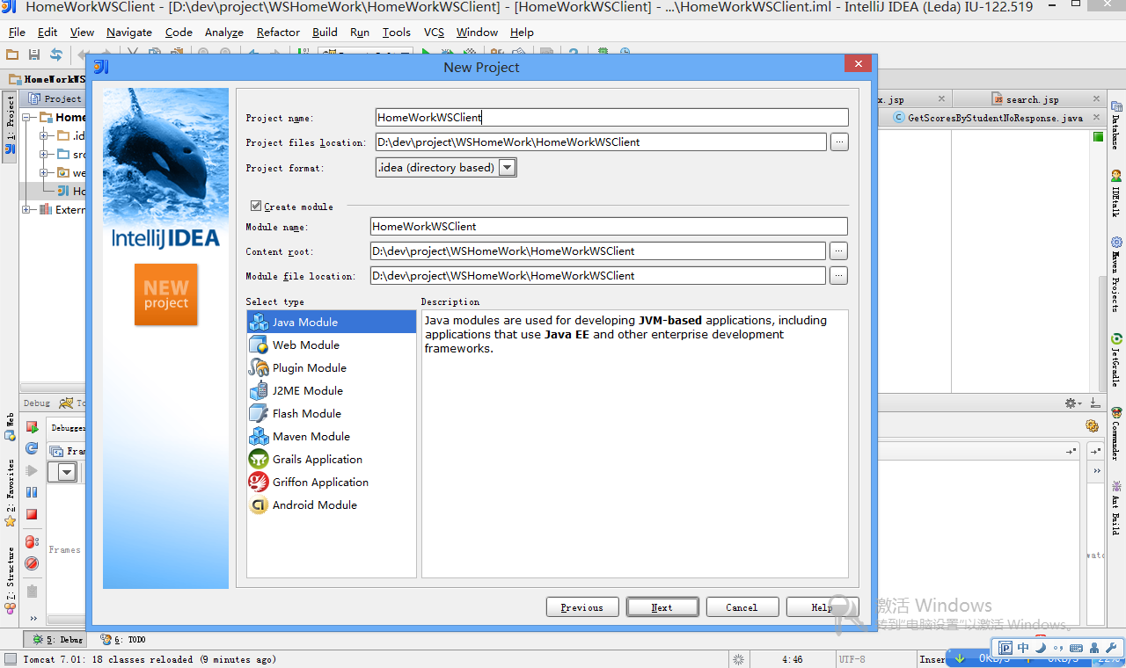
应用框架
项目名称
应用框架

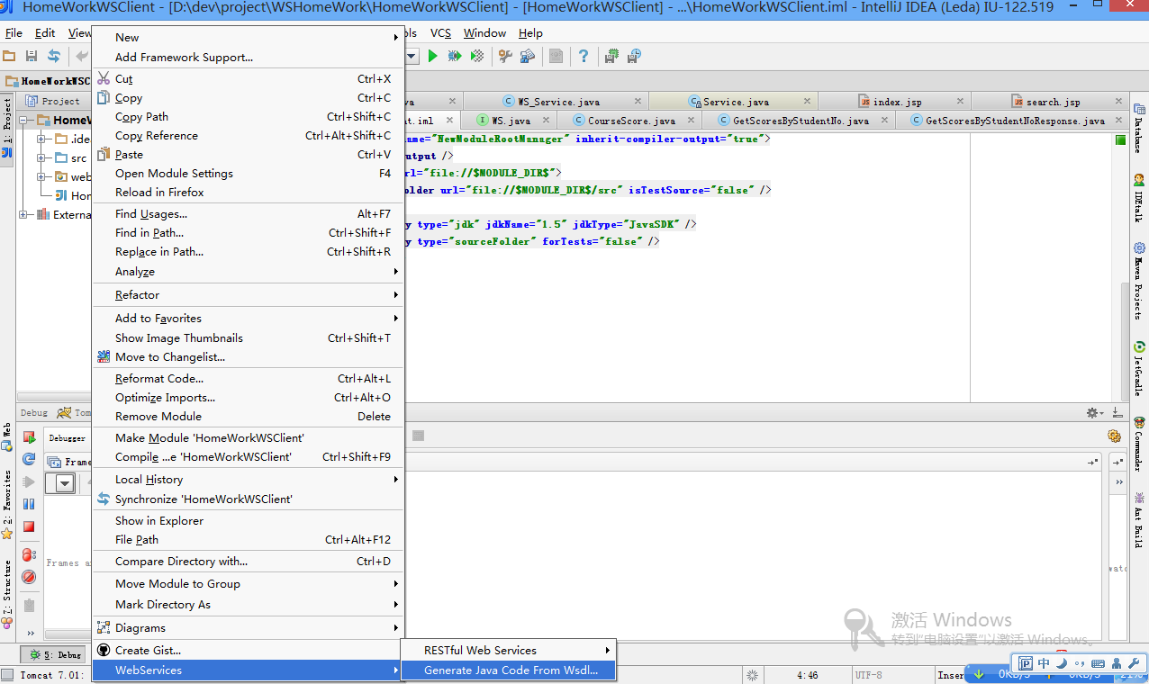
Web Service Client建立
新建Web Service Client

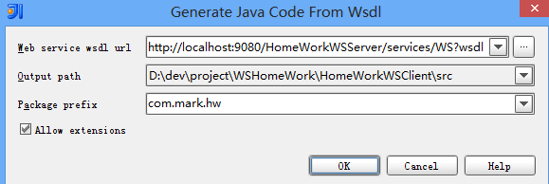
WSDL文件url地址

客户端程序自动生成如图结构以及客户端JSP code 编写
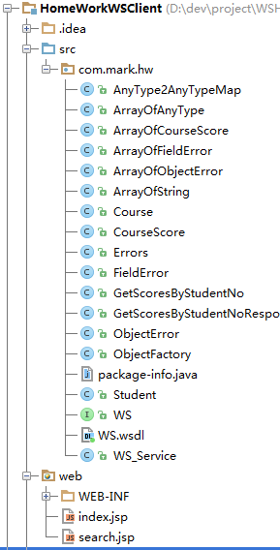
index。jsp 用于输入学号
<%@page contentType="text/html;charset=UTF-8" language="java" %>
<html>
<head>
<title></title>
</head>
<body>
<form action="search.jsp" method="post">
学号：<input type="text" id="no" name="no">
<input type="submit" value="提交"> <br>
目前有两个学号：s001、s002

</form>
</body>
</html>

search.jsp 根据学号，调用web service进行查询学生成绩并且打印
<%@ page import="com.mark.hw.WS_Service" %>
<%@ page import="com.mark.hw.ArrayOfCourseScore" %>
<%@ page import="com.mark.hw.CourseScore" %>
<%@ page contentType="text/html;charset=UTF-8" language="java" %>
<html>
<head>
<title></title>
</head>
<body>
<table border="1px">
<%
String no = request.getParameter("no");
WS_Service ws = new WS_Service();
ArrayOfCourseScore alCourseScore = ws.getWSHttpPort().getScoresByStudentNo(no);
for (int i = 0; i < alCourseScore.getCourseScore().size(); i++) {
CourseScore courseScore = alCourseScore.getCourseScore().get(i);
out.println("<tr><td>" + courseScore.getStudent().getValue().getName().getValue()+"</td> ");
out.println("<td>" + courseScore.getCourse().getValue().getName().getValue() + "</td>");
out.println("<td>" + courseScore.getScore().getValue() + "</td></tr>");
}
%>
<a href="index.jsp" name="">back</a>
</table>
</body>
</html>

实验结果

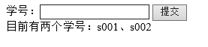
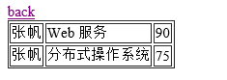

参考网址

grails 框架 参考网址：http://www.grails.org/
本次实验所有code 都可以通过

