DecisionReady
Hackathon Evidence & Submission Proof
Agents for Humans Hackathon | Professional Agents
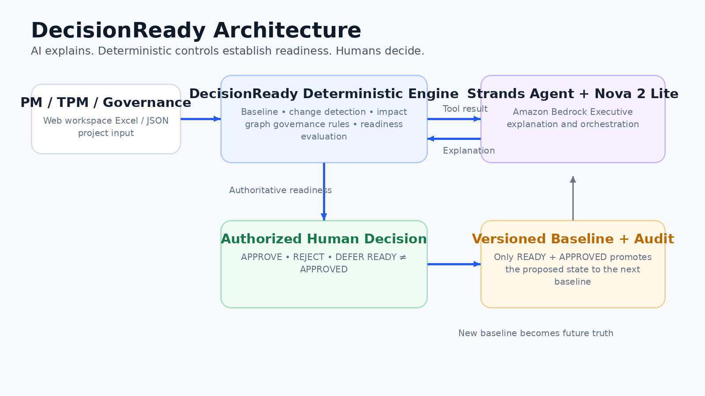
AI explains. Deterministic controls establish readiness. Humans decide.
Prepared September 12, 2026

1. Executive Summary
DecisionReady is a human-governed AI decision control system for complex program change. It determines whether a proposed change has enough governed evidence and approvals to be ready for a consequential human decision. The system uses Strands Agents and Amazon Nova 2 Lite on Amazon Bedrock for explanation and orchestration, while a deterministic Python engine remains authoritative for change detection, impact analysis, governance requirements, blockers, readiness, and baseline promotion.
Core trust boundary: READY does not mean APPROVED. Only an authorized human may APPROVE, REJECT, or DEFER.

2. Submission Readiness Evidence
Evidence Item | Status | Proof / Location
Public code repository | Verified | https://github.com/atoosabiglari-PM/decisionready
Latest public implementation | Verified | Commit d507a52 - Add business-friendly Excel project import
Public deployment | Verified from deployment log | AWS Elastic Beanstalk environment decisionready-demo deployed successfully
Live application | Available | http://decisionready-atoosa.us-west-2.elasticbeanstalk.com
Strands Agents | Implemented | Strands Agent calls authoritative DecisionReady tool before readiness explanation
Amazon Bedrock / Nova | Implemented | Amazon Nova 2 Lite: us.amazon.nova-2-lite-v1:0 in us-west-2
Deterministic governance | Implemented | Change detection, impact graph, governance rules, readiness, baseline promotion
Human authority | Implemented | APPROVE / REJECT / DEFER; READY ≠ APPROVED
Business-friendly intake | Implemented | Excel workbook import plus advanced JSON path
Automated tests | Verified by terminal run | 46 passing tests
Open-source license | Present | Apache License 2.0

3. End-to-End Governed Lifecycle
The lifecycle demonstrated in the deployed product is: approved baseline → proposed change → deterministic impact/governance analysis → NOT_READY → governance requirements satisfied → READY → authorized human decision → new baseline and audit trail.
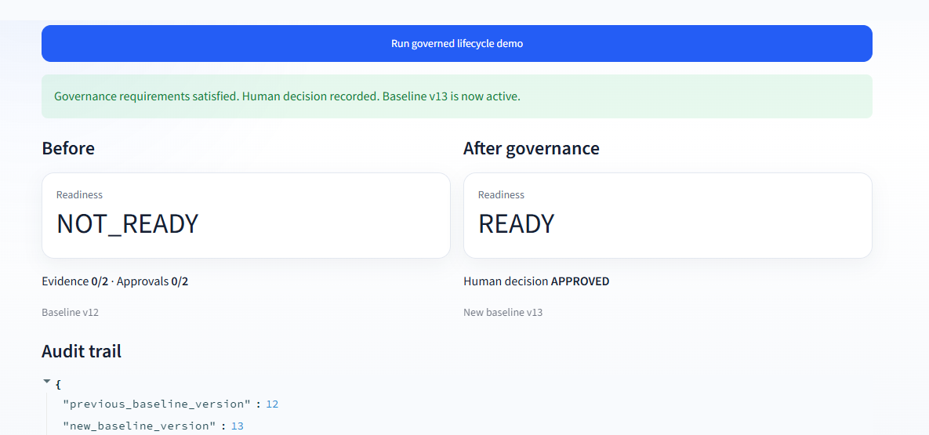
Figure 1. Public DecisionReady lifecycle showing NOT_READY before governance and READY after governance, followed by a human APPROVED decision and a new baseline.
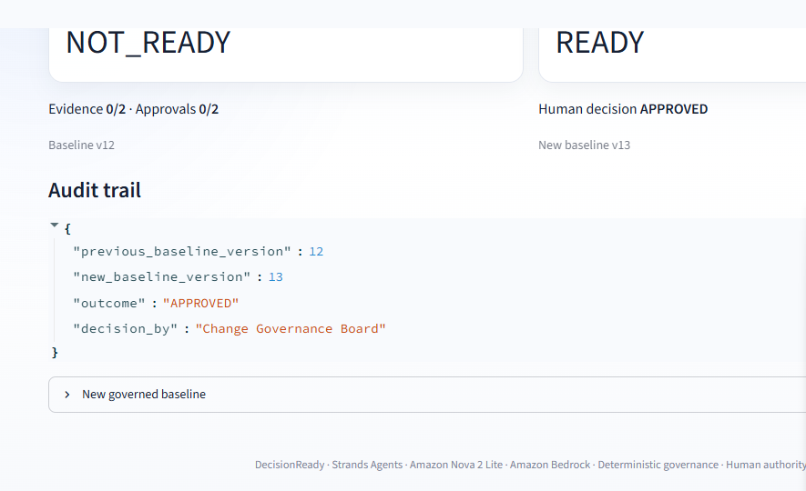
Figure 2. Audit evidence records the previous baseline, new baseline, human outcome, and decision authority.
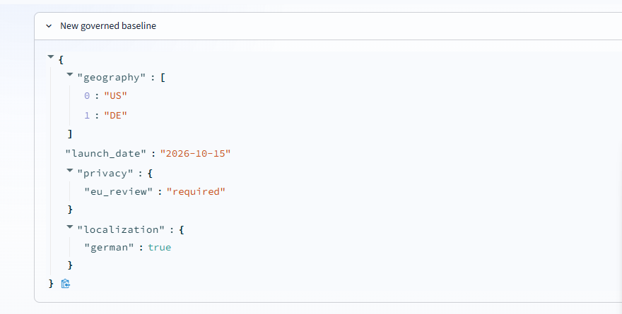
Figure 3. The approved proposed state becomes the next governed baseline, including Germany, the new launch date, EU review requirement, and German localization.

4. Germany Demo Evidence
The primary demo workbook is `demo_data/DecisionReady_Germany_Project_Demo.xlsx`. It contains three business-facing sheets: Project, Approved Baseline, and Proposed Change. No JSON knowledge is required for the normal demo path.
Dimension | Approved Baseline v1 | Proposed Change
Geography | US | US + Germany
Launch date | 2026-10-01 | 2026-10-15
EU privacy review | Not required | Required
German localization | No | Yes
Expected initial result: NOT_READY. Governance rules require privacy evidence, schedule evidence, Privacy / Legal approval, and Program Sponsor approval. Once these human-governed requirements are satisfied, the deterministic engine returns READY. A human may then make the final decision.

5. Technical Evidence

Strands Agents tool boundary
The agent tool runs the authoritative DecisionReady scenario analysis. The system prompt requires tool use before a readiness assessment and prohibits the model from overriding the returned readiness state.

Amazon Nova 2 Lite
The deployed agent uses Amazon Nova 2 Lite through Amazon Bedrock in us-west-2. Bedrock permissions include model invocation and response streaming for the Elastic Beanstalk instance role.

Deterministic temporal semantics
Date direction and day deltas are derived deterministically so the model cannot reinterpret a later date as an acceleration or an earlier date as a delay.

Evidence integrity
Evidence only counts as satisfied when a source is provided. Human approval only counts when a named approver is recorded.

Baseline promotion
The lifecycle enforces that an APPROVED decision creates a new baseline only when readiness is READY; REJECTED or DEFERRED retains the existing baseline.

Excel intake
The Excel importer parses the Project, Approved Baseline, and Proposed Change sheets into the same generic internal document consumed by the deterministic workspace engine.

6. Competition Requirement Mapping
Devpost Requirement | DecisionReady Evidence
Text description | DEVPOST_DRAFT.md in this submission pack
Public code repository | github.com/atoosabiglari-PM/decisionready
README | README.md replacement in this submission pack
Architecture diagram | docs/evidence/DecisionReady_Architecture.png and docs/architecture.md
Demo video ≤ 5 minutes | VIDEO_SCRIPT.md provides a 4:30-4:50 target flow; recording still required
AWS Builder ID | Must be entered in Devpost by the entrant
Optional live demo | Elastic Beanstalk public URL available
Open-source license | Apache 2.0 already in repository

7. Evidence Sources
This report is grounded in the project repository, user-provided CloudShell deployment/test logs, and user-provided screenshots captured from the public DecisionReady deployment. Competition requirements were verified against the official Agents for Humans Devpost rules and FAQ on September 12, 2026.
- https://agentsforhumans.devpost.com/rules
- https://agentsforhumans.devpost.com/details/faqs
- https://github.com/atoosabiglari-PM/decisionready
- http://decisionready-atoosa.us-west-2.elasticbeanstalk.com

8. Final Submission Gaps
- Update the public repo README and architecture document with the submission-ready versions in this pack.
- Record and publicly upload the ≤5-minute video.
- Add the AWS Builder ID email in Devpost.
- Run one final live-demo smoke test immediately before recording/submission.
- Paste the final Devpost description and submit before September 14, 2026 at 5:00 PM PDT.

