# Task 1 [I]

# Introduction

System or software developed nowadays are large and complex to build. Developing such system requires teams of programmers, analysts, designer and tester etc. to work together. To manage all this complexity, different system development life cycle (SDLC) has been invented over the years, Kay (2002). It is process used by system developers to plan, design, test and deliver quality system to its client.

According to Rouse (N.D.) system development life cycle (SDLC) is conceptual model that describes all the phases in system development from its initial stage to finale stage. It is pre-planned stages of activities to develop a system that helps to produce system that meets client’s requirement within pre specified time and cost. It contains of a point by point arrangement portraying how to create, keep up, supplant and modify or upgrade particular system.

## Typical SDLC

Figure 1 Typical System development life cycle phases

A typical system development life cycle consists of five stages. Each of these stages are explained below here.

## Requirement gathering and analysis

This is first and imperative period of SDLC for the development of the system. According to ISTQB (N.D.) business prerequisites are accumulated in this stage. This stage gathers both functional and non-functional requirement of client via incorporates correspondence between venture stakeholders, clients and project team. This phase includes:

* Several feasibility studies
* Identification of requirement of client using several fact finding methods such as interviews, observations, questionnaire, surveys
* Prototype creation
* Documentation of SRS (software requirement specification)

## Design

In this phase Software Requirement Specification (SRS) from earlier phase is taken as reference to build architectural and technical design of the system (S. Samdani, N.D.). Whole system is broken into smaller component and how each component should work is defined. This phase describes how the system satisfies client’s requirements. To design system several system design tools are used. Several phases involved in the system design are:

* Designing algorithm, pseudo code
* Flowchart, Dataflow diagram, ER-Diagram
* Use case Diagram, Process representation etc.

## Implementation/Develop

After system is designed in previous stage, output of that phase becomes input of implementation phase. System is developed as per design specification i.e. actual system is built from conceptual design. Developer must follow the coding guideline by previous phases. Generally this phase takes longest time frame and it includes:

* Use complier, debugger to generate the code
* Actual UI Development
* Codding

## Testing

Gupta (2012) writes, in his blog that this phase analyzes if the system satisfies the client requirements. Once system is developed in implementation phase, it is transferred to testing environments. Several type of testing such as integration testing, stress testing, compatibility testing etc. are perform in order to ensure system satisfies the SRS document. In order to test the usability of the system, end users are allowed to test the system. Testing, debugging are repeated until system reaches its acceptance level specified in requirement and analyzing phase.

## 1.1.5. Deployment and Maintenance

Once the item is tried and prepared to be released developer, deploy the system to its client. Generally first deployment is limited segment of the system. Some training may be necessary for user before using the system as also stated by Justin (2013). Feedback from user is appreciated and finale version of the system is deployed once necessary maintenance is done. Further maintenance and upgrade are done if more feedbacks are required to be addressed. Deployment and maintenance phase also includes:

* Developed system is delivered to the client
* Maintain the system as per user feedback
* Improve/enhance the system addressing the feedback.

# Evaluation of Different SDLC methodologies

There are several types of SDLC and although all models have phases of planning and requirement analyzing, designing, implementing, testing and deploying, they vary in term of which phase is occurred after which phase. Or in some model few phases are merged and in some, one phase is separated in multiple phase. Below in this document some of the famous methodologies to plan the system development life cycle such as waterfall, agile, spiral, prototyping, RAD and DSDM are evaluated.

## **Waterfall**

Initially most professionals used to follow waterfall model since it is first and easiest to understand. It is similar to typical system life cycle. According to Toolbox (2009), waterfall model can also be referred as classic life cycle and linear sequential life cycle as it suggests systematic and sequential approach to software development. The whole system development cycle is separated in several phases and output of each phase becomes input for next phase. These phases are requirement gathering and analysis, design, implementation, testing, deployment and maintenance.

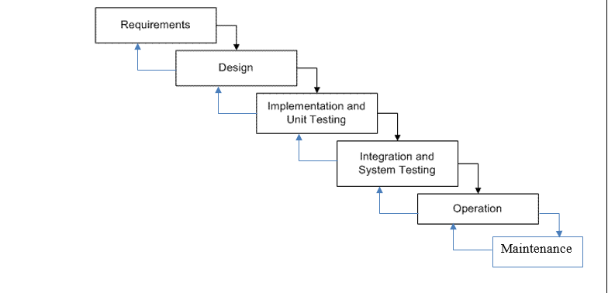

Figure 2 Waterfall SDLC model

## Key activities in each stages of waterfall:

|  |  |
| --- | --- |
| **Phase** | **Key responsibilities** |
| Requirement gathering  And Analysis | * All conceivable prerequisites of the system to be created are caught in this stage and well documented. * Several fact finding method are implemented during this stage to brainstorm about the product to be developed. * Several feasibility study are performed including economical, technical, legal to ensure system development is feasible. |
| Design | * In this phase how system would work to meet to client requirement is designed * Document from first stage is studied and conceptual system is designed using designing tools such as Use case diagram, ER diagram, Dataflow diagram etc. * All designs are documented |
| Implementation and unit testing | * Actual system is built in this stage strictly based on the documentation from design phase. * Unit testing is performed in this stage to ensure product meets the basic codding standard. |
| Integration and system Testing | * Several types of testing is performed in this stage to ensure the system satisfies the requirement of the client. * These tests includes integration, stress, compatibility testing etc. * Test logs are documented * If system does not meets the requirement of the client, system is returned to implementation phase to make the changes * If modification in implementation phase cannot address the issue, upper phase (design) is reviewed and if issue still persist, requirement analysis phase is reviewed * This process is repeated until system meets the requirement |
| Operation | * Developed system is deployed to client or distributed in market |
| Maintenance | * To maintain and enhance to quality of the system, feedback from the client is gathered * Issues faced by end user are addressed * necessary improvement are made |

## Strength and limitations of Waterfall model

Some key strengths and limitations of waterfall model is listed here.

Strengths

* Waterfall is easy to understand and implement
* Development cycle is separated into several key phases
* Each phases are carried out once a time hence project can be maintained easily
* Results of each phases can be well documented
* Schedule can be managed for each phases, hence approx. development time frame can be calculated
* Sequence of the phases are similar to typical SDLC, hence system with good quality can be achieved if requirement phase is well documented.

Limitations

* Adaption to changes in requirement is complex (if not impossible)
* Quality system cannot be achieved if requirement document is not well document
* Only works for small project, the bigger and complex system gets chances of waterfall model failing increases
* As there are no prototype, client have to wait for the finale phase for just trying the product

## Final Evaluation of waterfall model

After studying the features, strength and limitations of waterfall model, it shows there are some scenarios where this model can be successful.

* Project is small and less complex
* Requirement of client is stable, clear
* Development tools and technology is understood and stable
* Resources are well available

## **Agile model**

Full system is divided into smaller blocks of functions in this model. Agile is methodology which consist of incremental iteration. In each iteration one block of work is done. Once one iteration is completed, output is released and another iteration begins. These iterations (cycle) is very short of just one to five weeks. Each iteration involves various teams working simultaneously and includes process like planning, designing, developing and testing.

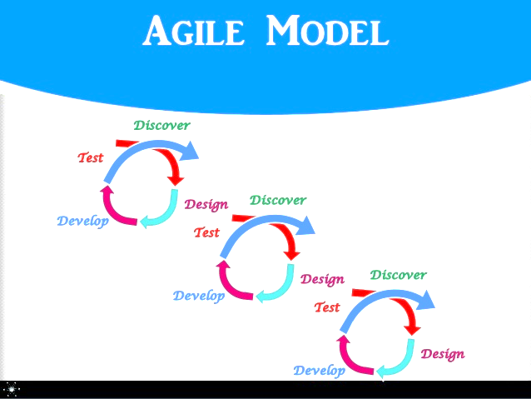

Figure 3 Representation of Agile model

Agile methodology is interaction oriented and flexible framework. It focuses on enhancement during and after product development.

## Key manifesto of agile model:

|  |
| --- |
| **Key Principles (agilemanifesto, N.D.)** |
| * Provide early delivery of quality product * Changes in clients requirement can be accommodate during any stage * Enhanced agility is achieved via technical excellence and design. * Gathering complete requirement at the beginning of system development can be complex job, agile model involves client-developer interaction which helps to get proper requirements * Cross functional teamwork is essential among agile team members * This model requires constant work |

## Strength and limitations of agile model

Some key strengths and limitations of spiral model is listed here.

Strengths

* Customer gets working product in short time
* Developer can address changes in requirement at any stage of development
* High quality system can be achieved
* Customer gets working products frequently

Limitations

* If the features of system in two different cycle are highly dependent releasing product can be complex
* Overall plan and lead is with expertize is required for agile to work
* Heavy customer interaction is required

## Final Evaluation of agile model

To begin the work on real project less planning is required than the typical life cycle. Less requirement details are required as new requirement can be addressed easily in next iteration. Agile model is useful when client is not clear about requirement and there are time/budget constraint.

## **Prototype model**

A prototype is a sample of the product that itself can be a working system. But it has very limited functionality and is not suitable to use as the finale system. Prototype helps to evaluate how the actual system would look like when system development is completed. There are two types of prototypes. There are two types of prototypes, Teach-ICT (N.D.).

1. Throwaway prototypes:

Prototypes are used only for information gathering and discarded later. As the better prototypes are build older prototypes are thrown away.

1. Evolutionary Prototypes:

This types of prototype evolves into real system.

According to IOTAP (2009) in prototype life cycle model, prototype is built, tested and distributed to clients and then modified with help of client’s feedback until acceptable prototype is developed for the actual system. Requirement are gathered via feedback from the user after prototype experience. This model is very popular as user can try the system at very early stage.

Basic requirement identification

Initial Prototype

User Feedback

Refined Prototype

Final Product

Figure 4 Representation of Prototype Model

## 

## Key activities in each stages of prototype model:

|  |  |
| --- | --- |
| **Phase** | **Key responsibilities** |
| Basic requirement identification | * Major requirements are identified * Focus is given to UI * Less focus is given to internal details and other details such as coding structure, security, performance etc. * Main input and output of the system is identified |
| Initial prototype | * Based on the basis requirement analysis, initial prototype is build. * Focuses on UI * System may not have working functions |
| Review the prototype | * In this phase, Initial prototype is distributed to customer * Feedback from the customer is collected |
| Revise/upgrade prototype | * Prototype is reworked in this phase and enhanced version of proto type is built. * This proto type is again given to user for further evaluation * Feedback is collected again and further enhancement is made to the prototype to accommodate user need. * This process repeats until user requirements are satisfied. And final product is built. |

## Strength and limitations of prototype model

Some key strengths and limitations of spiral model is listed here.

Strengths

* This model helps to build good relation between client-developer as constant interaction between these two parties is must
* User can try the system in early stage
* Allows clients to change their requirement, these changes can be accommodated
* Better system can be built at the end due to repetitive enhancement
* Clear requirement is not necessary at the beginning

Limitations

* System scope can get bigger than pre-expected as user-requirement keeps changing.
* Sometimes user mistakes prototype to the actual system.
* Sometimes even if system can be developed with much less effort and time with proper requirement analysis, it takes much more time as prototypes are need to be built

## Final Evaluation of prototype model

Generally, online systems have a high measure of interaction with end clients, are ideally suited for Prototype model. Here are some of the scenarios when implementing prototype model can be successful.

* If user does not have clear requirements
* There is no time and cost constraint

## **Spiral model**

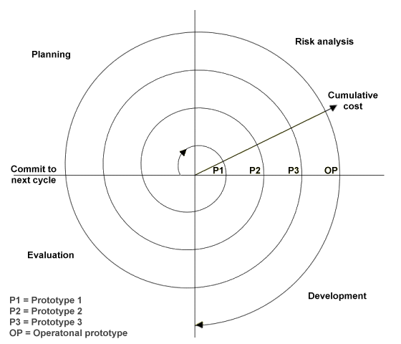According to tutorials point (N.D.) spiral model follows the controlled aspect of waterfall model and have iterative (spinal) characteristics and gives high importance to risk analysis. This model allows modification on system based on the client requirement and also show characterizes of prototype model. A complete cycle of development phase is repeated to achieve incremental improvement/modification of the system. Each output from one iteration becomes prototype for next iteration. This process continues until the final requirement of client is satisfied. There are four phases in spiral model, Planning, Risk Analysis, Engineering and Evaluation.

Figure 5 Spiral Model

(Source: http://www.technologyuk.net/computing/sad/images/spiral_model.gif)

## Key activities in each stages of spiral model:

|  |  |
| --- | --- |
| **Phase** | **Key responsibilities** |
| Planning (Identification) | * Information is studied and gathered with help of fact finding methods * During first iteration business requirements are identified/ studied * As the iteration progresses identification of system requirements, subsystem requirements and unit requirements takes place * All the finding are documented |
| Risk Analysis | * In this phase potential risks are identified by brainstorming the BRS (Business Requirement Specification) and SRS (System Requirement Specification) * After identification of risks, alternative solutions are proposed * risk elimination methods are planned and executed |
| Engineering (Deployment/ Construct or Build) | * System development takes place * Output from this phase is given to customer for evaluation * After each iteration, output from this phase gets near to final product |
| Evaluation | * During this phase client/ user evaluates the system * Feedback from the user is collected * These feedback reports are sent to planning phase of next iteration where these feedbacks are kept in mind while identifying higher level requirements. |

## Strength and limitations of spiral model

Some key strengths and limitations of spiral model is listed here.

Strengths

* Prototype version of system are distributed to clients, system can be used/ tried even before finale product is launched
* Larger project can be managed efficiently
* Change in requirement specifications can be accommodated
* New/improved features can be added to the system
* Effective risk evaluation takes place in this model, that means chances of project failure, exceeding pre-specified budget, time scale is very low
* Gives high importance to user feedback

Limitations

* This model requires larger number of development team member that also consists of risk control experts
* It can be costly and not beneficial for smaller projects.
* Number of iteration can be infinite
* Large number of documentation is required as the number of iteration increases.

## Final Evaluation of spiral model

This document evaluated features, stages, strengths and limitations of spiral life cycle model. Here are some scenario where spiral model can be used.

* Projects with high risk and risk evaluation necessary
* Requirement is not clear/stable
* There is no time constraint
* Newer version of system is required to be released to client

## **Rapid Application Development (RAD)**

Rapid application development life cycle methodology build quick prototype by sacrificing detailed planning. Minimal planning is done and a real functional module is developed parallel with their prototype. By this method application is completed in very short period.

According to Itinfo (N.D.) RAD uses object oriented methodology which helps to reduce the time frame of product development. It has iterative nature and at the end of each iteration new prototype is created.

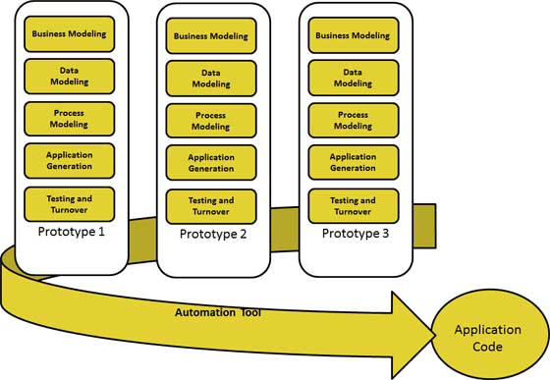

Figure 6 Rapid Application Development

## Key activities in each stages of RAD model:

|  |  |
| --- | --- |
| **Phase** | **Key responsibilities** |
| Business modeling | * In this phase business flow is identified * All other vital business information is gathered |
| Data modelling | * Data objects are defined from the report form business modeling phase * Data sets, attributes and their relations are identified |
| Process modeling | * Data objects from data modeling phase are used to achieve business requirement * CRUD operation (Create, Read, Update, Delete) for data object is defined |
| Application generation | * Automated system is used to convert process model and data model into real application |
| Testing and turnover | * New component are tested * All prototypes are independently tested * Data flow between different components is tested as finale test. |

## Strength and limitations of RAD model

Some key strengths and limitations of RAD model is listed here.

Strengths

* This model reduces the time cost of software development.
* Greater client satisfaction as changes in requirement can be addressed and early prototypes can be distributed to customer.
* High reusability of the system

Limitations

* Expensive model for small project
* Highly skilled/expertized system developer is required.
* Prototype built in each iteration must be reusable

## Final Evaluation of RAD model

RAD methodology can be successful if project can be modularized. Since it requires high level of technical competencies, RAD should only be used if development team has such man power. Before choosing this model budget should also be kept in mind as automated code generating tools are need to be brought.

## **Dynamic system development model (DSDM)**

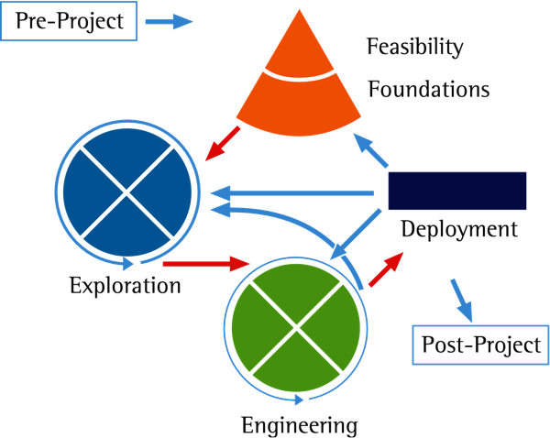Dynamic system development model (DSDM) follows agile approach and was founded to give RAD (Rapid application development model) a proper structure (Gupta [2], N.D.). DSDM involves continuous user involvement and incremental release. In this model, common system development problems such as exceeding time and budget limit and lack of user involvement are addressed. DSDM organizes the project in such way that business need can be achieved within pre specified time and budget allocation.

Figure 7 DSDM Model

* + 1. Principles of DSMD

There are nine essential principle of DSDM. Selectdb (N.D.) warns, these principles cannot be ignored, else pure DSDM model cannot be implemented and project failure risk is increased.

* High and active customer/user involvement
* Frequent delivery of product and their update packs
* Empowering team
* Focus on critical business need.
* Development must be iterative and incremental.
* Changes in requirement must be addressed
* Initial requirement should be kept at higher level as deeper level of requirement can be addressed via releases from iterations.
* Testing should be performed throughout the life cycle
* Must be co-operative approach among team members.

## Key activities in each stages of DSDM model:

|  |  |
| --- | --- |
| **Phase** | **Key responsibilities** |
| **Phase 1: Pre project** | |
| In this initial phase agreements between all parties are done through agreeing term of reference (TOR). Funding and other key components are realized. This phase ensure no complication arises in later stages. | |
| **Phase 2: The Project life Cycle** | |
| **Feasibility Study** | * Key feasibility studies are performed to ensure system is feasible * Criteria for feasibility studies includes technical, legal, economical etc. |
| **Foundation** | * Requirements are identified in high level * Product quality criteria is agreed * Development technology is described |
| **Exploration** | * Detailed requirements are identified via iterative and incremental investigation * Functional solution are designed to demonstrate how system would work and address business requirements |
| **Engineering** | * System is evolved into finale production through iterative and incremental work * Nonfunctional requirements such as security, capacity and performance and addressed |
| **Deployment** | * Product is deployed to client ( or incremental release is made available) * Train the user to operate the system * Provide system documentation, user guides to client |
| **Phase 3: Post Project** | |
| This is the finale phase of DSDM model. This phase is occurred when final deployment of system is completed. In this stage accrued benefits are assessed according to as mentioned in business case. | |

## Strength and limitations of DSDM model

Key strengths and limitations of DSDM model is listed here.

Strengths

* Term of agreement is approved hence complication between client and developer
* Makes sure project is feasible before beginning to work on project
* Quick product delivery
* Constant client involvement
* Iterative and incremental development ensures quality product
* Changes in requirement can be accommodated.

Limitations

* Term of Agreement must me clear to avoid complications in later stages
* Can be costlier as too many analysis, studies are required to be done.

## Final Evaluation of DSDM model

DSDM is an excellent and matured life cycle methodology. It makes sure system is delivered to client within agreed time and within budget. It ensures quality of delivered system is as according to the agreement between all parties.

# Summary

System development life cycle (SDLC) is development framework followed by developer to achieve the system goal and satisfy all requirements. This document explained various types of famous SDLC models. These models included waterfall, agile, spiral, prototyping, RAD and DSDM. Each model has their own advantage and limitation over another model. Each model has their own best suitable scenario. It is analyst’s responsibility to analyze the requirement of system and choose most suitable model to develop the system.

# Task 1 [II]

# Introduction

System investigation is initial studies to evaluate a system’s effectiveness. It is performed to analyze existing system as well as to evaluate scope, problem, audience, requirements and solutions for the new system. It is necessary and important to follow a framework during a system investigation to cover all the aspect of investigation.

Following procedural/ staged life cycle to develop a system ensures quality system is produced and delivered to client within cost and time boundaries. Life cycle is divided into different phases and each phase has its own importance on system investigation. Below in this document, importance of following a procedural life cycle on system investigation process is discussed.

# Phases of staged life cycle

|  |  |
| --- | --- |
| **Phase** | **Responsibilities** |
| Feasibility Study | * Analyst visit the client in order to understand the problem at high level. * Intended audiences are identified * Various constraints such as time, budget etc. are identified. * deficiencies in existing system found * Various alternative solution for the problem is designed * Solutions are analyzed based on feasibility criteria * Feasibility criteria includes: * Technical feasibility * Economical * Schedule * operational * Most suitable solution is proposed |
| **Importance** | |
| This is the first phase of staged life cycle. In this phase, analyst evaluates the system on several criteria. The final outcome of this phase decides weather system is suitable to develop or not.  Feasibility study helps system investigation team to understand viability of the system. If proposed system is economically impossible to develop under pre specified budget, project should not get greenlight. Similarly if system has features that are too complex to develop technically, alternative solution should be considered. Likewise other feasibility criteria helps to ensure complications will not arise during later stages of system development. This helps whole system investigation procedure. Other importance of feasibility study is that it helps to identify the basic problem, problems in existing system and intended audience. Even though it takes some amount of time to conduct feasibility study, looking at its advantages it is safe to say this stage of procedural life cycle is very important for the system investigation. | |
| Analysis | * Analyst identifies client requirement at detailed level * Relevant data are collected through various fact finding method * Functional and non-functional requirements are identified:   Functional requirement defines functions and functionality requirement of the system where as non-functional requirement describes remaining requirements such as quality attributes, judgment criteria etc.   * System requirement specification (SRS) is prepared to systematically manage all the findings and user requirement * SRS is responsible for defining all other components such as time and cost boundaries, evaluation criteria for the system etc. |
| **Importance** | |
| Analysis phase takes place after feasibility report arrives with green signal. Analyst uses various fact fining techniques to identify detailed requirements of client. Both functional and non-functional requirement are analyzed. **Analysis** phase helps system investigation team to understand clear, correct and consistent findings. These findings are prioritized, unambiguous and from creditable source.  After this phase system investigator has clear and detail information about the requirements, criteria for quality judgment, time and cost boundaries etc. One of few drawback of this stage is that it requires experienced and expert manpower to conduct analysis phase effectively. Analysis conducted by non-expert person could backfire the importance of this phase. | |
| Design | * Architectural level design   This is highest level design with no proper functional logic. At this level basic idea of the system to be developed is understood.   * High level design   At this level different module and functionality of system is described in design. It is less abstract version than architectural level. Core system, subsystem and their relation-interactions are described at this level.   * Detailed design   At this level all functions, and how those functions should works are described. Functionally of each subsystem and functions are logically described that can be later implemented into real system. |
| * Uses various system designing tools to design |
| **Importance** | |
| Based on the system requirement specification from analysis phase, system designs are developed to solve the problem. These designs are human readable. Multiple designs are prepared using system designing tools such as data flow diagram, ER diagram, use case diagram etc. Analyst evaluates all the designs and chooses the most suitable design based on system investigation. Design phase is extremely important as output from this includes database design, interface design, physical process model etc. | |
| Implementation | * Design is converted into real system |
| **Importance** | |
| At this phase the whole findings, plans, design from system investigation process is utilized and converted a real system to solve the requirements of the client. This part is most important phase as this is where design prepared during designing phase is produced. | |
| Testing | * Several testing methodologies and techniques are implemented to test the system. * White box test and black box test are done |
| **Importance** | |
| This phase ensures system is as per coding standard and system is built bug and error free. If any issues is noted, it is documented. After this phase system is returned to implementation phase is there is critical issue found. If issue is small and negligible product is released to client for further feedback. This phase ensures user gets bug/error free system. Though it requires time/cost and effort to conduct testing phase successfully, it helps to develop efficient system. | |
| Review | * Functional and non-functional performance of the system is reviewed * Testing logs, feedback from clients are analyzed |
| **Importance** | |
| This is the last stage of procedural/staged life cycle. Here system is reviewed if system satisfies the requirement standard set during feasibility and analyzing stage. This phase reviews if designs prepared during system investigations is able to meet the client requirement or not. Review phase is very important as positive review result of the system means successful system investigation. | |

# Summary

This document discussed the importance of following a framework, procedural/staged life cycle. Discussion shows each stages while following staged life cycle has its own importance on system investigation. For example, first phase which is feasibility study determines if the project is suitable according to limited time/cash limits or other criteria. Similarly, analysis phase helps system investigation process the gather functional and nonfunctional requirements at detailed level.

Discussion shows following procedural life cycle requires expert leader, time, cost and effort to follow successfully. But it largely reduces risk of project failure. Additionally, it saves time, cost and effort to perform system investigation in long run. It is important to follow procedural life cycle and it helps to perform successful system investigation and develop a feasible system that can satisfy both user and system requirements.

# Task 2 [I]

# Feasibility study components

Feasibility study evaluates a project on various criteria such as legal, financial, operational, social etc. to understand the viability of the project. Hofstrand, D. and Holz-Clause, M. (N.D.) suggests, it is study that analyzes the possible negative or positive outcome of the project before investing time and money. For example if a game Development Company wants to develop a game, they need to conduct feasibility study in order to determine whether to begin the project. Feasibility study team analyses who would buy it, will there be any legal issue, is it technically possible to develop such game, what system would support this game, can this game cover the investment made and so on. If the outcome from the analysis is positive, project gets green signal otherwise alternative solutions are suggested.

Stakeholders should able to read the outcome from the feasibility study. Hence, all the findings and analysis during feasibility study is required to be well documented. To achieve this, FSR (feasibility study report) is prepared. FSR has different components that helps to manage and document the feasibility study. Each components of feasibility study are discussed below here.

1. **Introduction**
   1. Purpose
   2. Methodologies
   3. Background/History
2. **Document Structure**
   1. Intended Audience
3. **Feasibility Criteria**
4. **Outcome**
   1. Possible Alternative Solutions
   2. Evaluation Criteria
   3. Feasible Solution
5. **Conclusion and Recommendation**

# Introduction

This component gives basic overview of the project. Project background is provided here. Fact finding methodologies while collecting information are mentioned here as well as reference materials used during feasibility study is also listed here. It has some subsections such as purpose, background, methodologies etc. Number of these subsections varies based on the project.

## Purpose

This section describes the reasons to carry out feasibility study on that particular project. This is very important section as this gives reader the idea of what is the report all about. What would be outcome of report and how that FSR would help on project initiation.

* + 1. Methodologies

Methodologies used during feasibility study are described here. Examples of such methodologies are interviews, observation, cost/ benefit analysis, questionnaire etc.

* + 1. Background/History

Project background is described in this section.

# Document structure

## Intended Audience

All the primary as well as secondary audiences are described here.

# Feasibility criteria

All collected information are analyzed here based on various feasibility criteria. Again number of feasibility criteria considered during feasibility study may vary based on the nature of project. Such feasibility criteria includes:

1. Economic feasibility

Economic feasibility study on most of the cases is most important feasibility criteria considered by organization. Here cost required to develop and the project and available budget is analyzed. In addition, financial benefits from the project is analyzed. Cost/ benefit analysis is done to perform this study. If the predicted outcome from the project in future much less than investment made, it can have negative impact on organization’s economy.

1. Technical feasibility

This criteria evaluates whether if technology required to complete such project is available. It also analyzes if technical man power to develop or complete the project can be arranged else less technically complicated alternative solution is proposed.

1. Legal feasibility

This is another criteria to evaluate the feasibility of the project to be developed. Here legal issues that can arise later during implementation or deployment phase is analyzed. It is made sure that organization has all the necessary legal papers, agreement papers etc. to avoid possible conflicts.

1. Operational feasibility

This criteria analyzes the system based on how the new project would fit with existing environment. It identifies the usability of the new system by its client. Sometimes even though system can address the business problem, implementation of such system can cause difficulty in daily life of organization.

1. Social feasibility

Social feasibility study evaluates the acceptance of the new project within the society. Term society can be referred as direct or indirect stakeholders such as clients, customers, employee, managers and directors etc. If the project is not taken well by its stakeholders, chances of its failure is much higher. Hence such issues need to be addressed before initializing the project development.

1. Schedule feasibility

Within this study criteria, rough calculation on project completion timeframe is calculated. Outcome from the prediction is compared with the predetermined schedule constraint. If estimated time to complete the project is larger than the actual allocated time, it shows project is not feasible. Schedule feasibility study also perform study on whether allocated timeline is suitable itself for such types of projects. If the allocated time is very low for any project or not suitable of such projects, this report recommends to reconsider the time allocation.

# Outcome

## Possible alternative solutions

Possible alternative solution(s) is/are listed and described in this section. Features, benefits, costs of all these alternative solution must be well described. This component helps the reader to understand possible alternative ways to solve the problem.

## Evaluation criteria

This section takes place when there is more than one possible solution and most viable system is needed to be recommended.

In this sections evaluation criteria is identified and used to judge the suitability of each alternative solution. Various feasibility criteria is considered while making the judgments. Preset constraints are considered such as cost constraints, organizational policies, available technologies etc. Feasible solution

## Feasible solution

After each alternatives are critically analyzed based on evaluation criteria the most viable solution among all the alternative is proposed as most feasible solution. This is actual outcome of the FSR. If this section fails to identify any feasible solution project cannot get positive signal for investment.

# Conclusion and Recommendation

In this section recommendation and conclusion based on the study performed is provided. If the project has single solution, outcome of the report is recommendation of whether project is feasible to initialize or not. But if there are multiple alternative solutions available, most feasible solution is recommended based on the study performed.

# Summary

This document discussed various components of feasibility study report. Each component of report has their own role to play and has individual importance. A good feasibility report helps the user understand the purpose of document, methodologies used for research, critical used for making judgment and finale conclusion that if proposed system is feasible or not.

# Task 2 [II]

# Introduction

The purpose of this report is to perform and access the impact of different feasibility criteria on system investigation of **Academic Portal** for **Phoenix College.** Phoenix College, an educational institution is currently facing various issues while working with existing system. Hence requirement of a system is decided. But before investing money and time on new system, viability of system is required to be analyzed.Several fact finding techniques are used to gather required information. These information later used for feasibility study on several key evaluation criteria.

# Purpose

* Access the impact of economic feasibility on system investigation
* Access the impact of technical feasibility
* Access the impact of legal feasibility
* Access the impact of schedule feasibility
* Access the impact of organizational feasibility
* Access the impact of social

# Applied Fact Finding Methods

Fact finding techniques are applied to find and gather information by system analyst to perform a system study. This process (fact-finding) is one of the key step during system investigation. According to Shah (2008) success of the study depends on the availability of accurate data. While gathering information, analyst interacts with several stakeholders of the project to identify information such as requirements, scope, constraints etc. According to Shah (2008) success of the study depends on the availability of accurate data. To gather such accurate information several methods can be applied such as interview, observation, record view, group focus etc. Techniques applied during feasibility study of academic portal for Phoenix College are listed below here.

## Interview

Basically, interview is fact finding method in which series of questions is asked to participant and their answers are noted as information. Interview can be conducted individually or in group. Before the conduction an interview, meeting with participant is fixed and questions to be asked during interview are prepare that can help to collect the required information.

To gather information that can help to analyze feasibility of the “Academic Portal” and access the impacts of feasibility criteria, several interviews are conducted. Participant in these interview includes head of department of different department of Phoenix College. Some of the questions asked during interview are listed here. How information of students, teachers, departments, exam etc. are maintained currently

1. What are the main problem the existing system is producing
2. How students are informed about exam, library books, assignments etc.
3. How students submit their assignment
4. How students and teachers teacher interact with each other during off-college time
5. How students share their ideas, old paper.

Answers during interview is noted in a report and further analyzed to find accurate information.

## Questionnaires

Similar to interview, in questionnaire set of questions is listed in paper and distributed among related stakeholders. Their responses are further evaluated to gather accurate information. Questionnaire generally has objective questions.

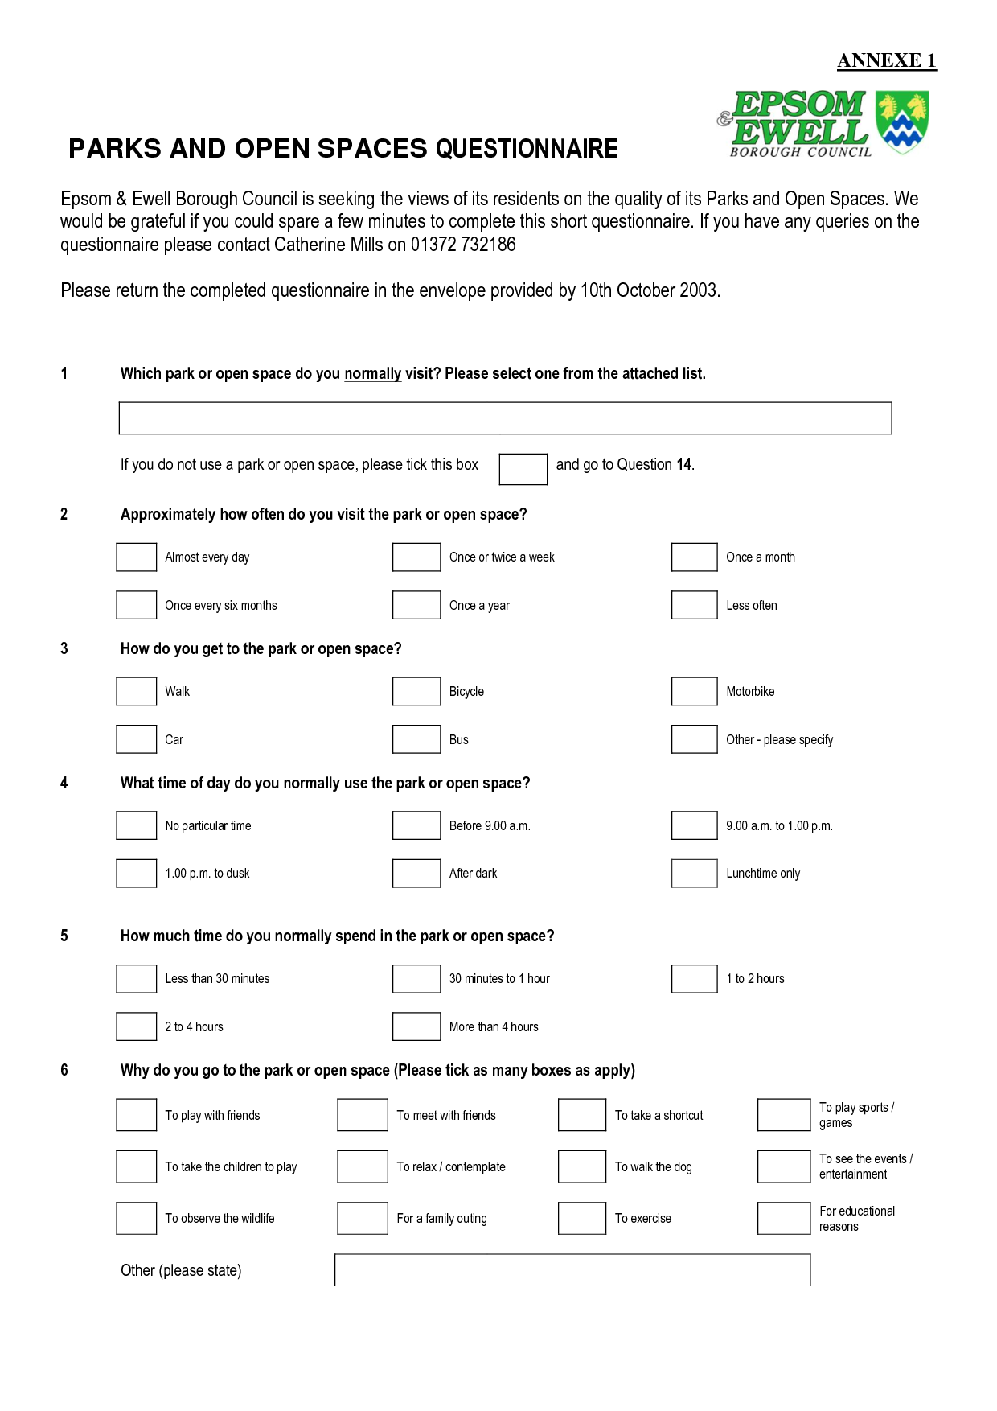

Figure Example of Questionnaire

During information gathering for Academic portal, questionnaires were distributed among stake holders such as teachers, students, staffs etc. Some the questions from questionnaire are listed here.

1. Rate the existing information system in the range 0-10
2. What environment you prefer for new system
   1. Web
   2. Mobile
3. What operating system you use
   1. Windows 8 or later
   2. Windows 7 or older
   3. Linux
   4. Mac
4. Tick the features you want in new system
   1. Online exam
   2. Online library
   3. Blogs
   4. Data/file sharing
   5. Personal profile
   6. Online notification
   7. Online assignment submission
   8. Online discussion
   9. Other [mention here]……………….
5. Is the current system secure
   1. Yes
   2. No
   3. Don’t know
6. How often you go online
   1. Daily
   2. Once a week
   3. Rarely
   4. Never
7. Do you like to share/discuss your ideas with other students/ teachers
   1. Yes
   2. No
8. How you get college notice
   1. Via friends
   2. Via notice board
   3. Via college website
   4. Via SMS
   5. Via phone call

## Observation and Document checking

In this type of fact finding method analyst visits project location and observe work flow, documents, reports, bills, work environments etc. to gather related information. Some of the observation done during fact finding for Academic portal is listed here.

1. Student Register
2. Notice Board
3. Library book keeping
4. Assignment Department

## Observe Sheet

|  |  |  |
| --- | --- | --- |
| S.N. | Observe object | What was observed |
| 1. | Student Register | How student are managed in class |
| 2. | Notice Board | How notice is published to student, staffs and teachers |
| 3. | Library book keeping | How students check the status of books |
| 4. | Assignment Department | How assignment is distributed, managed |

## Group Focus/ Workshop

Group focus is another popular fact finding technique where group of selected individuals discussed over a particular topic to gather information. Group focus takes place in comfortable environment where all participant engage in dynamic discussion. All members share their knowledge, experience on the topic. Generally group focus emphases on gathering information as much as possible from its participating members than going into conclusion.

With help of this technique, more information is gathered for the academic portal project. Some the group focus session involved group of teachers, group students and group of department head.

# Fact finding summary

After analyzing the collected information from fact finding process, following are the finding that are useful for system feasibility study.

|  |  |
| --- | --- |
| **Finding** | **Description** |
| Predicted Budget | NRs. 200,000 |
| Predicted Time | 6 Months |
| Organizational Constraints | * Only member from phoenix should able to use the portal * Only admin should able to create new user * Only teacher should able to upload assignment * All members should have access to FAQ pages |
| User Requirements | * Authentication * File Share/download * Assignment Upload/Submission * Discussion/ Blog * Private Messaging * Notification * FAQ |
| * Most of the student/teachers uses Microsoft OS platform | |

# Accessing Impact of Feasibility criteria

Feasibility study is performed to understand the viability of system under different criteria. Each criteria has their own importance on the system investigation. Impact of different criteria on system investigation is accessed below in this report.

## Economic feasibility

***Estimated Expenses (High Level Prediction)***

* Analysis and Design and implementations : NRs. 110,000
* Quality Assurance/check : NRs. 40,000
* Web publishing : NRs. 20,000
* Maintenance : NRs. 10,000 :Total (**NRs. 180,000**)

Above is the very high level cost prediction for the project based on the information gathered from fact finding. This prediction (**NRs. 180,000**) shows the system is economically feasible as the cost constraint is NRs. 200,000.

Impact

The main purpose of this criteria is to ensure that the system can be developed within pre-specified cost hence complications will not arise during later phase of system development. If system does not able to finish within cost constraint, it can cause large loss of both money and time to organization.

For example,

Let’s say here is a scenario where feasibility study was not carried based on economic criteria and project was given green light. Capacity of organization to invest on the project was only 1 million and now as time passed by, total cost invested on system is already 98 percent of investment capacity but only 60 percent of system is completed. Here is situation where complication is arise as system cannot be developed within budget limit now by any mean hence either organization need to forget the project which would cause loss of 1 million or they need to take loan from bank or other party to finish the project. This example shows how feasibility study makes impact on system investigation. It gives direct recommendation if the system can be given go ahead signal or alternative solution need to be identified. If alternative solutions are already there, most feasible solution is advised.

For the current project, system is economically feasible to start the work based on company budget.

## Technical feasibility

***High level Technical Requirement for development phase (Estimation)***

|  |  |
| --- | --- |
| Component | Availability in the market |
| High configuration computer for design, coding and testing | YES |
| PHP or ASP.net platform | YES |
| MySQL or SQL SERVER or Oracle Database | YES |
| Web publishing | YES |

***High level technical requirement for user (Estimation)***

|  |  |
| --- | --- |
| Component | Availability |
| Computer with windows 7 or later | YES |
| Internet Connection | YES |

All technical components required during development phase of the system is easily available in the market. In addition to this, intended user of the system (teachers, students, and administrator) has required technical component to use the system.

Impact

Technical feasibility takes place to study if system is technically feasible for both development and later deployment phase. Technical components required for the system should be available in market/ organization for the development phase (Mukund, n.d.). Additionally, affordability of the technology must be considered. Similarly, user must have technical requirements to use the system. It is analyst’s responsibility to analyze if system to be developed is technically suitable for targeted client. If proper study in not done prior to starting the project and user cannot use the system once it’s developed, this can cause huge financial loss to organization.

Current project is technically feasible for both development and use phases. Student, teacher and all intended users of system would be able to use this system within their technical limitations.

## Legal Feasibility

|  |  |
| --- | --- |
| Component | Availability |
| Legal document of organization | YES (Registered Organization) |
| Contract document for the project | YES (signed if project gets green light) |
| Web Application criteria is legal in country | YES |

Information gathered during observation and interview session shows all the required legal document is available.

Impact

Legal feasibility study is done to ensure all the legal procedure are completed before starting the project to avoid unnecessary complications (Katimuneetorn, n.d.). For example, if there is some issue between client and developed, contract paper can help to solve the issue. Additionally, if system is developed and law of that country forbid such system, it cause loss of both time and money. Hence it is must to carry out legal feasibility during feasibility study. For the current project, organization have all the required documents and such system is legal in country. Hence system is legally feasible.

## Social Feasibility

Most of the student and teachers own computer. Information technology is well accepted in the targeted society. Gathered information shows most of the student has social network and spends time on internet. Group focus on team of guardians shows they are familiar with use of internet and has no problem with it for academic use.

Impact

According to NNA (n.d.) feasibility study on social criteria is performed to study social acceptance of the system/project. If study is not carried out properly and then system is not accepted by society it can cause failure of the system. A project must be accepted by society if it is to be successful. It is must to consider the acceptances of system/project by the group which is directly affected by proposed system.

## Schedule Feasibility

***Schedule Prediction (High Level)***

* Analysis and Design: 1 Month(s)
* Implementation: 2.5 Month(s)
* Testing and Quality Check/Assurance: 1 Month (s)
* Deployment and Maintenance: 1 Month(s)

Total: **5.5 Month(s)**

Above is the high level prediction of schedule for the project. Project development phase is divided into smaller phase to estimate the timeframe. Schedule constraint identified after fact finding is six months and estimated time for the project completion is five and half months.

Impact

Completing a project within pre-specified deadline is huge responsibility. Feasibility study compares allocated time for the system development with the predicted time. It analyze weather given time is enough for the system development (Bowen, 2013). If given time is not enough for the project, study report recommends to look for alternative solution or drop the project. This helps to avoid unnecessary problem that can arise when project does not finish in time.

Study shows current project is feasible based on schedule criteria meaning project can complete within. Phoenix College can start using system within estimated time which helps to satisfy related stakeholders.

## Organizational constraints Feasibility

|  |  |
| --- | --- |
| Constraint | Can constraint be addressed in system? |
| Only member from phoenix should able to use the portal | Yes |
| Only admin should able to allow new user | Yes |
| Only teacher should able to upload assignment | Yes |

Every organization has their own organizational constraints that everyone must follow. During fact finding some of the organizational constraints from Phoenix College was identified. All constrains can be addressed during system design phase.

Impact

Organizational constraints has important role to play during system investigation. System is planned based on how organization works and organizational policy. For example, Phoenix college has set constraint that only college member should able to access the system it means designed system must contain authentication process. This helps to maintain security of information of college and its members. Similarly, all other constraints must be considered while designing the system. If some constraints cannot be satisfied, it should be reported in feasibility study report. Further discussion should be done with higher authority of organization for final decision.

# Conclusion and Recommendation

This document accessed impact of various feasibility criteria. Information gathered from fact finding process was analyzed to identify the constraints to be considered. Based on these constraints, feasibility criteria and their impact on system investigation is accessed. According to Exforsys (2006) if all criteria is not analyzed properly, it can have negative impact on system and can cause project failure. After successfully accessing the impact of each criteria and performing feasibility study it is recommended to proceed to later phases of system investigation. Academic portal is feasible based on economic, technical, legal, social and organizational feasibility criteria.

# Task 3 [I]

# Introduction

Phoenix College is Kathmandu valley based international multi-stream educational organization that provides international undergraduate degree on various subjects such as hotel management, business and information technology. Phoenix has more than five hundred students and more than fifty faculty members including teachers and staffs. This college is managed via various departments such as exam, human resource, account, administration, marketing etc. Phoenix plans to develop an online system named “Academic Portal” that can resolve various issues they are facing from existing system.

# Purpose

1. To identify and specify features and issues in existing system
2. To plan and design new system that can maintain college record online
3. To identify the requirements specification to design new system
4. To identify, specify and implement constraints such as cost, time, hardware-software platform etc. while designing the system

# Existing System

Phoenix is currently managing academic records in traditional system such as paper document and Microsoft excel. Each department has trained staff that can manage documents.

## Features

1. Information about student of each class/faculty/batch is managed in separate document.
2. Documents are password protected and only authorized person can access them.
3. Backup can be taken manually.
4. Students are notified via notice board.
5. Students need to submit their assignment on hard copy.

## Issues in Existing System

1. Documents cannot be accessed via internet
2. If user forgets password, there is no password recovery mechanism
3. Has no features that students/teachers can take advantage directly by accessing it
4. If computer that has documents has problem, daily work of college can affect
5. Backup need to take manually
6. No managed relational database system

For a college of international stature having a traditional system and not having online system that can provide various facilities to their teachers and student can hinder their image.

# Stakeholders

## Students

Students are direct stakeholder for the new system. New system will help student to improve their academic performance. They would have direct access to academic notes, discussion threads and professors.

## Teachers

Teachers shall use the system for starting discussion, sharing notes, helping students and giving assignments. They can receive assignment response via same system.

## Departments

Major departments of Phoenix College can use the new system for interaction with student and teacher. They can also use the system for managing academic records. Notices about exam, fees etc. can be sent to all user via online portal.

# Constraints

## Cost

* Maximum of NRs. 200,000 is allocated by Phoenix College for new system.

## Time

* Maximum of 6 month is granted for planning, designing and developing the system.

## Organizational Constraints

* Privacy is very important, one member should not able to access private stuff of another member
* Admin should able to create, delete , modify

## Hardware Platform and software

**Client Side Platform**

* Any system that can run windows 7 or later should support the new system

## Legacy System

* Phoenix College does not expects just an upgrade from existing traditional system, they want to develop new online system with features mentioned above.

## User Interface

* System User interface must be accessible
* User interface must include suitable image and alternative text
* User interface should be interactive

## Scope

The new system will be a web application (online system) for Phoenix College. This system will provide new features for intended users and help to eliminate issues in existing system. User will be able to access this system via internet with computer that satisfies minimum requirement. Propose system is designed after critical feasibility study and would have following features:

1. System would manage information regarding students, faculty members etc.
2. Administrative user would be able to create, edit, delete groups, forums, departments, courses, users etc.
3. All teachers, students will have individual user name and password
4. Teachers would be able to start discussion and invite other teachers, students
5. Students would be able to share new thread, join discussion/forum ( after approval of discussion/forum’s owner)
6. Students would be able to start private messaging with teachers, students
7. Student would be able to share files with individual or group
8. Student would be able to submit assignment online
9. Students/Teachers would be able to start blog
10. User would be able to conduct survey
11. Administrative user would be able to send notice to students/user via email and SMS

# Requirements Specification

## Cost Requirement

|  |  |  |  |  |
| --- | --- | --- | --- | --- |
| **S.N.** | **Task** | **Work Force Rate (NRS)** | **Total Hour Required** | **Sub Total (NRS)** |
| 1. | Analysis | 5,00 Per Hour | 30 | 15,000 |
| 2. | Planning | 500 P/Hr. | 30 | 15,000 |
| 3. | Design | 500 P/ Hr. | 40 | 20,000 |
| 4. | Implementation | 400 P/ Hr. | 150 | 60,000 |
| 5. | Quality Assurance/Check | 1000 P/ Hr. | 35 | 35,000 |
| 6. | Web Hosting | 10,000 | - | 10,000 |
| 7. | Web Server Space | 10,000 | - | 10,000 |
| 8. | Maintenance | 10,000 | - | 10,000 |
| 8. | Training | 5,000 | - | 10,000 |
| **Total (NRS)** | | | | **185,000/-** |

## Schedule Requirement

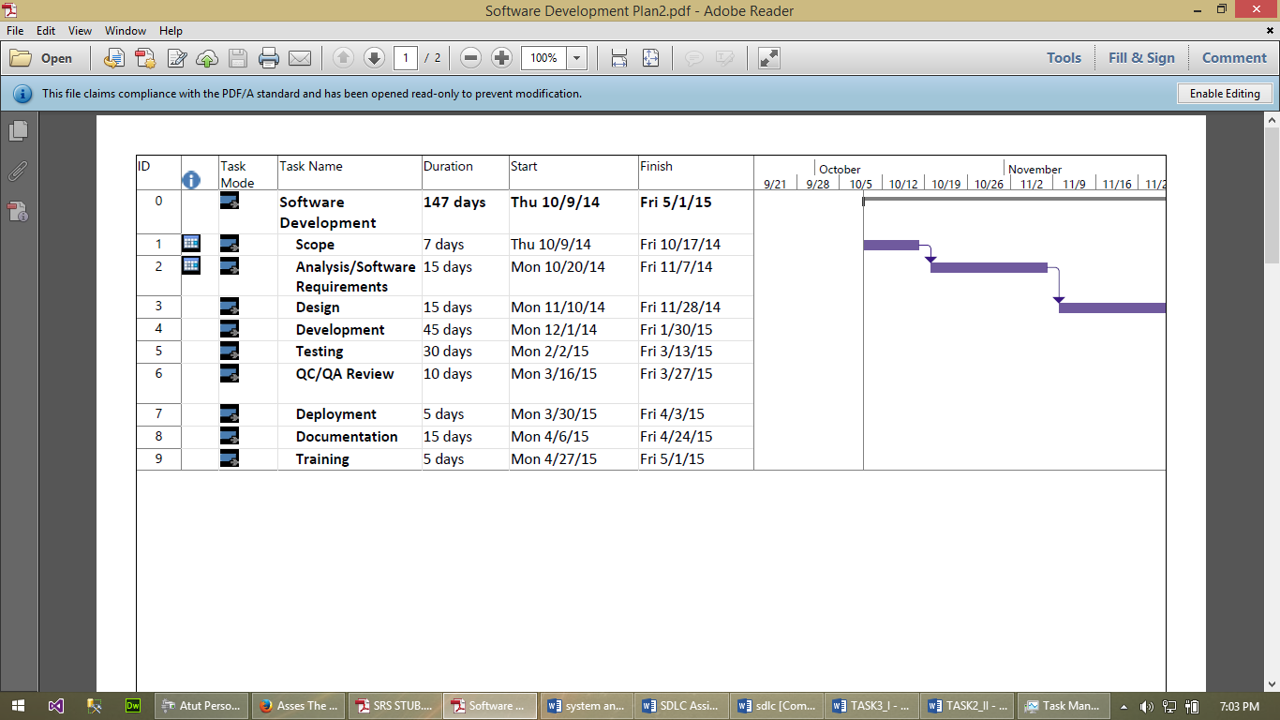

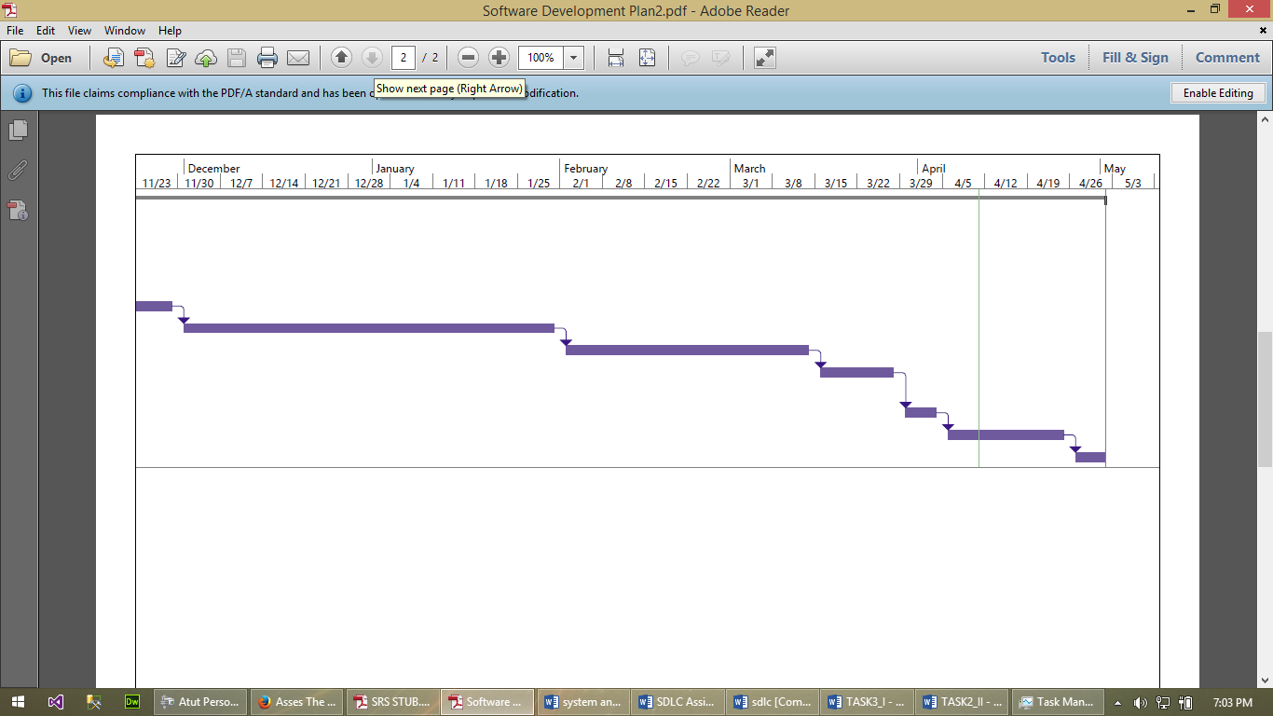

## Hardware / Software Requirement

Hardware Speciation

**Developer Side**

1. RAM - 4GB
2. Processor - Intel I5
3. Hard Disk - 320 GB

**Client Side**

Any computer (laptop/desktop) that supports windows supports windows 7 or later and able to browse through internet smoothly.

Software Specification

Developer / Client Side

1. Operating System - Windows 7 or later
2. Applications-
3. Microsoft SQL server 2008 or later (For database system) ***(Developer computer)***
4. Visual Studio 10 or later (For UI)***(Developer computer)***
5. Updated Browser that supports HTML5 and JavaScript
   1. User Interface

User interface would be designed with HTML and CSS using Visual studio tool. Forms would be properly validated and for user interactivity there will be suitable use of JavaScript, menus, jQuery, bootstrap etc.

## Functional Requirements

## Authorization

|  |  |
| --- | --- |
| **Description** | This feature would allow user to enter main page of the system. Only users with valid credential will be able to use the system. |
| **Input** | Credentials (username, password) provided to user by college administration |
| **Output** | User will land into corresponding page based on input data |
| **Process** | If username and password matches information in database user page will redirect to home/profile page of that user |
| **Alternation Process** | If username and password does not match, page will redirect to invalid login page with error message where user can try another login or user password retrieval process |
| **Condition** | When user first browse into the application user must not be logged in and when user closes the browsed he/she is auto logged out from the system |

## Content Sharing

|  |  |
| --- | --- |
| **Description** | User can share different type of files such as pdf, multimedia, Photoshop etc. |
| **Input** | Files to be shared, groups and individual with whom files are to be shared |
| **Output** | Files would be uploaded to online portal and other users will able access them |
| **Process** | User chooses individual, groups to share the file and shares file using ‘share section’, uploaded file will be saved on database and only owner or user with administrative right will be able to modify/delete them. |
| **Condition** | * User must be logged in * File must be of less than 25 MB |

## Blogging

|  |  |
| --- | --- |
| **Description** | User can create new blog and other user can give comment |
| **Input** | Subject, content, forum where blog are to be created |
| **Output** | New blog is created in specified forum with given subject and content |
| **Process** | Logged in user goes to blog section, then choose appropriate forum and give subject and content and specify the group for the blog |
| **Condition** | User can only create blog on forum on which they are allowed to by administrator |

## Discussion Panel

|  |  |
| --- | --- |
| **Description** | User will be able to start new discussion with teachers and students |
| **Input** | Subject, Content |
| **Output** | New discussion will be created on which other user can give their view |
| **Process** | Logged in user set subject and give content through submission form |
| **Condition** | User must be logged in |

## Private Messaging

|  |  |
| --- | --- |
| **Description** | User will able to start private messaging with another user |
| **Input** | ID of another user, messaging content |
| **Output** | Targeted user will get private message and notification and sender will receive sent successful message. |
| **Process** | User goes to New Message section then specify the recipient’s ID and message content |
| **Alternative Process** | User goes to recipient’s profile and choose send private message option. Then sends content though submission form. |
| **Condition** | * Sender must be logged * Private message must be allowed by recipient user in her/his profile setting |

## Notification

|  |  |
| --- | --- |
| **Description** | User receive notification about exam, fees, assignments, holidays |
| **Input** | Notification from administrator, teachers, private message |
| **Output** | User receives notification in their profile and also through email and SMS |
| **Process** | User gets notification when admin/professors share a notice or private message is received. |
| **Condition** | * “Receive Notification” is allowed in user setting * To receive SMS notification User must be subscribed to “SMS Notification” through User Setting |

## Assignment

|  |  |
| --- | --- |
| **Description** | Professor User will be able to give assignment to their student through online portal. |
| **Input** | Assignment topic, Questions, group of student to whom assignment is targeted, deadline |
| **Output** | Students will receive notification about assignment |
| **Process** | Logged in professor/teacher goes to assignment section and select new assignment. Then user sets the group, deadline and submit assignment details through submission assignment. |
| **Condition** | * User must be logged in as administrative/professor user * User must select target group and deadline |

## Assignment Submission

|  |  |
| --- | --- |
| **Description** | User will be able to submit assignment through online portal. |
| **Input** | Assignment Presentation, Report, document |
| **Output** | User will receive successful submission notification. |
| **Process** | Logged in user goes to assignment section and select assignment. User submits assignment file through submission form. |
| **Condition** | * User must be logged in * User can only submit assignment of Units they are allowed by administrator/Professor |

## Search Functionality

|  |  |
| --- | --- |
| **Description** | User will be able to search other user, group, blogs etc. through search box |
| **Input** | Search keyword |
| **Output** | Corresponding page with search result |
| **Process** | Logged in user types keyword in search box and press search button or enter key to get the result |
| **Condition** | * User must be logged in * Only public contents can be found in search result |

## Administrative Management

|  |  |
| --- | --- |
| **Description** | Administrator can create/delete and modify new user/group/contents |
| **Input** | Information of new user, group, forum |
| **Output** | New user, group, forum is created |
| **Process** | Administrator login to system using administrative credential and use manage section where he/she create/modify/delete groups, users etc. |
| **Condition** | * User must be logged in as administrator * To create new user/group, there cannot be existing user/group with same name * If a blog, discussion, survey is deleted or modified owner user will get notification |

## FAQ (Frequently Asked Questions) page

|  |  |
| --- | --- |
| **Description** | Any user will get answer of frequently asked questions from this section |
| **Input** | Keyword for the question, Select FAQ page |
| **Output** | FAQ page |
| **Process** | Logged in user selects FAQ section of the system |
| **Alternative Process** | Logged in user types question’s keyword in search section |
| **Condition** | * User must be logged in |

## Non-Functional Requirements

## Security

* Username and password will be stored in database in encryption form
* SQL injection prevention method must be implemented
* If someone tries to login using wrong password for 5 times continuously, account will be locked and user will get SMS notification
* IP of each logged in user would be stored in database

## Availability

Users should be able to access the system anytime. System will be web hosted using highly reliable hosting service provider. During the maintenance session users will get alternative page when they browse the system.

## Performance

High number of user should be able to use the system at once. College has total of 500 students hence at least 250 user should be use the system/ submit assignment at once.

## Disaster Recovery

Backup of the system and database will be take automatically by web hosting provider. Web hosting service provider would create disaster recovery copy of system and database of separate server which can be downloaded when service provider system crashes.

# Conclusion

This document investigated new system “Academic Portal” for Phoenix College. For this features and issues of existing system was studied. Proposed academic portal is planned and designed considering the constraints set by college. This new system would be able to eliminate the problem faced by current system and satisfy all the identified requirement. This document ensures online portal will satisfy both functional as well as non-functions requirements and work as reference document for system design phase.

# Task 3 [II]

# Tools and Techniques of system design

Development of new system or modification of existing system becomes easier when work of different components within system is described through various tools and techniques. These tools and techniques helps to understand flow of data within system, work process, process and entity relation etc. System investigation of Academic portal for Phoenix College is carried out in this document using several tools and techniques.

# Use case diagram

Use case diagram is graphical representation of how user interacts with different element of system. Use case diagram of a system consists use case for different type of users. For example, use case diagram of authentication phase for registered and non-registered user can be different. It helps see through user’s perspective and design user friendly system. Use case for different interface of Academic portal is design below here.

## User Authorization

This use case describes, all registered users will login though login page. This login page will also have recover password feature if user forget their password or username. Additionally, administrator will be able to create and manage user for the system once they successfully logged in.

## Professor Assignment Upload

Successfully logged in professor user will have access to feature that allows upload and manage assignment and assign them to group of students. For this they will access assignment upload via dashboard. Involved group of student will get notification that they are assigned a new assignment.

## Student Assignment Submission

Logged in Students will able to submit their assignment submission. After submission teacher will get notification as well as student will get confirmation notice.

## Discussion Thread

Any logged in user will able to create new discussion via dashboard. While logged in administrator will have authority to moderate discussions. Additionally, other users will get notifications and will be able to post comment.

## File Sharing/Download

This use case shows logged in student/teacher will be able to share and download file via dashboard where they will have access to file share feature.

## Private Messaging

This use case shows logged in uses will be able to start new private messaging via dashboard. Furthermore, users will be able to reply message to received private message.

## Notification System

This use case shows logged in users will receive notification about assignment, discussion, file share etc. Users will also get SMS and Email notification optionally (Only if user has allowed).

## Common pages browsing

Logged users will be able to browse through other common feature pages of the portal.

# ER Diagram

ER diagram (Entity Relation) diagram is graphical representation of relation between different entities of the system. ER diagram consists of entities, their relations, attributes and attributes of relation. This techniques helps to design database for the system as conversion of ER model to real database system can easily be accomplished.

ER for academic portal consists of entities such as members, class, users, assignment submission, assignment upload, discussion, blog etc. and their relation. Database created from this ER will be able to satisfy database requirement of the system.ER diagram for Academic portal is designed in next page below.

## ER diagram Design

# Context Diagram

Context diagram is graphical representation of overall system at very high level. Context diagram describes top level process of the system and entities within the system. This system helps to understand the scope of the system.

Context diagram of Academic portal consists top level process (Academic Portal) and external entities that represents various scopes of proposed system. It shows how different scopes of system works together at very high level. External entities involved in context diagram a students, teachers, administrators, database, exam department and academic department.

Figure Context Diagram

# Dataflow diagram

Data flow diagram helps to understand how data flows with in system in terms of inputs and outputs. It can be understood as detailed version of context diagram and contains multiple processes. It shows where data goes and from where it comes, how data is stored etc. This tools helps to plan core architecture of system. For academic portal, data flow diagram for each proposed features are designed in next page below.

## Dataflow Diagram Design

# Conclusion

In this document system investigation for academic portal is done though help of various system analysis tools such as context diagram, use case diagram, dataflow diagram and ER diagram. Each tool and technique helps to investigate different aspect of the system. For example, designed use case diagram investigates how user would interact with various interfaces of the system. Whereas, ER diagram investigates how different objects within system relate with another object, thus helping to design database system for academic portal. Context diagram represents different scopes of the portal. And designed DFD (dataflow diagram) represents how data flows within the portal. Hence, complete system investigation is performed with use of appropriate tools and techniques.

# Task 3 [III]

# Background

Phoenix College is an educational institution based on Kathmandu valley. They are currently using traditional system to manage information of around five hundred students and more than fifty staffs. But traditional system does not satisfies the requirements of college, hence administration as decided to develop a new system.

Academic Portal is an online system proposed for Phoenix College to overcome problem they are facing from existing problem. This system will provide additional features to students and professor that will help to manage information as well as improve status of college. This document will serve as support document for the system investigation and provide investigation overview to its reader.

# Problem Statement

Following are the major scope of proposed system:

1. Academic portal would manage information regarding students, faculty members etc.
2. Administrator will create, edit, delete groups, forums, departments, courses, users etc.
3. Users (Admin/Student/Teachers) will login to system using username/password from any computer that satisfies minimum requirement
4. Users have feature that allows to start discussion and invite other user
5. User can start private messaging with any other user (recipient user must allow private message)
6. User can share files with individual or group
7. Student user would have facility to submit assignment online
8. Students/Teachers would be able to start blog
9. Users would be able to conduct survey
10. User will get notification via email and SMS

# Meanings, Abbreviations and Acronyms

* + 1. Academic Portal

Academic portal refers to new proposed (designed system) for phoenix college that eliminates issues in existing system and helps teachers, students with new features such as online sharing, blogging, assignment submission, notification, messaging etc.

* + 1. System

System refers to new online portal named “Academic Portal”.

* + 1. Administrative Users

User with authorities to create and modify groups, provide assignment, send notifications etc. There can be multiple type of administrative users such as academic, exam, account etc.

* + 1. Users

The primary users of this system would be students. Faculty members would use this system to get notices, take part in discussion and share documents with other user.

# Data Collection Methodologies

## Interview

Head of department from Exam department, account department and HR department were interviewed to collect the information. Interview involved questions regarding how current system is maintain the information, notice system, assignment submission system, future requirement, problems etc.

## Questionnaires

Questionnaires is another data collection method applied during data finding process and worked effectively. Collection of question regarding current system, requirement, satisfaction etc. were distributed among student and teacher. Collected data were further analyzed to identify the required information.

## Observation and Document checking

Existing system, exam and assignment department and student attendance register was observed to gather necessary information.

## Group Focus/ Workshop

Several group focus session was conducted involving separate groups of staffs, students, HODs etc. Key points during session was noted for further evaluation.

# Findings

|  |  |  |  |
| --- | --- | --- | --- |
| **S.N.** | | **Finding** | **Description** |
| **Constraints** | | | |
| 1. | Cost Constraint | | Fact finding from interview session helped to understand the maximum budget is Nrs.200,000 |
| 2. | Schedule Constraint | | Finding shows maximum timescale allowed for system development is six months. This period includes time allocation for analyzing and planning phase. |
| 3. | Platform Constraint | | Finding shows most of the students/teachers uses computer with windows 7 or later and has moderate system specification. Hence minimum requirement of the system is new system must computer with windows 7 or later. |
| 4. | Legal Documents | | Fact finding process shows collect has all required legal documents including contract document. |
| 6. | Feasibility of the system | | Analysis of the collected information and evaluation of feasibility criteria shows proposed system is feasible to begin development phase. |
| **User Requirements** | | | |
| 1 | Authentication | | There should be authentication mechanism that only member from Phoenix college would be able to access the portal |
| 2 | File Share/download | | User should be able to share files and download shared files |
| 3 | Assignment Upload/Submission | | There should be Feature that allow teachers to upload assignments and student to submit assignment |
| 4 | Discussion | | There should be feature that allow members to create and maintain discussion thread |
| 5 | Blog | | There should be blog mechanism for members |
| 6 | Private Messaging | | Private messaging feature should be available for members |
| 7 | Notification | | There should be mechanism for notification |
| 8 | FAQ page | | All member should be able to access FAQ page for help. |

Table Fact Findings

# Evaluation of how requirement has be addressed

|  |  |  |
| --- | --- | --- |
| **S.N.** | **Requirement** | **Evaluation** |
| 1 | Authentication | Academic portal is designed to have authentication mechanism, only registered users can access the system using right combination of username and password. For new user, he/she will have to demand authentication credentials from student department. |
| 2 | File Share/download | Academic portal has designated system for file sharing where user can upload and share files with individual user or a group. Additionally, other user who has access to shared files can download them to their local storage. |
| 3 | Assignment Upload/Submission | Academic portal has feature that allows users to upload and submit assignment. |
| 4 | Discussion | Logged in user will have access to discussion feature that allows to create and maintain discussion while other users can make comment on the post. |
| 5 | Blog | Like discussion academic portal has blog feature that allows user to write blogs. |
| 6 | Private Messaging | Academic portal has private messaging feature that enables users to send message to individuals or group privately. |
| 7 | Notification | All users of academic portal will get notification on various events such as getting message, assignment, comment on post etc. |
| 8 | FAQ page | Academic portal has dedicated FAQ page for every member who can browse the page to clear their confusion regarding various portal related questions. |

Table Requirements and how system satisfies the requirements

# Conclusion and Recommendations

Proposed system is based identified constraints and requirements. Table 2 above evaluates how various features of proposed system is able to satisfy the all the requirements. Requirements are identified after analyzing information collected using different fact finding methods. It is recommended to proceed to implementation phase of system based on system investigation performed for academic portal.

# Task 3 [II] Feedback Response

# ER Diagram working mechanism evaluation

ER Diagram for academic portal consists of several entities represented as rectangle. Each entities has their attributes and represented with oval. And finally relation between entities also known as relationship are represented with rhombus shape. All the member of Phoenix College is represented by member entity. Members are categorized into two categories named student and teachers. Both types of member shares some common attributes like name, age, MID, address, image, email but also has individual attributes like teachers has experience and qualification attributes. All users, teachers, students have member id as an attributes. User of the system is represented by user entity and has attributes like member id, user id, password, and recovery email. User entity has relation with user type entity named “of type”. Similarly User has relation with other entities such as forum, member and faculty named “manages”.

File Entity has attributes of File id, name, owner and upload date. User has relationship with file entity named “share” which means user can share files. Similarly, there are entities like blog, comment, assignments and class which has relation with user entity. At last notification entity has attributes of notification id, type and time and has relationship with user entity named “receives” which means user can receive notification and also has relationship with notification type. ER diagram of the academic portal has represented all required entities, their attributes and their relation with other entities. This system investigation can be used to develop relationship database management system for the portal.

# Context Diagram working mechanism evaluation

The purpose of the context diagram is to define system boundaries. In context diagram, system is represented by circle, external entities are represented by rectangle and data flow is represented by arrow. In the context diagram of the academic portal has system called academic portal represented by a circle. There are several external entities and are linked to the system. Student external entity is linked with the system and send request such as creating blog, discussion, comments, messaging, search etc. which is represented in dotted box.

Similarly, teacher external entity can send request to the system regarding blogs, assignments, discussions, surveys etc. Another external entity named administrator can send requests to system and manage users, forums, discussions, groups, faculties, class etc. Exam and account department external entities sends notices to the system. And at last database external entities stores information and files. This context diagram of academic portal helps to understand the working of the whole system at highest level.

# Dataflow Diagram working mechanism evaluation

Level 0 and Level 1 data flow diagrams (DFD) are drawn for academic portal. In level 0 DFD, external entities like student and teachers sends request to the system and receives response. Data store is linked with system to store system information.

In level 1 Data Flow Diagram there are several sub processes like user management, login system, class management etc. In Authorization process 1.0, registered members tries to login using credentials. System retrieve login information from login data store. System allows login success to members with valid credentials. In Assignment management system 4.0, teacher members upload files and system store them in uploaded assignment data store.

Similarly, using same system, students upload submission for the system and then system stores the files into assignment submission data store. User can create and maintain discussion and comments using discussion system 5.0 and comment system 6.0 respectively. Each system stores their data in the respective data stores. In Files management system 7.0, user can upload and download file. System stores the uploaded files into the file data store. And at last administrative users can create and maintain faculties and classes using faculty management system 8.0 and class management system 9.0 respectively. System stores their data in respective data stores. This DFD drawn for academic portal clearly demonstrates core process and sub processes in the system and external entities. It illustrates how data is to be flowed in the system. This DFD provides lower level structure of the system.