HG

ACTION = { move camp, hunt, foraging}

ACTION constraints
{
δ time expenditure: distrib(θ1)
1 agent / δ time quantums
reward : distrib(θ2)
succes/fail considered inside reward distribution

}

//-----------------------------------------------------
Move Camp

Decission
{
Assert : When you arrive to your new home after moving, we consider you have
perfect knowledge of the new home range since the first second.
Rationale: from the limits of your home range you can catch details far away in
the next cell.
}

Cost = 1 day.
Reward = 0.
Score for decission = richness of cell / income.
//-----------------------------------------------------
Home Range

Sector space splitting. HG will explore the home range in sectors. The center is the settlement.
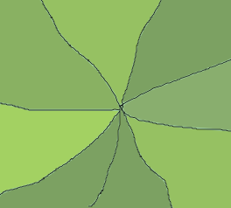
A sector could be see as a drifting to promising resources. The same on the choice of moving settlement. HG move with a directionality following the promising sector.

//-----------------------------------------------------
Hunter

Cost = 3 days. Distrib?

6 days hunting? Sequence of 2 hunting senssions = 3+3?

hunting session = (go, scan, hunt, return home);
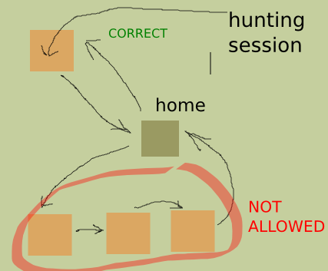

10km x 10km home range

//-----------------------------------------------------
Gather

Cost = 1 day. Distrib?
//-----------------------------------------------------
Season

# days?
# huntins/season?
# gather/season?
//-----------------------------------------------------
Working resources

the couple + children
children account as extra help on gathering/hunting : sum factor.

Estimate children factor from data?

couple_factor is aprox adult_factor*2
f_reward = couple_factor + children_factor*#children

linear regression?

