The concept of modelling is widely extended. It comes from the natural observation of the world and the curiosity or need to reproduce it.

Compt Modelling + Complx Syst Simul
→ advances : geology, life sciences, bioinformatics, geoinformatics, health informatics, etc.
→ Social Sciences : growing
initial problems : qualitative/discursive sciences with some quantitative and statistical_support : number, statistics: mean, stddev, distrib shape,... no
more.
Models from Math,CompScience: formal languages, math models, …
Perception of difficult modeling from SocSc point of view. ABMs+Complex systems
experience, AI expirience ve a salvar-los
For this reason, agent-based simulation allows the implementation of experiments and studies that would not be viable otherwise \cite{Pavon2008}.

\section{Why model}

Modelling will be our framework for communication between archeologists' and sociologists' knowledge and their conceptualizations with our formal representations from computer science practices ( simulation, algorithms, AI ).

%què és modelar?
Identify separable entities, processes, relationships (rellevant information to the question to solve).
Introspection exercise : domain of discourse → conceptualizations → formal representation
mainly :
mathematical expressions : arithmetics, calculus, algebra, logic.
Knowledge representation.
→ conceptual modelling.
Sound and Complete (if it is possible)
→ right down all the details ( the relevants, anything left out will change the outcome )
→ coherence,consistency of the parts
→ unambiguity

Simplification
  - relevant
    - complete according to the phenomena that inspires the question
    - anything left out will change the outcome
    - not relevant added items will produce noise
  - useful
  - justifiable (scientifycally, statistically,... ?)

Indeed just thinking about something implies an unconscious projection of our mental frame hence producing a set of concepts and relationships that give birth to a model. The only is the it was not made explicit through some formal representation.
As Epstein \cite{Epstein2008} says \textit{“Anyone who ventures a projection, or imagines how a social dynamic—an epidemic, war, or migration—would unfold is running some model”}

LifeCycle of Model development :
afegir : monotonicity? anything added cannot generate incoherence, so, do not add the new part or delete the old one that produces so ( and it could be considered update or revision ).

Pidd Boxes : no sé com posar-ho...

%el model com a eina de treball en grups multidisciplinars

SocSc : NatLang : {ambig, less structured } due to the systems.
Vocabulary interconnection
rigor is needed → formalization : process of translation to a formal,rigorous framework
Knowledge 1, Knowledge 2,Knowledge 3... Framework 1, Framework 2, Framework 3
Translate to a same metalanguage → there, under the same Framework we can find more easily
the connections to make it work together.

modelling will be a process that helps to find a consensus for expressing the concepts and properties,
helps to ellicite knowledge, arrange ambiguities.
When a interdiscpl team shares their capabilities to circle a problem communication issues will arise.
Modelling shall be an exercise of shared development that can approach positions.
Social Sciences is

%com cal modelar
correct simplification
  - boundaries
  - answer question

example

%simplicity
These practices should lead to a preference for simple models
1.- Occam
2.- simplicity : smaller models, less complexity, easier error detection, less items to justify(so less criticable)

%ATMsimple vs complex

complexity:
credibility(harder)
verification
validation
justification(harder)
Justify, Validate, Verify each one
analysis & conclusions get harder to extract
criticability
objective/subjctive modelling decisions
experts' point of view
why them and not the others you left out?

As Robinson \cite{Robinson2008} states simple models have many advantages,
such as they are faster,
require less data,
are more flexible
and, more importantly, if we better understand them we can better interpret their results.

Davies \cite{Davies2003} states one should be carefull to simplify certain natural processes
since it presumes certain assumptions about how they work so one could miss some important facet to explain it.

At this point how do we construct the model?
Top-down?
Bottom-up?
Consider a set of subsystems
explore them enable/disable pressence
add increasing complexity subsystems : eg. Agent Policy

KISS Lemma

%George Box
Although good modelling of the parts could be accomplished lefting out the non-relevant phenomena, quoting George Box, the model will be wrong, what matters is whether it will be useful for us or not.\\
------------------------------------------------------------------
Modelling in Social Sciences :
plan:
society/social sc descrip,
modelling targets/items,
possible paradigms
functional modelling : bank loan f (cash, degrees, job, socio-cultural level) → yes/no)
dyn.syst,
particles,
... ABM),
non covered issues that motivate ABM,
bridge to ABM section
society/social sc descrip
“A human ecosystem is a complex adaptive system involving people, other living entities, an environment, information exchange and the co-evolution of all of these things over time. “
from “Complex Science for a Complex World; Exploring Human Ecosystems with Agents”
Edited by Pascal Perez and David Batten. August 2006
modelling targets/items
Society consists of a set of interacting entities. The entities are either people or activity units. The life of an individual is a trajectory of participation and value in a structure of social activity units. The history of a social activity unit is a population flow of individual trajectories characterised by population participation and value parameters. In pursuit of value, populations of individuals flow through the structure, selectively participating and differentially performing. Ordinary living involves a participation of people in the social activities of family, leisure and holidays, shopping, work and travel. Activity within a unit is structured by relationships and choices, rules, rituals and randomness. Ordinary living also involves the participation of cultural ideas and artefacts in social activities.

Coleman (1964, pp. 9–53), in his opening chapter identifies five uses of mathematics in sociology:
descriptive statements of observed behaviour
???mathematical techniques for arriving at ‘disposition’ properties
quantitative empirical generalisations
use of mathematics in theory construction
prediction models

The social sciences seek to understand not only how individuals behave but also how the interaction of many individuals leads to large-scale outcomes. Understanding a political or economic system requires more than an understanding of the individuals that comprise the system. It also requires understanding how the individuals interact with each other, and how the results can be more than the sum of the parts.
Identify
explica les coses de manera que la ciencia va identificar els individuus sobre els que va començar a construir abstraccions que son eñ nivell on perceben dinàmiques q després volen modelar. ABM permet desfer el camí i tornar al principi : els individuus. Això et donarà punts per introduir els ABM.
actors : groups, entities/persons
relationships
2-ary, 3-ary...
creation, destruction, params
transitivity and other properties
networks
cooperation / competition / … coordination & cooperation(distinguish them)
agents need to know about “the other” : other's model
mind model
(a) Strategic beliefs (in the sense of strategic rationality), which consist
of individuals’ mental states produced by, and taking into account, the
mental states of other, possibly interfering, agents.
(b) Group beliefs and intentions (Gilbert 1987, 1989; Tuomela 1991,
1992), which consist of the sharing of similar beliefs and intentions by an aggregate of agents. Social thinkers have been debating what exactly
should be meant by “we-ness” and “we-intentions”, and where precisely the core of groups and teams resides, without reaching any satisfactory agreement.
environment
spacial issues
economy
actions – interaction - perception
over environment
over other agents

do not project, allow phenomena appear in a fair play procedure ( avoid muppet model ?)

take into account complex systems phenomena
emergence
chaotic processes

and all these items could be seen from the economic, demographic, cultural, spatial point of
view(Growing...Epstein).

possible paradigms : functional modelling : bank loan f (cash, degrees, job, socio-cultural level) → yes/no) ,dyn.syst, particles,... ABM),
math to physics = comput. sci. to soc. Sci.
math more spread in econometrics.
Pro's of simulation vs maths ( Taber & Timpone 1996)
+programming languages are more expressive, less abstract than most mathematical techniques.
+programs deal more easily with parallel processes and processes without a well-
defined order of actions ( respect math equations)
+programs are studied by Soft Engineering
modularity, extendibility...
discipline focused on combine programs to huge program systems
we can manage great amounts of piece of programs:
error detection
maintenance ( modularity, piece update,...)
+ will see further : heterogenicity

aimed at variables, correlations; model is an statistical equation/structure
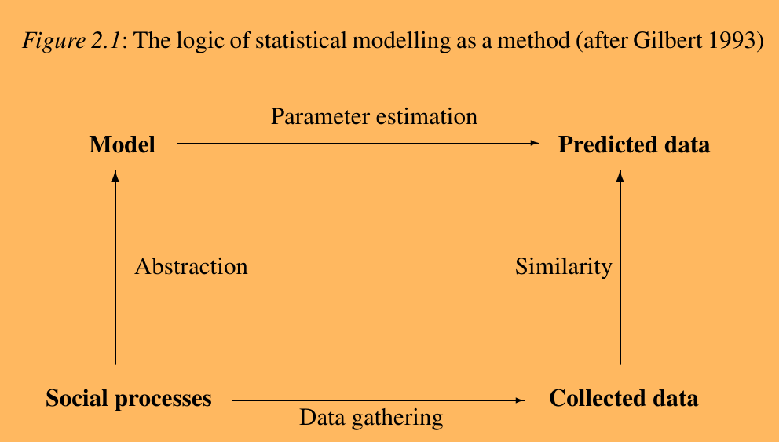

In the social sciences, the target is always a dynamic entity, changing
over time and reacting to its environment. It has both structure and be-
haviour. This means that the model must also be dynamic. With complex
models, especially if the specification is nonlinear, such analytical
reasoning can be very difficult or impossible. In these cases, simulation
is often the only way. As it was explained on the chapters above.

aimed at processes. Explanatory model → predictions; model is an algorithm/program
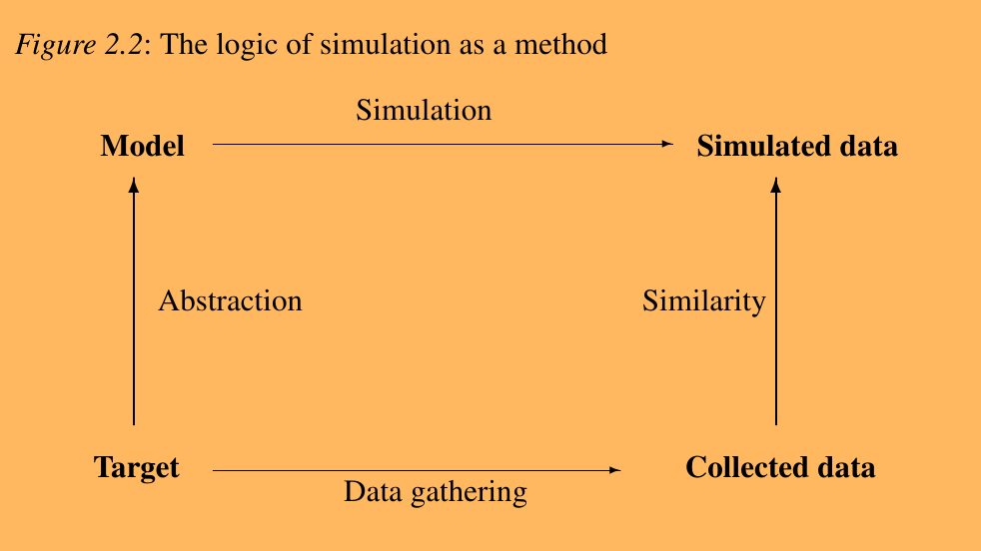

Table 1.1: A comparison of social science simulation techniques
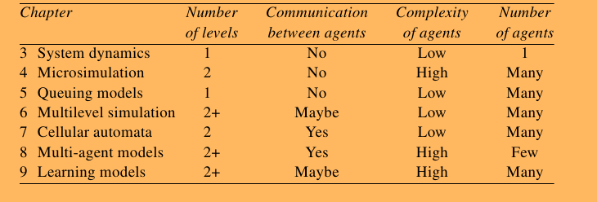

The stages of simulation-based research
definition of the target
purpose/question
prediction/prognosis
diagnosis
theory validation / discovering
study future possible worlds
observations : get parameters and initial conditions
assumptions
design model
computer programming
verification
run simulation
gather results
validation
sensivity analisys
non covered issues that motivate ABM
Another issue has to do with the very nature of the systems one is modeling with ABM in the social sciences: they most often involve human agents, with potentially irrational behavior, subjective choices, and complex psychology—in other words, soft factors, difficult to quantify, calibrate, and sometimes justify.
Co-operation and conflict:
Such a simple dichotomy is fallacious. The fine-grained modelling of sociality allowed by the study of artificial society could greatly enhance our capacity to account for the complexity of interaction.
(a) there are many forms of co-operation and conflict, as well as many forms of altruistic
and selfish, desirable and undesirable social action;
(b) the alternatives are not clear-cut: there are forms of apparently cooperative action that
may be regarded as being conflictual. Social exchange, for example, although
notionally a form of co-operation, may give rise to manipulation and produce
inequality;
(c) many concrete examples of sociality are neither advantageous nor harmful to co-
operation. For example, conversation is itself neither intrinsically conflictual nor co-
operative. Furthermore, many abstract categories of social action are neither pro- nor
anti-social. Consider, for example, communication, which may be either co-operative
or aggressive; and influence and persuasion, which may be either selfish or altruistic;
and
(d) a social action may be governed by a complex hierarchy of goals so that a given
action’s lower-level goals may differ from the higher-level ones. A pro-social action
may be included in an anti-social plan and vice versa. Deception may be used for
helping, and co-operation for cheating.

“rational choice theory” ( we want to use/reflect in the individuals )
bridge to ABM section

“A human ecosystem is a complex adaptive system involving people, other living entities, an environment, information exchange and the co-evolution of all of these things over time. “
from “Complex Science for a Complex World; Exploring Human Ecosystems with Agents”
Edited by Pascal Perez and David Batten. August 2006

book of Conflict, Social Maths...:

Mathematical Sociology
Society consists of a set of interacting entities. The entities are either people or activity units. The life of an individual is a trajectory of participation and value in a structure of social activity units. The history of a social activity unit is a population flow of individual trajectories characterised by population participation and value parameters. In pursuit of value, populations of individuals flow through the structure, selectively participating and differentially performing. Ordinary living involves a participation of people in the social activities of family, leisure and holidays, shopping, work and travel. Activity within a unit is structured by relationships and choices, rules, rituals and randomness. Ordinary living also involves the participation of cultural ideas and artefacts in social activities. Trajectories of value are exemplified in the religious conversions of William Wilberforce and in the common patterns identified in cultural stories. Population flows of participation and performance are illustrated using an educational case study.

Coleman (1964, pp. 9–53), in his opening chapter identifies five uses of mathematics in sociology:
descriptive statements of observed behaviour
mathematical techniques for arriving at ‘disposition’ properties
quantitative empirical generalisations
use of mathematics in theory construction
prediction models

The social sciences seek to understand not only how individuals behave but also how the interaction of many individuals leads to large-scale outcomes. Understanding a political or economic system requires more than an understanding of the individuals that comprise the system. It also requires understanding how the individuals interact with each other, and how the results can be more than the sum of the parts.
Another issue has to do with the very nature of the systems one is modeling with ABM in the social sciences: they most often involve human agents, with potentially irrational behavior, subjective choices, and complex psychology—in other words, soft factors, difficult to quantify, calibrate, and sometimes justify.

Identify
explica les coses de manera que la ciencia va identificar els individuus sobre els que va començar a construir abstraccions que son eñ nivell on perceben dinàmiques q després volen modelar. ABM permet desfer el camí i tornar al principi : els individuus. Això et donarà punts per introduir els ABM.
actors : groups, entities/persons
relationships
2-ary, 3-ary...
creation, destruction, params
transitivity and other properties
networks
cooperation / competition / … coordination & cooperation(distinguish them)
agents need to know about “the other” : other's model
mind model
(a) Strategic beliefs (in the sense of strategic rationality), which consist of
individuals’ mental states produced by, and taking into account, the
mental states of other, possibly interfering, agents.
(b) Group beliefs and intentions (Gilbert 1987, 1989; Tuomela 1991,
1992), which consist of the sharing of similar beliefs and intentions by an aggregate of agents.
Social thinkers have been debating what exactly should be meant by “we- ness” and “we-intentions”, and where precisely the core of groups and teams resides, without reaching any satisfactory agreement.
environment
spacial issues
economy
actions – interaction - perception
over environment
over other agents

do not project, allow phenomena appear in a fair play procedure ( avoid muppet model ?)

take into account complex systems phenomena
emergence
chaotic processes

and all these items could be seen from the economic, demographic, cultural, spatial point of
view(Growing...Epstein).

Book “Artificial Societies” Gilbert et al.

Descriptive vs Prescriptive
new societies
exploratory simulation

Notwithstanding the importance of its theoretical contributions, the study of society has
always been plagued with some crucial methodological and empirical difficulties. For
example, social theorists often fail to provide sufficiently specific models, categories of
analysis and conceptual instruments for the exploration of social reality. As a result, a
wide gap continues to exist between empirical research and theorizing.

Nowadays, sociologists have all but abandoned the creation of large, comprehensive theories. However, many also seem to have relinquished ambitions to engage in any form of modelling of social reality.
Dissatisfied with the poor predictive or explanatory power of theories of action, sociologists have taken refuge in claiming that social reality cannot be described scientifically because it is construed by and only accessible through the minds of heterogeneous agents.

Social simulation studies provide an opportunity to fill the gap between empirical
research and theoretical work, while avoiding the individualist tendency of most
mathematically-based approaches. In particular, social simulation provides not only a
methodology for testing hypotheses, but also an observatory of social processes.

Co-operation and conflict:
Such a simple dichotomy is fallacious. The fine-grained modelling of sociality allowed by the study of artificial society could greatly enhance our capacity to account for the complexity of interaction.
(a) there are many forms of co-operation and conflict, as well as many forms of altruistic
and selfish, desirable and undesirable social action;
(b) the alternatives are not clear-cut: there are forms of apparently cooperative action that
may be regarded as being conflictual. Social exchange, for example, although
notionally a form of co-operation, may give rise to manipulation and produce
inequality;
(c) many concrete examples of sociality are neither advantageous nor harmful to co-
operation. For example, conversation is itself neither intrinsically conflictual nor co-
operative. Furthermore, many abstract categories of social action are neither pro- nor
anti-social. Consider, for example, communication, which may be either co-operative
or aggressive; and influence and persuasion, which may be either selfish or altruistic;
and
(d) a social action may be governed by a complex hierarchy of goals so that a given
action’s lower-level goals may differ from the higher-level ones. A pro-social action
may be included in an anti-social plan and vice versa. Deception may be used for
helping, and co-operation for cheating.

Self-sufficient agents and social interference
interference
pre-interaction existing structures ( present in nuce)

Book “Simulation for social scientists” Gilbert
from example of choosing a mate (pg15)
theory(of behaviour, of...)(in textual form) → specification of procedures
→ computer program → launch statistical experiments

math to physics = comput. sci. to soc. sci.

math more spread in econometrics.
Pro's of simulation vs maths ( Taber & Timpone 1996)
+programming languages are more expressive, less abstract than most mathematical techniques.
+programs deal more easily with parallel processes and processes without a well-defined order of actions ( respect math equations)
+programs are studied by Soft Engineering
modularity, extendibility...
discipline focused on combine programs to huge program systems
we can manage great amounts of piece of programs:
error detection
maintenance ( modularity, piece update,...)
+ will see further : heterogenicity

complex system

Table 1.1: A comparison of social science simulation techniques

pg28! “In the social sciences, the target is always a dynamic entity, changing...” per aqui treuràs coses per al capítol

posar el gràfic de pg29 en endevant, per que això és el q cal fer desde el Social Modelling...

pg31 : The stages of simulation-based research
definition of the target
purpose/question
prediction/prognosis
diagnosis
theory validation / discovering
study future possible worlds
observations : get parameters and initial conditions
assumptions
design model
correct and relevant simplifications
computer programming
verification
run simulation
gather results
validation
sensivity analisys

pg32 : designing a model
simplification
how many data do I have?
Few data, abstract/simple model → understand target system
more data, accurate model → prediction

At the heart of research on artificial societies is the goal of finding
theories that apply not just to human societies but to societies of interacting
agents generally.

verif&valid pg35
simulation : stochastic execution → difficult to verif/valid, every run is different.
use test cases : result known a priori, easy predictable.
Validation via statistical matching : distribution, etc...
Initial conditions & Assumptions sensivity : butterfly effect

error : where it comes from? Model? Gathered data?

sensivity analysis pg37
rate of change of output vs rate of change of input parameters and assumption.
Test robustness
test adaptability of the actors
high sensivity could be a symptom of bad particular values used in the simulation
test parameters, chosen by your own intuition the most relevant

too abstract model → hard to connect results & conclusions with target system.
tot el capitol 2 es interessant

leads to concepts?

Person : agent, particle
People : gas model, fluid model, mass statistics, group modelling, dynamic systems...

relationships

leads to ABM

++++++++++++++++++++++++++++++
ABM

Definit/Description
ABM is a modeling methodology that relys on a application engineering architecture called Multi Agent Systems from A.I.

Seguint el paradigma d'ABM, els systemes a modelar es descomposen en entitats anomenades agents per als que es defineix el seu comportament en un entorn, com interactua amb aquest i amb els altres agents. L'activitat principal dels agents és la presa de decisions. Cada agent individualment avalua l'estat actual de l'entorn, tenint en compte els altres agents, i d'acord amb els seus objectius realitza una acció que executarà contra el sistema ( entorn + agents que puguin estar implicats).
El sistema s'executa en un bucle constant d'avaluacions, decissions i accions dels agents que l'habiten.
This will lead to situations of iterated interactions between a set of agents in a framework of cooperation, coordination or competition. Although simple agents in such an interaction environment can make emerge many complex patterns and be a good model of real world systems, the methodology considers also features like mind models, authomatic learning or evolution and natural selection in agents endowing the agents with enhanced adaptation.
(Eric Bonabeau. “Agent-based modeling: Methods and techniques for simulating human systems
”, PNAS May 14, 2002 vol. 99).

1. J. H. Miller and S. E. Page, Complex Adaptive Systems: An Introduction
to Computational Models of Social Life (Princeton Studies in Complexity).
(Princeton University Press, March 2007). ISBN 0691127026.
6. J. Epstein and R. Axtell, Growing Artificial Societies. Social Science from
the Bottom Up. (MIT Press, 1996).
11. J. M. Epstein, Generative Social Science: Studies in Agent-Based Compu-
tational Modeling. Princeton Studies in Complexity, (Princeton University
Press, January 2007). ISBN 0691125473.
Benefits of ABM ( possible subsection)
(ref. PNAS.org)
There are some striking features that make ABM stand out from other paradigms or approaches. ABM copes with the simple and bottom constituents of social science implicated in the modelization of a system, hence it can sometimes allow to describe a system naturally. It is not easy to develop an agent, but you are working with a metaphor with a structure and concepts that we have at hand everyday. So it is more manageable, natural to express things with that “language”. Also, it is more flexible in the modelization. And to finish enumeration, ABM captures emergent phenomena. ABM follows the arise of emergence from its definition, following the bottom-up generation of phenomena from the atomic constituents when the system is run.
ABM is most indicated for describing and simulating a system composed of “behavioral” entities. Whether one is attempting to describe a traffic jam, the stock market, voters, or how an organization works, ABM makes the model seem closer to reality. For example, it is more natural to describe how a party of hunters move in a terrain and circle their preys than to come up with the equations that govern the dynamics of the density of hunters. Because the density equations result from the behavior of hunters, the ABM approach will also enable the user to study aggregate properties.

Pregunta al Xavi sobre això:
classical : social system → conceptualizations → person, people → abstractions (groups, social dynamics,...) → model the abstractions.
ABM : social system → conceptualizations → person, people → model the people.
Classical : you need an extra step of inferited knowledge a priori

It is advisable, because it can be more natural, to use ABM through the constituent units' activities under the next conditions.

- The behavior of individuals cannot be clearly defined through aggregate transition rates.
- Individual behavior is complex. Everything can be done with equations, in principle, but the complexity of differential equations increases exponentially as the complexity of behavior increases. Describing complex individual behavior with equations becomes intractable.
- Activities are a more natural way of describing the system than processes.
- Validation and calibration of the model through expert judgment is crucial. ABM is often the most appropriate way of describing what is actually happening in the real world, and the experts can easily “connect” to the model and have a feeling of “ownership”.
- Stochasticity applies to the agents' behavior. With ABM, sources of randomness are applied to the right places as opposed to a noise term added more or less arbitrarily to an aggregate equation.

Besides naturality in expressing models, ABM can manage agents at different levels of aggregation. The decission units can be a person but also social entities like families, couples or tribes with their own rules for intearaction and behaviour. You can tune your model easily moving between different layers of abstraction from social sciences. ABM works with models where decission-making and aggregation is clearly separated. The range of complexity of the agent, its behavior, degree of rationality, ability to learn and evolve, and rules of interactions can be tuned more independently of the range of complexity of the aggregation, individualality, and groups.( explica-ho mes)
A last characteristic feature of agent computing, although not often noted, is that once a
model has been created it provides not merely one aspect of the solution — the equilibria, say, or
the stability — but rather entire solution trajectories.[Axtell2000]
ABM issues
[Axtell2000]%%TODO desplagia
However, the agent-based modeling methodology has one significant disadvantage vis-a-
vis mathematical modeling. Despite the fact that each run of such a model yields is a sufficiency
theorem, a single run does not provide any information on the robustness of such theorems. That
is, given that agent model A yields result R, how much change in A is necessary in order for R to
no longer obtain? In mathematical economics such questions are often formally resolvable via
inspection, simple differentiation, the implicit function theorem, comparative statics, and so on.
The only way to treat this problem in agent computing is through multiple runs, systematically
varying initial conditions or parameters in order to assess the robustness of results. While the
curse of dimensionality places a practical upper bound on the size of the parameter space that can
be checked for robustness, it is also the case that vast performance increases of computer
hardware are rapidly converting what was once perhaps a fatal difficulty into a manageable one.
MultiAgent Systems - CONCEPTUAL FRAMEWORK
Do not forget the distributed architecture of applic that apply MAS to solver their issues:
multi corporations, distributed data, interoperation

Synchrony. The timing of interactions implicitly specifies a global clock and the definition of a
model “period.” The order of agent activation must be systematically randomized from period to
period in order to avoid the production of artifacts, phenomena that arise due to accidentally
imposed inter-agent correlations and that are not robust to seemingly innocuous code changes.<-- fairplay, nice scheduling

Concepts, Items, Constituents of MAS – CONCEPTUAL FRAMEWORK
Agents
An agent is an encapsulated computer system that is situated in some environment
and that is capable of flexible, autonomous action in that environment in order to
meet its design objectives.[M. Wooldridge, Agent-based software engineering, IEE Proc. Software Engineering 144 (1) (1997) 26–37.]
There are a number of points about this definition that require further explanation. Agents
are:
(i) clearly identifiable problem solving entities with well-defined boundaries and
interfaces;
(ii) situated (embedded) in a particular environment—they receive inputs related to the
state of their environment through sensors and they act on the environment through
effectors;
(iii) designed to fulfill a specific purpose—they have particular objectives (goals) to
achieve;
(iv) autonomous—they have control both over their internal state and over their own
behaviour; 3
(v) capable of exhibiting flexible problem solving behaviour in pursuit of their design
objectives—they need to be both reactive (able to respond in a timely fashion to
changes that occur in their environment) and reactive (able to act in anticipation of
future goals) [ M. Wooldridge, N.R. Jennings, Intelligent agents: Theory and practice, Knowledge Engineering Re-view 10 (2) (1995) 115–152.].
agent -> metaphor ( agrada a l'Ulisses)

---------agents, una component que dispara la no linearitat i per tant la complexitat\\
---------heterogeneitat : dos \`atoms de Carboni es comporten igual en mateixes condicions, les persones no.\\

Features:
\\
agents ( els features isolats )
goal planning/seeking
reasoning
adaptation
decission making
\\
social interaction
\\
emergence
complex behaviour patterns arising from goals and social interactions.
counterintuitive patterns : example of the colum in front of the exit door.
\\
bottom-up modelization
identify reasoning/deciding units : what will become agents
identify agents' relationships.
\\
natural correspondence/matching of identified entities in social systems vs
agents in the ABMs theoretical framework

Decission
Coop
Coord
Competition
Emergence:Emergence is the outcome of the parts of the system that due to the dynamics of the intearactions of these parts. Emergence cannot be predicted from only the constituents and their addition, the feedback must be taken into consideration. Emergence is a global effect produced by local dynamics. Exemple de la columna I una altre que sigui de social sciences...
there is potential for emergent phenomena, i.e., when:
.- Agent behaviour is non linear ( weight sum of variables), or is expressed with discontinuities, if-then rules in a categorical framework or in discrete non continous manner.
.- Under memory phenomena, path-dependence, and hysteresis, non-markovian behavior, or temporal correlations, including learning and adaptation.
.- Heterogeneous interactions between agents.
.- When there is unstability to perturbations although the system could be defined linearly.
Emergence

In agent-based modeling (ABM), a system is modeled as a collection of autonomous decision-making entities called agents. Each agent individually assesses its situation and makes decisions on the basis of a set of rules. Agents may execute various behaviors appropriate for the system they represent—for example, producing, consuming, or selling. Repetitive competitive interactions between agents are a feature of agent-based modeling, which relies on the power of computers to explore dynamics out of the reach of pure mathematical methods (1, 2). At the simplest level, an agent-based model consists of a system of agents and the relationships between them. Even a simple agent-based model can exhibit complex behavior patterns (3) and provide valuable information about the dynamics of the real-world system that it emulates. In addition, agents may be capable of evolving, allowing unanticipated behaviors to emerge. Sophisticated ABM sometimes incorporates neural networks, evolutionary algorithms, or other learning techniques to allow realistic learning and adaptation.(Eric Bonabeau. “Agent-based modeling: Methods and techniques for simulating human systems
”, PNAS May 14, 2002 vol. 99).

The benefits of ABM over other modeling techniques can be captured in three statements: (i) ABM captures emergent phenomena; (ii) ABM provides a natural description of a system; and (iii) ABM is flexible. It is clear, however, that the ability of ABM to deal with emergent phenomena is what drives the other benefits.(Eric Bonabeau 2002)

ABM is flexible. (copia tb emergence i natural i description)
The flexibility of ABM can be observed along multiple dimensions. For example, it is easy to add more agents to an agent-based model. ABM also provides a natural framework for tuning the complexity of the agents: behavior, degree of rationality, ability to learn and evolve, and rules of interactions. Another dimension of flexibility is the ability to change levels of description and aggregation: one can easily play with aggregate agents, subgroups of agents, and single agents, with different levels of description coexisting in a given model. One may want to use ABM when the appropriate level of description or complexity is not known ahead of time and finding it requires some tinkering.
→ you want make some slight changes in the conceptual layer of the modelling, parameter change, new policy; changes in the ABM layer is proportional and easy to change according to the retunning
(un poco por la patilla, refina-ho)

When Is ABM Useful? (cada punt pot ser exemplificat amb un feature de Gujarat I Sugarscape)
It should be clear from the examples presented in this article that ABM can bring significant benefits when applied to human systems. It is useful at this point to summarize when it is best to use ABM:
- When the interactions between the agents are complex, nonlinear, discontinuous, or discrete (for example, when the behavior of an agent can be altered dramatically, even discontinuously, by other agents). Example: all examples described in this article.
- When space is crucial and the agents' positions are not fixed. Example: fire escape, theme park, supermarket, traffic.
- When the population is heterogeneous, when each individual is (potentially) different. Example: virtually every example in this article.
- When the topology of the interactions is heterogeneous and complex. Example: when interactions are homogeneous and globally mixing, there is no need for agent-based simulation, but social networks are rarely homogeneous, they are characterized by clusters, leading to deviations from the average behavior.
- When the agents exhibit complex behavior, including learning and adaptation. Example: NASDAQ, ISPs.

*How could the decentralized local interactions of heterogeneous
autonomous agents generate the given regularity?
The agent-based computational model is well-suited to the study of this
question since the following features are characteristic: heterogeneity,autonomy,explicit space,local interactions,many computational agent-based models also assume: bounded rationality,
→ relating space : each agent position changes, hence, the interaction neighbourhood also changes → dynamic conditions → so, explicit space is an important feature to take into account → it's a feedback condition → space changes me, I change space, hence, space produces another change.... loop...

¿Qué ventajas tienen los MBA?
La gran ventaja de los MBA es la posibilidad de descubrir y explicar el comportamiento emergente de
sistemas complejos como resultado de las características y comportamiento de las partes del mismo.
Así, esta aproximación no necesita basarse en asunciones exógenas o imposiciones de equilibrio del
sistema, sino que el comportamiento del mismo surge endógenamente (botton-up).

Generative Social Sciences – Epstein:
Explanation and Generative Sufficiency,pg6

MultiAgSist + Simul = ABM?
We apply MultiAgSist Method to solve our simulations. : social sciences ← ABM

ABM Process Engineering:
Vazquez enuncia uns quants. Nosaltres hem seguit l'esquema dels ODD(Grimm et al 2006, rev.2011) (pel meu sugarscape tambe). Pq? Pq entre BSC, can IMF i can Ramirez s'ha triat.
1.- s'esta usant bastant
2.- es criticable però sembla una interficie bona per a comunicar-se amb els experts
Conceptual Framework → MULTIAGENT Systems
agent
cooper-coord-competit
emergence
Decision making

say that it is a metaphor that sees the world as a framework where some entities interact : perception, decission process(delivering/reaction) over an internal world model, action.
You endow the agents with autonomy that allows them to learn, and leads to enhance their adaptability

The benefits of ABM over other modeling techniques can be captured in three statements: (i) ABM captures emergent phenomena; (ii) ABM provides a natural description of a system; and (iii) ABM is flexible. It is clear, however, that the ability of ABM to deal with emergent phenomena is what drives the other benefits.

There is no instant method to translate a theory into an ABM model. Like all programming, writing an ABM is a skill which requires training, knowledge of good practice, experience and individual insight.

ABM a natural way of modelling:

classical : social system → conceptualizations → person, people → abstractions (groups, social dynamics,...) → model the abstractions.

ABM : social system → conceptualizations → person, people → model the people.
Classical : you need an extra step of inferited knowledge a priori

One may want to use ABM when describing the system from the perspective of its constituent units' activities is more natural, i.e., when:
- The behavior of individuals cannot be clearly defined through aggregate transition rates.
- Individual behavior is complex. Everything can be done with equations, in principle, but the complexity of differential equations increases exponentially as the complexity of behavior increases. Describing complex individual behavior with equations becomes intractable.
- Activities are a more natural way of describing the system than processes.
- Validation and calibration of the model through expert judgment is crucial. ABM is often the most appropriate way of describing what is actually happening in the real world, and the experts can easily “connect” to the model and have a feeling of “ownership.”
- Stochasticity applies to the agents' behavior. With ABM, sources of randomness are applied to the right places as opposed to a noise term added more or less arbitrarily to an aggregate equation.

ABM applies to cases where people are influenced by their social context, that is, what others around them do.
**************************************************************************
RUSSEL & NORVIG

Simple reflex
Tables:state->action
Rules: if c then act.
Model-based reflex
Internal state( depends on history of perceptions).
Model of the world(its dynamics independent of “myself” behaviour). Model of the actions, its effects.
of the current state. The agent program is shown in Figure 2.12. The interesting part is the
function UPDATE-STATE, which is responsible for creating the new internal state description.
As well as interpreting the new percept in the light of existing knowledge about the state, it
uses information about how the world evolves to keep track of the unseen parts of the world,
and also must know about what the agent's actions do to the state of the world. Detailed
examples appear in Chapters 10 and 17.
goal-based
Some systems and agent behaviour must be described this way. -example-
A state of the environment or of the agent is specified. The agent must find the way to fulfill this within his reach of perceptions and actions.
Desirable situations are seeked → goals, seeked states of environment or agent.
Actions → satisfy goals non achievable from a single action execution: search + planning techniques
Goals could be a design feature of the agent (survive & reproduce), or could be set in runtime by conditions in the environment or through user commandment.
utility-based
Goal-based models are a dycothomic approach to environment change through actions. A goal is considered achievable or not achievable, an agent is commited to a goal or is not commited to that goal. Many fields have shown things usually work in a fuzzy manner or probabilistically.
Example
a)1 scenario : 1 goal-based no pot resoldre ( o no optimament ) vs 1 utility-based.
Hunter : longer path in foraging sessions
b)robot soccers : you could pass the ball to a partner or try to score. The actions “pass” and “score” must be evaluated and tagged with a probability.
c)Fire simulation : escape routes ( pots usar utility?) : timeout wait time at a door with congestion.
Path finding algorithms... (optimization instead of deliberation!)
d)chess player → game theory : broker, auctions, ¿fishmarket?

An agent will find a set of available goals which will have different benefit for that agent, according to the nature of the problem to solve. The goals, the states of environment and agent will be weighted in function of preferences, probability of success, or benefit for the agent. Also, there is some related optimization trend or related likelihood of achieving positive results. Uncertainty is the term used when there are many solutions to choose or if the goal is not sure to be achieved.
Uncertainty(chap13 Russell... maybe ch16)
Preference and similar issues are modeled through textbf{utility functions}. Utility functions map goals and desired states to a quantitative dimension, a scoring.Utility ponderation allows to break ties in goal selection. Utility functions will give extra heuristic information about the likelihood achieving a goal.
(chapt2 Russel&Norvig)
example : foraging sector 1, sector 2,... : utility = #calories ( pero digues densitat d'aliment, zones de muntanya...). Pensa un altre exemple semblant pero mes evident

Utility-based agents guide their choice of goals with textbf{utility functions}.
Weighted goals? Weighted states? Preference → utility.
Related to optimization, costs and benefit.
Breaks ties in goal selection. Utility can represent the likelihood of achieving a goal.
