High Level Design

Genaro Andazola

ND

[Company address]

Teddy Howe

Gavin Hsu

Ashley Towne

Tony Villano

Jack Weisenberger

Table of Contents

1 Introduction 3

2 Problem Statement and Proposed Solution 3

3 System Requirements 4

4 System Block Diagram 5

4.1 Overall System: 5

4.2 Subsystem and Interface Requirements: 5

4.3 Future Enhancement Requirements 6

5 High Level Design Decisions 7

6 Open Questions 7

7 Major Component Costs 7

8 Conclusions 7

# Introduction

There is an effort in the College of Engineering to improve the freshman engineering course (EE 10111-10112) and make the course more interesting and educational. One of the problems relevant to EE senior design is that there is not an adequate introduction to the fun side of electrical engineering that teaches fundamental concepts of what electrical engineers do.

# Problem Statement and Proposed Solution

Our goal is to create an engaging module for the freshman engineering course representative of the different applications of EE in the real world. There is presently little exposure to EE concepts in the freshman course. In addition to emphasizing civil engineering, computer science, and robotics, the freshman course should contain a module that focuses on circuits and signal processing, clearly expresses what EE entails, and sparks interest in the field among the freshmen. The concepts fundamental to EE are also transferrable skills among different engineering disciplines, such as familiarity with microcontrollers, filters, and circuits.

The proposed solution is a new EE learning module, using an EE Toolbox that will contain components to allow students to gain an introduction to the different aspects of EE. The Toolbox will be an interactive learning environment designed to cover the basics of the Learning Objectives (listed below). In order to achieve these learning objectives, the Toolbox will contain many components, also listed below.

Learning Objectives:  
-basic signal processing: waveforms, waveform synthesis, basic signal analysis in time/frequency domains. Students would have the ability to input a waveform (audio signal) through the audio jack and have the software process it digitally using preprogrammed digital filters.  
-RC circuits and software digital equivalents: The signal can be passed through the breadboard, using predesigned or student-initiated circuits.

Components:   
Breadboard/circuit components/sensors  
Signal generator  
Display (LEDs, computer screen)  
Audio I/O

# System Requirements

Power:

* USB power
* Button or switch

User interface

* Input
  + Buttons to select options
* Output
  + Plot graphs of signals
  + Toggle between time and frequency domains

Breadboard

* Able to accept an input signal from the audio jack
* Prebuilt circuitry
  + Hardware plugins consisting of prebuilt circuits for students to put on the breadboard and connect to their simpler circuits
  + Needs to be compatible with the breadboard and easy to use

Audio I/O

* Audio jack
* Speakers
  + Amplifier
* Volume control

Casing

* Toolbox, clear and pretty, size of a large laptop
* LEDs
* Containers for basic circuitry/removable components
* Fold closed, like a laptop

Intelligence

* Accept analog signals
* Signal processing software
* Buttons for navigation

# System Block Diagram

## Overall System:

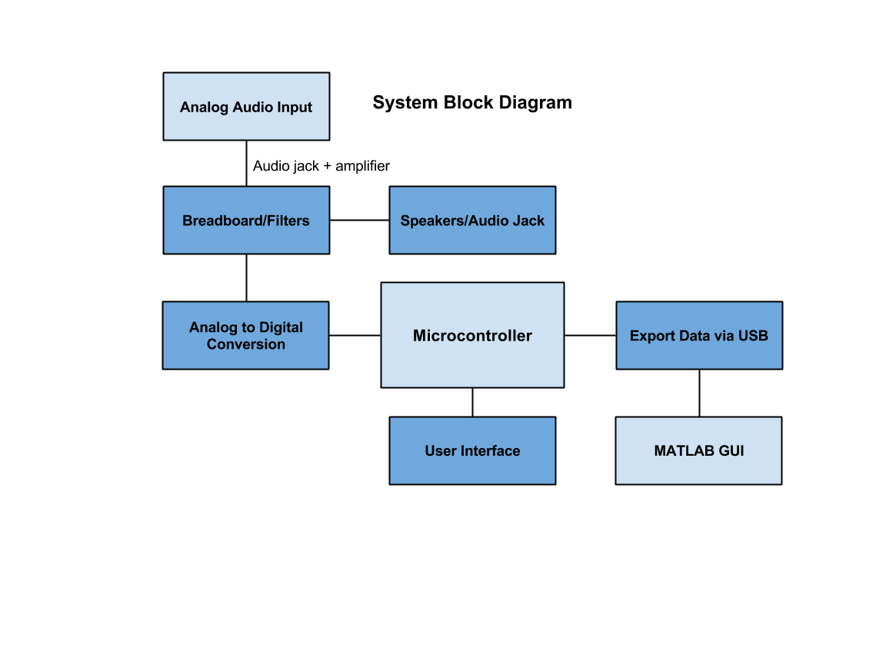

## Subsystem and Interface Requirements:

Power: USB

* USB plug, either into a computer or into a wall using a USB adaptor

External hardware plugins

* Filters
* Amplifiers
* ADC

Data output

* Plot graphs of inputs and/or outputs
* Select time vs. frequency domains

Speaker

* Need a control amplifier

Audio jack

* Takes in a signal
* Send to ADC in microcontroller

Software

* Signal processing software
  + FFT function
* Plotting functions

## Future Enhancement Requirements

* Additional capability for signal generation: sawtooth and square waves
* USB plugin
  + Saving output plots
  + Possibly for plugging in a laptop for extended functionality.
* Programmability (via the keyboard or Pickit3)
* Cabinet for charging a set of Toolboxes, potentially wireless charging

# High Level Design Decisions

User interface: buttons as inputs (as opposed to toggles or switches)

Building our own amplifiers (as opposed to buying one)

Using an external sinusoid generator, which entails having an external circuit board that connects to the board we design (exact part number TBD)

# Open Questions

Part numbers: signal generator, audio jack, speakers, rechargeable battery, wall plug and adaptor

Number and color of LEDs

Casing materials

Exact design of adaptors for audio components

# Major Component Costs

Sinusoid generator ~$10

Power supplies ~$50

Audio components ~$25

Breadboard and circuit components ~$10

Casing materials ~$10-100

# Conclusions

This project has the potential to have a lasting impact on the engineering department at Notre Dame. The subcomponents of the project provide expandability in terms of external hardware plugins and pursuing future enhancements. The subcomponents are diverse in their purpose and implementation, which will draw on knowledge of both devices and signal processing.