Little Swan Lake Club

By-Laws, Covenants and Rules & Regulations

Revised 2014
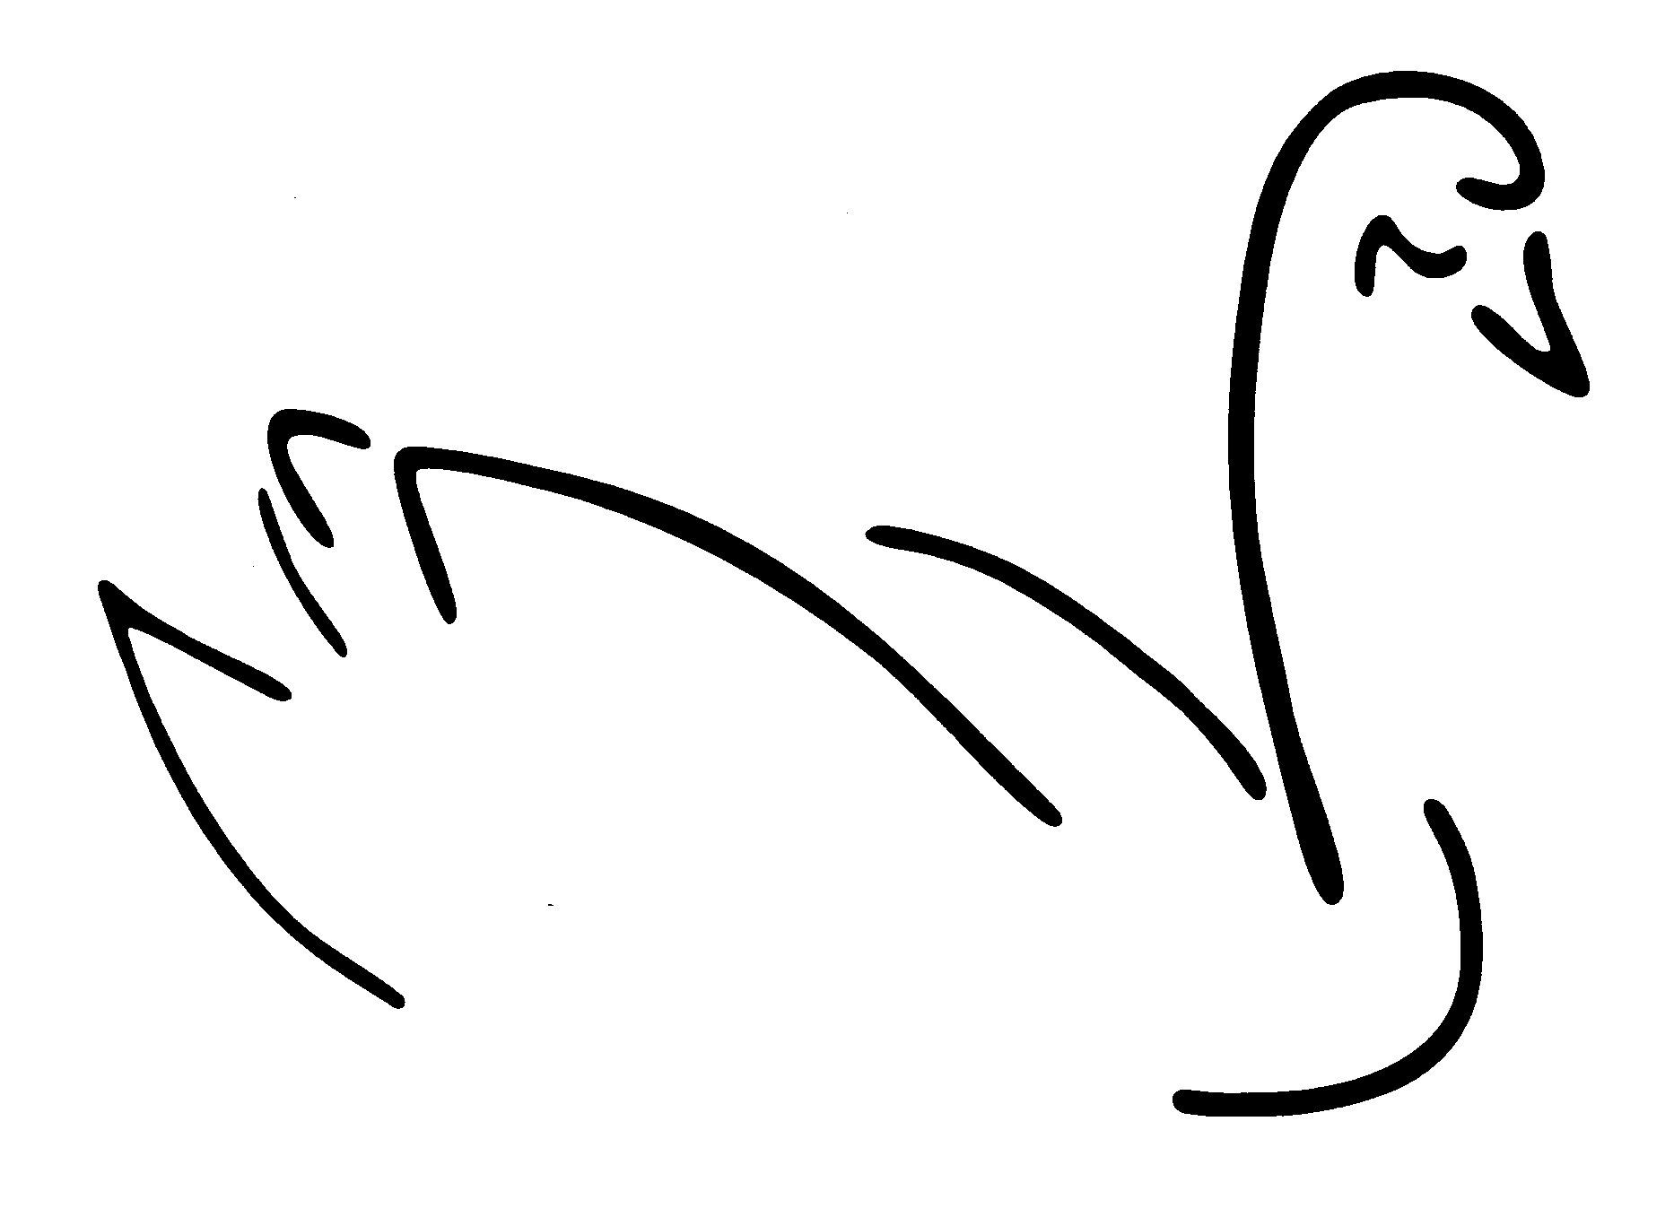
Attention: Should a lot owner lease his/her lot, the lot owner must explain the rules & regulations to the lessee and provide the lessee with a copy of the current rules & regulations book.

LITTLE SWAN LAKE CLUB

The Lake Board welcomes you to Little Swan Lake Club. We are pleased you chose this site as your year-round home or four season vacation area. The Lake has approximately a 10-mile shoreline, is two and one-half miles long. Conditions are ideal and all water activities are controlled for the safety of members and their guests. Deer, ducks, geese and other wildlife are found in great abundance throughout the Little Swan Lake area, but no hunting is allowed.

The Master Land Use Plan and preliminary architectural plans for the club and similar structures will be reviewed and modified from time to time in accordance with suggestions of residents and the continuing research and design program of the Club. These plans are guides, not unchangeable designs, and will be implemented within the overall pattern originally established in a manner responsive to the developing needs of the community. The advance planning and firm legal controls will, however, provide permanent protection against blighted neighborhoods, encroaching commercial establishments, overcrowding, intermixing of public and residential areas, unsightly buildings, and other conditions which plague many lake areas.

Club privilege is granted to all resident members in good standing, their spouses or life partners, and all their unmarried children under twenty-one (21) years of age residing with parent members, and to unmarried children under twenty-five (25) years of age who have not finished college, school or Armed Services.

Every lot owner shall be a member of Little Swan Lake Club, and shall be entitled to one vote for each lot owned. The current Annual membership dues are $150 per household, regardless of how many lots owned. Late fees are $25. Additional membership cards are available for $1.00 each.

Outlots are provided on the Lake for the purpose of providing access to the lake for all home sites without lake frontage. A shelter and grills are available on some outlots for your use.

A series of land covenants control all residential areas of Little Swan Lake developed by the Club. These covenants have been prepared after extensive investigations of other resort areas, and represent an effort on the part of the Club to establish a series of land use controls which will enable the community to protect itself against the development of any conditions which would ruin the attractiveness of the neighborhood or the pleasure of owning a home within the Little Swan Lake area. Under normal circumstances the covenants are administered in a manner designed to reasonably accommodate differing individual desires and tastes. However, they are sufficiently complete to provide legal authority by means of which the Club and the property owners in the community may prohibit any anticipated activities which would represent abuses by an individual of the rights of the neighborhood.

The architectural controls are administered by the Little Swan Lake Club Board, the Building Committee, and the Warren County Zoning Board. It is the aim of the Club to encourage the construction of homes of good quality architectural design, of proper size for their neighborhood, and appropriate design to the surroundings.

The following pages will provide the basic information on By-laws, Declaration of Covenants, Conditions and Restrictions, and the Rules & Regulations which include rules relating to: Building Code, Boat docks, Swimming, Boat rules and winter rules, Boat Registration, Outlot rules and regulations, fishing rules, Hunting and Trapping rules and general information.

Please remember, if you don’t find an answer to a question do not assume an answer. The Lake Board meets the first Monday of each month, at 7:00 p.m., in the Clubhouse, to answer your questions, or contact one of the Little Swan Lake Club Board Members listed in the annual letter.

Thank you,
Little Swan Lake Club Board

