
LSL Club Newsletter www.littleswanlake.net
Please send your photos to LSLClerk@hotmail.com  JUNE 2017 LSL Newsletter  Please join us on July 8th for LIVE OUTDOOR MUSIC!   The Schubies (a local group from Galesburg) - 80’s 90’s pop.  Where: LSL Clubhouse Pavilion – 5:30 - 7:30 pm  Some seating is available in the pavilion, but, we encourage you to bring a snack & your lawn chair or drive up in your boat or pontoon.  Enjoy an evening of great music. There will be a free will donation.   Recent Fish Kill  The LSL Board contacted the Illinois DNR to report the occurrence of thousands of gizzard shad that started dying about a week ago. We wanted to find out why this may have happened and to ask questions about how to remove the dead fish.  We received a response from fisheries biologist Rob Hilsabeck, IL DNR. Rob indicated that several lakes are experiencing a similar situation and he suggested that the kill is likely due to a large change in water temperature or a bacterium that only kills gizzard shad—not other species of fish.  He added that gizzard shad are not a desirable kind of fish in our lake. In the best-case scenario, this fish kill will eliminate the entire gizzard shad population in the lake. If not, it will take several years for the population to rebound to a high density again. We hope that is the case.  Most likely the shad were introduced a couple of years ago due to fisherman throwing their extra minnows back in the lake. If you remember we saw the shad boiling the water in the spring during the spawn. That spawn introduced thousands of gizzard shad into the lake. Reading other articles from biologists, indicates that many shad also die after they spawn, very much like salmon. We hope all fisherman who use minnows as bait will not dump them in Little Swan Lake.  Because the gizzard shad have already spawned again, you will see many small fish swimming in circles creating a mini vortex. Because shad are very sensitive to large temperature changes, we hope there is a hard freeze in the winter that could kill many of the new shad.  The LSL Board is also discussing adding some larger predator fish like walleye and northern pike to help with the problem. They love to eat shad!  Thanks to all LSL residents for pitching in to remove dispose of the dead fish! We would like to single out Bob Morrow who removed thousands of dead fish from the east end of the lake in front of his house, along the boat ramp down and around the shoreline to the dam helping everyone who uses the ramp or the clubhouse.  Mr. Hilsabeck said that excess nitrogen can trigger an algae bloom –We really hope that doesn’t happen. In the meantime, please keep your shorelines clean of the last few dead fish.  Water Well News  Water testing on new Well #7 has been completed. The new well will be put into production very soon. Thanks for your patience. The landscaping and fences around the well will be completed in June.   Removal of Old Car Tires from the Lake  The EPA regulation states that car tires must be removed from lakes as soon as possible. “These discarded tires, if improperly managed, serve as habitats for disease-carrying vectors, particularly mosquitoes.” See www.epa.illinois.gov/topics/waste-management/waste-disposal/used-tires/ for more information. Questions? Call Gary Miller, 309-371-0069.   LSL Membership Fees  All LSL Membership Fees ($150.00 Membership Fee and $35.00 per lot Maintenance Fee) were due by March 1st. If fees are delinquent, late fees will be charged starting May 1. Late fees will be $25.00 PLUS a 2% per month on the current past due amount PLUS any collection fees that may occur on top of these. The late fee amount increases each month you are late. So Please Pay On Time! Questions? Call or email our LSL Clerk, Barb Dunlap at 309-465-6734 / LSLClerk@hotmail.com. Thanks!   LSL Committees  We welcome new people to our Committees – see committee list on this page. If you are interested in helping, please let us know. We’d love to have you! Contact the LSL Clerk, Barb Dunlap at LSLClerk@hotmail.com.   How to Reserve the LSL Clubhouse for Your Event  Only LSL Club members can reserve the facility. The reservation form is online. See Rules of Use for LSL Clubhouse. Contact Chrisa Anderson at 309-696-7148.   Building Permit Reminder  LSL has rules concerning any new or improved construction on your property. Be aware. Any project, such as a house, boathouse or storage shed, dock, boatlift, deck, garage, home addition, etc. requires a permit and approval by the LSL Building Committee. If you have questions concerning rules, please contact Dave Hoppes, 815-494-9506. For Building Forms, contact Barb Dunlap at (boscobarb@gmail.com ).  Boating & Fishing News   Lake Patrol News  We have a new patrol person, Tom Winski, who will be helping Gary Miller patrol the lake this summer. Please be aware of and follow all boating and fishing regulations. We want everyone to have fun and to stay safe.  If you have any questions, call Gary Miller, 309-371-0069.   “No Wake Zone” Safety Rules  Swimming off of boats in the no wake zone is allowed with the following rules: 1) Boats must be anchored and the motor turned off; 2) Boats must stay in the center of the no wake zone, not in the traffic lanes; 3) Swimming will only be allowed from 30 minutes before sunrise until 30 minutes after sunset; 4) Swimmers must stay within 30 ft. of their boat; 5) A responsible person, 18 years or older must stay in the boat; 6) NO DIVING allowed. Rules will be strictly enforced with a minimum fine of $25 for the first offense and repeated offenses could lead to loss of lake privileges.  Ladies of the Lake Club News  The Rummage Sale & Raffle was a huge success!  A big thank you to everyone who donated items for the sale, helped set it up and for the “shoppers.” The proceeds ($900) will be used to help maintain the Memory Garden next to the clubhouse. This month also, John Huston (Berwick) and crew came to freshen the gardens by adding some mulch and new rock. It looks great!   Garden Volunteers  We owe another big thanks to the all our gardening volunteers who keep the garden in great shape by weeding and pruning once a month under the guidance of Tom & Mary Ingrasias.    Little Swan Lake Shirts  Ladies of the Lake club has Little Swan Lake clothing for sale.  Sweatshirts & t-shirts are available in a variety of sizes for adults and children. Please call Barb Jonckheere at 630-263-0283 or Patty Andersen 309-775-9008.   Ladies of the Lake  The Ladies of the Lake club hosts a luncheon on the first Wednesday of each month at noon. These luncheons may be potluck or brown bag affairs which are held at the Clubhouse. Sometimes we plan a day’s outing that includes lunch in a nearby town. Call Jane Stevens for more information, 309-465-3466.   Need photos for the LSL website  Send your photos to Bob Andersen at r-andersen@wiu.edu.  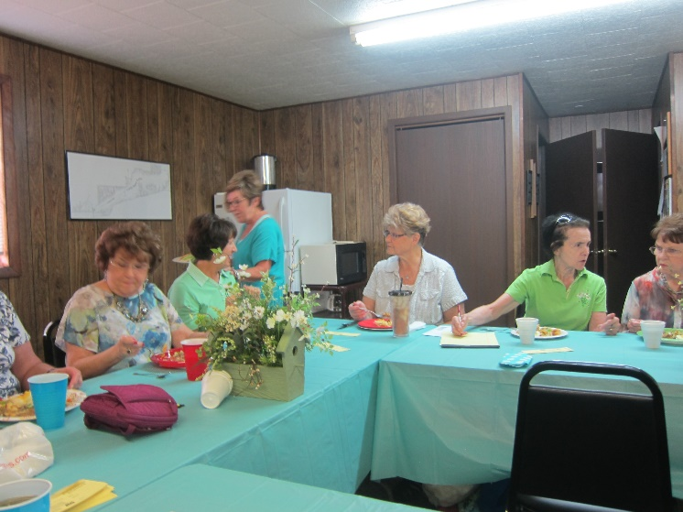  Area Community Events   SUMMER FARMERS MARKETS  Good Hope Gardens – a sustainable farm  Monday thru Saturday - 10am – 6pm  Good Hope, IL, 445 East Main Street  309-456-3400  Macomb Farmers Market  Thursdays & Saturdays only - 7am - 1pm  Macomb, IL, Chandler Park on West Carroll Street   JUNE EVENTS  June 11 – Wyatt Earp Birthplace Open House – 1-4pm  Monmouth, IL - 406 South 3rd Street  309-221-0265  Free will donation.  June 16 & 17 – More on 34 (sales along US Hwy. 34)  Miles & miles of sales from Galesburg to Aurora!  309-761-8473 / www.moreon34.com  June 17 - Wine, Whiskers & Whimsy – 5-7pm  Humane Society Fundraiser  Macomb, IL, Taylor’s Hall, 121 So. Randolph Street  Tickets: $25  June 22 - 25 – Galesburg Railroad Days – 4 days of fun!  Downtown Galesburg, IL  History, carnival & fun for families.  309-343-2485 / Galesburg.railroaddays.org  June 24 – Kirkwood Days – 7a.m – 10pm  Downtown Kirkwood, IL  Family activities & carnival.  https://m.facebook.com/kirwoodDays/  JULY EVENTS  July 8 - Little Swan Lake LIVE OUTDOOR MUSIC  The Schubies (Galesburg) - 80’s 90’s pop  Where: LSL Clubhouse – 5:30 - 7:30 pm  Bring a snack & your lawn chair or you can  drive up in your boat. Free will donation.   AUGUST EVENTS  August 17, 18, 19 – Avon Fat Steer Show – 3 days of fun!  Avon, IL Fairgrounds | LSL Board & Committee Members  LSL Board Members  President  Jerome Stenger  309-256-2580  37bluecoupe@gmail.com  Vice-President  Chrisa Anderson  309-696-7148  canderson1014@gmail.com  Secretary  Carlene Adams  309-465-9278 res  309-255-5340 cell  adams_carlene@yahoo.com  Treasurer  Bob Andersen  309-775-9008 res  217-649-1304 cell  r-andersen@wiu.edu  Clerk  Barb Dunlap  309-465-6734 LSLClerk@hotmail.com  Publicity / Newsletter  Nancy Hoppes  309-465-5277  dnhoppes@mchsi.com  Lake Operations  Alan Jonckheere  630-263-0283  amjonckheere@gmail.com  Lake and Dam  Joe Russell  309-465-3033  jmrussell@grics.net  Mowing  Jennifer Friedrich-Kuehn  309-224-2284  Boating  Chad Lydic  309-221-0041  commandolb@hotmail.com  Fishing  Charles Ackers  309-221-0643  Charlesackers2006@gmail.com  Lake Patrol  Gary Miller  309-371-0069  Roads  Clay Bricker  309-536-1231  cbricker3410@gmail.com  LSL Committees  Building  Dave Hoppes (building permits)  815-494-9506  Contact Barb Dunlap for forms.  boscobarb@gmail.com  Clubhouse Rental & Long Range Planning  Chrisa Anderson  309-696-7148  Candersen1014@gmail.com  Boat Registration  Dave Hoppes  309-465-5277  dnhoppes@mchsi.com  Siltation  Carlene Adams  465-9278  Adams_carlene@yahoo.com  Sanitation  Jim Maher  309-651-2973  Dave Hoppes  815-494-9006
  Summer 2017 Ladies of the Lake Luncheon Dates
  Please mark your calendars!
  July 5, 2017 – Hostesses: Sandy Morrow & Carlene Adams
  Brown Bag (bring your own lunch). Refreshments & dessert will be provided. Meet at the LSL Clubhouse at noon.
  August 2, 2017 - Hostesses: Gail Maher & Bev Versteeg
  Luncheon at the LSL Clubhouse at noon. Bring a dish to pass and your own table setting. Refreshments will be provided.
www.facebook.com/avonfatsteershow
Call 309-360-4023

