1. Open command prompt at project directory.
2. Type “npm install” and enter. This will install node_modules
3. Then, “npm start” to start server.
4. Open command prompt again.
5. Type “node test” and enter. This will requests put method 500 times.

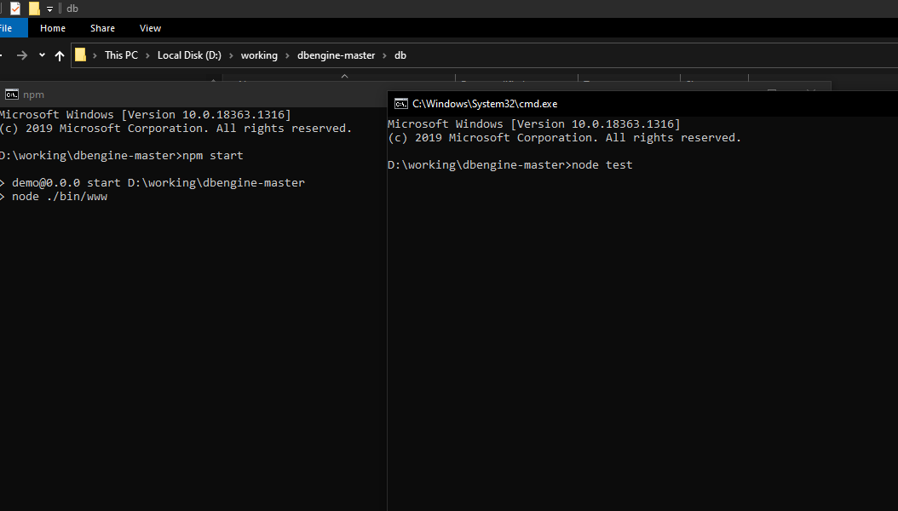

1. You can test “put” method and storage specification, identifier specification, performance specification by viewing db folder.

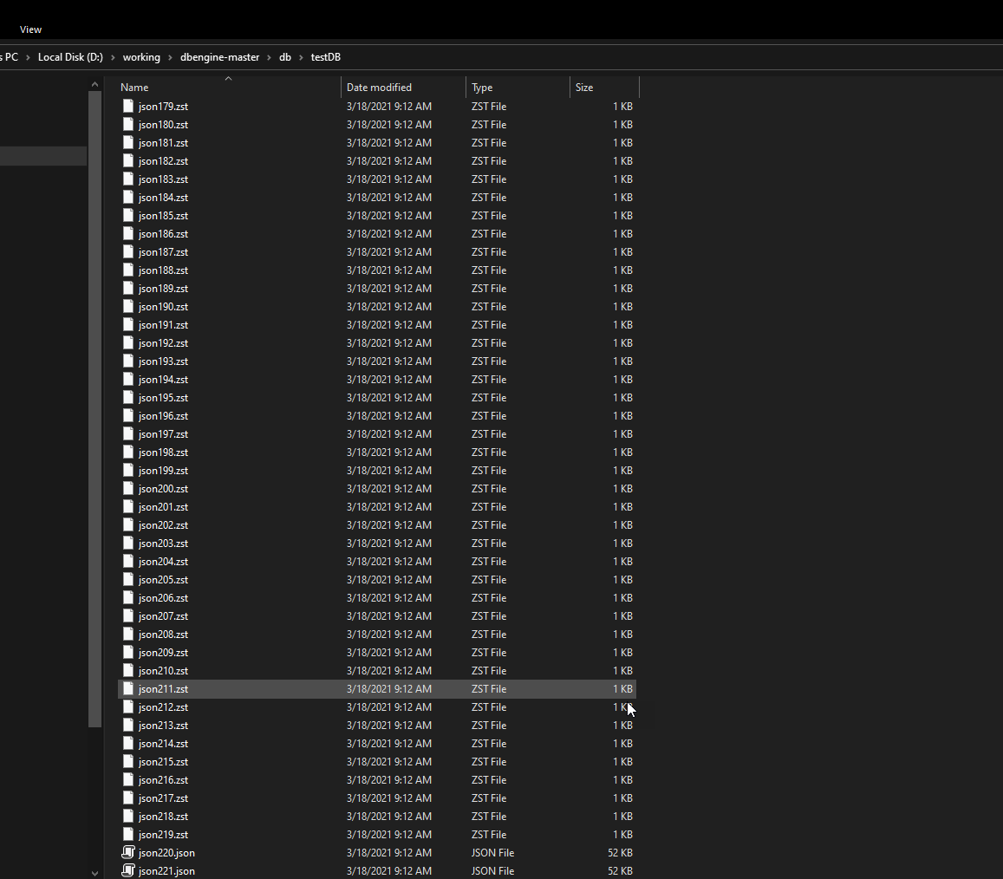

The last two files(json220.json, json221.json) was generated by “put method”, but haven’t compressed yet by background process.

1. You can test “get” method by access localhost:3000/db/testDB:json1 .