**CPSC 437 01/CPSC 537 01**

**Intro to Database System Project Report**

**Teammates**: Trehan, Nikhil | Bilal Abu-Ghazaleh | Wai Pan Wong | Hongwei Song

**The intention of our project**:

We download original CSV file from National Institutes of Health. The original project was about Chest X-ray. Chest X-ray exam is one of the most frequent and cost-effective medical imaging examinations. The difficult part is to make diagnosis of specific thorax disease though x-Ray images, even if with the help of deep learning work. In this project, researchers provide enhanced dataset, which contains 6 more diseases categories and more chest X-ray images. The original dataset is extracted from the clinical PACS database at National Institutes of Health clinical center. In this csv file, it contains image_ID, Finding_labels (the corresponding diseases category), patient information including their IDs, age, gender and the view position when they took chest x-Ray (PA means the beams pass from back-to-front, AP means the beams pass from front-to-back). As for our project, we cited this original file as our data source, and we build a website for doctors. When doctors type gender, range of age of patients, and view position, the website will output the statistical results of specific diseases like how many people have such disease.

**Why my project is useful and interesting?**

The most useful thing in this project is for doctors, they can quickly learn about the statistical distribution of specific chest diseases, and for each doctor, they can get their customized information based on their own input.

**What are the technique challenges?**

When we did this project, the technique challenges included combining JavaScript, Python and SQL query together, and another issue was to decompose the original one table into two tables to make it meet the BCNF.

Getting information and sending info from python module/ server to the html /javascript end. Although the Python module was able to compute the SQL query with the user input parameters, receiving and sending those parameters from the HTML/JS end posed a technical challenge.

**What NF our table design meets?**

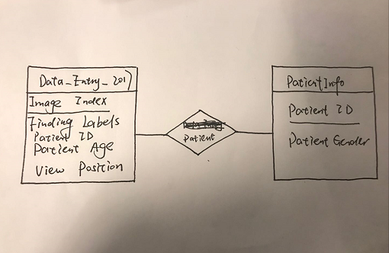Our table meets BCNF.