Mechanisms of Temporal Stability in Natural Communities

Loreau and de Mazancourt (2013) analyzed a Lotka-Volterra competition model that incorporated environmental and demographic stochasticity in search of mechanisms underlying diversity-stability relationships. They found three main mechanisms that promote stability in competitive communities:
- Asynchrony of species’ intrinsic responses to environmental fluctuations
- Differences in the speed at which species respond to perturbations
- Reduction in the strength of competition

The questions we seek to answer are:
- Which mechanisms have the largest effects on temporal stability, given a parameterized population model based on empirical data?
- How well do these mechanisms predict temporal stability in natural competitive communities?

To answer these questions, we will use two different, but very related approaches. For (1) we will use a parameterized IPM to play “games” where we alter parameters related to the mechanisms above to look at the effect of those changes on temporal stability from perturbed simulations compared to un-perturbed simulations. For (2) we will use a parameterized IPM (but maybe this will be an IBM problem?) to simulate communities for each quadrat – that is, based on each quadrat’s species composition and initial size structure we will simulate the IPM (this is why I am thinking this may be an IBM problem – the IPM may just go to “equilibrium” size structure each time). Each quadrat will have its own CV (stability) and we can look for generalities across the quadrats in terms of the sign and effect size of each of the three mechanisms when used to predict the CV (figure below).

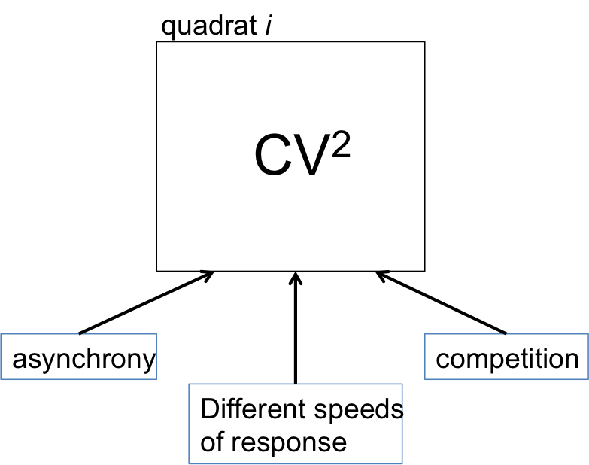

So, the critical step is to estimate mechanisms 1-3 from the vital rate regressions and the IPM (IBM). In brief, here is what we propose for each mechanism:

- Asynchrony: the synchrony of species’ environmental responses (φ_{e}) is rather straightforward to calculate, even if getting the right parameters may be a bit of a challenge. It is defined as:

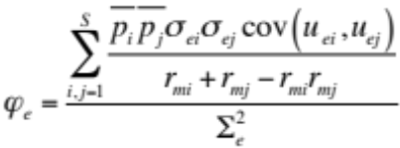

where p is just the average proportional abundance (cover, in our case) of each species, σ_{e} is the standard deviation of the vector of year effects from the fitted vital rate regressions, cov(u_{ei}, u_{ej}) is the covariance of the year effect matrix (species × year), and the rs are the intrinsic rates of growth for each species (average growth rate from IPM when the focal species is modeled with no conspecifics). The denominator, Σ²_{e}, is the mean scaled environmental variance:

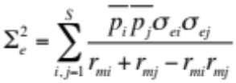

Note that when u_{ei} = u_{ej} then the denominator of the synchrony equation equals the numerator, resulting in perfect synchrony, φ_{e} = 1.

The trick here is how to combine the year effects, and their associated covariance, from the separate vital rate regressions. We, ideally, would want one number here. PETER: any ideas here? Can we get this from the IPM post hoc?

- Difference in speed of species’ response to environmental perturbations. This basically just the variability among species’ intrinsic growth rate (r_{m}). We can obtain this by running simulations for each species in isolation and calculating the growth rate at each time step. Then, at each time step we can take the standard deviation of the four species’ intrinsic growth rates. Lastly, we can average these standard deviations over the length of the simulation to estimate total variability among speed of species’ response to the environment.

- Strength of competition. Another tricky one. For each vital rate regression we can estimate the competition coefficients, and maybe even collapse this into an aggregate measure of species competition, but how do we combine across vital rate regressions? Similar to the problem in 1 above. PETER: any ideas here too? Can we get some type of estimate from the IPM?

RESPONSE FROM PETER:
Mechanism 1: environmental responses
The way I do this in my storage effect work is to simulate each species' "yearly intrinsic growth rate" (there is an intrinsic growth rate for each set of year specific parameters) and then look for correlations among the species. The intrinsic growth rate integrates across the different life stages.

Mechanism 2: rate of response
What you have sounds good. Just a different summary of what I described under #1 (I guess you will average across the year-specific rates? Or set the random year effects to zero and just simulate one intrinsic growth rate for the "average" environment?)

Mechanism 3: competition
I'm not sure exactly how you want to measure the strength of competition. Do you mean interspecific competition? Do you mean the difference between intra and inter? The first thing that comes to mind is the "sensitivity to competition" metric of Carroll, Cardinale, Nesbit 2011 Ecology. Chengjin used this for the Ecol Monogr ms (now in review) as a step towards calculating niche differences. Basically, we simulate a species' intrinsic growth rate (geometric mean across the year specific rates) and then simulate the species' invasion growth rate (growth rate in the presence of competitors at their equilibrium abundances). The bigger the difference, the more sensitive a species is to competition. If there is no difference, then interspecific competition has zero effect. You can also get facilitation (invasion growth rate > intrinsic growth rate).

