Andrew Tressler

Srilekha Dodda

CS3502

2 October 2025

Homework 2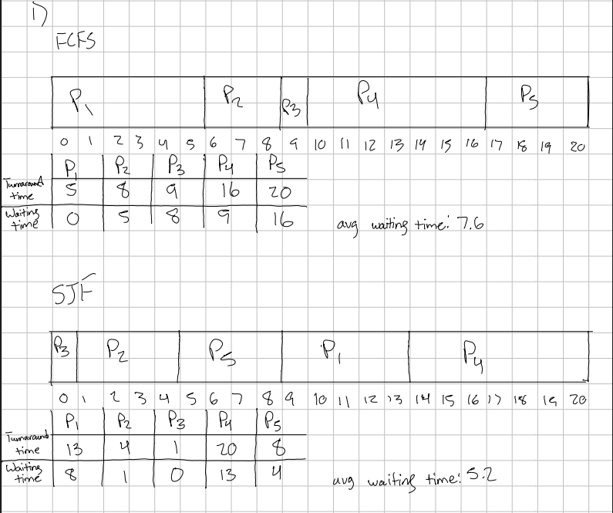

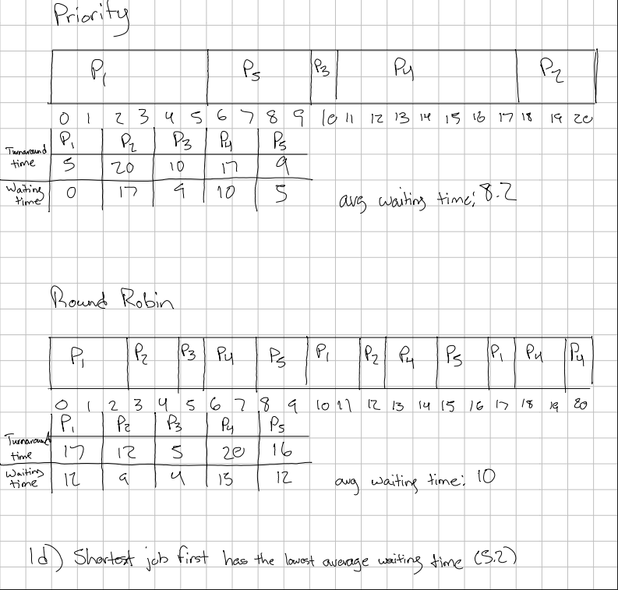

2)

Code contained in FileCopy.c.

I used VSCode to write and compile my code. I had to open VSCode in WSL to regenerate my build settings to work for Linux.

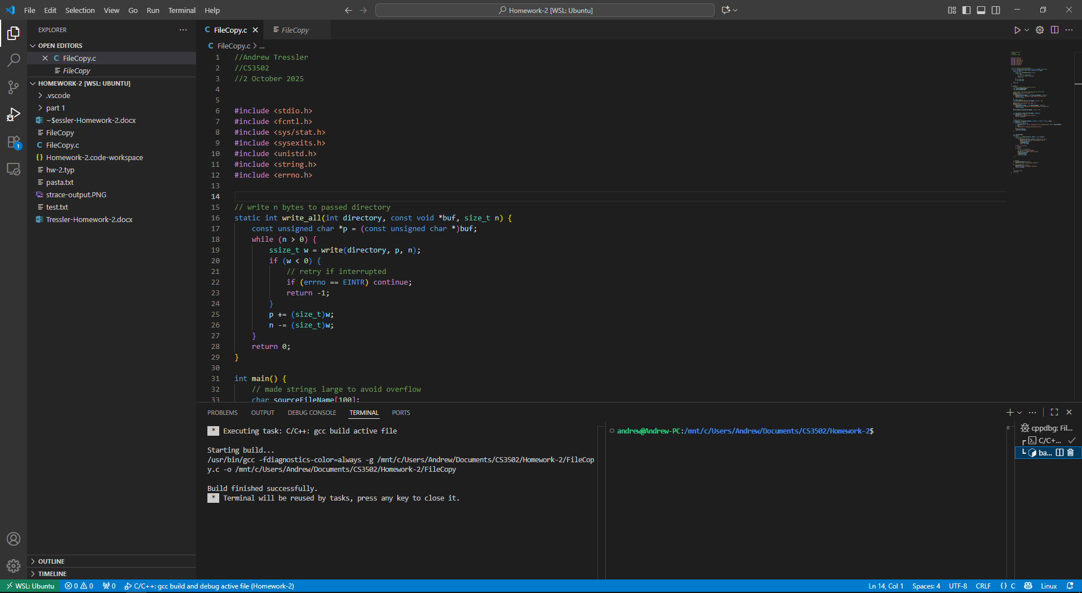

I then opened a WSL terminal, navigated to the directory, and opened the executable file using the strace command.

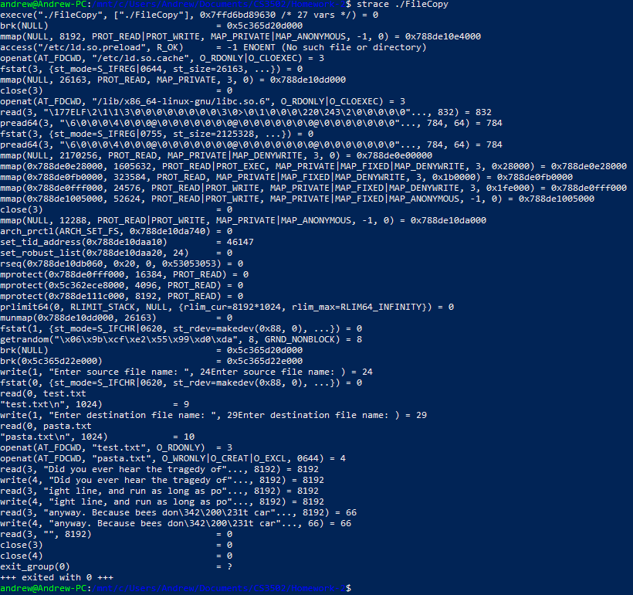

Because I get the file names from the console using fgets() instead of using arguments, I have to type the file names in the console while strace is running. I observed that I gave input during read() calls:

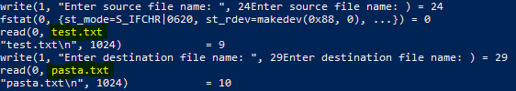

In the next line, my input is shown along with it’s length in chars (ex. test.txt\n = 9 chars, \n being counted as one)

After getting the file names, it calls openat(). The first call is to read the file “test.txt” and the second call creates a new file “pasta.txt”. “test.txt” is assigned the id 3 and “pasta.txt” is assigned the id 4 (since open returns an int).



After opening the files, it begins to read the contents of the source file and write them to the output file. On line 77 of FileCopy.c, I declared the buffer to be of size 8192 bytes. Because of this, it copies in 8192 byte sections until all of the data in the source file has been copied. Because the total size of my “test.txt” file is 16,450 bytes, the total size of the individual calls sums to 32,900 bytes.

read() - 8192 + 8192 + 66 = 16,450 bytes read

write() - 8192 + 8192 + 66 = 16,450 bytes written

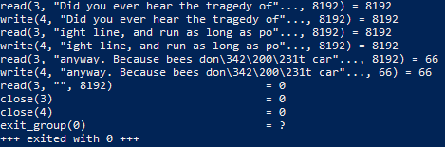

After all of the contents have been read, it calls close() for both the source and destination file. It then calls exit_group(0) with exit code 0, since that’s what I have main() return at the end of the program after running successfully.

Output of FileCopy:

