Python File Integrity IDS

Project Overview:
The Python File Integrity Monitoring (FIM) Tool is designed to track file changes in real time. It monitors file additions, modifications, and deletions to detect unauthorized changes. This tool helps improve security by keeping a close watch on file integrity, making it ideal for both home labs and professional environments.
Prompt to Start monitoring
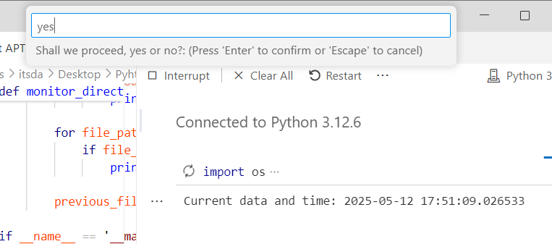
pro
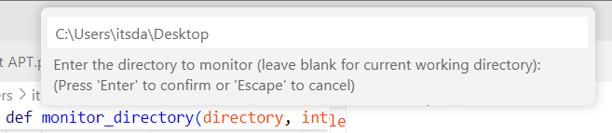

1. Name Change Detection:
Shows the tool detecting a file name change. Logs both the old and new names along with the timestamp.
- Why: Helps spot tampering or suspicious renaming.

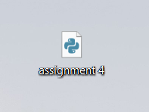
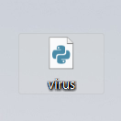

2. File Deletion Detection:
Logs when a file is deleted, recording the file path and deletion time.
- Why: Identifies unexpected file removals, which could indicate data loss or tampering.
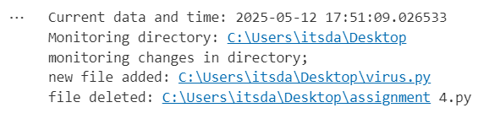
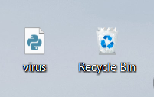

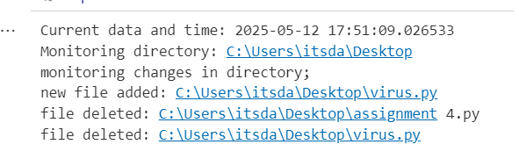

3. New File Installation:
Detects when a new file is added to the directory. Logs the file path and creation time.
- Why: Helps identify unauthorized file installations or malware.
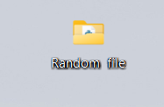

4. File Access and Modification:
Tracks when a file is opened or edited, logging the access time.
- Why: Detects unauthorized file access or unexpected modifications
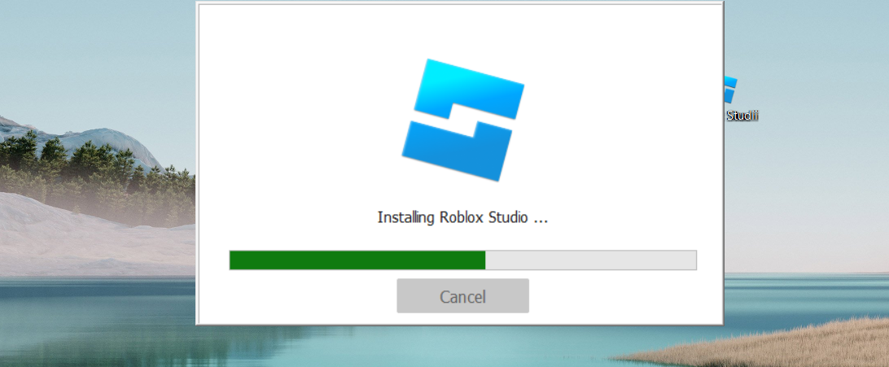

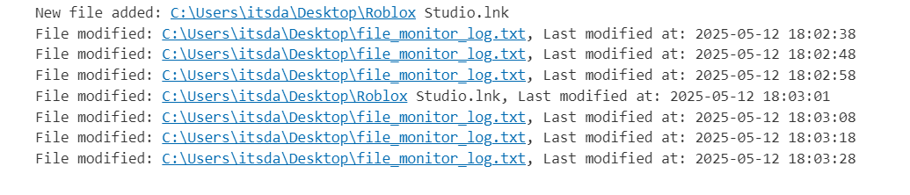

Why This Tool Matters:
This tool helps security professionals detect suspicious file changes in real time. It’s lightweight, easy to use, and works well with other security tools, making it a practical addition to both lab and enterprise environments.
Let me know if you need any more adjustments!

