Name – Atri Gulati
Company – Bot consulting
Date – 30-11-2025
Project – RAG based chatbot

A) Architecture & Design

1. High-Level Architecture
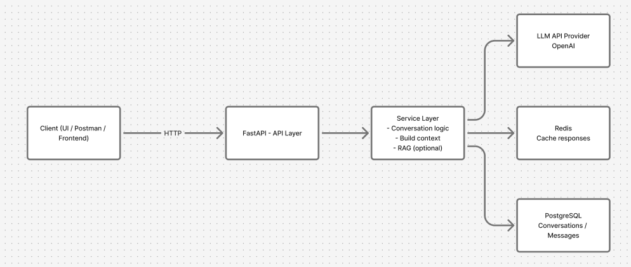

Component Summary
• API Layer (FastAPI) – exposes endpoints, handles validation.
• Service Layer – core conversation logic, builds LLM prompt, optional RAG flow.
• PostgreSQL– stores users, messages, conversations.
• Redis– caches repeated queries & summaries.
• LLM Provider– external model call (OpenAI).
• Optional RAG Store– retrieves document chunks if user chats with a PDF.

2. Tech Stack Justification
• FastAPI – simple, fast, async-friendly, great for clean APIs.
• PostgreSQL– reliable and structured; ideal for ordered chat history.
• Redis – reduces token cost by caching responses.
• LLM API– fulfills requirement to integrate a real model.
• Chroma (optional)– lightweight option for document-based retrieval.
B) Data & Storage Design

1. Database Choice
PostgreSQL
- Structured data fits conversations/messages well.
- Strong ordering via timestamps + auto-increment IDs.
- Easy joins + indexing on conversation_id.
- Reliable and simple to run locally or via Docker.

2. Storing Conversation History Efficiently
- Every message stored as a row in a Message table.
- Indexed by conversation_id for fast retrieval.
- Old messages can be summarized and replaced with a short summary string.
- Redis caches the last N messages for faster LLM context assembly.

3. Maintaining Message Ordering
Two layers of ordering:
- Primary key (auto-increment)
- created_at timestamp

Ordering is guaranteed by sorting:
ORDER BY created_at ASC

Token Usage
Token tracking is not yet implemented in code, but the design supports it.
Each message would store an estimated token_count, allowing the system to:
- track total cost per conversation
- limit how much history is sent to the LLM
- trigger auto-summarization once token limits are reached
This enables predictable cost control and avoids LLM context overflow.
C) REST API Design
Overview
Simple REST interface to:
- Start a conversation
- Add messages
- List past conversations
- Fetch full history
- Delete a conversation
Endpoints follow clean resource-based URLs and standard HTTP semantics.
1. POST /conversations
Description: Create a new conversation + handle first user message.
Payload:
{
"title": "Support Chat",
"first_message": "Hello!"
}
Response:
{
"conversation_id": 1,
"answer": "Hi! How can I help you?"
}
Why POST: creating a new resource.
2. POST /conversations/{id}/messages
Description: Add a new user message to an existing conversation.
Payload:
{
"message": "What can you do?"
}
Response:
{
"answer": "I can assist with..."
}
Why POST: appending new message to an existing resource.
3. GET /conversations
Description: List all conversations for a user.
Query Parameters:
?page=1&size=20
Response:
[
{ "id": 1, "title": "Chat 1", "created_at": "..." },
{ "id": 2, "title": "Project Assistant", "created_at": "..." }
]
4. GET /conversations/{id}
Description: Return full conversation history.
Response:
[
{ "role": "user", "content": "Hello" },
{ "role": "assistant", "content": "Hi there!" }
]
2. Error Handling & HTTP Codes
Case | Code | Notes
Conversation not found | 404 | invalid ID
Bad payload / missing fields | 400 | Pydantic validation
Internal error / DB issue | 500 | server-side
LLM timeout | 503 | service temporarily unavailable
3. URL Structure
All conversation-related routes grouped under:
- /conversations
- /conversations/{id}
- /conversations/{id}/messages
D) LLM Context & Cost Management
1. How Context Is Constructed
system_prompt
- optional: conversation summary
- last N messages (sliding window)
- optional: RAG retrieved chunks
- current user message
2. When History Exceeds Model Limits
If total tokens get too large:
- Summarize old messages
- Compress early parts of the conversation.
- Replace them with short summaries stored in DB.
- Use a sliding window
- Only keep the most recent messages (e.g., last 10–15).
- Cost Reduction Strategies
LLM tokens cost money, so the system uses a few simple tricks:
- Sliding Window
    - Keep only relevant recent context:
    - history = last_n_messages
- Summarization
    - Older history is replaced with:
    - "Earlier conversation summary: …
5. Token Usage Planning (not implemented)
Designed to support:
- token_count stored per message
- triggers for summarization
- cost tracking per conversation
(Explained in Section B.)

E) Error Handling & Scalability
1. Error Handling
Common Failure Points & How the System Deals With Them
1. LLM API Timeout
- Retry with small exponential backoff.
- Return a friendly fallback message if LLM still fails:
- "The model is taking too long to respond. Try again."
2. DB Write Failure
- Use transaction rollback.
- Log the error for debugging.
- Return:
- 500 – internal server error
3. Token Limit Breach
- Trigger auto-summarization.
- Drop oldest messages via sliding window.
- Keep context under model limit.
4. Invalid Conversation ID
- Return:
- 404 – conversation not found
5. Missing/Invalid Input
- Pydantic handles validation.
- Return:
- 400 – bad request
2. Logging & Monitoring
Minimal but effective:
- Log LLM errors (timeouts, rate limits).
- Log DB exceptions.
- Optionally log token usage per conversation.
- Add basic request logs for debugging.
- (Enough for a case study; production can use Prometheus/Grafana.)
3. Scalability
Where Bottlenecks Will Appear First (Realistic)
Component | Bottleneck | Why
LLM API | rate limits | heavy traffic = more calls
PostgreSQL | high read/write on messages | many conversations × many messages
Chroma (optional) | slow retrieval | large PDFs, high embedding count

