Comparaciones número reproductivo efectivo

04/08/2020

## Comparación para Bogotá

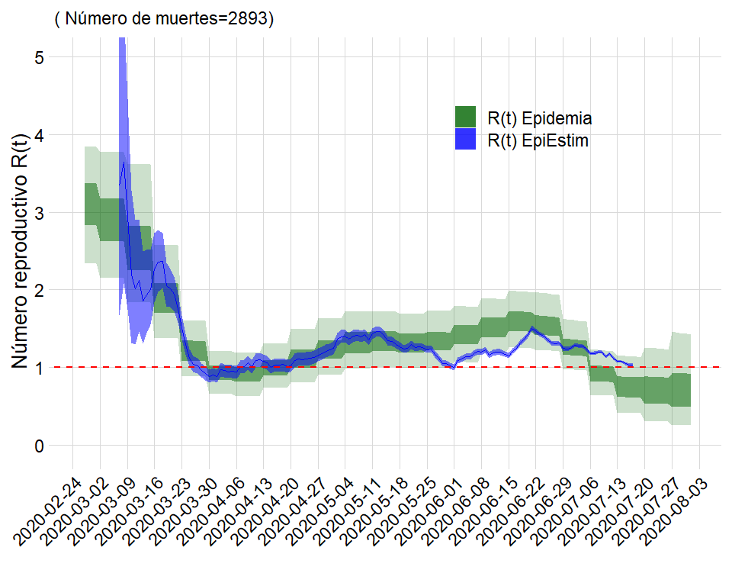

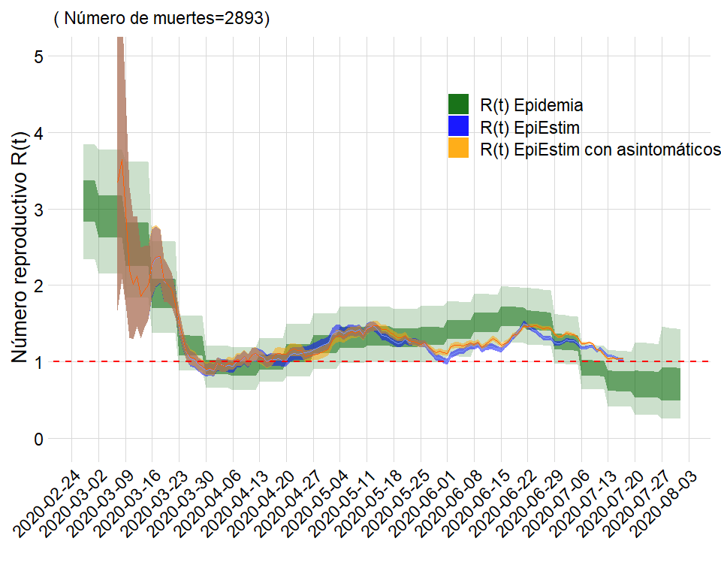

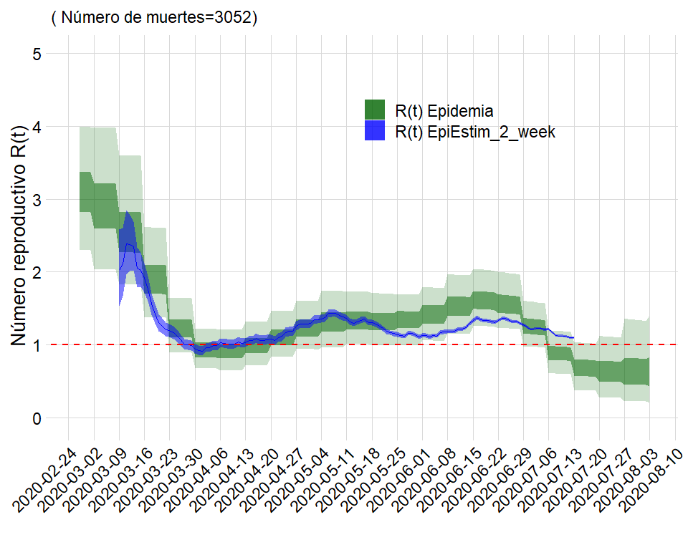

## Comparación para Barranquilla

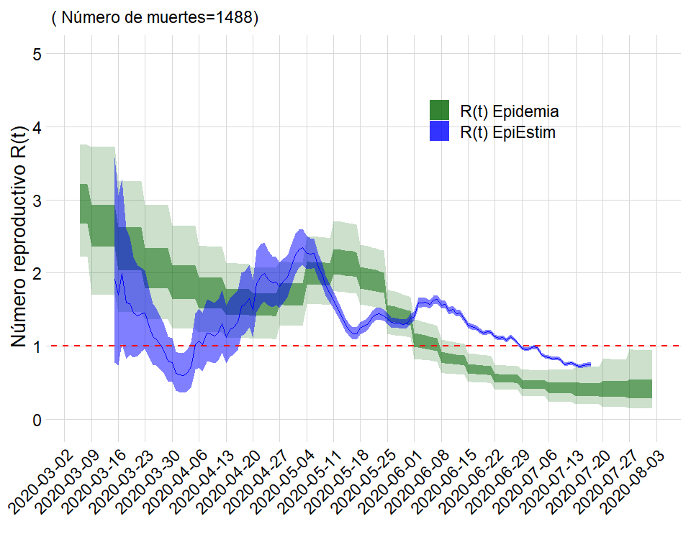

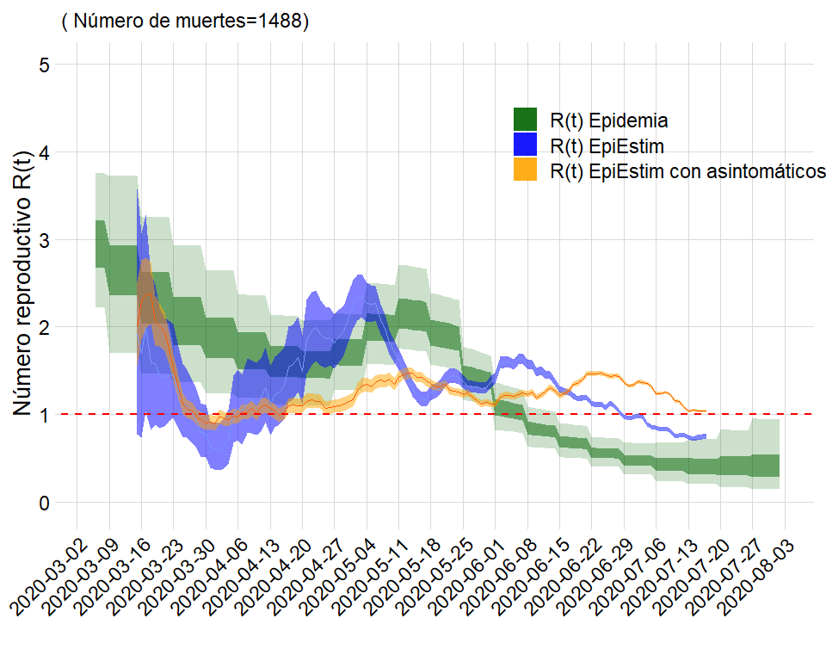

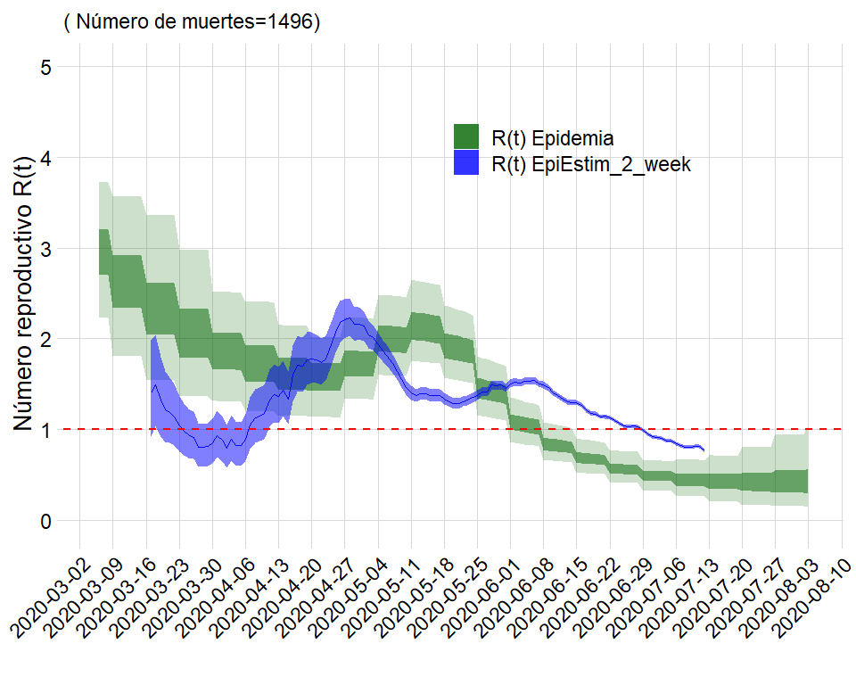

## Comparación para atlantico

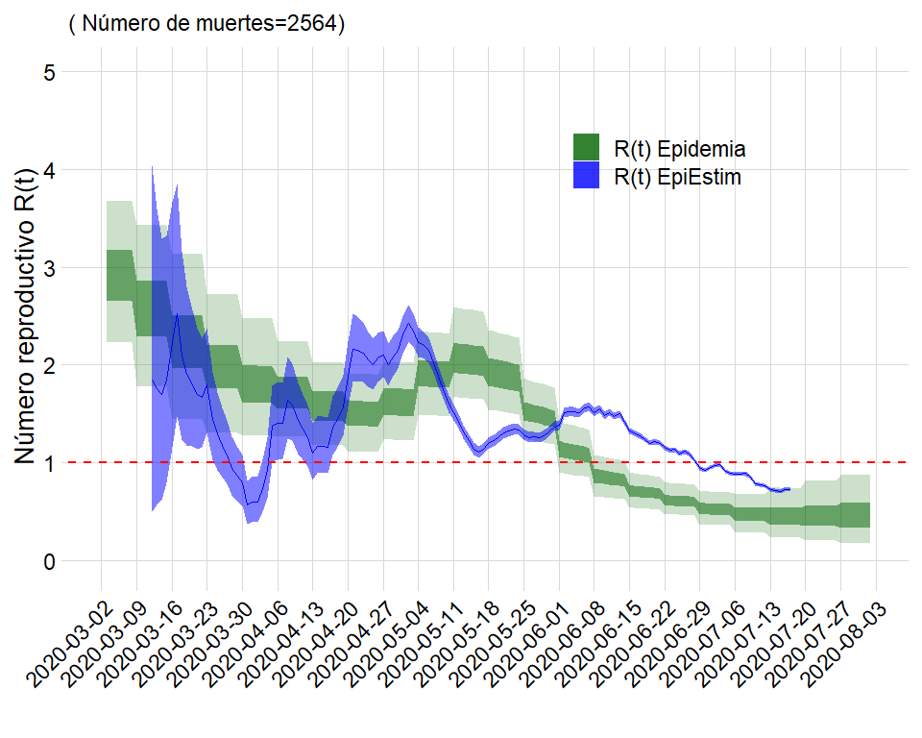

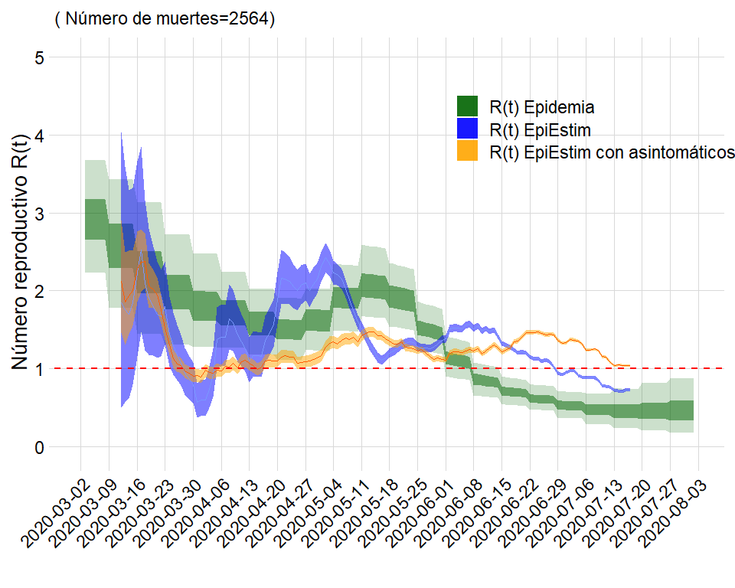

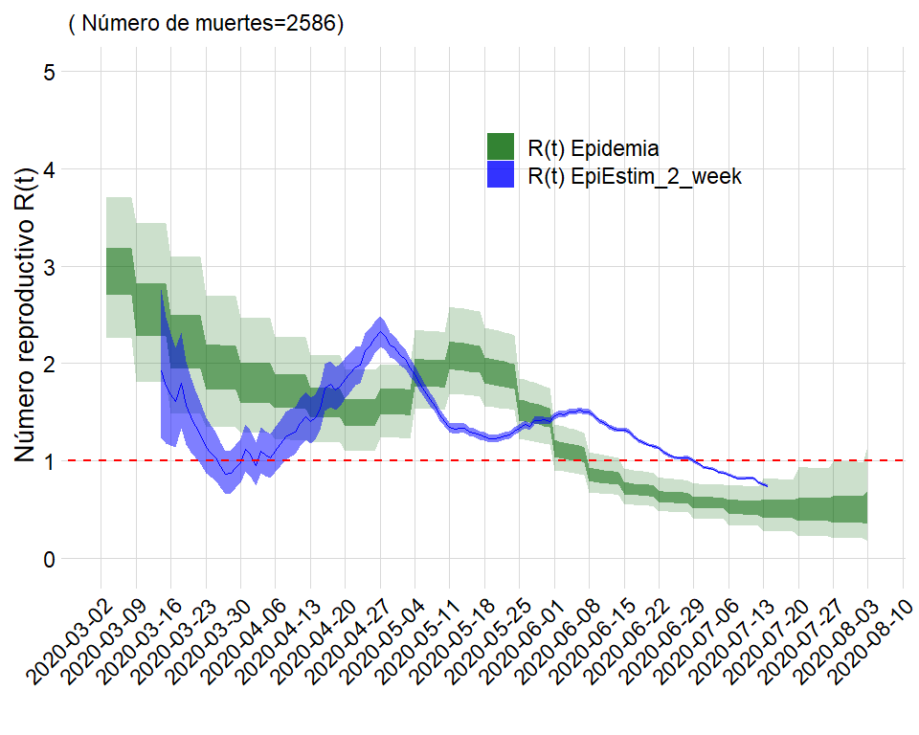

## Comparación para Cartagena

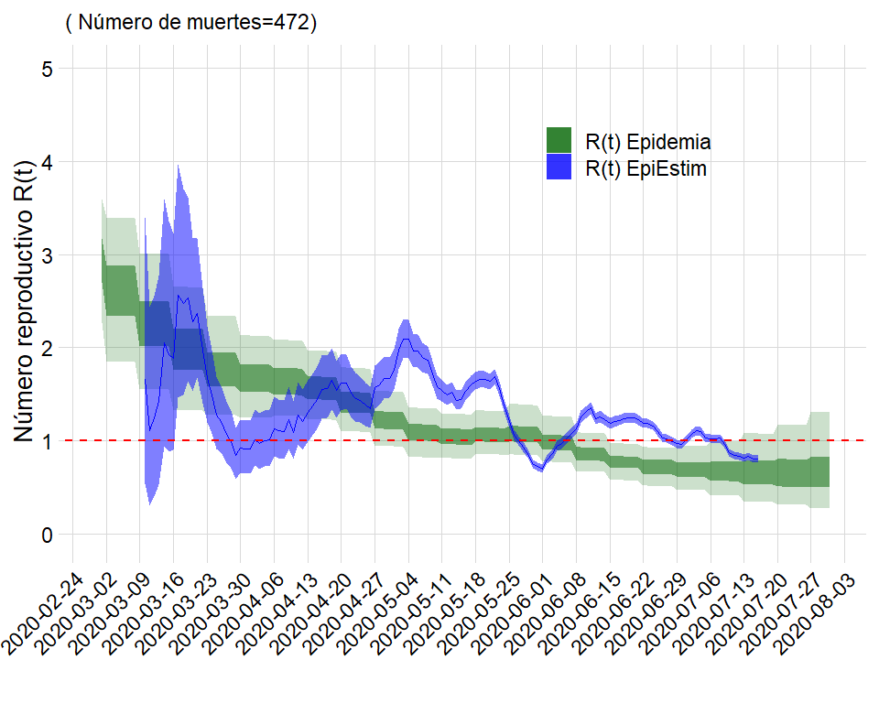

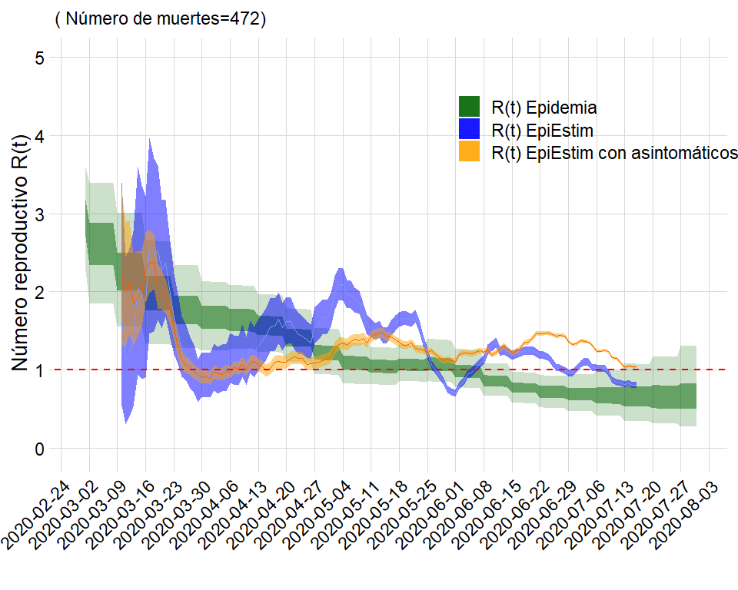

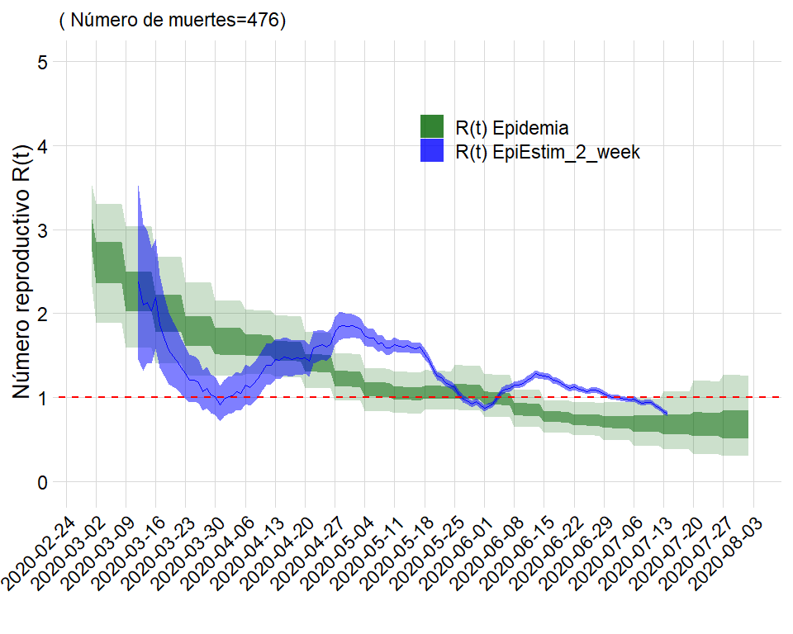

## Comparación para Bolívar

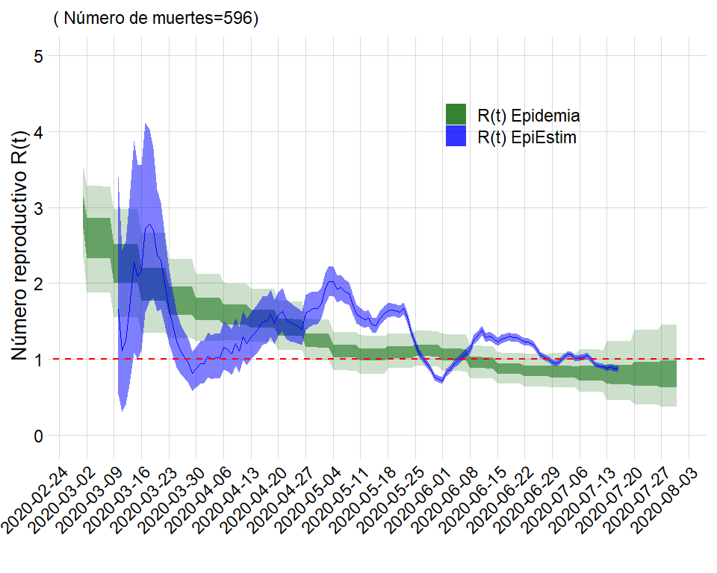

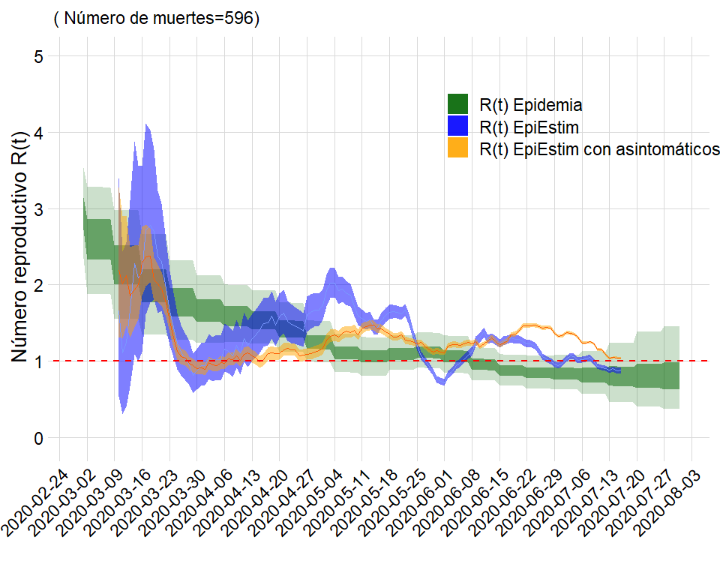

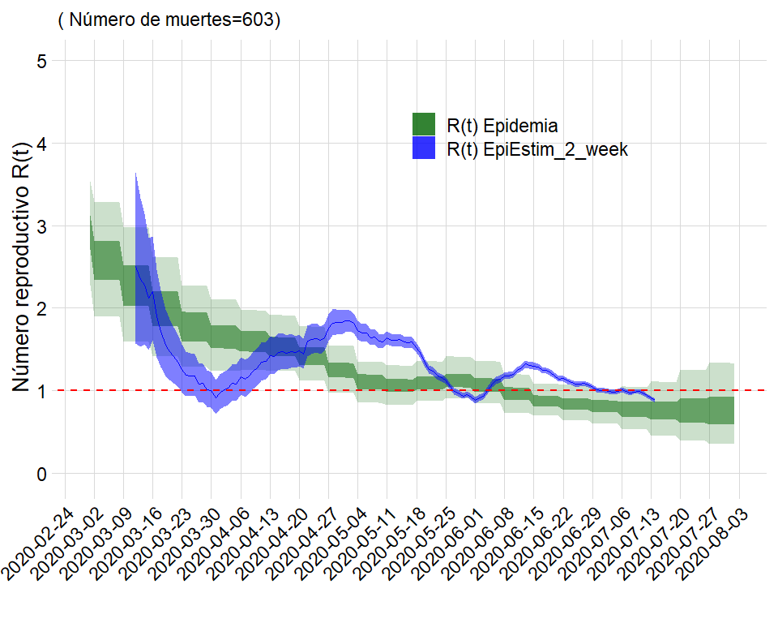

## Comparación para Amazonas

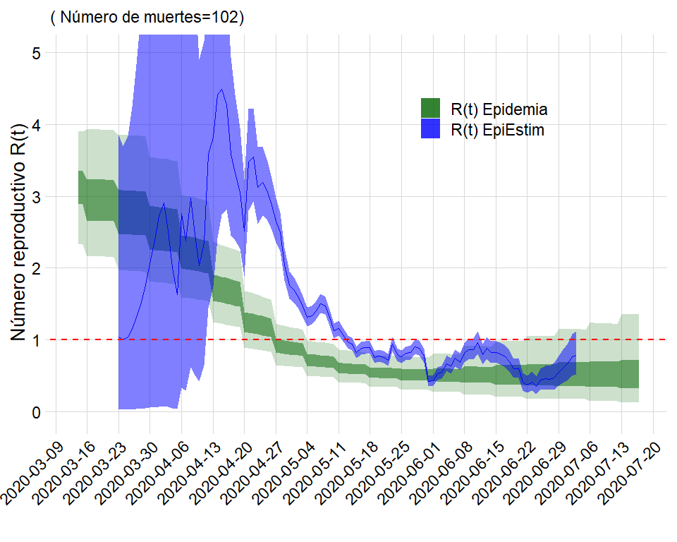

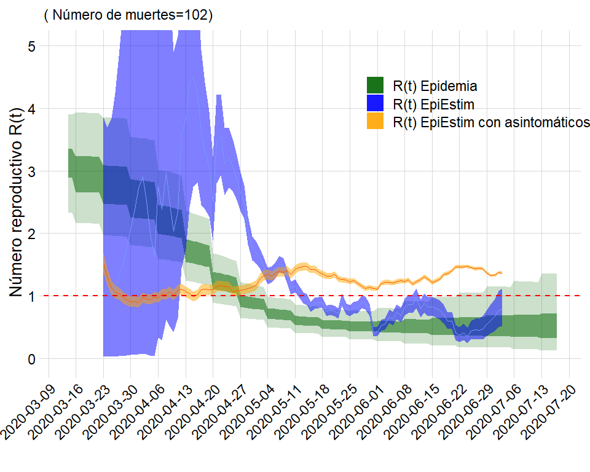

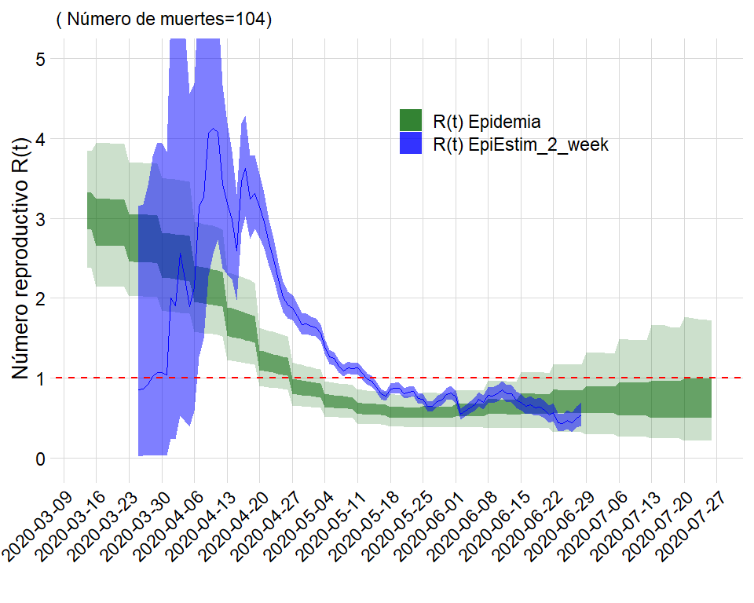

## Comparación para Cali

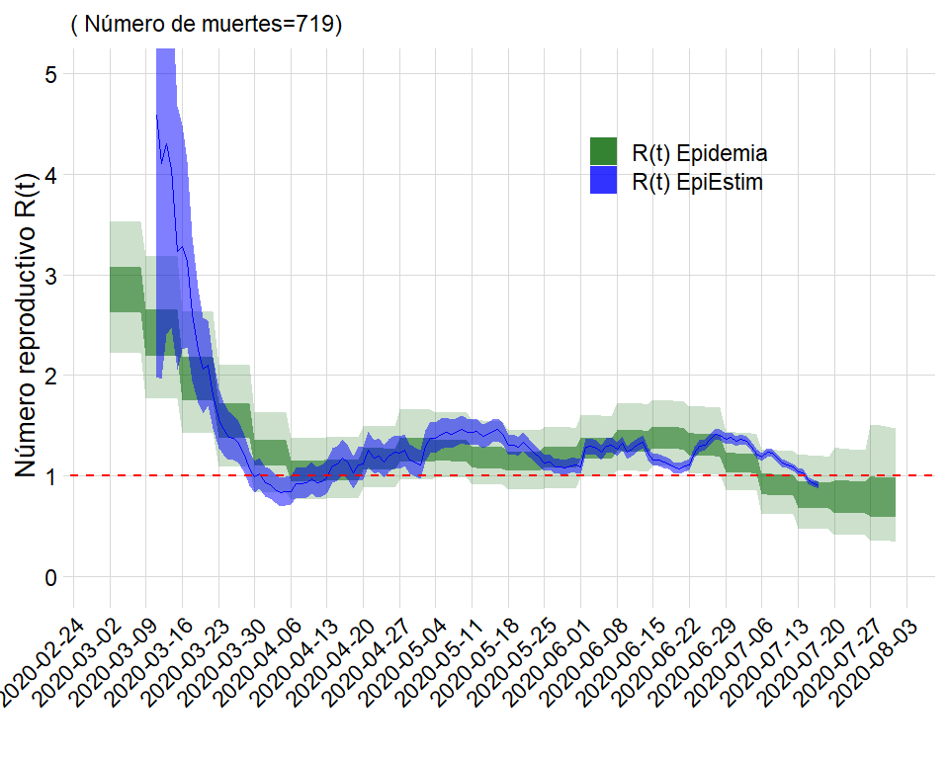

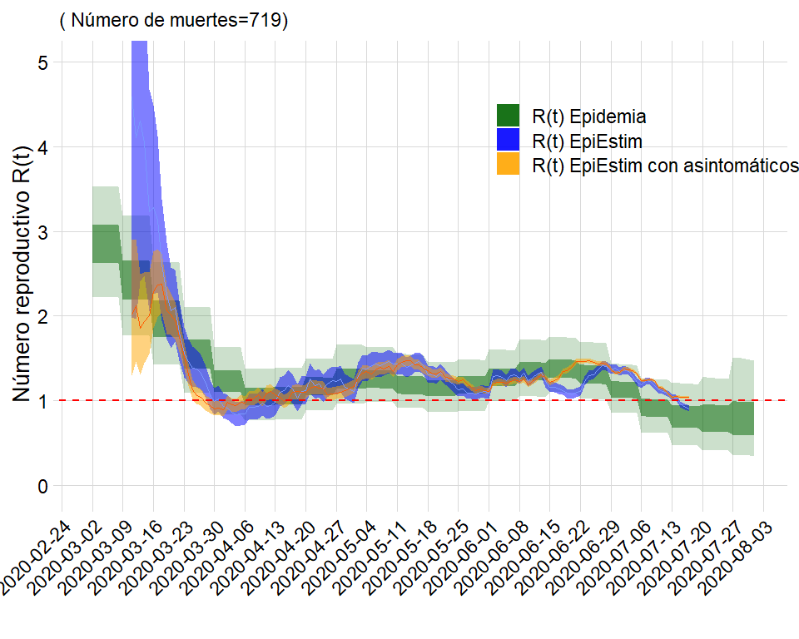

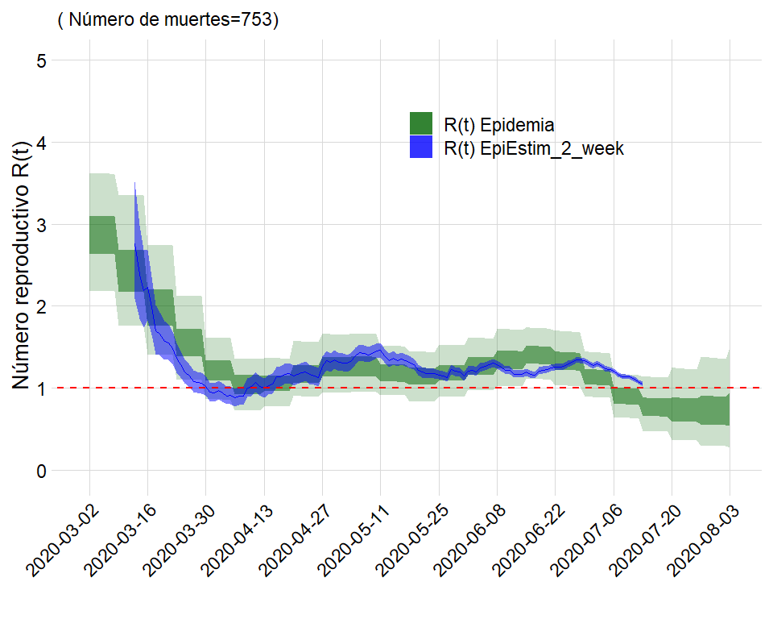

## Comparación para Valle del Cauca

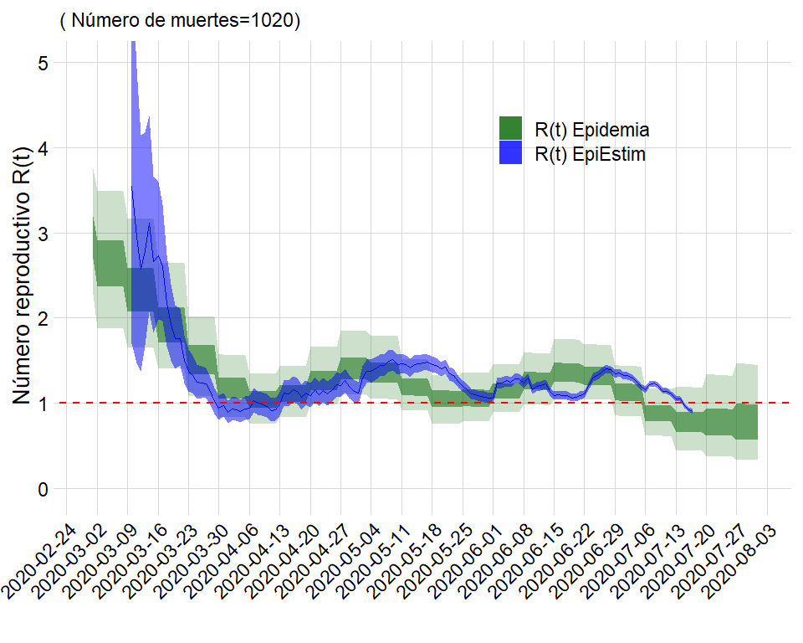

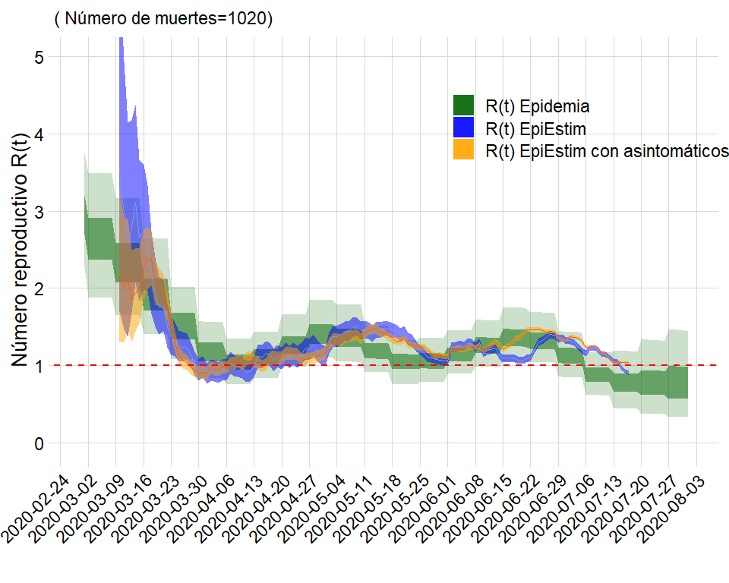

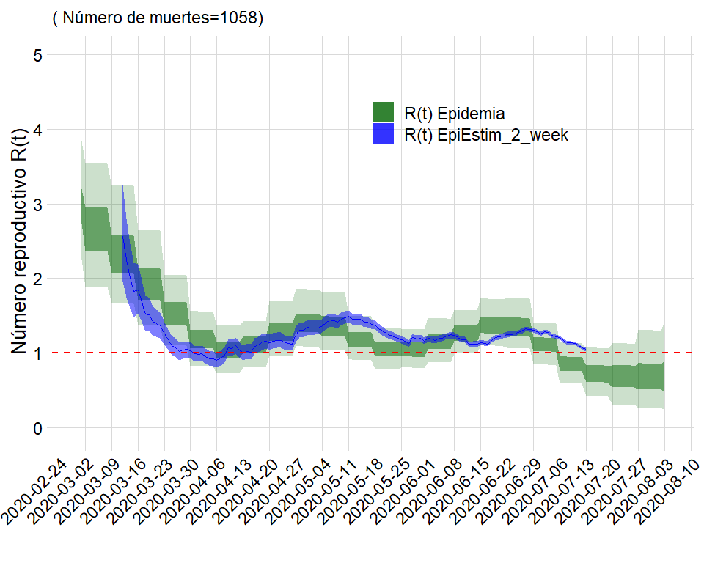

## Comparación para Medellín

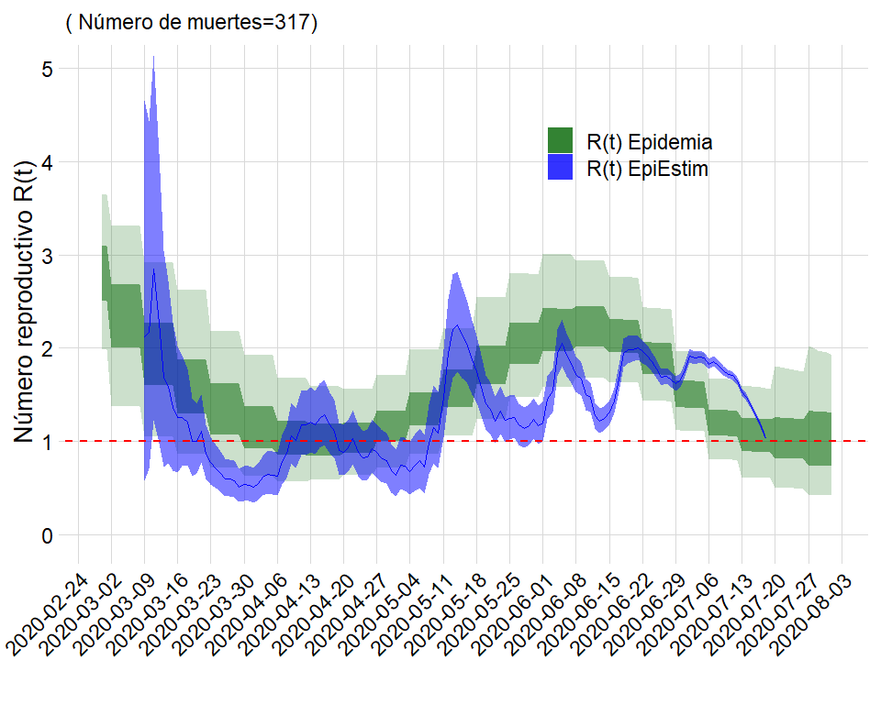

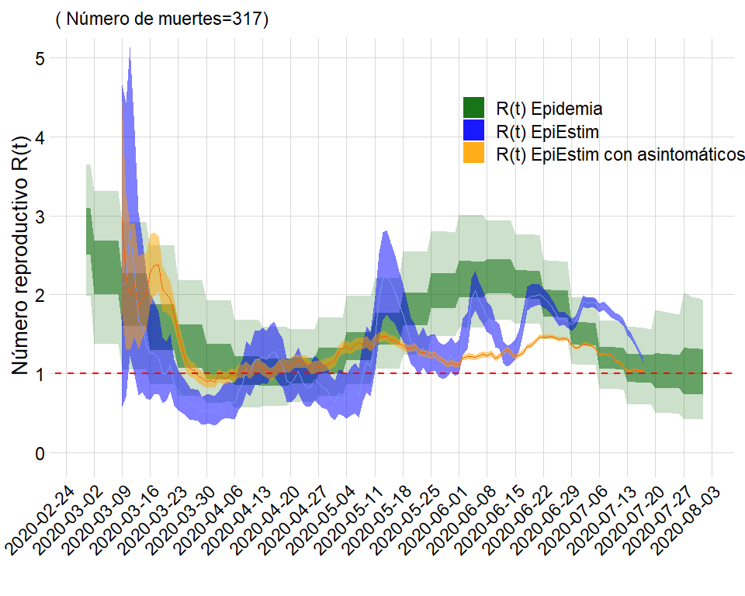

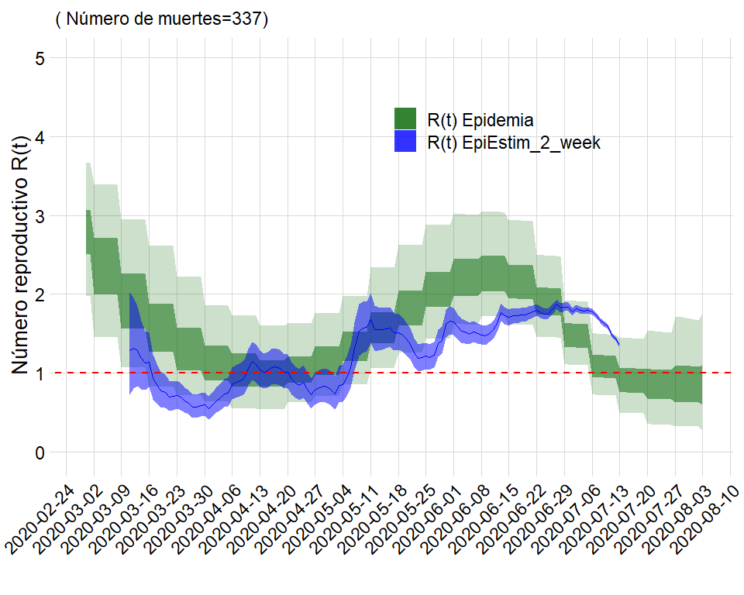

## Comparación para Antioquia

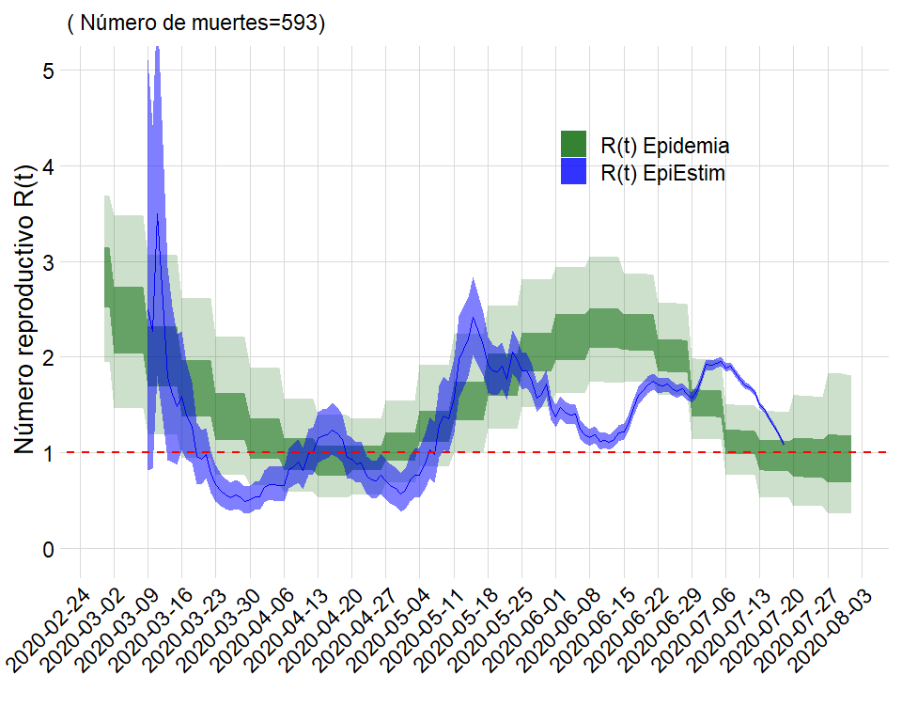

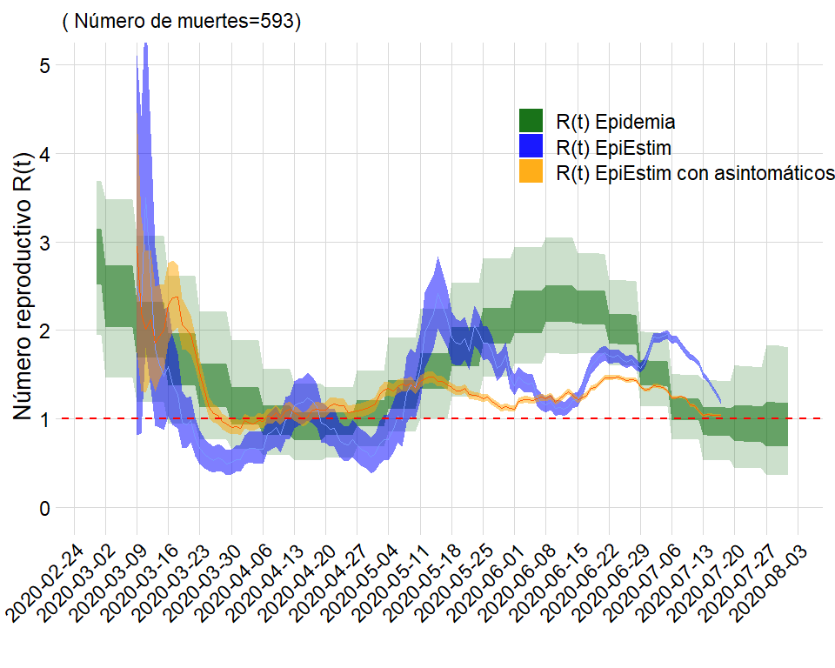

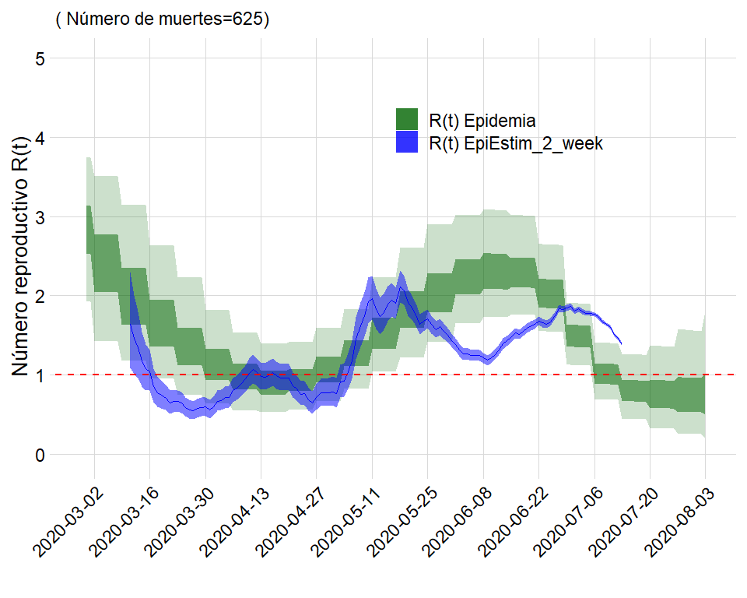

## Comparación para Meta

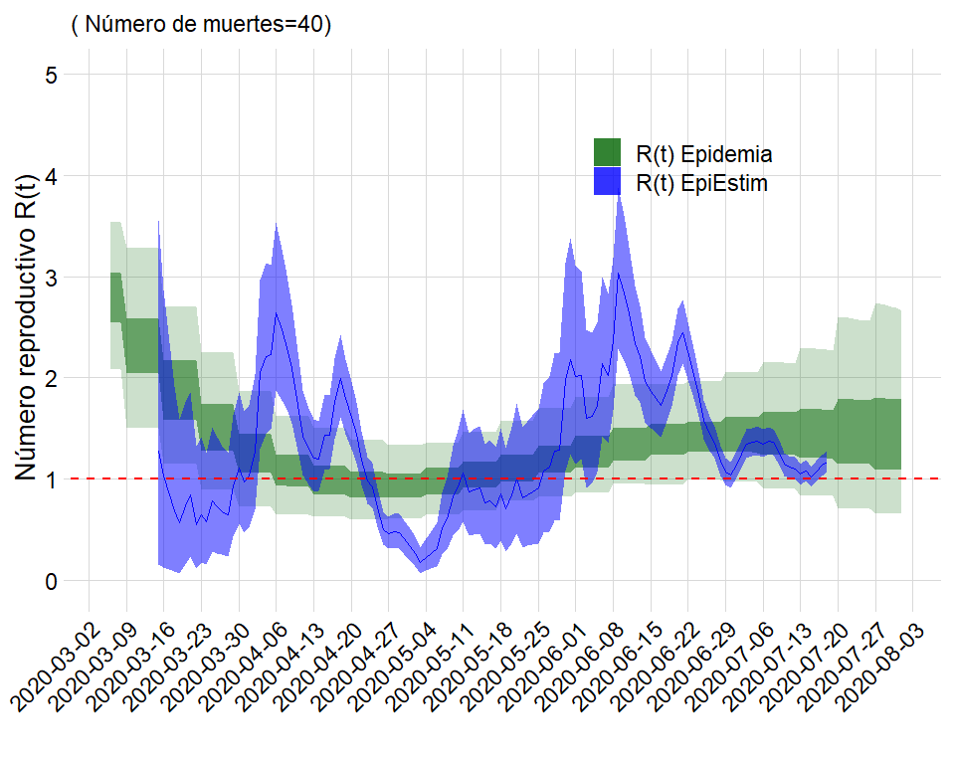

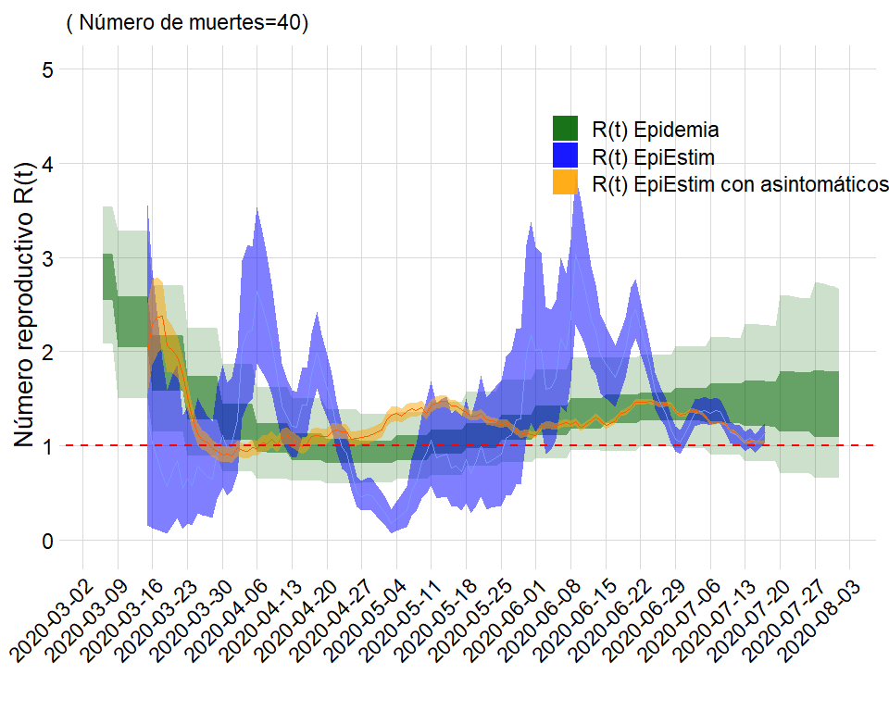

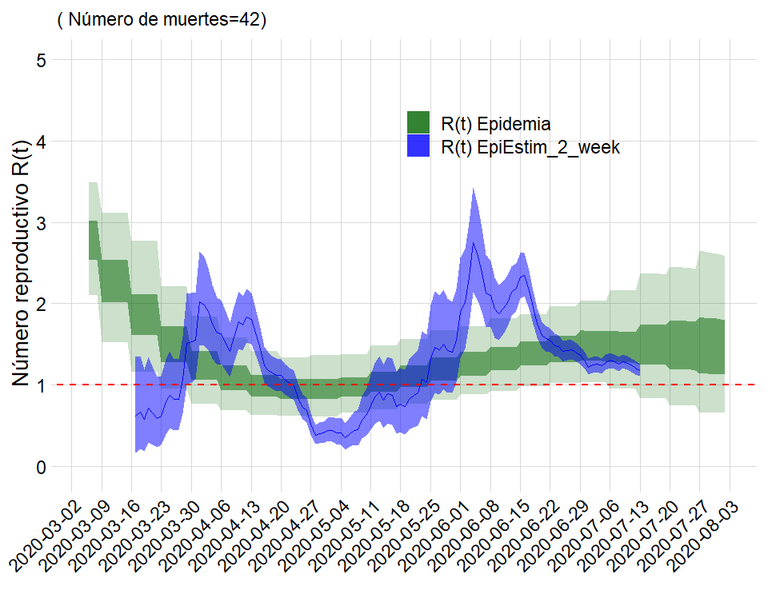

## Comparación para Boyacá

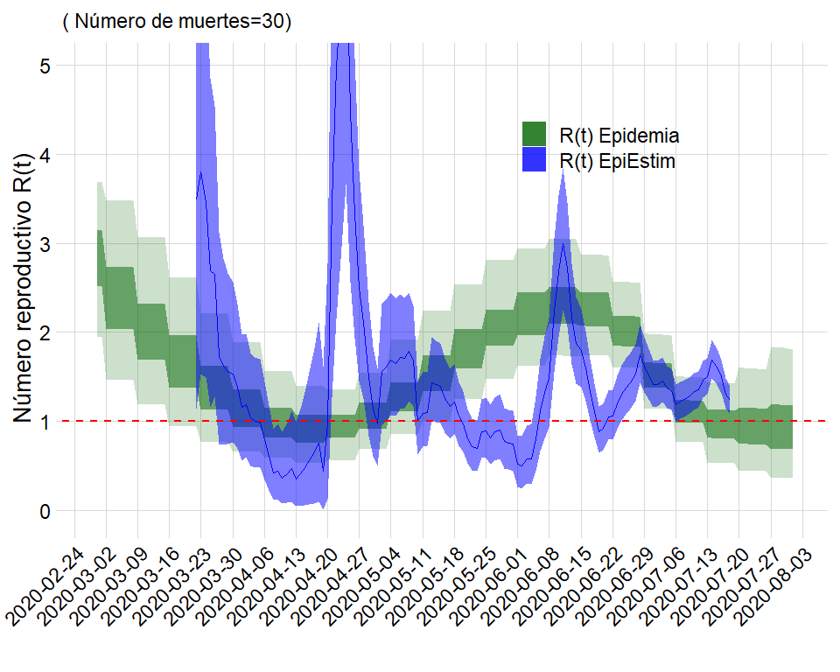

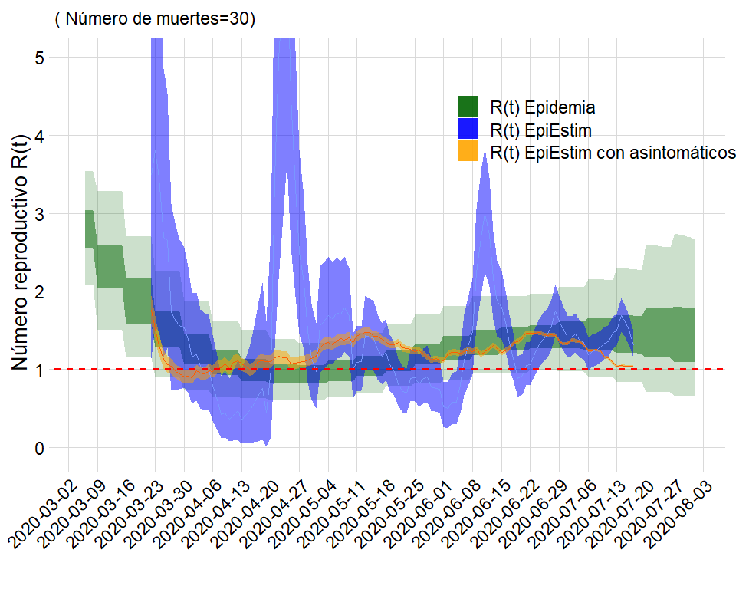

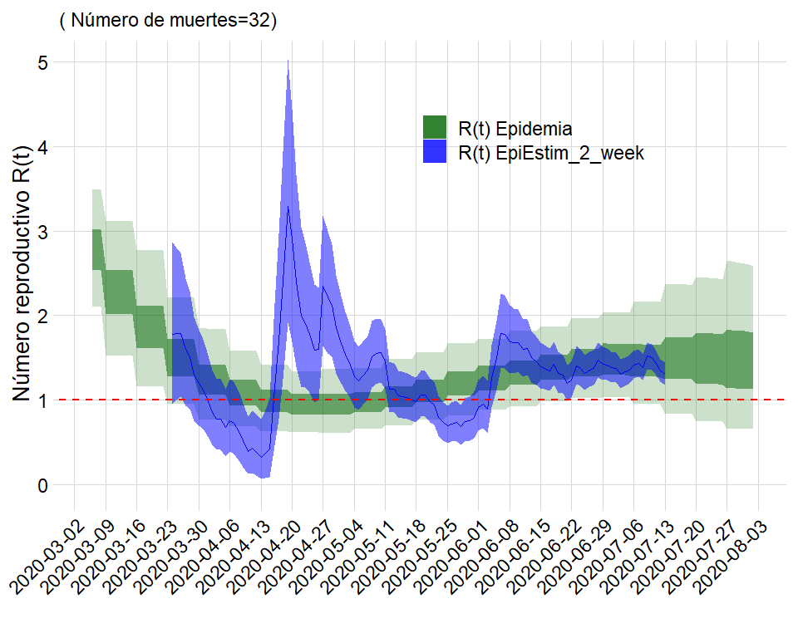

## Comparación para Chocó

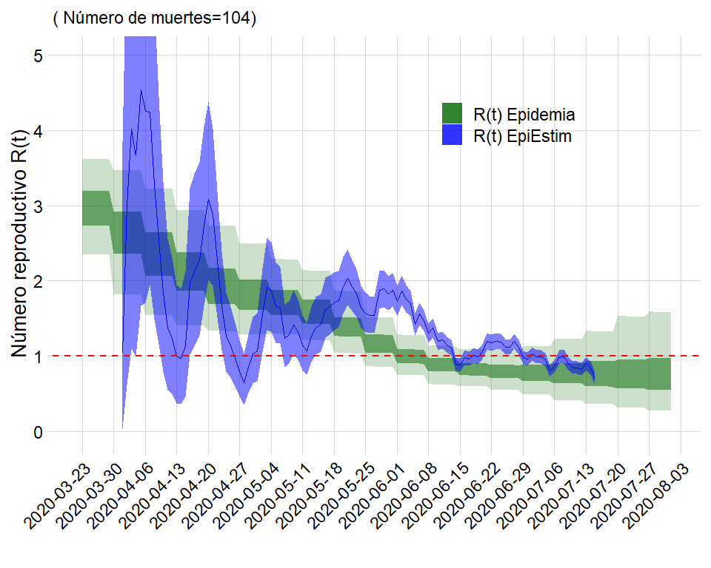

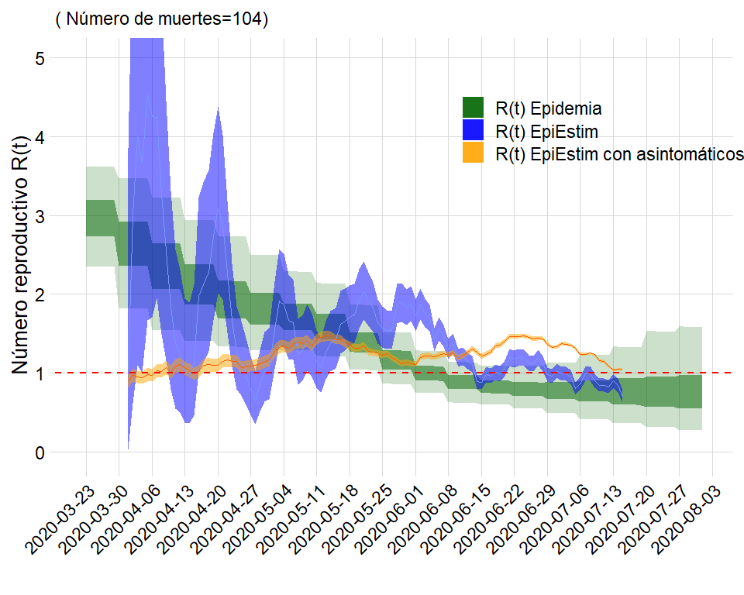

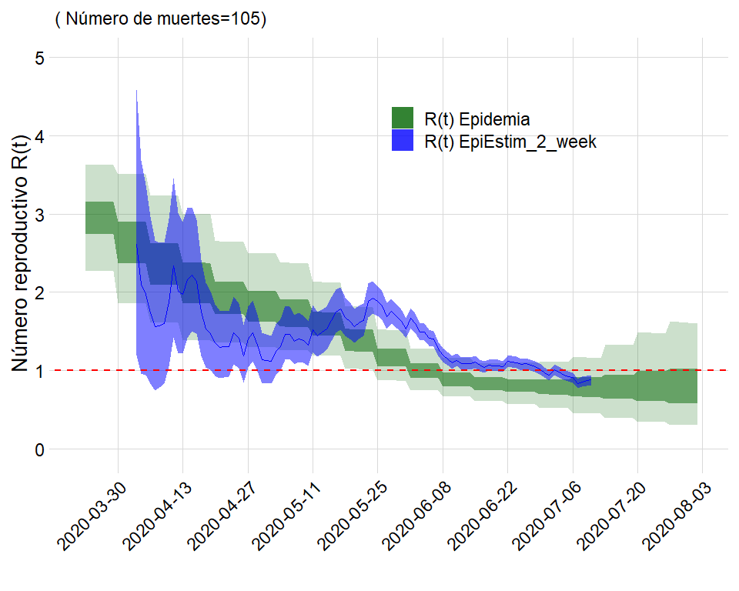

## Tasas de ataque

## rangos_age Bogotá Cali Medellín Atlántico Valle Bolívar  
## 1 pop_0_4 0.9489999 0.9388422 0.9565837 0.9206722 0.9317420 0.9092230  
## 2 pop_5_9 0.9829776 0.9809170 0.9836623 0.9789175 0.9796223 0.9773433  
## 3 pop_10_14 0.9904155 0.9890615 0.9902890 0.9878962 0.9880815 0.9873593  
## 4 pop_15_19 0.9777695 0.9761790 0.9764114 0.9746807 0.9756643 0.9739050  
## 5 pop_20_24 0.8573110 0.8711103 0.8581582 0.8669888 0.8739326 0.8670440  
## 6 pop_25_29 0.8437688 0.8689592 0.8462285 0.8655521 0.8759881 0.8711685  
## 7 pop_30_34 0.8349084 0.8577294 0.8361973 0.8554895 0.8652277 0.8632876  
## 8 pop_35_39 0.9022464 0.9205565 0.9067000 0.9200011 0.9258678 0.9289719  
## 9 pop_40_44 0.8425595 0.8576707 0.8535732 0.8643854 0.8628527 0.8734983  
## 10 pop_45_49 0.8693625 0.8745041 0.8759472 0.8856637 0.8777941 0.8897897  
## 11 pop_50_54 0.8592108 0.8582045 0.8551646 0.8770650 0.8623029 0.8824431  
## 12 pop_55_59 0.7803535 0.7765252 0.7711897 0.7954132 0.7799817 0.8031580  
## 13 pop_60_64 0.8170124 0.8057954 0.8036827 0.8354687 0.8093392 0.8446768  
## 14 pop_65_69 0.7995128 0.7824188 0.7811592 0.8167228 0.7850850 0.8233853  
## 15 pop_70_74 0.7898755 0.7617158 0.7668154 0.8028774 0.7636823 0.8046410  
## 16 pop_75_m 0.7811809 0.7390451 0.7578905 0.7974862 0.7450768 0.7871857  
## Boyacá Chocó Meta Amazonas Antioquia  
## 1 0.9327861 0.8849681 0.9222828 0.8649103 0.9410006  
## 2 0.9796183 0.9735296 0.9786974 0.9710045 0.9814495  
## 3 0.9879557 0.9846674 0.9874392 0.9836316 0.9889857  
## 4 0.9757213 0.9711701 0.9744572 0.9714387 0.9762047  
## 5 0.8779999 0.8641208 0.8690948 0.8734163 0.8659827  
## 6 0.8850534 0.8730681 0.8692990 0.8818563 0.8589206  
## 7 0.8701564 0.8657635 0.8574926 0.8740732 0.8469276  
## 8 0.9248016 0.9392620 0.9191385 0.9411841 0.9131336  
## 9 0.8548067 0.8964432 0.8592763 0.9008149 0.8585743  
## 10 0.8734964 0.9109050 0.8811106 0.9145953 0.8795316  
## 11 0.8634944 0.9177597 0.8758672 0.9236136 0.8618836  
## 12 0.7829236 0.8303631 0.7987489 0.8515516 0.7788305  
## 13 0.8104373 0.8722750 0.8423734 0.9064024 0.8129585  
## 14 0.7834181 0.8578562 0.8271138 0.8888169 0.7918779  
## 15 0.7579430 0.8514970 0.8118083 0.8826162 0.7778836  
## 16 0.7296098 0.8855101 0.8064591 0.8326299 0.7724026