Problem 1

1. Each of the following 20 spectrograms represents an audio clip for a recording of me saying “testing one two three”. The spectrograms can be separated into groups each with a different window size increasing from 5ms, to 10ms, 25ms, 50ms, and 100ms. Within each group, four different FFT sizes were used by padding the windowed data to match a data size matching an increasing power of two.

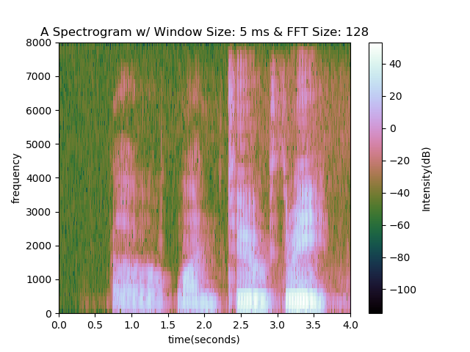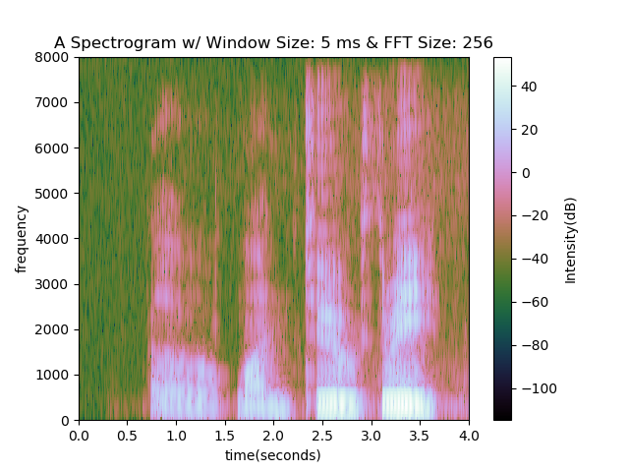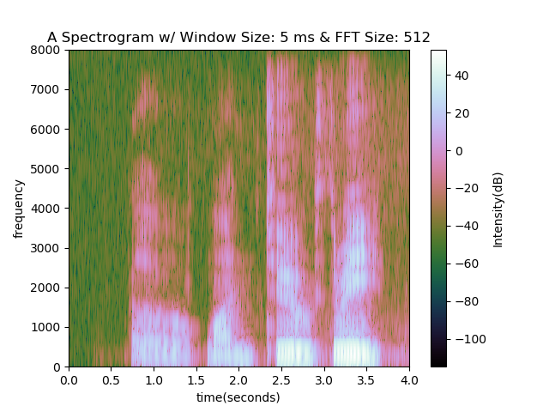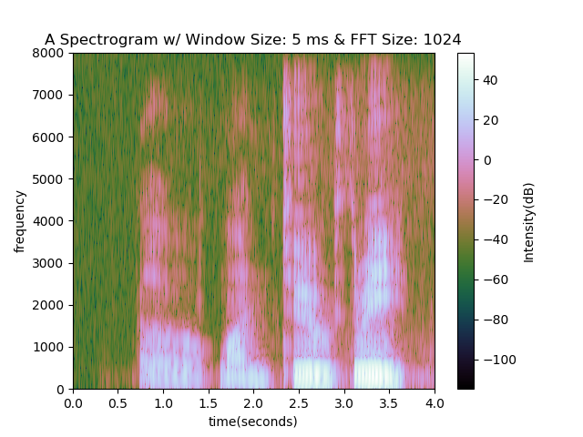

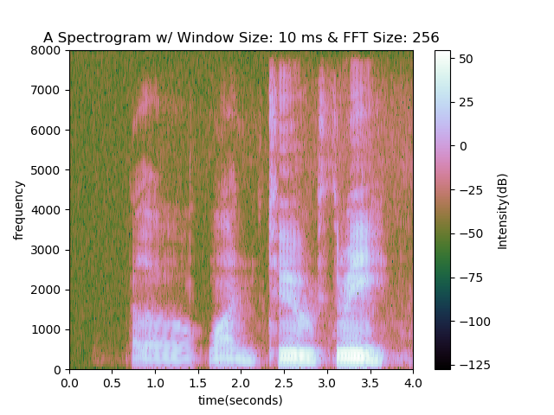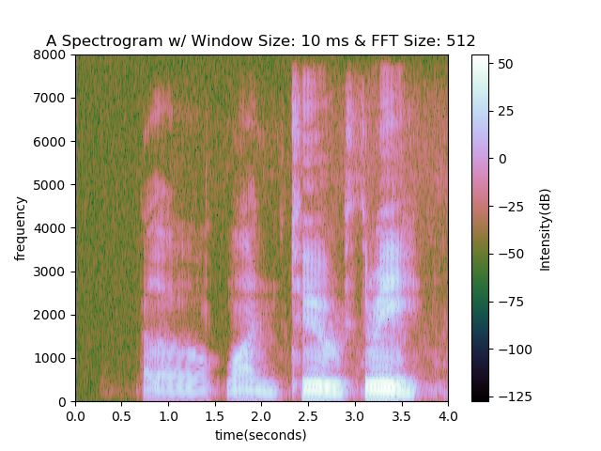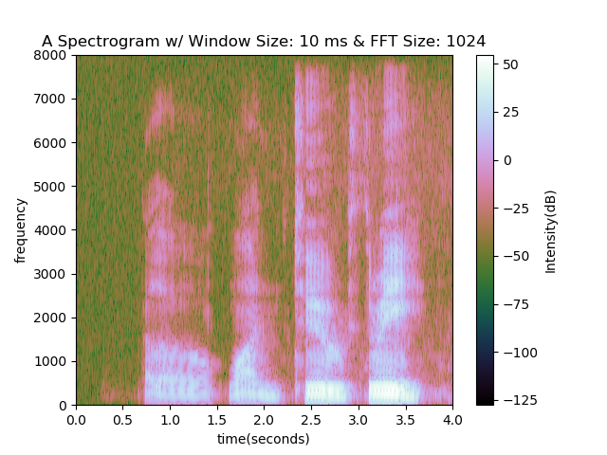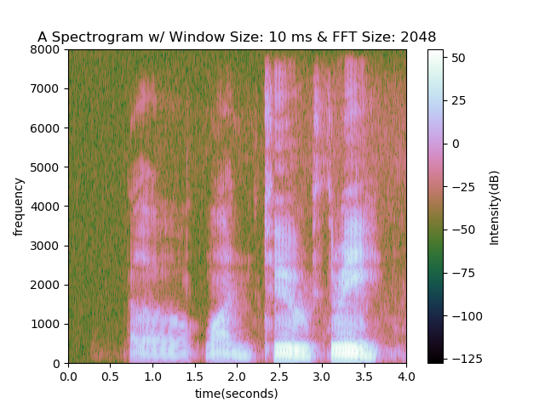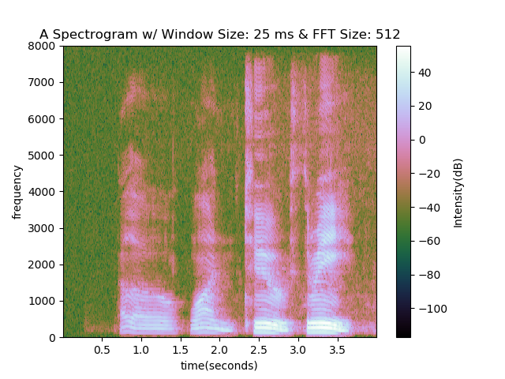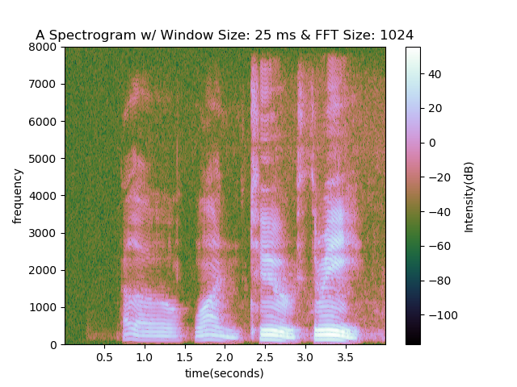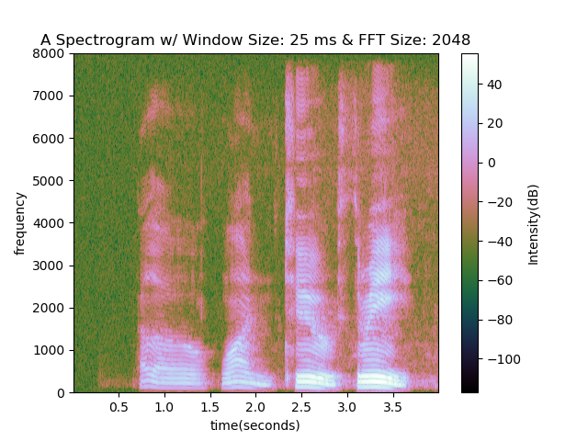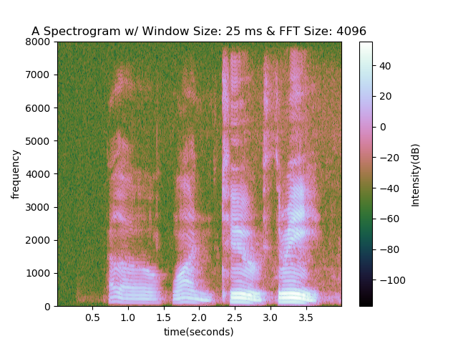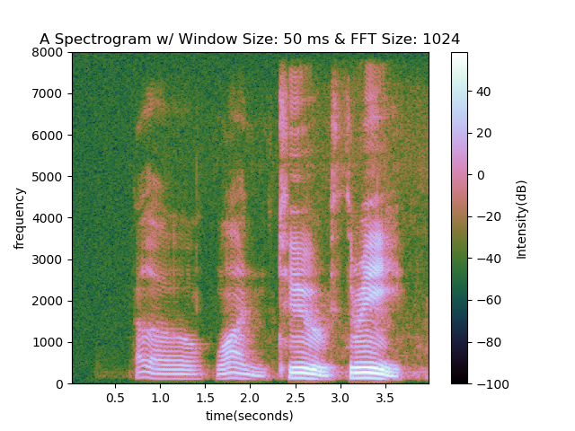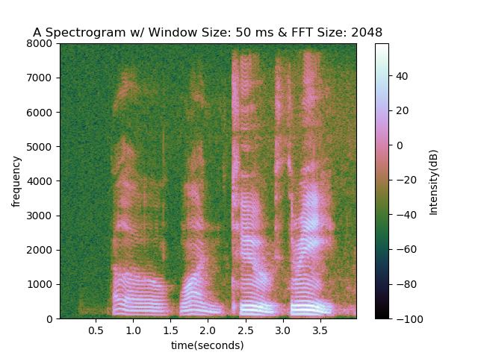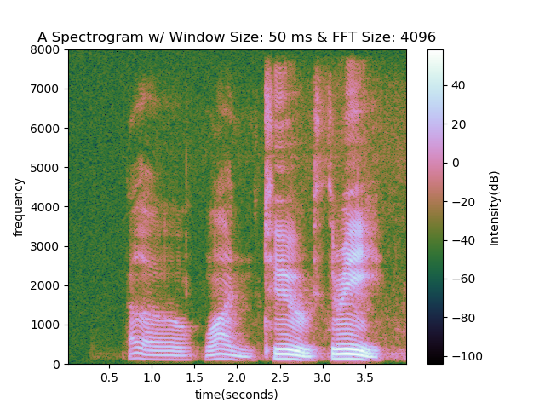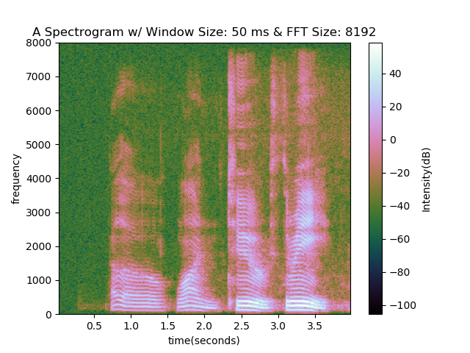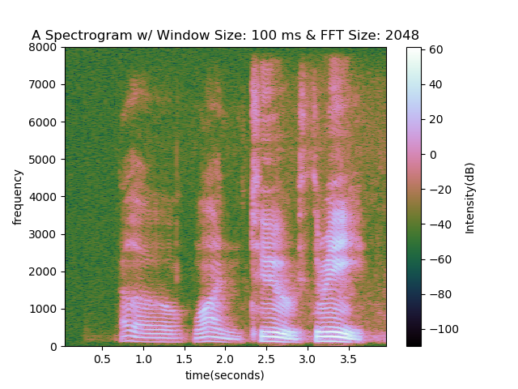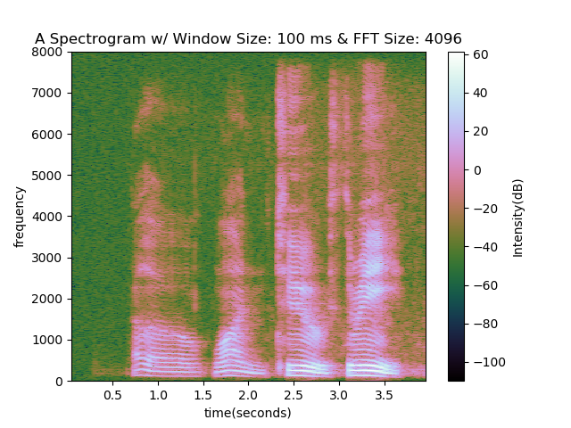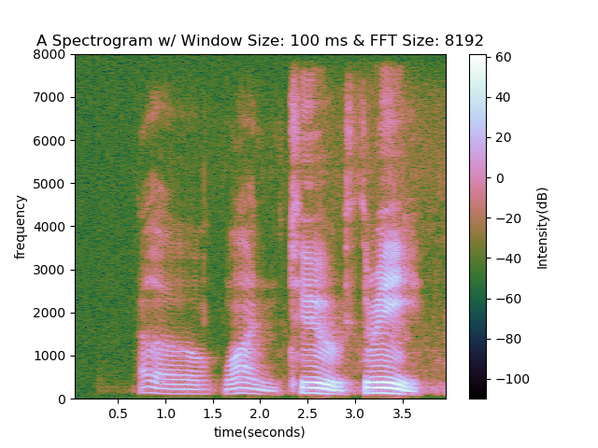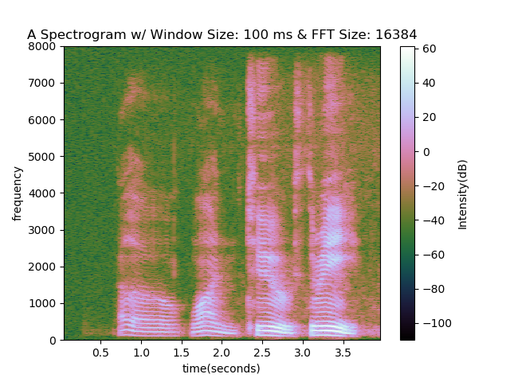

1. The following is a grid of all the spectrograms in a single figure. Each row represents a different window size with the top row using a 5ms window and the bottom row using a 100ms window. Each column represents a different FFT size with the left most column using the smallest power of two that is also bigger than the windowed sample size.

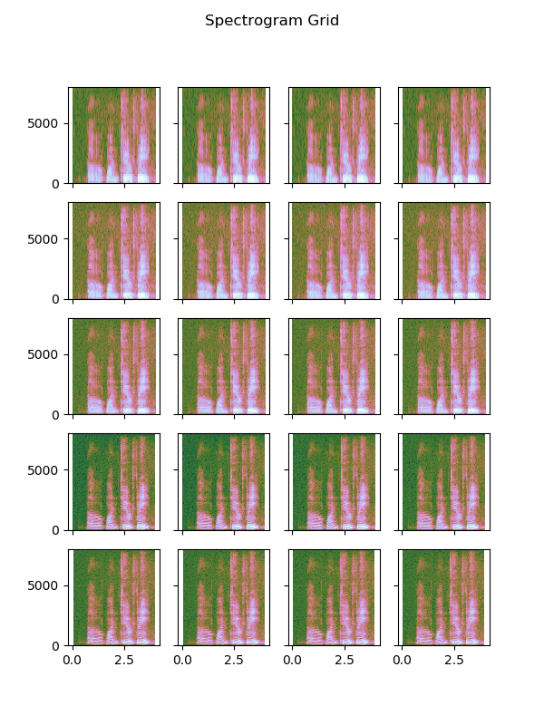

1. When using small window sizes, the frequency resolution seems to be lower. Many of the harmonic features that can be seen with the larger window sizes can’t be seen with the smaller window size. The features seem to blur together.
2. The differences between the graphs that used the same window size but different FFT sizes seemed to be very small. There were small areas occasionally that seemed to have some slight differences in how the intensity varies, but there were no major differences that would prevent me from visually differentiating one spectrogram from another as long as the window sizes were the same.

Problem 2

1. A
2. B
3. C

Problem 3

Can use python fft

Create own: speech windowing, calling fft, taking magnitudes, mel-warping, avging fft magnitude outputs, log transforms, calling ifft transform (same as dct), compare delta features.

1. A
2. I used a hamming window function:

Where N = the width of the window which in this case is 25ms or 400 sample points.

1. C
2. D
3. E
4. F
5. g