Andrew Trlica

May 25, 2015

**DRAFT**

*Methodology for meta-analysis of impact of enhanced efficiency fertilizers on corn yield in Midwest*

[Assuming there will be material already written on the database construction]

**Analysis and data**

Data on study results were taken from the database prepared during the systematic review portion of this study (Supplemental). All analysis was performed using the R software application (ref). All R scripts for data preparation and calculations are provided in Supplemental information.

**Calculation of effect sizes**

The meta-analysis considered the effect on corn yield of fertilizer with efficiency enhancing products (enhanced efficiency fertilizer, EEF) to the same fertilizer sources without the enhancement products (standard fertilizer, SF). Because all yield measurements were made on the same scale and were of comparable magnitude, the mean difference between EEF and non-EEF treatments was used as the measure of effect size (need ref for these two equations):

**D = X.barEEF–X.barSF**

The variance of *D* was calculated not assuming similar variances for each result mean:

**S2D = S2EEF/nEEF + S2SF/nSF**

The database of studies in this meta-analysis recorded mean and dispersion of results at the level of the individual experimental units, and studies often reported many results representing many combinations of several experimental parameters. The effect size *D* was calculated using two different approaches:

(1) Matching yield results within each study between experiments using EEF and identical experimental conditions using SF (“matched” effect sizes);

(2) Within each study, calculating composite means and variances across all experimental conditions for each EEF versus the corresponding SF source alone (“composite” effect sizes).

Under the matched-effects approach within each study the reported means of EEF and SF results were matched across 16 experimental parameters: Total N rate, fall N rate, spring N rate, N rate at planting/emergence, N rate for side-dress post-emergence, Second split N rate, third split N rate, application timing, split N applications, fall vs. spring application, N placement, N placement (second), planting date, county, rotation, and tillage.

Under the composite-effects approach within each study the reported means were averaged with weighting based on the number observations. Composite variances were calculated as the pooled variance of the results:

**S2pooled = Σ[(ni-1) × S2i] / Σ(ni-1)**

Under the matching approach any results reported under identical experimental conditions within a study were also combined using the same compositing approach as above to determine a single mean and variance.

A log response ratio was also calculated as an effect size following the two means comparison methods described above (Supplemental).

*Alternate log response ratio approach (Supplemental)*Given that the scale of the effects of EEF might have varied with overall yield levels, a parallel meta-analysis was conducted using the log response ratio (LRR) of yields as a metric of effect size. The LRR was calculated as follows:

**LRR = Log(X.barEEF/X.barSF)**

A positive LRR indicated greater proportional yield under EFF. The variance of the LRR was calculated following Hedges et al. (1999):

**S2LRR = S2EEF/(nEEF ×X.bar2EEF) + S2SF/(nSF ×X.bar2SF)**

*Yield with EEF under lower N conditions*

To specifically analyze the effect of EEF on yield under low N conditions, a separate meta-analysis was conducted using the above approaches restricted to experiments with < 150 lbs. N ac-1. This cutoff represents the approximately lower 60% of experiments recorded in this study with calculable effect sizes.

**Meta-analysis approach**

A random-effects meta-analysis was performed within each fertilizer source/efficiency product combination (ref). The variance of true effect sizes (T2) was estimated using the technique of DerSimmonian and Laird (1986). Weights of the effect size were estimated as:

**Wi* = 1/(Si2D + T2)**

The 95% confidence interval of the summary effect of each EEF/SF category was estimated using the Z distribution (ref).

**Results**

Results of the meta-analysis using the matching approach showed that within each fertilizer source and EEF combination there was considerable range of effect, with each EEF type showing both negative and positive impact on corn yield (Table 1). Urea with NBPT, NBPT+DCD, and polymer-coated urea showed summary effects significantly greater than zero (p < 0.05). The urea+NBPT summary effect was based on 39 paired identical experimental observations but all of these were reported within a single study. Across all fertilizers, use of enhanced efficiency products showed both positive and negative effect sizes (i.e. there were records of increased and decreased corn yield with use of EEF in all fertilizer categories). Summary effects in general tended to be small but positive, with confidence intervals that included zero.

Table 1: Results of meta-analysis on paired effect sizes (mean difference in yield). Figures include number of studies and effect sizes obtained for each analysis category, Effect size (D, Mg ha-1) and Variance (S2D), T2 (estimated true variance in effect sizes), I2 (% variation due to variance in true effect size), Q (observed variation : within-study error), p value and confidence interval for summary effects, and observed range of effect sizes. Summary effect significantly different from 0 (p < 0.05) labeled with *.

|  |  |  |  |  |  |  |  |  |  |  |  |  |  |  |  |  |  |  |  |  |
| --- | --- | --- | --- | --- | --- | --- | --- | --- | --- | --- | --- | --- | --- | --- | --- | --- | --- | --- | --- | --- |
| **Fertilizer/EEF** |  | |  | |  | |  | |  | |  | |  | | **95% CI** | | | **ES Range** | | |
| **# effects (studies)** | **Summary effect (D)** | | **S2D** | | **T2** | | **I2** | | **Q** | | **p(Z ≠ 0)** | | **Low** | | **High** | **Low** | | **High** |
| **Urea** |  |  | |  | |  | |  | |  | |  | |  | |  |  | |  |
| *PCF* | 100 (18) | *0.144 | | 0.005 | | 0.160 | | 37.2% | | 157.5 | | 0.047 | | 0.002 | | 0.287 | -1.927 | | 1.834 |
| *nitrapyrin* | 31 (5) | 0.054 | | 0.006 | | 0.061 | | 37.2% | | 47.8 | | 0.480 | | -0.097 | | 0.205 | -0.750 | | 1.200 |
| *NBPT* | 39 (1) | *0.319 | | 0.010 | | 0 | | 0% | | 32.9 | | 0.001 | | 0.123 | | 0.515 | -1.180 | | 1.620 |
| *NBPT+DCD* | 62 (8) | *0.226 | | 0.009 | | 0.084 | | 16.5% | | 73.1 | | 0.017 | | 0.041 | | 0.411 | -1.785 | | 1.730 |
| *S.R.* | 14 (5) | 0.206 | | 0.020 | | 0 | | 0% | | 11.8 | | 0.140 | | -0.067 | | 0.480 | -0.450 | | 2.620 |
| **UAN** |  |  | |  | |  | |  | |  | |  | |  | |  |  | |  |
| *nitrapyrin* | 14 (3) | -0.030 | | 0.018 | | 0 | | 0% | | 8.9 | | 0.823 | | -0.295 | | 0.235 | -0.535 | | 0.880 |
| *NBPT* | 53 (2) | 0.097 | | 0.005 | | 0 | | 0% | | 30.4 | | 0.156 | | -0.037 | | 0.232 | -1.670 | | 2.000 |
| *NBPT+DCD* | 46 (4) | 0.072 | | 0.015 | | 0.265 | | 42.9% | | 78.8 | | 0.564 | | -0.172 | | 0.315 | -1.310 | | 1.320 |
| *S.R.* | 2 (1) | -0.084 | | 0.164 | | 0.103 | | 30.0% | | 1.4 | | 0.836 | | -0.877 | | 0.710 | -0.590 | | 0.240 |
| *thiosulfate* | 39 (1) | -0.132 | | 0.012 | | 0.103 | | 23.6% | | 49.7 | | 0.233 | | -0.348 | | 0.085 | -1.130 | | 1.400 |
| **AA** |  |  | |  | |  | |  | |  | |  | |  | |  |  | |  |
| *nitrapyrin* | 21 (14) | 0.150 | | 0.007 | | 0.015 | | 11.5% | | 22.6 | | 0.066 | | -0.010 | | 0.311 | -0.500 | | 1.300 |

A examination of the meta-analysis results using the composite effect sizes showed less extreme summary effects in general compared to the analysis of the matched effect sizes (Figures 1–3). The single study that examined UAN with NBPT showed an effect significantly different from zero, but no other summary effects were significant at the p < 0.05 threshold. The difference in level of significance between summary effects calculated from paired and composite effect sizes likely reflects the larger number of experiment pairs and effect sizes obtained using the matching approach as well as the potentially more sensitive measures of effect size possible when results were matched to similar experimental conditions within each study.

The range of effect sizes implied comparative losses in yield of up to 32 bu ac-1 to gains of approximately 36 bu ac-1 with use of EEF. However, the mean effect of the use of EEF was comparatively small: Approximately +0.9–5.1 bu ac-1 with urea, -3.0–1.6 bu ac-1 with UAN, and +2.4 bu ac-1 with AA.

Results of meta-analysis using the matched effect sizes calculated as LRR were in most respects similar to the results using the mean difference (Table S1, supplemental). Unlike the summary effect for mean difference, the summary effect of LRR for Urea+PCF was non-significant (p > 0.06). The summary LRR for AA+nitrapyrin was nearly significant (p > 0.05) in contrast to slightly exceeding the significance threshold in the mean difference results (p > 0.06). As in the mean difference results, the summary LRR for Urea+NBPT and Urea+NBPT+DCD were positive and significantly different from zero. In agreement with the mean difference results, the range of effect sizes and 95% confidence interval of the summary effects (as Response Ratio) generally spanned either side of 1 (both positive and negative impacts on yield were measured relative to non-EEF).

Restricting the meta-analysis only to results of experiments in which less than 150 lbs N ac-1 total was applied per season, summary effects calculated from matched effect sizes were in general somewhat lower than in the analysis of the full data set. None of the summary effects in this low-N analysis were significantly different from zero (Supplemental).

Table 2: Results of meta-analysis on paired effect sizes using log response ratio (LRR) Figures include number of studies and effect sizes obtained for each analysis category, effect size (LRR) and variance (S2LRR), T2 (estimated true variance in effect sizes), I2 (% variation due to variance in true effect size), Q (observed variation : within-study error), p value and confidence interval for summary effects, and observed range of effect sizes (expressed as Response Ratios (RR) for ease of interpretation). Summary effect significantly different from 0 (p < 0.05) labeled with *.

|  |  |  |  |  |  |  |  |  |  |  |  |
| --- | --- | --- | --- | --- | --- | --- | --- | --- | --- | --- | --- |
| **Fertilizer/EEF** |  |  |  |  |  |  |  | **RR 95% CI** | | **RR range** | |
| **# effects (studies)** | **Summary effect**  **(LRR x 10-2)** | **S2LRR (x 10-4)** | **T2**  **(x 10-4)** | **I2** | **Q** | **p(Z ≠ 0)** | **Low** | **High** | **Low** | **High** |
| **Urea** |  |  |  |  |  |  |  |  |  |  |  |
| *PCF* | 100 (18) | 1.193 | 0.406 | 12.120 | 37% | 157.2 | 0.061 | 0.999 | 1.025 | 0.862 | 1.175 |
| *nitrapyrin* | 31 (5) | 0.495 | 0.421 | 4.419 | 38% | 48.3 | 0.446 | 0.992 | 1.018 | 0.934 | 1.087 |
| *NBPT* | 39 (1) | *2.774 | 0.882 | 0 | 0% | 33.3 | 0.003 | 1.009 | 1.047 | 0.904 | 1.120 |
| *NBPT+DCD* | 62 (8) | *1.979 | 0.704 | 7.270 | 18% | 74.6 | 0.018 | 1.003 | 1.037 | 0.817 | 1.139 |
| *S.R.* | 14 (5) | 1.567 | 1.235 | 0 | 0% | 12.1 | 0.159 | 0.994 | 1.038 | 0.969 | 1.218 |
| **UAN** |  |  |  |  |  |  |  |  |  |  |  |
| *nitrapyrin* | 14 (3) | -0.254 | 1.340 | 0 | 0% | 9.0 | 0.826 | 0.975 | 1.020 | 0.954 | 1.094 |
| *NBPT* | 53 (2) | 1.132 | 0.449 | 0 | 0% | 29.7 | 0.091 | 0.998 | 1.025 | 0.865 | 1.279 |
| *NBPT+DCD* | 46 (4) | 0.554 | 1.343 | 22.056 | 41% | 76.7 | 0.632 | 0.983 | 1.029 | 0.874 | 1.145 |
| *S.R.* | 2 (1) | -0.734 | 7.384 | 4.203 | 28% | 1.4 | 0.787 | 0.941 | 1.047 | 0.965 | 1.019 |
| *thiosulfate* | 39 (1) | -1.538 | 1.151 | 9.613 | 23% | 49.4 | 0.152 | 0.964 | 1.006 | 0.880 | 1.194 |
| **AA** |  |  |  |  |  |  |  |  |  |  |  |
| *nitrapyrin* | 21 (14) | 1.240 | 0.409 | 0.766 | 9% | 22.1 | 0.053 | 1.000 | 1.025 | 0.955 | 1.103 |

Table 3: (Supplemental Information) Summary effects for experiments with lower N rate (< 150 lbs N ac-1)

|  |  |  |  |  |  |  |  |  |  |  |  |
| --- | --- | --- | --- | --- | --- | --- | --- | --- | --- | --- | --- |
|  |  |  |  |  |  |  |  | **95% CI** | | **ES Range** | |
| **Fertilizer/EEF** | **Effects N** | **Summary effect (D)** | **S2D** | **T2** | **I2** | **Q** | **p(Z ≠ 0)** | **Low** | **High** | **Low** | **High** |
| **Urea** |  |  |  |  |  |  |  |  |  |  |  |
| *PCF* | 50 (11) | 0.043 | 0.005 | 0.014 | 0.052 | 51.703 | 0.556 | -0.100 | 0.186 | -1.260 | 0.970 |
| *nitrapyrin* | 30 (4) | 0.069 | 0.007 | 0.066 | 0.376 | 46.468 | 0.395 | -0.090 | 0.227 | -0.750 | 1.200 |
| *NBPT* | 20 (1) | 0.259 | 0.019 | 0.000 | -0.604 | 11.848 | 0.059 | -0.010 | 0.529 | -1.040 | 0.900 |
| *NBPT+DCD* | 21 (2) | 0.126 | 0.032 | 0.253 | 0.401 | 33.402 | 0.482 | -0.225 | 0.477 | -1.490 | 1.170 |
| *S.R.* | 10 (5) | 0.170 | 0.020 | 0.000 | -0.037 | 8.677 | 0.228 | -0.107 | 0.447 | -0.450 | 2.620 |
| **UAN** |  |  |  |  |  |  |  |  |  |  |  |
| *nitrapyrin* | 14 (3) | -0.030 | 0.018 | 0.000 | -0.459 | 8.910 | 0.823 | -0.295 | 0.235 | -0.535 | 0.880 |
| *NBPT* | 23 (2) | -0.002 | 0.010 | 0.000 | -0.556 | 14.138 | 0.987 | -0.200 | 0.197 | -0.804 | 2.000 |
| *NBPT+DCD* | 20 (1) | -0.066 | 0.028 | 0.155 | 0.302 | 27.239 | 0.697 | -0.396 | 0.265 | -1.170 | 0.94 |
| *thiosulfate* | 20 (1) | -0.089 | 0.026 | 0.121 | 0.263 | 25.774 | 0.582 | -0.404 | 0.227 | -0.910 | 1.320 |
| **AA** |  |  |  |  |  |  |  |  |  |  |  |
| *nitrapyrin* | 20 (14) | 0.102 | 0.007 | 0.005 | 0.034 | 19.664 | 0.228 | -0.064 | 0.267 | -0.500 | 1.300 |

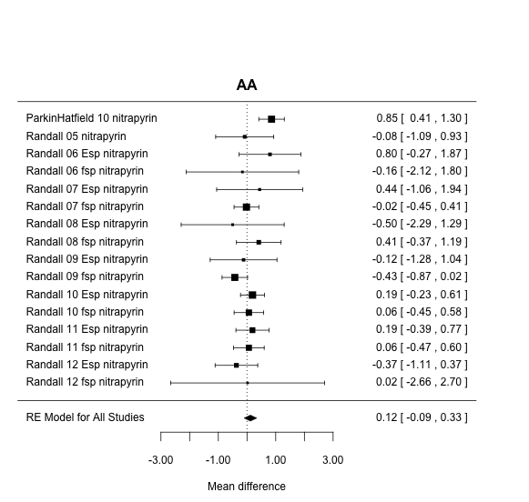

Figure 1: Forest plot of effect of EEF on corn grown with AA, means composited within studies.

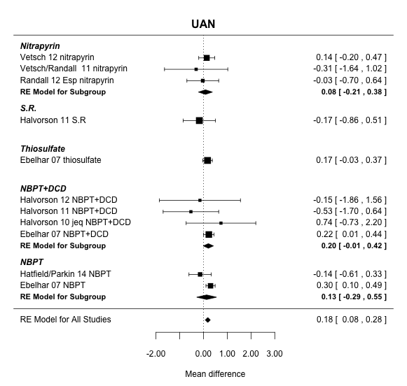

Figure 2: Forest plot of effect of EEF on corn grown with UAN, means composited within studies.

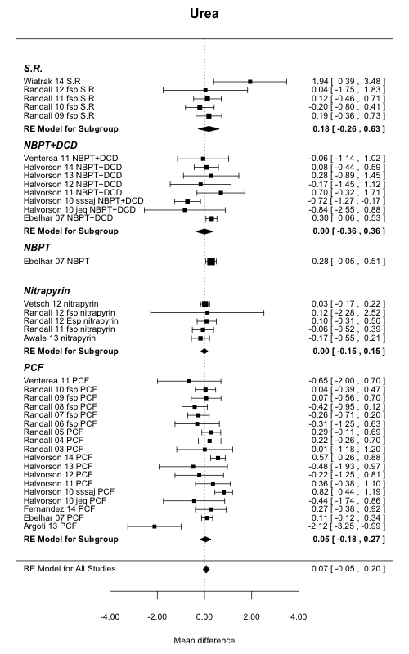

Figure 3: Forest plot of effect of EEF on corn grown with urea, means composited within studies

Hedges, L.V., Gurevich, J. and P.S. Curtis. 1999. Ecology 80(4): 1150-1156.

DerSimmonian, R. & N. Liard. 1986. Controlled Clinical Trials 7(3): 177-188.