In order to use fire and forget sounds first you select the gameObject that you want to play the sound then you click add component and then you add an audio source then you add the sound clip to the audio source and then you uncheck loop and play on awake. You also need to make a script and add
GetComponent<AudioSource>().Play();
When you want the sound to play
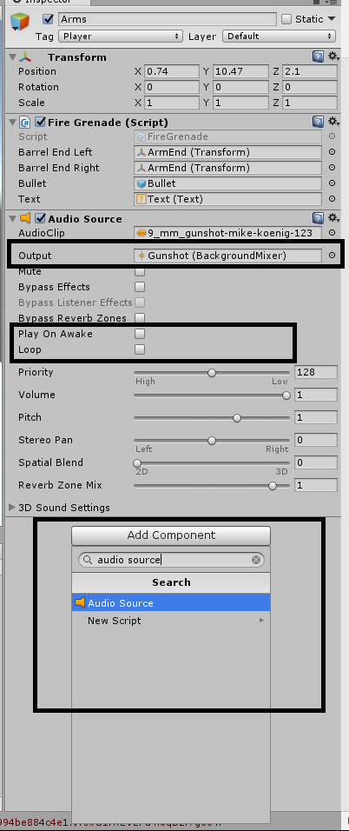
In order to loop all you have to do is check loop and play on awake on the audio source you want to loop

In order to create a mixer you need to go to the assets folder in unity's projects tab right click -> create asset -> audio mixer. In order to add a new group you right click on master and press add Group and then you select that group in your audio source. In order to change the volume of a mixer group you just have to change the slider for that group.

