**Problem #1**:

*Exercise 2 from section 7.9 of ITSL textbook*

Suppose that a curve is computed to smoothly fit a set of points using the following formula:

Where represent the m’th derivative of (and ). Provide example sketches of in each of the following scenarios.

***Answer:***

As approaches infinity, the first term (standard sum of squares term) does not matter because is dominating the equation. Because m=0 and , therefore goes to zero. Below is a sketch of as a function of x.

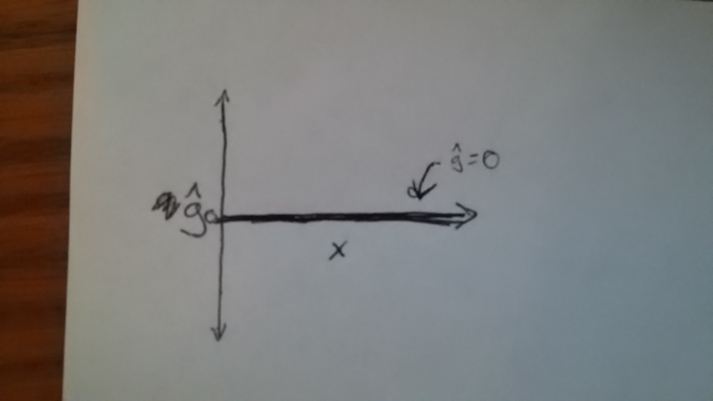

***Answer:***

As approaches infinity, the first term (standard sum of squares term) does not matter because is dominating the equation. Because m=1 and , therefore goes to a constant “c” (which may not be zero). Below is one possible sketch of as a function of x.

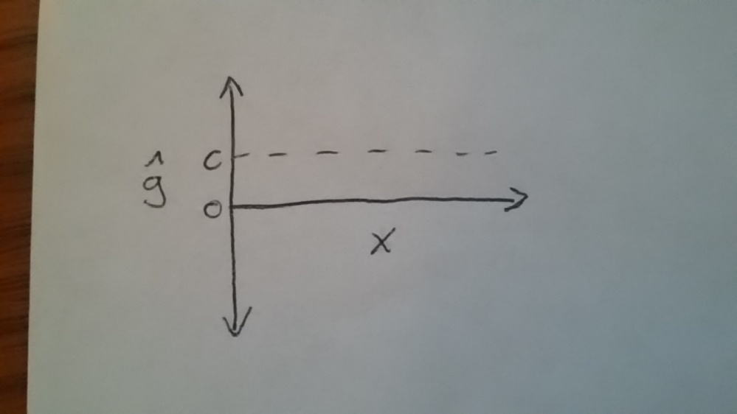

***Answer:***

As approaches infinity, the first term (standard sum of squares term) does not matter because is dominating the equation. Because m=2 and , therefore goes to a linear line of some sort (which may not have a zero slope). Below is one possible sketch of as a function of x.

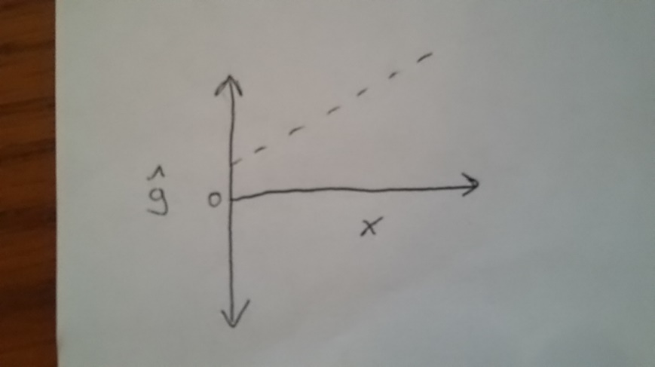

***Answer:***

As approaches infinity, the first term (standard sum of squares term) does not matter because is dominating the equation. Because m=3 and , therefore goes to a quadratic of some sort. Below is one possible sketch of as a function of x.

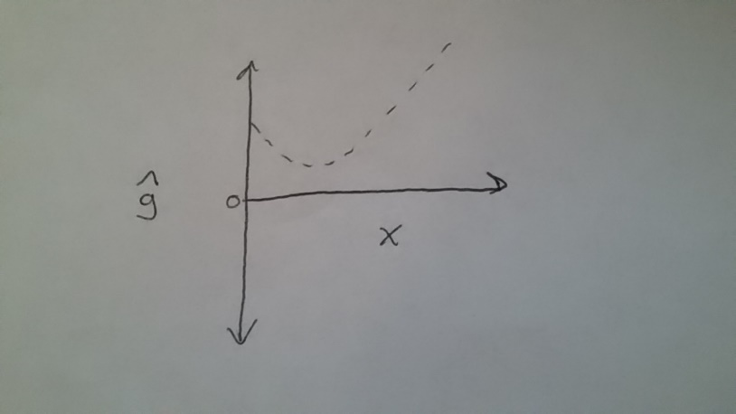

***Answer:***

As goes to zero, the smoothing term no longer plays a role in the equation. We are therefore left with the standard residual sum of squares linear regression. in the case can take on many shapes, such as a linear line. Below is one possible sketch of as a function of x.



**Problem #2**:

*Exercise 3 from section 7.9 of ITSL textbook*

Suppose we fit a curve with basis functions . We fit the linear regression model

And obtain coefficient estimates . Sketch the estimated curve between X=-2 and X=2. Note the intercepts, slopes, and other relevant information.

***Answer:***

A sketch of the curve between X=-2 and X=2 is shown below:

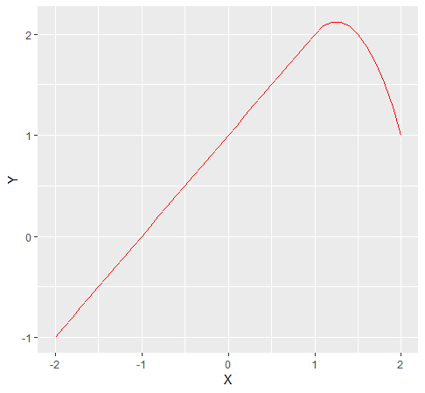

Looking at the plot above:

* the intercept term (where X=0) is Y=1
* for values where X<1, the slope of the curve above is 1
* for values where X≥1, the slope of the curve above is (5-4X)

*R-code:*

################

## Problem #2 ##

################

library(ggplot2)

X = seq(-2, 2, 0.1)

Y = rep(NA, length(X))

for(i in 1:length(X)){

if(X[i]<1){

Y[i] = 1+X[i]

}

if(X[i]>=1){

Y[i] = 1+X[i]-(2*((X[i]-1)^2))

}

}

df <- data.frame(Y,X)

## include connected line

ggplot(df, aes(x=X, y=Y)) + geom_line(color="red")

**Problem #3**:

*Modified from exercise 7 from section 7.9 of ITSL textbook*

The “Wage” data set contains a number of other features not explored in this chapter, such as marital status (maritl), job class (jobclass), and others. Explore the relationships between some of these other predictors and wage, and use non-linear fitting techniques in order to fit flexible models to the data. Create plots of the results obtained and write a summary of your findings.

***Answer:***

Shown below are box plots of “wage” by marital status:

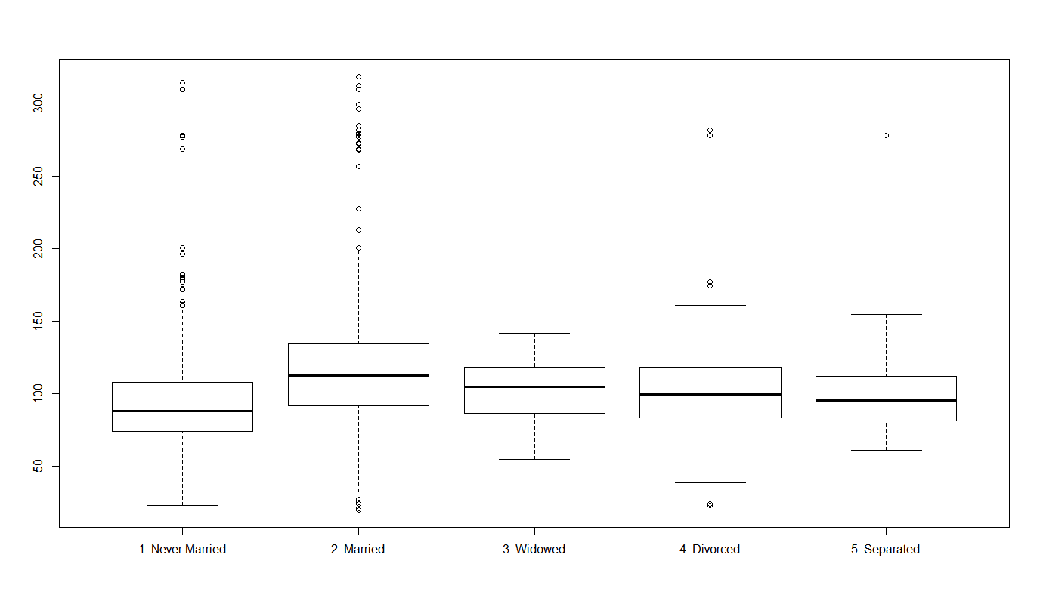

Shown below are box plots of “wage” by job class:

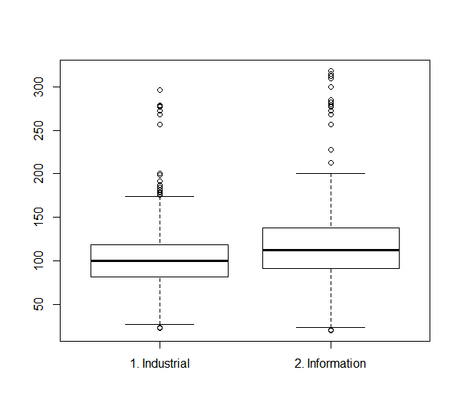

Inspecting the boxplots above, it appears on a univariate basis that those who are married have a higher wage than other marital categories (at least based on assessing only the estimated mean, and not assessing the inferential coverage). It also appears that those in job class “Information” have a higher wage than those in job class “Industrial”.

Let us run a multivariate GAM with age, marital status, and job class all in the model. Also, compare this model to models with just age and marital status, just age and job class, and just age. The output is below:

Analysis of Deviance Table

Model 1: wage ~ ns(age, 5)

Model 2: wage ~ ns(age, 5) + maritl

Model 3: wage ~ ns(age, 5) + maritl + jobclass

Resid. Df Resid. Dev Df Deviance Pr(>Chi)

1 2994 4768634

2 2990 4647371 4 121263 < 2.2e-16 ***

3 2989 4477023 1 170348 < 2.2e-16 ***

---

Signif. codes: 0 ‘***’ 0.001 ‘**’ 0.01 ‘*’ 0.05 ‘.’ 0.1 ‘ ’ 1

Analysis of Deviance Table

Model 1: wage ~ ns(age, 5)

Model 2: wage ~ ns(age, 5) + jobclass

Model 3: wage ~ ns(age, 5) + maritl + jobclass

Resid. Df Resid. Dev Df Deviance Pr(>Chi)

1 2994 4768634

2 2993 4601881 1 166752 < 2.2e-16 ***

3 2989 4477023 4 124858 < 2.2e-16 ***

---

Signif. codes: 0 ‘***’ 0.001 ‘**’ 0.01 ‘*’ 0.05 ‘.’ 0.1 ‘ ’ 1

From the summary output above, it appears that both marital status and job class are significant with age included in the model (to adjust for possible confounding by age).

Plots of the recovered “Model 3” with age, marital status, and job class all included in the model is shown below:

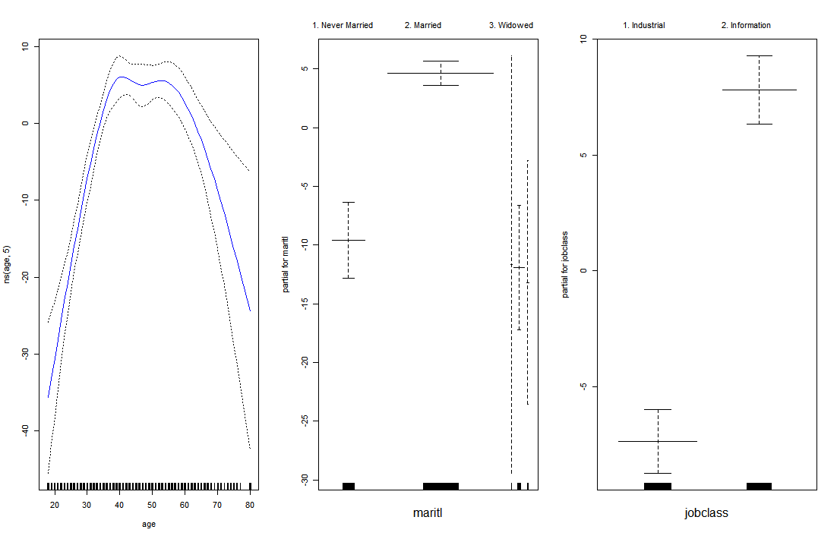

From the plots above, we can see when including the variables in a multivariate GAM, there is a statistically significant difference in the outcome wage by marital status, as well as by job class, even when adjusting for age.

R-code:

################

## Problem #4 ##

################

library(ISLR)

data(Wage)

plot(Wage$maritl, Wage$wage)

plot(Wage$jobclass, Wage$wage)

require(gam)

gam.fit1 <- gam(wage~ns(age,5), data=Wage)

gam.fit2.1 <- gam(wage~ns(age,5)+maritl, data=Wage)

gam.fit2.2 <- gam(wage~ns(age,5)+jobclass, data=Wage)

gam.fit3 <- gam(wage~ns(age,5)+maritl+jobclass, data=Wage)

anova(gam.fit1, gam.fit2.1, gam.fit3)

anova(gam.fit1, gam.fit2.2, gam.fit3)

par(mfrow=c(1,3))

plot(gam.fit3, se=TRUE, col="blue")

**Problem #4**:

*Modified from exercise 9 from section 7.9 of ITSL textbook*

This question uses the variables “dis” (the weighted mean of distances to give Boston employment centers) and “nox” (nitrogen oxides conventration in parts per million) from the “Boston” data. We will treat “dis” as the predictor and “nox” as the response.

1. Use the “poly()” function to fit a cubic polynomial regression to predict “nox” using “dis”. Report the regression output, and plot the resulting data and polynomial fits.

***Answer:***

The regression ouput is below, along with the plot of the resulting data and polynomial fits:

Call:

lm(formula = nox ~ poly(dis, 3), data = Boston)

Residuals:

Min 1Q Median 3Q Max

-0.121130 -0.040619 -0.009738 0.023385 0.194904

Coefficients:

Estimate Std. Error t value Pr(>|t|)

(Intercept) 0.554695 0.002759 201.021 < 2e-16 ***

poly(dis, 3)1 -2.003096 0.062071 -32.271 < 2e-16 ***

poly(dis, 3)2 0.856330 0.062071 13.796 < 2e-16 ***

poly(dis, 3)3 -0.318049 0.062071 -5.124 4.27e-07 ***

---

Signif. codes: 0 ‘***’ 0.001 ‘**’ 0.01 ‘*’ 0.05 ‘.’ 0.1 ‘ ’ 1

Residual standard error: 0.06207 on 502 degrees of freedom

Multiple R-squared: 0.7148, Adjusted R-squared: 0.7131

F-statistic: 419.3 on 3 and 502 DF, p-value: < 2.2e-16

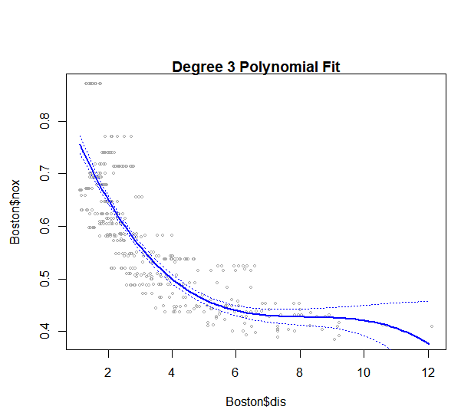

1. Plot the polynomial fits for a range of different polynomial degrees (say, 1 to 10), and report the associated residual sum of squares.

***Results:***

The data were fit for polynomial degrees 1 through 10, with the associated RSS reported below:

|  |  |
| --- | --- |
| **Polynomial Degree** | **RSS** |
| 1 | 2.768563 |
| 2 | 2.035262 |
| 3 | 1.934107 |
| 4 | 1.932981 |
| 5 | 1.915290 |
| 6 | 1.878257 |
| 7 | 1.849484 |
| 8 | 1.835630 |
| 9 | 1.833331 |
| 10 | 1.832171 |

The plot of results in the table above is below:

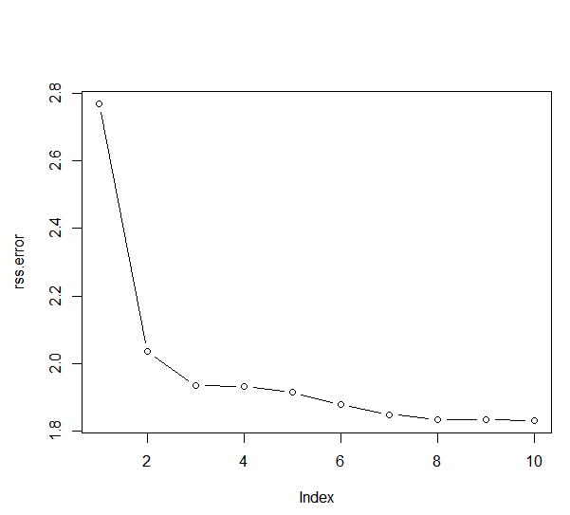

1. Perform cross-validation or another approach to select the optimal degree for the polynomial, and explain your results.

***Results:***

The plot of the 10-fold cross validated error for different degrees of polynomial fits is shown below:

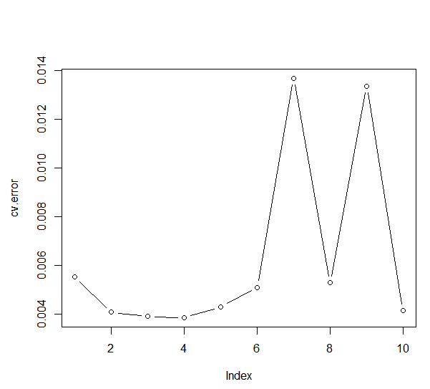

From the plot above, a model with polynomial degree 4 is optimal (given it has the lowest cross-validation error as per the plot).

1. Use the “bs()” function to fit a regression spline to predict “nox” using “dis”. Report the output for the fit using seven degrees of freedom. How did you choose the knots? Plot the resulting fit.

***Answer:***

The output from the fit model is shown below:

Call:

lm(formula = nox ~ bs(dis, df = 7), data = Boston)

Residuals:

Min 1Q Median 3Q Max

-0.12702 -0.03821 -0.01068 0.02296 0.19579

Coefficients:

Estimate Std. Error t value Pr(>|t|)

(Intercept) 0.64558 0.02633 24.516 < 2e-16 ***

bs(dis, df = 7)1 0.11238 0.04098 2.742 0.00632 **

bs(dis, df = 7)2 0.02461 0.02638 0.933 0.35138

bs(dis, df = 7)3 -0.09216 0.03119 -2.955 0.00327 **

bs(dis, df = 7)4 -0.16212 0.02829 -5.731 1.73e-08 ***

bs(dis, df = 7)5 -0.22224 0.03873 -5.738 1.66e-08 ***

bs(dis, df = 7)6 -0.24885 0.05147 -4.834 1.78e-06 ***

bs(dis, df = 7)7 -0.23091 0.05779 -3.995 7.44e-05 ***

---

Signif. codes: 0 ‘***’ 0.001 ‘**’ 0.01 ‘*’ 0.05 ‘.’ 0.1 ‘ ’ 1

Residual standard error: 0.06062 on 498 degrees of freedom

Multiple R-squared: 0.7301, Adjusted R-squared: 0.7264

F-statistic: 192.5 on 7 and 498 DF, p-value: < 2.2e-16

The knots were selected to occur at uniform intervals along the variables “dis”. The plot of the resulting fit is shown below:

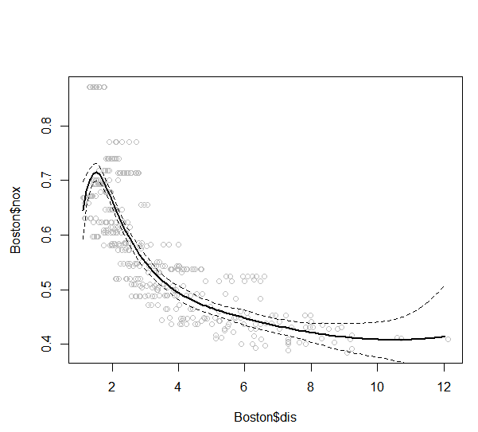

1. Now fit a regression spline for a range of degrees of freedom, and plot the resulting fits and report the resulting RSS. Describe the results obtained.

***Answer:***

The data were fit for degrees of freedom 4 through 10, with the associated RSS reported below:

|  |  |
| --- | --- |
| **Degrees of Freedom** | **RSS** |
| 4 | 1.922775 |
| 5 | 1.840173 |
| 6 | 1.833966 |
| 7 | 1.829884 |
| 8 | 1.816995 |
| 9 | 1.825653 |
| 10 | 1.792535 |

The plot of results in the table above is below:

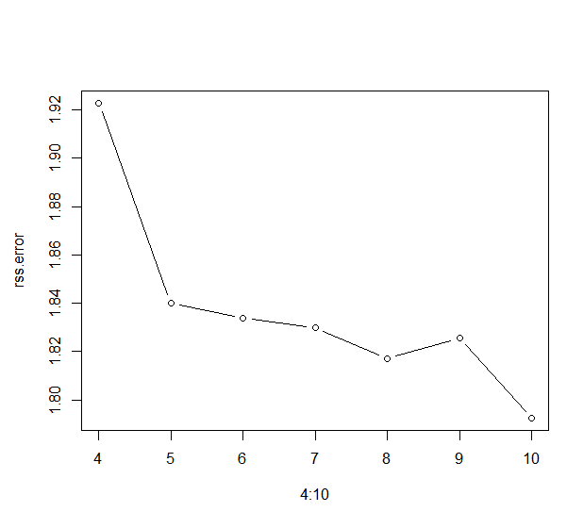

1. Perform cross-validation or another approach in order to select the best degrees of freedom for a regression spline on this data. Describe your results.

***Answer:***

The plot of the 10-fold cross validated error for different degrees of freedom for the spline model is shown below:

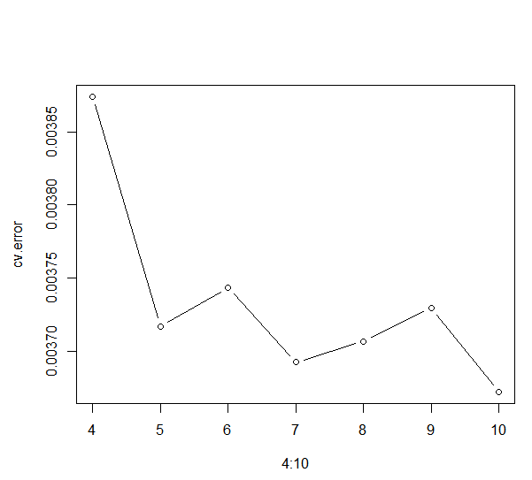

From the plot above, a spline model with 10 degrees of freedom is optimal (given it has the lowest cross-validation error as per the plot).

*R-code:*

################

## Problem #4 ##

################

############

## Part A ##

############

library(MASS)

data(Boston)

set.seed(1)

fit.03 <- lm(nox~poly(dis,3), data=Boston)

dislims <- range(Boston$dis)

dis.grid <- seq(dislims[1], dislims[2], 0.1)

preds <- predict(fit.03, newdata=list(dis=dis.grid), se=TRUE)

se.bands <- preds$fit + cbind(2*preds$se.fit, -2*preds$se.fit)

par(mfrow=c(1,1), mar=c(4.5,4.5,1,1), oma=c(0,0,4,0))

plot(Boston$dis, Boston$nox, xlim=dislims, cex=0.5, col="darkgrey")

title("Degree 3 Polynomial Fit")

lines(dis.grid, preds$fit, lwd=2, col="blue")

matlines(dis.grid, se.bands, lwd=1, col="blue", lty=3)

summary(fit.03)

############

## Part B ##

############

rss.error <- rep(0,10)

for (i in 1:10) {

lm.fit <- lm(nox~poly(dis,i), data=Boston)

rss.error[i] <- sum(lm.fit$residuals^2)

}

rss.error

plot(rss.error, type="b")

############

## Part C ##

############

require(boot)

set.seed(1)

cv.error <- rep(0,10)

for (i in 1:10) {

glm.fit <- glm(nox~poly(dis,i), data=Boston)

cv.error[i] <- cv.glm(Boston, glm.fit, K=10)$delta[1] # [1]:std, [2]:bias-corrected

}

cv.error

plot(cv.error, type="b")

############

## Part D ##

############

require(splines)

fit.sp <- lm(nox~bs(dis, df=7), data=Boston)

pred <- predict(fit.sp, newdata=list(dis=dis.grid), se=T)

plot(Boston$dis, Boston$nox, col="gray")

lines(dis.grid, pred$fit, lwd=2)

lines(dis.grid, pred$fit+2*pred$se, lty="dashed")

lines(dis.grid, pred$fit-2*pred$se, lty="dashed")

# set df to select knots at uniform quantiles of `dis`

attr(bs(Boston$dis,df=7),"knots")

############

## Part E ##

############

require(splines)

set.seed(1)

rss.error <- rep(0,7)

for (i in 4:10) {

fit.sp <- lm(nox~bs(dis, df=i), data=Boston)

rss.error[i-3] <- sum(fit.sp$residuals^2)

}

rss.error

plot(4:10, rss.error, type="b")

############

## Part F ##

############

require(splines)

require(boot)

set.seed(1)

cv.error <- rep(0,7)

for (i in 4:10) {

glm.fit <- glm(nox~bs(dis, df=i), data=Boston)

cv.error[i-3] <- cv.glm(Boston, glm.fit, K=10)$delta[1]

}

cv.error

plot(4:10, cv.error, type="b")

**Problem #5**:

*Exercise 11 from section 7.9 of ITSL textbook*

In Section 7.7, it was mentioned the GAMs are generally fit using a backfitting approach. The idea behind backfitting is actually quite simple. We will now explore backfitting in the context of multiple linear regression.

Suppose that we would like to perform multiple linear regression, but we do not have software to do so. Instead, we only have software to perform simple linear regression. Therefore, we take the following iterative approach: we repeatedly hold all but one coefficient estimate fixed at its current value, and update only that coefficient estimate using a simple linear regression. The process is continued until convergence.

We now try this out on a toy example:

1. Generate a response and two predictors and , with n=100.

***Answer:***

Vectors , , and where all drawn from a standard normal distribution with mead=0 and sd=1. The vector Y was specified based on the following equation:

With:

The resulting plot of the 100 observations in vector Y is shown below:

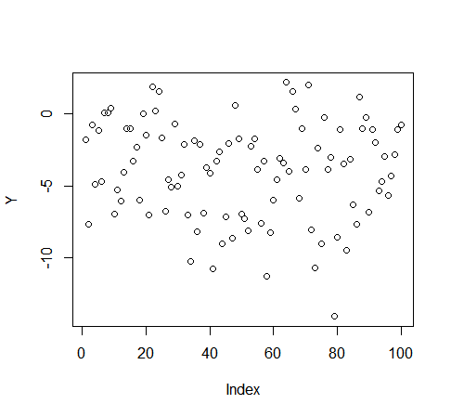

1. Initialize to take on a value of your choice. It does not matter what value you choose.

***Answer:***

I initialized to take on value “1”

1. Keeping fixed, fit the model

***Answer:***

The summary of the fit model is shown below:

Call:

lm(formula = a ~ X2)

Residuals:

Min 1Q Median 3Q Max

-3.03397 -0.69975 -0.06979 0.66364 3.03669

Coefficients:

Estimate Std. Error t value Pr(>|t|)

(Intercept) -4.0850 0.1099 -37.16 <2e-16 ***

X2 -2.7485 0.1122 -24.50 <2e-16 ***

---

Signif. codes: 0 ‘***’ 0.001 ‘**’ 0.01 ‘*’ 0.05 ‘.’ 0.1 ‘ ’ 1

Residual standard error: 1.098 on 98 degrees of freedom

Multiple R-squared: 0.8596, Adjusted R-squared: 0.8582

F-statistic: 600.2 on 1 and 98 DF, p-value: < 2.2e-16

1. Keeping fixed, fit the model

***Answer:***

From the estimated model in part (c), was estimated to be -2.7485. was fixed and the model above was fit. The summary of the fit model is shown below:

Call:

lm(formula = a ~ X1)

Residuals:

Min 1Q Median 3Q Max

-2.44997 -0.64968 -0.01681 0.57761 2.41076

Coefficients:

Estimate Std. Error t value Pr(>|t|)

(Intercept) -4.09296 0.09907 -41.31 <2e-16 ***

X1 1.47494 0.10021 14.72 <2e-16 ***

---

Signif. codes: 0 ‘***’ 0.001 ‘**’ 0.01 ‘*’ 0.05 ‘.’ 0.1 ‘ ’ 1

Residual standard error: 0.9906 on 98 degrees of freedom

Multiple R-squared: 0.6885, Adjusted R-squared: 0.6854

F-statistic: 216.6 on 1 and 98 DF, p-value: < 2.2e-16

1. Write a for loop to repeat (c) and (d) 1,000 times. Report the estimates of , , and at each iteration of the for loop. Create a plot in which each of these values is displayed with , , and each shown in a different color.

***Answer:***

The resulting plot is shown below:

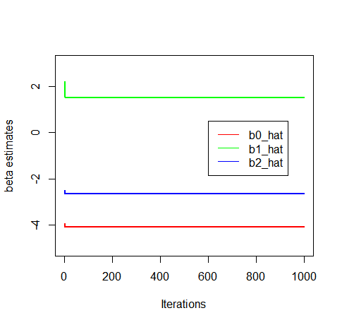

1. Compare your answer in (e) to the results of simply performing multiple linear regression to predict using and . Use the “abline()” function to overlay those multiple linear regression coefficient estimates on the plot obtained in (e).

***Answer:***

The summary results of running the multiple linear regression using the “lm()” function is shown below:

Call:

lm(formula = Y ~ X1 + X2)

Residuals:

Min 1Q Median 3Q Max

-2.47208 -0.62476 0.01248 0.59219 2.55400

Coefficients:

Estimate Std. Error t value Pr(>|t|)

(Intercept) -4.08866 0.09911 -41.25 <2e-16 ***

X1 1.49788 0.10255 14.61 <2e-16 ***

X2 -2.64058 0.10356 -25.50 <2e-16 ***

---

Signif. codes: 0 ‘***’ 0.001 ‘**’ 0.01 ‘*’ 0.05 ‘.’ 0.1 ‘ ’ 1

Residual standard error: 0.9901 on 97 degrees of freedom

Multiple R-squared: 0.9171, Adjusted R-squared: 0.9154

F-statistic: 536.4 on 2 and 97 DF, p-value: < 2.2e-16

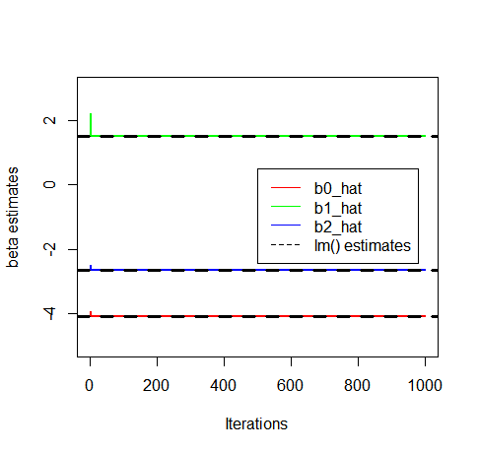

From the summary output of the “lm()” function as well as the plot above, we can see that the coefficient estimates the backfitting procedure converged to are the very same values the “lm()” function estimated. We can see the colored lines (backfitting procedure) and dashed lines (lm procedure) perfectly correspond and overlap.

1. On this data set, how many backfitting iterations were required in order to obtain a “good” approximation to the multiple regression coefficient estimates?

***Answer:***

Looking at the plot in the results of part (f), as well as inspecting the elements of the vectors of collected data from each iterative step from part (f), the iteratively generated estimates from the backfitting procedure converged to the same estimates produced by the “lm()” function after approximately 10 iterations. So even though 1000 iterations were carried out, in this particular problem only 10 were required for “good” convergence.

R-code:

################

## Problem #5 ##

################

############

## Part A ##

############

set.seed(123456)

X1 <- rnorm(100, 0, 1)

X2 <- rnorm(100, 0, 1)

beta_0 <- -4.2

beta_1 <- 1.5

beta_2 <- -2.7

eps <- rnorm(100, 0, 1)

Y <- beta_0 + beta_1*X1 + beta_2*X2 + eps

plot(Y)

############

## Part B ##

############

bhat_1 <- 1

############

## Part C ##

############

a <- Y - bhat_1*X1

summary(lm(a~X2))

bhat_2 <- lm(a~X2)$coef[2]

############

## Part D ##

############

a <- Y - bhat_2*X2

summary(lm(a~X1))

bhat_1 <- lm(a~X1)$coef[2]

############

## Part E ##

############

b0_hat <- rep(NA, 1001)

b1_hat <- rep(NA, 1001)

b2_hat <- rep(NA, 1001)

b0_hat[1] <- 1

b1_hat[1] <- 1

b2_hat[1] <- 1

for(i in 2:1001){

##estimate b0

a <- Y - (b1_hat[i-1]*X1) - (b2_hat[i-1]*X2)

b0_hat[i] <- lm(a~1)$coef[1]

rm(a)

##estimate b1

a <- Y - b0_hat[i-1] - (b2_hat[i-1]*X2)

b1_hat[i] <- lm(a~X1-1)$coef[1]

##estimate b2

a <- Y - b0_hat[i-1] - (b1_hat[i-1]*X1)

b2_hat[i] <- lm(a~X2-1)$coef[1]

}

b0_hat <- b0_hat[2:1001]

b1_hat <- b1_hat[2:1001]

b2_hat <- b2_hat[2:1001]

plot(b0_hat, type='l', col="red", lwd=2, xlab="Iterations", ylab="beta estimates", ylim=c(-5,3))

lines(b1_hat, type='l', col="green", lwd=2)

lines(b2_hat, type='l', col="blue", lwd=2)

legend(x=600,y=0.5, c("b0_hat", "b1_hat", "b2_hat"), lty=c(1,1,1), col=c("red","green","blue"))

############

## Part F ##

############

summary(lm(Y~X1+X2))

lm_fit <- lm(Y~X1+X2)

plot(b0_hat, type='l', col="red", lwd=2, xlab="Iterations", ylab="beta estimates", ylim=c(-5,3))

lines(b1_hat, type='l', col="green", lwd=2)

lines(b2_hat, type='l', col="blue", lwd=2)

abline(h=coef(lm_fit)[1], lty="dashed", lwd=3)

abline(h=coef(lm_fit)[2], lty="dashed", lwd=3)

abline(h=coef(lm_fit)[3], lty="dashed", lwd=3)

legend(x=500,y=0.5, c("b0_hat", "b1_hat", "b2_hat", "lm() estimates"), lty=c(1,1,1,2), col=c("red","green","blue", "black"))

**Problem #6**:

*Modified from exercise 12 from section 7.9 of ITSL textbook*

This problem is a continuation of exercise 11. In a toy example with p=50, show that one can approximate the multiple linear regression coefficient estimates by repeatedly performing simple linear regression in a backfitting procedure. How many backfitting iterations are required in order to obtain a “good” approximation to the multiple regression coefficient estimates? Create a plot to justify your answer.

***Answer:***

Below are similar type plots to those in “Problem #5”. Of the 51 estimates parameters (1 intercept and p=50 parameters), the colored lines show the estimated regression coefficients from each iterative step from the backtesting procedure, with the dashed lines showing the estimates from the “lm()” function. I have split the 51 parameter estimates over 5 plots for ease of viewing. As we can see, the backtesting procedure produced estimates that converged to the estimates obtained from the “lm()” function. From inspection of the graphs, as well as inspecting the elements of the vectors of collected data from each iterative step, most of the coefficient estimates converged to “good” estimates (i.e. similar to the estimates produced by the “lm()” function) within approximately 15 to 20 iterative steps using the backtesting procedure.

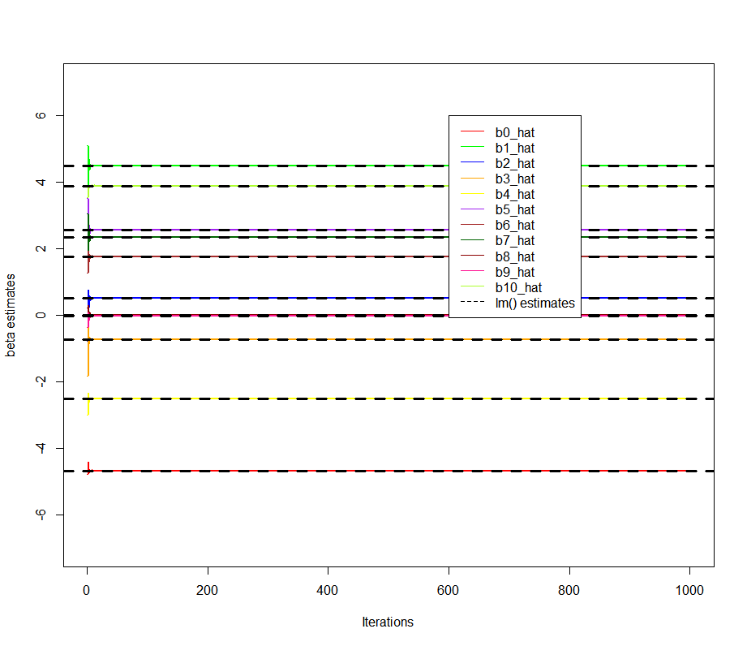

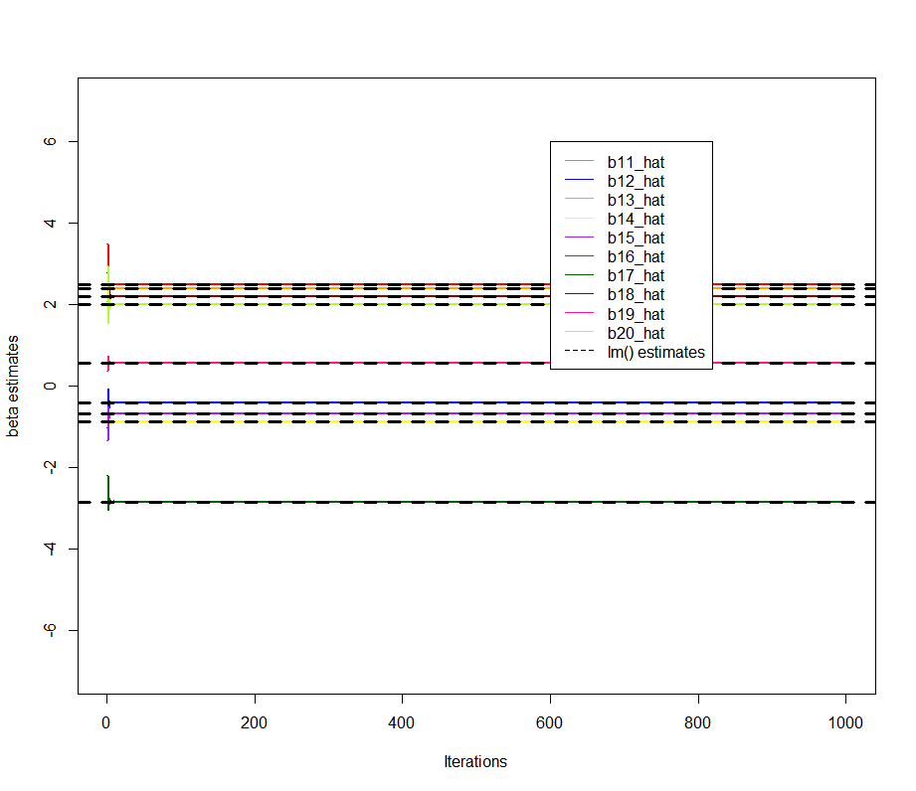

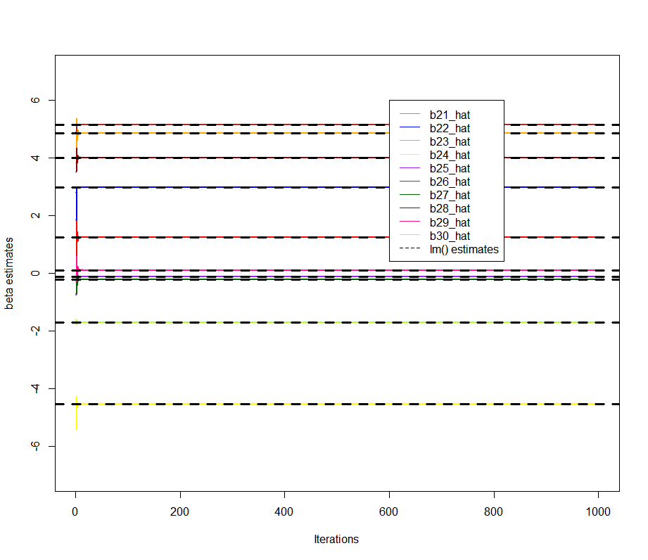

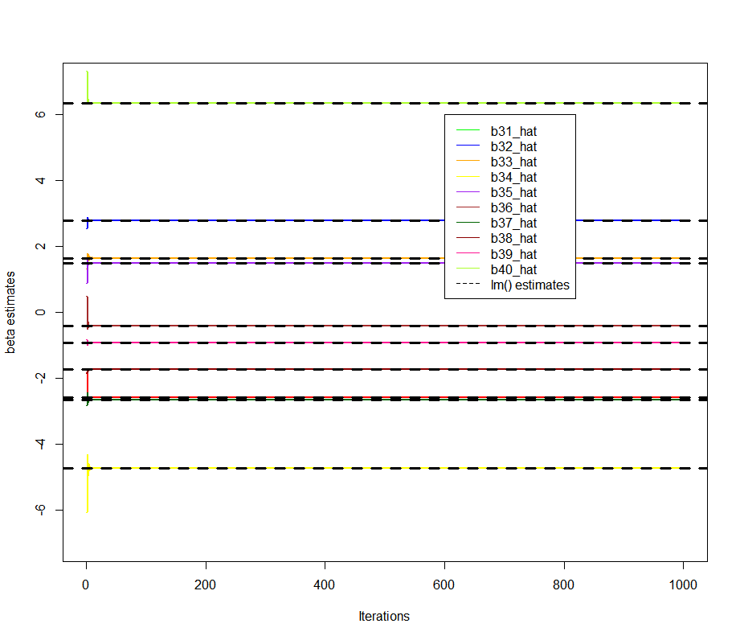

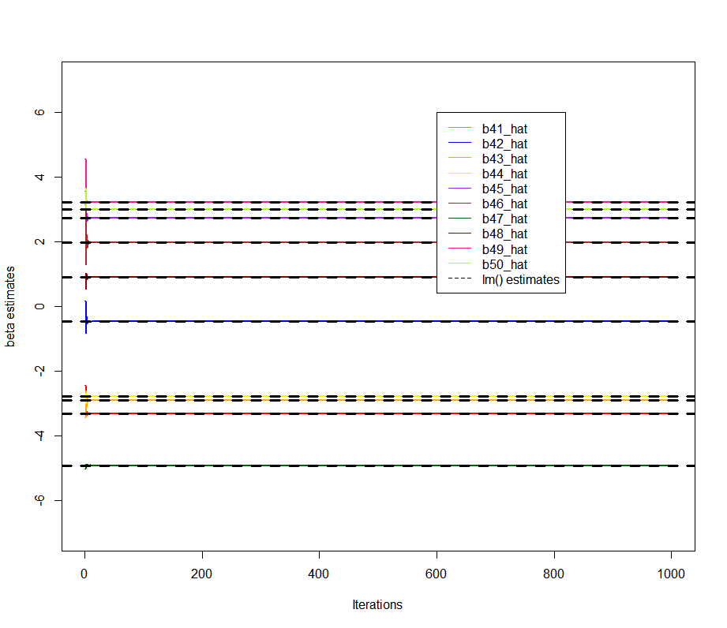

*R-code:*

################

## Problem #6 ##

################

library(dplyr)

set.seed(123456)

X0 <- rep(1, 100)

X1 <- rnorm(100, 0, 1)

X2 <- rnorm(100, 0, 1)

X3 <- rnorm(100, 0, 1)

X4 <- rnorm(100, 0, 1)

X5 <- rnorm(100, 0, 1)

X6 <- rnorm(100, 0, 1)

X7 <- rnorm(100, 0, 1)

X8 <- rnorm(100, 0, 1)

X9 <- rnorm(100, 0, 1)

X10 <- rnorm(100, 0, 1)

X11 <- rnorm(100, 0, 1)

X12 <- rnorm(100, 0, 1)

X13 <- rnorm(100, 0, 1)

X14 <- rnorm(100, 0, 1)

X15 <- rnorm(100, 0, 1)

X16 <- rnorm(100, 0, 1)

X17 <- rnorm(100, 0, 1)

X18 <- rnorm(100, 0, 1)

X19 <- rnorm(100, 0, 1)

X20 <- rnorm(100, 0, 1)

X21 <- rnorm(100, 0, 1)

X22 <- rnorm(100, 0, 1)

X23 <- rnorm(100, 0, 1)

X24 <- rnorm(100, 0, 1)

X25 <- rnorm(100, 0, 1)

X26 <- rnorm(100, 0, 1)

X27 <- rnorm(100, 0, 1)

X28 <- rnorm(100, 0, 1)

X29 <- rnorm(100, 0, 1)

X30 <- rnorm(100, 0, 1)

X31 <- rnorm(100, 0, 1)

X32 <- rnorm(100, 0, 1)

X33 <- rnorm(100, 0, 1)

X34 <- rnorm(100, 0, 1)

X35 <- rnorm(100, 0, 1)

X36 <- rnorm(100, 0, 1)

X37 <- rnorm(100, 0, 1)

X38 <- rnorm(100, 0, 1)

X39 <- rnorm(100, 0, 1)

X40 <- rnorm(100, 0, 1)

X41 <- rnorm(100, 0, 1)

X42 <- rnorm(100, 0, 1)

X43 <- rnorm(100, 0, 1)

X44 <- rnorm(100, 0, 1)

X45 <- rnorm(100, 0, 1)

X46 <- rnorm(100, 0, 1)

X47 <- rnorm(100, 0, 1)

X48 <- rnorm(100, 0, 1)

X49 <- rnorm(100, 0, 1)

X50 <- rnorm(100, 0, 1)

eps <- rnorm(100, 0, 1)

df <- data.frame(X0, X1, X2, X3, X4, X5, X6, X7, X8, X9,

X10, X11, X12, X13, X14, X15, X16, X17, X18, X19,

X20, X21, X22, X23, X24, X25, X26, X27, X28, X29,

X30, X31, X32, X33, X34, X35, X36, X37, X38, X39,

X40, X41, X42, X43, X44, X45, X46, X47, X48, X49, X50)

Betas <- runif(51, min=-4, max=4)

Y <- as.matrix(df)%*%Betas + eps

b0_hat <- rep(NA, 1001)

b1_hat <- rep(NA, 1001)

b2_hat <- rep(NA, 1001)

b3_hat <- rep(NA, 1001)

b4_hat <- rep(NA, 1001)

b5_hat <- rep(NA, 1001)

b6_hat <- rep(NA, 1001)

b7_hat <- rep(NA, 1001)

b8_hat <- rep(NA, 1001)

b9_hat <- rep(NA, 1001)

b10_hat <- rep(NA, 1001)

b11_hat <- rep(NA, 1001)

b12_hat <- rep(NA, 1001)

b13_hat <- rep(NA, 1001)

b14_hat <- rep(NA, 1001)

b15_hat <- rep(NA, 1001)

b16_hat <- rep(NA, 1001)

b17_hat <- rep(NA, 1001)

b18_hat <- rep(NA, 1001)

b19_hat <- rep(NA, 1001)

b20_hat <- rep(NA, 1001)

b21_hat <- rep(NA, 1001)

b22_hat <- rep(NA, 1001)

b23_hat <- rep(NA, 1001)

b24_hat <- rep(NA, 1001)

b25_hat <- rep(NA, 1001)

b26_hat <- rep(NA, 1001)

b27_hat <- rep(NA, 1001)

b28_hat <- rep(NA, 1001)

b29_hat <- rep(NA, 1001)

b30_hat <- rep(NA, 1001)

b31_hat <- rep(NA, 1001)

b32_hat <- rep(NA, 1001)

b33_hat <- rep(NA, 1001)

b34_hat <- rep(NA, 1001)

b35_hat <- rep(NA, 1001)

b36_hat <- rep(NA, 1001)

b37_hat <- rep(NA, 1001)

b38_hat <- rep(NA, 1001)

b39_hat <- rep(NA, 1001)

b40_hat <- rep(NA, 1001)

b41_hat <- rep(NA, 1001)

b42_hat <- rep(NA, 1001)

b43_hat <- rep(NA, 1001)

b44_hat <- rep(NA, 1001)

b45_hat <- rep(NA, 1001)

b46_hat <- rep(NA, 1001)

b47_hat <- rep(NA, 1001)

b48_hat <- rep(NA, 1001)

b49_hat <- rep(NA, 1001)

b50_hat <- rep(NA, 1001)

b0_hat[1] <- b1_hat[1] <- b2_hat[1] <- b3_hat[1] <- b4_hat[1] <- b5_hat[1] <- b6_hat[1] <- b7_hat[1] <- b8_hat[1] <- b9_hat[1] <- 1

b10_hat[1] <- b11_hat[1] <- b12_hat[1] <- b13_hat[1] <- b14_hat[1] <- b15_hat[1] <- b16_hat[1] <- b17_hat[1] <- b18_hat[1] <- b19_hat[1] <- 1

b20_hat[1] <- b21_hat[1] <- b22_hat[1] <- b23_hat[1] <- b24_hat[1] <- b25_hat[1] <- b26_hat[1] <- b27_hat[1] <- b28_hat[1] <- b29_hat[1] <- 1

b30_hat[1] <- b31_hat[1] <- b32_hat[1] <- b33_hat[1] <- b34_hat[1] <- b35_hat[1] <- b36_hat[1] <- b37_hat[1] <- b38_hat[1] <- b39_hat[1] <- 1

b40_hat[1] <- b41_hat[1] <- b42_hat[1] <- b43_hat[1] <- b44_hat[1] <- b45_hat[1] <- b46_hat[1] <- b47_hat[1] <- b48_hat[1] <- b49_hat[1] <- b50_hat[1] <- 1

for(i in 2:1001){

print(i)

##estimate b0

a <- Y - (b1_hat[i-1]*X1) - (b2_hat[i-1]*X2) - (b3_hat[i-1]*X3) - (b4_hat[i-1]*X4) - (b5_hat[i-1]*X5) - (b6_hat[i-1]*X6) - (b7_hat[i-1]*X7) - (b8_hat[i-1]*X8) - (b9_hat[i-1]*X9) - (b10_hat[i-1]*X10)

- (b11_hat[i-1]*X11) - (b12_hat[i-1]*X12) - (b13_hat[i-1]*X13) - (b14_hat[i-1]*X14) - (b15_hat[i-1]*X15) - (b16_hat[i-1]*X16) - (b17_hat[i-1]*X17) - (b18_hat[i-1]*X18) - (b19_hat[i-1]*X19) - (b20_hat[i-1]*X20)

- (b21_hat[i-1]*X21) - (b22_hat[i-1]*X22) - (b23_hat[i-1]*X23) - (b24_hat[i-1]*X24) - (b25_hat[i-1]*X25) - (b26_hat[i-1]*X26) - (b27_hat[i-1]*X27) - (b28_hat[i-1]*X28) - (b29_hat[i-1]*X29) - (b30_hat[i-1]*X30)

- (b31_hat[i-1]*X31) - (b32_hat[i-1]*X32) - (b33_hat[i-1]*X33) - (b34_hat[i-1]*X34) - (b35_hat[i-1]*X35) - (b36_hat[i-1]*X36) - (b37_hat[i-1]*X37) - (b38_hat[i-1]*X38) - (b39_hat[i-1]*X39) - (b40_hat[i-1]*X40)

- (b41_hat[i-1]*X41) - (b42_hat[i-1]*X42) - (b43_hat[i-1]*X43) - (b44_hat[i-1]*X44) - (b45_hat[i-1]*X45) - (b46_hat[i-1]*X46) - (b47_hat[i-1]*X47) - (b48_hat[i-1]*X48) - (b49_hat[i-1]*X49) - (b50_hat[i-1]*X50)

b0_hat[i] <- lm(a~1)$coef[1]

rm(a)

##estimate b1

a <- Y - b0_hat[i] - (b2_hat[i-1]*X2) - (b3_hat[i-1]*X3) - (b4_hat[i-1]*X4) - (b5_hat[i-1]*X5) - (b6_hat[i-1]*X6) - (b7_hat[i-1]*X7) - (b8_hat[i-1]*X8) - (b9_hat[i-1]*X9) - (b10_hat[i-1]*X10)

- (b11_hat[i-1]*X11) - (b12_hat[i-1]*X12) - (b13_hat[i-1]*X13) - (b14_hat[i-1]*X14) - (b15_hat[i-1]*X15) - (b16_hat[i-1]*X16) - (b17_hat[i-1]*X17) - (b18_hat[i-1]*X18) - (b19_hat[i-1]*X19) - (b20_hat[i-1]*X20)

- (b21_hat[i-1]*X21) - (b22_hat[i-1]*X22) - (b23_hat[i-1]*X23) - (b24_hat[i-1]*X24) - (b25_hat[i-1]*X25) - (b26_hat[i-1]*X26) - (b27_hat[i-1]*X27) - (b28_hat[i-1]*X28) - (b29_hat[i-1]*X29) - (b30_hat[i-1]*X30)

- (b31_hat[i-1]*X31) - (b32_hat[i-1]*X32) - (b33_hat[i-1]*X33) - (b34_hat[i-1]*X34) - (b35_hat[i-1]*X35) - (b36_hat[i-1]*X36) - (b37_hat[i-1]*X37) - (b38_hat[i-1]*X38) - (b39_hat[i-1]*X39) - (b40_hat[i-1]*X40)

- (b41_hat[i-1]*X41) - (b42_hat[i-1]*X42) - (b43_hat[i-1]*X43) - (b44_hat[i-1]*X44) - (b45_hat[i-1]*X45) - (b46_hat[i-1]*X46) - (b47_hat[i-1]*X47) - (b48_hat[i-1]*X48) - (b49_hat[i-1]*X49) - (b50_hat[i-1]*X50)

b1_hat[i] <- lm(a~X1-1)$coef[1]

rm(a)

##estimate b2

a <- Y - b0_hat[i] - (b1_hat[i-1]*X1) - (b3_hat[i-1]*X3) - (b4_hat[i-1]*X4) - (b5_hat[i-1]*X5) - (b6_hat[i-1]*X6) - (b7_hat[i-1]*X7) - (b8_hat[i-1]*X8) - (b9_hat[i-1]*X9) - (b10_hat[i-1]*X10)

- (b11_hat[i-1]*X11) - (b12_hat[i-1]*X12) - (b13_hat[i-1]*X13) - (b14_hat[i-1]*X14) - (b15_hat[i-1]*X15) - (b16_hat[i-1]*X16) - (b17_hat[i-1]*X17) - (b18_hat[i-1]*X18) - (b19_hat[i-1]*X19) - (b20_hat[i-1]*X20)

- (b21_hat[i-1]*X21) - (b22_hat[i-1]*X22) - (b23_hat[i-1]*X23) - (b24_hat[i-1]*X24) - (b25_hat[i-1]*X25) - (b26_hat[i-1]*X26) - (b27_hat[i-1]*X27) - (b28_hat[i-1]*X28) - (b29_hat[i-1]*X29) - (b30_hat[i-1]*X30)

- (b31_hat[i-1]*X31) - (b32_hat[i-1]*X32) - (b33_hat[i-1]*X33) - (b34_hat[i-1]*X34) - (b35_hat[i-1]*X35) - (b36_hat[i-1]*X36) - (b37_hat[i-1]*X37) - (b38_hat[i-1]*X38) - (b39_hat[i-1]*X39) - (b40_hat[i-1]*X40)

- (b41_hat[i-1]*X41) - (b42_hat[i-1]*X42) - (b43_hat[i-1]*X43) - (b44_hat[i-1]*X44) - (b45_hat[i-1]*X45) - (b46_hat[i-1]*X46) - (b47_hat[i-1]*X47) - (b48_hat[i-1]*X48) - (b49_hat[i-1]*X49) - (b50_hat[i-1]*X50)

b2_hat[i] <- lm(a~X2-1)$coef[1]

rm(a)

##estimate b3

a <- Y - b0_hat[i] - (b1_hat[i-1]*X1) - (b2_hat[i-1]*X2) - (b4_hat[i-1]*X4) - (b5_hat[i-1]*X5) - (b6_hat[i-1]*X6) - (b7_hat[i-1]*X7) - (b8_hat[i-1]*X8) - (b9_hat[i-1]*X9) - (b10_hat[i-1]*X10)

- (b11_hat[i-1]*X11) - (b12_hat[i-1]*X12) - (b13_hat[i-1]*X13) - (b14_hat[i-1]*X14) - (b15_hat[i-1]*X15) - (b16_hat[i-1]*X16) - (b17_hat[i-1]*X17) - (b18_hat[i-1]*X18) - (b19_hat[i-1]*X19) - (b20_hat[i-1]*X20)

- (b21_hat[i-1]*X21) - (b22_hat[i-1]*X22) - (b23_hat[i-1]*X23) - (b24_hat[i-1]*X24) - (b25_hat[i-1]*X25) - (b26_hat[i-1]*X26) - (b27_hat[i-1]*X27) - (b28_hat[i-1]*X28) - (b29_hat[i-1]*X29) - (b30_hat[i-1]*X30)

- (b31_hat[i-1]*X31) - (b32_hat[i-1]*X32) - (b33_hat[i-1]*X33) - (b34_hat[i-1]*X34) - (b35_hat[i-1]*X35) - (b36_hat[i-1]*X36) - (b37_hat[i-1]*X37) - (b38_hat[i-1]*X38) - (b39_hat[i-1]*X39) - (b40_hat[i-1]*X40)

- (b41_hat[i-1]*X41) - (b42_hat[i-1]*X42) - (b43_hat[i-1]*X43) - (b44_hat[i-1]*X44) - (b45_hat[i-1]*X45) - (b46_hat[i-1]*X46) - (b47_hat[i-1]*X47) - (b48_hat[i-1]*X48) - (b49_hat[i-1]*X49) - (b50_hat[i-1]*X50)

b3_hat[i] <- lm(a~X3-1)$coef[1]

rm(a)

##estimate b4

a <- Y - b0_hat[i] - (b1_hat[i-1]*X1) - (b2_hat[i-1]*X2) - (b3_hat[i-1]*X3) - (b5_hat[i-1]*X5) - (b6_hat[i-1]*X6) - (b7_hat[i-1]*X7) - (b8_hat[i-1]*X8) - (b9_hat[i-1]*X9) - (b10_hat[i-1]*X10)

- (b11_hat[i-1]*X11) - (b12_hat[i-1]*X12) - (b13_hat[i-1]*X13) - (b14_hat[i-1]*X14) - (b15_hat[i-1]*X15) - (b16_hat[i-1]*X16) - (b17_hat[i-1]*X17) - (b18_hat[i-1]*X18) - (b19_hat[i-1]*X19) - (b20_hat[i-1]*X20)

- (b21_hat[i-1]*X21) - (b22_hat[i-1]*X22) - (b23_hat[i-1]*X23) - (b24_hat[i-1]*X24) - (b25_hat[i-1]*X25) - (b26_hat[i-1]*X26) - (b27_hat[i-1]*X27) - (b28_hat[i-1]*X28) - (b29_hat[i-1]*X29) - (b30_hat[i-1]*X30)

- (b31_hat[i-1]*X31) - (b32_hat[i-1]*X32) - (b33_hat[i-1]*X33) - (b34_hat[i-1]*X34) - (b35_hat[i-1]*X35) - (b36_hat[i-1]*X36) - (b37_hat[i-1]*X37) - (b38_hat[i-1]*X38) - (b39_hat[i-1]*X39) - (b40_hat[i-1]*X40)

- (b41_hat[i-1]*X41) - (b42_hat[i-1]*X42) - (b43_hat[i-1]*X43) - (b44_hat[i-1]*X44) - (b45_hat[i-1]*X45) - (b46_hat[i-1]*X46) - (b47_hat[i-1]*X47) - (b48_hat[i-1]*X48) - (b49_hat[i-1]*X49) - (b50_hat[i-1]*X50)

b4_hat[i] <- lm(a~X4-1)$coef[1]

rm(a)

##estimate b5

a <- Y - b0_hat[i] - (b1_hat[i-1]*X1) - (b2_hat[i-1]*X2) - (b3_hat[i-1]*X3) - (b4_hat[i-1]*X4) - (b6_hat[i-1]*X6) - (b7_hat[i-1]*X7) - (b8_hat[i-1]*X8) - (b9_hat[i-1]*X9) - (b10_hat[i-1]*X10)

- (b11_hat[i-1]*X11) - (b12_hat[i-1]*X12) - (b13_hat[i-1]*X13) - (b14_hat[i-1]*X14) - (b15_hat[i-1]*X15) - (b16_hat[i-1]*X16) - (b17_hat[i-1]*X17) - (b18_hat[i-1]*X18) - (b19_hat[i-1]*X19) - (b20_hat[i-1]*X20)

- (b21_hat[i-1]*X21) - (b22_hat[i-1]*X22) - (b23_hat[i-1]*X23) - (b24_hat[i-1]*X24) - (b25_hat[i-1]*X25) - (b26_hat[i-1]*X26) - (b27_hat[i-1]*X27) - (b28_hat[i-1]*X28) - (b29_hat[i-1]*X29) - (b30_hat[i-1]*X30)

- (b31_hat[i-1]*X31) - (b32_hat[i-1]*X32) - (b33_hat[i-1]*X33) - (b34_hat[i-1]*X34) - (b35_hat[i-1]*X35) - (b36_hat[i-1]*X36) - (b37_hat[i-1]*X37) - (b38_hat[i-1]*X38) - (b39_hat[i-1]*X39) - (b40_hat[i-1]*X40)

- (b41_hat[i-1]*X41) - (b42_hat[i-1]*X42) - (b43_hat[i-1]*X43) - (b44_hat[i-1]*X44) - (b45_hat[i-1]*X45) - (b46_hat[i-1]*X46) - (b47_hat[i-1]*X47) - (b48_hat[i-1]*X48) - (b49_hat[i-1]*X49) - (b50_hat[i-1]*X50)

b5_hat[i] <- lm(a~X5-1)$coef[1]

rm(a)

##estimate b6

a <- Y - b0_hat[i] - (b1_hat[i-1]*X1) - (b2_hat[i-1]*X2) - (b3_hat[i-1]*X3) - (b4_hat[i-1]*X4) - (b5_hat[i-1]*X5) - (b7_hat[i-1]*X7) - (b8_hat[i-1]*X8) - (b9_hat[i-1]*X9) - (b10_hat[i-1]*X10)

- (b11_hat[i-1]*X11) - (b12_hat[i-1]*X12) - (b13_hat[i-1]*X13) - (b14_hat[i-1]*X14) - (b15_hat[i-1]*X15) - (b16_hat[i-1]*X16) - (b17_hat[i-1]*X17) - (b18_hat[i-1]*X18) - (b19_hat[i-1]*X19) - (b20_hat[i-1]*X20)

- (b21_hat[i-1]*X21) - (b22_hat[i-1]*X22) - (b23_hat[i-1]*X23) - (b24_hat[i-1]*X24) - (b25_hat[i-1]*X25) - (b26_hat[i-1]*X26) - (b27_hat[i-1]*X27) - (b28_hat[i-1]*X28) - (b29_hat[i-1]*X29) - (b30_hat[i-1]*X30)

- (b31_hat[i-1]*X31) - (b32_hat[i-1]*X32) - (b33_hat[i-1]*X33) - (b34_hat[i-1]*X34) - (b35_hat[i-1]*X35) - (b36_hat[i-1]*X36) - (b37_hat[i-1]*X37) - (b38_hat[i-1]*X38) - (b39_hat[i-1]*X39) - (b40_hat[i-1]*X40)

- (b41_hat[i-1]*X41) - (b42_hat[i-1]*X42) - (b43_hat[i-1]*X43) - (b44_hat[i-1]*X44) - (b45_hat[i-1]*X45) - (b46_hat[i-1]*X46) - (b47_hat[i-1]*X47) - (b48_hat[i-1]*X48) - (b49_hat[i-1]*X49) - (b50_hat[i-1]*X50)

b6_hat[i] <- lm(a~X6-1)$coef[1]

rm(a)

##estimate b7

a <- Y - b0_hat[i] - (b1_hat[i-1]*X1) - (b2_hat[i-1]*X2) - (b3_hat[i-1]*X3) - (b4_hat[i-1]*X4) - (b5_hat[i-1]*X5) - (b6_hat[i-1]*X6) - (b8_hat[i-1]*X8) - (b9_hat[i-1]*X9) - (b10_hat[i-1]*X10)

- (b11_hat[i-1]*X11) - (b12_hat[i-1]*X12) - (b13_hat[i-1]*X13) - (b14_hat[i-1]*X14) - (b15_hat[i-1]*X15) - (b16_hat[i-1]*X16) - (b17_hat[i-1]*X17) - (b18_hat[i-1]*X18) - (b19_hat[i-1]*X19) - (b20_hat[i-1]*X20)

- (b21_hat[i-1]*X21) - (b22_hat[i-1]*X22) - (b23_hat[i-1]*X23) - (b24_hat[i-1]*X24) - (b25_hat[i-1]*X25) - (b26_hat[i-1]*X26) - (b27_hat[i-1]*X27) - (b28_hat[i-1]*X28) - (b29_hat[i-1]*X29) - (b30_hat[i-1]*X30)

- (b31_hat[i-1]*X31) - (b32_hat[i-1]*X32) - (b33_hat[i-1]*X33) - (b34_hat[i-1]*X34) - (b35_hat[i-1]*X35) - (b36_hat[i-1]*X36) - (b37_hat[i-1]*X37) - (b38_hat[i-1]*X38) - (b39_hat[i-1]*X39) - (b40_hat[i-1]*X40)

- (b41_hat[i-1]*X41) - (b42_hat[i-1]*X42) - (b43_hat[i-1]*X43) - (b44_hat[i-1]*X44) - (b45_hat[i-1]*X45) - (b46_hat[i-1]*X46) - (b47_hat[i-1]*X47) - (b48_hat[i-1]*X48) - (b49_hat[i-1]*X49) - (b50_hat[i-1]*X50)

b7_hat[i] <- lm(a~X7-1)$coef[1]

rm(a)

##estimate b8

a <- Y - b0_hat[i] - (b1_hat[i-1]*X1) - (b2_hat[i-1]*X2) - (b3_hat[i-1]*X3) - (b4_hat[i-1]*X4) - (b5_hat[i-1]*X5) - (b6_hat[i-1]*X6) - (b7_hat[i-1]*X7) - (b9_hat[i-1]*X9) - (b10_hat[i-1]*X10)

- (b11_hat[i-1]*X11) - (b12_hat[i-1]*X12) - (b13_hat[i-1]*X13) - (b14_hat[i-1]*X14) - (b15_hat[i-1]*X15) - (b16_hat[i-1]*X16) - (b17_hat[i-1]*X17) - (b18_hat[i-1]*X18) - (b19_hat[i-1]*X19) - (b20_hat[i-1]*X20)

- (b21_hat[i-1]*X21) - (b22_hat[i-1]*X22) - (b23_hat[i-1]*X23) - (b24_hat[i-1]*X24) - (b25_hat[i-1]*X25) - (b26_hat[i-1]*X26) - (b27_hat[i-1]*X27) - (b28_hat[i-1]*X28) - (b29_hat[i-1]*X29) - (b30_hat[i-1]*X30)

- (b31_hat[i-1]*X31) - (b32_hat[i-1]*X32) - (b33_hat[i-1]*X33) - (b34_hat[i-1]*X34) - (b35_hat[i-1]*X35) - (b36_hat[i-1]*X36) - (b37_hat[i-1]*X37) - (b38_hat[i-1]*X38) - (b39_hat[i-1]*X39) - (b40_hat[i-1]*X40)

- (b41_hat[i-1]*X41) - (b42_hat[i-1]*X42) - (b43_hat[i-1]*X43) - (b44_hat[i-1]*X44) - (b45_hat[i-1]*X45) - (b46_hat[i-1]*X46) - (b47_hat[i-1]*X47) - (b48_hat[i-1]*X48) - (b49_hat[i-1]*X49) - (b50_hat[i-1]*X50)

b8_hat[i] <- lm(a~X8-1)$coef[1]

rm(a)

##estimate b9

a <- Y - b0_hat[i] - (b1_hat[i-1]*X1) - (b2_hat[i-1]*X2) - (b3_hat[i-1]*X3) - (b4_hat[i-1]*X4) - (b5_hat[i-1]*X5) - (b6_hat[i-1]*X6) - (b7_hat[i-1]*X7) - (b8_hat[i-1]*X8) - (b10_hat[i-1]*X10)

- (b11_hat[i-1]*X11) - (b12_hat[i-1]*X12) - (b13_hat[i-1]*X13) - (b14_hat[i-1]*X14) - (b15_hat[i-1]*X15) - (b16_hat[i-1]*X16) - (b17_hat[i-1]*X17) - (b18_hat[i-1]*X18) - (b19_hat[i-1]*X19) - (b20_hat[i-1]*X20)

- (b21_hat[i-1]*X21) - (b22_hat[i-1]*X22) - (b23_hat[i-1]*X23) - (b24_hat[i-1]*X24) - (b25_hat[i-1]*X25) - (b26_hat[i-1]*X26) - (b27_hat[i-1]*X27) - (b28_hat[i-1]*X28) - (b29_hat[i-1]*X29) - (b30_hat[i-1]*X30)

- (b31_hat[i-1]*X31) - (b32_hat[i-1]*X32) - (b33_hat[i-1]*X33) - (b34_hat[i-1]*X34) - (b35_hat[i-1]*X35) - (b36_hat[i-1]*X36) - (b37_hat[i-1]*X37) - (b38_hat[i-1]*X38) - (b39_hat[i-1]*X39) - (b40_hat[i-1]*X40)

- (b41_hat[i-1]*X41) - (b42_hat[i-1]*X42) - (b43_hat[i-1]*X43) - (b44_hat[i-1]*X44) - (b45_hat[i-1]*X45) - (b46_hat[i-1]*X46) - (b47_hat[i-1]*X47) - (b48_hat[i-1]*X48) - (b49_hat[i-1]*X49) - (b50_hat[i-1]*X50)

b9_hat[i] <- lm(a~X9-1)$coef[1]

rm(a)

##estimate b10

a <- Y - b0_hat[i] - (b1_hat[i-1]*X1) - (b2_hat[i-1]*X2) - (b3_hat[i-1]*X3) - (b4_hat[i-1]*X4) - (b5_hat[i-1]*X5) - (b6_hat[i-1]*X6) - (b7_hat[i-1]*X7) - (b8_hat[i-1]*X8) - (b9_hat[i-1]*X9)

- (b11_hat[i-1]*X11) - (b12_hat[i-1]*X12) - (b13_hat[i-1]*X13) - (b14_hat[i-1]*X14) - (b15_hat[i-1]*X15) - (b16_hat[i-1]*X16) - (b17_hat[i-1]*X17) - (b18_hat[i-1]*X18) - (b19_hat[i-1]*X19) - (b20_hat[i-1]*X20)

- (b21_hat[i-1]*X21) - (b22_hat[i-1]*X22) - (b23_hat[i-1]*X23) - (b24_hat[i-1]*X24) - (b25_hat[i-1]*X25) - (b26_hat[i-1]*X26) - (b27_hat[i-1]*X27) - (b28_hat[i-1]*X28) - (b29_hat[i-1]*X29) - (b30_hat[i-1]*X30)

- (b31_hat[i-1]*X31) - (b32_hat[i-1]*X32) - (b33_hat[i-1]*X33) - (b34_hat[i-1]*X34) - (b35_hat[i-1]*X35) - (b36_hat[i-1]*X36) - (b37_hat[i-1]*X37) - (b38_hat[i-1]*X38) - (b39_hat[i-1]*X39) - (b40_hat[i-1]*X40)

- (b41_hat[i-1]*X41) - (b42_hat[i-1]*X42) - (b43_hat[i-1]*X43) - (b44_hat[i-1]*X44) - (b45_hat[i-1]*X45) - (b46_hat[i-1]*X46) - (b47_hat[i-1]*X47) - (b48_hat[i-1]*X48) - (b49_hat[i-1]*X49) - (b50_hat[i-1]*X50)

b10_hat[i] <- lm(a~X10-1)$coef[1]

rm(a)

##estimate b11

a <- Y - b0_hat[i] - (b1_hat[i-1]*X1) - (b2_hat[i-1]*X2) - (b3_hat[i-1]*X3) - (b4_hat[i-1]*X4) - (b5_hat[i-1]*X5) - (b6_hat[i-1]*X6) - (b7_hat[i-1]*X7) - (b8_hat[i-1]*X8) - (b9_hat[i-1]*X9) - (b10_hat[i-1]*X10)

- (b12_hat[i-1]*X12) - (b13_hat[i-1]*X13) - (b14_hat[i-1]*X14) - (b15_hat[i-1]*X15) - (b16_hat[i-1]*X16) - (b17_hat[i-1]*X17) - (b18_hat[i-1]*X18) - (b19_hat[i-1]*X19) - (b20_hat[i-1]*X20)

- (b21_hat[i-1]*X21) - (b22_hat[i-1]*X22) - (b23_hat[i-1]*X23) - (b24_hat[i-1]*X24) - (b25_hat[i-1]*X25) - (b26_hat[i-1]*X26) - (b27_hat[i-1]*X27) - (b28_hat[i-1]*X28) - (b29_hat[i-1]*X29) - (b30_hat[i-1]*X30)

- (b31_hat[i-1]*X31) - (b32_hat[i-1]*X32) - (b33_hat[i-1]*X33) - (b34_hat[i-1]*X34) - (b35_hat[i-1]*X35) - (b36_hat[i-1]*X36) - (b37_hat[i-1]*X37) - (b38_hat[i-1]*X38) - (b39_hat[i-1]*X39) - (b40_hat[i-1]*X40)

- (b41_hat[i-1]*X41) - (b42_hat[i-1]*X42) - (b43_hat[i-1]*X43) - (b44_hat[i-1]*X44) - (b45_hat[i-1]*X45) - (b46_hat[i-1]*X46) - (b47_hat[i-1]*X47) - (b48_hat[i-1]*X48) - (b49_hat[i-1]*X49) - (b50_hat[i-1]*X50)

b11_hat[i] <- lm(a~X11-1)$coef[1]

rm(a)

##estimate b12

a <- Y - b0_hat[i] - (b1_hat[i-1]*X1) - (b2_hat[i-1]*X2) - (b3_hat[i-1]*X3) - (b4_hat[i-1]*X4) - (b5_hat[i-1]*X5) - (b6_hat[i-1]*X6) - (b7_hat[i-1]*X7) - (b8_hat[i-1]*X8) - (b9_hat[i-1]*X9) - (b10_hat[i-1]*X10)

- (b11_hat[i-1]*X11) - (b13_hat[i-1]*X13) - (b14_hat[i-1]*X14) - (b15_hat[i-1]*X15) - (b16_hat[i-1]*X16) - (b17_hat[i-1]*X17) - (b18_hat[i-1]*X18) - (b19_hat[i-1]*X19) - (b20_hat[i-1]*X20)

- (b21_hat[i-1]*X21) - (b22_hat[i-1]*X22) - (b23_hat[i-1]*X23) - (b24_hat[i-1]*X24) - (b25_hat[i-1]*X25) - (b26_hat[i-1]*X26) - (b27_hat[i-1]*X27) - (b28_hat[i-1]*X28) - (b29_hat[i-1]*X29) - (b30_hat[i-1]*X30)

- (b31_hat[i-1]*X31) - (b32_hat[i-1]*X32) - (b33_hat[i-1]*X33) - (b34_hat[i-1]*X34) - (b35_hat[i-1]*X35) - (b36_hat[i-1]*X36) - (b37_hat[i-1]*X37) - (b38_hat[i-1]*X38) - (b39_hat[i-1]*X39) - (b40_hat[i-1]*X40)

- (b41_hat[i-1]*X41) - (b42_hat[i-1]*X42) - (b43_hat[i-1]*X43) - (b44_hat[i-1]*X44) - (b45_hat[i-1]*X45) - (b46_hat[i-1]*X46) - (b47_hat[i-1]*X47) - (b48_hat[i-1]*X48) - (b49_hat[i-1]*X49) - (b50_hat[i-1]*X50)

b12_hat[i] <- lm(a~X12-1)$coef[1]

rm(a)

##estimate b13

a <- Y - b0_hat[i] - (b1_hat[i-1]*X1) - (b2_hat[i-1]*X2) - (b3_hat[i-1]*X3) - (b4_hat[i-1]*X4) - (b5_hat[i-1]*X5) - (b6_hat[i-1]*X6) - (b7_hat[i-1]*X7) - (b8_hat[i-1]*X8) - (b9_hat[i-1]*X9) - (b10_hat[i-1]*X10)

- (b11_hat[i-1]*X11) - (b12_hat[i-1]*X12) - (b14_hat[i-1]*X14) - (b15_hat[i-1]*X15) - (b16_hat[i-1]*X16) - (b17_hat[i-1]*X17) - (b18_hat[i-1]*X18) - (b19_hat[i-1]*X19) - (b20_hat[i-1]*X20)

- (b21_hat[i-1]*X21) - (b22_hat[i-1]*X22) - (b23_hat[i-1]*X23) - (b24_hat[i-1]*X24) - (b25_hat[i-1]*X25) - (b26_hat[i-1]*X26) - (b27_hat[i-1]*X27) - (b28_hat[i-1]*X28) - (b29_hat[i-1]*X29) - (b30_hat[i-1]*X30)

- (b31_hat[i-1]*X31) - (b32_hat[i-1]*X32) - (b33_hat[i-1]*X33) - (b34_hat[i-1]*X34) - (b35_hat[i-1]*X35) - (b36_hat[i-1]*X36) - (b37_hat[i-1]*X37) - (b38_hat[i-1]*X38) - (b39_hat[i-1]*X39) - (b40_hat[i-1]*X40)

- (b41_hat[i-1]*X41) - (b42_hat[i-1]*X42) - (b43_hat[i-1]*X43) - (b44_hat[i-1]*X44) - (b45_hat[i-1]*X45) - (b46_hat[i-1]*X46) - (b47_hat[i-1]*X47) - (b48_hat[i-1]*X48) - (b49_hat[i-1]*X49) - (b50_hat[i-1]*X50)

b13_hat[i] <- lm(a~X13-1)$coef[1]

rm(a)

##estimate b14

a <- Y - b0_hat[i] - (b1_hat[i-1]*X1) - (b2_hat[i-1]*X2) - (b3_hat[i-1]*X3) - (b4_hat[i-1]*X4) - (b5_hat[i-1]*X5) - (b6_hat[i-1]*X6) - (b7_hat[i-1]*X7) - (b8_hat[i-1]*X8) - (b9_hat[i-1]*X9) - (b10_hat[i-1]*X10)

- (b11_hat[i-1]*X11) - (b12_hat[i-1]*X12) - (b13_hat[i-1]*X13) - (b15_hat[i-1]*X15) - (b16_hat[i-1]*X16) - (b17_hat[i-1]*X17) - (b18_hat[i-1]*X18) - (b19_hat[i-1]*X19) - (b20_hat[i-1]*X20)

- (b21_hat[i-1]*X21) - (b22_hat[i-1]*X22) - (b23_hat[i-1]*X23) - (b24_hat[i-1]*X24) - (b25_hat[i-1]*X25) - (b26_hat[i-1]*X26) - (b27_hat[i-1]*X27) - (b28_hat[i-1]*X28) - (b29_hat[i-1]*X29) - (b30_hat[i-1]*X30)

- (b31_hat[i-1]*X31) - (b32_hat[i-1]*X32) - (b33_hat[i-1]*X33) - (b34_hat[i-1]*X34) - (b35_hat[i-1]*X35) - (b36_hat[i-1]*X36) - (b37_hat[i-1]*X37) - (b38_hat[i-1]*X38) - (b39_hat[i-1]*X39) - (b40_hat[i-1]*X40)

- (b41_hat[i-1]*X41) - (b42_hat[i-1]*X42) - (b43_hat[i-1]*X43) - (b44_hat[i-1]*X44) - (b45_hat[i-1]*X45) - (b46_hat[i-1]*X46) - (b47_hat[i-1]*X47) - (b48_hat[i-1]*X48) - (b49_hat[i-1]*X49) - (b50_hat[i-1]*X50)

b14_hat[i] <- lm(a~X14-1)$coef[1]

rm(a)

##estimate b15

a <- Y - b0_hat[i] - (b1_hat[i-1]*X1) - (b2_hat[i-1]*X2) - (b3_hat[i-1]*X3) - (b4_hat[i-1]*X4) - (b5_hat[i-1]*X5) - (b6_hat[i-1]*X6) - (b7_hat[i-1]*X7) - (b8_hat[i-1]*X8) - (b9_hat[i-1]*X9) - (b10_hat[i-1]*X10)

- (b11_hat[i-1]*X11) - (b12_hat[i-1]*X12) - (b13_hat[i-1]*X13) - (b14_hat[i-1]*X14) - (b16_hat[i-1]*X16) - (b17_hat[i-1]*X17) - (b18_hat[i-1]*X18) - (b19_hat[i-1]*X19) - (b20_hat[i-1]*X20)

- (b21_hat[i-1]*X21) - (b22_hat[i-1]*X22) - (b23_hat[i-1]*X23) - (b24_hat[i-1]*X24) - (b25_hat[i-1]*X25) - (b26_hat[i-1]*X26) - (b27_hat[i-1]*X27) - (b28_hat[i-1]*X28) - (b29_hat[i-1]*X29) - (b30_hat[i-1]*X30)

- (b31_hat[i-1]*X31) - (b32_hat[i-1]*X32) - (b33_hat[i-1]*X33) - (b34_hat[i-1]*X34) - (b35_hat[i-1]*X35) - (b36_hat[i-1]*X36) - (b37_hat[i-1]*X37) - (b38_hat[i-1]*X38) - (b39_hat[i-1]*X39) - (b40_hat[i-1]*X40)

- (b41_hat[i-1]*X41) - (b42_hat[i-1]*X42) - (b43_hat[i-1]*X43) - (b44_hat[i-1]*X44) - (b45_hat[i-1]*X45) - (b46_hat[i-1]*X46) - (b47_hat[i-1]*X47) - (b48_hat[i-1]*X48) - (b49_hat[i-1]*X49) - (b50_hat[i-1]*X50)

b15_hat[i] <- lm(a~X15-1)$coef[1]

rm(a)

##estimate b16

a <- Y - b0_hat[i] - (b1_hat[i-1]*X1) - (b2_hat[i-1]*X2) - (b3_hat[i-1]*X3) - (b4_hat[i-1]*X4) - (b5_hat[i-1]*X5) - (b6_hat[i-1]*X6) - (b7_hat[i-1]*X7) - (b8_hat[i-1]*X8) - (b9_hat[i-1]*X9) - (b10_hat[i-1]*X10)

- (b11_hat[i-1]*X11) - (b12_hat[i-1]*X12) - (b13_hat[i-1]*X13) - (b14_hat[i-1]*X14) - (b15_hat[i-1]*X15) - (b17_hat[i-1]*X17) - (b18_hat[i-1]*X18) - (b19_hat[i-1]*X19) - (b20_hat[i-1]*X20)

- (b21_hat[i-1]*X21) - (b22_hat[i-1]*X22) - (b23_hat[i-1]*X23) - (b24_hat[i-1]*X24) - (b25_hat[i-1]*X25) - (b26_hat[i-1]*X26) - (b27_hat[i-1]*X27) - (b28_hat[i-1]*X28) - (b29_hat[i-1]*X29) - (b30_hat[i-1]*X30)

- (b31_hat[i-1]*X31) - (b32_hat[i-1]*X32) - (b33_hat[i-1]*X33) - (b34_hat[i-1]*X34) - (b35_hat[i-1]*X35) - (b36_hat[i-1]*X36) - (b37_hat[i-1]*X37) - (b38_hat[i-1]*X38) - (b39_hat[i-1]*X39) - (b40_hat[i-1]*X40)

- (b41_hat[i-1]*X41) - (b42_hat[i-1]*X42) - (b43_hat[i-1]*X43) - (b44_hat[i-1]*X44) - (b45_hat[i-1]*X45) - (b46_hat[i-1]*X46) - (b47_hat[i-1]*X47) - (b48_hat[i-1]*X48) - (b49_hat[i-1]*X49) - (b50_hat[i-1]*X50)

b16_hat[i] <- lm(a~X16-1)$coef[1]

rm(a)

##estimate b17

a <- Y - b0_hat[i] - (b1_hat[i-1]*X1) - (b2_hat[i-1]*X2) - (b3_hat[i-1]*X3) - (b4_hat[i-1]*X4) - (b5_hat[i-1]*X5) - (b6_hat[i-1]*X6) - (b7_hat[i-1]*X7) - (b8_hat[i-1]*X8) - (b9_hat[i-1]*X9) - (b10_hat[i-1]*X10)

- (b11_hat[i-1]*X11) - (b12_hat[i-1]*X12) - (b13_hat[i-1]*X13) - (b14_hat[i-1]*X14) - (b15_hat[i-1]*X15) - (b16_hat[i-1]*X16) - (b18_hat[i-1]*X18) - (b19_hat[i-1]*X19) - (b20_hat[i-1]*X20)

- (b21_hat[i-1]*X21) - (b22_hat[i-1]*X22) - (b23_hat[i-1]*X23) - (b24_hat[i-1]*X24) - (b25_hat[i-1]*X25) - (b26_hat[i-1]*X26) - (b27_hat[i-1]*X27) - (b28_hat[i-1]*X28) - (b29_hat[i-1]*X29) - (b30_hat[i-1]*X30)

- (b31_hat[i-1]*X31) - (b32_hat[i-1]*X32) - (b33_hat[i-1]*X33) - (b34_hat[i-1]*X34) - (b35_hat[i-1]*X35) - (b36_hat[i-1]*X36) - (b37_hat[i-1]*X37) - (b38_hat[i-1]*X38) - (b39_hat[i-1]*X39) - (b40_hat[i-1]*X40)

- (b41_hat[i-1]*X41) - (b42_hat[i-1]*X42) - (b43_hat[i-1]*X43) - (b44_hat[i-1]*X44) - (b45_hat[i-1]*X45) - (b46_hat[i-1]*X46) - (b47_hat[i-1]*X47) - (b48_hat[i-1]*X48) - (b49_hat[i-1]*X49) - (b50_hat[i-1]*X50)

b17_hat[i] <- lm(a~X17-1)$coef[1]

rm(a)

##estimate b18

a <- Y - b0_hat[i] - (b1_hat[i-1]*X1) - (b2_hat[i-1]*X2) - (b3_hat[i-1]*X3) - (b4_hat[i-1]*X4) - (b5_hat[i-1]*X5) - (b6_hat[i-1]*X6) - (b7_hat[i-1]*X7) - (b8_hat[i-1]*X8) - (b9_hat[i-1]*X9) - (b10_hat[i-1]*X10)

- (b11_hat[i-1]*X11) - (b12_hat[i-1]*X12) - (b13_hat[i-1]*X13) - (b14_hat[i-1]*X14) - (b15_hat[i-1]*X15) - (b16_hat[i-1]*X16) - (b17_hat[i-1]*X17) - (b19_hat[i-1]*X19) - (b20_hat[i-1]*X20)

- (b21_hat[i-1]*X21) - (b22_hat[i-1]*X22) - (b23_hat[i-1]*X23) - (b24_hat[i-1]*X24) - (b25_hat[i-1]*X25) - (b26_hat[i-1]*X26) - (b27_hat[i-1]*X27) - (b28_hat[i-1]*X28) - (b29_hat[i-1]*X29) - (b30_hat[i-1]*X30)

- (b31_hat[i-1]*X31) - (b32_hat[i-1]*X32) - (b33_hat[i-1]*X33) - (b34_hat[i-1]*X34) - (b35_hat[i-1]*X35) - (b36_hat[i-1]*X36) - (b37_hat[i-1]*X37) - (b38_hat[i-1]*X38) - (b39_hat[i-1]*X39) - (b40_hat[i-1]*X40)

- (b41_hat[i-1]*X41) - (b42_hat[i-1]*X42) - (b43_hat[i-1]*X43) - (b44_hat[i-1]*X44) - (b45_hat[i-1]*X45) - (b46_hat[i-1]*X46) - (b47_hat[i-1]*X47) - (b48_hat[i-1]*X48) - (b49_hat[i-1]*X49) - (b50_hat[i-1]*X50)

b18_hat[i] <- lm(a~X18-1)$coef[1]

rm(a)

##estimate b19

a <- Y - b0_hat[i] - (b1_hat[i-1]*X1) - (b2_hat[i-1]*X2) - (b3_hat[i-1]*X3) - (b4_hat[i-1]*X4) - (b5_hat[i-1]*X5) - (b6_hat[i-1]*X6) - (b7_hat[i-1]*X7) - (b8_hat[i-1]*X8) - (b9_hat[i-1]*X9) - (b10_hat[i-1]*X10)

- (b11_hat[i-1]*X11) - (b12_hat[i-1]*X12) - (b13_hat[i-1]*X13) - (b14_hat[i-1]*X14) - (b15_hat[i-1]*X15) - (b16_hat[i-1]*X16) - (b17_hat[i-1]*X17) - (b18_hat[i-1]*X18) - (b20_hat[i-1]*X20)

- (b21_hat[i-1]*X21) - (b22_hat[i-1]*X22) - (b23_hat[i-1]*X23) - (b24_hat[i-1]*X24) - (b25_hat[i-1]*X25) - (b26_hat[i-1]*X26) - (b27_hat[i-1]*X27) - (b28_hat[i-1]*X28) - (b29_hat[i-1]*X29) - (b30_hat[i-1]*X30)

- (b31_hat[i-1]*X31) - (b32_hat[i-1]*X32) - (b33_hat[i-1]*X33) - (b34_hat[i-1]*X34) - (b35_hat[i-1]*X35) - (b36_hat[i-1]*X36) - (b37_hat[i-1]*X37) - (b38_hat[i-1]*X38) - (b39_hat[i-1]*X39) - (b40_hat[i-1]*X40)

- (b41_hat[i-1]*X41) - (b42_hat[i-1]*X42) - (b43_hat[i-1]*X43) - (b44_hat[i-1]*X44) - (b45_hat[i-1]*X45) - (b46_hat[i-1]*X46) - (b47_hat[i-1]*X47) - (b48_hat[i-1]*X48) - (b49_hat[i-1]*X49) - (b50_hat[i-1]*X50)

b19_hat[i] <- lm(a~X19-1)$coef[1]

rm(a)

##estimate b20

a <- Y - b0_hat[i] - (b1_hat[i-1]*X1) - (b2_hat[i-1]*X2) - (b3_hat[i-1]*X3) - (b4_hat[i-1]*X4) - (b5_hat[i-1]*X5) - (b6_hat[i-1]*X6) - (b7_hat[i-1]*X7) - (b8_hat[i-1]*X8) - (b9_hat[i-1]*X9) - (b10_hat[i-1]*X10)

- (b11_hat[i-1]*X11) - (b12_hat[i-1]*X12) - (b13_hat[i-1]*X13) - (b14_hat[i-1]*X14) - (b15_hat[i-1]*X15) - (b16_hat[i-1]*X16) - (b17_hat[i-1]*X17) - (b18_hat[i-1]*X18) - (b19_hat[i-1]*X19)

- (b21_hat[i-1]*X21) - (b22_hat[i-1]*X22) - (b23_hat[i-1]*X23) - (b24_hat[i-1]*X24) - (b25_hat[i-1]*X25) - (b26_hat[i-1]*X26) - (b27_hat[i-1]*X27) - (b28_hat[i-1]*X28) - (b29_hat[i-1]*X29) - (b30_hat[i-1]*X30)

- (b31_hat[i-1]*X31) - (b32_hat[i-1]*X32) - (b33_hat[i-1]*X33) - (b34_hat[i-1]*X34) - (b35_hat[i-1]*X35) - (b36_hat[i-1]*X36) - (b37_hat[i-1]*X37) - (b38_hat[i-1]*X38) - (b39_hat[i-1]*X39) - (b40_hat[i-1]*X40)

- (b41_hat[i-1]*X41) - (b42_hat[i-1]*X42) - (b43_hat[i-1]*X43) - (b44_hat[i-1]*X44) - (b45_hat[i-1]*X45) - (b46_hat[i-1]*X46) - (b47_hat[i-1]*X47) - (b48_hat[i-1]*X48) - (b49_hat[i-1]*X49) - (b50_hat[i-1]*X50)

b20_hat[i] <- lm(a~X20-1)$coef[1]

rm(a)

##estimate b21

a <- Y - b0_hat[i] - (b1_hat[i-1]*X1) - (b2_hat[i-1]*X2) - (b3_hat[i-1]*X3) - (b4_hat[i-1]*X4) - (b5_hat[i-1]*X5) - (b6_hat[i-1]*X6) - (b7_hat[i-1]*X7) - (b8_hat[i-1]*X8) - (b9_hat[i-1]*X9) - (b10_hat[i-1]*X10)

- (b11_hat[i-1]*X11) - (b12_hat[i-1]*X12) - (b13_hat[i-1]*X13) - (b14_hat[i-1]*X14) - (b15_hat[i-1]*X15) - (b16_hat[i-1]*X16) - (b17_hat[i-1]*X17) - (b18_hat[i-1]*X18) - (b19_hat[i-1]*X19) - (b20_hat[i-1]*X20)

- (b22_hat[i-1]*X22) - (b23_hat[i-1]*X23) - (b24_hat[i-1]*X24) - (b25_hat[i-1]*X25) - (b26_hat[i-1]*X26) - (b27_hat[i-1]*X27) - (b28_hat[i-1]*X28) - (b29_hat[i-1]*X29) - (b30_hat[i-1]*X30)

- (b31_hat[i-1]*X31) - (b32_hat[i-1]*X32) - (b33_hat[i-1]*X33) - (b34_hat[i-1]*X34) - (b35_hat[i-1]*X35) - (b36_hat[i-1]*X36) - (b37_hat[i-1]*X37) - (b38_hat[i-1]*X38) - (b39_hat[i-1]*X39) - (b40_hat[i-1]*X40)

- (b41_hat[i-1]*X41) - (b42_hat[i-1]*X42) - (b43_hat[i-1]*X43) - (b44_hat[i-1]*X44) - (b45_hat[i-1]*X45) - (b46_hat[i-1]*X46) - (b47_hat[i-1]*X47) - (b48_hat[i-1]*X48) - (b49_hat[i-1]*X49) - (b50_hat[i-1]*X50)

b21_hat[i] <- lm(a~X21-1)$coef[1]

rm(a)

##estimate b22

a <- Y - b0_hat[i] - (b1_hat[i-1]*X1) - (b2_hat[i-1]*X2) - (b3_hat[i-1]*X3) - (b4_hat[i-1]*X4) - (b5_hat[i-1]*X5) - (b6_hat[i-1]*X6) - (b7_hat[i-1]*X7) - (b8_hat[i-1]*X8) - (b9_hat[i-1]*X9) - (b10_hat[i-1]*X10)

- (b11_hat[i-1]*X11) - (b12_hat[i-1]*X12) - (b13_hat[i-1]*X13) - (b14_hat[i-1]*X14) - (b15_hat[i-1]*X15) - (b16_hat[i-1]*X16) - (b17_hat[i-1]*X17) - (b18_hat[i-1]*X18) - (b19_hat[i-1]*X19) - (b20_hat[i-1]*X20)

- (b21_hat[i-1]*X21) - (b23_hat[i-1]*X23) - (b24_hat[i-1]*X24) - (b25_hat[i-1]*X25) - (b26_hat[i-1]*X26) - (b27_hat[i-1]*X27) - (b28_hat[i-1]*X28) - (b29_hat[i-1]*X29) - (b30_hat[i-1]*X30)

- (b31_hat[i-1]*X31) - (b32_hat[i-1]*X32) - (b33_hat[i-1]*X33) - (b34_hat[i-1]*X34) - (b35_hat[i-1]*X35) - (b36_hat[i-1]*X36) - (b37_hat[i-1]*X37) - (b38_hat[i-1]*X38) - (b39_hat[i-1]*X39) - (b40_hat[i-1]*X40)

- (b41_hat[i-1]*X41) - (b42_hat[i-1]*X42) - (b43_hat[i-1]*X43) - (b44_hat[i-1]*X44) - (b45_hat[i-1]*X45) - (b46_hat[i-1]*X46) - (b47_hat[i-1]*X47) - (b48_hat[i-1]*X48) - (b49_hat[i-1]*X49) - (b50_hat[i-1]*X50)

b22_hat[i] <- lm(a~X22-1)$coef[1]

rm(a)

##estimate b23

a <- Y - b0_hat[i] - (b1_hat[i-1]*X1) - (b2_hat[i-1]*X2) - (b3_hat[i-1]*X3) - (b4_hat[i-1]*X4) - (b5_hat[i-1]*X5) - (b6_hat[i-1]*X6) - (b7_hat[i-1]*X7) - (b8_hat[i-1]*X8) - (b9_hat[i-1]*X9) - (b10_hat[i-1]*X10)

- (b11_hat[i-1]*X11) - (b12_hat[i-1]*X12) - (b13_hat[i-1]*X13) - (b14_hat[i-1]*X14) - (b15_hat[i-1]*X15) - (b16_hat[i-1]*X16) - (b17_hat[i-1]*X17) - (b18_hat[i-1]*X18) - (b19_hat[i-1]*X19) - (b20_hat[i-1]*X20)

- (b21_hat[i-1]*X21) - (b22_hat[i-1]*X22) - (b24_hat[i-1]*X24) - (b25_hat[i-1]*X25) - (b26_hat[i-1]*X26) - (b27_hat[i-1]*X27) - (b28_hat[i-1]*X28) - (b29_hat[i-1]*X29) - (b30_hat[i-1]*X30)

- (b31_hat[i-1]*X31) - (b32_hat[i-1]*X32) - (b33_hat[i-1]*X33) - (b34_hat[i-1]*X34) - (b35_hat[i-1]*X35) - (b36_hat[i-1]*X36) - (b37_hat[i-1]*X37) - (b38_hat[i-1]*X38) - (b39_hat[i-1]*X39) - (b40_hat[i-1]*X40)

- (b41_hat[i-1]*X41) - (b42_hat[i-1]*X42) - (b43_hat[i-1]*X43) - (b44_hat[i-1]*X44) - (b45_hat[i-1]*X45) - (b46_hat[i-1]*X46) - (b47_hat[i-1]*X47) - (b48_hat[i-1]*X48) - (b49_hat[i-1]*X49) - (b50_hat[i-1]*X50)

b23_hat[i] <- lm(a~X23-1)$coef[1]

rm(a)

##estimate b24

a <- Y - b0_hat[i] - (b1_hat[i-1]*X1) - (b2_hat[i-1]*X2) - (b3_hat[i-1]*X3) - (b4_hat[i-1]*X4) - (b5_hat[i-1]*X5) - (b6_hat[i-1]*X6) - (b7_hat[i-1]*X7) - (b8_hat[i-1]*X8) - (b9_hat[i-1]*X9) - (b10_hat[i-1]*X10)

- (b11_hat[i-1]*X11) - (b12_hat[i-1]*X12) - (b13_hat[i-1]*X13) - (b14_hat[i-1]*X14) - (b15_hat[i-1]*X15) - (b16_hat[i-1]*X16) - (b17_hat[i-1]*X17) - (b18_hat[i-1]*X18) - (b19_hat[i-1]*X19) - (b20_hat[i-1]*X20)

- (b21_hat[i-1]*X21) - (b22_hat[i-1]*X22) - (b23_hat[i-1]*X23) - (b25_hat[i-1]*X25) - (b26_hat[i-1]*X26) - (b27_hat[i-1]*X27) - (b28_hat[i-1]*X28) - (b29_hat[i-1]*X29) - (b30_hat[i-1]*X30)

- (b31_hat[i-1]*X31) - (b32_hat[i-1]*X32) - (b33_hat[i-1]*X33) - (b34_hat[i-1]*X34) - (b35_hat[i-1]*X35) - (b36_hat[i-1]*X36) - (b37_hat[i-1]*X37) - (b38_hat[i-1]*X38) - (b39_hat[i-1]*X39) - (b40_hat[i-1]*X40)

- (b41_hat[i-1]*X41) - (b42_hat[i-1]*X42) - (b43_hat[i-1]*X43) - (b44_hat[i-1]*X44) - (b45_hat[i-1]*X45) - (b46_hat[i-1]*X46) - (b47_hat[i-1]*X47) - (b48_hat[i-1]*X48) - (b49_hat[i-1]*X49) - (b50_hat[i-1]*X50)

b24_hat[i] <- lm(a~X24-1)$coef[1]

rm(a)

##estimate b25

a <- Y - b0_hat[i] - (b1_hat[i-1]*X1) - (b2_hat[i-1]*X2) - (b3_hat[i-1]*X3) - (b4_hat[i-1]*X4) - (b5_hat[i-1]*X5) - (b6_hat[i-1]*X6) - (b7_hat[i-1]*X7) - (b8_hat[i-1]*X8) - (b9_hat[i-1]*X9) - (b10_hat[i-1]*X10)

- (b11_hat[i-1]*X11) - (b12_hat[i-1]*X12) - (b13_hat[i-1]*X13) - (b14_hat[i-1]*X14) - (b15_hat[i-1]*X15) - (b16_hat[i-1]*X16) - (b17_hat[i-1]*X17) - (b18_hat[i-1]*X18) - (b19_hat[i-1]*X19) - (b20_hat[i-1]*X20)

- (b21_hat[i-1]*X21) - (b22_hat[i-1]*X22) - (b23_hat[i-1]*X23) - (b24_hat[i-1]*X24) - (b26_hat[i-1]*X26) - (b27_hat[i-1]*X27) - (b28_hat[i-1]*X28) - (b29_hat[i-1]*X29) - (b30_hat[i-1]*X30)

- (b31_hat[i-1]*X31) - (b32_hat[i-1]*X32) - (b33_hat[i-1]*X33) - (b34_hat[i-1]*X34) - (b35_hat[i-1]*X35) - (b36_hat[i-1]*X36) - (b37_hat[i-1]*X37) - (b38_hat[i-1]*X38) - (b39_hat[i-1]*X39) - (b40_hat[i-1]*X40)

- (b41_hat[i-1]*X41) - (b42_hat[i-1]*X42) - (b43_hat[i-1]*X43) - (b44_hat[i-1]*X44) - (b45_hat[i-1]*X45) - (b46_hat[i-1]*X46) - (b47_hat[i-1]*X47) - (b48_hat[i-1]*X48) - (b49_hat[i-1]*X49) - (b50_hat[i-1]*X50)

b25_hat[i] <- lm(a~X25-1)$coef[1]

rm(a)

##estimate b26

a <- Y - b0_hat[i] - (b1_hat[i-1]*X1) - (b2_hat[i-1]*X2) - (b3_hat[i-1]*X3) - (b4_hat[i-1]*X4) - (b5_hat[i-1]*X5) - (b6_hat[i-1]*X6) - (b7_hat[i-1]*X7) - (b8_hat[i-1]*X8) - (b9_hat[i-1]*X9) - (b10_hat[i-1]*X10)

- (b11_hat[i-1]*X11) - (b12_hat[i-1]*X12) - (b13_hat[i-1]*X13) - (b14_hat[i-1]*X14) - (b15_hat[i-1]*X15) - (b16_hat[i-1]*X16) - (b17_hat[i-1]*X17) - (b18_hat[i-1]*X18) - (b19_hat[i-1]*X19) - (b20_hat[i-1]*X20)

- (b21_hat[i-1]*X21) - (b22_hat[i-1]*X22) - (b23_hat[i-1]*X23) - (b24_hat[i-1]*X24) - (b25_hat[i-1]*X25) - (b27_hat[i-1]*X27) - (b28_hat[i-1]*X28) - (b29_hat[i-1]*X29) - (b30_hat[i-1]*X30)

- (b31_hat[i-1]*X31) - (b32_hat[i-1]*X32) - (b33_hat[i-1]*X33) - (b34_hat[i-1]*X34) - (b35_hat[i-1]*X35) - (b36_hat[i-1]*X36) - (b37_hat[i-1]*X37) - (b38_hat[i-1]*X38) - (b39_hat[i-1]*X39) - (b40_hat[i-1]*X40)

- (b41_hat[i-1]*X41) - (b42_hat[i-1]*X42) - (b43_hat[i-1]*X43) - (b44_hat[i-1]*X44) - (b45_hat[i-1]*X45) - (b46_hat[i-1]*X46) - (b47_hat[i-1]*X47) - (b48_hat[i-1]*X48) - (b49_hat[i-1]*X49) - (b50_hat[i-1]*X50)

b26_hat[i] <- lm(a~X26-1)$coef[1]

rm(a)

##estimate b27

a <- Y - b0_hat[i] - (b1_hat[i-1]*X1) - (b2_hat[i-1]*X2) - (b3_hat[i-1]*X3) - (b4_hat[i-1]*X4) - (b5_hat[i-1]*X5) - (b6_hat[i-1]*X6) - (b7_hat[i-1]*X7) - (b8_hat[i-1]*X8) - (b9_hat[i-1]*X9) - (b10_hat[i-1]*X10)

- (b11_hat[i-1]*X11) - (b12_hat[i-1]*X12) - (b13_hat[i-1]*X13) - (b14_hat[i-1]*X14) - (b15_hat[i-1]*X15) - (b16_hat[i-1]*X16) - (b17_hat[i-1]*X17) - (b18_hat[i-1]*X18) - (b19_hat[i-1]*X19) - (b20_hat[i-1]*X20)

- (b21_hat[i-1]*X21) - (b22_hat[i-1]*X22) - (b23_hat[i-1]*X23) - (b24_hat[i-1]*X24) - (b25_hat[i-1]*X25) - (b26_hat[i-1]*X26) - (b28_hat[i-1]*X28) - (b29_hat[i-1]*X29) - (b30_hat[i-1]*X30)

- (b31_hat[i-1]*X31) - (b32_hat[i-1]*X32) - (b33_hat[i-1]*X33) - (b34_hat[i-1]*X34) - (b35_hat[i-1]*X35) - (b36_hat[i-1]*X36) - (b37_hat[i-1]*X37) - (b38_hat[i-1]*X38) - (b39_hat[i-1]*X39) - (b40_hat[i-1]*X40)

- (b41_hat[i-1]*X41) - (b42_hat[i-1]*X42) - (b43_hat[i-1]*X43) - (b44_hat[i-1]*X44) - (b45_hat[i-1]*X45) - (b46_hat[i-1]*X46) - (b47_hat[i-1]*X47) - (b48_hat[i-1]*X48) - (b49_hat[i-1]*X49) - (b50_hat[i-1]*X50)

b27_hat[i] <- lm(a~X27-1)$coef[1]

rm(a)

##estimate b28

a <- Y - b0_hat[i] - (b1_hat[i-1]*X1) - (b2_hat[i-1]*X2) - (b3_hat[i-1]*X3) - (b4_hat[i-1]*X4) - (b5_hat[i-1]*X5) - (b6_hat[i-1]*X6) - (b7_hat[i-1]*X7) - (b8_hat[i-1]*X8) - (b9_hat[i-1]*X9) - (b10_hat[i-1]*X10)

- (b11_hat[i-1]*X11) - (b12_hat[i-1]*X12) - (b13_hat[i-1]*X13) - (b14_hat[i-1]*X14) - (b15_hat[i-1]*X15) - (b16_hat[i-1]*X16) - (b17_hat[i-1]*X17) - (b18_hat[i-1]*X18) - (b19_hat[i-1]*X19) - (b20_hat[i-1]*X20)

- (b21_hat[i-1]*X21) - (b22_hat[i-1]*X22) - (b23_hat[i-1]*X23) - (b24_hat[i-1]*X24) - (b25_hat[i-1]*X25) - (b26_hat[i-1]*X26) - (b27_hat[i-1]*X27) - (b29_hat[i-1]*X29) - (b30_hat[i-1]*X30)

- (b31_hat[i-1]*X31) - (b32_hat[i-1]*X32) - (b33_hat[i-1]*X33) - (b34_hat[i-1]*X34) - (b35_hat[i-1]*X35) - (b36_hat[i-1]*X36) - (b37_hat[i-1]*X37) - (b38_hat[i-1]*X38) - (b39_hat[i-1]*X39) - (b40_hat[i-1]*X40)

- (b41_hat[i-1]*X41) - (b42_hat[i-1]*X42) - (b43_hat[i-1]*X43) - (b44_hat[i-1]*X44) - (b45_hat[i-1]*X45) - (b46_hat[i-1]*X46) - (b47_hat[i-1]*X47) - (b48_hat[i-1]*X48) - (b49_hat[i-1]*X49) - (b50_hat[i-1]*X50)

b28_hat[i] <- lm(a~X28-1)$coef[1]

rm(a)

##estimate b29

a <- Y - b0_hat[i] - (b1_hat[i-1]*X1) - (b2_hat[i-1]*X2) - (b3_hat[i-1]*X3) - (b4_hat[i-1]*X4) - (b5_hat[i-1]*X5) - (b6_hat[i-1]*X6) - (b7_hat[i-1]*X7) - (b8_hat[i-1]*X8) - (b9_hat[i-1]*X9) - (b10_hat[i-1]*X10)

- (b11_hat[i-1]*X11) - (b12_hat[i-1]*X12) - (b13_hat[i-1]*X13) - (b14_hat[i-1]*X14) - (b15_hat[i-1]*X15) - (b16_hat[i-1]*X16) - (b17_hat[i-1]*X17) - (b18_hat[i-1]*X18) - (b19_hat[i-1]*X19) - (b20_hat[i-1]*X20)

- (b21_hat[i-1]*X21) - (b22_hat[i-1]*X22) - (b23_hat[i-1]*X23) - (b24_hat[i-1]*X24) - (b25_hat[i-1]*X25) - (b26_hat[i-1]*X26) - (b27_hat[i-1]*X27) - (b28_hat[i-1]*X28) - (b30_hat[i-1]*X30)

- (b31_hat[i-1]*X31) - (b32_hat[i-1]*X32) - (b33_hat[i-1]*X33) - (b34_hat[i-1]*X34) - (b35_hat[i-1]*X35) - (b36_hat[i-1]*X36) - (b37_hat[i-1]*X37) - (b38_hat[i-1]*X38) - (b39_hat[i-1]*X39) - (b40_hat[i-1]*X40)

- (b41_hat[i-1]*X41) - (b42_hat[i-1]*X42) - (b43_hat[i-1]*X43) - (b44_hat[i-1]*X44) - (b45_hat[i-1]*X45) - (b46_hat[i-1]*X46) - (b47_hat[i-1]*X47) - (b48_hat[i-1]*X48) - (b49_hat[i-1]*X49) - (b50_hat[i-1]*X50)

b29_hat[i] <- lm(a~X29-1)$coef[1]

rm(a)

##estimate b30

a <- Y - b0_hat[i] - (b1_hat[i-1]*X1) - (b2_hat[i-1]*X2) - (b3_hat[i-1]*X3) - (b4_hat[i-1]*X4) - (b5_hat[i-1]*X5) - (b6_hat[i-1]*X6) - (b7_hat[i-1]*X7) - (b8_hat[i-1]*X8) - (b9_hat[i-1]*X9) - (b10_hat[i-1]*X10)

- (b11_hat[i-1]*X11) - (b12_hat[i-1]*X12) - (b13_hat[i-1]*X13) - (b14_hat[i-1]*X14) - (b15_hat[i-1]*X15) - (b16_hat[i-1]*X16) - (b17_hat[i-1]*X17) - (b18_hat[i-1]*X18) - (b19_hat[i-1]*X19) - (b20_hat[i-1]*X20)

- (b21_hat[i-1]*X21) - (b22_hat[i-1]*X22) - (b23_hat[i-1]*X23) - (b24_hat[i-1]*X24) - (b25_hat[i-1]*X25) - (b26_hat[i-1]*X26) - (b27_hat[i-1]*X27) - (b28_hat[i-1]*X28) - (b29_hat[i-1]*X29)

- (b31_hat[i-1]*X31) - (b32_hat[i-1]*X32) - (b33_hat[i-1]*X33) - (b34_hat[i-1]*X34) - (b35_hat[i-1]*X35) - (b36_hat[i-1]*X36) - (b37_hat[i-1]*X37) - (b38_hat[i-1]*X38) - (b39_hat[i-1]*X39) - (b40_hat[i-1]*X40)

- (b41_hat[i-1]*X41) - (b42_hat[i-1]*X42) - (b43_hat[i-1]*X43) - (b44_hat[i-1]*X44) - (b45_hat[i-1]*X45) - (b46_hat[i-1]*X46) - (b47_hat[i-1]*X47) - (b48_hat[i-1]*X48) - (b49_hat[i-1]*X49) - (b50_hat[i-1]*X50)

b30_hat[i] <- lm(a~X30-1)$coef[1]

rm(a)

##estimate b31

a <- Y - b0_hat[i] - (b1_hat[i-1]*X1) - (b2_hat[i-1]*X2) - (b3_hat[i-1]*X3) - (b4_hat[i-1]*X4) - (b5_hat[i-1]*X5) - (b6_hat[i-1]*X6) - (b7_hat[i-1]*X7) - (b8_hat[i-1]*X8) - (b9_hat[i-1]*X9) - (b10_hat[i-1]*X10)

- (b11_hat[i-1]*X11) - (b12_hat[i-1]*X12) - (b13_hat[i-1]*X13) - (b14_hat[i-1]*X14) - (b15_hat[i-1]*X15) - (b16_hat[i-1]*X16) - (b17_hat[i-1]*X17) - (b18_hat[i-1]*X18) - (b19_hat[i-1]*X19) - (b20_hat[i-1]*X20)

- (b21_hat[i-1]*X21) - (b22_hat[i-1]*X22) - (b23_hat[i-1]*X23) - (b24_hat[i-1]*X24) - (b25_hat[i-1]*X25) - (b26_hat[i-1]*X26) - (b27_hat[i-1]*X27) - (b28_hat[i-1]*X28) - (b29_hat[i-1]*X29) - (b30_hat[i-1]*X30)

- (b32_hat[i-1]*X32) - (b33_hat[i-1]*X33) - (b34_hat[i-1]*X34) - (b35_hat[i-1]*X35) - (b36_hat[i-1]*X36) - (b37_hat[i-1]*X37) - (b38_hat[i-1]*X38) - (b39_hat[i-1]*X39) - (b40_hat[i-1]*X40)

- (b41_hat[i-1]*X41) - (b42_hat[i-1]*X42) - (b43_hat[i-1]*X43) - (b44_hat[i-1]*X44) - (b45_hat[i-1]*X45) - (b46_hat[i-1]*X46) - (b47_hat[i-1]*X47) - (b48_hat[i-1]*X48) - (b49_hat[i-1]*X49) - (b50_hat[i-1]*X50)

b31_hat[i] <- lm(a~X31-1)$coef[1]

rm(a)

##estimate b32

a <- Y - b0_hat[i] - (b1_hat[i-1]*X1) - (b2_hat[i-1]*X2) - (b3_hat[i-1]*X3) - (b4_hat[i-1]*X4) - (b5_hat[i-1]*X5) - (b6_hat[i-1]*X6) - (b7_hat[i-1]*X7) - (b8_hat[i-1]*X8) - (b9_hat[i-1]*X9) - (b10_hat[i-1]*X10)

- (b11_hat[i-1]*X11) - (b12_hat[i-1]*X12) - (b13_hat[i-1]*X13) - (b14_hat[i-1]*X14) - (b15_hat[i-1]*X15) - (b16_hat[i-1]*X16) - (b17_hat[i-1]*X17) - (b18_hat[i-1]*X18) - (b19_hat[i-1]*X19) - (b20_hat[i-1]*X20)

- (b21_hat[i-1]*X21) - (b22_hat[i-1]*X22) - (b23_hat[i-1]*X23) - (b24_hat[i-1]*X24) - (b25_hat[i-1]*X25) - (b26_hat[i-1]*X26) - (b27_hat[i-1]*X27) - (b28_hat[i-1]*X28) - (b29_hat[i-1]*X29) - (b30_hat[i-1]*X30)

- (b31_hat[i-1]*X31) - (b33_hat[i-1]*X33) - (b34_hat[i-1]*X34) - (b35_hat[i-1]*X35) - (b36_hat[i-1]*X36) - (b37_hat[i-1]*X37) - (b38_hat[i-1]*X38) - (b39_hat[i-1]*X39) - (b40_hat[i-1]*X40)

- (b41_hat[i-1]*X41) - (b42_hat[i-1]*X42) - (b43_hat[i-1]*X43) - (b44_hat[i-1]*X44) - (b45_hat[i-1]*X45) - (b46_hat[i-1]*X46) - (b47_hat[i-1]*X47) - (b48_hat[i-1]*X48) - (b49_hat[i-1]*X49) - (b50_hat[i-1]*X50)

b32_hat[i] <- lm(a~X32-1)$coef[1]

rm(a)

##estimate b33

a <- Y - b0_hat[i] - (b1_hat[i-1]*X1) - (b2_hat[i-1]*X2) - (b3_hat[i-1]*X3) - (b4_hat[i-1]*X4) - (b5_hat[i-1]*X5) - (b6_hat[i-1]*X6) - (b7_hat[i-1]*X7) - (b8_hat[i-1]*X8) - (b9_hat[i-1]*X9) - (b10_hat[i-1]*X10)

- (b11_hat[i-1]*X11) - (b12_hat[i-1]*X12) - (b13_hat[i-1]*X13) - (b14_hat[i-1]*X14) - (b15_hat[i-1]*X15) - (b16_hat[i-1]*X16) - (b17_hat[i-1]*X17) - (b18_hat[i-1]*X18) - (b19_hat[i-1]*X19) - (b20_hat[i-1]*X20)

- (b21_hat[i-1]*X21) - (b22_hat[i-1]*X22) - (b23_hat[i-1]*X23) - (b24_hat[i-1]*X24) - (b25_hat[i-1]*X25) - (b26_hat[i-1]*X26) - (b27_hat[i-1]*X27) - (b28_hat[i-1]*X28) - (b29_hat[i-1]*X29) - (b30_hat[i-1]*X30)

- (b31_hat[i-1]*X31) - (b32_hat[i-1]*X32) - (b34_hat[i-1]*X34) - (b35_hat[i-1]*X35) - (b36_hat[i-1]*X36) - (b37_hat[i-1]*X37) - (b38_hat[i-1]*X38) - (b39_hat[i-1]*X39) - (b40_hat[i-1]*X40)

- (b41_hat[i-1]*X41) - (b42_hat[i-1]*X42) - (b43_hat[i-1]*X43) - (b44_hat[i-1]*X44) - (b45_hat[i-1]*X45) - (b46_hat[i-1]*X46) - (b47_hat[i-1]*X47) - (b48_hat[i-1]*X48) - (b49_hat[i-1]*X49) - (b50_hat[i-1]*X50)

b33_hat[i] <- lm(a~X33-1)$coef[1]

rm(a)

##estimate b34

a <- Y - b0_hat[i] - (b1_hat[i-1]*X1) - (b2_hat[i-1]*X2) - (b3_hat[i-1]*X3) - (b4_hat[i-1]*X4) - (b5_hat[i-1]*X5) - (b6_hat[i-1]*X6) - (b7_hat[i-1]*X7) - (b8_hat[i-1]*X8) - (b9_hat[i-1]*X9) - (b10_hat[i-1]*X10)

- (b11_hat[i-1]*X11) - (b12_hat[i-1]*X12) - (b13_hat[i-1]*X13) - (b14_hat[i-1]*X14) - (b15_hat[i-1]*X15) - (b16_hat[i-1]*X16) - (b17_hat[i-1]*X17) - (b18_hat[i-1]*X18) - (b19_hat[i-1]*X19) - (b20_hat[i-1]*X20)

- (b21_hat[i-1]*X21) - (b22_hat[i-1]*X22) - (b23_hat[i-1]*X23) - (b24_hat[i-1]*X24) - (b25_hat[i-1]*X25) - (b26_hat[i-1]*X26) - (b27_hat[i-1]*X27) - (b28_hat[i-1]*X28) - (b29_hat[i-1]*X29) - (b30_hat[i-1]*X30)

- (b31_hat[i-1]*X31) - (b32_hat[i-1]*X32) - (b33_hat[i-1]*X33) - (b35_hat[i-1]*X35) - (b36_hat[i-1]*X36) - (b37_hat[i-1]*X37) - (b38_hat[i-1]*X38) - (b39_hat[i-1]*X39) - (b40_hat[i-1]*X40)

- (b41_hat[i-1]*X41) - (b42_hat[i-1]*X42) - (b43_hat[i-1]*X43) - (b44_hat[i-1]*X44) - (b45_hat[i-1]*X45) - (b46_hat[i-1]*X46) - (b47_hat[i-1]*X47) - (b48_hat[i-1]*X48) - (b49_hat[i-1]*X49) - (b50_hat[i-1]*X50)

b34_hat[i] <- lm(a~X34-1)$coef[1]

rm(a)

##estimate b35

a <- Y - b0_hat[i] - (b1_hat[i-1]*X1) - (b2_hat[i-1]*X2) - (b3_hat[i-1]*X3) - (b4_hat[i-1]*X4) - (b5_hat[i-1]*X5) - (b6_hat[i-1]*X6) - (b7_hat[i-1]*X7) - (b8_hat[i-1]*X8) - (b9_hat[i-1]*X9) - (b10_hat[i-1]*X10)

- (b11_hat[i-1]*X11) - (b12_hat[i-1]*X12) - (b13_hat[i-1]*X13) - (b14_hat[i-1]*X14) - (b15_hat[i-1]*X15) - (b16_hat[i-1]*X16) - (b17_hat[i-1]*X17) - (b18_hat[i-1]*X18) - (b19_hat[i-1]*X19) - (b20_hat[i-1]*X20)

- (b21_hat[i-1]*X21) - (b22_hat[i-1]*X22) - (b23_hat[i-1]*X23) - (b24_hat[i-1]*X24) - (b25_hat[i-1]*X25) - (b26_hat[i-1]*X26) - (b27_hat[i-1]*X27) - (b28_hat[i-1]*X28) - (b29_hat[i-1]*X29) - (b30_hat[i-1]*X30)

- (b31_hat[i-1]*X31) - (b32_hat[i-1]*X32) - (b33_hat[i-1]*X33) - (b34_hat[i-1]*X34) - (b36_hat[i-1]*X36) - (b37_hat[i-1]*X37) - (b38_hat[i-1]*X38) - (b39_hat[i-1]*X39) - (b40_hat[i-1]*X40)

- (b41_hat[i-1]*X41) - (b42_hat[i-1]*X42) - (b43_hat[i-1]*X43) - (b44_hat[i-1]*X44) - (b45_hat[i-1]*X45) - (b46_hat[i-1]*X46) - (b47_hat[i-1]*X47) - (b48_hat[i-1]*X48) - (b49_hat[i-1]*X49) - (b50_hat[i-1]*X50)

b35_hat[i] <- lm(a~X35-1)$coef[1]

rm(a)

##estimate b36

a <- Y - b0_hat[i] - (b1_hat[i-1]*X1) - (b2_hat[i-1]*X2) - (b3_hat[i-1]*X3) - (b4_hat[i-1]*X4) - (b5_hat[i-1]*X5) - (b6_hat[i-1]*X6) - (b7_hat[i-1]*X7) - (b8_hat[i-1]*X8) - (b9_hat[i-1]*X9) - (b10_hat[i-1]*X10)

- (b11_hat[i-1]*X11) - (b12_hat[i-1]*X12) - (b13_hat[i-1]*X13) - (b14_hat[i-1]*X14) - (b15_hat[i-1]*X15) - (b16_hat[i-1]*X16) - (b17_hat[i-1]*X17) - (b18_hat[i-1]*X18) - (b19_hat[i-1]*X19) - (b20_hat[i-1]*X20)

- (b21_hat[i-1]*X21) - (b22_hat[i-1]*X22) - (b23_hat[i-1]*X23) - (b24_hat[i-1]*X24) - (b25_hat[i-1]*X25) - (b26_hat[i-1]*X26) - (b27_hat[i-1]*X27) - (b28_hat[i-1]*X28) - (b29_hat[i-1]*X29) - (b30_hat[i-1]*X30)

- (b31_hat[i-1]*X31) - (b32_hat[i-1]*X32) - (b33_hat[i-1]*X33) - (b34_hat[i-1]*X34) - (b35_hat[i-1]*X35) - (b37_hat[i-1]*X37) - (b38_hat[i-1]*X38) - (b39_hat[i-1]*X39) - (b40_hat[i-1]*X40)

- (b41_hat[i-1]*X41) - (b42_hat[i-1]*X42) - (b43_hat[i-1]*X43) - (b44_hat[i-1]*X44) - (b45_hat[i-1]*X45) - (b46_hat[i-1]*X46) - (b47_hat[i-1]*X47) - (b48_hat[i-1]*X48) - (b49_hat[i-1]*X49) - (b50_hat[i-1]*X50)

b36_hat[i] <- lm(a~X36-1)$coef[1]

rm(a)

##estimate b37

a <- Y - b0_hat[i] - (b1_hat[i-1]*X1) - (b2_hat[i-1]*X2) - (b3_hat[i-1]*X3) - (b4_hat[i-1]*X4) - (b5_hat[i-1]*X5) - (b6_hat[i-1]*X6) - (b7_hat[i-1]*X7) - (b8_hat[i-1]*X8) - (b9_hat[i-1]*X9) - (b10_hat[i-1]*X10)

- (b11_hat[i-1]*X11) - (b12_hat[i-1]*X12) - (b13_hat[i-1]*X13) - (b14_hat[i-1]*X14) - (b15_hat[i-1]*X15) - (b16_hat[i-1]*X16) - (b17_hat[i-1]*X17) - (b18_hat[i-1]*X18) - (b19_hat[i-1]*X19) - (b20_hat[i-1]*X20)

- (b21_hat[i-1]*X21) - (b22_hat[i-1]*X22) - (b23_hat[i-1]*X23) - (b24_hat[i-1]*X24) - (b25_hat[i-1]*X25) - (b26_hat[i-1]*X26) - (b27_hat[i-1]*X27) - (b28_hat[i-1]*X28) - (b29_hat[i-1]*X29) - (b30_hat[i-1]*X30)

- (b31_hat[i-1]*X31) - (b32_hat[i-1]*X32) - (b33_hat[i-1]*X33) - (b34_hat[i-1]*X34) - (b35_hat[i-1]*X35) - (b36_hat[i-1]*X36) - (b38_hat[i-1]*X38) - (b39_hat[i-1]*X39) - (b40_hat[i-1]*X40)

- (b41_hat[i-1]*X41) - (b42_hat[i-1]*X42) - (b43_hat[i-1]*X43) - (b44_hat[i-1]*X44) - (b45_hat[i-1]*X45) - (b46_hat[i-1]*X46) - (b47_hat[i-1]*X47) - (b48_hat[i-1]*X48) - (b49_hat[i-1]*X49) - (b50_hat[i-1]*X50)

b37_hat[i] <- lm(a~X37-1)$coef[1]

rm(a)

##estimate b38

a <- Y - b0_hat[i] - (b1_hat[i-1]*X1) - (b2_hat[i-1]*X2) - (b3_hat[i-1]*X3) - (b4_hat[i-1]*X4) - (b5_hat[i-1]*X5) - (b6_hat[i-1]*X6) - (b7_hat[i-1]*X7) - (b8_hat[i-1]*X8) - (b9_hat[i-1]*X9) - (b10_hat[i-1]*X10)

- (b11_hat[i-1]*X11) - (b12_hat[i-1]*X12) - (b13_hat[i-1]*X13) - (b14_hat[i-1]*X14) - (b15_hat[i-1]*X15) - (b16_hat[i-1]*X16) - (b17_hat[i-1]*X17) - (b18_hat[i-1]*X18) - (b19_hat[i-1]*X19) - (b20_hat[i-1]*X20)

- (b21_hat[i-1]*X21) - (b22_hat[i-1]*X22) - (b23_hat[i-1]*X23) - (b24_hat[i-1]*X24) - (b25_hat[i-1]*X25) - (b26_hat[i-1]*X26) - (b27_hat[i-1]*X27) - (b28_hat[i-1]*X28) - (b29_hat[i-1]*X29) - (b30_hat[i-1]*X30)

- (b31_hat[i-1]*X31) - (b32_hat[i-1]*X32) - (b33_hat[i-1]*X33) - (b34_hat[i-1]*X34) - (b35_hat[i-1]*X35) - (b36_hat[i-1]*X36) - (b37_hat[i-1]*X37) - (b39_hat[i-1]*X39) - (b40_hat[i-1]*X40)

- (b41_hat[i-1]*X41) - (b42_hat[i-1]*X42) - (b43_hat[i-1]*X43) - (b44_hat[i-1]*X44) - (b45_hat[i-1]*X45) - (b46_hat[i-1]*X46) - (b47_hat[i-1]*X47) - (b48_hat[i-1]*X48) - (b49_hat[i-1]*X49) - (b50_hat[i-1]*X50)

b38_hat[i] <- lm(a~X38-1)$coef[1]

rm(a)

##estimate b39

a <- Y - b0_hat[i] - (b1_hat[i-1]*X1) - (b2_hat[i-1]*X2) - (b3_hat[i-1]*X3) - (b4_hat[i-1]*X4) - (b5_hat[i-1]*X5) - (b6_hat[i-1]*X6) - (b7_hat[i-1]*X7) - (b8_hat[i-1]*X8) - (b9_hat[i-1]*X9) - (b10_hat[i-1]*X10)

- (b11_hat[i-1]*X11) - (b12_hat[i-1]*X12) - (b13_hat[i-1]*X13) - (b14_hat[i-1]*X14) - (b15_hat[i-1]*X15) - (b16_hat[i-1]*X16) - (b17_hat[i-1]*X17) - (b18_hat[i-1]*X18) - (b19_hat[i-1]*X19) - (b20_hat[i-1]*X20)

- (b21_hat[i-1]*X21) - (b22_hat[i-1]*X22) - (b23_hat[i-1]*X23) - (b24_hat[i-1]*X24) - (b25_hat[i-1]*X25) - (b26_hat[i-1]*X26) - (b27_hat[i-1]*X27) - (b28_hat[i-1]*X28) - (b29_hat[i-1]*X29) - (b30_hat[i-1]*X30)

- (b31_hat[i-1]*X31) - (b32_hat[i-1]*X32) - (b33_hat[i-1]*X33) - (b34_hat[i-1]*X34) - (b35_hat[i-1]*X35) - (b36_hat[i-1]*X36) - (b37_hat[i-1]*X37) - (b38_hat[i-1]*X38) - (b40_hat[i-1]*X40)

- (b41_hat[i-1]*X41) - (b42_hat[i-1]*X42) - (b43_hat[i-1]*X43) - (b44_hat[i-1]*X44) - (b45_hat[i-1]*X45) - (b46_hat[i-1]*X46) - (b47_hat[i-1]*X47) - (b48_hat[i-1]*X48) - (b49_hat[i-1]*X49) - (b50_hat[i-1]*X50)

b39_hat[i] <- lm(a~X39-1)$coef[1]

rm(a)

##estimate b40

a <- Y - b0_hat[i] - (b1_hat[i-1]*X1) - (b2_hat[i-1]*X2) - (b3_hat[i-1]*X3) - (b4_hat[i-1]*X4) - (b5_hat[i-1]*X5) - (b6_hat[i-1]*X6) - (b7_hat[i-1]*X7) - (b8_hat[i-1]*X8) - (b9_hat[i-1]*X9) - (b10_hat[i-1]*X10)

- (b11_hat[i-1]*X11) - (b12_hat[i-1]*X12) - (b13_hat[i-1]*X13) - (b14_hat[i-1]*X14) - (b15_hat[i-1]*X15) - (b16_hat[i-1]*X16) - (b17_hat[i-1]*X17) - (b18_hat[i-1]*X18) - (b19_hat[i-1]*X19) - (b20_hat[i-1]*X20)

- (b21_hat[i-1]*X21) - (b22_hat[i-1]*X22) - (b23_hat[i-1]*X23) - (b24_hat[i-1]*X24) - (b25_hat[i-1]*X25) - (b26_hat[i-1]*X26) - (b27_hat[i-1]*X27) - (b28_hat[i-1]*X28) - (b29_hat[i-1]*X29) - (b30_hat[i-1]*X30)

- (b31_hat[i-1]*X31) - (b32_hat[i-1]*X32) - (b33_hat[i-1]*X33) - (b34_hat[i-1]*X34) - (b35_hat[i-1]*X35) - (b36_hat[i-1]*X36) - (b37_hat[i-1]*X37) - (b38_hat[i-1]*X38) - (b39_hat[i-1]*X39)

- (b41_hat[i-1]*X41) - (b42_hat[i-1]*X42) - (b43_hat[i-1]*X43) - (b44_hat[i-1]*X44) - (b45_hat[i-1]*X45) - (b46_hat[i-1]*X46) - (b47_hat[i-1]*X47) - (b48_hat[i-1]*X48) - (b49_hat[i-1]*X49) - (b50_hat[i-1]*X50)

b40_hat[i] <- lm(a~X40-1)$coef[1]

rm(a)

##estimate b41

a <- Y - b0_hat[i] - (b1_hat[i-1]*X1) - (b2_hat[i-1]*X2) - (b3_hat[i-1]*X3) - (b4_hat[i-1]*X4) - (b5_hat[i-1]*X5) - (b6_hat[i-1]*X6) - (b7_hat[i-1]*X7) - (b8_hat[i-1]*X8) - (b9_hat[i-1]*X9) - (b10_hat[i-1]*X10)

- (b11_hat[i-1]*X11) - (b12_hat[i-1]*X12) - (b13_hat[i-1]*X13) - (b14_hat[i-1]*X14) - (b15_hat[i-1]*X15) - (b16_hat[i-1]*X16) - (b17_hat[i-1]*X17) - (b18_hat[i-1]*X18) - (b19_hat[i-1]*X19) - (b20_hat[i-1]*X20)

- (b21_hat[i-1]*X21) - (b22_hat[i-1]*X22) - (b23_hat[i-1]*X23) - (b24_hat[i-1]*X24) - (b25_hat[i-1]*X25) - (b26_hat[i-1]*X26) - (b27_hat[i-1]*X27) - (b28_hat[i-1]*X28) - (b29_hat[i-1]*X29) - (b30_hat[i-1]*X30)

- (b31_hat[i-1]*X31) - (b32_hat[i-1]*X32) - (b33_hat[i-1]*X33) - (b34_hat[i-1]*X34) - (b35_hat[i-1]*X35) - (b36_hat[i-1]*X36) - (b37_hat[i-1]*X37) - (b38_hat[i-1]*X38) - (b39_hat[i-1]*X39) - (b40_hat[i-1]*X40)

- (b42_hat[i-1]*X42) - (b43_hat[i-1]*X43) - (b44_hat[i-1]*X44) - (b45_hat[i-1]*X45) - (b46_hat[i-1]*X46) - (b47_hat[i-1]*X47) - (b48_hat[i-1]*X48) - (b49_hat[i-1]*X49) - (b50_hat[i-1]*X50)

b41_hat[i] <- lm(a~X41-1)$coef[1]

rm(a)

##estimate b42

a <- Y - b0_hat[i] - (b1_hat[i-1]*X1) - (b2_hat[i-1]*X2) - (b3_hat[i-1]*X3) - (b4_hat[i-1]*X4) - (b5_hat[i-1]*X5) - (b6_hat[i-1]*X6) - (b7_hat[i-1]*X7) - (b8_hat[i-1]*X8) - (b9_hat[i-1]*X9) - (b10_hat[i-1]*X10)

- (b11_hat[i-1]*X11) - (b12_hat[i-1]*X12) - (b13_hat[i-1]*X13) - (b14_hat[i-1]*X14) - (b15_hat[i-1]*X15) - (b16_hat[i-1]*X16) - (b17_hat[i-1]*X17) - (b18_hat[i-1]*X18) - (b19_hat[i-1]*X19) - (b20_hat[i-1]*X20)

- (b21_hat[i-1]*X21) - (b22_hat[i-1]*X22) - (b23_hat[i-1]*X23) - (b24_hat[i-1]*X24) - (b25_hat[i-1]*X25) - (b26_hat[i-1]*X26) - (b27_hat[i-1]*X27) - (b28_hat[i-1]*X28) - (b29_hat[i-1]*X29) - (b30_hat[i-1]*X30)

- (b31_hat[i-1]*X31) - (b32_hat[i-1]*X32) - (b33_hat[i-1]*X33) - (b34_hat[i-1]*X34) - (b35_hat[i-1]*X35) - (b36_hat[i-1]*X36) - (b37_hat[i-1]*X37) - (b38_hat[i-1]*X38) - (b39_hat[i-1]*X39) - (b40_hat[i-1]*X40)

- (b41_hat[i-1]*X41) - (b43_hat[i-1]*X43) - (b44_hat[i-1]*X44) - (b45_hat[i-1]*X45) - (b46_hat[i-1]*X46) - (b47_hat[i-1]*X47) - (b48_hat[i-1]*X48) - (b49_hat[i-1]*X49) - (b50_hat[i-1]*X50)

b42_hat[i] <- lm(a~X42-1)$coef[1]

rm(a)

##estimate b43

a <- Y - b0_hat[i] - (b1_hat[i-1]*X1) - (b2_hat[i-1]*X2) - (b3_hat[i-1]*X3) - (b4_hat[i-1]*X4) - (b5_hat[i-1]*X5) - (b6_hat[i-1]*X6) - (b7_hat[i-1]*X7) - (b8_hat[i-1]*X8) - (b9_hat[i-1]*X9) - (b10_hat[i-1]*X10)

- (b11_hat[i-1]*X11) - (b12_hat[i-1]*X12) - (b13_hat[i-1]*X13) - (b14_hat[i-1]*X14) - (b15_hat[i-1]*X15) - (b16_hat[i-1]*X16) - (b17_hat[i-1]*X17) - (b18_hat[i-1]*X18) - (b19_hat[i-1]*X19) - (b20_hat[i-1]*X20)

- (b21_hat[i-1]*X21) - (b22_hat[i-1]*X22) - (b23_hat[i-1]*X23) - (b24_hat[i-1]*X24) - (b25_hat[i-1]*X25) - (b26_hat[i-1]*X26) - (b27_hat[i-1]*X27) - (b28_hat[i-1]*X28) - (b29_hat[i-1]*X29) - (b30_hat[i-1]*X30)

- (b31_hat[i-1]*X31) - (b32_hat[i-1]*X32) - (b33_hat[i-1]*X33) - (b34_hat[i-1]*X34) - (b35_hat[i-1]*X35) - (b36_hat[i-1]*X36) - (b37_hat[i-1]*X37) - (b38_hat[i-1]*X38) - (b39_hat[i-1]*X39) - (b40_hat[i-1]*X40)

- (b41_hat[i-1]*X41) - (b42_hat[i-1]*X42) - (b44_hat[i-1]*X44) - (b45_hat[i-1]*X45) - (b46_hat[i-1]*X46) - (b47_hat[i-1]*X47) - (b48_hat[i-1]*X48) - (b49_hat[i-1]*X49) - (b50_hat[i-1]*X50)

b43_hat[i] <- lm(a~X43-1)$coef[1]

rm(a)

##estimate b44

a <- Y - b0_hat[i] - (b1_hat[i-1]*X1) - (b2_hat[i-1]*X2) - (b3_hat[i-1]*X3) - (b4_hat[i-1]*X4) - (b5_hat[i-1]*X5) - (b6_hat[i-1]*X6) - (b7_hat[i-1]*X7) - (b8_hat[i-1]*X8) - (b9_hat[i-1]*X9) - (b10_hat[i-1]*X10)

- (b11_hat[i-1]*X11) - (b12_hat[i-1]*X12) - (b13_hat[i-1]*X13) - (b14_hat[i-1]*X14) - (b15_hat[i-1]*X15) - (b16_hat[i-1]*X16) - (b17_hat[i-1]*X17) - (b18_hat[i-1]*X18) - (b19_hat[i-1]*X19) - (b20_hat[i-1]*X20)

- (b21_hat[i-1]*X21) - (b22_hat[i-1]*X22) - (b23_hat[i-1]*X23) - (b24_hat[i-1]*X24) - (b25_hat[i-1]*X25) - (b26_hat[i-1]*X26) - (b27_hat[i-1]*X27) - (b28_hat[i-1]*X28) - (b29_hat[i-1]*X29) - (b30_hat[i-1]*X30)

- (b31_hat[i-1]*X31) - (b32_hat[i-1]*X32) - (b33_hat[i-1]*X33) - (b34_hat[i-1]*X34) - (b35_hat[i-1]*X35) - (b36_hat[i-1]*X36) - (b37_hat[i-1]*X37) - (b38_hat[i-1]*X38) - (b39_hat[i-1]*X39) - (b40_hat[i-1]*X40)

- (b41_hat[i-1]*X41) - (b42_hat[i-1]*X42) - (b43_hat[i-1]*X43) - (b45_hat[i-1]*X45) - (b46_hat[i-1]*X46) - (b47_hat[i-1]*X47) - (b48_hat[i-1]*X48) - (b49_hat[i-1]*X49) - (b50_hat[i-1]*X50)

b44_hat[i] <- lm(a~X44-1)$coef[1]

rm(a)

##estimate b45

a <- Y - b0_hat[i] - (b1_hat[i-1]*X1) - (b2_hat[i-1]*X2) - (b3_hat[i-1]*X3) - (b4_hat[i-1]*X4) - (b5_hat[i-1]*X5) - (b6_hat[i-1]*X6) - (b7_hat[i-1]*X7) - (b8_hat[i-1]*X8) - (b9_hat[i-1]*X9) - (b10_hat[i-1]*X10)

- (b11_hat[i-1]*X11) - (b12_hat[i-1]*X12) - (b13_hat[i-1]*X13) - (b14_hat[i-1]*X14) - (b15_hat[i-1]*X15) - (b16_hat[i-1]*X16) - (b17_hat[i-1]*X17) - (b18_hat[i-1]*X18) - (b19_hat[i-1]*X19) - (b20_hat[i-1]*X20)

- (b21_hat[i-1]*X21) - (b22_hat[i-1]*X22) - (b23_hat[i-1]*X23) - (b24_hat[i-1]*X24) - (b25_hat[i-1]*X25) - (b26_hat[i-1]*X26) - (b27_hat[i-1]*X27) - (b28_hat[i-1]*X28) - (b29_hat[i-1]*X29) - (b30_hat[i-1]*X30)

- (b31_hat[i-1]*X31) - (b32_hat[i-1]*X32) - (b33_hat[i-1]*X33) - (b34_hat[i-1]*X34) - (b35_hat[i-1]*X35) - (b36_hat[i-1]*X36) - (b37_hat[i-1]*X37) - (b38_hat[i-1]*X38) - (b39_hat[i-1]*X39) - (b40_hat[i-1]*X40)

- (b41_hat[i-1]*X41) - (b42_hat[i-1]*X42) - (b43_hat[i-1]*X43) - (b44_hat[i-1]*X44) - (b46_hat[i-1]*X46) - (b47_hat[i-1]*X47) - (b48_hat[i-1]*X48) - (b49_hat[i-1]*X49) - (b50_hat[i-1]*X50)

b45_hat[i] <- lm(a~X45-1)$coef[1]

rm(a)

##estimate b46

a <- Y - b0_hat[i] - (b1_hat[i-1]*X1) - (b2_hat[i-1]*X2) - (b3_hat[i-1]*X3) - (b4_hat[i-1]*X4) - (b5_hat[i-1]*X5) - (b6_hat[i-1]*X6) - (b7_hat[i-1]*X7) - (b8_hat[i-1]*X8) - (b9_hat[i-1]*X9) - (b10_hat[i-1]*X10)

- (b11_hat[i-1]*X11) - (b12_hat[i-1]*X12) - (b13_hat[i-1]*X13) - (b14_hat[i-1]*X14) - (b15_hat[i-1]*X15) - (b16_hat[i-1]*X16) - (b17_hat[i-1]*X17) - (b18_hat[i-1]*X18) - (b19_hat[i-1]*X19) - (b20_hat[i-1]*X20)

- (b21_hat[i-1]*X21) - (b22_hat[i-1]*X22) - (b23_hat[i-1]*X23) - (b24_hat[i-1]*X24) - (b25_hat[i-1]*X25) - (b26_hat[i-1]*X26) - (b27_hat[i-1]*X27) - (b28_hat[i-1]*X28) - (b29_hat[i-1]*X29) - (b30_hat[i-1]*X30)

- (b31_hat[i-1]*X31) - (b32_hat[i-1]*X32) - (b33_hat[i-1]*X33) - (b34_hat[i-1]*X34) - (b35_hat[i-1]*X35) - (b36_hat[i-1]*X36) - (b37_hat[i-1]*X37) - (b38_hat[i-1]*X38) - (b39_hat[i-1]*X39) - (b40_hat[i-1]*X40)

- (b41_hat[i-1]*X41) - (b42_hat[i-1]*X42) - (b43_hat[i-1]*X43) - (b44_hat[i-1]*X44) - (b45_hat[i-1]*X45) - (b47_hat[i-1]*X47) - (b48_hat[i-1]*X48) - (b49_hat[i-1]*X49) - (b50_hat[i-1]*X50)

b46_hat[i] <- lm(a~X46-1)$coef[1]

rm(a)

##estimate b47

a <- Y - b0_hat[i] - (b1_hat[i-1]*X1) - (b2_hat[i-1]*X2) - (b3_hat[i-1]*X3) - (b4_hat[i-1]*X4) - (b5_hat[i-1]*X5) - (b6_hat[i-1]*X6) - (b7_hat[i-1]*X7) - (b8_hat[i-1]*X8) - (b9_hat[i-1]*X9) - (b10_hat[i-1]*X10)

- (b11_hat[i-1]*X11) - (b12_hat[i-1]*X12) - (b13_hat[i-1]*X13) - (b14_hat[i-1]*X14) - (b15_hat[i-1]*X15) - (b16_hat[i-1]*X16) - (b17_hat[i-1]*X17) - (b18_hat[i-1]*X18) - (b19_hat[i-1]*X19) - (b20_hat[i-1]*X20)

- (b21_hat[i-1]*X21) - (b22_hat[i-1]*X22) - (b23_hat[i-1]*X23) - (b24_hat[i-1]*X24) - (b25_hat[i-1]*X25) - (b26_hat[i-1]*X26) - (b27_hat[i-1]*X27) - (b28_hat[i-1]*X28) - (b29_hat[i-1]*X29) - (b30_hat[i-1]*X30)

- (b31_hat[i-1]*X31) - (b32_hat[i-1]*X32) - (b33_hat[i-1]*X33) - (b34_hat[i-1]*X34) - (b35_hat[i-1]*X35) - (b36_hat[i-1]*X36) - (b37_hat[i-1]*X37) - (b38_hat[i-1]*X38) - (b39_hat[i-1]*X39) - (b40_hat[i-1]*X40)

- (b41_hat[i-1]*X41) - (b42_hat[i-1]*X42) - (b43_hat[i-1]*X43) - (b44_hat[i-1]*X44) - (b45_hat[i-1]*X45) - (b46_hat[i-1]*X46) - (b48_hat[i-1]*X48) - (b49_hat[i-1]*X49) - (b50_hat[i-1]*X50)

b47_hat[i] <- lm(a~X47-1)$coef[1]

rm(a)

##estimate b48

a <- Y - b0_hat[i] - (b1_hat[i-1]*X1) - (b2_hat[i-1]*X2) - (b3_hat[i-1]*X3) - (b4_hat[i-1]*X4) - (b5_hat[i-1]*X5) - (b6_hat[i-1]*X6) - (b7_hat[i-1]*X7) - (b8_hat[i-1]*X8) - (b9_hat[i-1]*X9) - (b10_hat[i-1]*X10)

- (b11_hat[i-1]*X11) - (b12_hat[i-1]*X12) - (b13_hat[i-1]*X13) - (b14_hat[i-1]*X14) - (b15_hat[i-1]*X15) - (b16_hat[i-1]*X16) - (b17_hat[i-1]*X17) - (b18_hat[i-1]*X18) - (b19_hat[i-1]*X19) - (b20_hat[i-1]*X20)

- (b21_hat[i-1]*X21) - (b22_hat[i-1]*X22) - (b23_hat[i-1]*X23) - (b24_hat[i-1]*X24) - (b25_hat[i-1]*X25) - (b26_hat[i-1]*X26) - (b27_hat[i-1]*X27) - (b28_hat[i-1]*X28) - (b29_hat[i-1]*X29) - (b30_hat[i-1]*X30)

- (b31_hat[i-1]*X31) - (b32_hat[i-1]*X32) - (b33_hat[i-1]*X33) - (b34_hat[i-1]*X34) - (b35_hat[i-1]*X35) - (b36_hat[i-1]*X36) - (b37_hat[i-1]*X37) - (b38_hat[i-1]*X38) - (b39_hat[i-1]*X39) - (b40_hat[i-1]*X40)

- (b41_hat[i-1]*X41) - (b42_hat[i-1]*X42) - (b43_hat[i-1]*X43) - (b44_hat[i-1]*X44) - (b45_hat[i-1]*X45) - (b46_hat[i-1]*X46) - (b47_hat[i-1]*X47) - (b49_hat[i-1]*X49) - (b50_hat[i-1]*X50)

b48_hat[i] <- lm(a~X48-1)$coef[1]

rm(a)

##estimate b49

a <- Y - b0_hat[i] - (b1_hat[i-1]*X1) - (b2_hat[i-1]*X2) - (b3_hat[i-1]*X3) - (b4_hat[i-1]*X4) - (b5_hat[i-1]*X5) - (b6_hat[i-1]*X6) - (b7_hat[i-1]*X7) - (b8_hat[i-1]*X8) - (b9_hat[i-1]*X9) - (b10_hat[i-1]*X10)

- (b11_hat[i-1]*X11) - (b12_hat[i-1]*X12) - (b13_hat[i-1]*X13) - (b14_hat[i-1]*X14) - (b15_hat[i-1]*X15) - (b16_hat[i-1]*X16) - (b17_hat[i-1]*X17) - (b18_hat[i-1]*X18) - (b19_hat[i-1]*X19) - (b20_hat[i-1]*X20)

- (b21_hat[i-1]*X21) - (b22_hat[i-1]*X22) - (b23_hat[i-1]*X23) - (b24_hat[i-1]*X24) - (b25_hat[i-1]*X25) - (b26_hat[i-1]*X26) - (b27_hat[i-1]*X27) - (b28_hat[i-1]*X28) - (b29_hat[i-1]*X29) - (b30_hat[i-1]*X30)

- (b31_hat[i-1]*X31) - (b32_hat[i-1]*X32) - (b33_hat[i-1]*X33) - (b34_hat[i-1]*X34) - (b35_hat[i-1]*X35) - (b36_hat[i-1]*X36) - (b37_hat[i-1]*X37) - (b38_hat[i-1]*X38) - (b39_hat[i-1]*X39) - (b40_hat[i-1]*X40)

- (b41_hat[i-1]*X41) - (b42_hat[i-1]*X42) - (b43_hat[i-1]*X43) - (b44_hat[i-1]*X44) - (b45_hat[i-1]*X45) - (b46_hat[i-1]*X46) - (b47_hat[i-1]*X47) - (b48_hat[i-1]*X48) - (b50_hat[i-1]*X50)

b49_hat[i] <- lm(a~X49-1)$coef[1]

rm(a)

##estimate b50

a <- Y - b0_hat[i] - (b1_hat[i-1]*X1) - (b2_hat[i-1]*X2) - (b3_hat[i-1]*X3) - (b4_hat[i-1]*X4) - (b5_hat[i-1]*X5) - (b6_hat[i-1]*X6) - (b7_hat[i-1]*X7) - (b8_hat[i-1]*X8) - (b9_hat[i-1]*X9) - (b10_hat[i-1]*X10)

- (b11_hat[i-1]*X11) - (b12_hat[i-1]*X12) - (b13_hat[i-1]*X13) - (b14_hat[i-1]*X14) - (b15_hat[i-1]*X15) - (b16_hat[i-1]*X16) - (b17_hat[i-1]*X17) - (b18_hat[i-1]*X18) - (b19_hat[i-1]*X19) - (b20_hat[i-1]*X20)

- (b21_hat[i-1]*X21) - (b22_hat[i-1]*X22) - (b23_hat[i-1]*X23) - (b24_hat[i-1]*X24) - (b25_hat[i-1]*X25) - (b26_hat[i-1]*X26) - (b27_hat[i-1]*X27) - (b28_hat[i-1]*X28) - (b29_hat[i-1]*X29) - (b30_hat[i-1]*X30)

- (b31_hat[i-1]*X31) - (b32_hat[i-1]*X32) - (b33_hat[i-1]*X33) - (b34_hat[i-1]*X34) - (b35_hat[i-1]*X35) - (b36_hat[i-1]*X36) - (b37_hat[i-1]*X37) - (b38_hat[i-1]*X38) - (b39_hat[i-1]*X39) - (b40_hat[i-1]*X40)

- (b41_hat[i-1]*X41) - (b42_hat[i-1]*X42) - (b43_hat[i-1]*X43) - (b44_hat[i-1]*X44) - (b45_hat[i-1]*X45) - (b46_hat[i-1]*X46) - (b47_hat[i-1]*X47) - (b48_hat[i-1]*X48) - (b49_hat[i-1]*X49)

b50_hat[i] <- lm(a~X50-1)$coef[1]

rm(a)

}

b0_hat <- b0_hat[2:1001]

b1_hat <- b1_hat[2:1001]

b2_hat <- b2_hat[2:1001]

b3_hat <- b3_hat[2:1001]

b4_hat <- b4_hat[2:1001]

b5_hat <- b5_hat[2:1001]

b6_hat <- b6_hat[2:1001]

b7_hat <- b7_hat[2:1001]

b8_hat <- b8_hat[2:1001]

b9_hat <- b9_hat[2:1001]

b10_hat <- b10_hat[2:1001]

b11_hat <- b11_hat[2:1001]

b12_hat <- b12_hat[2:1001]

b13_hat <- b13_hat[2:1001]

b14_hat <- b14_hat[2:1001]

b15_hat <- b15_hat[2:1001]

b16_hat <- b16_hat[2:1001]

b17_hat <- b17_hat[2:1001]

b18_hat <- b18_hat[2:1001]

b19_hat <- b19_hat[2:1001]

b20_hat <- b20_hat[2:1001]

b21_hat <- b21_hat[2:1001]

b22_hat <- b22_hat[2:1001]

b23_hat <- b23_hat[2:1001]

b24_hat <- b24_hat[2:1001]

b25_hat <- b25_hat[2:1001]

b26_hat <- b26_hat[2:1001]

b27_hat <- b27_hat[2:1001]

b28_hat <- b28_hat[2:1001]

b29_hat <- b29_hat[2:1001]

b30_hat <- b30_hat[2:1001]

b31_hat <- b31_hat[2:1001]

b32_hat <- b32_hat[2:1001]

b33_hat <- b33_hat[2:1001]

b34_hat <- b34_hat[2:1001]

b35_hat <- b35_hat[2:1001]

b36_hat <- b36_hat[2:1001]

b37_hat <- b37_hat[2:1001]

b38_hat <- b38_hat[2:1001]

b39_hat <- b39_hat[2:1001]

b40_hat <- b40_hat[2:1001]

b41_hat <- b41_hat[2:1001]

b42_hat <- b42_hat[2:1001]

b43_hat <- b43_hat[2:1001]

b44_hat <- b44_hat[2:1001]

b45_hat <- b45_hat[2:1001]

b46_hat <- b46_hat[2:1001]

b47_hat <- b47_hat[2:1001]

b48_hat <- b48_hat[2:1001]

b49_hat <- b49_hat[2:1001]

b50_hat <- b50_hat[2:1001]

df_new <- select(df, -X0)

df_new$Y <- Y

lm_fit <- lm(Y~., data=df_new)

plot(b0_hat, type='l', col="red", lwd=2, xlab="Iterations", ylab="beta estimates", ylim=c(-7,7))

lines(b1_hat, type='l', col="green", lwd=2)

lines(b2_hat, type='l', col="blue", lwd=2)

lines(b3_hat, type='l', col="orange", lwd=2)

lines(b4_hat, type='l', col="yellow", lwd=2)

lines(b5_hat, type='l', col="purple", lwd=2)

lines(b6_hat, type='l', col="brown", lwd=2)

lines(b7_hat, type='l', col="darkgreen", lwd=2)

lines(b8_hat, type='l', col="darkred", lwd=2)

lines(b9_hat, type='l', col="deeppink", lwd=2)

lines(b10_hat, type='l', col="greenyellow", lwd=2)

abline(h=coef(lm_fit)[1], lty="dashed", lwd=3)

abline(h=coef(lm_fit)[2], lty="dashed", lwd=3)

abline(h=coef(lm_fit)[3], lty="dashed", lwd=3)

abline(h=coef(lm_fit)[4], lty="dashed", lwd=3)

abline(h=coef(lm_fit)[5], lty="dashed", lwd=3)

abline(h=coef(lm_fit)[6], lty="dashed", lwd=3)

abline(h=coef(lm_fit)[7], lty="dashed", lwd=3)

abline(h=coef(lm_fit)[8], lty="dashed", lwd=3)

abline(h=coef(lm_fit)[9], lty="dashed", lwd=3)

abline(h=coef(lm_fit)[10], lty="dashed", lwd=3)

abline(h=coef(lm_fit)[11], lty="dashed", lwd=3)

legend(x=600,y=5, c("b0_hat", "b1_hat", "b2_hat", "b3_hat", "b4_hat", "b5_hat", "b6_hat", "b7_hat", "b8_hat", "b9_hat", "b10_hat", "lm() estimates"), lty=c(1,1,1,1,1,1,1,1,1,1,1,2), col=c("red","green","blue", "orange","yellow","purple", "brown","darkgreen","darkred", "deeppink", "greenyellow", "black"))

plot(b11_hat, type='l', col="red", lwd=2, xlab="Iterations", ylab="beta estimates", ylim=c(-7,7))

lines(b12_hat, type='l', col="blue", lwd=2)

lines(b13_hat, type='l', col="orange", lwd=2)

lines(b14_hat, type='l', col="yellow", lwd=2)

lines(b15_hat, type='l', col="purple", lwd=2)

lines(b16_hat, type='l', col="brown", lwd=2)

lines(b17_hat, type='l', col="darkgreen", lwd=2)

lines(b18_hat, type='l', col="darkred", lwd=2)

lines(b19_hat, type='l', col="deeppink", lwd=2)

lines(b20_hat, type='l', col="greenyellow", lwd=2)

abline(h=coef(lm_fit)[12], lty="dashed", lwd=3)

abline(h=coef(lm_fit)[13], lty="dashed", lwd=3)

abline(h=coef(lm_fit)[14], lty="dashed", lwd=3)

abline(h=coef(lm_fit)[15], lty="dashed", lwd=3)

abline(h=coef(lm_fit)[16], lty="dashed", lwd=3)

abline(h=coef(lm_fit)[17], lty="dashed", lwd=3)

abline(h=coef(lm_fit)[18], lty="dashed", lwd=3)

abline(h=coef(lm_fit)[19], lty="dashed", lwd=3)

abline(h=coef(lm_fit)[20], lty="dashed", lwd=3)

abline(h=coef(lm_fit)[21], lty="dashed", lwd=3)

legend(x=600,y=6, c("b11_hat", "b12_hat", "b13_hat", "b14_hat", "b15_hat", "b16_hat", "b17_hat", "b18_hat", "b19_hat", "b20_hat", "lm() estimates"), lty=c(1,1,1,1,1,1,1,1,1,1,2), col=c("green","blue", "orange","yellow","purple", "brown","darkgreen","darkred", "deeppink", "greenyellow", "black"))

plot(b21_hat, type='l', col="red", lwd=2, xlab="Iterations", ylab="beta estimates", ylim=c(-7,7))

lines(b22_hat, type='l', col="blue", lwd=2)

lines(b23_hat, type='l', col="orange", lwd=2)

lines(b24_hat, type='l', col="yellow", lwd=2)

lines(b25_hat, type='l', col="purple", lwd=2)

lines(b26_hat, type='l', col="brown", lwd=2)

lines(b27_hat, type='l', col="darkgreen", lwd=2)

lines(b28_hat, type='l', col="darkred", lwd=2)

lines(b29_hat, type='l', col="deeppink", lwd=2)

lines(b30_hat, type='l', col="greenyellow", lwd=2)

abline(h=coef(lm_fit)[22], lty="dashed", lwd=3)

abline(h=coef(lm_fit)[23], lty="dashed", lwd=3)

abline(h=coef(lm_fit)[24], lty="dashed", lwd=3)

abline(h=coef(lm_fit)[25], lty="dashed", lwd=3)

abline(h=coef(lm_fit)[26], lty="dashed", lwd=3)

abline(h=coef(lm_fit)[27], lty="dashed", lwd=3)

abline(h=coef(lm_fit)[28], lty="dashed", lwd=3)

abline(h=coef(lm_fit)[29], lty="dashed", lwd=3)

abline(h=coef(lm_fit)[30], lty="dashed", lwd=3)

abline(h=coef(lm_fit)[31], lty="dashed", lwd=3)

legend(x=600,y=6, c("b21_hat", "b22_hat", "b23_hat", "b24_hat", "b25_hat", "b26_hat", "b27_hat", "b28_hat", "b29_hat", "b30_hat", "lm() estimates"), lty=c(1,1,1,1,1,1,1,1,1,1,2), col=c("green","blue", "orange","yellow","purple", "brown","darkgreen","darkred", "deeppink", "greenyellow", "black"))

plot(b31_hat, type='l', col="red", lwd=2, xlab="Iterations", ylab="beta estimates", ylim=c(-7,7))

lines(b32_hat, type='l', col="blue", lwd=2)

lines(b33_hat, type='l', col="orange", lwd=2)

lines(b34_hat, type='l', col="yellow", lwd=2)

lines(b35_hat, type='l', col="purple", lwd=2)

lines(b36_hat, type='l', col="brown", lwd=2)

lines(b37_hat, type='l', col="darkgreen", lwd=2)

lines(b38_hat, type='l', col="darkred", lwd=2)

lines(b39_hat, type='l', col="deeppink", lwd=2)

lines(b40_hat, type='l', col="greenyellow", lwd=2)

abline(h=coef(lm_fit)[32], lty="dashed", lwd=3)

abline(h=coef(lm_fit)[33], lty="dashed", lwd=3)

abline(h=coef(lm_fit)[34], lty="dashed", lwd=3)

abline(h=coef(lm_fit)[35], lty="dashed", lwd=3)

abline(h=coef(lm_fit)[36], lty="dashed", lwd=3)

abline(h=coef(lm_fit)[37], lty="dashed", lwd=3)

abline(h=coef(lm_fit)[38], lty="dashed", lwd=3)

abline(h=coef(lm_fit)[39], lty="dashed", lwd=3)

abline(h=coef(lm_fit)[40], lty="dashed", lwd=3)

abline(h=coef(lm_fit)[41], lty="dashed", lwd=3)

legend(x=600,y=6, c("b31_hat", "b32_hat", "b33_hat", "b34_hat", "b35_hat", "b36_hat", "b37_hat", "b38_hat", "b39_hat", "b40_hat", "lm() estimates"), lty=c(1,1,1,1,1,1,1,1,1,1,2), col=c("green","blue", "orange","yellow","purple", "brown","darkgreen","darkred", "deeppink", "greenyellow", "black"))

plot(b41_hat, type='l', col="red", lwd=2, xlab="Iterations", ylab="beta estimates", ylim=c(-7,7))

lines(b42_hat, type='l', col="blue", lwd=2)

lines(b43_hat, type='l', col="orange", lwd=2)

lines(b44_hat, type='l', col="yellow", lwd=2)

lines(b45_hat, type='l', col="purple", lwd=2)

lines(b46_hat, type='l', col="brown", lwd=2)

lines(b47_hat, type='l', col="darkgreen", lwd=2)

lines(b48_hat, type='l', col="darkred", lwd=2)

lines(b49_hat, type='l', col="deeppink", lwd=2)

lines(b50_hat, type='l', col="greenyellow", lwd=2)

abline(h=coef(lm_fit)[42], lty="dashed", lwd=3)

abline(h=coef(lm_fit)[43], lty="dashed", lwd=3)

abline(h=coef(lm_fit)[44], lty="dashed", lwd=3)

abline(h=coef(lm_fit)[45], lty="dashed", lwd=3)

abline(h=coef(lm_fit)[46], lty="dashed", lwd=3)

abline(h=coef(lm_fit)[47], lty="dashed", lwd=3)

abline(h=coef(lm_fit)[48], lty="dashed", lwd=3)

abline(h=coef(lm_fit)[49], lty="dashed", lwd=3)

abline(h=coef(lm_fit)[50], lty="dashed", lwd=3)

abline(h=coef(lm_fit)[51], lty="dashed", lwd=3)

legend(x=600,y=6, c("b41_hat", "b42_hat", "b43_hat", "b44_hat", "b45_hat", "b46_hat", "b47_hat", "b48_hat", "b49_hat", "b50_hat", "lm() estimates"), lty=c(1,1,1,1,1,1,1,1,1,1,2), col=c("green","blue", "orange","yellow","purple", "brown","darkgreen","darkred", "deeppink", "greenyellow", "black"))