The ATRSHMLOG

What's in there ? We are Version 2.0.0 now….

Table of Contents
Introduction 16
The usual chapter you won't need to read 16
History first 19
How it began, how it was revived, how it goes on 19
The next version 1.1.0 20
The next version 1.2.0 21
The next version 2.0.0 22
Whom do we have to thank for this ? 24
The guys behind this module 24
The guys who have made it better 24
The basics of the ATRSoft GmbH Shared Memory logging module 25
This is the first must read chapter 25
Why to build it 26
The ways to get a working module 26
Definition : BASEDIR 26
Definition : Module 27
Definition : Support program 27
Definition : Library ( THE ) 29
Definition : Headers 29
Definition : Build programs 30
Definition : Helper 33
Definition : Layer 33
Definition : JNI Layer 34
Definition : The perl layer 36
Definition : The python layer 36
Definition : The ruby layer 36
Definition : The SWIG layer 37
Definition : The area 37
Definition : The event 37
Definition : The environment 38
Definition : The flag files 38
How to build it 40
The hopefully working way 40
After the download 40
Check for completeness 44
Check for the platform 46
First time: build 49
First test : create the buffer 51
First test : init the area 52
First test: run the simplest test program 53
First test: getting the log into files 55
First time : converting binary to human readable 60
When it does not work for you 63
Check the C compiler 66
Check the C++ compiler 68
Check the OS if the things fail to run 69
When it does not fit for your needs 70
Changes with the build in initialization stuff 70
Changes in the code 72
Adding stuff 73
Now that I have it – how do I use it ? 74
The way to implement a simple logging program 74
Include stdio.h 75
Starting point and parameters 76
Calling the library function printf 76
Returning from main 76
The final end (or not ?) 77
Adding the module 77
Attaching to an area 79
Adding the logging 81
Compile and test 82
The deep stuff 84
Measuring a printf 89
The big example for the C community 91
main 92
eval 94
exec 95
expr 95
funcs 96
The rest 96
The database support 97
The basics for PostgreSQL 98
atrshmlogdb_postgres.c 99
The basics for MariaDB 101
atrshmlogdb_mariadb.c 101
The Oracle experience 103
atrshmlogdb_oracle.c 104
The cassandra NOSQL Database 108
Bad start …. 108
Reset… 111
atrshmlogdb_cassandra.c 112
The java language support 116
How it works 116
How to use it 117
How to build it in the first place 117
The java directory 118
The bin directory 119
Copy headers and lib from the C module 122
Change into your vendor and jdk directory 123
Setting the environment 128
Building with create_jni_lib.sh 129
Testing the jni bridge 131
Details 132
The python language support 139
Python's SEX 139
How it works 140
How to use it 140
How to build it in the first place 141
The python directory 142
The bin directory 143
Copy headers and lib from the C module 145
Change into your src directory 146
Setting the environment 148
Building with create_python_lib.sh 149
Testing the python bridge 150
Details 151
The perl language support 155
Perl XS 156
How it works 156
How to use it 157
How to build it in the first place 157
The perl directory 158
The bin directory 159
Copy headers and lib from the C module 162
Change into your src directory 163
Setting the environment 165
Building with create_perl_lib.sh 166
Testing the perl bridge 167
Details 168
Tests 172
The one fits all SWIG approach 173
How it works 173
How to use it 173
How to build it in the first place 174
The SWIG directory 175
The bin directory 176
Copy headers and lib from the C module 179
Change into your src directory 180
Setting the environment 182
Building with create_swig_lib.sh 183
Testing the tcl bridge 184
Details 186
The ruby approach 190
How it works 192
How to use it 194
How to build it in the first place 195
The ruby directory 196
The bin directory 197
Copy headers and lib from the C module 199
Change into your atrshmlog directory 200
The build with rake ... 205
Testing the ruby module 207
Details. 208
Another platform : CentOS 210
Get the compiler to work that you need 210
Changing the build scripts 212
Testing 215
Another platform : FreeBSD 216
Another platform : OpenBSD 218
Another platform : NetBSD 220
Another platform : Solaris 221
Another platform : Ubuntu 222
Another platform : OpenSUSE 223
Another platform : Debian 8.6 224
Another platform : SLES 225
Another platform : cygwin 227
After the unpack 229
Prepare headers – NO MORE …. 230
First compile 231
The cygserver start 233
Create of a buffer 235
Making the area with init 236
First test with atrshmlogtest00 237
Reader for transfer 238
Conversion of the binary to human readable form 240
Another platform : mingw 242
Copy the headers – NO MORE ... 243
Compile with makeall.sh 245
End of compile 246
Path handling for vanilla cmd 247
Creating the buffer 248
The init of the area 250
First test with atrshmlogtest00 251
Starting the reader for memory fetching 252
Conversion of the binary into human readable text 254
The jni layer for mingw 256
Testing the jni bridge for mingw 258
What are those numbers for ? Adjustment process ? 260
Now we need to know how fast it is 260
Now we know how fast it is – can we make it faster ? 264
A low throughput scenario 265
A scenario for a long term running low throughput program 266
A scenario with low throughput and multiple threads 266
A scenario with high throughput and small number of threads 267
A scenario with very high throughput 267
Statistics 269
When I change it, what then ? 271
The Adjustment 272
Changes in the first place in atrshmlog.h 272
Changes for internals 272
Changes for the code 273
Local changes for your own system 275
Patches 276
Wouldn't it be nice to get this, too ? 277
The glory details 278
Theory of the module 279
The way to log in shared memory – or how to circumvent it 282
Cindy's classroom 285
Back to work 289
A word about fences – or should I say memory barriers ? 292
Fence 1 293
Fence 2 293
Fence 3 294
Fence 4 294
Fence 5 294
Fence 6 294
Fence 7 294
Fence 8 294
Fence 9 294
Fence 10 295
Fence 11 295
Fence 12 295
Fence 13 295
And now for the gallery – the C module way 296
The log buffer 302
state 302
shmsize 302
next_append 302
next_full 302
pid 302
tid 302
inittime 302
inittimetsc_before inittimetsc_after 303
Lasttime lasttimetsc_before lasttimetsc_after 303
starttransfer 303
acquiretime 303
id 303
chksum 303
safeguard 303
number_dispatched 304
counter_write0 to counter_write2_adaptive_very_fast 304
info 304
The area 304
shmversion 304
shmid 304
shmsafeguard 304
Shma shmf 304
shmcount 305
ich_habe_fertig 305
Readerflag readerpid 305
Writerflag writerpid 305
logbuffers 305
The tbuff struct in client 305
next_cleanup 305
next_full 306
next_append 306
safeguardfront 306
Pid tid 306
acquiretime 306
id 306
size 306
maxsize 306
dispose 306
dispatched 307
number_dispatched to counter_write2_adaptive_very_fast 307
b 307
The thread locals 307
i 307
atrshmlog_idnotok 307
atrshmlog_targetbuffer_arr 307
atrshmlog_targetbuffer_index 307
atrshmlog_shm_count 307
atrshmlog_buff 308
strategy 308
autoflush 308
atrshmlog_thread_pid atrshmlog_thread_tid 308
number_dispatched to counter_write2_adaptive_very_fast 308
The slave local 308
next 308
tid 308
g 308
The io head 310
order 310
version 310
Tlen 310
Pid 310
Tid 310
Buffernumber 310
Filenumber 310
Inittime 310
inittsc_before 310
inittsc_after 310
Lasttime 310
lasttsc_before 311
lasttsc_after 311
Difftimetransfer 311
Starttransfer 311
Acquiretime 311
Id 311
number_dispatched 311
counter_write0 311
counter_write0_discard 311
counter_write0_wait 311
counter_write0_adaptive 311
counter_write0_adaptive_fast 311
counter_write0_adaptive_very_fast 311
counter_write1 312
counter_write1_discard 312
counter_write1_wait 312
counter_write1_adaptive 312
counter_write1_adaptive_fast 312
counter_write1_adaptive_very_fast 312
counter_write2 312
counter_write2_discard 312
counter_write2_wait 312
counter_write2_adaptive 312
counter_write2_adaptive_fast 312
counter_write2_adaptive_very_fast 312
starttime 312
Endtime 313
Deltatime 313
Totallen 313
Eventnumber 313
Userflag 313
Eventflag 313
Startreal 313
Endreal 313
Deltareal 313
Payload 313
The externs 313
The macros 314
Real code 314
atrshmlogc.c 314
atrshmlog_write0, atrshmlog_write1, atrshmlog_write2 315
atrshmlog_attach 317
atrshmlog_reattach 319
atrshmlog_detach 320
atrshmlog_init_shm_log 320
atrshmlog_cleanup_locks 321
atrshmlog_verify 321
atrshmlog_create 321
atrshmlog_delete 322
atrshmlog_get_area 322
atrshmlog_get_area_count 322
atrshmlog_get_area_version 323
atrshmlog_get_area_ich_habe_fertig 323
atrshmlog_set_area_ich_habe_fertig 323
atrshmlog_transfer_mem_to_shm 323
atrshmlog_read_fetch 324
atrshmlog_read 325
atrshmlog_alloc 325
atrshmlog_il_connect_buffers_list 326
atrshmlog_acquire_buffer 326
atrshmlog_dispatch_buffer 326
atrshmlog_free 327
atrshmlog_flush 327
atrshmlog_get_last_mem_to_shm 327
atrshmlog_init_thread_local 328
atrshmlog_init_in_write 328
atrshmlog_stop 328
atrshmlog_turn_logging_off 329
atrshmlog_reuse_thread_buffers 329
atrshmlog_exit_cleanup 330
atrshmlog_create_slave 330
atrshmlog_f_list_buffer_slave_proc 331
atrshmlog_decrement_slave_count 331
atrshmlog_remove_slave_via_local 332
atrshmlog_get_next_slave_local 332
atrshmlog_get_slave_tid 332
atrshmlog_get_slave_to_shm_wait 332
atrshmlog_set_slave_to_shm_wait 333
atrshmlog_turn_slave_off 333
atrshmlog_get_env 333
atrshmlog_get_env_shmid 333
atrshmlog_get_env_id_suffix 333
atrshmlog_get_env_prefix 333
atrshmlog_set_env_prefix 334
atrshmlog_buffers_prealloced 334
atrshmlog_il_get_raw_buffers 335
atrshmlog_get_logging 335
atrshmlog_get_realtime 336
atrshmlog_get_statistics 336
atrshmlog_sleep_nanos 336
atrshmlog_set_event_locks_max 336
atrshmlog_init_events 337
atrshmlog_get_acquire_count 337
atrshmlog_get_autoflush_process 337
atrshmlog_get_buffer_id 337
atrshmlog_get_buffer_max_size 337
atrshmlog_get_buffer_size 338
atrshmlog_get_clock_id 338
atrshmlog_get_checksum 338
atrshmlog_get_env_id_suffix 338
atrshmlog_get_event 338
atrshmlog_get_event_locks_max 338
atrshmlog_get_thread_fence_1 338
atrshmlog_get_thread_fence_2 338
atrshmlog_get_thread_fence_3 338
atrshmlog_get_thread_fence_4 339
atrshmlog_get_thread_fence_5 339
atrshmlog_get_thread_fence_6 339
atrshmlog_get_thread_fence_7 339
atrshmlog_get_thread_fence_8 339
atrshmlog_get_thread_fence_9 339
atrshmlog_get_thread_fence_10 339
atrshmlog_get_thread_fence_11 339
atrshmlog_get_thread_fence_12 339
atrshmlog_get_thread_fence_13 340
atrshmlog_get_f_list_buffer_slave_count 340
atrshmlog_get_init_buffers_in_advance 340
atrshmlog_get_inittime 340
atrshmlog_get_inittime_tsc_after 340
atrshmlog_get_inittime_tsc_before 340
atrshmlog_get_minor_version 340
atrshmlog_get_patch_version 340
atrshmlog_get_prealloc_buffer_count 340
atrshmlog_get_shmid 341
atrshmlog_get_f_list_buffer_slave_wait 341
atrshmlog_get_statistics_max_index 341
atrshmlog_get_strategy 341
atrshmlog_get_strategy_process 341
atrshmlog_get_targetbuffer_max 341
atrshmlog_get_tid 341
atrshmlog_get_thread_local_tid 341
atrshmlog_get_thread_local_pid 341
atrshmlog_get_thread_local_index 342
atrshmlog_get_thread_local_count 342
atrshmlog_get_thread_local_buffer 342
atrshmlog_get_thread_buffer_next_cleanup 342
atrshmlog_get_thread_buffer_next_full 342
atrshmlog_get_thread_buffer_next_append 342
atrshmlog_get_thread_buffer_safeguard 342
atrshmlog_get_thread_buffer_pid 342
atrshmlog_get_thread_buffer_tid 342
atrshmlog_get_thread_buffer_acquiretime 343
atrshmlog_get_thread_buffer_id 343
atrshmlog_get_thread_buffer_chksum 343
atrshmlog_get_thread_buffer_size 343
atrshmlog_get_thread_buffer_maxsize 343
atrshmlog_get_thread_buffer_dispose 343
atrshmlog_get_thread_buffer_dispatched 343
atrshmlog_get_thread_buffer_payload 343
atrshmlog_fill_chunk_head 343
atrshmlog_int32_change_order 344
atrshmlog_int64_change_order 344
atrshmlog_io_head_change_order 344
atrshmlog_chunk_head_change_order 344
atrshmlog_get_version 344
atrshmlog_get_wait_for_slaves 344
atrshmlog_set_init_buffers_in_advance_off 344
atrshmlog_set_init_buffers_in_advance_on 344
atrshmlog_set_buffer_size 344
atrshmlog_set_autoflush 345
atrshmlog_set_autoflush_process 345
atrshmlog_set_checksum 345
atrshmlog_set_clock_id 345
atrshmlog_set_event 345
atrshmlog_set_event_on 345
atrshmlog_set_event_off 345
atrshmlog_set_thread_fence_1 345
atrshmlog_set_thread_fence_2 345
atrshmlog_set_thread_fence_3 346
atrshmlog_set_thread_fence_4 346
atrshmlog_set_thread_fence_5 346
atrshmlog_set_thread_fence_6 346
atrshmlog_set_thread_fence_7 346
atrshmlog_set_thread_fence_8 346
atrshmlog_set_thread_fence_9 346
atrshmlog_set_thread_fence_10 346
atrshmlog_set_thread_fence_11 346
atrshmlog_set_thread_fence_12 347
atrshmlog_set_thread_fence_13 347
atrshmlog_set_logging_process_off_final 347
atrshmlog_set_f_list_buffer_slave_count 347
atrshmlog_set_logging_process_off 347
atrshmlog_set_logging_process_on 347
atrshmlog_set_prealloc_buffer_count 347
atrshmlog_set_f_list_buffer_slave_wait 348
atrshmlog_set_strategy 348
atrshmlog_set_strategy_process 348
atrshmlog_set_targetbuffer_max 348
atrshmlog_set_thread_fence 348
atrshmlog_set_wait_for_slaves_off 348
atrshmlog_set_wait_for_slaves_on 348
atrshmlog_set_f_list_buffer_slave_run_off 348
atrshmlog_init_via_env 348
atrshmlog_init_via_file 349
NON INLINE CODE 349
All files with _flag.c 352
All files with _buffer.c 352
All remaining files with _list.c 352
Best behavior 352
Appendix 353
Error codes 379
atrshmlog_error_ok 379
atrshmlog_error_error 379
atrshmlog_error_error2 379
atrshmlog_error_error3 380
atrshmlog_error_error4 380
atrshmlog_error_error5 380
atrshmlog_error_connect_1 380
atrshmlog_error_connect_2 380
atrshmlog_error_init_thread_local_1 380
atrshmlog_error_mem_to_shm_1 381
atrshmlog_error_mem_to_shm_2 381
atrshmlog_error_mem_to_shm_3 381
atrshmlog_error_mem_to_shm_4 381
atrshmlog_error_mem_to_shm_5 382
atrshmlog_error_mem_to_shm_6 382
atrshmlog_error_mem_to_shm_7 382
atrshmlog_error_mem_to_shm_8 382
atrshmlog_error_attach_1 383
atrshmlog_error_attach_2 383
atrshmlog_error_attach_3 383
atrshmlog_error_attach_4 383
atrshmlog_error_attach_5 383
atrshmlog_error_attach_6 384
atrshmlog_error_attach_7 384
atrshmlog_error_init_in_write_1 384
atrshmlog_error_write0_1 385
atrshmlog_error_write0_2 385
atrshmlog_error_write0_3 385
atrshmlog_error_write0_4 385
atrshmlog_error_write0_5 386
atrshmlog_error_write0_6 386
atrshmlog_error_write0_7 386
atrshmlog_error_write0_8 386
atrshmlog_error_write0_9 387
atrshmlog_error_write0_10 387
atrshmlog_error_write1_1 387
atrshmlog_error_write1_2 387
atrshmlog_error_write1_3 388
atrshmlog_error_write1_4 388
atrshmlog_error_write1_5 388
atrshmlog_error_write1_6 388
atrshmlog_error_write1_7 389
atrshmlog_error_write1_8 389
atrshmlog_error_write1_9 389
atrshmlog_error_write1_10 389
atrshmlog_error_write1_11 389
atrshmlog_error_write1_12 390
atrshmlog_error_write1_13 390
atrshmlog_error_write2_1 390
atrshmlog_error_write2_2 390
atrshmlog_error_write2_3 391
atrshmlog_error_write2_4 391
atrshmlog_error_write2_5 391
atrshmlog_error_write2_6 391
atrshmlog_error_write2_7 392
atrshmlog_error_write2_8 392
atrshmlog_error_write2_9 392
atrshmlog_error_write2_10 392
atrshmlog_error_write2_11 393
atrshmlog_error_write2_12 393
atrshmlog_error_write2_13 393
atrshmlog_error_area_version_1 393
atrshmlog_error_area_count_1 394
atrshmlog_error_area_ich_habe_fertig_1 394
atrshmlog_error_get_event_1 394
atrshmlog_error_get_logging_1 395
atrshmlog_error_get_logging_2 395
atrshmlog_error_get_logging_3 395
atrshmlog_error_get_logging_4 395
atrshmlog_error_create_1 396
atrshmlog_error_create_2 396
atrshmlog_error_create_3 396
atrshmlog_error_create_4 396
atrshmlog_error_init_shm_1 396
atrshmlog_error_init_shm_2 397
atrshmlog_error_init_shm_3 397
atrshmlog_error_read_1 397
atrshmlog_error_read_2 398
atrshmlog_error_read_3 398
atrshmlog_error_read_4 398
atrshmlog_error_read_5 398
atrshmlog_error_read_6 399
atrshmlog_error_read_fetch_1 399
atrshmlog_error_read_fetch_2 399
atrshmlog_error_read_fetch_3 400
atrshmlog_error_read_fetch_4 400
atrshmlog_error_read_fetch_5 400
atrshmlog_error_read_fetch_6 400
atrshmlog_error_verify_1 401
atrshmlog_error_verify_2 401
atrshmlog_error_verify_3 401
atrshmlog_error_verify_4 401
atrshmlog_error_verify_5 402
atrshmlog_error_verify_6 402
atrshmlog_error_buffer_slave_1 402
atrshmlog_error_get_strategy_1 402
atrshmlog_error_set_strategy_1 403
atrshmlog_error_get_autoflush_1 403
atrshmlog_error_set_autoflush_1 403
atrshmlog_error_reattach_1 403
atrshmlog_error_reattach_2 404
atrshmlog_error_reattach_3 404
atrshmlog_error_reattach_4 404
Statistics 405
atrshmlog_counter_time_low 405
atrshmlog_counter_time_high 405
atrshmlog_counter_attach 405
atrshmlog_counter_get_raw 405
atrshmlog_counter_free 406
atrshmlog_counter_alloc 406
atrshmlog_counter_dispatch 406
atrshmlog_counter_mem_to_shm 406
atrshmlog_counter_mem_to_shm_doit 407
atrshmlog_counter_mem_to_shm_full 407
atrshmlog_counter_create_slave 407
atrshmlog_counter_stop 407
atrshmlog_counter_write0 408
atrshmlog_counter_write0_abort1 408
atrshmlog_counter_write0_abort2 408
atrshmlog_counter_write0_abort3 408
atrshmlog_counter_write0_abort4 408
atrshmlog_counter_write0_discard 409
atrshmlog_counter_write0_wait 409
atrshmlog_counter_write0_adaptive 409
atrshmlog_counter_write0_adaptive_fast 409
atrshmlog_counter_write0_adaptive_very_fast 409
atrshmlog_counter_write_safeguard 410
atrshmlog_counter_write_safeguard_shm 410
atrshmlog_counter_write1 410
atrshmlog_counter_write1_abort1 410
atrshmlog_counter_write1_abort2 410
atrshmlog_counter_write1_abort3 411
atrshmlog_counter_write1_abort4 411
atrshmlog_counter_write1_discard 411
atrshmlog_counter_write1_wait 411
atrshmlog_counter_write1_adaptive 412
atrshmlog_counter_write1_adaptive_fast 412
atrshmlog_counter_write1_adaptive_very_fast 412
atrshmlog_counter_write1_abort5 412
atrshmlog_counter_write1_abort6 412
atrshmlog_counter_write1_abort7 413
atrshmlog_counter_write2 413
atrshmlog_counter_write2_abort1 413
atrshmlog_counter_write2_abort2 413
atrshmlog_counter_write2_abort3 414
atrshmlog_counter_write2_abort4 414
atrshmlog_counter_write2_discard 414
atrshmlog_counter_write2_wait 414
atrshmlog_counter_write2_adaptive 414
atrshmlog_counter_write2_adaptive_fast 415
atrshmlog_counter_write2_adaptive_very_fast 415
atrshmlog_counter_write2_abort5 415
atrshmlog_counter_write2_abort6 415
atrshmlog_counter_write2_abort7 416
atrshmlog_counter_set_slave_count 416
atrshmlog_counter_set_clock_id 416
atrshmlog_counter_slave_off 416
atrshmlog_counter_set_event_locks 416
atrshmlog_counter_set_buffer_size 417
atrshmlog_counter_set_wait_slaves_on 417
atrshmlog_counter_set_wait_slaves_off 417
atrshmlog_counter_set_slave_wait 417
atrshmlog_counter_set_prealloc_count 418
atrshmlog_counter_set_thread_fence 418
atrshmlog_counter_create 418
atrshmlog_counter_create_abort1 418
atrshmlog_counter_create_abort2 418
atrshmlog_counter_create_abort3 419
atrshmlog_counter_create_abort4 419
atrshmlog_counter_delete 419
atrshmlog_counter_cleanup_locks 419
atrshmlog_counter_init_shm 419
atrshmlog_counter_read 420
atrshmlog_counter_read_doit 420
atrshmlog_counter_read_fetch 420
atrshmlog_counter_read_fetch_doit 420
atrshmlog_counter_verify 420
atrshmlog_counter_logging_process_on 421
atrshmlog_counter_logging_process_off 421
atrshmlog_counter_set_strategy 421
atrshmlog_counter_set_strategy_process 421
atrshmlog_counter_set_event 422
atrshmlog_counter_set_env_prefix 422
atrshmlog_counter_exit_cleanup 422
atrshmlog_counter_flush 422
atrshmlog_counter_logging_process_off_final 422
atrshmlog_counter_turn_logging_off 423
atrshmlog_counter_init_in_advance_on 423
atrshmlog_counter_init_in_advance_off 423
atrshmlog_counter_reuse_thread_buffers 423
atrshmlog_counter_set_autoflush 424
atrshmlog_counter_fence_alarm_1 424
atrshmlog_counter_fence_alarm_2 424
atrshmlog_counter_detach 424
atrshmlog_counter_reattach 424
Thread local statistics 425
Strategy 426
atrshmlog_strategy_discard 426
atrshmlog_strategy_spin_loop 426
atrshmlog_strategy_wait 426
atrshmlog_strategy_adaptive 427
atrshmlog_strategy_adaptive_fast 427
atrshmlog_strategy_adaptive_very_fast 427
Environment setting 428
ATRSHMLOG 429
ATRSHMLOG_ID 429
ATRSHMLOG_COUNT 429
ATRSHMLOG_INIT_IN_ADVANCE 430
ATRSHMLOG_STRATEGY 430
ATRSHMLOG_STRATEGY_WAIT_TIME 430
ATRSHMLOG_DELIMITER_VALUE 430
ATRSHMLOG_EVENT_COUNT_MAX 431
ATRSHMLOG_BUFFER_SIZE 431
ATRSHMLOG_PREALLOC_COUNT 431
ATRSHMLOG_SLAVE_WAIT_NANOS 432
ATRSHMLOG_SLAVE_COUNT 432
ATRSHMLOG_WAIT_FOR_SLAVES_ON 432
ATRSHMLOG_CLOCK_ID 433
ATRSHMLOG_CHECKSUM 433
ATRSHMLOG_FENCE_1 to 13 434
ATRSHMLOG_LOGGING_IS_OFF_AT_START 434
ATRSHMLOG_EVENT_NULL 434
ATRSHMLOG_EVENT_ONOFF 435
ATRSHMLOG_TARGETBUFFER_MAX 435
ATRSHMLOG_FETCH_COUNT 436
ATRSHMLOG_WRITE_COUNT 436
ATRSHMLOG_ALLOC_ADVANCED 436
Functions to use before attach 438
atrshmlog_set_env_prefix 438
atrshmlog_set_event_locks_max 438
atrshmlog_set_buffer_size 438
atrshmlog_set_f_list_buffer_slave_count 438
atrshmlog_set_clock_id 438
atrshmlog_set_wait_for_slaves_on 438
atrshmlog_set_wait_for_slaves_off 438
atrshmlog_set_f_list_buffer_slave_wait 439
atrshmlog_set_prealloc_buffer_count 439
atrshmlog_set_strategy_process 439
atrshmlog_set_autoflush_process 439
atrshmlog_set_strategy_wait_wait_time 439
atrshmlog_set_slave_to_shm_wait 439
atrshmlog_set_thread_fence_1 to atrshmlog_set_thread_fence_13 439
atrshmlog_set_init_buffers_in_advance_on 439
atrshmlog_set_init_buffers_in_advance_off 439
atrshmlog_set_targetbuffer_max 440

Introduction
As always...

The usual chapter you won't need to read
As I had the luxury to read a book about the korn shell I stumbled over a very unusual intro. The guy addressed the need for such a thing to be – not there. Simply put: no one reads today such a first chapter without info.
So what ? I still think I have to start somehow, so this is my try.
Everyone who has made development in the software business had at some point to do some thing that we loosely call logging.
To be a bit more specific, there was in the early days of computing a time when a program had to run without interaction with a user. So the programs who crashed or did some minor damage were a real pain in the ass.
No way to get information about what went wrong – so the guys started to do the write to a special place thing. Write at this address in memory a 1 or 2 and when the thing crashed check for the values in the places to see what was done and what not ....
OK. Then the first problem oriented languages arrived at the scene, and the guys who wrote programs changed. Before you could have easily mistaken them for doctors or people of the scientific stuff – wearing white was in at those days. Perhaps it was really some kind of BLACK science to make a program run. Or a library. Or an include, or or or ....
But from then on the guys thought no longer in terms of memory addresses and bpl and js codes, but more in equations and something that was a similar thing for nearly all languages, the assignments. And of course string handling.
And so the way to find out what the problem was when the program didn't do what it should was to write some information on a thing called the console.
This was a special kind of file in fact. You could code your program, let it compile, then run and after this you got not only the output for your program, but also the output of the console while the thing was running.
This was a big step into a new direction – you could now wear normal clothing, no more white dress....
And then it came to the idea to make that console thing even some kind of working in two directions. The input for the program was no longer a thing of using files, but now also a thing to make so called input statements in the program that could take information from the console and deliver it to the program when it needed it.
In fact this was simply a two file approach, with one getting the output and the other holding the input, but it was nearly as if you could now talk to the program.
Wow. Interaction by using files .... but it worked, and then when the time came to try the real thing – making the OS of the system giving real key strokes from real users to a program, that in return gave output to a thing that was readable for the user without wearing a white cloth – a new understanding of the use of the console began.
It was the time when the guys changed again. This time they were some highly misunderstood geeks who looked Star Trek and discussed in their free time about making game programs and not about the newest car of the president....
It was time for the so called real time operating system with multi user capability.
So the console became the place where god – or root – could talk to his child and get its answers.
Sometimes the so called super user could give his new thoughts to the thing, sometimes give it a boost for processing time, and sometimes even set it to sleep .
All with the use of the console, which was now the preferred way to interact with a program.
OK. Now the guys from the processor guild came in, and when they saw how this console thing worked they instantly implemented in their processors special instructions, so that god – or root – could faster speak to the program. The CPU of this time had special IO ops for CIN and COUT .
And this could have been a nice and prospering finish, if it weren't for the guys from Xerox which invented the GUI and the stuff that today stands between nearly every user and his program – the Desktop or touch thing metaphor to handle things without having a console....
Back to reality.
Today we have 99 % of the users of computers in a shape that is far from everything that was needed to use a computer in the first 50 years of their existence. So the metaphor of the desktop and the today touch screen analogon is clearly the way these want to communicate with their programs.
The console is still living in the areas of program development and operating background systems like databases or today's application servers.
So we use today the console mostly in the area of IT pros who have the need for a direct communication without any good looking GUI ballast.
If you are in this business, you know why its a good thing to have a console – mostly for inspection of the things the program in question does, sometimes to interact while it is running. Sometimes to even kill it. And most the time to automate things with a scrpt language then.
Today you can get access to a console on every so called UNIX derivat, even the Android and the Mac OS X systems, and if you insist for the so called fenster;plural systems too.
So for the pro the console is a vital thing, and for the rest of the users something they don't need at all.
Back to logging.
For most programs its a fact that they produce a lot of output on a console. So this thing is simply not the right one to hold that much information. Its better to use a log file.
Files for logging were near the same time introduced thing with the console.
While the console is for interaction and lets say starters in business, the log file is for the long term the better thing.
OK, its ugly to keep all there files in place for inspections, and even worse its not clear if you get what you want – or need – but its the only way to do it else. So the log file is the one thing every system developer and operator has to know. And has to use.
Logging is in this sense the approach of the developer to give useful information for himself or for other developers at a well defined place. And later the operators who know near all or nothing about the system can try to get information from them too.
Logging is in this sense a time shifted one way communication from the developer to someone else who has to figure out what happened in the program.
We usually use a file for this, and logging into a file is today as easy as making three lines of code and then do what you think is needed to be done for the content to log.
So logging is even so important that the latest champion in the ring for application development got its own well known file based logging module log4j.
Logging is the standard way to get info from your database if anything is not right, and from your application servers, even from the OS itself.
This said, there is a small but very persistent class of problems that the file based logging cannot solve. One is the logging of high speed applications, and one is the logging of crash systems.
This is the area where the approach of logging into a memory region comes again in place. It was the first way to check for a broken program – writing at defined memory locations some codes – and is in high performance environments the only thing that can be used to come up with the log without slowing down the process to an absurd slow speed of file logging.
So there we are.
We need a log without a file in one of these special areas, and one is the area of programs that make them self heavy use of files on a low level, like the shell programs does.
If you really want to log a fast system you will recognize that the logging itself can be a problem bigger than the internal of the program itself – especially in multi threaded programs.
So if you need a log and you cannot use the files approach – here is an alternative.
If you need a crash log – well, that's different. Then you will be better suited with one of the many shared memory buffer loggers from the internet community.

History first

This is for the first version.
Version 1.0.0

How it began, how it was revived, how it goes on
OK. The first time i had the idea was somewhere in 1991 when i made on an HP UX 7 system several programs to simply check what was able to do with that new UNIX thing – at least for me, who had only seen simple monitor based OS's and one super high class supercomputer with its own front end computers that filled a whole floor at the university of cologne in the 1980's.
I had some trouble to get it right for a lisp interpreter – the thing crashed in more or less silly ways and i could not find it right on the top with the debugger that I had – so I wrote some data to a buffer in shared memory and when my program was long gone could check for its content with a dumper.
Then I finished the educational stuff, and came into a company that made use of shared memory for a complex cache system – it was horrible to see the guy who tried to do it right, and so i made myself the plan to develop something better than the first thing to help – but it didn't came to that. Only some raw sketches survived.
In 1997 it was time to catch up with a team that made some very interesting developments on the newest IBM hardware driven by the AIX system. There they had the need for high speed logging – and it was a multi thread system, too – and accepted my idea to make the logging not on file base, but with a shared memory buffer and a dumper program.
It worked well. At least for this project.
After switching to new duties in new companies I didn't need the log – there were plenty solutions in those projects, and I think at least three time the crash dump thing, and so I simply used the stuff that was given for the logging from some senior programmers.
It was in early 2016 when the logging thing came up again. A project needed some help with performance problems and stuff like debugging scripts in korn shell environments.
Logging from a shell is easy – use a file and echo to it. But logging without changing the scripts, and worse not changing the file handler semantics is best non trivial.
So I gave the fact credit that the shell code was somehow open source and tried to make a logger module for the thing.
Basic stuff was done in a week, and after doing some rough changes I got a thing that was an internal log of the shell operations on a level where no set -x ever could reach ...
It was in fact a disaster when it came to a simple loop running a counter from one to a million. At best one fifth of the speed. That was BAD.
So I started to make some additional effort for the logging – use of multiple buffers, use of alternate buffer writing and in the last time some trials with buffered logging.
After seven months – the project had decided that it could live with the performance and never needed an internal log – the thing was gone to a very different place. I now had alternate buffers used for threads, supporting threads inside to do the housekeeping and a multi threaded queuing reader that did make use of atomics all over the place. So much for comparison of this thing with a crash dumper or a simple ring buffer write for a program.
It is now nearly end of 2016, and I have added at least basic support for the java user and the python and perl and SWIG thing right after the thing is documented and made it to GitHub – perhaps someone is really interested and can use it ?

The next version 1.1.0
Now it is the 1.1.0. Have made some ajustments in the header after I got it run on nearly a dozen systems. And yes, even my friend Dr. C.H. made it on the fenster;plural.
So we have now a simpler way to set the build env – only the rigth dot file needed.
For the module itself only minor changes. The usual things when you found something has to be made better….
Interested ?
The autoflush thing. Set it on and you can make it directly in the area – or at least to the slave . That's nice for the post mortem analyze of bad things.
The checksum to help to find fence problems - or better when you need a fence.
The slave functions to handle the slave list and its entries.
The flush that only dispatches the non empty buffers.
The reuse and turn off things.
That alone would be a new release, but most interesting is now the new test thing in tests. And we have a driver in t_test.sh now in place.
So you can start to test before you put it in your stuff. OK, I have already some additional tests on my list for 1.2.0, but for now the new tests are a first step in the right direction.
So after some changes here and there and rough 8 new functions also the documentation needed an update.
And of course the layers. Still fighting the test game with jni, perl and python. Only swig will be off topic here – its in perl done and depends on the language, so simply use the perl as an inspiration – or sent me your thing and I integrate it like perl.
For the layers most things are related to the C module – as always. But for jni I made also a new write – using startindex and length is convenient when you have to log only last part of a big string.
Together with the big bunch of binaries in unsupported it has been a bigger step.
For 1.2.0 most things will be fixing attach logic problems, better synchonization in the lists and the environment. And a SQL and a NO SQL logger.
But for 1.1.0 we are here now.

The next version 1.2.0
This time we have many small changes for the impls. Some minor additions like setters and getters for some variables which were not in place.
OK. I give up. Here the real new things.
There is now the detach and reattach. You can detach and attach as you need. The thing solves the need to run without logging at all. And then if you need again.
With the reattach you have control. Still a first attach is needed. But in the reattach its up to you what you want to do.
The logging itself has become the nice and slow autoflush options. If you need a log before you encounter a process death this is for you.
And the logging checks now the pid and flags for the writer. We have as a start a detach and a set of the slaves count – which indeed now starts and stops the necessary number of slaves.
Of course the attach after detach can not be made via this mechanism – its simply out then ...
This is new work, so in future I hope to add helpful things here too.
We have also the new self reflexion things – mostly for those that need to know everything about all.
And the new and more robust list for the slaves. Now we can really kill them and still fix the list after it.
And the better reflexion even for buffers. So you can see what is in after a write – at least the layers can use it, in the C world its easier to use the pointers and structs. But now you have it.
And at last the big database things. Now you can convert or read into a db. I have done the basics, but for more speed still some of the things need a tuneup, so you can do your best now and make the things faster.
I have done a basic PostgreSQL use and after this a Mariadb (mysql fork) and so you can do it with your favorite open source db.
And the Oracle thing, if you insist to do it.
And an Apache cassandra for my buddy Dirk Hoppmann at Innogy, who needs desperately a cassandra supporter.
So you can use also a NO SQL thing here.
And finally we have the ruby now in. So I think we have now the script languages of choice for the posix platform in – python, ruby and perl (well, that's still the SWIG and not a XS for now) and for the rest the vanilla SWIG ( tcl as a testcase).
And yes, everything was done fast and in short time, so there is plenty room for improvements in the 1.3.0 next time – and still I have now the tests there is enough room for bugs – hope I find them before you do.
But for the 1.2.0 this is it. More functions, mostly the missing reflexion and the robust handling of the lists. And for the better data mining now the database thing. Have fun.

The next version 2.0.0
So now we got a change I the basics. The atomic for the ich habe fertig has gone.
I checked for the contention and found that atomics are indeed a source of it. So I got rid of the no longer used.
This was a change in the write functions, so they now do not need to test the buffer till it's really needed for the atomic.
And for the shared memory buffer it was the change from ich habe fertig to the simple int flag.
What's next ?
Well, the thread can now use more buffers – there is a default for 2 , but you can set a new up to 16 buffers now. It is done via function or via default. For the default I have a new environment variable in place.
So we can now try to make high load logging a bit more smooth. Set the number of buffers to a higher max …
Beside this I did mostly internal cleanup stuff. The headers that are incuded are now mostly at the spot you need them. No more pollution by including them in the atrshmlog.h or the internal.
All in all this is more a service release. Not so much more development, but making it running a bit better.
Most changes were for the write functions. I think I am now at the minimum. Even smallest changes and bigger once do not gain any more speed.
I checked the transactional memory thing, but that seems to be more a way to use small qantities of memory in parallel. So I didn't try to make it in threre…
We have now the other systems back in the build, so this is a full release with all new unsupported binaries. This took perhaps most of the time at all.

Whom do we have to thank for this ?

The guys behind this module
Well, that's me in the first place. And of course the guys at DB Systel AG at Frankfurt am Main who had the need for a korn shell programmer in the first place, namely Stefan Künstler and Thorsten Beilke.
And there is the guy who always thinks in java terms when he discusses things with me, Dr. Christoph Höffner, who made the java thing a first target after the korn shell didn't make it.
And now also Dirk Hoppmann who made the NO SQL database an option.

The guys who have made it better
Well, that's for now only a placeholder. Give me a post card if you have any ideas in that way. Perhaps you will see your name here in a later version.

The basics of the ATRSoft GmbH Shared Memory logging module

This is the first must read chapter
The module is implemented in C. To be precise its ISO 9899:2011, that's C 11. The supporting programs are implemented in C and C++ - some of them can be of C99 and C++11.
A C++ port is on my todo list. Comes later.
Use of any stuff in the module is free, its given to you with the perhaps least restrictive of all open source licenses, the APACHE license. Please understand that this is done to make it possible for you to use it in any environment you need to. It is not done to make you rich. So you can in fact sell this thing for money, but you cannot change the fact that you are not the creator and so the thing is owned by the company who sponsored most of its development.
This is the ATRSoft GmbH.
This will be the last time you see this name in the documentation. The letters ATR come from the initials of the programmer who did it, and its a mere coincidence that the letters match to the first three of the name of the company.
This is the legal section, so you can be sure now that you can use the module, even in a compiled form in your production code, sell it together with it and don't have to plan for a big lawyer stuff in the future. The only thing you cannot do is claiming you made it – that's all.
The module consists of a source code module in C – so its possible to make changes if you need them. You have the control of the changes, and if they are good I will toke over them in the code base – if you want it and it makes sense to me.

Why to build it
To make a long story short: I had bad experience with binary stuff on Linux over time. In the beginning you have it easy – you build and check on some other flavors and that's it.
Over time things start to change. After some years even best crafted software was broken for the build. Binaries simply throw bad references at the start up – or worse, didn't run after that or worst did produce wrong results.
So a simple and robust approach for the build and source code was the answer. And yes, when its source code its open source for me, too.
So no tree of binary artifacts that can be used out of the box – only some in the unsupported tree.
Instead a simple build with some scripts and that's all. Even the much loved fenster;plural system can make it with the help of cygwin and mingw today to a real scripting paradise.
So building from source it is.

The ways to get a working module
We have to start with some definitions here, so that you can understand the rest of the documentation.

Definition : BASEDIR
This is the directory you will unpack the tar ball or zip or download from GitHub. There is no single root directory as you normally get, so its up to you to decide if you need it. I use an account as base, so I haven't done the root directory. I don't need it. But its a bit messy there indeed.
If you are in a multi user system and you can create an account then simply do it. I have mine named in short shmlog, so that should do it in most cases.
If you cannot make an account switch to a directory you can make the unpack thing and create an own root directory.
In the documentation I will call this the BASEDIR.
If it is an account or a separate directory does not matter, but for keeping things simple you should not use it for other things. The scripts are simple, and if you mix other things in it could end in a mess, so please sent me no reports of failed builds when you do this with other systems code inside the BASEDIR. I will ignore that.
If its needed I will refer to the thing simply as BASEDIR, meaning you can replace it with your actual path to the thing and i will simply stay with that.
You will need rough 50 MB for the thing, and this is a big reserve for the build and a simple test. When you plan to do a speed test its more in GB – the log of an atrshmlogtest03 can easy end up in GB sizes….

Definition : Module
The module consist of the compiled code from the C source code files. The files holding its code are atrshmlog.c and all sources in the impls subdirectory of the BASEDIR. After you have unpacked the tarball or downloaded it you can find the files in src and there in impls.
We use the term module most of the time to refer to the compiled code, the C functions and data structures.
There is sometimes a second C file in place, for example for java the jni file atrshmlogjnipackage.c . This in NOT the module, even if it seems to act like it from the view of the user, in this case the java developer.

Definition : Support program
There is a bunch of support programs. At least when you use the plain C code version, you have not only the module, but also those programs in place. They are having the source code in the files with the program name ending in the .c suffix. So its easy for you to talk about the source code and meanwhile to actually think of the compiled program.
The exceptions of these are the scripts that use perl and shell. They are support programs in this sense. But there is no c source code. Its the script itself that is executed.
Here is a list and a short abstract.
- atrshmlogcalc
The script to analyze converted output files of the log.
- atrshmlogcheckcomplete
The script to check the completeness of the source code distro together with the files.txt list.
- atrshmlogchecksystem
The script to analyze the kind of platform, architecture, flavor, compiler and cross-compile you have in place.
- atrshmlogconv
The script to convert the binary log files from the reader into a human readable text file. Works for a whole directory tree.
- atrshmlogconvert
The program that converts one binary log file into a human readable text file and optionally create the thread statistics file too.
- atrshmlogcreate
The program that creates a shared memory buffer for use as a logging area.
- atrshmlogdefect
The test tool to show offsets in the area for variables and buffers and for making byte changes for testing.
- atrshmlogdelete
The program to delete a shared memory buffer, so the system can reuse the memory and the given ID for the buffer.
- atrshmlogdump
The program to read out the area and write it into a binary. IT only reads, it does not change.
- atrshmlogerror
The script to convert a list of error numbers into more readable information.
- atrshmlogfinish
The program to clean up resources of the area so that you no longer use them and can delete the area – or reuse it.
- atrshmloginit
The program to initialize a shared memory buffer with the resources that are needed to use it as an area.
- atrshmlogoff
The program to switch off the system wide logging via the flag in the area.
- atrshmlogon
The program to switch on the system wide logging via the flag in the area.
- atrshmlogreaderd
The program to transfer log from the area to the file system.
- atrshmlogreset
The program to reinitialize the area if needed.
- atrshmlogsignalreader
The program to set an information for a reader in the area.
- atrshmlogsignalwriter
The program to set an information for a writer in the area.
- atrshmlogsort
The script to combine log files into one text files on base of the folder that they are in and ordered by the start time for the content in the resulting file – which has the fixed name prot.txt.
- atrshmlogstat
The script to get a rough estimation about the time profile of your logging.
- atrshmlogstopreader
The script to stop the atrshmlogreaderd via signal.
- atrshmlogverify
The program to check for the correctness of the area.
- atrshmloggenbuffers
The program to generate the impls file for static buffers conform to your changes in the internal header file for the count.
- atrshmlogtime
The calculator of a clicktime based on the init and last times from a written buffer.

Definition : Library ( THE )
The module is compiled and then a library is build. Its the library that holds the module binary code. Its name is libatrshmlogc.a and its a static link library. The footprint is rough 380 k , so I think you can live with a static link. If you need a dynamic one check the script buddylib.sh and change it.
Binary versions will be no part of the distro for now. If you think you cannot live with this, contact me and I will see what I can do for you. And don't forget to check the unsupported first….
The library is used in the linking of some programs, so it is also a test for using the thing.
You should use the library with your own code, but its also possible to link in the objects – just what you need.

Definition : Headers
The module consists of the C source code. To work it needs not only the library, but also the two headers atrshmlog.h and atrshmlog_internal.h. The headers have been there for a long time, because I felt uneasy with doing all the structure and define stuff in an C file or put it in the interface header. So the internal header was there to hold that stuff. For the interface as a client the atrshmlog.h is all you need. See the demo programs atrshmlogtest00 and atrshmlogtest01 for this.
If you really need more – you try to implement an own converter, or an own reader – you can use the atrshmlog_internal.h header to get the info that you will need.
The most important thing you have to do before you compile the module is to set up the correct defines in the headers, so check the adjustment chapter for this. And don't forget the platform include – without this you cannot use the headers.

Definition : Build programs
The build of the module and the layers is mostly done with simple script programs. This has the advantage that things are easy and you can simply adapt the module and the layers to your target platform.
And there is no problem with any dependency stuff that could create inconsistent builds. We do it simply from ground on up complete.
The disadvantage is that you can not use the classical approach – configure, make, make install.
There is simply no make file.
No make ?
Yes, no make.
The module has to be build complete – so a make is something you don't need in using the module, only in development if you need the advantage of modularization of the build process. And you need dependency's with a make – which is something that could be confused in a bad environment.
And yes, I had some rough time to get hands on the buildenv for the korn shell, and yes I had two times bad luck in the past for programs I need and the make was simply no longer working.
So no make.
But for the development it showed that the compile cycle was so short that a dependency steering was not needed. Simply build from ground did the job in less than 30 seconds (on a Linux box, cygwin and mingw is a different story...).
So the build was made for the module with a central steering script.
Its the makeall.sh.
For the stuff that is at least suspected to be specific I created some helper scripts. So the compile of the C source files is done with one script, the linking of the programs with another.
Later on the C++ programs came in and so I introduced a script for this too.
And we have one initial step with the execution of a variable setter script, the dot.platfom.sh.
This sets some basic info's for the rest of the scripts.
For a supported platform a version with the name of the platform is delivered in the BASEDIR too.
But for now we have only those scripts in the build
- makeall.sh
The script that builds the module from ground up.
- g99.sh
The script gets the C source name and delivers a compiled object code with the basename and uses the C 11 compiler of your choice. Parts can be done in C 99 – which was the first approach – but only C 11 can do all stuff.
- g++14w.sh
The script gets the name of the C++ source and compiles it into a program, so the module is linked as the library to it.
- ell.sh
The script gets the name of a program or its object file and links the object file with the module object to the program.
- buddylib.sh
The script builds the library after the compiler has made the object code files.
- buddydoc.sh
The script starts the documentation creation process. For now it simply starts doxygen.

There are some files that are used from the makeall.sh to decide what to do, they are simple files that contain only one name in a line and can be sees as the steering mechanism that makeall.sh does its job.
The files are
- shmbinfiles
- shmbininternalfiles
- shmcfiles
- shmCPPfiles
- shmtestcfiles
- shmbininternalfiles_mariadb
- shmbininternalfiles_oracle
- shmbininternalfiles_postgres
- shmbininternalfiles_cassandra

That's a very strange system, but it does the job.
If you have to change it, simply leave the original in a copy tree, and make the changes for the files in place.
The makeall.sh uses the bash shell as its interpreter, you can use a different shell by changing the replacement codes for the new shell.
I tested the ksh version Version AJM 93u+ 2012-08-01 by simply changing the shell bang and it worked. So if you don't have the bash try the ksh instead for it.
For the g99.sh, g++14w.sh and ell.sh the change to ksh works the same.
So if you cannot use a bash you can use the ksh instead. This should do the job for most UNIX's that do not have a bash installed.
If you have only a shell – well, you get it. Change the replacement stuff to the old glory basename replaces and you are in again.
For the fenster;plural system we use a cygwin in this document, so the bash is on board here.
If you really need to leave the path of the so called posix systems you can try to re-implement the scripts with the thing you have on the platform. This is normally some thing similar to a shell that execute script code. Of course you can use the multi platform script languages of your choice too.
In the later versions I hope to support perl and python.
If you really insist you can also use the command .com / cmd.exe things. Simply switch to the syntax of the thing and do the makeall.cmd with it. Its not so much complicated, but i will not try this for now. Simply don't have a working fenster;plural box with the compiler of it – and as long the compiler does not support C11 I won't even try it.
Mac OS X should do the job with the on board shell – its a bash as far as I know for now.
For the rest: use your posix conform gnu upgraded system and make a run for the makeall.sh, take the code from g99.sh, ell.sh and g++14w.sh and duplicate it and you are there.
Additional scripts are there too.
- Atrshmlogcheckcomplete
This is a perl script, you should need only the executable perl itself for it. It checks together with the base info in files.txt for the existence of the files of the distro. You should run this as the very first script after you have unpacked a distro.
- Atrshmlogchecksystem
This is a perl script, same as for the check complete. This script tries to figure out what your platform is. This is done best after you have unpack the distro and tested for its completeness.
- Cleanall.sh
This is a little helper to get rid of generated stuff if you need to start from a fresh ground. Its used best after you encounter a problem in the build and need to restart form step 1.
- seal.sh
This script makes the files in the tree read only. So you have a relative safety that your work is not overwritten accidentally after you have done development in the tree.
- Unseal.sh
That's the thing you need to make all things writable in a tree, the opposite of the seal.sh.
- Packdistro.sh
If there is a need to pack the things together that constitutes the distro you can use this. In case you have a nasty problem and no way to solve – pack the distro and then sent it to me for analyze. At least a source code inspection can be done this way.
- The layer scripts
Every layer has its own additional build scripts. They are done in the layer chapters. So for now I only mention that there are script too.
- t_test.sh
Last but not least our newbie – making tests with one command line .

Definition : Helper
There are some helpers in the scripts. They are here to do things that you could do by a line or two of code on the shell, but that would be more work than we want to do. Its most for the conversion of files and the sort, but also the platform check and the completeness check and the calc are helpers in this sense.
For the code I use what I think is best. So if you insist you can make a program instead. Or use a different script language. Its up to you. But in the module I will try to use only the helpers for the things I have defined above – bash and ksh for scripts, perl for the more complicated stuff.

Definition : Layer
Beside the use of the module in a C environment – which can be also the C++ environment as I have it in my case on the x86_64 Linux systems with gnu compilers – there is a set of so called layers .
They try to make the module usable for other language environments.
The most prominent is the java layer, which is based on the jni part of java. So I call it the jni layer. There are more layers in this version, we have perl , python , ruby and for the SWIG to make these happy that can make use of SWIG – its as far as I know a best supported C to anything else bridge software. So you find there a tcl for example.
A layer consists at least of a thing that the target environment uses as the interface. In case of jni its the java class that defines also the native methods. In case of the python it will be the python module itself. For ruby its the module only, no rb file so far. For Perl there is the pm and the stuff in the so itself. For the rest I don't know for now.
Sometimes there is also an additional artifact needed. For the jni we need not only the java class, but also the byte code and an intermediate layer implemented in C and – after compiler resulting in - a library. So this is the jni library, don't mix it with the module library. You can check for the names, I will try at least to use different names for the different layers – jni in the jni, py in the python, pl in the perl and so on. So it should be possible to have all libraries in place and still not end up in a mixed mess for linking and loading.
For other layers simply sent me a post card and I will see what I can do.

Definition : JNI Layer
For the support of the java community I have created a jni layer that reside in the BASEDIR sub directory java. You have the basic parts in the sub directory src.
The layer is far from perfect, but it gives you at least access to the functions of the module. Be sure you understand it before you try to chance things.
To make things difficult there are several java implementations, so I took the last one I had to deal with – oracle jdk 1.8.0_66 – and gave it a start.
So you will find for my implementation in the java directory a sub directory oracle, there a jdk1.8.0_66.
If I support different jdk's I will put the implementation aside in a vendor and version specific directory, the rest will be hopefully the same.
For now I support
- oracle jdk 1.8.0 66 for fedora 23
- oracle jdk 1.8.0 102 for cygwin mingw
- fedora openjdk-1.8.0.111 for fedora 23
- IBM java-x86_64-80 for fedora 23
You find a bin and a doc and a src directory in there.
For the bin you find some scripts that help to implement the layer.
The scripts are there for reference, not for use.
In the doc folder you find some stuff that helps you at least to take the first step in making a jni work. Its a simple tutorial, so you need to check for the documentation of the jdk too. But its a start if you are new in the business to make jni, so don't ignore it if you are a newbie – like me.
In the src directory you find the needed stuff to build actually the jni layer.
The directory contains of the usual tree for the package the jni layer is located, the two classes that are supported in this version, and the directory to hold the includes on C source side and the directory to hold the resulting library with the jni bridge and at last the directory with the includes.
So the files are
- dot.java.sh
The environment variables are set in the first step when you want to do something by this file. So if you need a different environment setting change it. It mainly sets the JAVA_HOME variable. For the PATH things are clear. There is also the name of the target system, its the name of the include directory in the jni include directory.
- create_jni_lib.sh
The script that does all the needed things in one run. You need to have the environment up – best use the dot.java.sh for it – and the rest is then done step by step by the script. You have to execute this after you have copied the library and headers in place.
- atrshmlogjnipackage.c
The jni bridge code. This is mostly the hand crafted thing you develop after you got the header from the javah tool. Be sure you know what you do if you change it.
- compile_jni_stub.sh
The script to make the jni bridge together with the module into a loadable library. Its simple and needs the new library as the first argument. The rest are the C source and library you need.
- compile_to_class_package_version.sh
The script that compiles the java class into the byte code file. The byte code is then used on java side, while the bridge code is used from the native stubs to call the C functions of the module. Making this simple is wrong, so check your jdk documentation if you need to do something different.
- compile_to_class_package_tests.sh
The script that compiles the test programs – or should I say classes – in the tests package. So you can simply recompile by using it.
- create_header_package_version.sh
The script that created the jni bridge header file from the byte code of the class. Be sure you know your jdk, then change it if needed.
- start_package_log.sh
The script starts a simple test run. So you see how you have to handle the paths – there are binary load, library load and java paths – and does the simple call to the test class main method.
- start_package_test.sh
The script starts the tests in the test package. So you can make a full test run and check if any test has problems.
- wrong_create_header_package_version.sh
Consider this a warning. You can call the tool in a different way, but the resulting header is wrong – at least for me. Compare to the correct one. And then check for your jdk what you need.
After this stuff you have the includes directory, that holds the module C source headers and gets the jni bridge header from the create header thing.
Last is the package tree with the java code file for the class ATRSHMLOG and ATRSHMLOGTest ( how surprising ...) which are holding the Java class for the module access and the helper test class to do some basic tests. And a subpackage tests with the pendants to the C module t_test programs.
Details to the layers are in the chapters for the layers.

Definition : The perl layer
The parts you need to make the perl interpreter using the module. In this case its the SWIG definition file, the helper wrapper C code, the generated wrap C code, the generated pm file and the shared library.

Definition : The python layer
The parts you need to make the python interpreter using the module. In this case its the module C code file, the helper include for the module file and the shared library.

Definition : The ruby layer
The parts you need to make the ruby interpreter using the module. In this case its the module C code file , the gem style buid environment and the shared library.

Definition : The SWIG layer
The parts you need to make the SWIG generating the things for using the module. In this case its the SWIG definition file, the helper wrapper C code, the generated wrap C code, the shared library and any optional file made for the target language.

Definition : The area
The module uses a shared memory buffer. This buffer is given from the OS with a special OS dependent call. So you get a buffer at some address in your address space. This buffer has to be initialized. So the buffer then contains sometimes resources that are bound via handles or structures or simple pointers.
In the development I tried first mutex's, then condition variables, then atomics. All can – but must not – have an OS dependent resource that is bound to something in the OS controlled memory. So I decided not to combine the acquisition of the memory and the initialization. This is a thing that I normally sell as separation of responsibility's to people who ask me why I did it this way.
And so I do this again.
Separate the responsibility's.
One thing is getting the buffer, another thing is the initialization, another the deinitialization – call it delete, finally or whatever – and the last thing the delete of the buffer – which is indeed a simple give back to the OS.
So I need a term for the buffer when it is initialized. This is different from the state when it is only raw memory.
This is then the AREA.
Its simply the initialized and ready to operate buffer.
Keep in mind that it could be on a system that you end dead if you simply give back the buffer without deinitialization.
For now I think that the use of atomics makes it harmless at best. So I skip the finish normally by myself – but your platform could see this different. So check your documentation about the use of whatever is used in the module if you are not sure. Or simply use the finish program and its functionality.

Definition : The event
This is a bit stolen from the IBM world and the Oracle Database world. Its the meaning of “a place in your target system where you log and its state”.
So an event is an location in the target system – for example the first thing in a C main function after doing the initialization.
And it has a kind of state – actually I use a char of the C system, so in theory at least 256 possible states.
In practice there are only two states. State 0 and state 1.
State 0 is non logging. So an event with state 0 does simply not log.
State 1 is logging. So the event will log.
In this sense its a kind of on off switch for a special log located at an defined point in your target system.
To make this theoretical brabbel a bit more sense simply check the logging macros ATRSHMLOG_WRITE in the atrshmlog.h header.

Definition : The environment
This means a special set of environment variables. The module uses a prefix and then different suffix's to build the names that are needed. Its possible to set the prefix different, one way via changing the modules define in a header, another using a function call before the initialization of the process side module parts, and another with setting the one and only variable you should not set – its the prefix itself and then its value is used as the new prefix.
So if you check in the module you will see that there is a get for environment variables that have the prefix part in the name first (oha, that's a prefix !) and if you need you can make use things to change the prefix. For the suffix its a define, so you are only having the option to recompile the thing to change that. Of course you are then up to yourself if something not matches in your setup of a use of the module – but this is another story.
The prefix is used in the variable initialization, so if you don't have the environment in place you can use the flag files instead. Then you do the things with files, and its a bit slower, but its the best I could come up in case of a logging login shell that had to use the module. Setting environment variables so that a login shell uses them is at best administrator stuff and could compromise the whole system, so I leave this to you. Use in that case the flag files instead.

Definition : The flag files
Using the flag files is a replacement for the use of environment variables. It was needed to do this to make it possible to use the module for a login shell. I think that's the only place you will need it.
This said – if you have problems with using the environment variables – you can switch at least to this way.
To do so is simple, but a bit boring, too. Simply check for the naming you need for the environment variable, create a file with that name and a .TXT suffix, and give it the right content. Everything is done in numbers, so you have simply write the number in question into the file. A little example would be
ATRSHMLOG_ID=123456
export ATRSHMLOG_ID
for the environment way, and
echo 123456 > ATRSHMLOG_ID.TXT
for the flag file.
The flag files are used when no environment variable is set – but only the ID makes the difference. So you cannot mix them. Its either the env or the flag files else.

How to build it
From scratch of course….

The hopefully working way
OK. We begin as simple as possible.

After the download
I assume you got the module as an tar ball or a zip file, or you have made a GitHub download.
So the thing is located at the BASEDIR ( see above if you missed something here …).
We open our OS shell for the user that has access. It looks in my case like this.
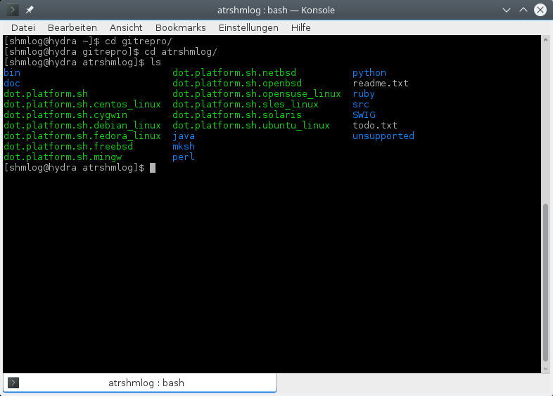
Illustration 1: The BASEDIR after unpacking the tar ball....
For starters, there are the directories bin, doc, java, mksh, perl, python, ruby, src, SWIG.
The unsupported contains stuff that I not officially support, but you can use it.
For the sake of a fast success ignore the rest ....
We check now the bin, it should be in the path of the user that's logged in, so the scripts there should be in place and executable.
Well here is what I get from an ls bin

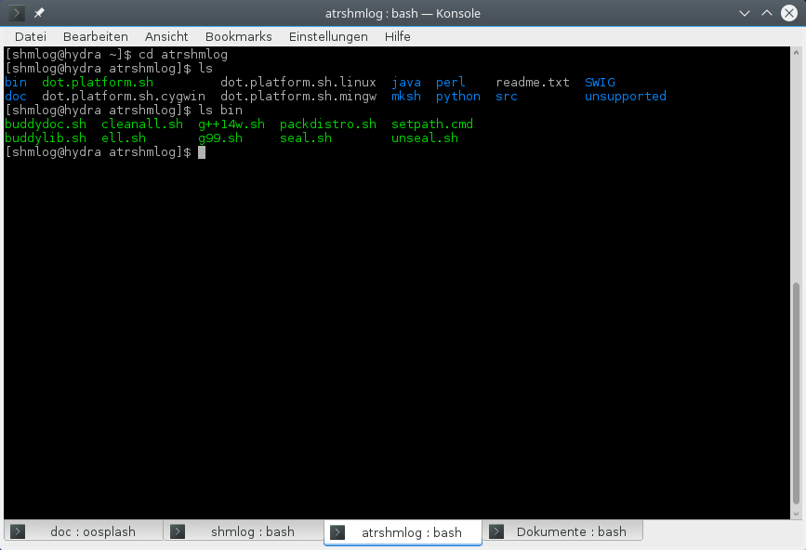
Illustration 2: The bin directory with the build scripts

Looks OK for me.
You should have only the regular scripts in place here.
OK. We can now switch to the place where the things have to be used. Its the src directory.

Looks like this

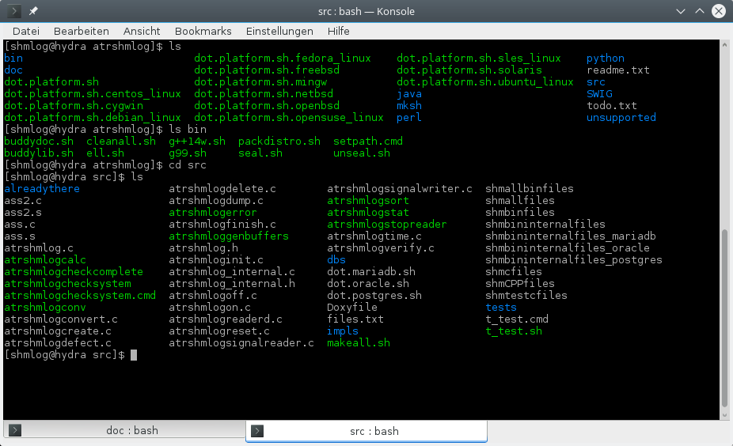
Illustration 3: The clean src directory
Well. That's better. Everything in place, only one unsupported helper in here….

Check for completeness

We check now for a complete distro with the atrshmlogcheckcomplete script.

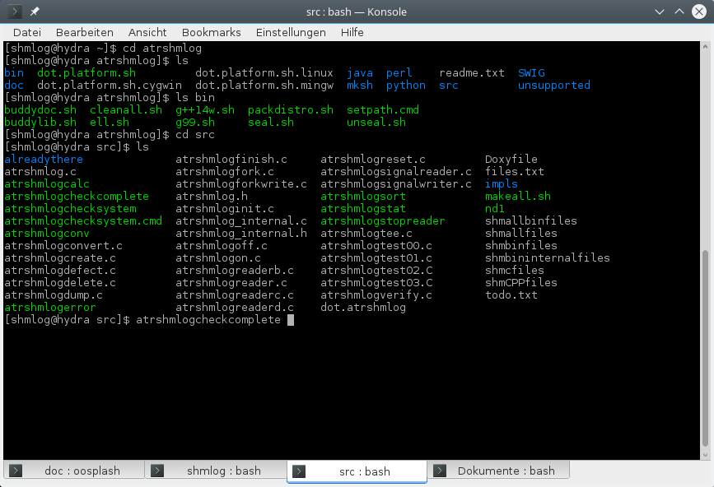
Illustration 4: Check for complete script start
The start is done as usual. Execute it.
It checks out, everything is in place.

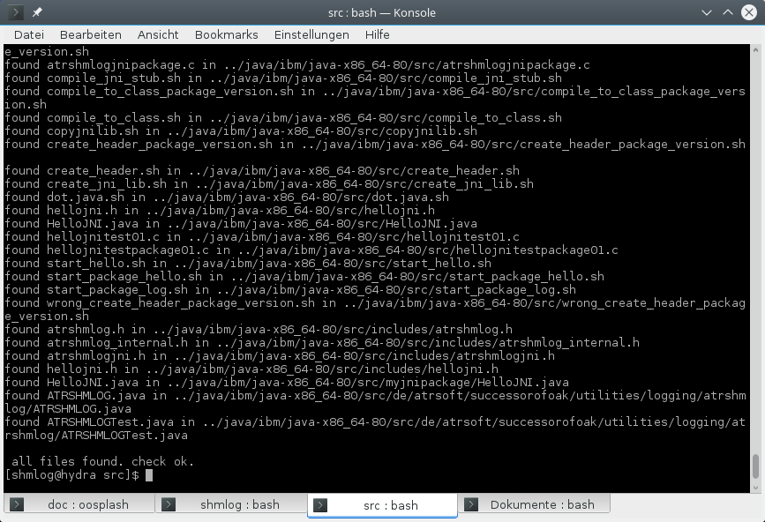
Illustration 5: Result for the check complete script.
So we can go on with this.

Check for the platform

OK. We can now check for the platform we use with atrshmlogchecksystem. I spare us the execution, only the outcome here.

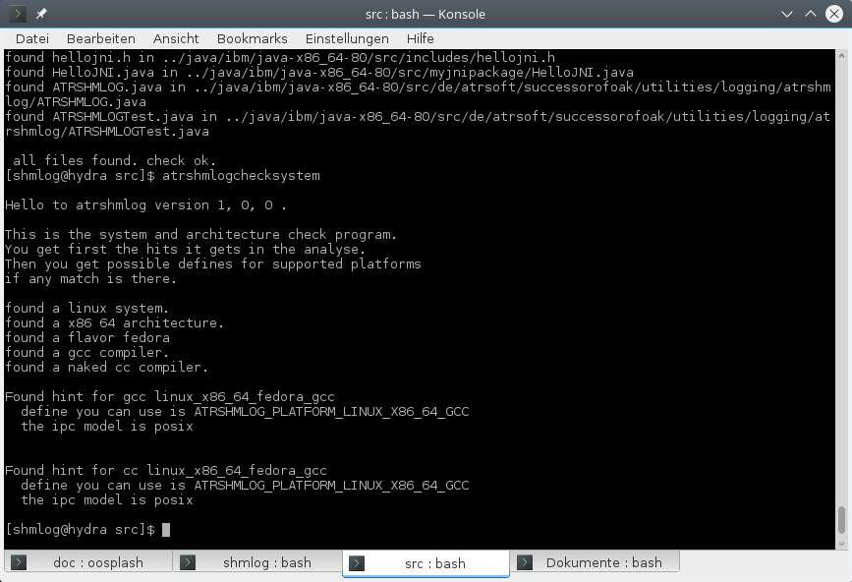
Illustration 6: Analyze the system with the check system script
That's a Linux, a x86_64, flavor is fedora, and we have a gcc and a cc in place, both can be used as supported platform with the define ATRSHMLOG_PLATFOM_LINUX_X86_64_GCC set to 1 in the header. So we can use the existing dot file for that platform, dot.platform.sh.fedora_linux.

Now we can load the environment variables for the platform. We switch back to BASEDIR. Then we source the already there dot.platform.sh.fedora_linux file (for my box – yours depend on your system). Then we switch back. Be sure to make the cd because the script has to be used in its directory.

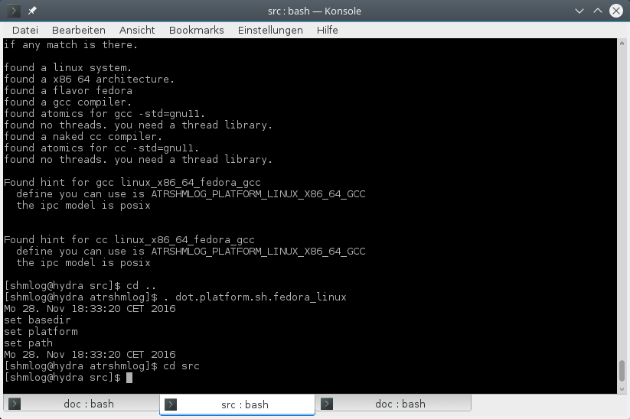
Illustration 7: Setting the right environment
So we have now the environment variables in place.

First time: build

Now we make the module with the one and only call to makeall.sh.
After entering makeall.sh and then return ....

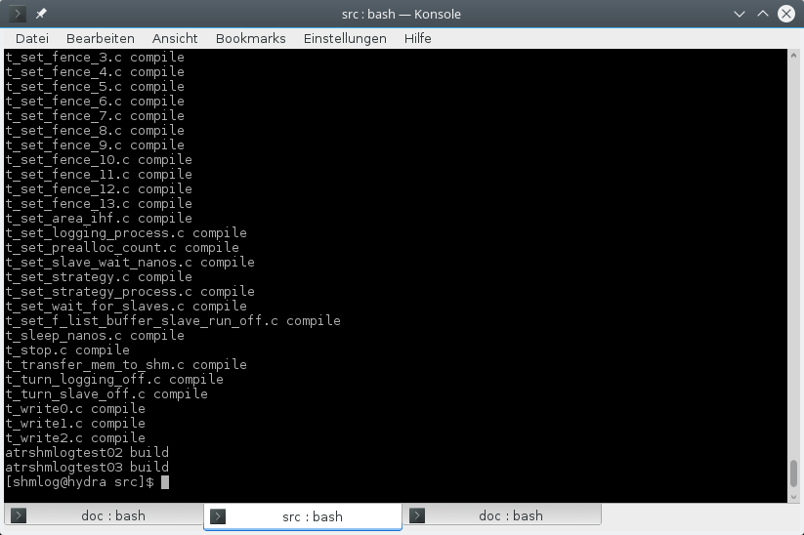
Illustration 8: After the makeall.sh finished
That was not so bad. Everything in place now, the documentation created by doxygen right in place and last but not least the module compiled, the programs there and the library too.

Well, we check it.

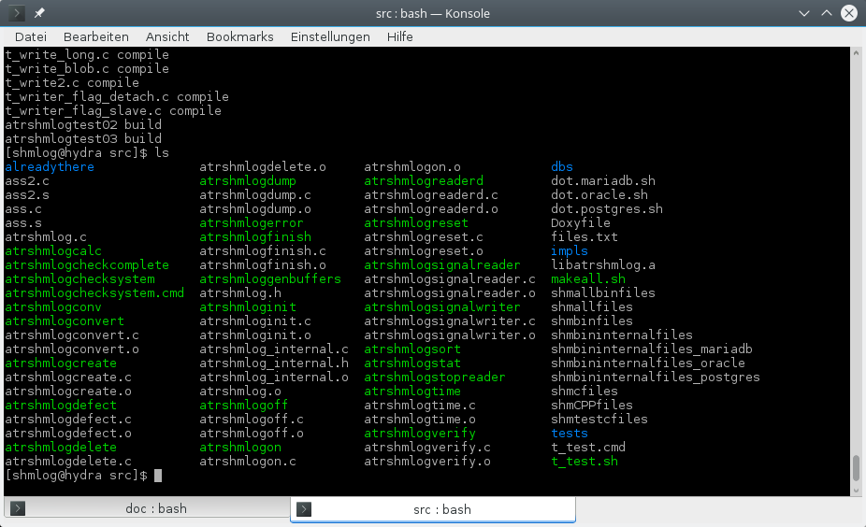
Illustration 9: Checking the build result with a ls
Looks fine for me, so change to the BASEDIR, then to doc, and check for the HTML folder. If the files are brand new and your browser is happy with the index.html that's it for the build.
See the testing for how to use them in detail. For a quick run we do it here just to have the first expression how to do things.

First test : create the buffer

We create a shared memory buffer with the ipc key 4711 – that's a very well known number for a city nearby, so I think only some guru guys would try to use it in the system before. If you are having the right to do the shared memory thing, then it should work. So we start up the atrshmlogcreate and use the 4711 as key. The second parameter is for the number of buffers, we use an 8 here, which is for normal tests more than sufficient.

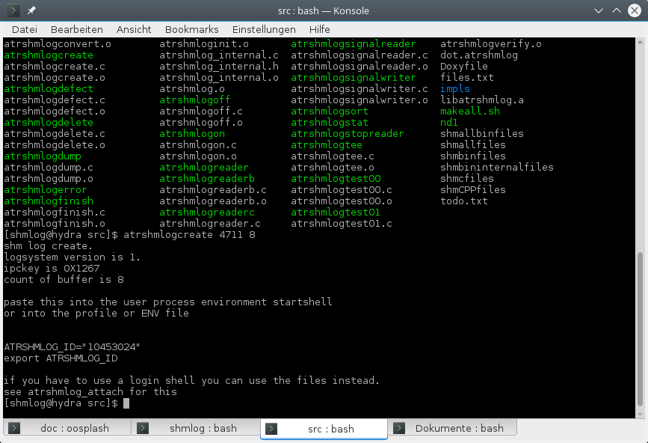
Illustration 10: A first test. We create a buffer for 8 log buffers with key 4711.
Looks good. The thing seems to make its job, there is an output that claims the ID should be in my case

10453024
and that I should set some environment variable that way. Well, cut and paste is easy for Linux, so I set it.
Side note: The last version of atrshmlogcreate also produces a file with the setting, its named dot.atrshmlog and you can use it right away as a dot file in your shell. For mingw its called atrshmlog.cmd. And if you insist you can give the atrshmlogcreate a third parameter now with the name.

First test : init the area

So now we have the raw buffer, its time to initialize it. We call atrshmloginit for this. The parameter is the number of buffers, in our case 8. And here it goes.

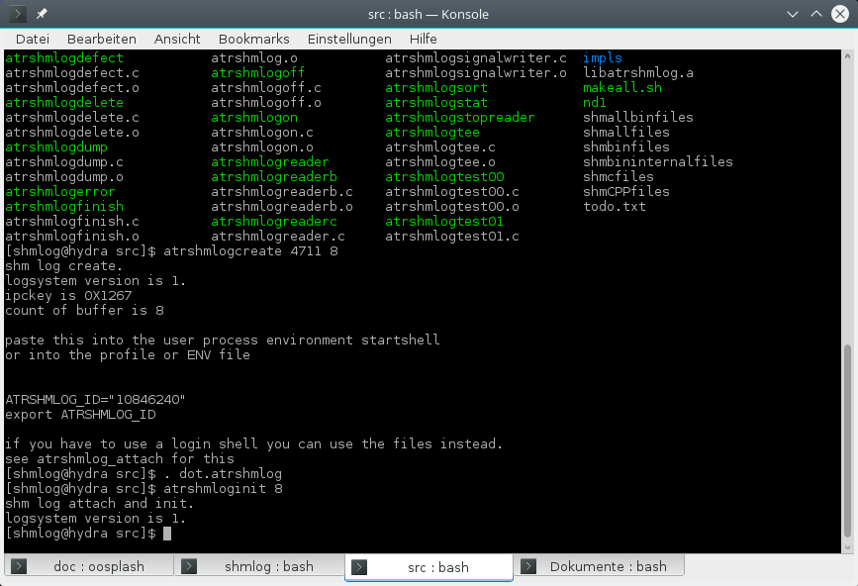
Illustration 11: Initialize the area

Setting the environment variable according to the output of the create and then initializing the buffer. In the last version the buffer count is alredy set in the environment and so we even don't need that here any more.

First test: run the simplest test program

Nice. We have now the area. We could now try a verify, or a defect, or any other thing that uses it. So we begin for starters with the simplest program that can use the log, the hello world example. Its the atrshmlogtest00 . No parameters needed, simply start it.

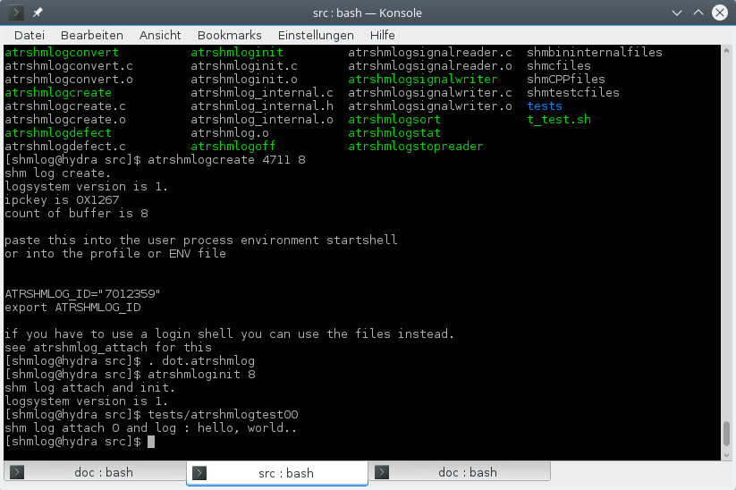
Illustration 12: Testing the log with the hello world demo program.

Looks good.
Now we have to check if we really have log.

First test: getting the log into files

The thing can be done by using verify, which will give us at least one used buffer, or we can use dump, and then check the hex codes ( ups, I think I pass that) or we can use the reader to fetch the log and write it down.
For the simplicity of the first steps we use the reader. Its after all the usual way to get the log. And a verify is nice – only one line to type, but – but shown not the content.
OK. So the reader it is.
In this version the reader will be the atrshmlogreaderd .
And we have one complication. The thing will start, connect to the area, then check for data to transfer, do the transfer, and then sleep as long as we don't stop it and wait for more data.
So we can do two things here. Start it, wait for a small time, lets say 5 seconds, then kill it with the usual ctrl-c thing. Second thing is to start and then signal the reader its done. In this case the readerd will transfer the buffer and end after some seconds by itself. This can even be set in advance of the start of the reader, so it simply make the transfer for the buffers in place and ends immediate after that.
We use the later thing, because we can do it without that ctrl-c thing, and then see for the output. To do this we have to set the signal in place with atrshmlogstopreader. No parameters needed.
Then we can start the reader. It needs a target directory, so I give it a d1 as target. The rest is done by the reader.

This looks like this for me

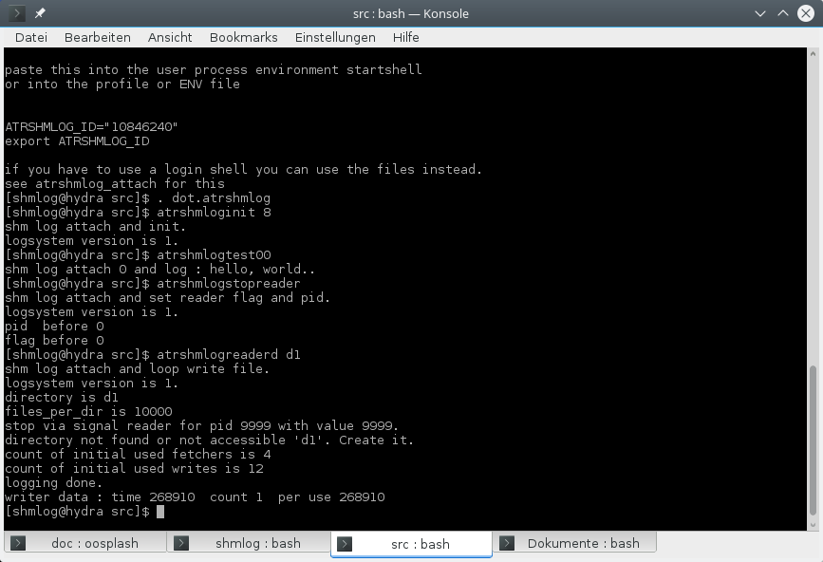
Illustration 13: Setting the area to no more logging and reading the data.

Looking good again.
The reader took some time to write down the buffer. Its also the average time, because there was only one buffer. We use those numbers later in the adjustment. The reader also told us that it uses multiple threads for doing its stuff. See the reader chapter later about this and the adjustment chapter, too.
For now we only have to check if the log is really in the file system. We can do this with an ls. To be not to fast : its in the first directory that the reader uses. That's directory d1/0 in this case. The reader simply starts to create directories in the root, that's d1 and uses numbers for the name – if your OS cannot do this change the reader to use something like s0 or similar.

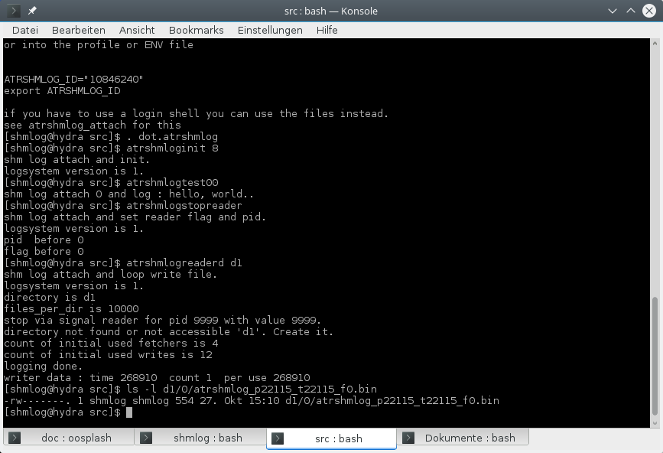
Illustration 14: The content of the directory tree d1 after transfer.

OK. There it is. The numbers depend on the process id and tid, so they change normally.
Now we have to use the converter. To do that is simple. Start it – its not connected to an area, so you can use it at any time, only two parameters and that's it.
The other way is to use the helper atrshmlogconv. Calls the converter for every transferred bin file in the tree.

First time : converting binary to human readable

That's the way we do it normally. So here it is

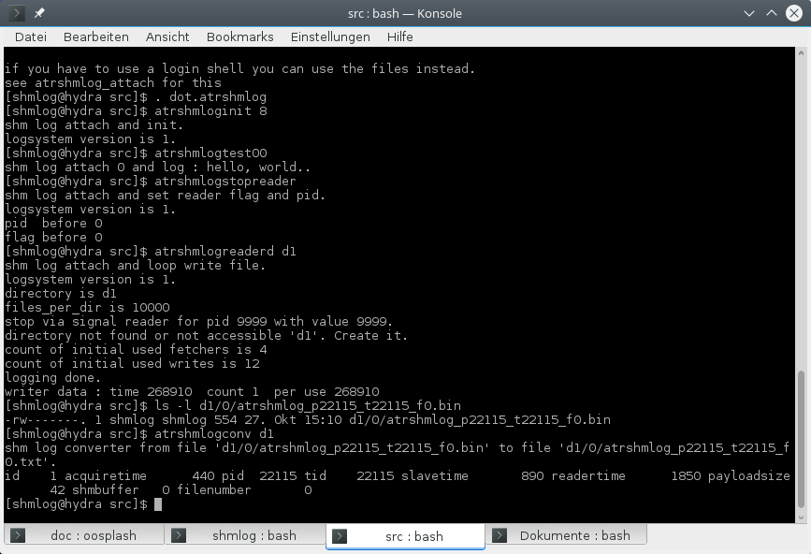
Illustration 15: Convert binary to human readable text.

Converting all bin files in the tree with the helper atrshmlogconv , and some new statistics.

Looks good. We have some interesting info's in the second line, but for now let them be there. Its part of the adjustment process to use these numbers.

We have now a converted bin file into a readable text. So here is the content. We use the simple cat.

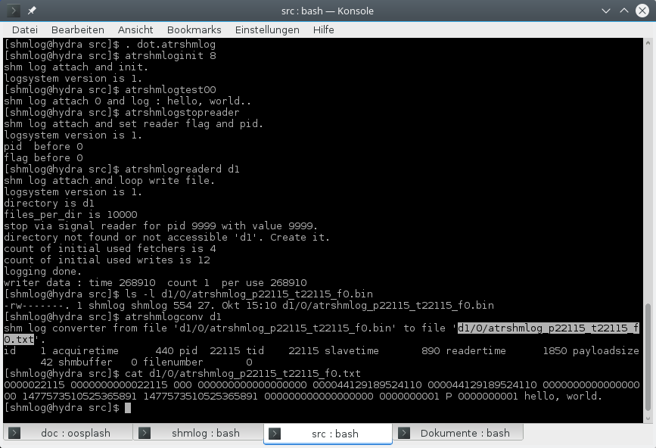
Illustration 16: The resulting log in text form.

That's a lot of numbers for now, and the text at the end.
Seems to me it worked.

When it does not work for you
OK. Bad things can happen.
Is it the wrong platform ?
First check if you are really on a supported platform.
Check the dot files in BASEDIR for this.
Check the header atrshmlog.h for it:
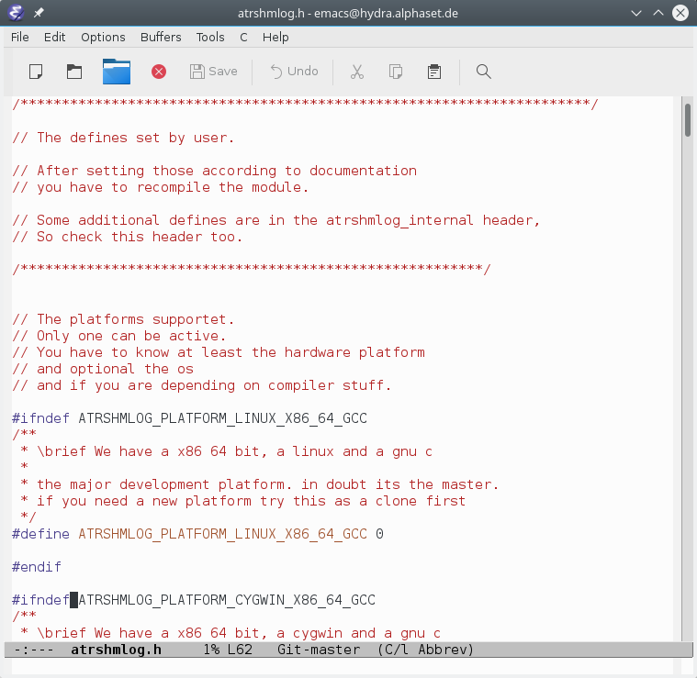
Illustration 17: Supported platforms in the atrshmlog.h header
There is a small helper to do the check, for now we do it manual. Or use the atrshmlogchecksystem.
So you will find as supported platform a define. And the define has a value 1 or 0. There can be only one of them on 1, so check which one it is. If all are 0 check if your system is in the supported platforms with atrshmlogchecksystem and with the dot files in BASEDIR.
For the vanilla module it is the
ATRSHMLOG_PLATFORM_LINUX_X86_64_GCC
So if you have another platform you have to check for it and then change the 1 to 0 and for that platform the 0 to 1. Use the vanilla dot.platform.sh.
Then try again the makeall.sh.
If you don't know your platform its a bit harder. First there is the question if you are on an OS that is supported. For this version the supported OS are:
- Linux
- Cygwin
- Mingw (via cygwin)
- BSD
- Solaris
If you are on a Linux but does not know it, you can find out with the uname program. Its installed on nearly every Linux and also on nearly every other UNIX and UNIX like OS.
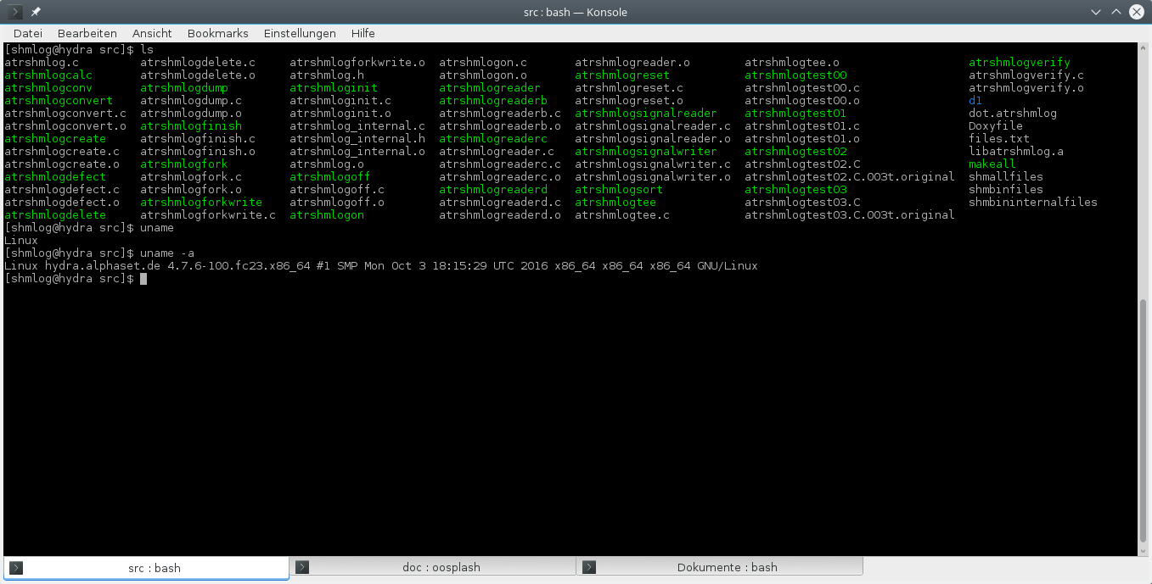
Illustration 18: Detecting the OS and the architecture with uname
OK. This gives you at least a clue about the OS. The atrshmlogchecksystem can also check for the supported platforms what it is exactly. It uses for this some heuristics about the etc directory for the Linux and BSD systems.
When you get also the -a parameter to work you normally also get the architecture of the system.
Here is an output for another system:

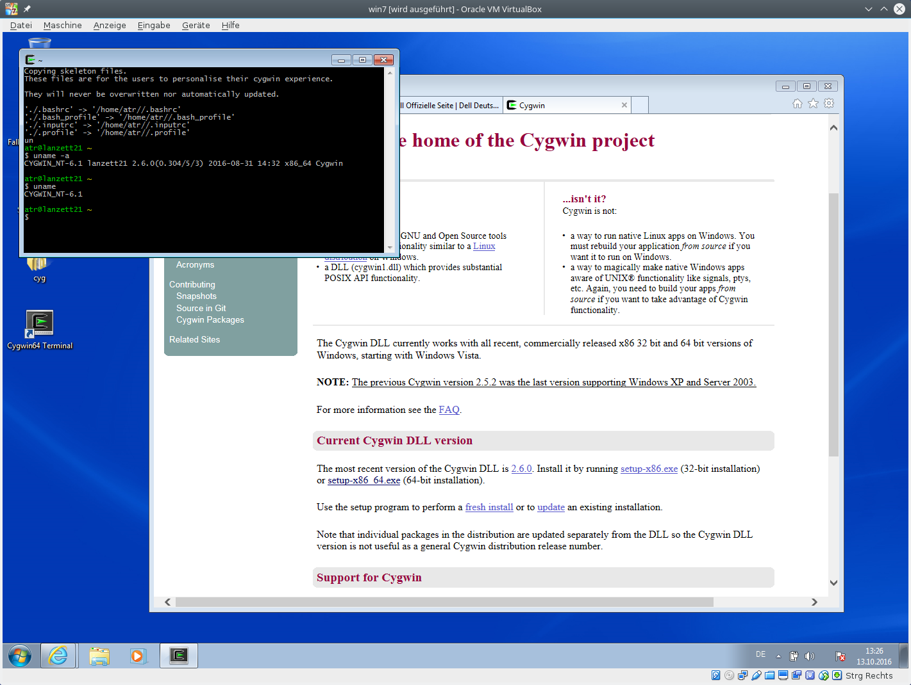
Illustration 19: Platform check for another system.
And here is a cygwin for starters.

Check the C compiler
Next comes the question of the installed compiler and tool chain.
You will need at least an ISO C 11 conform compiler with support for atomics.
For the compiler you have to check the documentation. For my platform I have to give it a -std=gnu11 flag to do the job.
A quick check is to compile a program that includes stdatomic.h . So we simply try a five liner:
#include <stdio.h>
#include <stdatomic.h>
int main ()
{
printf(„hello world\n“);
}

or simply use the atrshmlogcheckc.c file as it is done by atrshmlogchecksystem in tests subdirectory.

And that's it:
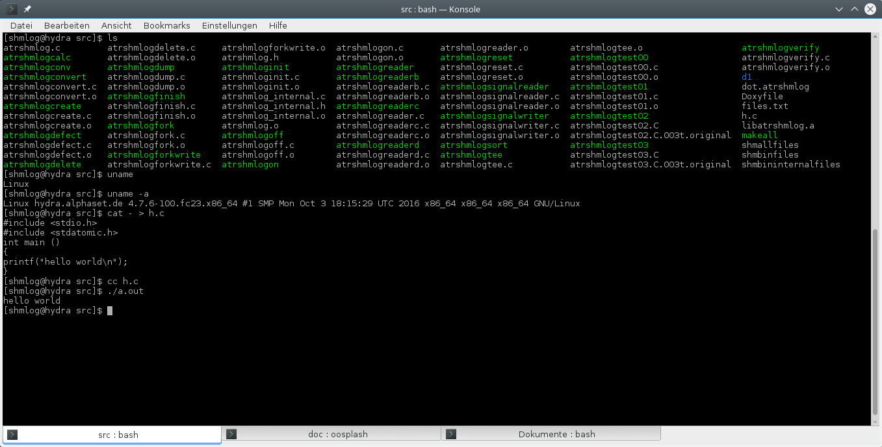
Illustration 20: Check for a conform compiler and the atomic header.
OK, the header is there and the compiler seems at least not complain about it.
So next is a test for thread local, which is new in C 11.
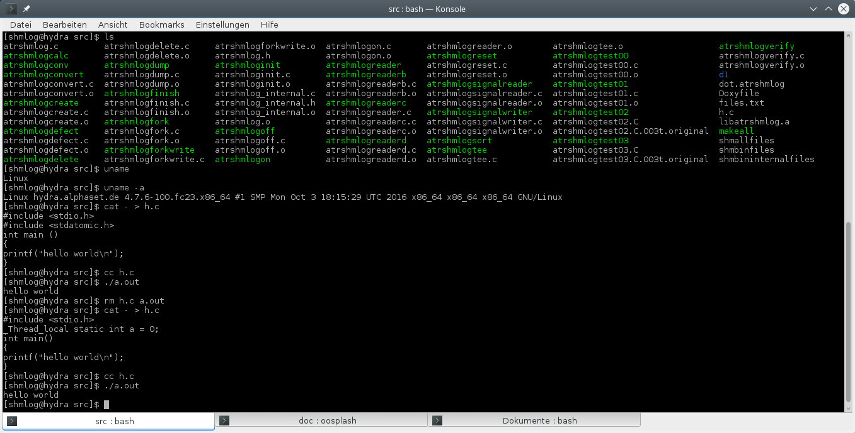
Illustration 21: Check for a C 11 feature, the _Thread_local
If you have any trouble at this point, you have to check the compiler and the libraries. This is depending on your platform and so I can give you only a hint. Call the compiler with a flag -help or –help and see for its output, then check the man page or if it does not have man pages any doc in the /usr/share directories for documentation to the thing. Having this said – I assume you are running a UNIX box and it has at least standard layout for the files.
There is actually one supported platform that does not support thread loacal storage. It is the OpenBSD. Then you can resort to the thread specific storage as it is done there.
What if my compiler is indeed C 11 but no support for stdatomic ? That's for example the case for CentOS 7.2 and SLES 12 SP2 actually ( gcc 4.8 does the C11 thing, but no stdatomic.h there).
One thing possible: Install a newer version of the compiler (here its was done for gcc 5.4.0 and the source code, the thing is not available as rpm for now).
What if this does not work ?
Here is at least on project that tries to deliver for C11 compilers the atomics that don't have them on the net. Try to find this : http://stdatomic.gforge.inria.fr
If any thing fails its at least a try to get the gcc up and running. It supports the atomic till C11 was integrated from 4.9.1 on, so chances are good you get it with this. Then you have to check if the library is linkage compatible with your target and if that's the case you are back in business. This was done for example for Sloaris 5.11 (now socalled opensolaris 11.3 x86 64 ).
Its also possible to use a clang 3.8 at least, if your platform supports that (see the FreeBSD and NetBSD for this).
If you have made it for the C module and the library and the programs you can use it.

Check the C++ compiler
The C++ programs are another story.
Its possible for the platform I use to use the C header with atomics and with inline mode. And the C++ compiler does it too. So we have a coupling here of the two things.
If your C compiler supports the inline that does not necessarily mean your C++ compiler agrees. Then you have to switch the inline off for the C++ part. And that means you need link able functions in the module too.
This is not supported for now, so you have to switch inline off for both.
If you don't want to do this there is a unsupported hack, its that you compile the module inline, and make a new file of the only inlined stuff, compile that without inline and link it with the C++ together. Its not tested but it should do the job – don't forget to use the right headers after this hack, you will need one with and one without inline in most cases.

Check the OS if the things fail to run
Having it compiled can still mean you get trouble for the execution.
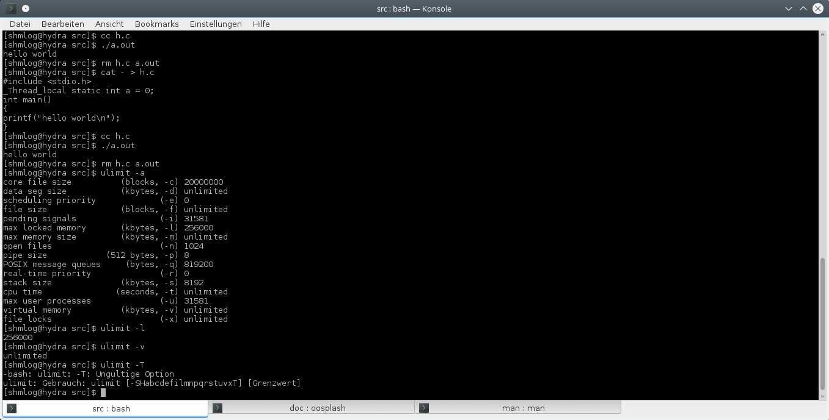
Illustration 22: Limits for the user
We see here that there are some settings on my box that could affect the shared memory use.
I have used here ulimit, its a shell build.
If you encounter problems that would be the first thing to check for.
Second is that the OS allows only special users to build a shared memory buffer.
So you have to know the system for the settings then.

When it does not fit for your needs
So far you have made it, and it made the tests too.
But you recognize you need something different.
So what can you do about it ?

Changes with the build in initialization stuff
The first way is to simply check the possible changes for values the module uses in the already made initialization process. You have to check for the attach function. It contains a list for changeable values.
Here is short overview:
- atrshmlog_init_buffers_in_advance
You can set the init of buffers before use with memset.
- atrshmlog_buffer_strategy
You can set the wait strategy in a buffer full situation for the process.
- atrshmlog_strategy_wait_wait_time
You can set the wait time in the wait strategy.
- atrshmlog_delimiter
You can set a new delimiter char in the argv concat of write2.
- atrshmlog_buffer_infosize
You can set the buffer size for dynamic allocated log buffers.
- atrshmlog_prealloc_buffer_count
You can set the number of buffers to allocate in one low level alloc. This is also the number of static buffers at program startup.
- atrshmlog_f_list_buffer_slave_wait
You can set the wait time a slave sleeps if no buffers to work available.
- atrshmlog_f_list_buffer_slave_count
You can set the numbers of slaves to start with.
- atrshmlog_wait_for_slaves
You can set the wait flag for the cleanup for wait for slave to finish first.
- atrshmlog_clock_id
You can set the clock id for get_clocktime
- atrshmlog_thread_fence_1 to 13
You can set the thread fence flag for the fences.
- atrshmlog_event_locks_max
You can set the maximum index for events.
- atrshmlog_logging
You can set the logging process flag .
- atrshmlog_checksum
You can set the checksum flag if you suspect problems for synchronization of threads to trigger the checksum tests.
- atrshmlog_targetbuffer_max
You can set the number of buffers a thread will try to use for logging.

There is also a set of values that can be changed by the user with a function.
So this is the first thing. What if it is simply not enough ?

Changes in the code
Well, as with all open source code – you have it after all on your box right in front of your nose.
So you can make changes.
Its easy. You only have to check for the thing you need to be changes and then make it. Then a makeall.sh and the distribution to the places you need this new thing.
There is one thing you should do at least when you try to change the code – change the version too.

#define ATRSHMLOGVERSION (XXX)

in atrshmlog_internal.h.

This is not for making a new module on the internet, its for your local module. You have then a way to circumvent use of mixed modules. If there is any old module in place it will complain about the version. So this is a safety for you. Choose a number of 100 and above, I doubt it will make it with its normal development.
After making a change to the code you can check for the success by using the test programs.
Does it have a positive impact and its OK this way then simply use it.
If you have instead the need that your change has to be in the next version too you have some options.
Making it big, making it small.
Making it big means you have a change for the module that is for the benefit for other users too. Then you should pack your version, and sent the maintainer (which is me for now) a post card with it in the attachment so he can check for it. If it is a good thing it will be in the next version.
Making it small - if you have only partly this in mind or simply need it only for you you can make it with a patch. Most systems support creating patches with a diff and a patch program. So you create a patch and make it work with the next version by using the patch. No more editing in this case.
This was one reason for splitting up the former one file atrshmlog.c into the impls. Its much easier to handle patches this way.
Still, the version should then be changed. Don't forget this in your patches.

Adding stuff
OK, you made a new thing now and think its worth the money but you are not selfish so you want to make it into the module.
There are simple questions you should first answer yourself.
- Is it making anything else not to work ?
- Is it making no overhead for others ?
- Is it needing permanent maintenance ?
- Is it of interest of a special group of users ?
Well, that stuff.
If your answers are good, then pack your version and sent me a postcard with it.
For an example we choose the java jni layer. You found a way to log binary an object and that's nice in the converter you patched too.
So your patch consists of a thing that would be very nice to have for all java users of the module.
Does it break other uses ? HM, I guess it will not, so you can answer that with a no.
Will it have overhead for others ? HM, depends. If the new converter has to check for every little entry it could be some seconds in the conversion, but I doubt that would a problem. If it has to fire up a jvm for every single conversion – well, that's different. This would likely end up in a big howling group of C and other users why to have such a thing in there.... OK, for the sake of the discussion its a no, no overhead.
Will it need permanent maintenance ? Well, that's a GOOD question, because you are not the maintainer. So for now if you have that thing in a way the maintainer has to do hours of overtime its bad. For the sake of the discussion it has not.
OK. Is it only of use for a special group ? That's a clear yes. No others than the java developers need such a thing. Or at least need THIS thing. If others need from time to time a similar thing it could be a good start to a plugin feature for the converter – so we simply cannot make it here a no or yes – only if its definitely only for a special group it would be a no.
So now, would it be a disqualification ?
No, because if it is of interest it would be a thing to integrate for the layer in question, and so we would have a new converter for the java folks here in the module.
You see, its not always that clear, but I think in most cases an addition will make it to the layer, or the module. But it depends and so you should give it at least a try.

Now that I have it – how do I use it ?
To use the module should be easy in case you have a C or C++ language environment. At least for the platforms I have encountered its no big problem to link a library or include an object that was made from the system C compiler.
Things can change if you need different compilers, or you are located on the fenster;plural system where you easy end up in the so called dll hell.
But for now we focus on the use in an environment where you have regular support from the compiler and can use the module as is.

The way to implement a simple logging program
This is for the starters, so skip it if you have already done development. We will target a simple C program here.
The module can be used in any C environment by using the headers and the compiled module, the library, or the source itself as include.
So for the simple task to integrate it in a program we start with the well known minimalism C program, known as hello world.

The hello world is doing a lot of stuff, but we will see for that later. For now we start with a simple thing like this:
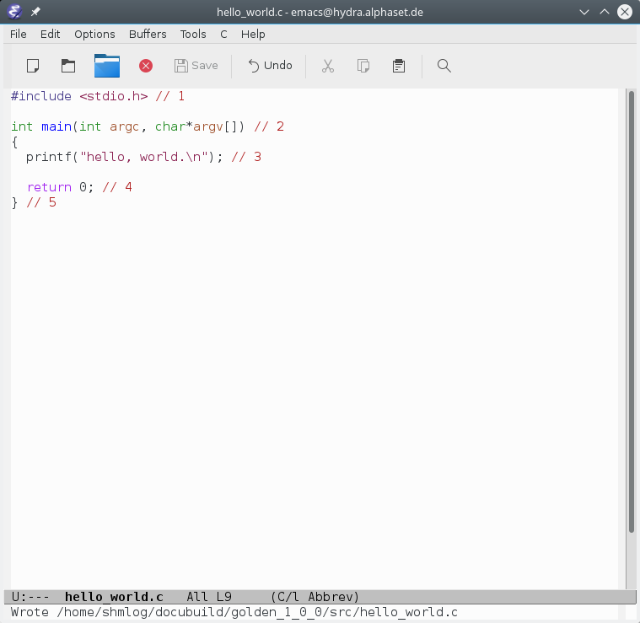
Illustration 23: A hello world program C source code
Yes, I know its not right, some things are old school and and and ... but it will do the job here.
Compile as C11 and execute it.
Then see for the lines again.

Include stdio.h
That's the first thing. So we use the whole standard library of the compiler chain here. Most likely you have a glibc in place, or a similar thing. For the UNIX's its different. But you have definitely not some byte's object here, but a lot of stuff in place you don't know normally.
Make a simple nm of the binary and check what it needs.
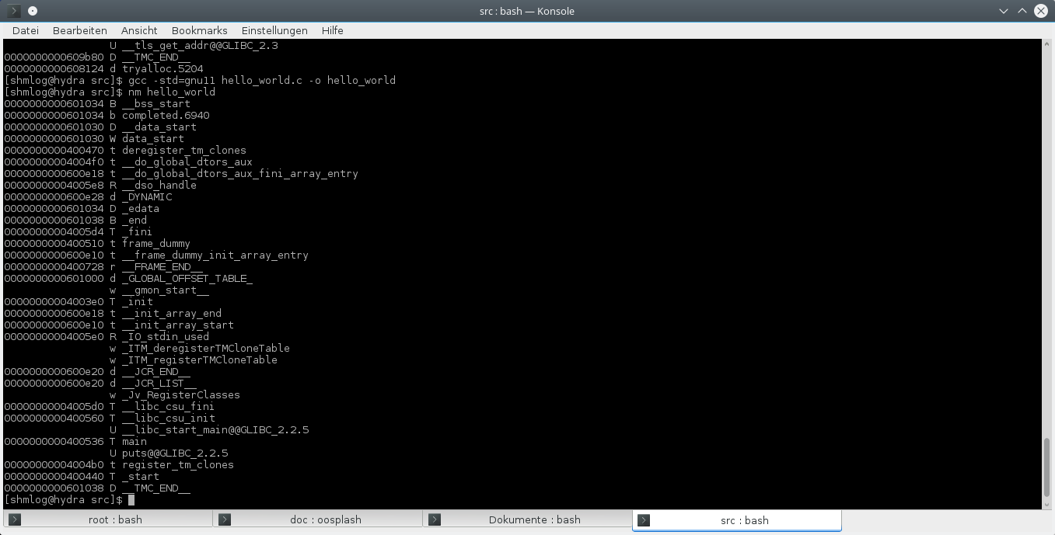
Illustration 24: A hello worlds internal stuff.

Starting point and parameters
The program will first have to initialize the library, its dynamic memory handling, the environment variables and parameter areas and such stuff. Then the main is hit and your code is on the list. So for now we have to realize there is a lot of initialization before the main starts.

Calling the library function printf
OK, this is easy. The object already reduced that to a simple puts. Still this means that the library is called, and you can see the puts@@GLIBC_2.2.5 in place here.
Its not unusual to have the C library on board – at least on a UNIX system – but its possible sometimes to do without it. For the platform I use its still clear that I will have the library on board so I will use it in the module too.

Returning from main
This is a place were we normally say, well, that's it.
In fact its far from it. There is a lot of deinitialize stuff to do, and we can see this in the nm listing is rough a third of the entry's handling de stuff. So be prepared that a program just not ends. It gives control to the library and then finishes, eventually even a special end stub like the start stup is called, so be prepared for things that can happen after you call things like return or exit.

The final end (or not ?)
After doing all this deinit stuff there is still the cleanup for the process you created. Resources of the system are claimed back from the OS and the OS has to do at least for the file handles and the memory a lot of stuff.
So you see, a hello world is far from the thing you normally are told. Its an opera in several acts.

Adding the module
That's simple. We compiled the module already, so we can use the library. Or make the source include approach. Last thing will be used in the big example below, so I switch to the library here.
First we have to check for the module what has to be done. And we find that we can live for the first test drive with two things here.
First we need the interface of the module. That's the include atrshmlog.h.
OK, the folks of the hard core line will say its sufficient to declare those needed functions simply yourself as extern, but for now I will use the header.
That's the clean solution here.

So we need the include of it in place.
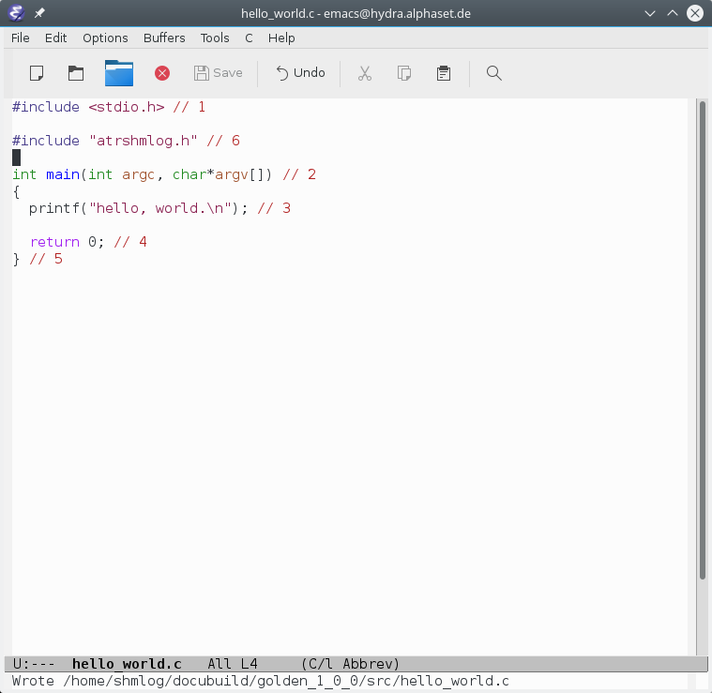
Illustration 25: The include added
Its no special thing to include it, so you can do it before or after the stdio.h, itself does not include that thing. In this version there is only one include that is done by the atrshmlog.h itself, and that's the stdint.h. So we add this here and have no change for the program else.
So far we have now the most functions available, we have to call the first vital one. Its the atrshmlog_attach().

Attaching to an area
We have to connect to an area. No area, no logging. Period.
So this is done with the attach function.
It takes its knowledge from environment variables or flag files, so there are no parameters here. We simply have to call it.
Why we ?
OK. This is perhaps worth the discussion .
Its theoretical possible to do the initialization together with the first use of the log.
That's called lazy evaluation in many programming community's.
I decided not to do this.
Lazy evaluation would shift the point of error for the log to a first use situation. And that's more than bad if you think in terms of separation of responsibility's. The attach and the possible error situation should be clear and so the log simply should do an explicit attach and initialization operation.
This has the advantage that you have control over the things done. And you can be sure that the code you write can make the decision what to do. And not some deep down buried mechanism inside a who knows when called piece of code.
On the bad side this means that its possible to make some logging before the program executes the attach. So the module must handle the infamous problem of use before initialization. That's a problem that becomes vital in C++ program, where you can use initialization code for your statics. In C its less a problem. So for now we ignore that.

We add the attach.
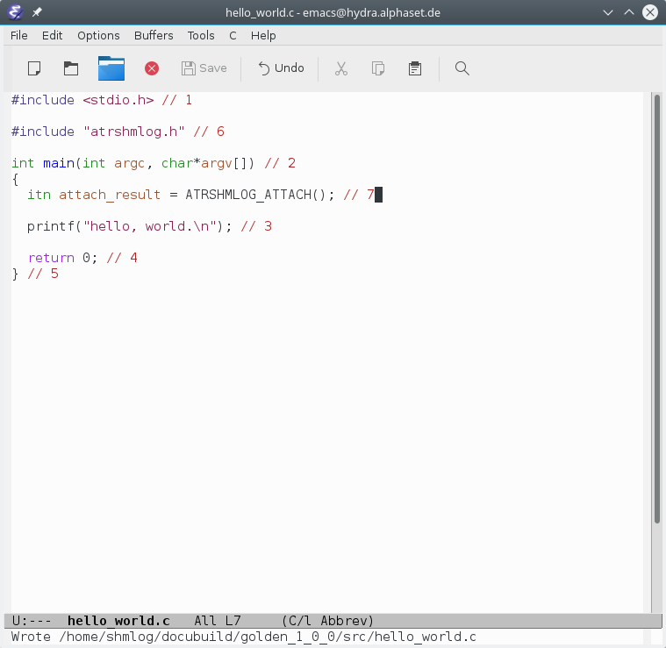
Illustration 26: Attaching to the area.
Now we can add the one logging call we need.

Adding the logging
So all we need now is the one log call we want to make here.
If we ignore the result of the attach it will end up in checking an event that's not set and an global process logging flag that's 0. So no damage is done. Only some cycles of your CPU will be needed to realize that the log cannot be made.
That's the theory. In practice you have to realize that there can be hidden costs if you play games with things that are needed for the logging, especially when it comes to building log info.
So you should ask yourself if you can live with that too.
If not, then try to make use of the return value, or use the Macro ATRSHMLOG_EVENTCHECK() here.
For our small example we have only a static text, so it is no problem to do it simple here.
OK. Now after we have it we compile it, and link the thing like the programs of the module.
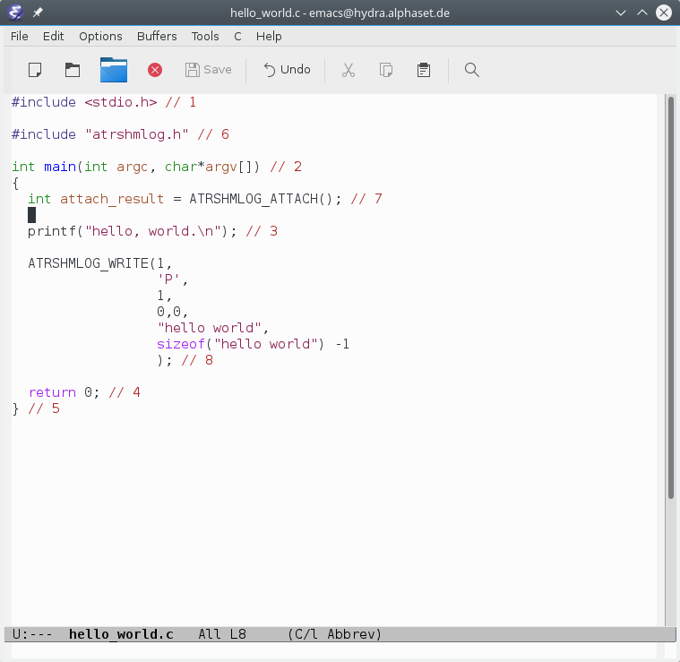
Illustration 27: Adding the logging ( and correcting a nasty error too)

Compile and test
So its after all the object liked together.
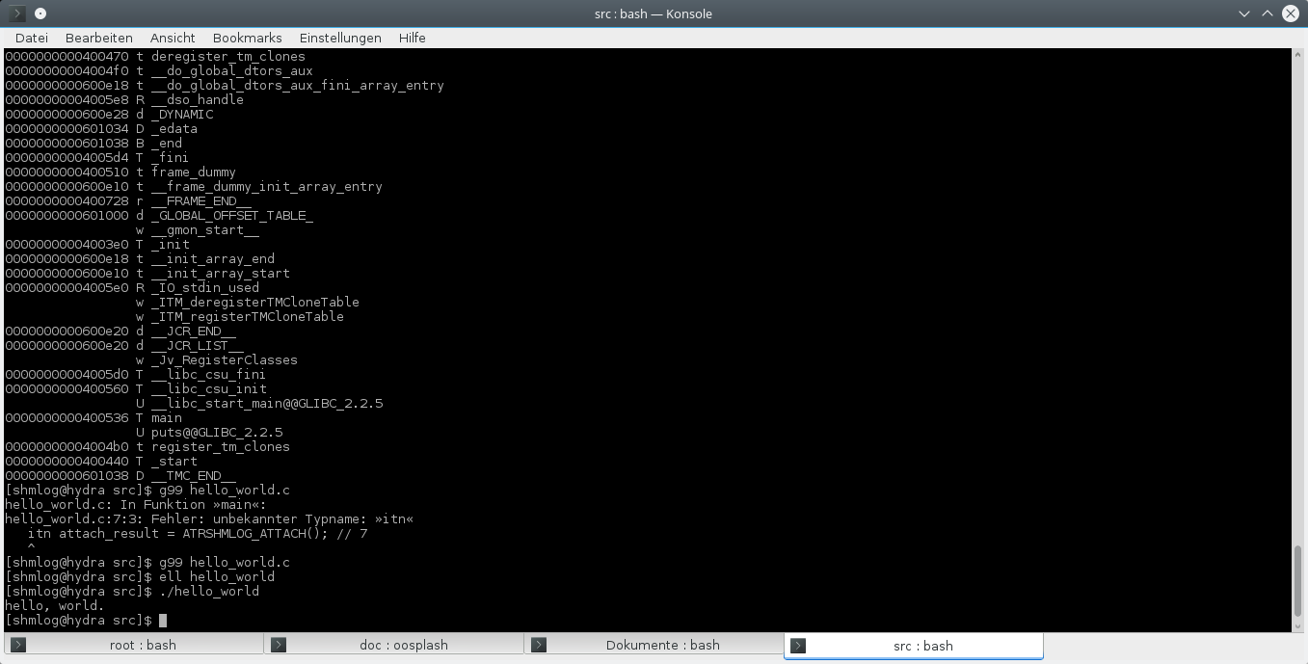
Illustration 28: The build and a first test.
Great. At least it seems it does not crash (core dump is possible for the account I use) and that's it.
To see the log we need to make the area, initialize it, use the thing, take the reader to get the output and convert to text.
That was already part in How to build chapter, so see there. Here is the output when its done.
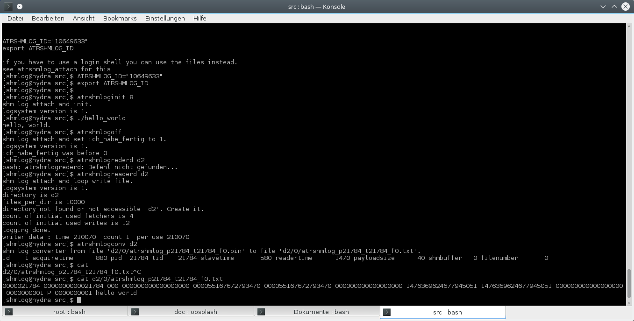
Illustration 29: The output after a test against an active area (and some upses)
OK,for an old man doing it by hand its OK.
So....

The deep stuff

.... now to the line 8.
See it again:

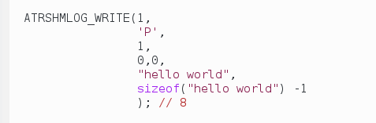
Illustration 30: The deep stuff

OK. There is now a lot to say here about how to make a log entry.
Please check after this the HTML or man or latex documentation. Try to become familiar with the way such things are said in the online help. This makes it easy for you to see for the other stuff whats perhaps really in there.
First of all we have here again a MACRO.
I didn't say this before, but using the MACRO of a function is the preferred way if you use the module.
There is some kind of hidden test here in place, so its definitely better than the call of the function atrshmlog_write1(). And as always when it comes to a C library its a kind of last defense line against last minute changes in the module itself. You only use a macro and the guy in the backyard can make adjustments you don't have to know.
In this case we have the eventcheck right before in place, so the function will not be called if that check gives a no go for the event number 1.
Next there is the set of parameters, all seems simple for now. A number, a character, a number, two zeros, a string constant – OK, that's a bit wired, a sizeof of the thing and a – 1 .
First things first.
Check now the HTML documentation for the Macro:
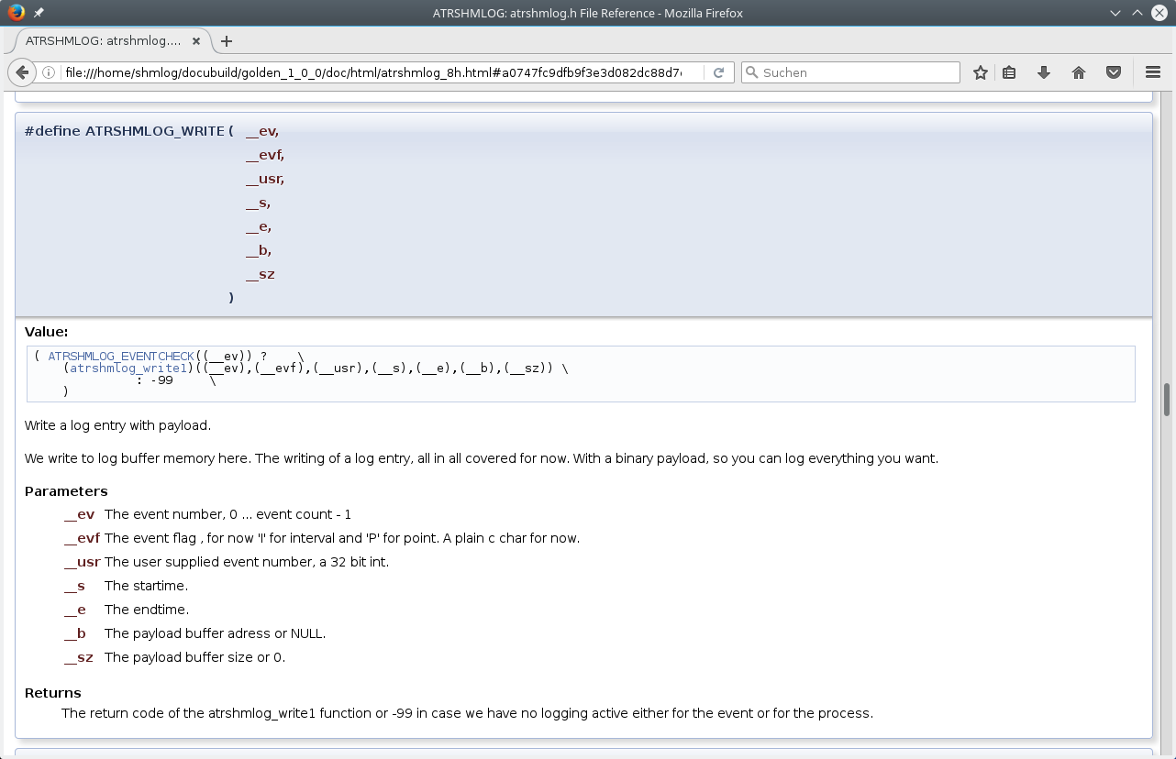
Illustration 31: The online documentation for ATRSHMLOG_WRITE
OK. The first number is the event. So we use that event in case we want to switch that thing on or off. Per default the events are on when we are attached, and off when we didn't make the attach. The attach can make some tricky things in the initialization, so see for it when you have time for this. You can set events on, off and define the meaning upside down to minimize your work for the things.
For now we know we can switch the logging off if we set the event 1 to off.
Next is the eventflag, that is a character and it is needed in the transfer chain at several points. For now simply accept that we take a big P and mean that we have a point in time log entry. And its a C string type info.
Next is the user event. Its an info we can use, so I used her a 1. If I had an info worth it and fitting in an int32 value I could give it here. Othen this is the case when a loop is in place. So you get the picture. Use YOUR favorite thing here. The event is strictly for the module used, and the eventflag too, but for the userevent its your free thing to use.
Now comes the pair of 0 values, and we see that this should have been the starttime and endtime.
OK, here comes the big info for you. If you do a log and you do a point in time type, the endtime is always set to the starttime. So the second 0 is simply there to make the compiler happy.
You can of course now start to write a bunch of different macros to cover this. But you will not gain additional functionality, so for now I have at least accepted that I give it then a zero.
For the starttime its different. If you have one you can put it in, if not a zero here means the thing will call internal the gettime function and use this. And because of the point in time thing its the same value that ends up for the endtime.
OK. This is a little bit tricky, but it saves really time and space in many cases. For the not point in time its the endtime that is fetched internal, so you need only the starttime there.
And for the layers its a big difference to need a gettime call or not. So this is a hidden mechanism, but this is a thing I had to accept after the tests and so I broke here my rule of separation of responsibility's – you can get the time not only with the gettime function, but also in a deep buried way in the write functions too.
The next is an address of a buffer, and the last the size of the buffer.
Surprise.
The write uses not the natural way to transfer a C string – this would be easy to do, and it would mean for many uses to do it right. But instead we use a buffer with start and length.
So we do a binary transfer here, and yes, we can do that for real binary data.
Its up to the convert to handle the things we log. The transfer is itself always binary, so we don't see any changes for the payload of the log call till it ends in the file written by the reader.
This has a big impact: We have to know the start and size of the thing, so we call in doubt a strlen or have a calculated result at hand for the size (that's the sizeof here).
Its then our program that crashes if we had the much to othen happen bad luck thing with C strings.
Not the module. You will see this in the debugger in case it happens.
On the bright side we can log what we want, from strings to structures to raw memory. As long as we know what we do it will be transferred. If it is not too big, of course.
The bad side of this is that we have in doubt to change the converter. But this is another story. See the chapter for the converter for this.
OK. Now that we have realized the way the write transfers its clear what it is all about the last parameter – we let the compiler calculate the buffer length, and because this will involve the terminating 0 byte we get rid of it by reducing the size by one.
And now back to the log output.
Here is the line we got from the converter. This time we name the fields one by one
- 0000021784
That's the first number, and it is the process id. Check for it when you run the program.
- 0000000000021784
That's the thread id. Its the same for such a simple program as hello world. For programs that use multi threading its different. On my platform I have access to the Linux thread id, so I use this here, on others it could be also a different thing like a pthread id or worse. But its for now a 64 bit number in the system.
- 000
This is the buffer id that was given to the buffer in the program. We can see this way when we switch buffers. And when we recycle them for different threads.
- 000000000000000000
This is the file number that was used by the reader to write the log down. This can be used to see if we have a change in the use of buffers in the file system.
- 000055167672793470
This is the starttime. Its a clicktime, meaning we have here the clicks of the tick counter register of the CPU – not a real time, but the best thing a CPU can give you to know when a thing happens.
- 000055167672793470
The endtime. As already mentioned in this example a copy of the starttime. Next example will use a different one.
- 000000000000000000
The delta for starttime and endtime. In this example its zero ( Why ? Can you figure it out ?).
- 1476369624677945051
The estimated real time for the starttime. The converter uses two mealtime measurements and calculated an estimation for the time that corresponds to the click time. Its the number of nanoseconds since the system starts to count. In case of my platform its the time since 01.01.1970 00:00:00: UTC. In nanos.
- 1476369624677945051
The endtime.
- 000000000000000000
The delta.
- 0000000001
The event of the log entry.
- P
The eventflag of the log entry.
- 0000000001
The userevent.
- hello world
The payload.
The converter has some stuff inside to make multiple lines if you insist to have them in the payload.
So for our first try its OK.

Now we have done this we can start to do some interesting things.
We build in a gettime for the start, a endtime for the printf and then see what that costs.
And to make things interesting we use this time the arguments of the program.

Measuring a printf

OK. That's simple. We add a gettime for the time and then do an interval instead of a point in time log.

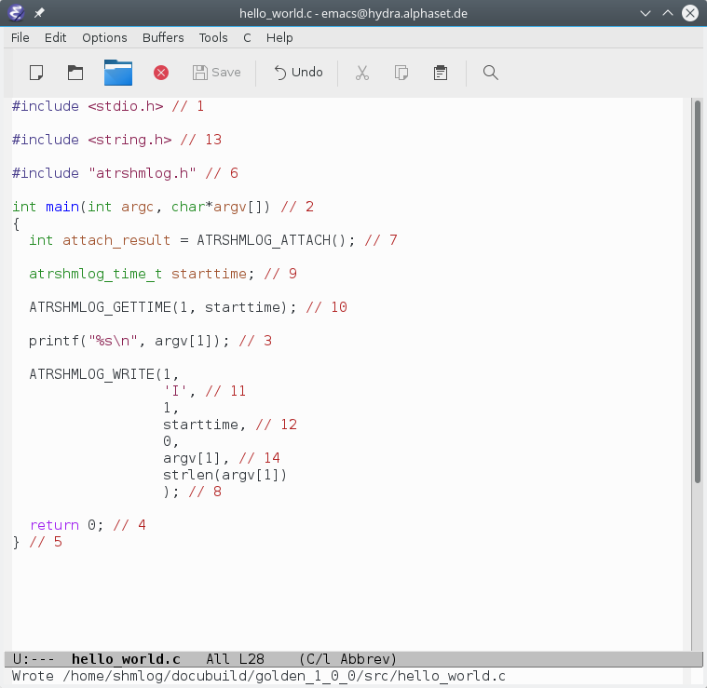
Illustration 32: Hello world with use of argv and timing the printf

That made it then to this
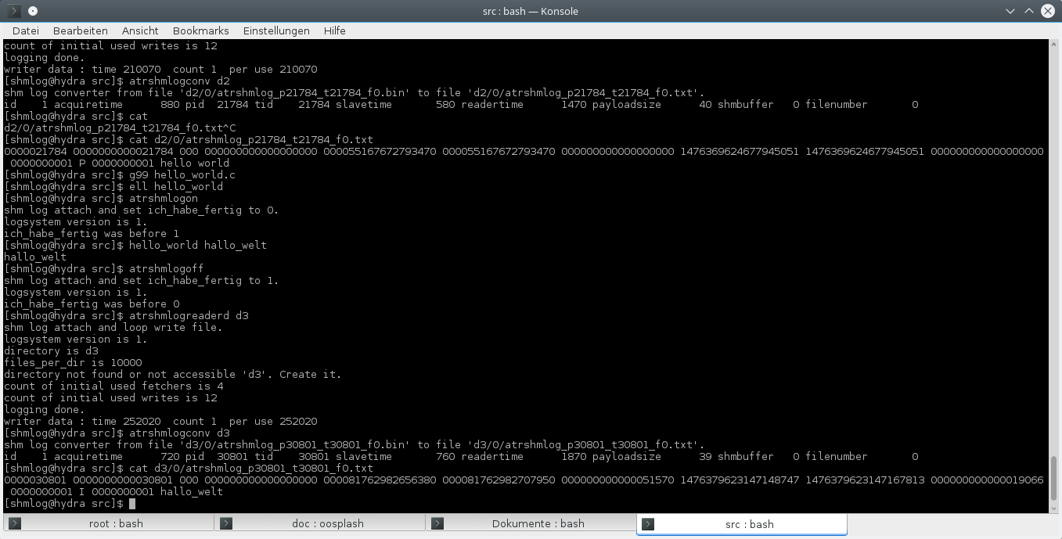
Illustration 33: The test for hello world with argv use and printf timing
Wow. 51000 clicks for the printf thing.
Now we can make tests with it – I leave that to you. Try at least to test the time needed for the gettime and the write with a static string. The make some tests for the printf and the file operations fopen, fwrite, fflush etc.
After this its time to switch to a big example.

The big example for the C community

OK. Now its time for something greater. We use an exiting program source code here and implement the logging.
The thing was simple. Support the korn shell.
This said I made the first log version and checked for the korn shell code – I knew the guys at former bell labs were today doing things in a relative open way, so the source code should be there. And as a hint I had already seen a ksh – not the pdksh – on a system about three years ago….
I found a dead end after the other. Yes, there was the source and yes, that server was down. The usual thing when a guy leaves the company and the company starts to forget….
Try to keep it up, but …
… did made it again run, Try again and …
… down again….
BAD.
So I switched to the distro at hand. Found a rpm. Found the source rpm.
Surprise.
The thing used an own build system. And it was not there. Only the source tree for the shell.
Switch to another distro. Check for ksh. Bingo. Found rpm. Found source rpm.
This time luckily with the build environment ( Its the next generation make of those guys, called nmake – which was a good idea of the guys, but a little software company at Redmond had the same idea for a bastard that I nether liked at all …. so all hits for nmake were a real punch in the air).
OK. Adapting to my distro.
OK. Building the stuff.
OK. Checking for the compiler I used (was c99 that time, not c11, but worked).
OK. Find the main and then see what you can do.
OK. Include done, module added as an include (was one file at that time).
OK. Thing started, connected to the area and made logging.
OK. Try to understand how the source worked, try to implement useful logging.
OK. Had it done after 5 days ( 5 ? wow, didn't thought it would be possible, but OK).
When I then came into contact for the technical guy – Mr. Sven Winnecke - ….
Surprise.
Its not the korn shell of David Korn, but the mksh of the MirOS BSD.
Umpf.
Check for the source. Got it.
Bring it to run on the distro.
OK. I could build.
OK. Check for main.
OK. Attach is done.
OK. Logging works as before.
OK. Try to implement useful logging.
OK. Had it done after 5 days (again … only 5 ?).
The next months were a permanent refinement of the logging itself, and from time to time changes in the source to make a better logging. Most things in the source had to do with the problem that there was no clear info in the thing about the most wanted info in a log – the position in the system – this time not the position of the writes, that was easy, but for the executed intermediate code the line in the corresponding shell script. This was about 80 % of the work and has nothing to do with the log itself, its the simple problem in case you don't have the thumb on it in the phase of design and evolution to make a thing work that any user suspects to be there out of the box.
OK. After all that fighting with source code of other people – it worked.
I got the line number with an approximation in the case it was not there and carefully changed the code so it was there where I needed it.
After two months I could focus on the log itself again.
Making it faster, making it better for multithreaded programs and all the stuff for mutex's, then condition variables, support threads and at last – atomics. And the memory model thing ….
Back to the thing at hand.
Its the mksh version 52 b. Now replaced by c, and I have no intention to do it again. So 52 b will be our big example.

main
You find the code in BASEDIR/mksh/mksh.logging.
First thing is of course main. You open up your favorite text editor and then in main.c it is.
You have the unchanged source in the tree BASEDIR/mksh/mksh.52b for reference.
Remember the hello world ?
Adding the header, adding the attach.
See line 819 and follows. I use some time variables here. Needless to say I did some changes for the type, but it was always that simple use of variables here.
Just to find about some speed timings I made some otherwise not useful logging's. Simply ignore them.
After the attach in line 831 we can skip to 990. The thing uses an initialization function here, so making some timings here is a real thing to do.
Ever had discussions about program start up ? Well, that's now a thing you can check for…
I use here a simple approach for the events numbering. Every implementation file gets its own hundreds number range. So I use here 1 to 99. And after playing some games I came up at end with using the same event for the time measurement call and the log call. Oh, and I didn't had the hidden timing in the write at that time, so I do every gettime for endtime, too.
In line 1007 is one of the vital branches. The main interpreter loop. In 1022 the other loop.
OK. This means some playing with if else and making new events to make possible to switch of timing and logging I don't need.
Back to the initialization, go to line 181. main_init.
Timing is OK. Make a gettime. Then long time no need to do a thing – its after all internal stuff of the shell, so I don't need times here. The interesting spot is at 370, where I have to give the shell the knowledge of the variables I used in the attach – or better – the name and value it should use for it.
Making a shell logging is one thing. Having it running in login shell mode is another. You cannot simply set system wide variables. So you need something different. In this case it were the flag files.
So now you know why they her . Its for a logging shell and you cannot set environment variables before it has started.
And yes, I could live with a “so what ?” her – but I wanted the values most vital after the start inside as variables. So I had to set them in the shell's init . Here.
Next thing interesting was the file include stuff. Every shell starts in normal mode and reads in include files.
A profile here, some alias file there, eventually. A history …
So from line 524 on we have the include stuff and its timing.
Ever had discussions about the time you need for start up and config files ? Now we know that….
Things are a bit strange to me, but in line 670 we are back on the money for init file timings.
I line 800 we have done so far that init stuff.
There is one dirty thing here. The line number problem. Solution was a more or less heuristically one : make a line number guess and keep it up to date when you have one. So I introduced in the – single threaded – shell source a global variable, g_linehint. Every time I have one I set it. When I don't have one, I use the g_linehint.
That's a bit dirty, but the result is to have a line number that is most accurate for the logging, only one line off some time. I can live with that.
Include is the next interesting thing. You take a file and include it. Again is the timing of interest, and the logging needs a good line number – of the processed file of course, not the file the include is in, but the file you process now…
We start in 1056 and take our time. The some vital info's – which include.
Ever have tried to figure out how many files you process in a shell start up on a system – and what files ? Now we know that.
Next thing is the command. Most wanted for timing. How long took …
Turns out its the next thing, shell , we need for it.
Its too much to give back in a simple text, so I spare you most of it. The case is perhaps the only thing you should investigate.
The rest is support stuff, perhaps someone needs logging here, but not for me…
At the end in line 2556 I did the one and only thing I needed at that time – include the module itself as source. Today it is needed to do this with the library, so this is now wrong.

eval
Its more than interesting to see how the shell handles a diametrical conflict – execute scripts as fast as you can on one side, execute dynamic stuff on the other side, and last doing interactive input handling. So eval is a vital spot – you call it more othen than you think.
OK. include made in 26.
Ups, what's that ? Substitute ? Interesting. Give it a timing and log.
Next is evalstr, the thing is used at several places. Also a vital target for logging. BAD THING: more code for error handling and logging in those cases than real code. Sometimes logging can be elegant, but that low level thing is not.
The expand then brings lots of parsing stuff. So logging and timing again. OK. We are already over 50 % ….
Then only supporting stuff. No need for more logging.

exec

Most likely the most important thing – the executor. The shell uses a scan compile execute internal code approach. So this is the thing that really does the things we want to do.
Right in line 75, we start our logging's…. Good new: we have – sometimes – line numbers and can update our heuristic helper hack.
Bad news, only part of the time …
Well, this sucks, but I can't change it. So some playing with variables here. Then back to business. Line 205.
THE MAIN INTERPRETERS SWITCH.
Bingo.
From here on we can tell what a simple command takes – i.e. a program call.
And ( command ) sequences, and | ing, and the not so othen seen ; things ….
And also some less othen seen things, like the co process.
All in all this is the real jackpot, till we reach line 800. Simply get the info you have and write it out.
Some helpers need attention too. Comexec is one of them. After some iterations we have a logging for the external binary's. Wow.
Bad thing. Need another helper variable, the command name . But its local, so I guess it hurts not too much. Again we get sometimes line numbers …
define. Nice . How long takes it to make a variable … or function… or undefine it ….
And again a nice one. Built in.
Ever had discussions about using internals or external programs ? Or functions ? Now we know that.
Skip some support stuff. No need for a log. Hit 1934. The builtin execution.
There are two bastards, one is WAIT and one is SLEEP.
Here we are for the wait.
Last action in this file is iosetup. Ever had discussions about the speed of the io operations for the shell ? Now we now that.

expr

This is also a vital thing – anything you try to do in the right side of ….
Starts with line 205, v_evaluate.
But I overdid it. So after some iterations its the only place now.

funcs

OK. Here are the next targets. We start with the smallest of all, the . Command.
Line 1800 and we are in. Sourcing of files in a already compiled script context – how othen did we discuss if it were too expensive to make include files to source … Now we now it.
Line 1910 , the WAIT.

The rest is support stuff, no logging needed.

The rest

Well, we could use eventually. Some additional logging, but for my purpose its enough.

Build the thing, set up a working area, run and see for yourself.
Never again discussions about times for functions, scripts, programs …
How nice that could have been.
Sad to say, but they never needed such a thing.
So this is now the one big example how to log ( and its a boring one, only the usual stuff, and no real new functionality ) - but its there and if you are interested you can make it run – remove the source include in main, link a library and you are in.
Needless to say that I had two times changed the use of the macros, so I had to work it again two times, but after all it was relative stable.

The database support
The database support is new in Version 1.2.0. It is possible now to transfer log into a database for retrieval and analyse.
The fact that you need not only to log in a small development environment but also in production means you need something to log to that is used for analyse for log for a long time.
Most likely a simple check of file contents is sufficient to detect a problem in your log – some log entry like “I am dying of memory starvation in ...” would be a trigger from a program to a reader of the log…
But you can do better.
You can make a filter to check for the log entry and then fire your own actions…
OK. In between there is the need to have for big logging applications a way to navigate through those tons of log entries.
And when bad comes to bad you even have to make the inspection from a special division in your company that is strictly decoupled from development…
So the solution is to use not a simple file system – where you can spent hours to catch the one and only interesting entry in grepping or test editors searches – but to use the today sin qua non of holding data – a database.
Well, that's at least the theory.
And yes, you can use for example a sql loader to simply push the text files into a database….
But we can do better.
We can use a converter to push into the database – its already everything in place when we start to make the file output things. So why not write to a database instead ?
Was not so hard.
I started to clean up the converter first, then I introduced some database abstraction and this evolved in time. After I had made it in the converter I found it not so difficut to do it in the reader too.
And so the dbs directory became a real thing.
First I did it with the PostgreSQL.
After all we are a open source module, so the first targets will be open source databases. And for me its a fact the sql buddy's are the things in place to do the analyse here….
So I took what my fedora has already on board.
I installed the devel support. And then the thing was checked for the documentation and for example code and yes, it was running in 2 days.
Made some adjustments and then found it was time to give the db independent part a chance to do it with the next one – and so I took the mariadb. Its for fedora the next choice – after all open source (again) and a wildly used one too.
After mastering also the mariadb I became curiose – I am after all an Oracle consultant in real life beside C and C++ development – and so I started to master the Oracle too.
This was more work as expected. I have lived for 25 years with using an Oracle – and in C code – but only with the embedded SQL and the Pro*C compiler. So some things were allways in place that are not for free. Mostly the connection set up was “already done” with the simple things deep inside the Pro*C stuff…
After this I needed a week to master the LOB approach. And yes, I need it. No big char type that can safe me from a CLOB – at least if you insist to make a big curve around the dreaded LONG things.
And yes, for my UCS2 I did NOT want to simply switch the NLS settings – that would have been too easy – but use BLOB.
So the thing costed me many look ups in the documentation and the examples… which are full of things I consider an error in my eyes.
But then I made it at the end – at least for the convert.
There is much room for improvements.
For the PostgreSQL I think the use of prepared statements could use a tuneup, and eventually a new version even can now do an array insert … but I don't know this for now.
For mariadb there is definetely an array insert now – but not in my version on Fedora 23 – its too old.
OK. When I get big with f25 I will recheck this ….
For Oracle there are several things to try. First the local DB – had my DB on a different machine, so only network speed…
Next the array inserts – well, that's at least a nice theory. For the Blobs it will become a nightmare I guess.. but then, why not ?
And of course – direct path. Don't underestimate its speed.
Next thing was to start at the famous (?) NO SQL path. So I took my buddy's advice and got hands on the cassandra from Apache. Perhaps in the next version a mongodb will follow.

The basics for PostgreSQL
OK. So you have the module build and now want the PostgreSQL support.
First thing is to have the devel support in place.
Next is to set up a database cluster (that's the term they use here) and then make it work with firewalling – OH, I forgot – we use of course NOT localhost here. We have to do this after all in production with a network between – so learn to do this.
The dot.postgres.sh file contains my example setings for it.
The dbs/atrshmlog_postgresql.sql contains the things to build a small set of tables to insert data.
We need a sequence for the identity of the entries. I did not do too much here because in practise the insert has to be done fast, so this is only a scratch pad solution. The real work is later to move the data to tables that can be used to analyse it – meaning you will need more indexes, eventually partitions and additional fields and tables ….
So we have only the tables to insert in. For the use this is enough.
I use a table for the conventional text logs and one for the ucs2 things. That should do the job at least for me.
Next is the code to do the things.

atrshmlogdb_postgres.c
Fire up your favorite text editor and load in the file.
After the usual comments and the include of the interface for postgres we have at line 38 the real definition of atrshmlog_dbsession_s.
The struct holds the connection info – I work with multiple connections – at least I think for the reader this is a must.
Then the line 156 (atrshmlog_create_db) is next target.
We have here the setup of the things we need.
First the connection data from the environment.
Then we connect and start to prepare the needed statements.
Site note:
The guys on the web seem not to have a clear view if this makes things faster. Seems all stuff is done today from the Java developers, and I doubt they will really understand what the database has to do – they only see their JDBC drivers and they seem not to be too nice to them here….
So I use – of course – prepared statements. And yes, even the BEGIN is one.
Line 228 ( PQprepare) start with the commit.
Next is rollback, begin and the select for the sequence – I decide in the first version not to try to be too tricky, so I use an explicit sequence here.
Line 325 starts the inserts. I have three, one for the head data from one log buffer and two for the payload inserts – I call internal the thing a chunk of data – its a composite of compressed numbers and a string.
Line 511(atrshmlog_cleanup_db) we make the usual cleanup thing to stop the connection and shut down our database action.
Line 541 the one simple thing – begin is done.
To be honest, I doubt it will really make a difference, but I tent not to get weak on the small once.
So even a simple begin is a statement and I use a prepared here.
Same pattern for commit at 580 (atrshmlog_commit_db) and rollback at 619 (atrshmlog_rollback_db).
One thing that is perhaps a bit oversize is the state machine thing I use to decide if I can do a commit or rollback – I need a begin before to enter state 3 ….
Line 658 (atrshmlog_insert_db_head) enters the real things here. We start to insert.
Seems postgres loves the theory. In theory the best is to use a normalized transfer model for binary data. Here they use network order. That's ok for me, I have made a bunch of functions to switch the order – if its needed – and then do the job. Later on when I plan to have non Intels in this will pay off. For now we have simply two times a flip in orientation. One on the module side, and one in the postgres server ….
The important thing is to NOT use text. This would kill any advantage for the prepared – you can then simply go back to the Java guys who try to solve everything in the database area by using STRING …..
Line 822 ( atrshmlog_insert_db_cstring ) we have our next insert, this time the payload for text.
I did one thing here I normally would not have done. The length is made by strlen. But the PostgreSQL cannot do the embedded zero things – so a cut off if you have done a I or P log with binary is better than having a crash in the converter.
So I cut off if you make an embedded null here.
Because I simply don't know I have made the payload also a text field, not binary. I think that should at least help if conversions and encodings come in. And for text this is a definitive possibility….
Line 913 ( atrshmlog_insert_db_ucs2string) we enter the ucs2 thing – I use a bytea, so this time binary is ok.
There is one dirty thing here in the next one. Line 1004 (atrshmlog_get_head_seq_db) seems to be a simple select – but ….
The byte order thing would demand to first get it binary in network order – which would be ok for me, then transform it to machine, then transform it back in the inserts …
I did a short cut ( and I assume some day this will curse me ) and simply leave it in network order – its used this way then directly in the inserts….
A simple cleanup ends the thing. I have in Oracle the cursor and on server side the usage from sql for multiple sessions – here in postgres it seems to be restricted to the session that makes it. So we need the cleanup, but I hate to wast cpu cycles to do the same things multiple times. So in case of the postgres I will see if I can make it so a server side reuse somehow. Perhaps I enter the server side programming after all ….

The basics for MariaDB
After the PostgreSQL I started with the mariadb – had some basic ground for postgres for release 7 ( Oh boy) and mysql (version 3.1 Oh boy Oh boy …).
So today things are different.
The acquisition of mysql by Oracle was made and today you have the best known open source database for Linux in the hads of – well – should I say 100% pure capitalism loving burocats ?
OK. The open source community started the mariadb thing and today I find that as a replacement on my box.
Lets see what I can do.
First I found the lack of sequences a problem. There was some stuff about a sequence engine for making dummy tables on the fly, but that could not work for me.
So I checked the postings and found that LAST ID thing.
OK, that can be a replacement.
For the transactions I was warned by the past and yes , the autocommit was still on.
Next was the lack of the begin – but that was not a real problem.
When I then made the first server I had some trouble with the firewall, but still made it to my network version. You can check the dot.mariadb.sh for my settings. I suggest you make a same setup for the tests.
I had also some trouble to make the account working, but again some articles helped me. So I use an atrshmlog database, a user that logs in and simply ends up in that thing as default, and then the rest is nearly the same as postgres.
For the data I could use the medium types – if you plan to make bigger things you have to switch to the large once.
But all in all it was an easy thing till the coding started.

atrshmlogdb_mariadb.c
So fire up your favorite text editor and load the file in.
After the usual comments and the includes for - ? - mysql.h the line 38 (atrshmlog_dbsession_s) starts the fun part.
The mariadb needs a connection, some prepared statement handles and that's it.
So in line 144 (atrshmlog_create_db) we start with the connection.
First we get the data from environment and then we set up the module first to multithread mode – I don't know if I need it, but in an reader I think I need it definetely – and then make the connection.
I checked for the thing on the net, but the fedora 23 is simply not the hotest thing, so I had to pass the array operations.
But first things first.
Line 237 (is_autocommit_off) we shut off the autocommit.
I know its not the usual thing for mysql – but I am a big guy, can put on my cloths alone and even close my shoes. So I have found that most things in databases go wrong when someone tries to make it “simple for the users” and this is especially true for an autocommit. So turn this off.
Next is to prepare the statements. This time I get some handles – perhaps I can use them later in a multithread system for multiple threads ?
Line 448 (select_last_id ) we end this with the specialty of mysql to get the last id.
OK. We have no sequence to ask for, but then we have to ask for the last id ….
Line 469 (atrshmlog_cleanup_db) we have the ususal cleanup.
Next is a dummy – the missing begin.
Commit and rollback are – NOT – prepared statements , so I assume we have no way but to use thm in the usual way its done in mysql.
For the inserts the things start at 573 (atrshmlog_insert_db_head). The things resemble me to the oracle – but this comes later.
We use here the types in binary. Again I have to say : If you really want to have something from prepared you should also do the work on the data. No text if you can do it somehow in binary.
Bad thing: I need a bind allways for every statement – seems after all its not the same as for an Oracle for the reuse, more like the postgres here.
After getting the ID we can go on to the next insert.
Line 876 (atrshmlog_insert_db_cstring) we have the depending text payload.
Again we have no embedded null, so I use strlen here again.
The rest is the usual.
Line 988 (atrshmlog_insert_db_ucs2string) we do the blob thing. Its simple.
Last are the sequence dummy and the free for the statements – if I have it right it should work also for the multithread thing, but I did only the convert tests.

The Oracle experience
That was a tough one.
I have used Oracle for 25 years now – started with Oracle 5 in 1992 at Software Ley which became then a 6 in 1994 and a 7 in 1996. 1997 the first 8 and 2003 the 9. In 2005 an early 10 and in 2008 the 11. Now use a 12, and many things have changed ….
First I use it on the Linux of choice – a RedHat based system. Don't try Suse or Debian. Next I use it on the fedora 17 for the Server – which became the Red Hat 7 ground. And on the fedora 23 an installation that is used only for compile and connect to that server.
So this time I have added in unsuported an oracle directory with some scripts to help the setup.
The user is created, the connect made and the script for the schema objects can try to run. But first I need an additional environment setter to make oracle available on my box. Use it first, then switch to the dbs. There you find the connect info in the environment in the dot.oracle.sh.
After making the connects, fighting the ususal war against the firewall and then giving up by using the usual iptables -F I finally got the connect for my sqlplus session. Great.
Next came the study of the OCI Api – I had allways used a Pro*C for the things to do, so OCI was new for me – really, 25 years doing serious C and C++ stuff with Oracle, but no OCI …
First things were – well, a bit bigger than before. The Oracle made clear its no fun to work with on the lower levels. I count 8 Handle types, dozens of options and rough three different ways to put in the stuff. Finally I switched to the simplest – and slowest - thing.
Then the blobs come in. And this is a real mess….
The Oracle demo programs are at least a bit older than you expect – I see headers with 1980 s in there and real K & R C …
And tons of “i fixed this here and there “ comments.
Still I found at least three things that I would never do in a production code program – and so never in a demo.
After spending a week for the blob things I finally got my converter running.
You have next to check the schema definitions in atrshmlog_oracle.sql.
First try to set up your Oracle 12, then make it work from the box you make the converter and then come back.
Finished ? OK.
We have a sequence in place. Then the usual number stuff for the head. I miss a 64 bit integer here, but there is at least in the networking for OCI an option now ( since 11 the 64 bit int is in).
So next the dreaded blobs. One Clob and one Blob. And for the string payload I made the – usual – two times storage thing. And the len …
OK. If you start with Oracle you will not do this. You will use varchar2. And then when it comes to maxsize eventually a LONG….
But its wrong. Use CLOB. And if you have big data you should right switch back to school and first learn about tablespace, options to set the physical parameters of tables and all that stuff that today is not worth the money because everyone uses today a big storage box with his or her oracle databases – best multiple dbs with one box …
Forget performance.
To be honest – I learned how to calc a disk strip pattern to make reads fast … 25 years ago...
Today use the cache of the thing – the database and the storage box. Forget physical designs.
Next is to learn that some things still should be seperate. So DO use in production tablespaces. Best start right at this example and use one for the CLOB and BLOB.
But we are not in school here. So I simply say you should do it. I do not make it here in the simple Oracle intro – and it has no effect on the SQL itself.
Next is partitioning. If you can live without it – go back to PostgreSQL and mysql. Oracle lives from things like this in production. Lern it – and not the stupid simple on, the tow staged one with hashes.… ever wondered why MSSQL can never beat Oracle ? Check their way of partitioning…
We use simple indexes here, no function based, so I leave it to the partitioning to handle real big data.
Next thing you learn in Oracle is to hate things like “we need here a big string” .
No one needs it.
If you analyse production databases most strings are SHORT. Less than 20. Only an idiot tries to use strings in replace for a good number collection …
But all those tiny little programmers who don't know databases seem to thing that only “unlimited, at least 2 GB or bigger” seems the correct answer. Ever tried to send a 2 GB string from – let say – a java vm via network to a lets say Postgres ? Or a mysql ?
Do it. Then try to start thinking.
OK. For me it was clear when I started the log to db thing that I would have this problem. So I do the ususal. Make a second storage for the short once in the table and the CLOB as backup.
Len comes in to be very handy in case you need to decide what's where.
But we will not start here to do SQL analyzing. We only try to make it into the DB.

atrshmlogdb_oracle.c
So fire up your favorite text editor and load in the file.
First the usual comment and the includes. Not sure if I need the second oracle one but in the example it was, so it's here.
Next we have some prototypes for helpers that come in later. Accept the pollution of the namespace with very short and handy oracle types.
Line 77 (atrshmlog_dbsession_s) we start to set up the context for this module (I switch here to oracle naming, its better this way ...).
We have an environment, error handling, session, server connect , service and statement and bind and define handles ….
I have for the bind also the copy of the head and io head in place, also the id …
Line 211 ( atrshmlog_create_db) we start to set up our connection.
I don't try a pool here, I simply say we will have between 1 and 50 connections and if we have more than 2 active it will be hell of a traffic. So I do not use a pool, I simply try to use direct connects.
First the environment settings.
Then in line 274 ( OCIEnvNlsCreate) the creation of the environment (this was new – never had to do that in the embedded things – its simply there…).
AFTER SOME FIGHTINGS WITH ERRORS I FOUND THAT A SIZE OF 0 FOR THE CONTEXT ALLOCATION SIMPLY DOES not WORK WITH A GIVEN NON NULL ADRESS. YOU HAVE TO USE THEN A null FOR THE MEMPP...
ups, Upper case shift … but then - its for real.This cost me two hours alone ...
Till line 503 only the setup for the connection. Compare that with a mysql … or postgres ….
In 503 ( OCI_HTYPE_STMT ) we start the prepares.
We allocate handles for the select , the inserts and that's it. The begin is a dummy – could make it but its not needed – and commit and rollback are special functions.
Line 575 ( OCIStmtPrepare) we make the select.
Next we make the define so we only do it once.
Then the first insert.
Line 709 we are through, but not without some autch. The limit of Oracle catalog is 30 chars for an identifier. Ours have to be shorthen ….
Then the binds start…. I use name binding when possible. Its clean. Position binding leads fast to simple but strange errors in big systems… after the mainenance start...
I could have made it faster. Use arrays. Do it in one loop…. But for the sake of a clear example I wanted it line by line. So we need till 2513 for the binds….
Line 2555 ( OCIStmtPrepare) we have the next insert. And this time we have an oracle specialty. The returning clauses.
So for the blob and clob you will first have to insert an empty one. Then you have to select the thing back in your application – or you use a returning clause in the insert. Try this with jdbc … or something else ….
The oracle delivers a handle for the blob operations. Then you have to upload the blob itself.
Needless to say that this is far from everything you expect when you have used a mysql or postgres….
But it comes better. Wait for the actual doing. For now realize that this is a very different sql.
Again tons of bind. If you are very careful you will recognize one bind is missing…
Line 3222 ( OCIStmtPrepare) the ucs2 thing. This time a simple blob only.
Again tons of binds, but again one is missing.
Line 3860 (atrshmlog_cleanup_db) the cleanup.
I use a counting flag for doing the final cleanup – don't checked what happens if it is missing, but I assume a leak at least.
The begin is again a dummy. Oracle can work with it, and it can without. So I leave it off..
Commit and rollback are the usual function calls.
Line 4053 (atrshmlog_insert_db_head) the inserts begin.
Hm, wasn't hard after all. One simple execute – no more things. This seems to be a better thing as the other once…
Line 4091 the things start to change.
First we need helper code here. And additional structs. And typedefs to keep out mind still healthy.
Line 4113 ( atrshmlog_insert_db_cstring) the mystery of Oracle blob handling starts.
We have to bind that data here because we don't know the size. Its a string after all. So now we need the bind per call.
Next we have the bind that I missed compared with the others. The blob part.
Now strange things come. We need those structs to establish an input context and an output context.
Then we need a lob allocator handle.
Next is some bizarr setting from the example code ( I thing a hard coded 86 is far from everthing you should do in example code, but its for real … cdemodr )
Line 4267 (OCIBindDynamic) the real fun part starts. We introduce the dynamic bind and the callback function interface.
This is - at best – misleading stuff from the example. I had to fix at least the indicator thing. And the thing was supersized for array insert handling. This would be ok if there were a simple one example – but there isn't. Only thath complicated thing… You are thrown into a most complex array update thing, with multiple returnings and with at least three potential core dump actions that I had in my coding career.
HM.
So I simplified it to a single row operation, made proper contexts, made the callbacks a bit more handy and got running code.
Line 4302 the blob transfer begins.
After the clob works the blob is only a copy of it ….
Line 4352 ( atrshmlog_insert_db_ucs2string ) the ucs2 is in, this time without a second storage.
Last is simple stuff. The sequence and the cleanup of the prepared statements.
WAIT:
There is the callback stuff in place. Look careful the example and these and you will find a tricky problem in the demo … hint: indicators.
OK. After having 2 days for postgres, one and a half for mariadb, one week alone for oracle blobs.
I think I understand why people try the simple and cheap things now ….

The cassandra NOSQL Database

Bad start ….
Time goes by.
This is the only constant in the universe of software development. And this means that from five to ten years its needed to check if your impression how things should be done is right.
Don't blame the messager.
If you don't see the signs of the new era, well, the its time to change to a nice job in project manegement perhaps …
For the database today everyone is nervous.
The good old days of the big iron using big fat RDBMS of – lets say Oracle, IBM, Sybase, Ingres, Gupta, Informix, seem to end…
Also the good old days of SQL at all seem to end …
Its the time when so called IN MEMORY databases, cluster systems, even intelligent filesystems seem to get more and more attention.
And money.
And jobs.
One of this threads seem to be the so called NOSQL movement …
Well, this was the status of the things now ( January 2017 ) and I decided to support at least one of the so called NO SQL databases.
I am old fashion after all….
Back in time. Its 1995 and I discuss with some colleagues about a new way to do workflow…
After some days the database thing ends up in – postgres (yes, thats not a typo – its without SQL …).
In 1999 I made contact with a very low level one, mostly known for its simplicity and speed in simplest things … mysql.
We skip forward in time…
Today postgreSQL is happy to tell you that it is the feature fullest Object Relational SQL database on the plant.
Mariadb has made procedures, triggers, several in server languages, and - of course – full XA transaction support for a replication cluster ….
Sounds strange, but it seems that the old days with “no, we dont need that fat … at all” has gone when a system starts to try to do real things…
Were were we – ah, yes . No sql …
My colleaque Dirk Hoppmann told me about one of those so called NOSQL databases … He had serious problems with the guys that used it for the storage and if I could not spend some time to make me an expert for the thing, there is so few support on the ….
OK. I loaded the thing from its web side.
First thing after a download of the ACTUAL version is for me to check for the history of versions available .
If you use Oracle you know that there is allways a database somewhere in the company which is somewhat outdated …
I could not find them. Only two – lets say – some years old versions ? Nothing between ?
Next is the documentation.
I am an old fashion guy, so I like to download it and have it on my notebook – just in case I have a real customer in a bank with no connect to outside and a BIG amount of Iron in the walls …
No dowload available.
Only some very outdated copys of pdf from second and third party guys …
HM.
Next is to check for the client interface, mostly the C API …
NO C api available, only that Java things …
I began to regret my decision, perhaps I should not spent my time with … WAIT.
There was some info about a lib … abandoned, but the creator left a message he had switched to a company doing ..
OK. So long term support is not given from the creators, but a second source party....
I checked for the web site of the thing and found in the only available documentation …
TODO
TODO
TODO
TODO
TODO

No actual documentation on the web side without at least one TODO block in the docs if I try even the basics – AND NO WAY TO GET A FORMER ONE that could have been finished …

This is the time I start to invest the statistics.
Found at least three times that this – well – thing – seemed to be the sixth or even fifth most popular database after the big five ?!??
For real ?
OK.
I spent a day to realize the C API was never part of it (no wonder the java guys had the thumbs on it, so no cooperation with the rest of the world) – but a separate company hat seen this opportunity and dived in …
I checked that thing and found the guy that made the early C++ api hat really changes to this one …
And I found the needed API – its a C++ thing after all, but it works on he base of the extern C thing… so I was in with a C API after all.
To make a long story short – I hate this thing…
Take a deeep breath.
Shout out lout.
SHIT.
Then go back to work.
I downloaded the driver software from githup, made it run.
I downloaded the actual database from the project. Install it, set up a simple thing, run it.
I made the samples so far.
I found some simple things that worked.
I made some adjustments to the basic table setup and I was in in the thing again.
At least my installation did the simplest things – setting up a keyspace, creating some tables.
Next was to realize the guys at the company got brain damaged. Calling a header or a lib the same as the database project suggests the YOU made the thing … and they even sell support for some “all from one hand” things that deliver the databse too… just as if they would have created that thing …
I hate that. If I make a layer to something its for me clear I should NEVER sell it as if it were the real thing …
But that's an open source project on apache, and it seems they ignore totally the rest of the world – at least my impression when I check simple things like the docs – and so it still works for the rest of us.
I made it till I was hit from some – lets say – unexpected technical things….
So we end here the report of the old fashion guy in the land of new NOSQL database and switch to the view of a simple user….

Reset…
We have the cassandra 3.0.10 now in place.
I made some minor adjustments to run it against my actual network interface, not localhost – after all we want to do things for a cluster, not a dummy…
Making this thing work in a network needs also a login.
Well, perhaps I will change the default password in a month or so …
For now I have created a new role and I have made it to do real logins via the cqlsh tool.
Next was to make a keyspace.
Simple. No special things needed here – made only one error after all .. comes later …
So I could now switch to my keyspace and implement the tables…
Found no sequence thing.
BAD.
I checked he documentation and the net and found a counter thing – looked like a sequence like thing after all.
So I started with a table with a primary key col and a counter.
But no luck again . No way to combine a thing I call acid to that combination.
Even simplest support in form of the build in after update check failed.
Seem they mean it real with the distributed thing – but I honestly dont know how they will ever do the simplest things that way – I resort to an id table … and found me traped in a network error ? NoAvailableServer ???
Found that I was too optimistic for my keyspace – if you say you have TWO you MUST HAVE TWO of servers .. and so resetted the thing, made ONE node only and … it worked.
What was so complicated is the thing every database does different so far. The sequence thing.
The Oracle has a fullfledged one , and postgreSQL follows with something nearby.
For mysql and mariadb its a bare construct on their own, the last id select thing.
For C* - or should I say cassandra ? - its the NO WE CANT DO IT THING.
I tried the counters, but then I ran into a simple problem with no solution. The guys simply dont like the idea of an atomic op and so its not possible to ask for a number so that you can relay on its uniqness and use it from that on. You can only switch to the counter to increment or decrement – a transactional read in the same operation is not possible, even an update with a combined IF clause to make a busy loop select update loop fails.
So counters are for me – out. No use. Forget them.
I switched to a conventional table and an ID in it.
That worked after I fixed the thing of replication numbers for the keyspace – only one if you use only one node…
So I had a workaround for the counter problem. Its bad, but its the only way to do it clean in C*.
Next was easy. Use the example code and implement the insert, the selects and the update…
What did you say ?
Yes, you heard right. Select, Insert, Update .. Delete I don't need for the module .
What did you say ?
NO SQL ?
Oh, that.
Its pronounced here like “no, we cannot do that nice SQL things, we have only the basics of storage engines here...” - did I mention that was the mysql statement in 1999 word by word ?

atrshmlogdb_cassandra.c
Fire up your favorite text editor and load it in.
We start with the ususal comments.
Next is the include of datastax header. Its named simply like it was the real db thing …
We then have the session with the CassCluster, the CassSession and the connect thing – they use internal in java land all the time the Future things, so the datastax has done the same and so you use a future to get a connect to the somewhere in time coming result. Its for multithread things and most people like this because it it faster …
So we simply get the future of quality, wait till its done and then check the result and return codes.
We have a multithread application, so I simply make my connect to the cluster and they can do the rest. I dont need multiple batched queries from a thread, I need the thing I want to have to be done.
Next we have prepared statement handles – they could be shared I think – and a head_id and rowid.
The C* does allways need a full primary key and this means I have to use a rowid beside the head_id in the cstring and ucs string tables.
OK. I can live with that.
Line 153 (atrshmlog_create_db) we enter the real thing.
We need the port – hope its the same for all contact points – and then the keyspace and the user and password.
So after we got the things from environment we set up the structures for cluster and session.
Next are the contact points – and only one port ? hm. This seems to me like a misconception, but they seem to think its not worth to handle that per node – port. OK.
Next is the user and password thing, then the real connect is made in line 260 (cass_session_connect_keyspace).
I use here a short cut, switch directly into the target keyspace for my uploads.
Next is the prepare for the insert into the head table, the cstring and the ucs2 – its like a simple copy of the mariadb for me here.
The prepare is very simple – line 360 (cass_session_prepare).
To fast – its NOT that easy. The call is made asynchronous, so we get a future, not a real handle…
Line 368 (cass_future_get_prepared) we have our handle to the prepared statement…
I wonder – what if the comm call breaks – no return code checking here ? Didn't found it in the examples …
Next is the cstring , simple copy.. And the ucs2 is a simple copy too.
Line 493 (select_last_id) we start the workaround (? don't think this will ever change in C* universe, but for me its one ) for the missing atomic ID thing.
I read in a loop the value in question, I raise it with an conditional update (see later for that) and if the update made it its ok. If not I have to start again at ground zero, get the now hopefully right ID ...
So we have here the select …
… and line 522 (update_last_id) the update.
They call such a thing an lightweight transaction – its all done in the one statement, and so it works like an atomic, but its a slow down also. There is communication to the others to make it right, and if two connects try to change a thing at differend nodes the things are synchronized and only one will get the “yes, you have done it” result. The other(s) have to start again at ground zero, take the next value with a select …
Read C.F. Codd, 1970, ACME about the evil of early physical design in a otherwise mathematical perfect database world (and NO, Codd is NOT about SQL, its about the theoretical groundwork and its in mathematics, so this aplies to your database too).
OK. So we have in C* to do this shit.
Minor things:
I tried first a counter, I thought that should be exactly the thing in this case – but the IF broke – no valid contruct with a counter table …. what are the counters then good for ? Only counting ?
Next I got a ok when I updated the simple table, but a NoHostAvailable when I tried to do the IF.
After some googleling I got a similar thing on s.o. and figured out that the update is node local and does not concern the keyspace replication factor, but the update with IF does need the keyspace replication factor and so it need the real thing here : connect to the other node.
I had no node, so I dropped everything, made the replication a 1 and it worked …
So we switch this time to the get seq – its the most unexpected thing here.
Line 1390 (atrshmlog_get_head_seq_db) we have the logic in simple loop.
I use a label, and then I do the select. You need a statement, but this seems to be an internal op, no network. No error ? HM. I would have expect at least an out of memory check …
Next we execute – there are no bind variables in the select – its simply direct to the table …
We get the future and then get the real resiult. Next we read in the result – I copied the thing, so it looks a bit oversized to use an iterator pattern to read only one line from a table, but thats ok for me if it works …
Next we have to free all the inbetween things…
For the update with check we need the new value – and yes, there is no a = a + 1 thing for non counters (grin and ignore my sarcasm here ) and so we have to make the calc ourself.
For the test its the old value of course.
Next comes the result – in case of the IF we get one, and its the answer if we had success with the update or another session was faster …
Whats left is the jump back to the start in case we didn't make it. And yes, I could have used something better than the label and goto, but I think its the best way to comment the logic needed by C* here in the way you should do it – with the lowest possible logic in your programming language.
This Database is far from anything I can call “for real”.
Back to line 560 (atrshmlog_cleanup_db).
The usual free for the things in case we have to clean up – either in good or bad case.
As for all database modules I have the dummy in place if the thing does not make it – so we have still begin, commit and rollback, but they are only dummy parts here.
Line 653 (atrshmlog_insert_db_head) we insert into head.
We get a statement from the prepared, we set the bind variables. I don't know why there is a uint for 8 , 16 and 32 bit, but not for 64 in datastax – perhaps the guys missed it. I use then the int parts – should be no difference for the data after all in modern CPUs.
So after the 38 columns bind we get to work, check the result code and reset our helper rowid to 0.
This logic assums the rowid is simply done for one head in the client, no need for a second “light weight transaction” in C* ….
Line 1037 (atrshmlog_insert_db_cstring) we can enter the payload related things.
We use the head id from the get , then we set the rowid – I assume we do NOT insert in parallel from the client into the database and use here an atomic – and so we simply increment the rowid…
For the flag I have to make a small helper string, but thats ok for me. Simply didn't want to use the numeric value, instead like in the others a char or here an ASCII ….
Last is simple – C* uses the different C string things here in the same way – at least the datastax does it. No NULL bytes allowed (Thre is one with length, I assume it allows, but didn't find this documented...).
Line 1214 (atrshmlog_insert_db_ucs2string) we do the thing for the ucs2 java that we use in the others too. We make a blob insert.
What takes days to code and understand in OCI is here done in one simple function call – start of the thing and its length…
So after all its a very simple implementation. There is plenty of room for speed up if you work with a real cluster – you can make everything in a fire and forget way, put the futures on lists, ask them in the latest possible moment and then hope everything works out…
Or make a big loop around it and start over at ground zero if it went wrong…
Needless to say : There is no transaction. So if any of the inserts fails – I should at least have programmed the cleanup then.
But this seems to be missing in most examples – after all C* seems to live in an own universe and does not try to help us like the others. There is one thing I have to check for – the BATCH – and if this is worth the money perhaps I can use it here – but in the short time I had for the C* approach I could not do this. Next version I will try that to see if we can get at least the mess removed that way in case an error happens...
Or I have to code a cleanup via delete after this ...

The java language support
The java support was done after the development of the mksh logging. So in this phase the need for multi thread logging entered the scene. Before that it was – well, a simple thing to log in a simple big system, the mksh and former the ksh. From now on the thing changed dramatically.
There was a simple problem.
Logging was done with real-time time stamps – get_clocktime on Linux – and worked in an approach to direct transfer to shared memory buffer.
The tests with the thing made it clear that this could not work in a production environment like an application server.
So it became a change for the timing model – the click time approach – and an even more drastic change for the logging itself. It became a thread oriented logging with alternatively used buffers.
So the java support was done with that in mind.
When the time was right, a first approach to a jni base support layer was done.
After some iterations the layer is now in place, and you have near full support for the module.
You can use it even without the need for the C programs if you want – every function of the C module is supported on the java layer's jni module.
In practice its better to do things not twice, so I abandon the plan to deliver also java support programs in this version. That's up to the java community for now. But its possible to do at least the needed stuff for making areas and destroying them, so your work flow for testing is save. And if you made it to support programs I will happily integrate them here. You can use as a starting point the tests subpackage code...

How it works
The module is a jni implementation. Under cover you use the C module. The module is capable of doing its job simply by using the internal infrastructure as in a C environment. No need for changes inside.
This means you get in theory the same speed as for the C module itself. The only thing that slows down is the jni bridge itself.
So when it comes to timing its near 50 % of the raw C function. For logging its a bit slower, and because of the needed copy thing the module switched after some testing to the so called critical methods of the jni interface. No copy of string or arrays if it is not needed, only use as a read only address of data. Still for portability a use of the UTF converter if you need it.
The rest is more or less simple. Use of the function and no object stuff. Simple raw data types, no classes, no exceptions and no use of the java side. Barely some string creations.
If you are interested the atrshmlogjnipackage.c is a good start.

How to use it
The user needs the following parts:
- Class ATRSHMLOG.java
This is the low level jni layer class. And its the only class you will get for now for use. Check the implementation and focus on the backbone methods first – attach, gettime, write. The rest is simply there to make the module fully accessible and in case of need you can make use of create, delete, read and all other things.
- Shared library or dll atrshmlogjni
This is the bridge code from atrshmlogjnipackage.c and the linked library from the C module, libatrshmlogc.a. You need also the compiler support lib's and in case of the mingw port the additional dll ' s of the mingw system.
- The support programs
You need the matching C support programs for the basic stuff you don't want to reinvent. Reader, converter, even create and delete. So if you need a pure (?) jni only solution you can replace them with your own code java counterparts. But for now I deliver nothing so you should start with the C programs. In the tests package yu find anything you will need if you plan to make it in java only.
The rest is to copy the things created in the build process into something javaish – a zip or war or whatever thing – and then use it. The raw class will do fine for the start, but don't forget at least the other class files.
So you first have to build it – again I am not delivering binary code, only source, so if you are interested in binary you have to contact me and I will see what I can do. But for now you have to start with ATRSHMLOG.java and the jni bridge file atrshmlogjnipackage.c .

How to build it in the first place
We start with the C module.
After this is in place we have to check our next options.
We have in place implementations that should work out of the box for oracle jdk, openjdk and IBM jdk.
The oracle jdk is available for Linux – this was the major development platform. Its an outdated jdk 1.8.0 66 , but for jni its nearly identical for version 1.5 up to now.
The oracle jdk was also used for the mingw cross compile port for a win 7 system. So if you need this its best to start with the jdk 1.8.0 102. As for Linux it should work nearly same from java 1.5 on to now.
The openjdk is more or less the backbone today for the oracle jdk, so no surprise that this works too. It was first done for fedora and 1.8.0 111, but it should work for others identical.
The IBM jdk was made last and for Linux again first. Its a new 8.0 version. Should do it for fenster;plural too, but didn't test that. Should work from version 5.0 on to now.
So you have four jdk at hand that made it so far.
You know what you want to do – take one of these, check for your needs and then start working.

The java directory
We start with the basics.
The java stuff is located parallel to src – so we start at BASEDIR/java.
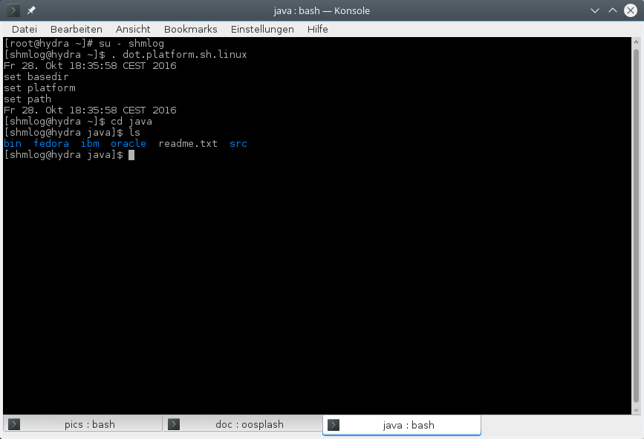
Illustration 34: The java ase directory
OK. We have a readme – check it – and a bin and a src. And then oracle , IBM and fedora.
For the bin its clear, there are some scripts.

The bin directory

That's my bin so far.
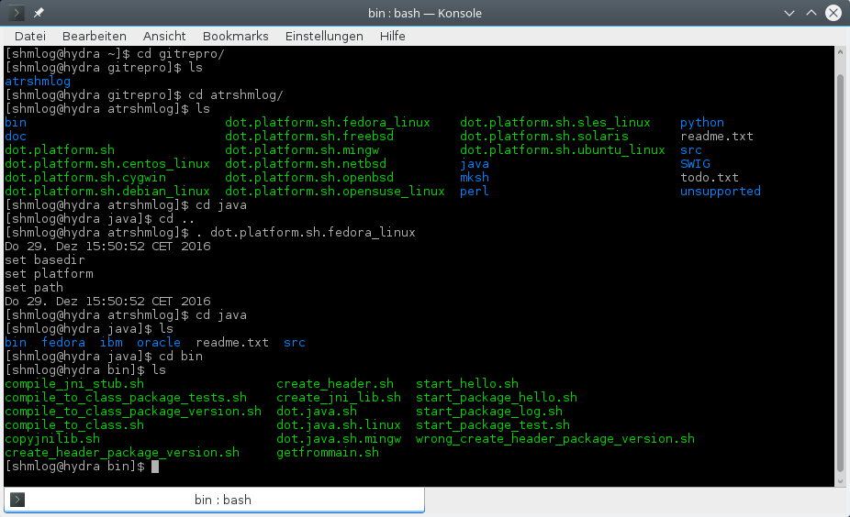
Illustration 35: The java bin with its scripts
We have here one script that is interesting now. The rest becomes clear when it comes to a real build cycle. So for now a short info about the scripts
- compile_jni_stub.sh
The main build script – its the same for the jni layer as the makeall.sh for the C module.
- compile_to_class_package_version.sh
The helper to compile the java class files to byte code. This is a helper for now, but in case you need it you can start it regular itself.
- compile_to_class_package_tests.sh
The helper to build the test package classes.
- compile_to_class.sh
The first version to do it – now only for documentation purpose.
- copyjnilib.sh
The helper to copy the jni bridge lib in place for testing.
- create_header_package_version.sh
The helper to create the C header from the byte code file of the jni bridge class.
- create_header.sh
The first header creation script, now only for documentation purpose.
- create_jni_lib.sh
The helper to compile the bridge C code and link to the library to get – ahem – the library ? I think here we have to distinguish the library ( C module ) and the jni bridge library for the jni stuff. We call the later from now on the jni library.
- dot.java.sh
The environment settings for the other scripts. Its the same for the java build as the dot.platform.sh for the C module.
- dot.java.sh.linux
OK, already done here.
- dot.java.sh.mingw
OK, already done here.
- getfrommain.sh
The script to transfer the headers and the library to all vendor specific jdk directory's. This is the real thing here, see below.
- start_hello.sh
Helper to start the jni thing for the first tests, now only here for documentation purpose.
- start_package_hello.sh
Another early bird. Simply for documentation purpose.
- start_package_log.sh
The helper to start the Test class main methods. This is the real thing – see below.
- start_package_test.sh
The helper to start the tests in the test package.
- wrong_create_header_package_version.sh
A gag – how to do it wrong … or : when a C programmer tries to do things logically with java . . .

OK. There were two real things, but only one for now. The getfrommain.sh. It transfers the headers and the library to the mystery vendor and jdk directory's. We see now for names like oracle and IBM and fedora, its time for a peek here…

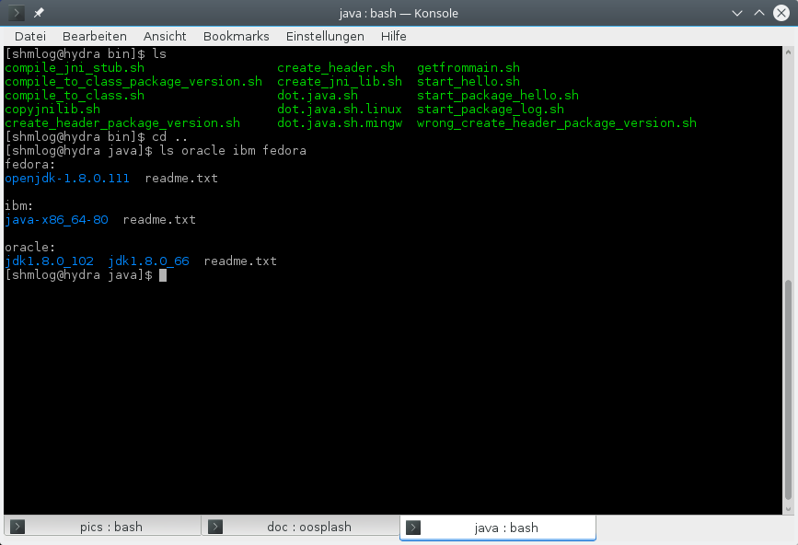
Illustration 36: The vendor's directories
So that's now the vendor things, and inside the jdk things.
You should now check for the best match and make a clone with the proper naming for vendor and jdk.
OK. So we transfer with getfrommain.sh from the src what's there to the whole bunch.
Meaning: you should have the real headers in src in place. And the real library. Don't mix platforms or versions – then you have to ignore that script.
If everything is right we can execute the script now. Its mandatory that you are in the java directory for its execution. So we call it relative with bin/getfrommain.sh.

Copy headers and lib from the C module

And so we do it
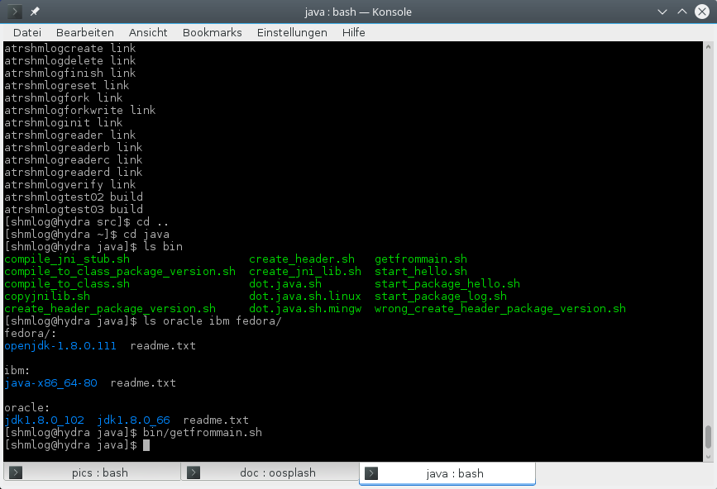
Illustration 37: Transfer from BASEDIR/src to the vendor's directories
Not much noise. Well, we will see….
Now its time to check for a vendor and the jdk directory's. We use here the first implementation, that's the oracle and the jdk1.8.8_66.

Change into your vendor and jdk directory
We change and then see for it
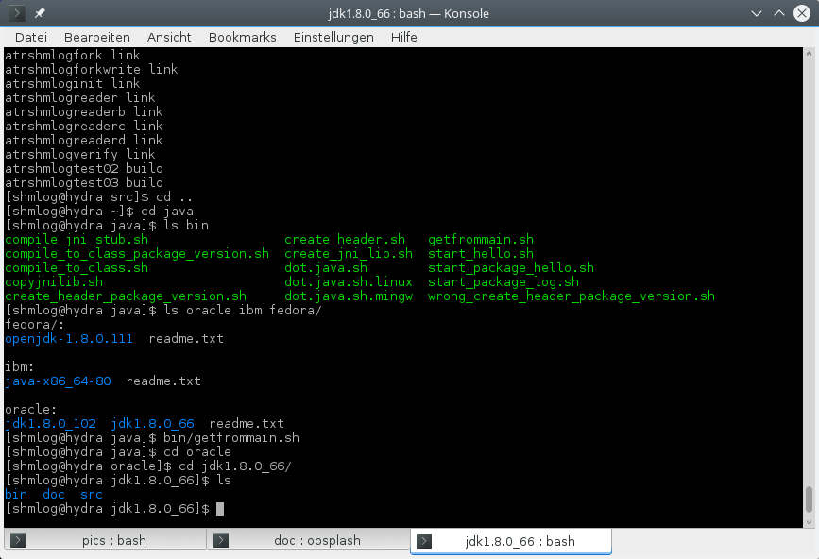
Illustration 38: Inside a vendor dierctory...

Not a real surprise. A bin – with scripts – a doc – with documentation – and a src.
Let's see for it.
The content of the three
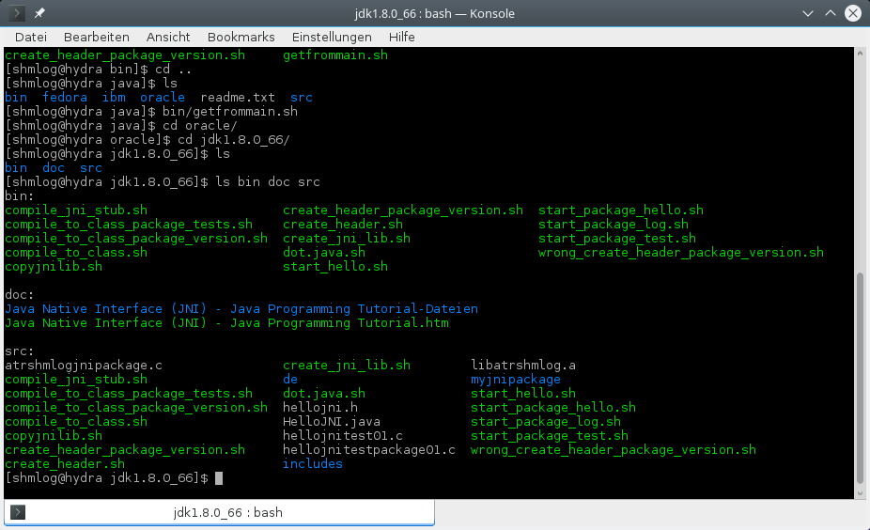
Illustration 39: .. and more inside of it.
OK. The bin seems to be a copy of the scripts – but in fact its an adapted copy – see later on.
The doc contains a nice little documentation of the basics in jni – if you are interested and have to do it by yourself you can check it. Its somewhat outdated for the examples, but it helps.
The src is the real thing. We have again the – adapted - scripts here, so we are free to change them if we need. For reference there are the scripts in bin, so don't change them in bin till you have done the whole thing. Start only in src with changing.
We switch to src and now comes the list of the files in there.
- compile_jni_stub.sh
As already said. The main build script.
- compile_to_class_package_version.sh
The helper for byte code generation.
- compile_to_class_package_tests.sh
The heper for byte code generation for test classes.
- compile_to_class.sh
Ignore it.
- copyjnilib.sh
The helper to copy the jni library.
- create_header_package_version.sh
The helper to create the C header.
- create_header.sh
Ignore it.
- create_jni_lib.sh
The helper to compile the bridge and link.
- dot.java.sh
The setting of the environment variables. Next thing to do.
- hellojni.h
The header for the simple example code.
- HelloJNI.java
The class for the simple test code.
- hellojnitest01.c
Test code for the simple test code.
- hellojnitestpackage01.c
Test code with a package.
- libatrshmlogc.a
The copy of the library from the C module (check time stamp and size and whatever you need too … should be from BASEDIR/src )
- start_hello.sh
Helper to start the simple test.
- start_package_hello.sh
Helper to start the simple package test.
- start_package_test.sh
Helper to start the tests in the test package.
- start_package_log.sh
Helper to start the Test class main in the package tree.
For the directory's : includes is clear – check for the files and for the time stamp and length of the headers from BASEDIR/src.
For de its the start of the package path. If you are a java developer you know what follows.
Check its end …
The package directory
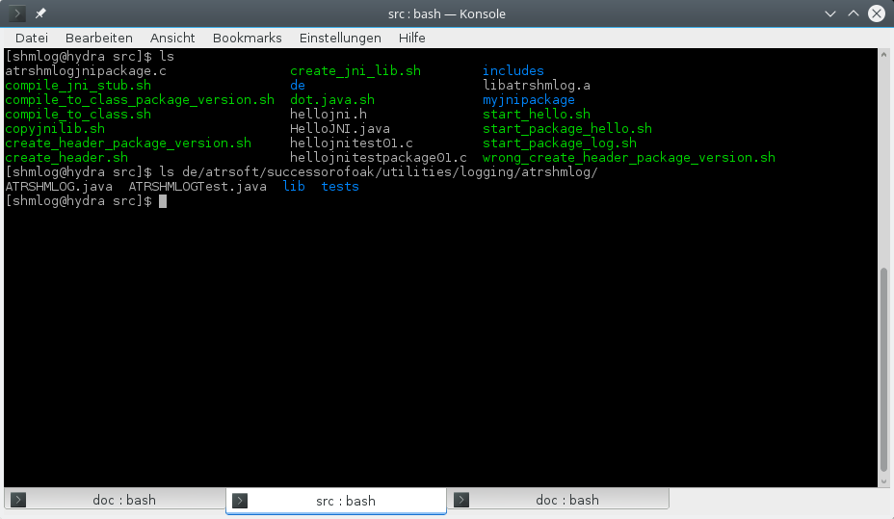
Illustration 40: Inside the package
Not very much.
- ATRSHMLOG.java
The jni bridge class.
- ATRSHMLOGTest.java
The test class – for now its the only test I have, so don't be surprised if more follows in the future.
- Lib
The directory that contains the jni library for test.
- Tests
the module test package.

OK. Now that we know that tree, check for the others.
When you are ready, you can read on.
Ready ? So fast – well, if you said so.
Every vendor has the jdk directory, and every jdk has the same structure. So our little helper getfrommain.sh is not so complicated after all.
It simply copy in every src directory the lib and in every includes the two include files.
Helps to do it manually. If you need.
The real different thing in every jdk is for now the dot.java.sh. It contains the settings of JAVA_HOME, the JAVA_OS and so changes from jdk to jdk. And from platform to platform.
If you check the jdk and its include directory, you will find the platform named directory for the stuff that is not identical for platforms.
So try to think backwards : if you have a new vendor and jdk you clone a nearby existing one, check for the JAVA_HOME, adapt that in the dot.java.sh, check for the directory in the jdk's include directory, adapt that to the JAVA_OS and with a little luck you are done.
The only thing left is the name of the library, and that's in the create_jni_lib.sh for the existing platforms.
So much for a complex build problem….
Its now time to do the thing.

Setting the environment
First you have to start with the platform settings from the C module.
Source the proper dot file in BASEDIR. Then switch to the java src again.
We then simply source dot.java.sh
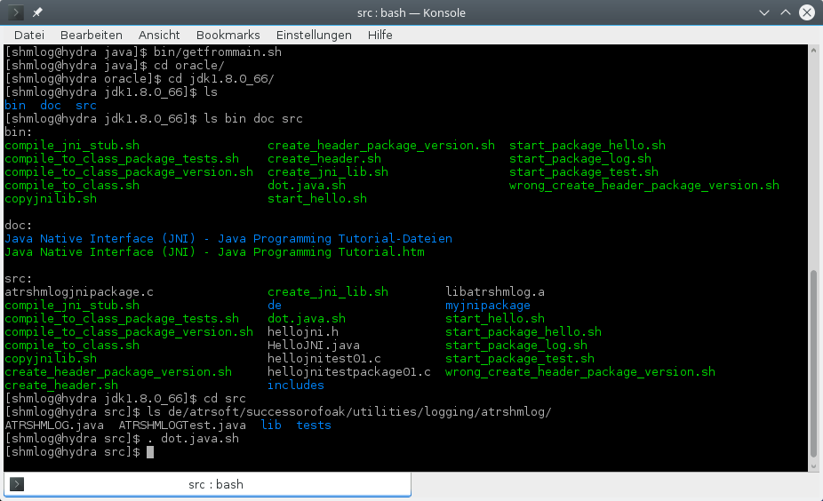
Illustration 41: Setting up the build environment
No noise here. If you insist you can check the environment.
Next is to start the build.

Building with create_jni_lib.sh
We start the script
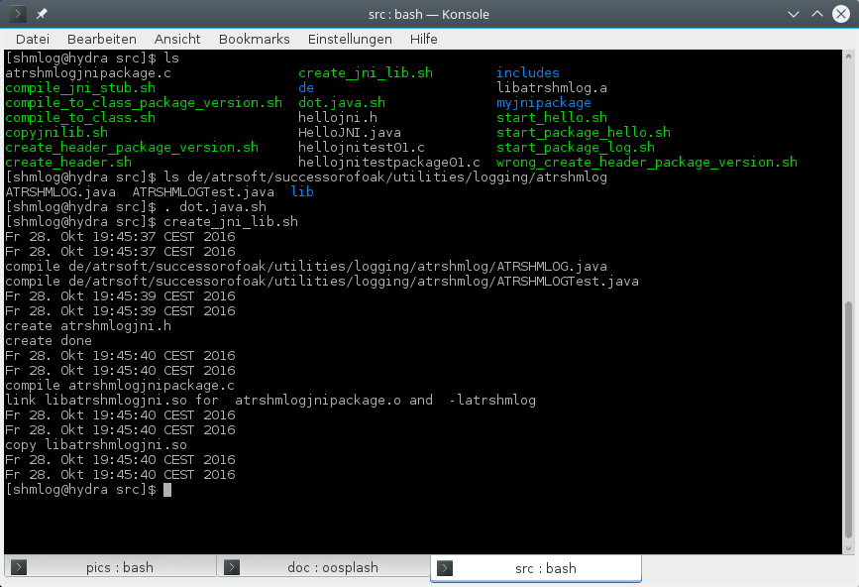
Illustration 42: Create the jni library – former version
And there we are.

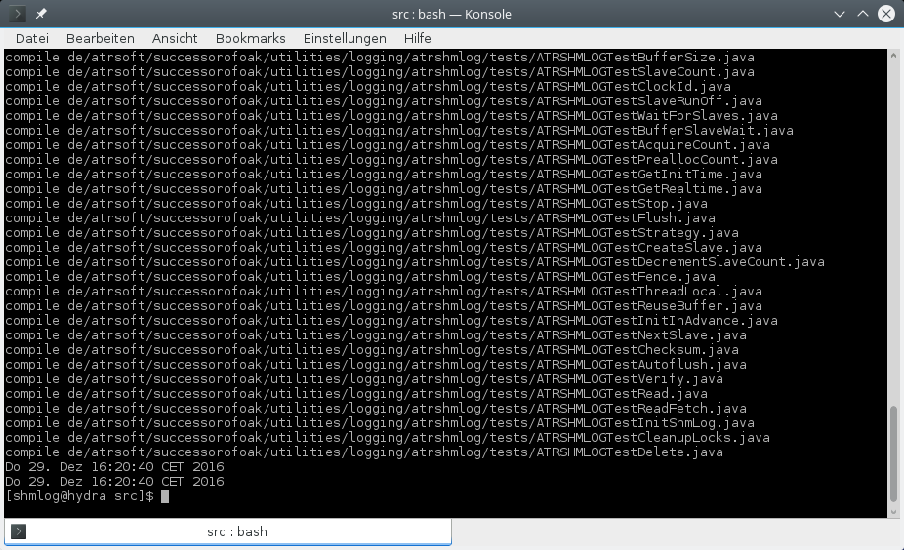
Illustration 43 And now from version 1.2.0 on the tests too.
Two compiles java classes, one new header creation. One compile and one link line. Finally the copy to the test directory.
And from this version on (1.2.0) the compile for the tests.
All what's left is the test with the main test class.

Testing the jni bridge
We have first to create a shared memory buffer with atrshmlogcreate. I will use 4711 and 8 for it. Then the init for the area. Next the test of the bridge. Then the reader and the convert.
At last we can check for the result log.
And because it was already done for the C test program we do it in short form now.
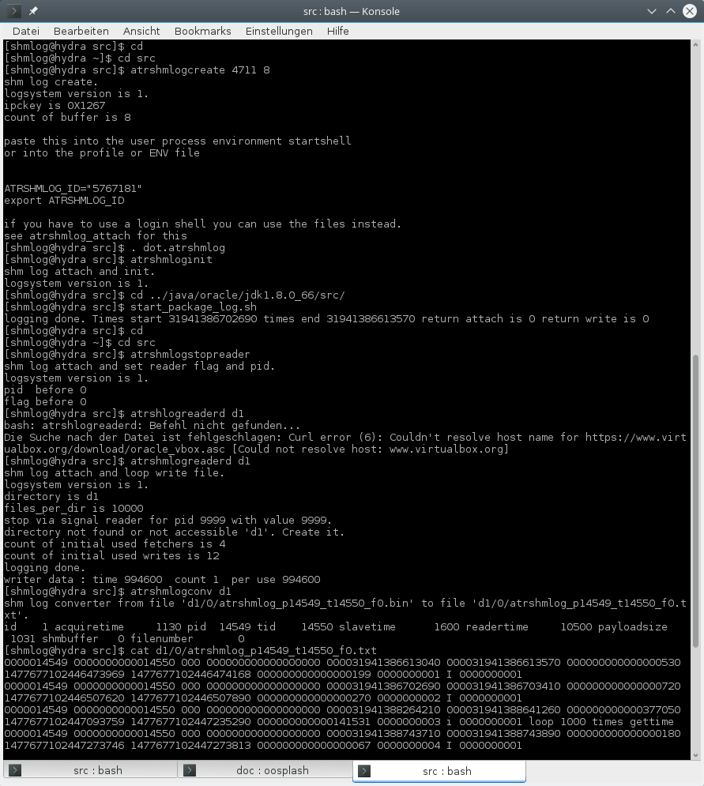
Illustration 44: Test of the jni bridge
HM. One glitch, but a typo is OK at least, the rest worked as expected.

Details
Now we can go in some detailed check for the jni class. For the use of it see the Test class. For the use of additional features you need to check the documentation of the methods. But that's the usual way to do it today after all. You can use the HTML for it, the class is in there or your favorite IDE and javadoc.
If you are interested in the way it works – see the C source or read the chapter about the glory details.
But for now some info from a non java programmer to the java code.
Open the ATRSHMLOG.java with your favorite text editor.
After some brubbling comments you touch the first thing of interest in line 70.
We load the bridge library here.
If you ever need to do that different you can change it. But try not to touch the native code – then you can use it still in place with the existing library. No need for a recompile.
Next stop is after the enum stuff. I did it because it feels right to have some enum's for this kind of stuff. Error codes is natural, and for the statistics the enum's can be a help if you need them. For the strategy its at least a start to understand them. So much for the enum's. And use them only after you are sure you understand the cost. For example don't make error enum if you encounter the 0 return code for most methods.
That takes us to line 1155 (EVENT_POINT_IN_TIME_C) . Seems to be some simple int numbers, but its worth the stop. We have the option to log not only C stuff strings ( which would be very poor in a java environment) but also to use a byte array. So you can tell the module in the logging what you want to do with it – have it to be a log of a byte array in C style, or in UCS2 style. And if it is a log for a Point in time – meaning we are having only one valid time stamp for the start or even none – or an interval in time – you guess it, its a start and an end time stamp (which can be a 0 for end, see below).
Ahem. Yes, and there is of course the logging of – Strings.
Here you really need to understand what it means. For the time thing its the same. You log a point – only one time has a meaning and its the point in time – or you log an interval. Same thing.
The real problem is the kind of String you want to get in the result log.
Having a language with a 2 byte per character string model makes it natural to log that strings. And so you can do that with the ucs2 constants. One for point, one for interval.
If you use C style you get an internal conversion in the jni bridge code from ucs2 to the thing that jni delivers as UTF string representation. That means your C buddy's have no problems to read the stuff – if they have an UTF conform environment.
That's nice to the C guys, but has a big burden – its slow and happens in the logging phase IN YOUR PROGRAM .
So I recommend to use that only as a last resort if things begin to become complicated with guys like project managers or architects or quality assurance or.. or .. or…
If it is really a problem : you can log strings into UTF. And its the jni that convert them. So that should be trustworthy for any guy of the former list.
If you want to have speed, well, then the ucs2 it is.
You have a potential problem with the actual version of the converter, because it then tries to make some silly simple conversion of it. But you get it one to one in the binary file.
You can try to develop a better converter, or write one in java – that's up to you.
For now – you need these four constants because they are hard coded into the module and into the converter. So use them. End of message …
Now we enter the methods code. I will focus on those of interest, for the others simply check the doc in the class or in the module.
First stop is attach, line 1196 (attach).
You use it to connect to a valid area in shared memory. The thing can be created by a tool like atrshmlogcreate and initialized by atrshmloginit, but you can also use the layers create and initShmLog methods – didn't try the later thing for now, so sent me a post card when it works.
Without the connect – no logging.
I suggest you make at least one run without a connect – should be running at full speed and without problems.
OK.
Where do we get the parameters for the attach from ?
Well, that's already said in the C module section – but I know you don't really read that – so I suggest you read the chapter about the environment variables and the attach at least.
Next is the gettime. Its the heart of the timing things, so let's see for the thing.
We have a 64 bit click counter timing model – I know, you didn't read the C module part ….
So we use them here as values. And use a low level long for it. No class, no fancy Long – a simple long. And that will be my last word here. No high level things. I don't need them. If you need them – use another log, it will be slow enough for your needs, I hope.
There is a static method for gettime too. Its sgettime. If you test and you can find its faster in let's say, more than 25 % then the object method please sent me a post card and I will do the static thing at least for the write too.
Speak of the devil. Next is write in line 1379 (write).
This is the reduced form, only core info, no payload at all. This can help if speed is all you need.
Next is the write with String. Please keep in mind that the simple thing has an deep inside buried mechanism to make sense of point in time and interval – which I have only added to reduce jni calls – and that it is capable of doing ucs2 and UTF. So you have to know what you want and use the correct event flag. See for the constants above.
Line 1538 (write) comes first to a surprise – why a second write with a String ?
To make a long story short: This is doing ucs2 only, and it is doing only part of the string – you can give the number of chars that are used from the beginning. So you don't have to make complicated String operations to build one that fits – if you have something big like a stack trace or a json package you can put it in and simply set a limit – no need to build up a new one. If the limit is too big the real length is used.
That's of course only half the thing. You can again log point in time or interval with it.
Line 1625 (write ) we have the third time write for a string, and this time you can give the startindex and the length. This is for logging the interesting part of big strings…. You can use it like the second write, only the startindex is needed here also in place and you can log the famous last part of your stack trace or json or whatever you need.
Line 1713 (write) is then the write for a byte array – so you can log everything you are capable to put in such a thing. Its converted in the standard converter as a C string or an ucs2 string. So to make use of it its best to make it for a separate converter of yours. The starting point is the chapter about make a new converter.
Now that we have the core comes the stuff that you perhaps never need – or perhaps do need.
So I try t focus on the details worth here.
Statistics can be helpful. So I build in that thing.
You can get them into an int array. To do that you have to give the array into the get thing, and to do that you need to know how big it is in creation of it – its max index plus one …
So much for statistics. See the enum's and the atrshmlogstat script for the info you get. Most can be helpful in the adjustment process.
We have a sleep internal in the module, and on most platforms its a nano sleep. So I decided to make it available to you. But be prepared: on some platforms it might not work as expected. See the internet for a discussion on that thing. I give you one hint: fenster;plural is again the bad guy in the game here. End of transmission…
Then comes the environment variable stuff. Can be helpful if you write your own tools, but I doubt you will need it. Perhaps the set prefix, if you like another name for the variables prefix part.
The version starts at line 1816 ( getVersion ) .
To make it simple: There is a major version and it is the compatibility level of the tools with respect to the area layout. Also the reader and in last consequence the converter is in here.
That means that I give a new version if the layout changes.
The minor version is then about new features. That can also mean a new platform – but the layout is not changed here.
Last is the patch version, which is about the bad thing stuff and how we get rid of it. Bugs.
For the major version I plan to do an odd even thing. Odd is a stable, even is an experimental but otherwise checked one.
With line 1851 (getEventLocksMax) we enter the event stuff. As you know from the former chapters … ups, I forgot, you don't read those. Right. Events are the way to say where your logging happens, and so you use them as an info like a line number – but not the same thing, please. So you can say something like “oh yeah, that was at event 2544 and now I understand why it did then event 7536….”. That stuff.
We have implemented an array of chars in C for them. So you have plenty of them (concrete a number of 10000) in the beginning. If you need more you can make it bigger. Costs memory. And because they are related to an location we can use them to switch logging on or off for that specific event. So the char array holds at least an on and off flag.
After the event stuff we have the logging state of the thing. There are flags to suppress it on level of the system ( the so called “Ich habe fertig” flag in the area) and on the process. For a thread you can shut down logging too. And for the final systems shutdown we have another one, so that you can come up against the so called zombie revival problem.
Next is the information about things in and around the shared memory area. That means the version, the buffer count and the flags. Also you can get the address of the area as a long and use it with a bunch of methods.
With 2019 ( getBufferMaxSize) we enter the configuration of the module. We can get and set a bunch of things. There is the buffer size first. Its fixed for the first buffers, but when dynamic allocation comes in we can change it (to be precise : reduce. No growth possible).
We can set the number of slave threads before the attach, and we can change the id of the clock we use in the getClocktime.
Then there is stuff to handle the slaves. You can shut them down if you think its a wise thing to do – they will exit their main loops the next time they hit it. You can set the wait flag for the cleanup for exiting the slaves, and you can set the time a slave waits when it has found out there is no work to do.
Line 2192 (getPreallocBufferCount) we enter the buffer handling. There are buffers for the log for the threads – so much here – and we have a bunch allocated static in advance. Everything else is up to the program - you can set the number of buffers we allocate in one low level alloc, set the initialization of them ( with memset 0 ).
In between – perhaps I should change this - is some other stuff. The inittime things. We make at attach a kind of time stamp triple, two clicktime and a real time. Every time we move a buffer to the area it gets the actual triple too. So we can approximate the clock times in the logging info with real time. Of course that depends on a bunch of heuristics, so don't trust it too far. For example on fenster;plural there is no thing like a get real time with nanos thing. Best approximation is a Filetime with nanos in 100 step width … did I ever mention I don't like that OS ?
You can get the id of the highest used buffer – which gives you an approximation how much memory is used for logging.
Then there is again stuff in line 2249 (stop). We can stop a threads logging. That's done by stop and it is the thread that has to call it for.
We can also flush the buffers. That is a good thing to slow it down – meaning we have after the flush no usable buffer till they have made the round trip to the area and then back. Consider be warned. And perhaps I will even make it worse – build something like an auto flush to help that guys from the debugging frontier division ….
Back to the buffers. An important thing is at 2108 . You can set the threads strategy. That means you can have the thread decide what to do if the buffers are full. In that case we need at last the options to discard or to spin lock. Waiting is also possible, and for highly unpredictable loads I have the adaptive strategy's in place. See the glory details for that. And the adjustment chapter.
In 2331( createSlave) we do the final thing for slaves – we create one if we need. OK, if we create we have also to maintain the opposite case – we kill one and then we have to balance the count with decrement.
The fences stuff follows. There are 13 thread fences build into the thing. See the glory details for the story behind them. You can switch them on if you need. That's for the case you encounter inconsistency for the log. Can happen. Had it in development two times. And for different platforms it can be worse. So they are off for the Intel boxes, but you can switch them on.
One method to get a real time, if it were not for the need to check this against your internal clock….
Now comes some odd stuff. We need to talk about a forced thread death here.
First in line 2577 (getThreadLocalsAdress) a method that the thread has to execute. It delivers the address of the thread local storage ( to be precise : we use a struct and that is the start address).
With the next you get the thread id – the thing is the best I could get, so be happy if it matches your thread system thread identification thing. If not you have to use the tid or the thread local address and match it to the thing you get from your system.
Now to work: line 2594( turnLoggingOff) makes a stop for a thread – and this time its with the threads thread local address done – so you can use it to turn down operation for a thread from your application. This works for a logging thread and a slave thread.
For the logging thread the buffers are dispatched to the area, and you never again make a log for it. No way back. The buffers are recycled after that and no longer the thread can use them.
For the slave the next activation will hit the end switch and the slave exits after the cleanup. So this is no kill, but a graceful and normally fast stop for the slave.
We skip the already mentioned init buffer stuff here.
Line 2632 (getNextSlaveLocal) . Next is the iteration method for the slave list. Well, you need a way to identify the slave, and you simply get no info from its start that's worth it. Perhaps I will change the interface in future, but now there is none. So you use the iteration and start with a null and get the first slave's local – a pice of memory for the slave only.. Call it with it and you get the next. Till end of story, then you get a null.
So you can pick a slave and use this together with the next method to get its tid. The rest is a call to turn off.
That's the simple and clean way. Now for the dirty way.
You need to kill the slave – why I don't know – so you have it here. Retrieve the slave local. Get the tid. Identify your target. Remove it form the slave list (next method) and then kill the slave.
You need to kill a thres (this time not a slave) - why I don't know – so you have it here. Retrieve the thread local. Get the tid. Identify your target. Then kill the thread. Use the reuse and the tid of the module to reclaim the buffers of the thread.
You will loose the buffers for recycle, the thread statistics, and the thread local will no longer be valid. So you cannot give the buffers free, but the cleanup at end will move them to the area at least.
There is now the reuse thread buffers method, so you can after the kill is done recycle the buffers if you have the tid of the thread – from the point of the module. Still you will loose the last statisics of it.
That's dirty, and if you misunderstood something best dangerous, likely fatal for your program. So be sure you know that you need that. I prefer the clean way. But you can do it…
At line 2952 (verify) we have the first administrative function of the module – verify. Its normally only part of the higher level so its not for normal clients. If you want to make all for the java things you can do this. Make your own verify.
Next is the clicktime via clock id . That's needed if you have different clock models or different OS calls. For now its simply a layer of the low level click time functions.
The next is read and readFetch. To make a long story short: you can write your own reader. The backbone functions are here. The interface is a bit odd at least. An array to put the stuff is OK, but an array for the secondary info's is at least odd. But its simple, fast, and I think I need no difficult oversize getter stuff then – don't forget that a reader has to be VERY performant.
For the read its the somewhat outdated call, use the readFetch instead.
Next is in line 2818 the create. So you can make your own buffers in a test driver or make your own version of the create tool.
This has the same consequences as for the module on the mingw port – and I guess for all the ways to handle the things on the fenster;plural system. Read the glory details for it or see the mingw port .
Next is the destroy of the buffer. OK, cleanup and init so we can mimicry the delete, init and finish tools.
Last at 3273 (peek) are two little helpers to be used to make a thing like the signal tools or the dump or the defect tool. They use the raw C pointer thing and you should NOT use them in any other thing like a valid area buffer.
OK, this was a fast trip through the thing.
Let me summarize it.
We can create, delete, init, deinit, inspect and switch flags for the area.
We can attach to it and then do things like read and write.
We can configure the parameters of the module, which are buffer related, and slave thread behavior.
We can inspect the environment – partly, only the variables here – and the initial times, real time and clicktimes.
And we can switch on and off the fences if we need them.
That's a lot more than a simple “open, write, flush, close” thing. So don't be surprised that it takes some time to master it. For the start check the Test class, its perhaps all you will ever need.
If you need more, check the tests package and its classes. This should cover most uses of the module.
As last resort you can check the C module and its documentation – after all the thing is in source code here … and you can at least try to check for the other programing language code once a time in you life, don't you ?

The python language support
After I had done the initial jni stuff it was clear for me to make it to other languages too.
So on my first list I had python, perl and for those others SWIG in case they use that.
For the python I had to start at ground zero.
I am a newbie in python, so I first had to take some basic stuff from the python documentation page about the making a C module work in python thing.
OK, that's not too hard. Making spam for the 3.6 was helpful.
And then I made it in rough 2 hours to a first test drive. The thing attached, took some times and wrote the technical log. WOW.
Next was to build all functions that are now the interface functions in my usage of terms here.
And again it worked out, I could even read and read_fetch things. NICE.
That was about 6 hours later.
Then I switched back and checked for the two things I had found in the spam that I wanted to support, the embedded thing – well, this was easy, nothing to do for me here – and the C API capsule thing.
This took again rough 10 hours and I had in the final state the core functions too.
So again some swift changes and several builds and I was there.
Next was to make a big review round, and after two hours I had it done so far.
Last thing was the thing you most likely already know – the thing about python sex.

Python's SEX
Well, all living things on earth seem to have that reproduction mechanism build in.

And this is also true for the mammal, reptile, bird, fish, even plants.

For the higher ordered it is always done by the mix of two individuals of different gender.

And so there is the male and female thing.

For the python's its different.

They have the gender 2 and 3.

Gender 2 is the python 2 way, and gender 3 is the python 3 way.

And they simply don't mix. Its not clear for me how the python's then reproduce, but that's the facts.

They simply don't mix and still the genders grow bigger and bigger …..

So I had to support not only the capsule C API, but also the two different genders 2 and 3.

OK, some macro stuff did the job, and so you can do it in the 2 way or the 3 way., and it was done in about an hour of my time with tests.

How it works
The module is a direct used implementation. Under cover you use the C module. The module is capable of doing its job simply by using the internal infrastructure as in a C environment. No need for changes inside.
This means you get in theory the same speed as for the C module itself. The only thing that slows down is the python parameter handling in the bridge code itself.
The rest is more or less simple. Use of the function and no object stuff. Simple raw data types, no classes, no exceptions and no use of the python side with the exception of the exception atrshmlog.error. Barely some string creations.
If you are interested the atrshmlogmodule.c is a good start.
The bridge always uses a so called core function.
The core function itself is used in the C API for the use in other modules. See the header atrshmlogmodule.h for this stuff.
The core function is most of the time only used to convert the types from a call to a C module function to the usual stuff in the python module.
The module gives also the error Object and a small number of constants to the user.
So you have this in module init.
A simple import gets it in. If you made a module for the 2 it must be used by a 2, if it was made for 3 it must be the 3 – any mix and you will encounter problems – best in build phase, worst in the try to load it.

How to use it
The user needs the following parts:
- Shared library or dll atrshmlog
This is the bridge code from atrshmlogmodule.c and the linked library from the C module, libatrshmlogc.a. You need also the compiler support lib's and in case of the mingw port the additional dll ' s of the mingw system.
- The support programs
You need the matching C support programs for the basic stuff you don't want to reinvent. Reader, converter, even create and delete. So if you need a pure (?) python only solution you can replace them with your own code python counterparts. But for now I deliver nothing so you should start with the C programs. If you insist you can take the code from the tests. That should do the job in most cases.
So you first have to build it – again I am not delivering binary code, only source, so if you are interested in binary you have to contact me and I will see what I can do. But for now you have to start with he python bridge file atrshmlogmodule.c and atrshmlogmodule.h.

How to build it in the first place
We start with the C module.
After this is in place we have to check our next options.
We have in place an implementation that should work out of the box for Linux and python2 and python3.
You have simply to know what you want to build. If you need both its possible to make the first and then copy the thing out of the directory to a safe place, then reset the environment and build the other. No need to build the C module again or tho clean up.

The python directory
We start with the basics.
The python stuff is located parallel to src – so we start at BASEDIR/python

OK. We have a readme – check it – and a bin, a doc and a src.
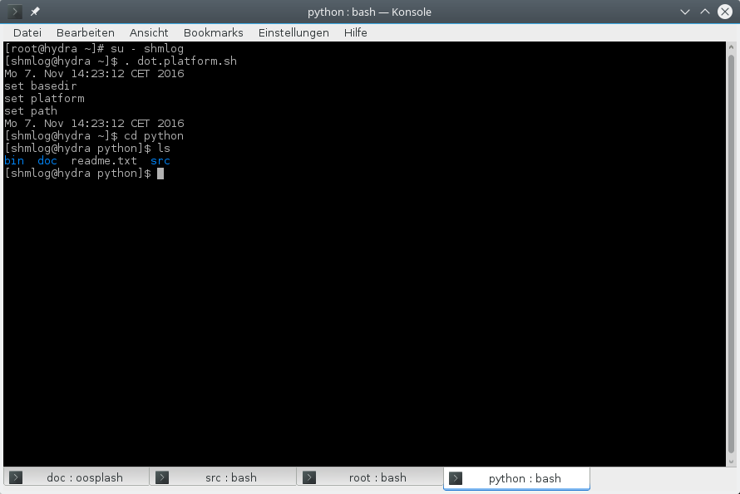
Illustration 45: The python basedir
For the bin its clear, there are some scripts.

The bin directory

That's my bin so far.
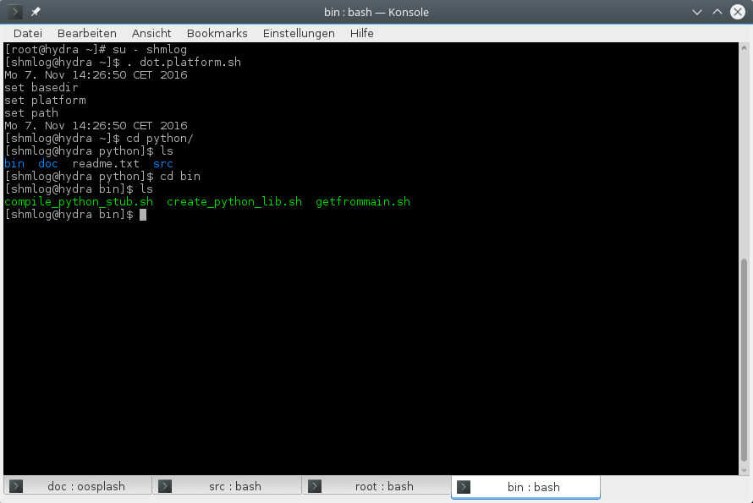
Illustration 46: The python bin directory with the scripts
We have here one script that is interesting now. The rest becomes clear when it comes to a real build cycle. So for now a short info about the scripts
- compile_python_stub.sh
The main build script – its the same for the python layer as the makeall.sh for the C module.
- create_python_lib.sh
The helper to compile the bridge C code and link to the library to get – ahem – the library ? I think here we have to distinguish the library ( C module ) and the python bridge library for the python stuff. We call the later from now on the python library.
- getfrommain.sh
The script to transfer the headers and the library to python directory's. This is the real thing here, see below.

OK. There were one real thing, but its one for now. The getfrommain.sh. It transfers the headers and the library to the mystery python directory's.

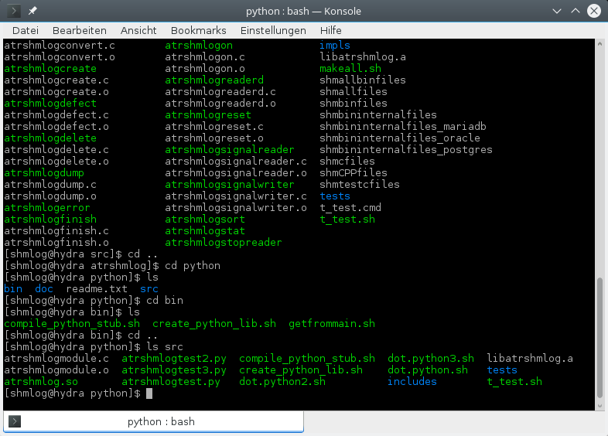
Illustration 47: The python source directory
So that's now the python things, and its the src.
OK. So we transfer with getfrommain.sh from the src what's there to the whole bunch.
Meaning: you should have the real headers in src in place. And the real library. Don't mix platforms or versions – then you have to ignore that script.
If everything is right we can execute the script now. Its mandatory that you are in the python directory for its execution. So we call it relative with bin/getfrommain.sh.

Copy headers and lib from the C module

And so we do it

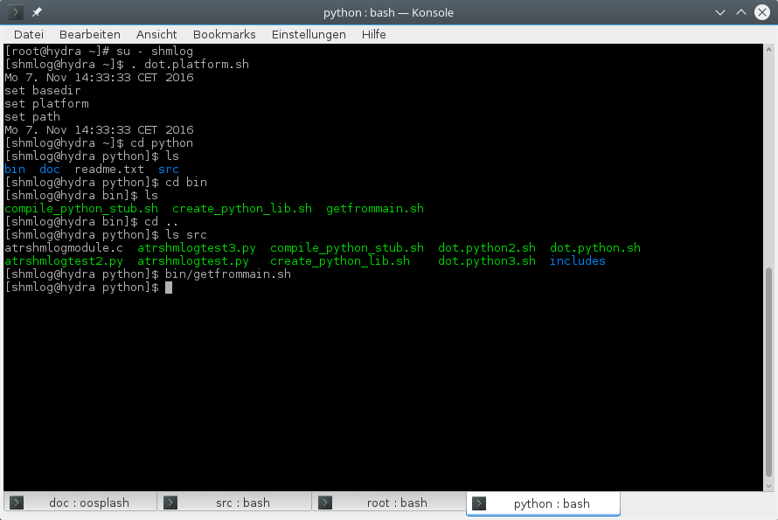
Illustration 48: Transfer of lib and headers before build

Not much noise. Well, we will see….
Now its time to check for the src directory's.

Change into your src directory
We change and then see for it

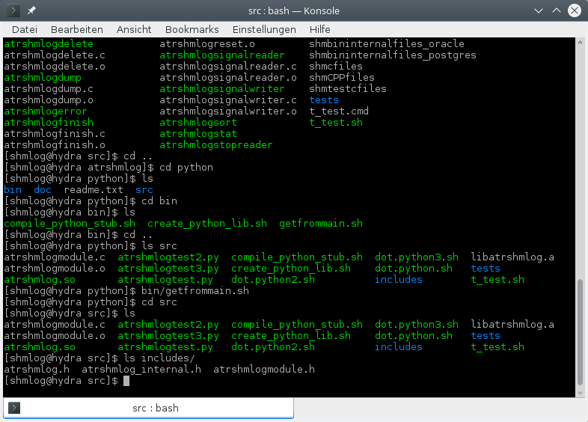
Illustration 49: Inside the source directory ready for build

The src is the real thing. We have again the – adapted - scripts here, so we are free to change them if we need. For reference there are the scripts in bin, so don't change them in bin till you have done the whole thing. Start only in src with changing.
We switch to src and now comes the list of the files in there.
- compile_python_stub.sh
As already said. The main build script..
- create_python_lib.sh
The helper to compile the bridge and link.
- dot.python.sh
The setting of the environment variables. Next thing to do.
- atrshmlogpython.c (former atrshmlogmodule.c)
The python bridge code.
- dot.python2.sh
The setting of the environment variables. Its the python2 this time for Linux.
- dot.python3.sh
The setting of the environment variables. Its the python3 this time for Linux. So you can change the dot.python.sh and have it still here for reference.
- libatrshmlogc.a
The copy of the library from the C module (check time stamp and size and whatever you need too … should be from BASEDIR/src )
- atrshmlogtest.py
Start the simple test.
- atrshmlogtest2.py
Helper to start the simple test with python2.
- atrshmlogtest3.py
Helper to start the simple test with python3 – so you can change the atrshmlogtest.py and still have it here as a reference.
For the directory's : includes is clear – check for the files and for the time stamp and length of the headers from BASEDIR/src.
Tests are the new tests for python. At least the python 3 is covered. And there is a test driver to run them all – t_test.sh.
OK. Now that we know that tree, check for the others.
When you are ready, you can read on.
Ready ? So fast – well, if you said so.
Its now time to do the thing.

Setting the environment
We have to put the platform in place first. So if you have not done it switch to BASEDIR and source the right dot file.
We then simply source dot.python.sh

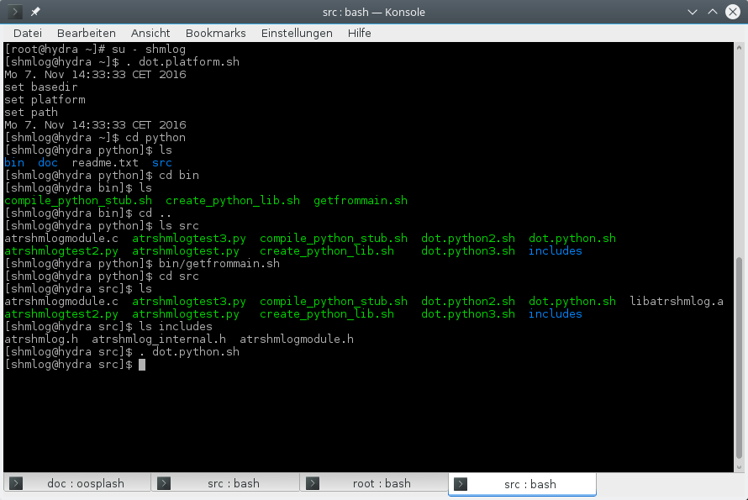
Illustration 50: Setting the build environment

No noise here. If you insist you can check the environment.
Next is to start the build.

Building with create_python_lib.sh
We start the script

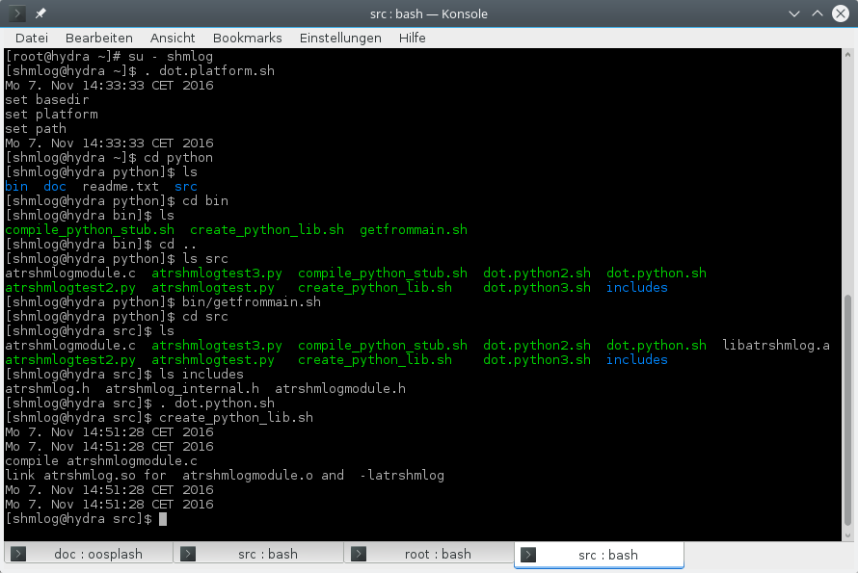
Illustration 51: Create the python library

And there we are.
One compile and one link line.
All what's left is the test.

Testing the python bridge
We have first to create a shared memory buffer with atrshmlogcreate. I will use 4711 and 8 for it. Then the init for the area. Next the test of the bridge. Then the reader and the convert.
At last we can check for the result log.
And because it was already done for the C test program we do it in short form now.

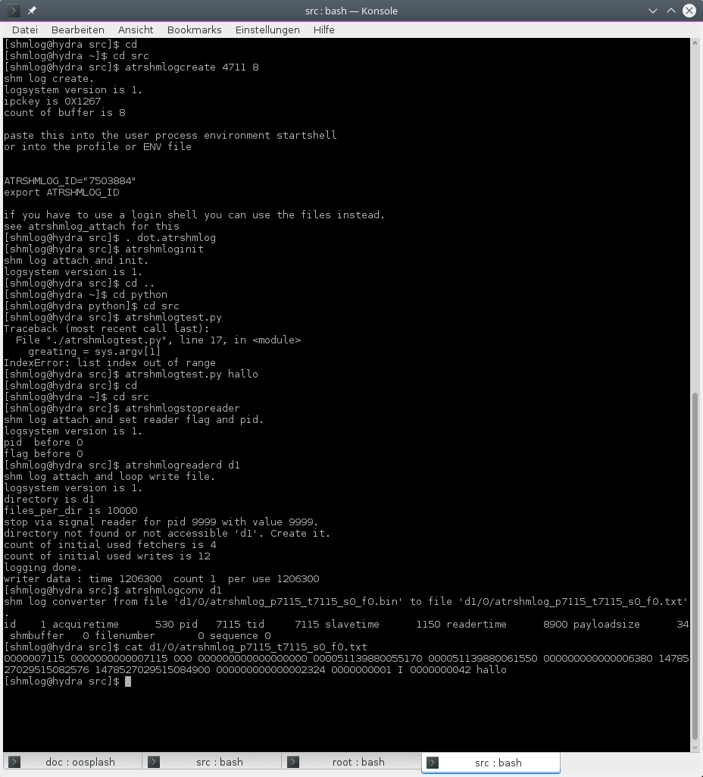
Illustration 52: Test of the python library

HM. One glitch, but a typo is OK at least, the rest worked as expected.

Details
Now we make it for the bridge in C.
Take your favorite text editor and open the atrshmlogpython.c.
We start with the usual comments about what it is…
Then line 25 (ATRSHMLOG_PYTHON_VERSION) we enter the python version code thing. Its set via -D in the build script. And its value is given from the dot file.
So here we have a first check group. Have we made a new version in python we will need a new check here …
Next we check our settings in the include directory we have given the thing to use.
Again a wrong or new version would be found here.
After the checks we set a define for the size_t thing and include the Python.h and our module and the C module files.
Now in 72 (u_s) we have a small helper, a struct thing for conversions. We use large numbers to transport addresses of the shared memory area around.
Then we have the error object. I use it in case the supported parameters for a call are wrong. For the module calls I return that returncode – no exceptions here. So if you get an exception its normally a problem with the supported parameters. For internal error you have to see what's the returncode.
Most functions even do not have one, they are simple getter's. So don't overdue the checking….
Next a small helper for making a list.
OK. And now we start the real thing.
The core functions in 127 (attach).
After I found the way to implement the C API capsule I made them. They simply call the C module functions. And they make on low level C the conversion from the internal types to the things I use in the bridge code.
So the rough hundred thirty functions that follow are the real working code functions.
They are the members in the C API pointer buffer.
And they are used in the interface code as the function that does the thing. So you get the same when you call them in the interpreter – via the interface function – or direct via the C API header trick.
Simple first one is attach.
For gettime I decided not to check events – its not worth that in a layer of multiple functions and with check for parameters in the way python does it – so its always on.
The write0 and write. Didn't check for binary now, according to docu it could work...
Again simple stuff for sleep nanos, and so long till we hit get_inittime.
Here I have the version in C with giving back two values via pointers. So we do not use the struct as in the C module here.
Again simple stuff till we hit get_realtime. Same goes here for the use of pointers as for get_inittime. We do not use the struct.
Again simple stuff till we hit the two we normally don't need in a client, the read and read_fetch.
Both can be used, but only read_fetch is the actual one. The read will disappear in the next version. For now we have both.
The core function simply makes again the type conversions into the types I use in the python part. And again the inittime and he lasttime are split into two pointer assignment operations.
And again that boring simple core functions.
Last are the two that I don't need in the C world, the things to inspect and change the area by a python user, the peek and poke things – same as for java I try to give you the minimal support and that's it.
So rough at 981 (get_buffer_append_anchor) and about 20 percent of the thing is done.
Now the interface code for the interpreter follows.
I had first the actual call to the C module functions in here, but after the core functions were introduced I had also to switch to them – its perhaps a bit slower that way. I will make some tests in the next version and eventually then support gettime and write direct here, and you will not have the same in the C API, but it will work still the same way in the C module.
Again the first is the attach. And its a simple one.
So we now have simple getter like calls to the core functions. No big deal.
The write is the first to use parameters. And no, I didn't try the keywords. Would be nice but also a bit slower I guess. If anyone is interested I will add them too. Simply sent me a post card (with a credit card attached ) and you are in ….
Next interesting stop is get_statistics. I use here the helper and create the result list.
Next some string things. See for the python 2 and 3 way to make strings if you have a problem with it.
Again simple boring getter like and setter like stuff till we hit get_time.
This time we need as result a tuple, so I do here the conversion from the given values to a touple.
If you find this interesting – I can't help you …
Again simple setter and getter stuff. Then we hit get_realtime
Again the pointer values are turned into a tuple.
Now we have from time to time the area and the thread locals in – both addresses and so pointers in C – and in the python interpreter I use a number – so I do the conversion in a bit unusual way by the union here – no cast or assignment to another type. So its up to the layout of the platform what you get as a number – no way for me to tell it – but its consistent that way.
OK. Now the big two again – read and read_fetch.
I have tried to take the buffer stuff out of reach if you don't use them – its a half MB after all – and moved the thing to thread local if you really plan to do it in multithread program way.
For the most things I have simple checks – and again for the parameters an exception if it fails. The rest is simple. I construct a tuple and you get what I have.
A tuple with only three or four values – bad thing happened.
For the real thing you get near 40 values back, and its the buffer as a byte array. So you are in with the binary things here.
After everything goes well you can use the tuple in the way you want. And I do not give back the buffer then – its assumed you have no read in a client, only in a dedicated reader – so you have to accept it will reuse the buffer from now on.
Next is again the simple stuff of getter and setter like functions. Starts with verify.
So we reach the end of the interface functions round about 5047 (get_buffer_append_anchor).
Now we have the methods array.
If there is more time I will start better comment strings for the methods. See next version.
About 5487 ( init_core) later we are in a little helper to clean the init function. I use here a helper to make the C API array – that's not a real need, could have made an initialization instead like in the C Module for the static buffers. But this is the way of the documentation for python org, so I didn't made it different.
After the hundred thirty are in, we reach the python 3 stuff.
The module is described with the module struct here.
To make things a bit cleaner in the init function I use some defines.
A return code helper – the python 2 is void, python3 delivers a reference – and an name adjustment for the one external function.
OK. This wasn't hard at all.
What's left is the init function itself.
I try some runtime checks here. Its normally too late for it – the different flavors are simply not link compatible for the used string and bytes buffer stuff. But if you ever get hands on a next version that is – here is the safety against wrong use.
Next comes the create for the 3 and initmodule for 2.
Well, could have made a helper to make them identical – but then I would have needed some tricks with defaults and this seemed not right to me here. So we have to live with the #if here.
Setting up the error object is same.
Also the helper for the core functions in the API array.
So next is the capsule and we are in for the module.
Wait – forgot the constants…
Having such things in C or Java it felt right to me to make them in python too.
So we have here the helper for the write0 and write. OK, perhaps I overdid it – but I used one and it worked.
So much for the details.
Now check the test scripts and you should be able to start the new logging thing.

The perl language support
After I had done the initial jni stuff it was clear for me to make it to other languages too.
So on my first list I had python, perl and for those others SWIG in case they use that.
For the perl I had to start at with my python experience.
I know something after 20 years of use for perl, but no internals so far. Only from the panther book the things how it should work with XS and with SWIG.
So I started with XS. It is after all the default for all modules for perl distros itself.
But I ran in some silly problems. Didn't get the right answers for my questions. Began to become a little bit frustrated after the easy way that python had made it.
So I switched to SWIG.
OK, that's not too hard. For the first test drive it took 30 minutes and I was back in business.
See Atrshmlog.i for it.
Then the small adjustments for names and that stuff, the ignore of not needed or pollution of name space things.
The remaining problems were the missing gettime – OK, that was easy, use an additional C source for the thing and make it there.
The return for the get_inittime and get_realtime came next. First found a thing about making a reference pointer work with some – sorry to say it – ugly helper functions like alloc, fetch, store and delete.
But it looked like it could work.
Checked some other hits from google and - BINGO.
With the OUTPUT things got back on the right direction again.
Same problem, only bigger in code was the get_statistics. Again a helper wrapper with OUTPUT solved it. So we are now in for 100 values – from which for now 85 are in use. The rest is 0.
Took then 3 hours to make it from the python core functions to the perl wrapper code for read and read_fetch.
But I skipped one thing.
Had core dumps when I first integrated the things and loaded the module.
Always at end I encountered a core.
I installed the debug stuff and then made it with gdb to the point of wreck.
Found a free of an environ[i] on the stack.
Environ ? Free ?
Then something made click and I checked the attach code. And yes, I had some putenv stuff in.
Don't know why perl insists to free the environment strings, but it does it. And so I made a small hack in the internal header. And a #if in putenv in the attach.
If you really NEED the putenv – which is for a login shell only – you now have to switch that define to 1 in the build of attach. So you have now normally no putenv in attach.
And it worked.
So after I had made the perl module I got also two test scripts, one for the usual small test and the other for the read_fetch. Nice to have it, but I doubt it will be of help for the reader stuff, more for debugging.
Final was the new tests folder with the script tests. You can start there for examples of the use in perl, too.

Perl XS

This was strange. I did some things – and they worked. Others didn't.
For example I could make the getter's for the int values. OK. But the getter's for 64 bit simply didn't work right.
So I had also the core dump thing – which I could solve in the SWIG session.
All in all this means you have for now to install SWIG and then can build it.
If you have problems to do that contact me and I will give the XS a second try. Or help you with the SWIG.

How it works
The SWIG uses its definition file to build a wrapper C code file and the perl module pm file for the use directive. So you have in place the swig wrapper, the additional C code file with the helpers and the C module itself.
The module is a direct used implementation. Under cover you use the C module. The module is capable of doing its job simply by using the internal infrastructure as in a C environment. No need for changes inside.
This means you get in theory the same speed as for the C module itself. The only thing that slows down is the perl parameter handling in the bridge code itself.
The rest is more or less simple. Use of the function and no object stuff. Simple raw data types, no classes, no exceptions and no use of the perl side. Barely some string creations.
If you are interested the atrshmlog_perlwrapper.c is a good start.
The module gives also the a small number of constants to the user.
Also the enum's are there, but here you have to use the C notation with the in C usual prefix.
A simple use gets it in.

How to use it
The user needs the following parts:
- Shared library or dll Atrshmlog
This is the bridge code from the SWIG code atrshmlog_wrap.c , the atrshmlog_perlwrapper.c and the linked library from the C module, libatrshmlogc.a. You need also the compiler support lib's and in case of the mingw port the additional dll ' s of the mingw system.
- The support programs
You need the matching C support programs for the basic stuff you don't want to reinvent. Reader, converter, even create and delete. So if you need a pure (?) perl only solution you can replace them with your own code perl counterparts. But for now I deliver nothing so you should start with the C programs.
So you first have to build it – again I am not delivering binary code, only source, so if you are interested in binary you have to contact me and I will see what I can do. But for now you have to start with the perl bridge file atrshmlog_perlwrapper.c and Atrshmlog.i.

How to build it in the first place
We start with the C module.
After this is in place we have to check our next options.
We have in place an implementation that should work out of the box for Linux and perl 5. Didn't test perl 6 yet, so no perl 6 for now from me – but for SWIG I think it should work too.

The perl directory
We start with the basics.
The perl stuff is located parallel to src – so we start at BASEDIR/perl
.
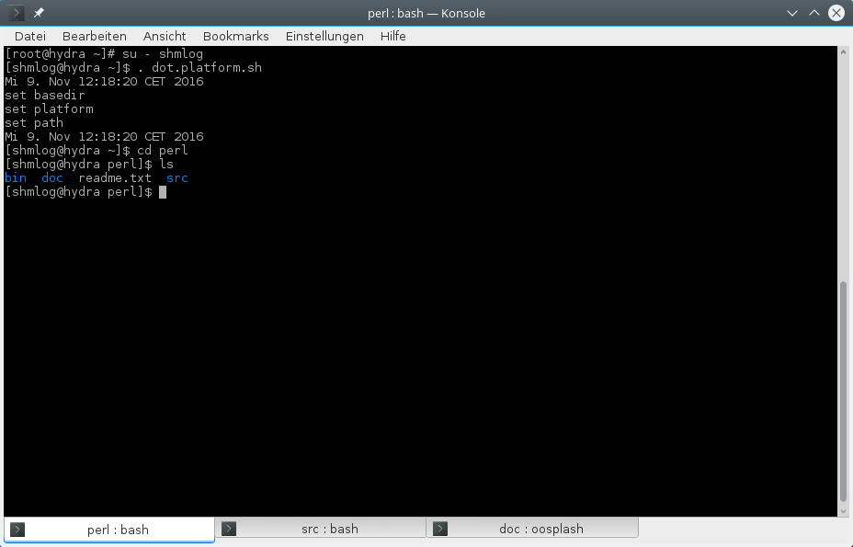
Illustration 53: The perl basedir

OK. We have a readme – check it – and a bin, a doc and a src.
For the bin its clear, there are some scripts.

The bin directory

That's my bin so far.

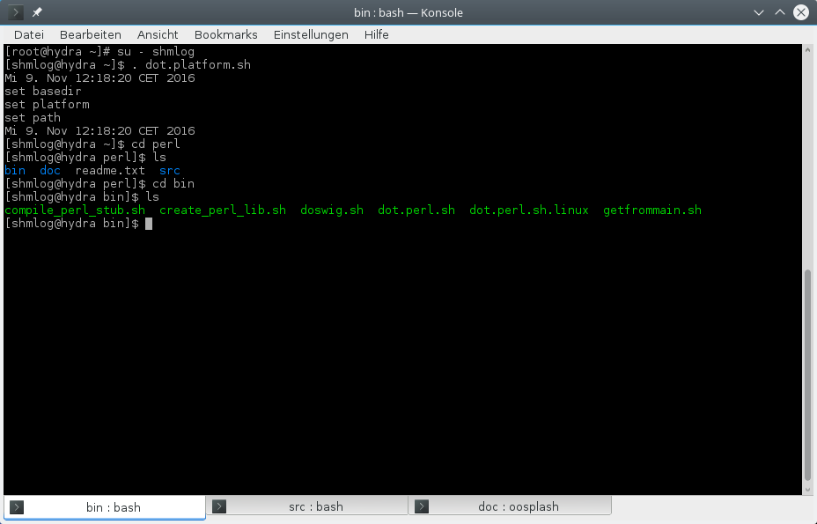
Illustration 54: The bin directory with the scripts

We have here one script that is interesting now. The rest becomes clear when it comes to a real build cycle. So for now a short info about the scripts
- compile_perl_stub.sh
The main build script – its the same for the perl layer as the makeall.sh for the C module.
- create_perl_lib.sh
The helper to compile the bridge C code and link to the library to get – ahem – the library ? I think here we have to distinguish the library ( C module ) and the perl bridge library for the perl stuff. We call the later from now on the perl library.
- getfrommain.sh
The script to transfer the headers and the library to perl directory's. This is the real thing here, see below.
- doswig.sh
This is the helper to do the swig generation for the SWIG wrapper and the perl pm file.
- dot.perl.sh
The environment setter.
- dot.perl.sh.linux
The Linux version – for now the same.

OK. There were one real thing, but its one for now. The getfrommain.sh. It transfers the headers and the library to the mystery perl directory's.

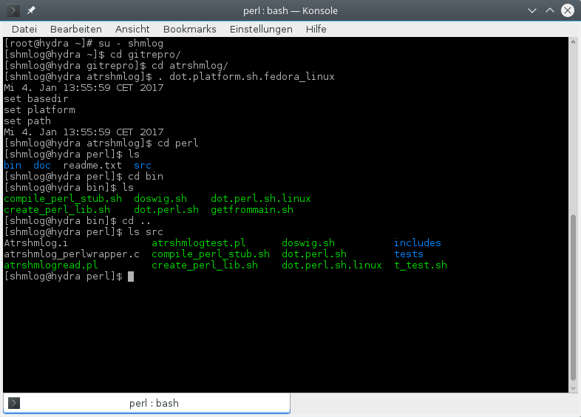
Illustration 55: The perl source directory

So that's now the perl things, and its the src.
OK. So we transfer with getfrommain.sh from the src what's there to the whole bunch.
Meaning: you should have the real headers in src in place. And the real library. Don't mix platforms or versions – then you have to ignore that script.
If everything is right we can execute the script now. Its mandatory that you are in the perl directory for its execution. So we call it relative with bin/getfrommain.sh.

Copy headers and lib from the C module

And so we do it

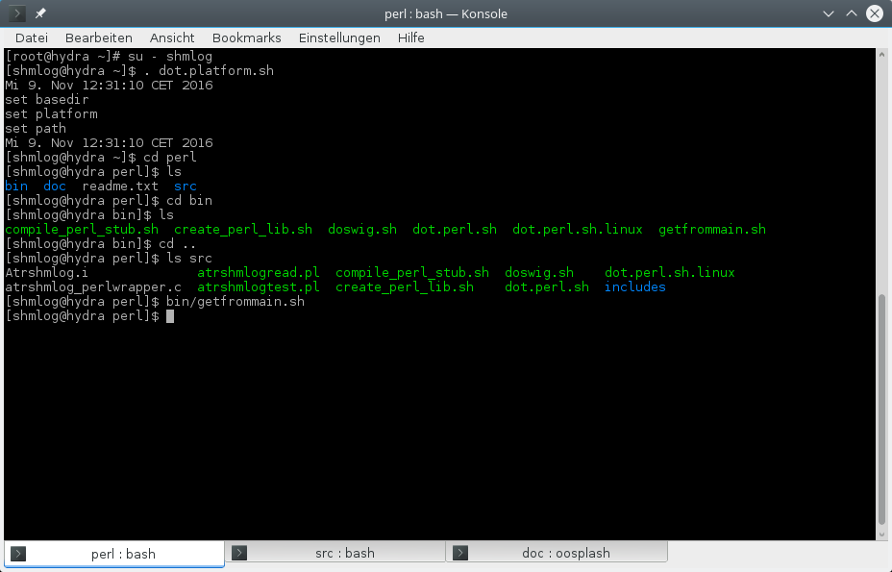
Illustration 56: Transfer of library and headers

Not much noise. Well, we will see….
Now its time to check for the src directory's.

Change into your src directory
We change and then see for it

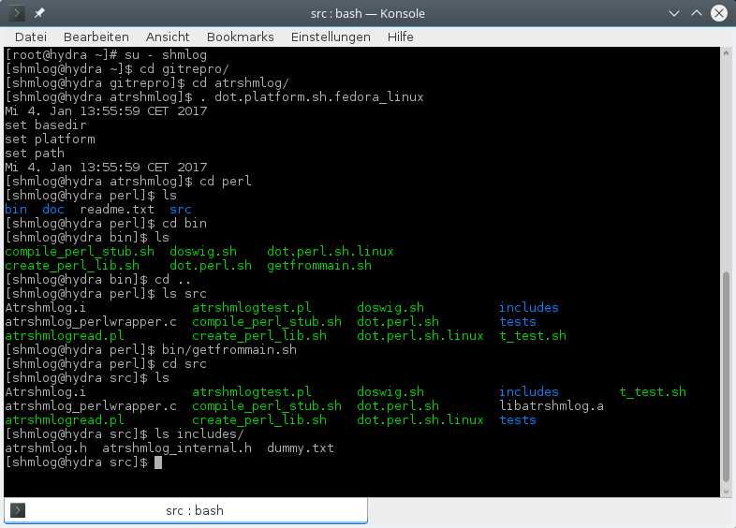
Illustration 57: Inside the source ready for build

The src is the real thing. We have again the – adapted - scripts here, so we are free to change them if we need. For reference there are the scripts in bin, so don't change them in bin till you have done the whole thing. Start only in src with changing.
We switch to src and now comes the list of the files in there.
- compile_perl_stub.sh
As already said. The main build script..
- create_perl_lib.sh
The helper to compile the bridge and link.
- dot.perl.sh
The setting of the environment variables. Next thing to do.
- doswig.sh
The helper to make the SWIG generator run.
- Atrshmlog.i
The SWIG definition file for this module.
- atrshmlog_perlwrapper.c
The perl bridge with helpers code.
- dot.perl.sh.linux
The setting of the environment variables for Linux.
- libatrshmlogc.a
The copy of the library from the C module (check time stamp and size and whatever you need too … should be from BASEDIR/src )
- atrshmlogtest.pl
Start the simple test.
- atrshmlogread.pl
Helper to start the simple test with read_fetch.

For the directory's : includes is clear – check for the files and for the time stamp and length of the headers from BASEDIR/src.
Then the tests with the test scripts.
OK. Now that we know that tree, check for the others.
When you are ready, you can read on.
Ready ? So fast – well, if you said so.
Its now time to do the thing.

Setting the environment
Before you do it you need an already up environment for the platform. In doubt switch to BASEDIR and source the dot file you need.
We then simply source dot.perl.sh

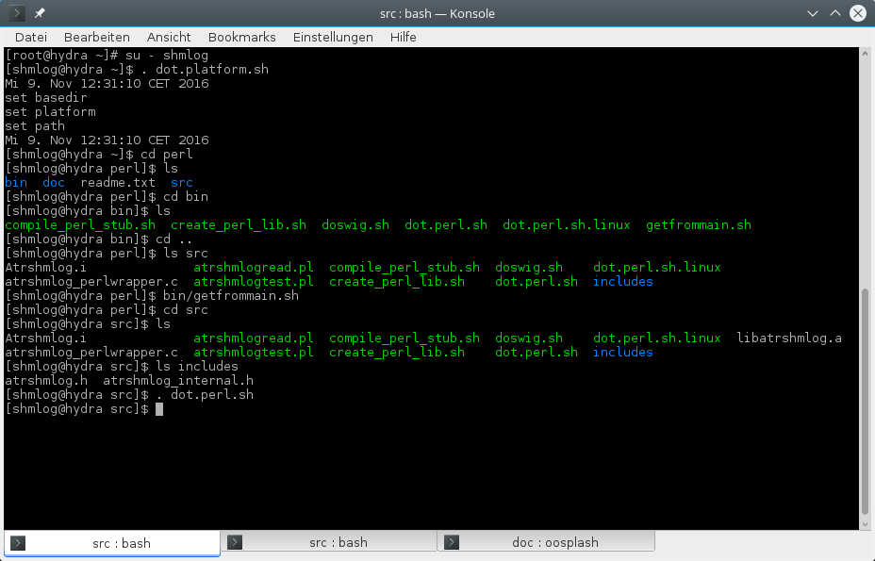
Illustration 58: Setting the environment for build

No noise here. If you insist you can check the environment.
Next is to start the build.

Building with create_perl_lib.sh
We start the script

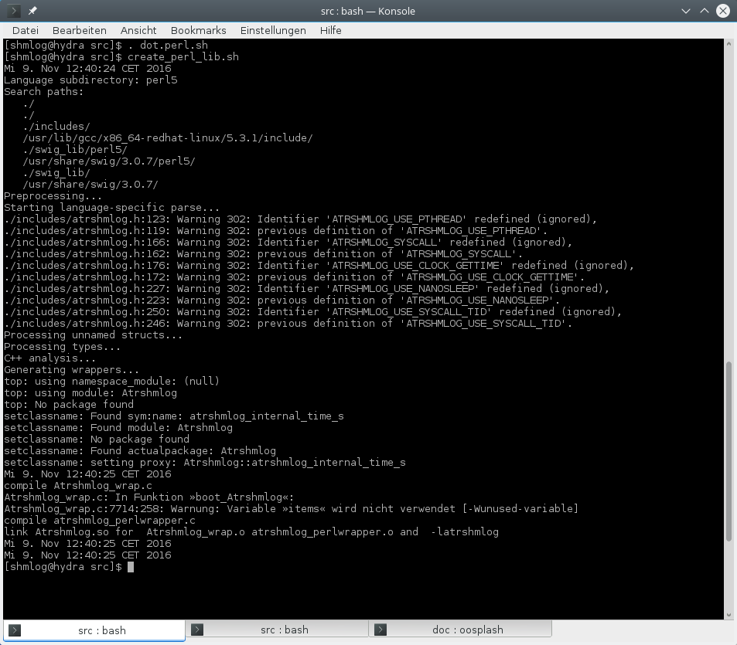
Illustration 59: Build the perl library

And there we are.
First it starts the SWIG generator for a perl module. After the swig is done its compile time.
One compile for the atrshmlog_wrap.c .
Next compile for the atrshmlog_perlwrapper.c .
And one link line.
All what's left is the test.

Testing the perl bridge
We have first to create a shared memory buffer with atrshmlogcreate. I will use 4711 and 8 for it. Then the init for the area. Next the test of the bridge. Then the reader and the convert.
At last we can check for the result log.
And because it was already done for the C test program we do it in short form now.

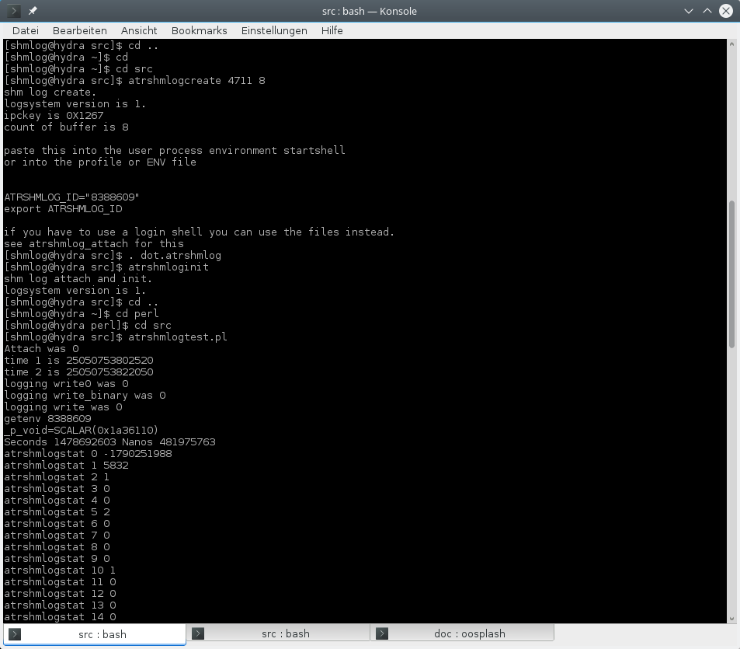
Illustration 60: Test of the perl library

HM. Worked as expected.
And here the result for the log after the fetch from the reader.

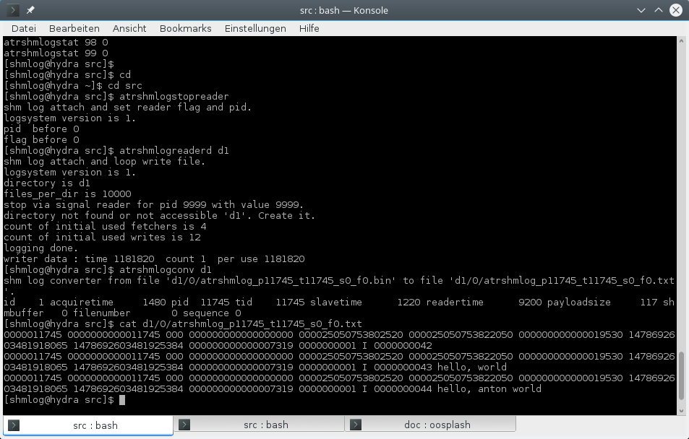
Illustration 61: Test log output
OK. So we have the log in here.

Details
Now we make it for the bridge in C.
Take your favorite text editor and open the Atrshmlog.i.
The file is not so complicated. Its only a bit bigger than a good SWIG example because of the rough hundred functions we have in here.
It starts with the usual comment stuff.
Then the definition of the module. I use a Camel case here like in most modules in perl.
Next is the code block for the wrapper file with the usual include of the C module.
What follows are the prototypes of the helpers that we will need.
There is only small need for helpers here – compared to the python its a really thin layer.
We need the otherwise inlined gettime.
And for the SWIG way to handle output the helpers of get_inittime, get_readtime and get_statistics.
The SWIG way is done by conversion of output pointer parameters into temporary variables – and then to give back them on the perl stack which makes them a simple return array.
So we get an array with two values from the get_inittime and the get_realtime.
For the get_statistics its a array of – well – hundred values for now. I simply say that's OK for me, after all I have hundred counters in place. And only 86 are in use now.
Last are the read and read_fetch helpers. They need a buffer and I have made it a full length one.
So with the small hacks for peek and poke the included code finish.

Next is the typemap include. I had a strange result when I had a comment after the thing – so I removed the comment and anything is now back to normal.
Its for the OUTPUT parameters, see later.
Then we have the typemap for the c string buffer handling in read and read_fetch.
I had some trouble with two things in the first place, so I added two defines to make the compiler work again.
Perhaps this is not needed for your SWIG implementation.
The n the ignore block follows. I simply cannot use the raw prototypes, so I use the include of the interface and the raw from the internal to make the SWIG see my C module functions.
This has a downside : I had to make for some variables a SWIG directive to NOT get some silly setter stuff.
And I catched some stuff from stdint.h here in too.
So that for the ignore block.
Next the translation of the names follow. Most is to cut of the atrshmlog_ prefix. For the helpers its the additional atratrshmlog_ prefix.
After that is set the include of the interface header is done.
Last are the prototypes of the helpers and the modifications to make the OUTPUT and cstring buffer things to work.
Now we can switch to the wrapper helpers code.
Open the atrshmlog_perlwrapper.c with your favorite text editor.
We start with the usual comment stuff.
Then the includes. We need a strlen in the write, so we have also the string.h header here.
First is gettime. Its more or less the Macro version here.
Next is write binary. We get at least a address and the length in here.
Then the heart of the client log, the write. We use a string here and take its length. No binary in here. If you need binary use the write_binary instead.
Next are the two getter for times. We need to make the output thing work, so no struct as return value in the perl layer. Instead we get with the OUTPUT typemap thing here two values on the return stack – which makes a array with two values for me. Perfect.
Then the get statistics. Again its only about a different interface and again the OUTPUT is used. This time you get 100 values in the return array.
For read and read_fetch we use a thread local buffer – its a malloced one and a big one.
So if you really plan to do the read or read_fetch thing you will need memory, and if you use multiple threads its for every thread an additional Mib.
We already made it for peek and poke in the definition file. So no implementation here.
And this is it. We are through alrea…. Ahem. OK.
The SWIG generated too.
I started after the XS didn't make it.
So first thing first – get an example and see how its done.
Swig's home page is OK for it. And it was a very simple one.
I checked also some things on google and found this should be easy. So I made the first approach.
And - BANG. Got compile errors for things I did not use in the first place – that's frustrating, crashing because of a thing you didn't need.
First was the conversion of a wchar_t value – the generated function was simply not there.
So because I even don't need it I made a define hack in the compile script.
Next was a missing off64_t. OK, next define.
After an hour I was up and running.
Next was to get info about the get_statistics thing. I got a scalar reference – nothing you can use in perl for the thing.
I checked google and found a nice article for perl98 about a return of arrays in C for perl. The thing was easy to make, some simple helper to alloc mem, then do the call of get_statistics with the returned scalar reference, then use some getter function to do the fetches into an perl array – and then delete the no longer alloced in between array.
Sounds great – for a C developer.
For a perl user after 20 years, well, horrible.
So I checked again when I made the get_inittime. And this time I found the real thing. A function that uses an OUTPUT in the prototype delivers a value back. Having more than one OUTPUT simply delivers multiple values. And for the types I had it was the simple number stuff – and so I got an array with two values back.
That was for a C developer a bit frustrating, but a helper did the job.
For the perl user it was - well, as expected. No big hooray or so. Simple use it.
Back to get_statistics.
Make a helper, use the array in between and see the thing was done in the wrap.c again. And it was OK.
Nice. Now the last three hours – the read and read_fetch.
Again the helper was needed because of the stuff that is delivered via pointers to the caller. I needed the OUTPUT again.
For the major part, the buffer, I had again to check. And I found a thing that worked for binary and did the allocation and the free in perl itself. OK, this was what I had in mind. For python the code was done in the core functions, so I simply made copy's and changed parts of them. After the three hours I had a working read_fetch demo.
Last hour. Cleanup the no longer needed. Make some helpful constants and rename the things.
Again the help of SWIG.org did the job.
And so we have now a SWIG generated wrapper.
Check the doswig.sh for the conversion and for a small hack for a erroneous construct that I made here.
Now open the Atrshmlog_wrap.c in your favorite text editor.
You find at the beginning the code for my two problematic compiler no-go.
Then you can skip the swig machinery code.
It about line 2100 when we are back in the module.
The SWIG first handles some variables and return struct things. I don't need them, but SWIG thinks it could not hurt.
For the variable's I tolerate the getter's. But the setters - I don't need them. So you are having now some immutable directives in the interface header to block that.
After the setters and getter's we enter the REAL stuff in 2300.
Attach.
Its a simple one, no parameters, only a return value.
And yes, its actual an int in Linux land here. So we get a simple wrapper.
Ignore the get_statistics here, its dead.
Next is the write0 . Some more parameters, but that's it.
Sleep nanos is simple, only a parameter, and again its an int for SWIG and we are in.
As you can see it is no big deal to read it. But to write would be a lot more work. So I am happy the generator works….
After the environment handling stuff with strings we enter the big number of simple setter and getter like functions.
Most look like the first two of them.
Some minor things to mention.
The area things are done in the jni and python by using numbers. Here they are scalar references.
About line 4400 we hit the otherwise inlined functions from the interface .
What follows are the prototypes from the definition file for the create, the delete, cleanup_locks and init_shm_log. After this we have the helpers in place.
The gettime is easy. The write_binary has some more to do. But again only parameter stuff.
With the get_inittime we enter the magic of OUTPUT. It simply works, so I don't question it.
Then the real get_statistics is in.
Its a big – but otherwise boring – version of the get time things.
And that's it for the wrap.c

Now the last thing we need – and the most important for the perl user – is the generated pm file.
Fire up your editor and load it in.
To make things easy you can skip the first lines. From line 50 on we have our new functions for the module.
The next we have is the not needed stuff for the return structs.
With line 200 we are in again. SWIG makes heavy use of structs and defines and constants and enum's in the generation, so we have them all in.
To be honest its a bit too much in my experience, but if it does not hurt I take it.
So you can now import it – have the shared lib and the compiler libs in place – and use it.

Tests
There is now a bunch of test scripts in tests and a do it all t_test.sh script. So testing is done more or less for all functions. But focus was not to test the C functions, only the way from the perl to the call of the C function. They are tested already in the C module.
But if you need examples you will have it here.

The one fits all SWIG approach
After I had done the initial jni stuff it was clear for me to make it to other languages too.
So on my first list I had python, perl and for those others SWIG in case they use that.
For the perl I had to start at with my python experience.
I tried the standard perl way, the XS, but failed. So I switched to SWIG – which I had on my list for later anyway. And it worked out.
So my SWIG was already done. But I don't know if I will change to XS back and so this is the vanilla SWIG chapter.
I chose as target the tcl – another now over 20 years well known language to support the embedding and to be embedded in over systems thing.
So we will ignore the perl swig solution for now and simply start from ground zero.
If you need another language you should do some experiments with the SWIG to find out if it supports your language as it did for perl and tcl.

How it works
The SWIG uses its definition file to build a wrapper C code file in tcl. No other files are in. So you have in place the swig wrapper, the additional C code file with the helpers and the C module itself.
The module is a direct used implementation. Under cover you use the C module. The module is capable of doing its job simply by using the internal infrastructure as in a C environment. No need for changes inside.
This means you get in theory the same speed as for the C module itself. The only thing that slows down is the tcl parameter handling in the bridge code itself.
The rest is more or less simple. Use of the function and no object stuff. Simple raw data types, no classes, no exceptions and no use of the tcl side. Barely some string creations.
If you are interested the atrshmlog_swigwrapper.c is a good start.
The module gives also the a small number of constants to the user.
Also the enum's are there, but here you have to use the C notation with the in C usual prefix.
A simple load gets it in.

How to use it
The user needs the following parts:
- Shared library or dll Atrshmlog
This is the bridge code from the SWIG code atrshmlog_wrap.c , the atrshmlog_swigwrapper.c and the linked library from the C module, libatrshmlogc.a. You need also the compiler support lib's and in case of the mingw port the additional dll ' s of the mingw system.
- The support programs
You need the matching C support programs for the basic stuff you don't want to reinvent. Reader, converter, even create and delete. So if you need a pure (?) own language only solution you can replace them with your own code counterparts. But for now I deliver nothing so you should start with the C programs.
So you first have to build it – again I am not delivering binary code, only source, so if you are interested in binary you have to contact me and I will see what I can do. But for now you have to start with the SWIG's bridge file atrshmlog_swigwrapper.c and Atrshmlog.i.

How to build it in the first place
We start with the C module.
After this is in place we have to check our next options.
We have in place an implementation that should work out of the box for Linux and tcl 8.6.

The SWIG directory
We start with the basics.
The SWIG stuff is located parallel to src – so we start at BASEDIR/SWIG
.
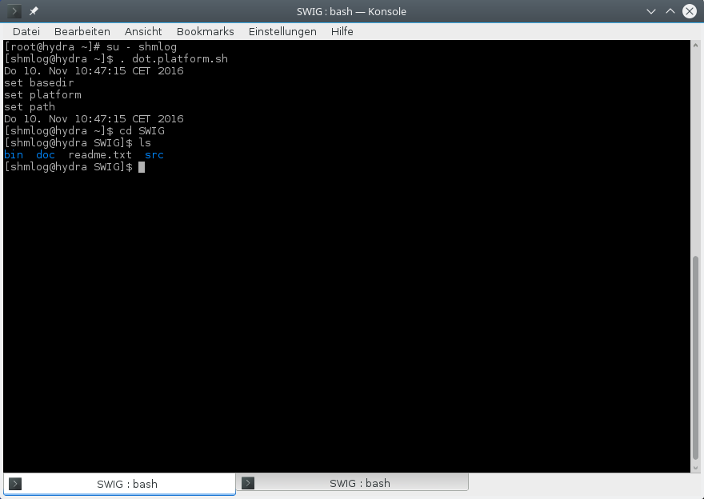
Illustration 62: The SWIG base directory

OK. We have a readme – check it – and a bin, a doc and a src.
For the bin its clear, there are some scripts.

The bin directory

That's my bin so far.

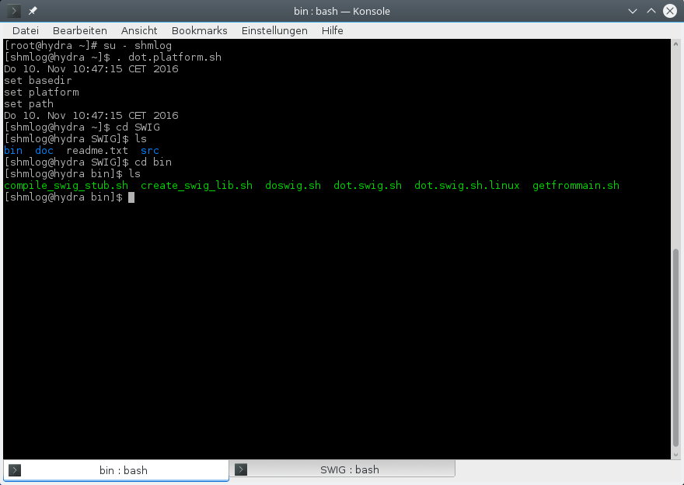
Illustration 63: The bin directory with the scripts

We have here one script that is interesting now. The rest becomes clear when it comes to a real build cycle. So for now a short info about the scripts
- compile_swig_stub.sh
The main build script – its the same for the SWIG layer as the makeall.sh for the C module.
- create_swig_lib.sh
The helper to compile the bridge C code and link to the library to get – ahem – the library ? I think here we have to distinguish the library ( C module ) and the SWIG bridge library for the target languages stuff. We call the later from now on the SWIG library.
- getfrommain.sh
The script to transfer the headers and the library to SWIG directory's. This is the real thing here, see below.
- doswig.sh
This is the helper to do the swig generation for the SWIG wrapper library..
- dot.swig.sh
The environment setter.
- dot.swig.sh.linux
The Linux version – for now the same.

OK. There were one real thing, but its one for now. The getfrommain.sh. It transfers the headers and the library to the mystery SWIG directory's.

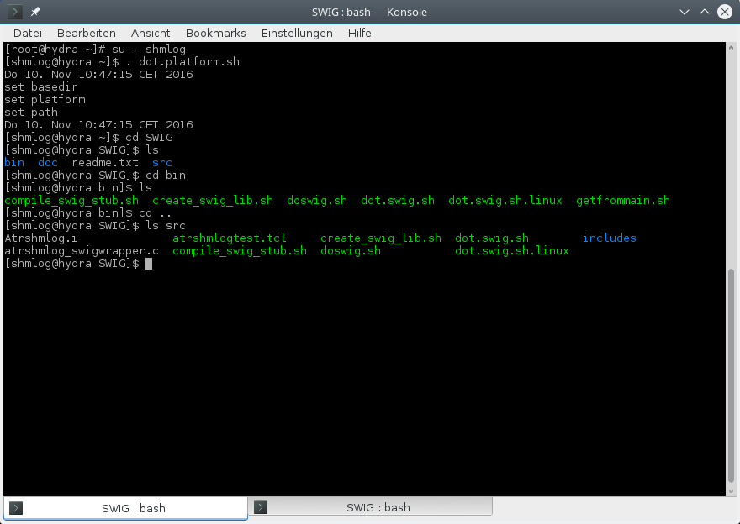
Illustration 64: The source directory for SWIG

So that's now the SWIG things, and its the src.
OK. So we transfer with getfrommain.sh from the src what's there to the whole bunch.
Meaning: you should have the real headers in src in place. And the real library. Don't mix platforms or versions – then you have to ignore that script.
If everything is right we can execute the script now. Its mandatory that you are in the SWIG directory for its execution. So we call it relative with bin/getfrommain.sh.

Copy headers and lib from the C module

And so we do it
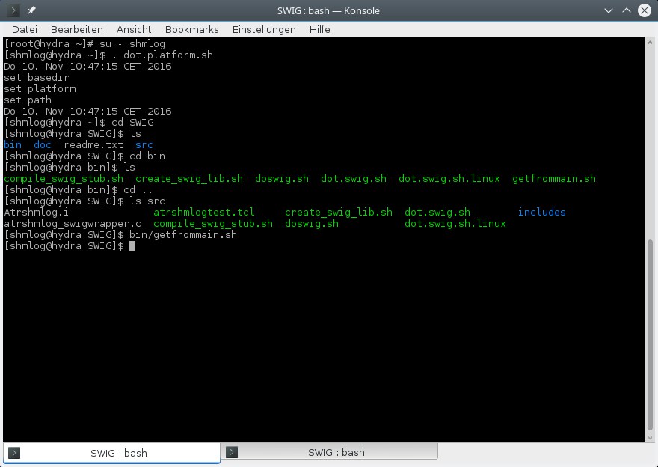
Illustration 65: Transfer of the library and the headers

Not much noise. Well, we will see….
Now its time to check for the src directory's.

Change into your src directory
We change and then see for it

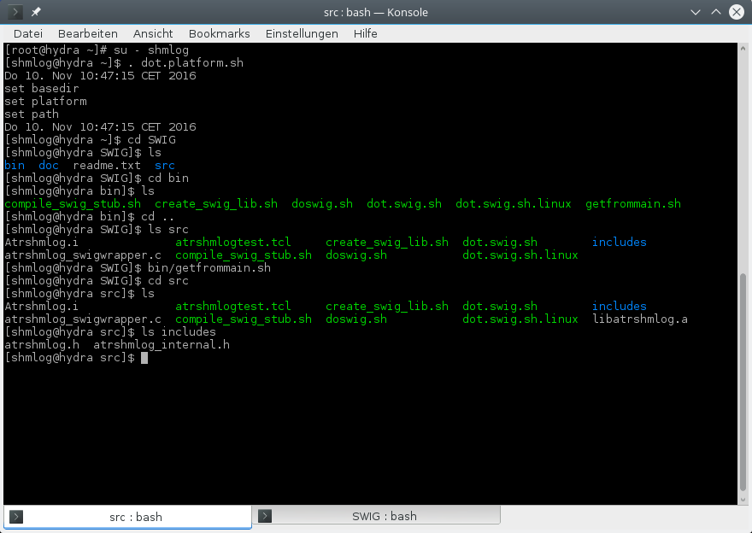
Illustration 66: Inside the source ready for build

The src is the real thing. We have again the – adapted - scripts here, so we are free to change them if we need. For reference there are the scripts in bin, so don't change them in bin till you have done the whole thing. Start only in src with changing.
We switch to src and now comes the list of the files in there.
- compile_swig_stub.sh
As already said. The main build script..
- create_swig_lib.sh
The helper to compile the bridge and link.
- dot.swig.sh
The setting of the environment variables. Next thing to do.
- doswig.sh
The helper to make the SWIG generator run.
- Atrshmlog.i
The SWIG definition file for this module.
- atrshmlog_swigwrapper.c
The SWIG bridge with helpers code.
- dot.swig.sh.linux
The setting of the environment variables for Linux.
- libatrshmlogc.a
The copy of the library from the C module (check time stamp and size and whatever you need too … should be from BASEDIR/src )
- atrshmlogtest.tcl
Start the simple test. For tcl

For the directory's : includes is clear – check for the files and for the time stamp and length of the headers from BASEDIR/src.
OK. Now that we know that tree, check for the others.
When you are ready, you can read on.
Ready ? So fast – well, if you said so.
Its now time to do the thing.

Setting the environment
Before you do it you need an up environment for the platform. So in doubt first switch to BASEDIR and source the dot file you need.
We then simply source dot.swig.sh

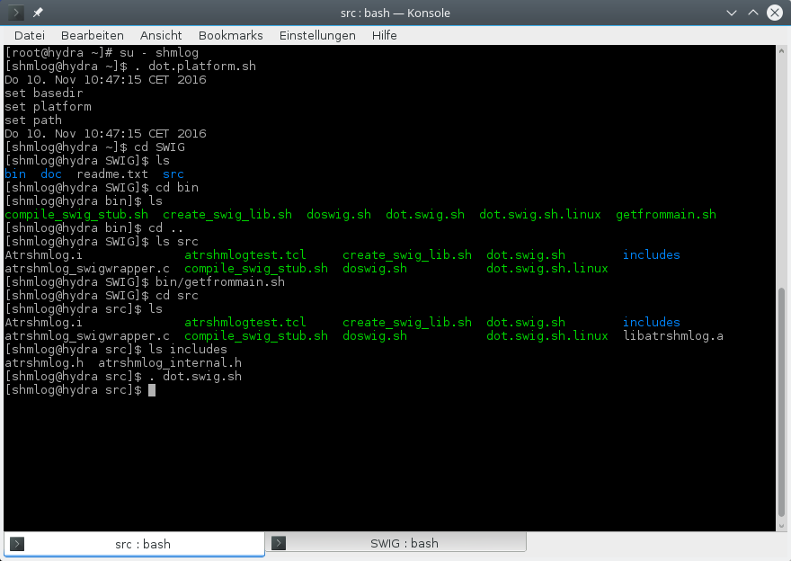
Illustration 67: Setting the build environment

No noise here. If you insist you can check the environment.
Next is to start the build.

Building with create_swig_lib.sh
We start the script. This time we don't have the target in place, so we have to give it as a parameter. And because the tcl does not have a module by default we give a second parameter to make it to surround our functions in a package with -namespace

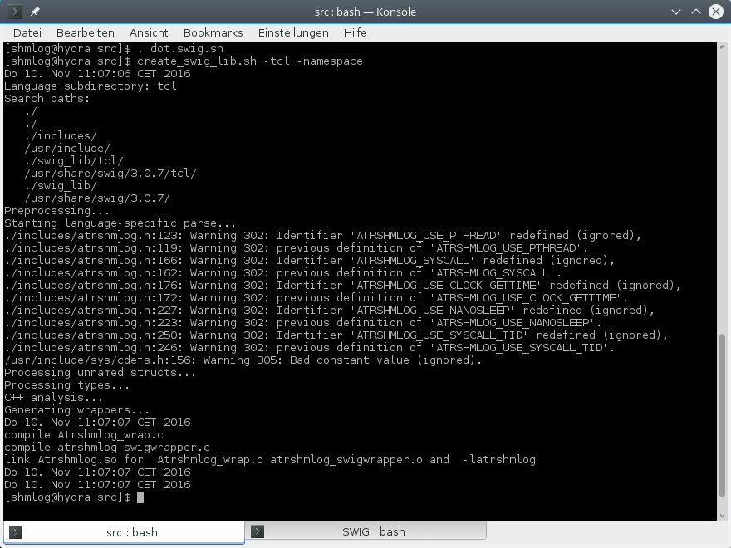
Illustration 68: Create the tcl library with SWIG

And there we are.
First it starts the SWIG generator for a tcl module. After the swig is done its compile time.
One compile for the atrshmlog_wrap.c .
Next compile for the atrshmlog_swigwrapper.c .
And one link line.
All what's left is the test.

Testing the tcl bridge
We have first to create a shared memory buffer with atrshmlogcreate. I will use 4711 and 8 for it. Then the init for the area. Next the test of the bridge. Then the reader and the convert.
At last we can check for the result log.
And because it was already done for the C test program we do it in short form now.

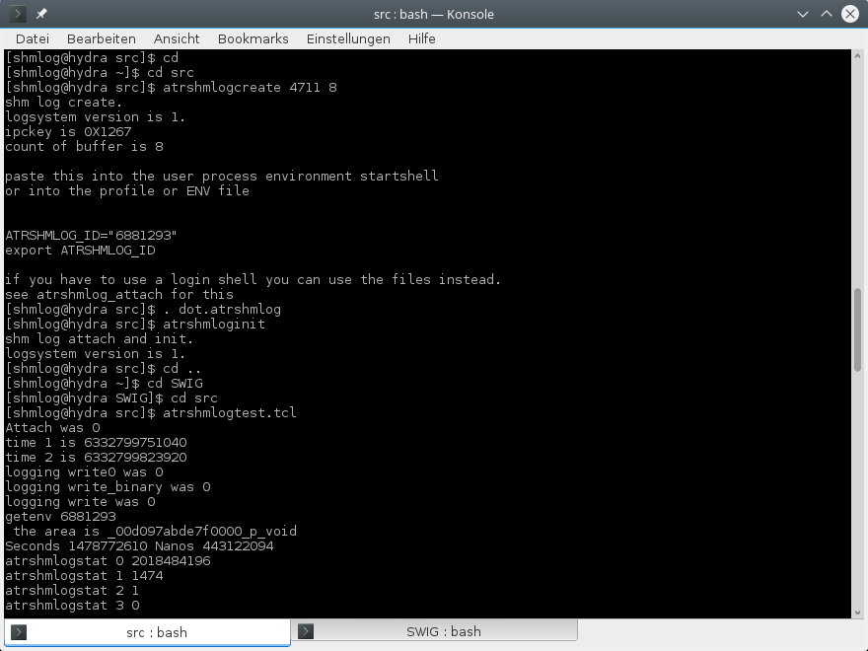
Illustration 69: Test the new tcl library

HM. Worked as expected.
And here the result for the log after the fetch from the reader.

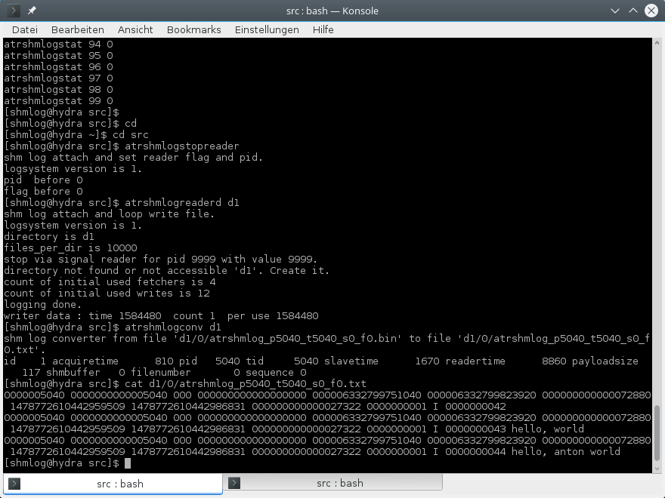
Illustration 70: The log result

OK. So we have the log in here.

Details
Now we make it for the bridge in C.
Take your favorite text editor and open the Atrshmlog.i.
The file is not so complicated. Its only a bit bigger than a good SWIG example because of the rough hundred functions we have in here.
It starts with the usual comment stuff.
Then the definition of the module. I use a Camel case here like in most modules in perl.
Next is the code block for the wrapper file with the usual include of the C module.
What follows are the prototypes of the helpers that we will need.
There is only small need for helpers here – compared to the python its a really thin layer.
We need the otherwise inlined gettime.
And for the SWIG way to handle output the helpers of get_inittime, get_readtime and get_statistics.
The SWIG way is done by conversion of output pointer parameters into temporary variables – and then to give back them on the interpreter in the natural way. For perl its an array on stack which makes them a simple return array. For tcl its a list.
So we get an tcl list with two values from the get_inittime and the get_realtime.
For the get_statistics its a list of – well – hundred values for now. I simply say that's OK for me, after all I have hundred counters in place. And only 85 are in use now.
Last are the read and read_fetch helpers. They need a buffer and I have made it a full length one.
So with the small hacks for peek and poke the included code finish.
Next is the typemap include. I had a strange result when I had a comment after the thing – so I removed the comment and anything is now back to normal.
Its for the OUTPUT parameters, see later.
Then we have the typemap for the c string buffer handling in read and read_fetch.
I had some trouble with two things in the first place, so I added two defines to make the compiler work again.
Perhaps this is not needed for your SWIG implementation.
Then the ignore block follows. I simply cannot use the raw prototypes, so I use the include of the interface and the raw from the internal to make the SWIG see my C module functions.
This has a downside : I had to make for some variables a SWIG directive to NOT get some silly setter stuff.
And I catched some stuff from stdint.h here in too.
So that for the ignore block.
Next the translation of the names follow. Most is to cut of the atrshmlog_ prefix. For the helpers its the additional atratrshmlog_ prefix.
After that is set the include of the interface header is done.
Last are the prototypes of the helpers and the modifications to make the OUTPUT and cstring buffer things to work.
Now we can switch to the wrapper helpers code.
Open the atrshmlog_swigwrapper.c with your favorite text editor.
We start with the usual comment stuff.
Then the includes. We need a strlen in the write, so we have also the string.h header here.
First is gettime. Its more or less the Macro version here.
Next is write binary. We get at least a address and the length in here.
Then the heart of the client log, the write. We use a string here and take its length. No binary in here. If you need binary use the write_binary instead.
Next are the two getter for times. We need to make the output thing work, so no struct as return value in the SWIG layer. Instead we get with the OUTPUT typemap thing here two values on the return stack – which makes a array with two values for me. Perfect.
Then the get statistics. Again its only about a different interface and again the OUTPUT is used. This time you get 100 values in the return array.
For read and read_fetch we use a thread local buffer – its a malloced one and a big one.
So if you really plan to do the read or read_fetch thing you will need memory, and if you use multiple threads its for every thread an additional Mib.
We already made it for peek and poke in the definition file. So no implementation here.
And this is it. We are through alrea…. Ahem. OK.
The SWIG generated too.
I started after the XS didn't make it.
So first thing first – get an example and see how its done.
Swig's home page is OK for it. And it was a very simple one.
I checked also some things on google and found this should be easy. So I made the first approach.
And - BANG. Got compile errors for things I did not use in the first place – that's frustrating, crashing because of a thing you didn't need.
First was the conversion of a wchar_t value – the generated function was simply not there.
So because I even don't need it I made a define hack in the compile script.
Next was a missing off64_t. OK, next define.
After an hour I was up and running.
Next was to get info about the get_statistics thing. I got a scalar reference – nothing you can use in perl for the thing.
I checked google and found a nice article for perl98 about a return of arrays in C for perl. The thing was easy to make, some simple helper to alloc mem, then do the call of get_statistics with the returned scalar reference, then use some getter function to do the fetches into an perl array – and then delete the no longer alloced in between array.
Sounds great – for a C developer.
For a perl user after 20 years, well, horrible. Guess its the same for the tcl folks.
So I checked again when I made the get_inittime. And this time I found the real thing. A function that uses an OUTPUT in the prototype delivers a value back. Having more than one OUTPUT simply delivers multiple values. And for the types I had it was the simple number stuff – and so I got an array with two values back.
That was for a C developer a bit frustrating, but a helper did the job.
For the perl user it was - well, as expected. No big hooray or so. Simple use it. Same for my first steps with tcl lists.
Back to get_statistics.
Make a helper, use the array in between and see the thing was done in the wrap.c again. And it was OK.
Nice. Now the last three hours – the read and read_fetch.
Again the helper was needed because of the stuff that is delivered via pointers to the caller. I needed the OUTPUT again.
For the major part, the buffer, I had again to check. And I found a thing that worked for binary and did the allocation and the free in perl itself. OK, this was what I had in mind. For python the code was done in the core functions, so I simply made copy's and changed parts of them. After the three hours I had a working read_fetch demo.
Last hour. Cleanup the no longer needed. Make some helpful constants and rename the things.
Again the help of SWIG.org did the job.
And so we have now a SWIG generated wrapper.
Check the doswig.sh for the conversion and for a small hack for a erroneous construct that I made here.
Now open the Atrshmlog_wrap.c in your favorite text editor.
You find at the beginning the code for my two problematic compiler no-go.
Then you can skip the swig machinery code.
It about line 2050 when we are back in the module.
The SWIG first handles some variables and return struct things. I don't need them, but SWIG thinks it could not hurt.
For the variable's I tolerate the getter's. But the setters - I don't need them. So you are having now some immutable directives in the interface header to block that.
After the setters and getter's we enter the REAL stuff in 2250.
Attach.
Its a simple one, no parameters, only a return value.
And yes, its actual an int in Linux land here. So we get a simple wrapper.
Ignore the get_statistics here, its dead.
Next is the write0 . Some more parameters, but that's it.
Sleep nanos is simple, only a parameter, and again its an int for SWIG and we are in.
As you can see it is no big deal to read it. But to write would be a lot more work. So I am happy the generator works….
After the environment handling stuff with strings we enter the big number of simple setter and getter like functions.
Most look like the first two of them.
Some minor things to mention.
The area things are done in the jni and python by using numbers. Here they are scalar references in perl, pointers in text in tcl.
About line 3750 we hit the otherwise inlined functions from the interface .
What follows are the prototypes from the definition file for the create, the delete, cleanup_locks and init_shm_log. After this we have the helpers in place.
The gettime is easy. The write_binary has some more to do. But again only parameter stuff.
With the get_inittime we enter the magic of OUTPUT. It simply works, so I don't question it.
Then the real get_statistics is in.
Its a big – but otherwise boring – version of the get time things.
And that's it for the wrap.c

The ruby approach
After I had done the initial jni stuff, it was clear for me to make it to other languages too.
So on my first list I had python, perl and for those others SWIG in case they use that.
After the next release I checked and found that ruby was a real one, like python. So I started the ruby module.
First things first. Collect examples and fragments and check for the short intro things. Wikipedia delivered me with the ruby-lang.org as starting point.
When I started it looked first if the ruby DIDN'T want to get big…
No alphabetical indexes, some example code that simply had errors – or at least misinterpretation in place for me – and no I-work-from-start-to-end-example-with-all-in that worked.
HM. Great.
So I switched to the study of the real docu… found the Gem things … checked for old code from before 2000 … found the argument number things with -1 and -2 and the (…) prototype things …
At last it all came together to a thing that works at least for me…
First thing was that there was a difference between most docus on the net for ruby before version xxx and after. Some things like the RSTRING()→ptr were gone, so the example could not work with my 2.2.5 version (December 2016).
After diging in those strange indexed documentation I started to do the thing that makes most sence – grep in the /usr/include/ruby for the thing …
Well, first I had of course to install ruby-devel.
Next I found the example for the gem on rubygem was a bit blurry – no one to one copy of the real thing, more fragments of files … hm.
Then I started to mix things and came at last to the point I could make a makefile – ok, I said that before, I do not use make in the module, nor do I use it in the layers – but for ruby its simply mandatory. I can circumvent it by making a make, copy the resulting lines from shell output into scripts, but that would be not the ruby way.
So I made the extconf.rb from the rubygem and an promissing example.
So I could make my first makefile and BUMMM.
The thing didn't had a simple way to get compiler flag and loader things in…
I made the dot.ruby.sh a bit more a copy of the former dot files with a build in setting for the CFLAGS – but it didnt work out.
Then I found the trick with the modification in the extconf of the CC variable – and I was back in business.
Now I could deliver the needed defines and flags to the compiler – in fact I deliver the compiler too – and the build ran through.
The first test gave my a full stop – no module found.
HM.
I found an example with an include directive after the load, and – bingo, that worked…
But…
Then I had polluted the global namespace with about 140 new names… no good.
I had allways trouble in scripting languages when a second or third definition of create, read, write and so on came in. No way.
Then I stumbled over the singleton thing. This was first a bit bizarr, but then it worked and gave me the nearly same syntax like python or even better like perl.
OK. I actually have made the module way, and not the class and object thing. So if you insist and sent me a post card I can switch to a class and an object… but for now I will use the minimalist thing I have, and that's a module with the singleton methods.
After that I made the tests by simply copy the perl versions in and some minor changes – mostly kill the $ and ; chars and the #{} for the embedded variables.
Last thing was a review of the build process and the adaption of the gem things as far as possible for the module. So you can now build with rake and you can make a gem of the thing.
But as long as the question of using singleton or object is open I will not place the thing on rubygem.

How it works
The ruby uses a direct build in for the C module. It is simply wrapped with one function. Most things work like in the python module for the basic functions. But here we have the interface code for the interpreter directly in place. So no function pointer gymnastic as in python or a second level of function call from the interpreter
The interpreter loads the module, init it with its init function and that's it for the startup. The rest is plain old scripting stuff: declare a new method name, give the adress of the function, and the number of parameters.
The ruby uses a mixed approach for the parameters.
First parameter count 0 – OK, that's a lie. There is allways a reference of at least a module or class or object. So in fact this means only the object/class/module reference.
Next is that there are parameters. One to … 17 ? ouch. One posting at least named that limit. I didn't try it, so I checked and found only a maximum of 6 needed by my functions.
With one exception. The new reattach.
So I made most of my setter and getter and functions with the proper number of arguments and when it came to the reattach I used the form with a parameter array in second place. In fact its a ruby array with the parameters. Not an array pointer for VALUE …
The fourth form with a variable argument list was not needed by me, so I pass that.
For the return thing it was the same as in python – make an array, put the things in and give it back.
This was easy, I had already in python done it this way, so I simply copied the python in this cases – read, read_fetch and get_statistics.
After making the constants for the write it was ready for test.
Minor problems were the strings – the usual we don't like null pointers thing. For the write I could reduce – ruby seems to be capable of using embedded nulls, so I don't need the binary write here.
All in all this was the thinnest layer I had. So there is only one additional catch.
The use of gettime, write and 64 bit timestamps. All other things are done with number – the variable lenght coded things – but here I tent to use the fastest I can get. That's FIX . And Autch. I have a limit of 63 bit here.
That's not a big thing if you do some testings. But for long time running systems it can be a problem. For now I simply ignore this – after all we are still in the era of silicon computers, not quantums, so the 64 bit will be sufficient. But loosing a bit hurts.
The rest is easy. I use the modules internal structures opaque, no pointers involved, no wrapping. Instead of that I use all pointer like things as adressed via numbers – the long things – and so I have no problem to use them – its like in java – only the number type is not the native long with 64 bit, but the ruby bignum.
So you can see the addresses if you print them out….
The rest works as designed. Only the read and read_fetch needed some rework when I realized the script layers were somehow dissolving - I recoded the things new for all four layers – which will most likely not break code. Instead of delivering sometimes only one or two numbers on the array I now deliver in all scriptings minimum three to four – so the coding of script tests is identical for the elements on the array.
After some hours the tests showed green and so we have now the ruby module.
The module is a direct used implementation. Under cover you use the C module. The module is capable of doing its job simply by using the internal infrastructure as in a C environment. No need for changes inside.
This means you get in theory the same speed as for the C module itself. The only thing that slows down is the tcl parameter handling in the bridge code itself.
The rest is more or less simple. Use of the function and no object stuff. Simple raw data types, no classes, no exceptions and no use of the ruby side. Barely some string creations.
If you are interested the atrshmlogruby.c is a good start.
The module gives also a small number of constants to the user.
A simple load with require gets it in.

How to use it
The user needs the following parts:
- Shared library or dll Atrshmlog
This is the bridge code from the ruby code atrshmlogruby.c and the linked library from the C module, libatrshmlogc.a. You need also the compiler support lib's and in case of the mingw port the additional dll ' s of the mingw system.
- The support programs
You need the matching C support programs for the basic stuff you don't want to reinvent. Reader, converter, even create and delete. So if you need a pure (?) own language only solution you can replace them with your own code counterparts. But for now I deliver nothing so you should start with the C programs. You can use the test scripts if you need examples for your code.
So you first have to build it – again I am not delivering binary code, only source, so if you are interested in binary you have to contact me and I will see what I can do. But for now you have to start with the ruby bridge file atrshmlogruby.c..

How to build it in the first place
We start with the C module.
After this is in place we have to check our next options.
We have in place an implementation that should work out of the box for Linux and ruby 2.2.5.

The ruby directory
We start with the basics.
The ruby stuff is located parallel to src – so we start at BASEDIR/ruby
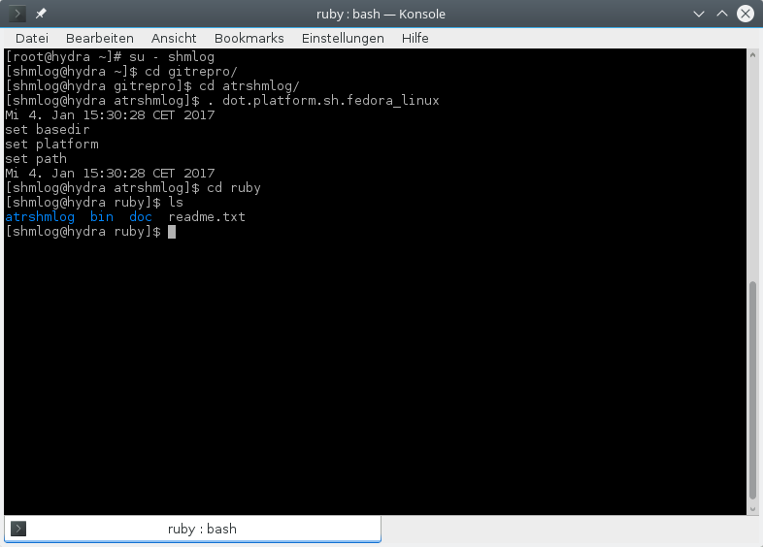
Illustration 71: The ruby base directory

OK. We have a readme – check it – and a bin, a doc and NOT a src, but a atrshmlog.
For the bin its clear, there are some scripts.

The bin directory

That's my bin so far.
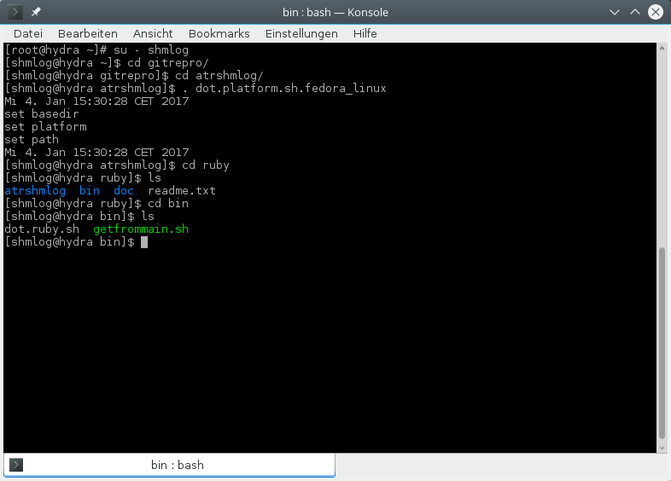
Illustration 72: The bin directory with the scripts

We have here one script that is interesting now. The rest becomes clear when it comes to a real build cycle. So for now a short info about the scripts
- getfrommain.sh
The script to transfer the headers and the library to ruby directory's. This is the real thing here, see below.
- dot.ruby.sh
The environment setter.

OK. There were one real thing, but its one for now. The getfrommain.sh. It transfers the headers and the library to the mystery ruby directory's.
The getfrommain
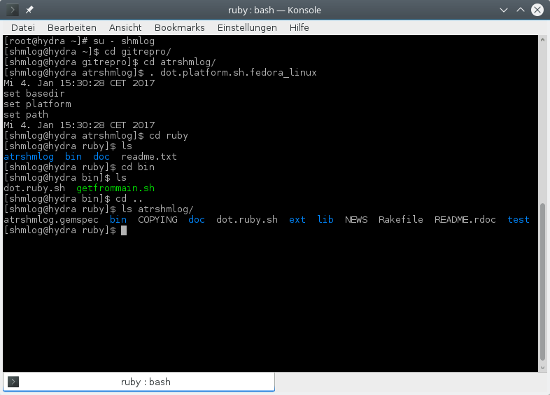
Illustration 73: The source directory for ruby

So that's now the ruby things, and its the atrshmlog.
OK. So we transfer with getfrommain.sh from the BASEDIR/src what's there to the whole bunch.
Meaning: you should have the real headers in src in place. And the real library. Don't mix platforms or versions – then you have to ignore that script.
If everything is right we can execute the script now. Its mandatory that you are in the ruby directory for its execution. So we call it relative with bin/getfrommain.sh.

Copy headers and lib from the C module

And so we do it
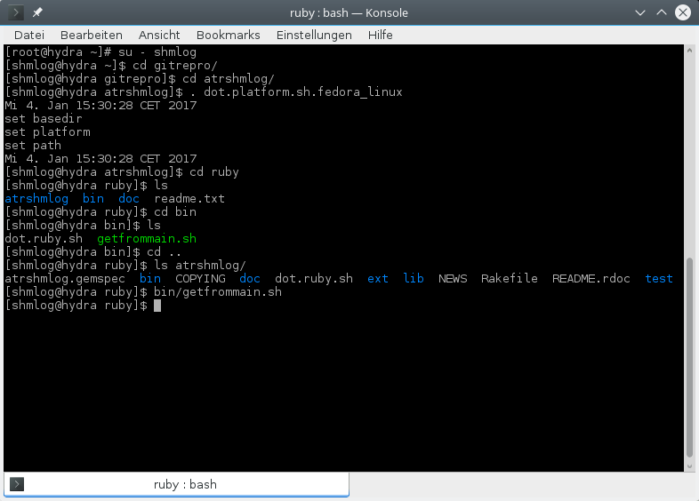
Illustration 74: Transfer of the library and the headers

Not much noise. Well, we will see….
Now its time to check for the atrshmlog directory's.
Site note:
Why not src ?
When I stumbled across the documentation I found several examples with no need for a special naming for the directory. So I started with src. But when the rubygem came in it made clear after some checks that the name should really be the name of the extension or gem. And so I switched to atrshmlog.

Change into your atrshmlog directory
We change and then see for it

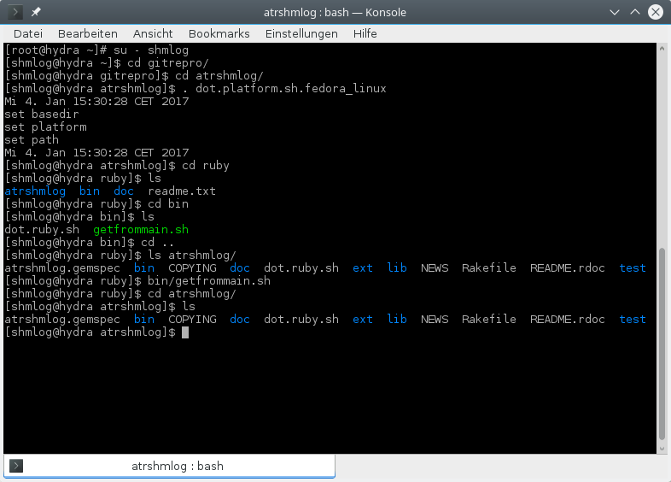
Illustration 75: Inside the atrshmlog
So we have here the usual ruby stuff in place.
For the files:
- atrshmlog.gemspec
The gem spec file for the module as if it were a gem
- COPYING
The license for the module, precise the hint for the Apache 2.0 licenses
- dot.ruby.sh
The script to set the environment. Most important setting for the CC variable.
- NEWS
Well. Whats new for this version .. everything :)
- Rakefile
The file to tell rake what to do. We use build here.
- README.rdoc
That's a dummy – for now there is only the html and odt documentation
For the directories its the bin, doc, lib and test as allways for a ruby module. Additional stuff is in ext for the extension – the real module in this case.
We check for the other directories first.

The ruby subdirectories:

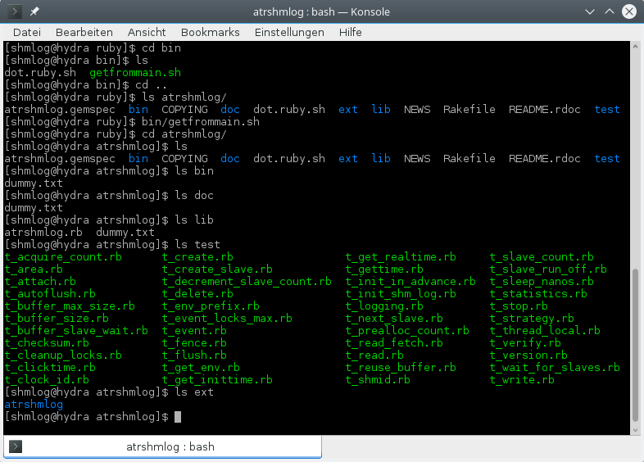
Illustration 76: The ruby subdirectories of the atrshmlog gem
So far we have some dummy stuff – to fill it will be part of the next version. For now we have a simplest lib part – only a small one liner in fact – and plenty of test stuff in place.
OK. The next step is according to the rubygem layout the ext/atrshmlog directory.

The ext atrshmlog :

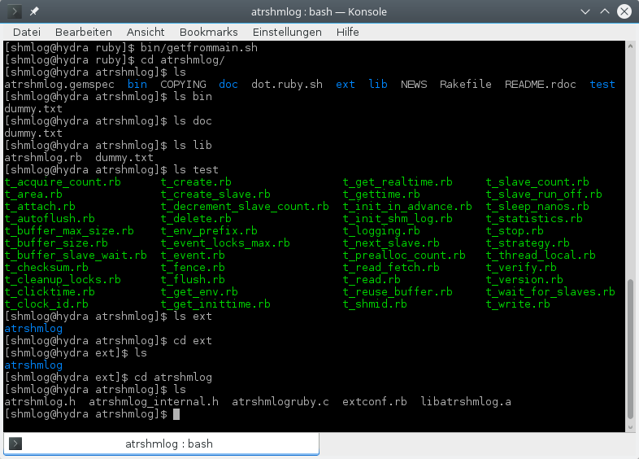
Illustration 77: The atrshmlog gem extension directory
OK. Here we have now the headers and the library of the C module. So here is the action in place.
There is the extconf.rb that is used to generate the make file and the module c file – this time I broke a rule, I appended ruby to the name. This is perhaps not ruby style, but so many files are atrshmlog.c in the whole system, so I try to change that if its possible. And it is possible.
We need the setings from the dot.ruby.sh, so we switch back and source it.

Setting the build environment, mostly the Defines via setting CC.
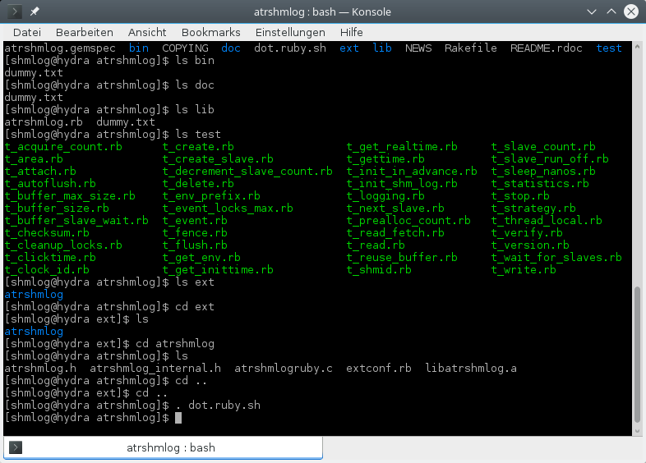
Illustration 78: Setting the environment CC
Now we can build with rake – if its installed ….

The build with rake ...
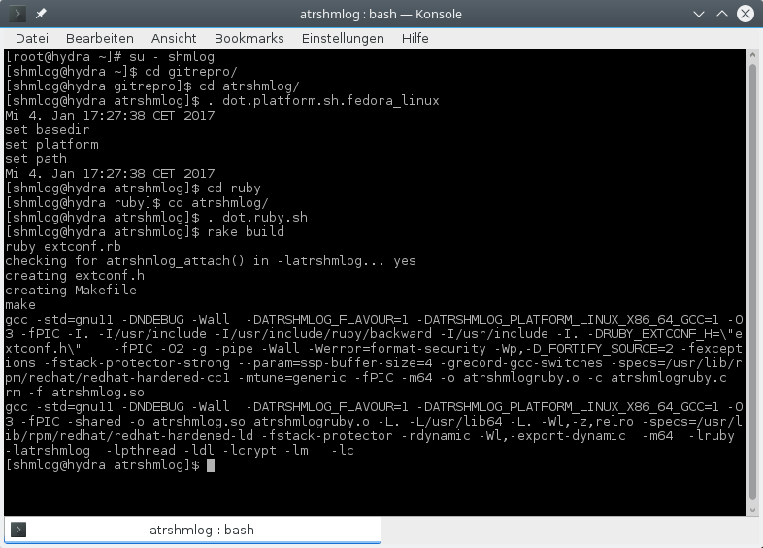
Illustration 79: The rake build
OK. Now we have the module build. That can be done also by running ruby extconf.rb and then running make in the shell. But its the ruby gem way to use a rake for it.
The real fun comes if you try to build a gem.

Building a gem…
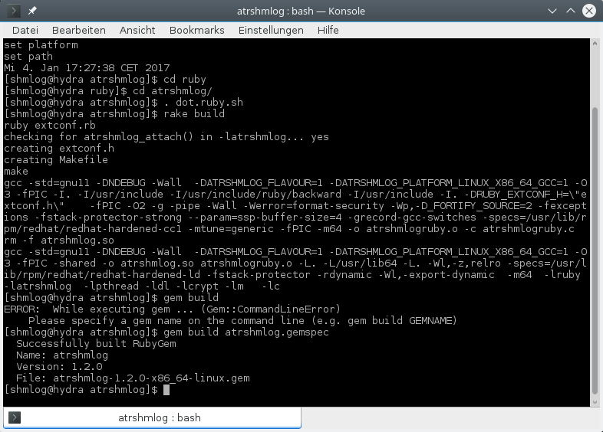
Illustration 80: building gem from the modue
So we have now a private gem, not one that is published. But we could do it – if it were not for the C module lib and the implementation question …

So we can now make a small test run with a test driver in tests. We do this in the way that we allways do it for the module, use the C module to set up the things and ask then what came through.

Testing the ruby module
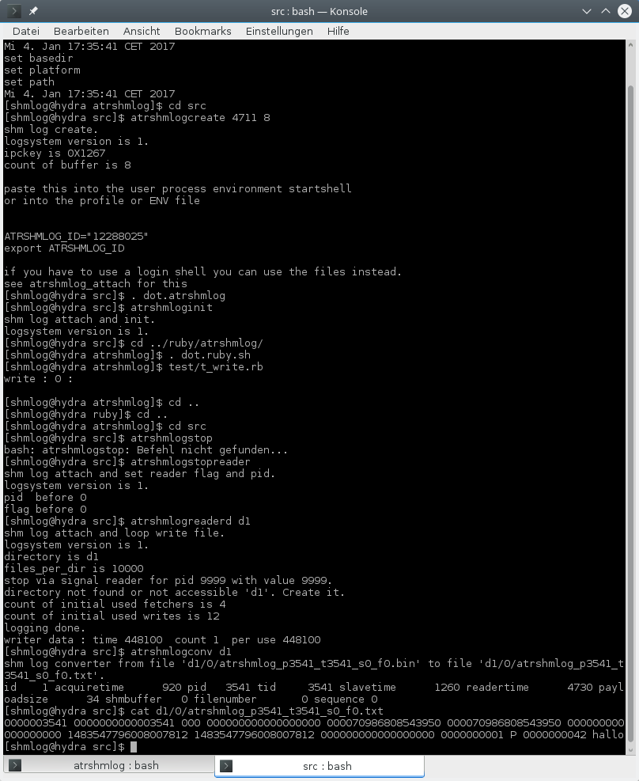
Illustration 81: Test of the ruby module
OK. Looks for me its working.

Details.
So its time to fire up your favorite text editor. Load in the ext/atrshmlog/atrshmlogruby.c file.
First comes the usual comment stuff.
Then the includes for ruby.h, extconf.h and the C module includes.
Line 28 (u_s) we have a little but helpful converter for pointers to unsigned long.
After the module anchor we start at 53 (attach) with the prototypes for the bridge functions.
Line 437 (Init_atrshmlog) we enter the initialization of the module.
As already mentioned I tried different styles and came up with the module and singleton approach. This is only done because it worked for me the simplest way after in the scripts. No checks for leaks or perfomance degration are done so far. If you know something about it – sent me a post card and I will use it.
After the module is made I implement the rest directly in it – no class, no object, no sub.
The functions are mapped one to one to the static functions. Most of them have zero or one additional parameter, only reattach uses array of parameters approach.
In 728 (EVENT_POINT_IN_TIME_UCS) the needed constants follow. I would have made more – but then we have also the rb in lib and so I think its eventually better to use it for the enum like stuff.
This will be decided in the next version – for now you simply have no others then the four here.
Line 739 (attach) starts the implementation of the bridge code functions.
The ruby code is dense, so its best to use at least some intermediate variables for debugging.
I have delivered in most cases a bignum and when the original does not deliver something a 0 instead.
Only the two performance critical functions gettime and write use FIX numbers. The rest tries to be safe and for the write I have implemented the checkings so you get an exception but no core dump. At least I hope that is the case – did not try negative tests so far …
For the strings I use intermedite arrays and handle them with memcpy. So in case the thing tries to give me funny encoded things it will be the same in the module.
For the write that means you can use embedded zero.
For all numbers the preferred way of using NUM2 …. delivers the checking. But if you play with strings its possible to make mistakes.
Consider be warned.
The read and read fetch use a thread local buffer – if they are called the first time its initialized to one million byte and then used. Be prepared for big footprint in case you try to make a reader….
At line 2110 (poke) we have the only functions that are not part of the C module, poke and peek.
We use simple numbers for the pointers, so be sure not to corrupt the numbers – you end up likely with a core dump else…
Line 2249 (reattach) we have the reattach with its different handling of the parameters. If you do not deliver the needed number of parameters it substitues 0 for it. Consider be warned.
We finish in 2573 . Compared to the other languaes this is indeed a very thin layer. And very small.

Another platform : CentOS
OK. My box is running a fedora 23, so no problem for the C 11 compiler.
But when I tried the CentOS 7.2 (at this time the best known clone for the RedHat 7 ) I found the compiler a bid off topic ( its now October 2016 and still a gcc 4.8 in place).
Yes, it had the c11 switch.
And yes, it had not the optional header stdatomic.h in place. So I googled a bit and came up with this.
How to make a running module for CentOS 7.2 ?
Its in the unsupported directory now. I will not integrate it because you can have a different compiler, so I leave that to you.
But I give you here the road map to do it.

Get the compiler to work that you need
First problem for the compiler is that you can not get any rpm so far. Seems that the need is not that big after all, so you simply have to do it for the old way. Get the source and then build it from scratch.
Getting the source is not a problem. Entry point is gcc.gnu.org. There we find links for downloads and we are in a tree that contains the whole versions available.
OK. We had a 4.8, and a 4.9 could do the job after some checks. But then I had experience with the 5.3 and so I switched to the latest 5.4 .
In theory you can make it local, no need for root here. But I still use root when it comes to a compiler so I made a g5 directory for root and unpacked the thing.
You should be careful before you start – its a 5 GB thing after all to make it.
Next I went into the configure
./configure --with-system-zlib --disable-multilib --enable-languages=c,c++
and got missing lib's for gmp, mpfr and mpc stuff.
HM. Had already made a full update and after checking with yum the things were already in place. So the devel companions where missing. Some yum install mpr-devel etc stuff ….
yum install gmp-devel
yum install mpfr-devel
yum install *mpc*
did the work and I could end the configure successful.
Now the usual make… took a while, about 2 hours on my box.
Make install again …. done.
I found my new buddy at /usr/local/bin and it was x86_64-unknown-linux-gnu-gcc-5.4.0.
So much for names you can expect today.

Changing the build scripts
I started with bin then. First the compiler stuff.
case $ATRSHMLOG_PLATFORM in
linux)
# linux x86_64 gnu
# CC="gcc -std=gnu11"
CC="x86_64-unknown-linux-gnu-gcc-5.4.0 -std=gnu11"
PICFLAG=-fPIC
OPTMODE=-O3
;;
That wasn't hard after all. Simply replace vanilla gcc. This was the g99.sh.
case $ATRSHMLOG_PLATFORM in
linux)
# linux x86_64 gnu
# CC="gcc -pthread"
CC="x86_64-unknown-linux-gnu-gcc-5.4.0 -pthread"
LIBMODULE=-latrshmlog
;;
and this was ell.sh.

For the dot file I made a copy dot.platform.sh.centos and adapted.
date

echo "set basedir "
# we set the basedir. so this must be used inplace in the correct dir
ATRSHMLOG_BASEDIR="$(pwd)"

export ATRSHMLOG_BASEDIR

echo "set platform"
# we set the platform for build

ATRSHMLOG_PLATFORM=linux

# ATRSHMLOG_PLATFORM=cygwin

# ATRSHMLOG_PLATFORM=mingw

export ATRSHMLOG_PLATFORM

echo "set path"
# we need a working path. so we assume its the basedir relative in bin
# what makes the thing

PATH="$PATH:$ATRSHMLOG_BASEDIR/bin:.:/usr/local/bin"

export PATH

date
# end of file

Not much difference, only the additional /usr/local/bin in the PATH.
The makeall.sh ran till it came to the C++ files. There I had at least some luck, the 4.8 could have made it if it weren't for the multithreading. It simply could not make the C++14 switch, so I had switched back to c++11, but that didn't work either. It complained to need a new one. So I gave it to the thing in g++14w.sh.
case $ATRSHMLOG_PLATFORM in
linux)
# linux x86_64 gnu
# CPP="g++ -std=c++11 -pthread -Wall -Weffc++ -fdump-tree-original"
CPP="g++ -std=gnu++1y -pthread -Wall -Weffc++ -fdump-tree-original"
PICFLAG=-fPIC
OPTMODE=-O3
LIBMODULE=-latrshmlog
;;

After that my makeall.sh ran complete.

In the end I integrated that in to the platform script for centos and now you only have to source that platform dot file and with the compiler in place and the rest will use that compiler.

Testing

And that's it. I made a short test run and got my wanted result:
0000009300 0000000000009300 000 000000000000000000 000086453358488444 000086453358488444 000000000000000000 1477592391142288024 1477592391142288024 000000000000000000 0000000001 P 0000000001 hello, world.
So there is nothing special for the CentOS 7.2, its only the compilers that had a glitch for me this time. The rest works as expected. I assume its the same for all from 6.0 on up to today's 7.2.
If the RedHat team will switch to a newer version of gcc you can forget this. Its only an interim needed workaround, and if you can get a rpm even not the time consuming compile is needed.
If you have to do it you must have the library's in place and you must have sufficient space for it. In principle you can say its a needed precondition for the module and you are through. And if you don't install that thing global, but in a local directory of yours you even don't have to be root for it.
So I can live with that.

Another platform : FreeBSD
So after making it for cygwin, mingw and another Linux it was time to try another posix platform. I had checked for the BSD UNIX's and found that FreeBSD was the most popular one.
So I made an installation on my virtualbox of the 11 release.
I am a newbie on the BSD, so I thought it should be different to Linux, but not so far away as a mingw.
After the install was done I found I was wrong about not so far from Linux. It was like being back in the RedHat 6 installation of 1999 – and yes, I mean the Red Hat 6, not the RHEL 6 here.
All I had was a vga terminal based installation – OK, I can live with that.
Next I found that I had to install even the package installer itself – I had made all the tiny switches and I had a 2.5 GB dvd image, but still a basics only installation – so much for using a big download image…
Next came that thing I call working environment was not there. I wanted to get a GUI environment running.
After one day I stopped that. I had done a lot of installs, but even with the ports thing I could not get it done right – having a KDE4 with US EN only is a bit sadistic when you have a german keyboard on your notebook….
So I installed the emacs, made login via ssh -X and worked in the ssh session instead of the GUI.
After that the thing was done in about 3 hours.
I had to switch to another bash place in the scripts and for perl. But that was not the only thing, also I had to change the scripts to accept a new platform – bsd – and later on a new flavour – freebsd.
When openbsd came in I switched to numbers and after one glitch the freebsd became the flavour 3 and openbsd the flavour 4.
I don't plan to make flavour's of mingw and cygwin, so they have a 1 for now.
After checking for the compiler I found a gcc from one of my installations – the bsd guys try NOT to have the newest gcc because of license problems. So the freebsd was in fact based on clang and not on gcc. But if you install anything serious you have one back …
Perfect. A new platform and a new compiler.
After some googleling I found I could make it with clang for the inline code assembler. GOOD.
The check system became a new part, the bsd and clang were addded and I found in the end only one thing strange. The call to get the thread id was for every bsd different. So I added the new platform in rough 2 hours and then made it through the compile.
The test was easy and I had my new platform up and running.
The rest is in the unsupported directory. Check for freebsd.
The stuff has been integrated now into the build scripts, but for the ksh support you will have to edit them in this release.

Another platform : OpenBSD
So after making it for cygwin, mingw and another Linux it was time to try another posix platform. I had checked for the BSD UNIX's and found that FreeBSD was the most popular one.
So I made an installation on my virtualbox of the 11 release.
The next best was, according to an Wikipedia entry of 2005, OpenBSD.
When I had made the FreeBSD I had already encountered a feeling of rough said old time – but OpenBSD seemed to top that in every aspect.
The compiler was still a gcc 4.2 – so no chance to do it with this one.
I found a 4.9.3 as optional package – OK, I thought I was through then.
And I was wrong. This 4.9.3 did NOT support the stdatomic.h . BAD.
I checked some Google entries and started to try to make it for my own gcc.
First I tried the 5.4.0 from my centos ride.
No luck – the build did not start at all.
After identifiing the missing headers of gmp, mpfr and mpc I added the Usr/local and at least my configure was ok now.
Then I had to install gmake – the make was not capable to use the Makefile. That's OK for me, I know why I don't use make in here after all …
So now the tools were doing fine.
But not the Build. I crashed in some gomp lib thing.
Did I need this thing ? – NO.
So I tried to make it without it. But no luck – no switch for setting OFF the GOMP…
HM. After doing it with a 4.9.4 and crash landing the same way I found the missing golden thing - -fPIC did the thing ….
Next moment I crash landed in the build for stdc++ …
OK. Start over, this time I only wanted the c language.
AgainI crash landed in the lib building stdc++ … so much for I don't get what I don't want in GNU gcc….
I ended by stopping my gcc experiments and switching over to clang.
This was because it was not there in the first place – the clang package is llvm, and so my tries with a clang didn't work first – but when I had found the hint on the web that is was in from september on I found it after some minutes.
OK. So I had already made it for FreeBSD with a clang – so what could …
BUMM. Again I crash landed.
This time it was a simple “no support for thread local storage” in my very first C source …
HM. This was a new one. I had a relative new clang – 3.8.2 for freebsd, 3.8.0 for openbsd – and still that different behaviour. WOW.
After some checking I found no alternatives for the compiler, no magic switch to make it do the thing. It was simply a platform problem. Googeling made me clear that I could not have it this way.
So my search focused on alternatives. And I did find at least a dozen links for something that could do the job – but every time I investigated I ended up with a “...but it is no way to replace the on openbsd missing support for ...” thing. HAHA.
OK. Drastic problems need sometimes drastic meatures.
So I checked the pthread for a solution. And I found the specific data functions.
After a test run I new what to do: switch over to a flavour in the bsd clang parts, use thread local where it is possible, and make a new approach to the pthread specific for the one system that didn't made it otherwise.
After 15 minutes the thing worked and I started the backport.
This was the moment when I got some mess in my headers for the macros. It was clear that I had now to make use of the flavour also in my defines and so I switched from names to numbers. Looking BAD, but working GOOD.
After that I made some additional error handling – till that moment I had one function that deliverd my thread local, now it could deliver not only thread local but also thread specific, but also a NULL pointer was now in.
After making the error enums bigger and the checkings I ended up with two more hours.
Then I made the final build for openbsd again, now with the new top of my master branch.
The I had still those anoying linker messages about strcat, strcpy and sprintf usage…
OK. Again three more hours of work and the openbsd was happy.
This still does not make a bit more safety, but the guys of that system seem to me like the old day guys of WWII , always arguing that a victory is not possible without a big fleet of battleships …. perhaps someone tells them that we have today carriers, drones and cruse missles for the job …

Another platform : NetBSD
So after making it for cygwin, mingw and another Linux it was time to try another posix platform. I had checked for the BSD UNIX's and found that FreeBSD was the most popular one.
So I made an installation on my virtualbox of the 11 release.
The next best was, according to an Wikipedia entry of 2005, OpenBSD.
After that thing I switched to the system that runs simply everywhere – from alpha to zaurus… the NetBSD.
The install was as already suspected a mix of commandline and vga gui boxes.
It was a 7.0.2 – for the download - but most parts identified itself still as 7.0.1.
After the thing was done the usual changes.
The sshd got a X11 forward, the root a login.
My next thing was to make pkg_add running. Some googleing did the job.
I found a doxygen, then the emacs, then the gcc 6.2.
After this I copied the source and started the adjustments.
The new platform and flavour made it to the scripts and then to the headers.
For the code the adjustments were minor. Only the additional flavour made more work than needed.
Later I replaced the stuff at most places with a new define and handled the thing now in the header.
OK. The adjustment took rough two hours. The best new thing was the leight weight processes – they seem to like different names for these things on the BSD's.
After the first test worked I made the backport and after two hours I had it up again and now with the new define in place.
Copy of the binaries to the new netbsd in unsupported and the documentation.
All in all this was a 6 hour thing.

Another platform : Solaris
After the BSD UNIX's it was time for the last platform of the established – Solaris.
The opensolaris 11.3 is the last edition of that former so vital platform.
Oracle simply does not develop any more, they focus on the Java and Database thing. So no more Solaris.
OK. There is a OpenIndiana now, but this project even does not support the sparc and sparc64 – so I think I have to pass that and start with the last Oracle version. Perhaps I go back to indiana next week – its a fast thing after all I got on Solaris.
Install was a mix of command line and some gui like boxes.
After I had made it, it took about 8 GB of discs – but still no cc, emacs or X support …
Found a switzerland based project to support for it – the opencws.
So I installed that too, then got the emacs from there.
But no luck. Problems with X11 forward… OK, I had made the sshd_config changes but still …
Found the xauth was not there – and so the simple message was kind of right that xauth could not set the cookies …
Switched to pkg and installed xauth. And with libxaw5 the thing came up.
BUMM. But it didn't work right – messy update of the thing – nothing you can really use to read a file. Founr something about font problem … well, then I pass it.
I gave up. Installed the gcc – this time a 5.2 – from cws and switched to emacs with /ssh: mode…
After some checking I had the bin files in place.
Then the header and then the impls.
Compile did its job, and…
The atrshmlogcreate gave me a error 0 ?!??
After some checking of the man page I found no IPC_… in Solaris beside CREATE .
OK, this was a minor thing. After all I have for the platform stuff for each platform the code separate, so a simple change made it.
After the test I started the backport.
It was rought 4 hours till I hit the doc now.

Another platform : Ubuntu
After the BSD UNIX's and the Solaris it was time to finish the x86 64 platforms I had on my list.
So I started with Ubuntu.
The download was short- the server took only a CD, no DVD.
After the install I had to install the X stuff – apt install xterm did it.
Then the emacs, the doxygen and gcc. It came with a gcc 6 , so no problems.
After rough an hour I got my binaries.
So I added a platform, but it has no impact for now.

Another platform : OpenSUSE
After the BSD UNIX's and the Solaris it was time to finish the x86 64 platforms I had on my list.
So I started with Ubuntu. Next was the OpenSuse. I had an somewhat outdated 12.2 and I stopped it.
From the download I got the leap 42.2 .
A full distro of rough 4 GB dvd …
But no gcc that I could use.
So I installed the gcc-6 and gcc6-c+ after it.
A new flavour was the result for the new names of the compiler.
After that everything as usual.
Binaries in about an hour.

Another platform : Debian 8.6
After the BSD UNIX's and the Solaris it was time to finish the x86 64 platforms I had on my list.
So I started with Ubuntu. Next was the OpenSuse.
Next the Debian.
I had luck – the 8.6 barely arrived and it came in with a 4.9.2 – gladly with stdatomic.h ….
So this was about an hour and I had the binaries.
A new flavour but I didn't need it.

Another platform : SLES
After the BSD UNIX's and the Solaris it was time to finish the x86 64 platforms I had on my list.
So I started with Ubuntu. Next was the OpenSuse. Then the Debian.
And now SLES.
First things first. I started in 1994 with a SUSE 5.3 Distro my Linux experience. Then I switched 1995 to Caldera – even did it because of the new fancy Matrox Millenium support and I really go a 4 MB up and running, then invested about 400 DM in the upgrade to 8 MB and got a taste of a Red Hat based system with a fast desktop.
I have still up and running a Red Hat 2.1 and a Caldera on top of kvm – so much for my SUSE experience that time.
In 1999 I got more and more trouble with my C++ project Hexagon on the fenster;plural – and after waiting for 2 years for an ISO confomant library handling I gave up .
So it was time for Red Hat 6. Then 7, 8 and 9.
After this I switched to fedora – and today I still try this instead of the so called long term supported business Linux's.
For SLES this was always a handicap – I am a Red Hat guy….
Download of two DVD images, Install – well, was nice compared to the vga style systems before.
But the registration key didn't work – HM.
Then my first problem. How to switch it from DHCP to static when the bastard didn't support the video right, and so I even didn't see the panel for networking in this minimalistic 640x 480 desktop….
Next I tried the yast in terminal mode – but again no luck. This time the terminal catched my function keys, so there was no way to confirm my settings after switching to some wildly divergent panels… I hate that.
I switched to the ssh and to the terminal version there and then got my IP changed.
Next I tried to get a gcc for 5 or 6, but NO luck. The thing even didn't try the network repository because of my broken registration code – at least I assume that.
OK. Close your eyes, count to 0 from 10 backwards, a deep scream “scheisse” and I went back to work.
I took the gcc 5.4.0 source to the thing. Of course the usual problem with the gmp, mpfr and mpc – libs were in place, but no sign of the headers. GRRRR.
No way to install something from the 4.5 GB DVD that could help, too.
So I downloaded the gmp, mpfr and mpc libs, made the configure make make install thing and then I could start my gcc 5.4.0 build.
OK, this is after all a Linux, and its important in the big business – the zOS machines and most of the inhouse servers that I know run on SLES and not on Red Hat in the companies I worked the last 4 years. So I wanted to support that whatever I have to do ….
After 6 hours of compiling I got my gcc 5.4.0.
After 10 minutes I had a set of binaries. But no doxygen – so I introduced a new flavour 10 and still had the doxygen in place – I hope you sles fellow can install that before you try to build. And that you don't need the sources to clean up that compiler mess.
Personal note:
In 1939 when WWII started the military guys had on top of their lists the big battleships with their 38+ cm main guns and the 28+ knots speed and the top class amour all around. So they insisted that it would be mandatory to get those ships in place and to attack. In May 1941, the last real battle took place and the at this time biggest military ship, the Hood, were sunk by Bismark and Prinz Eugen in about 6 minutes. The Prince of Wales was back to the construction set – nearly killed in one minute of cross fire.
Three days later the fall of the battleship began when the Ark Royal could made its move and topedoized the Bismark with one of here Sword Fish bombers ( thats a over 15 years old doppeldecker thing made of mostly wood that tim, not a fancy spitfire or tempest).
The rest of WWII was the history of battleships sunk by plane.
Today I have the impression that some Linux distros try the old WWII way with the battleship : no actual software, compilers about 2 major numbers back behind actual development, libs outdated and no developer support. That's so “safe” and “well proven” ...
Sounds like the Ubuntu got its famous glory after all because it did not follow that path.
And so I can only pray that the Linux distros start to learn from history and evolve. There was a time when a Red Hat had a brand new and even unofficial 2.96 gcc on board – today I have to compile the 5.4.0 by myself to support a 6 year old ISO standard in C on the CentOS 7.2 which is a Red Hat Enterprose 7.2 in fact…
Is there anyone who feels like me that there is something wrong in the way of handling the factor “modern” in this business linux world ? Have we really gone that old and fossile in the linux business ? And have we really not seen the consequences ?

Another platform : cygwin

For those who want to use it, there is a plain cygwin port.
Cygwin serves for the other port to fenster;plural as a build environment, but is not used for the module. See the mingw for that.
So the cygwin build is for those who are really trying to use cygwin – and there are at least some guys who are really interested in it.
So here we are for a cygwin.
You have to download not the full distro.
First check the cygwin master at
http://www.cygwin.com
for the latest download binary.
Load it on the box.
Then start it and give the permissions the thing needs.
After this you have to select some directory's and places and then the checking for download packages starts.

What to download ?

There is some stuff that is needed, but its only a small fraction.
- BASE
The base package of course. All in.
- Admin
The cygrunsrv. This is vital because you wont get shared memory if you are not having it up. This was formerly the cygserver and in BASE. Don't know why but now the script to configure is in BASE and its cygserver-config, but the main binary has been moved ( at least in the version i got in 10.2016).
- Devel
cygwin-devel, binutils, doxygen, gcc-core, gcc-g++, gdb (add the mingw if you plan to do that too)
- doc
cygwin-doc
- editors
emacs, vim
- interpreters
perl
- libs
all in.
- shells
bash
- utils
dos2unix
- publishing
texinfo and doxygen

That should do the job.
The rest is still the 1.0.0 version – so much for my love for cygwin. You simply have to use the cygwin dot file and no copy of headers any more. The rest is simply the same (ok, there is the tests now, but I hope you can figure that out by yourself).

After the unpack
We simply change to the BASEDIR
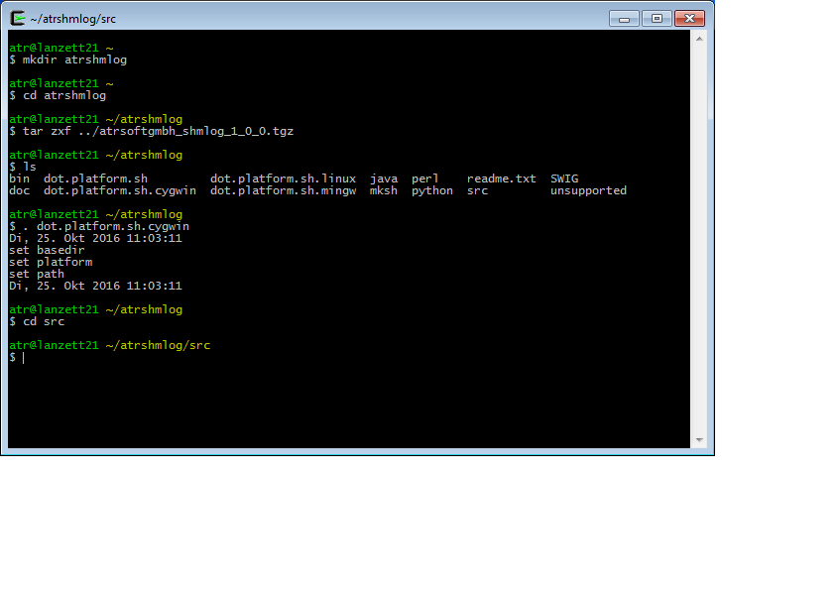
Illustration 82: The cygwin base directory after unpack
We start with source of the platform file. Its already there. Its name is
dot.platform.sh.cygwin
as you already could see in the picture.

Prepare headers – NO MORE ….

Next we prepare the headers. They are already adapted so we only have to copy them from the alreadythere directory.
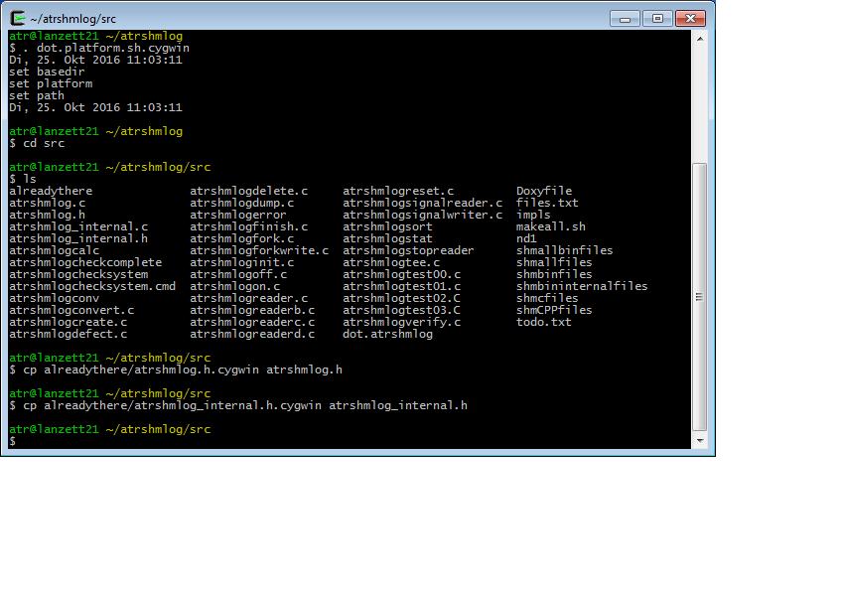
Illustration 83: Copy for the adapted headers.
Nothing dramatic so far. We start with the first compile.
FORGET THAT: now its done by the platform itself.

First compile

The makeall.sh in action:

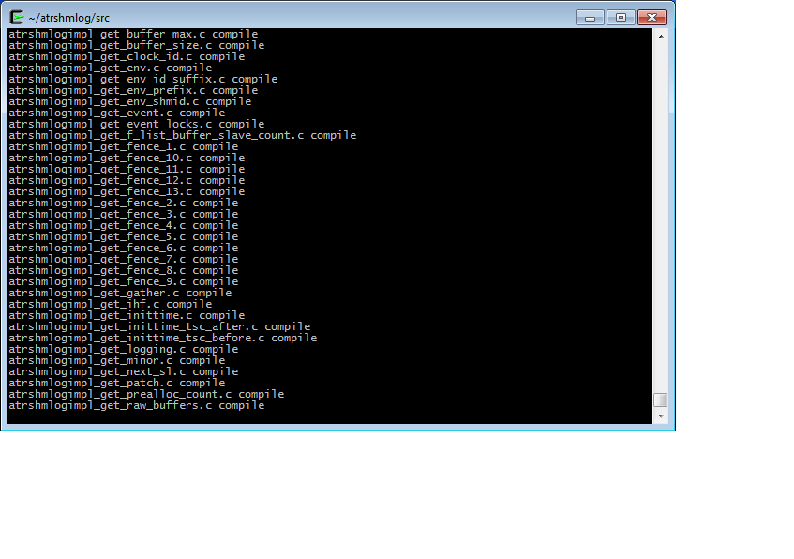
Illustration 84: Compile the module with makeall.sh
After a full 3.5 minute round we have the result (that was before the t_test.sh and tests ...).
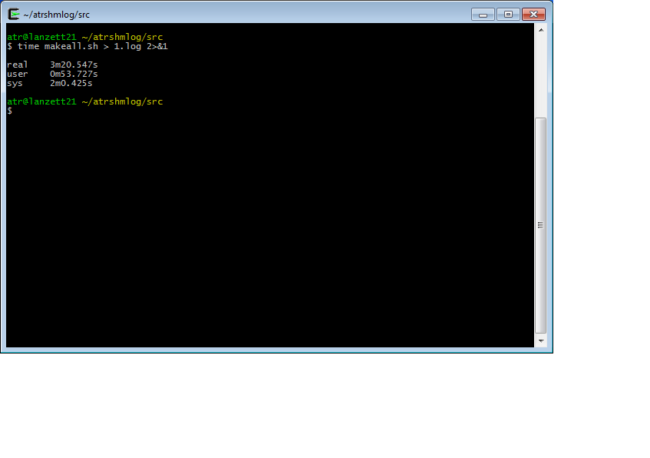
Illustration 85: Time for a compile in cygwin on my box

The cygserver start
Next we need the cygserver to run. So we have to use an administrative shell this time:

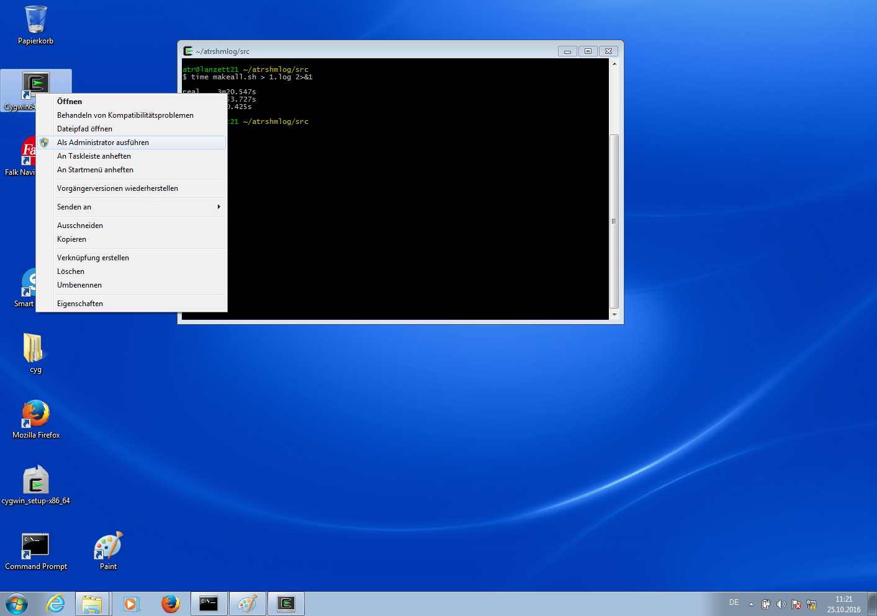
Illustration 86: Getting an administrator's shell
Open it with the right button context menu as administrative application.

OK. We can now start the server . Its mandatory for the use of the module. No ipc operations work without it.

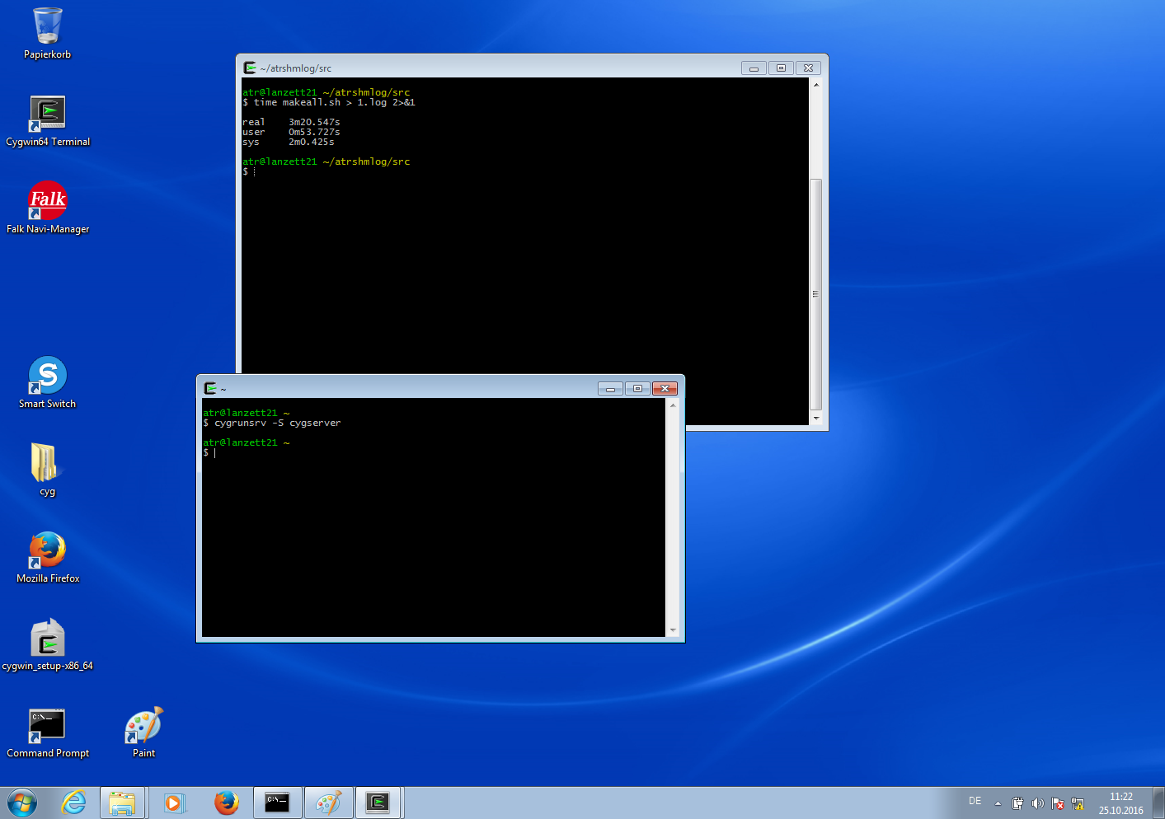
Illustration 87: Starting the cygrunsrv for the service cygserver
Up and running.

Create of a buffer
Now we can create the buffer as usual.
$ atrshmlogcreate 4711 8
does the job.
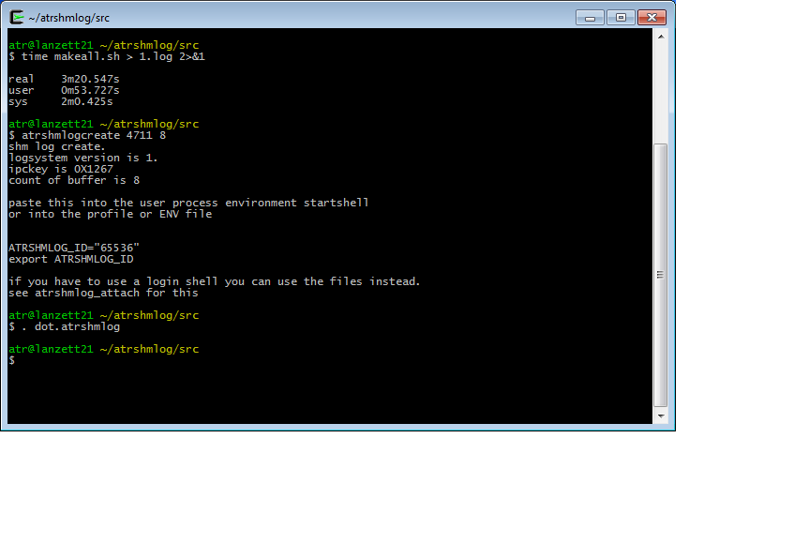
Illustration 88: Create the shared memory buffer
We can set the environment with the dot file.

Making the area with init

Now we init as before:

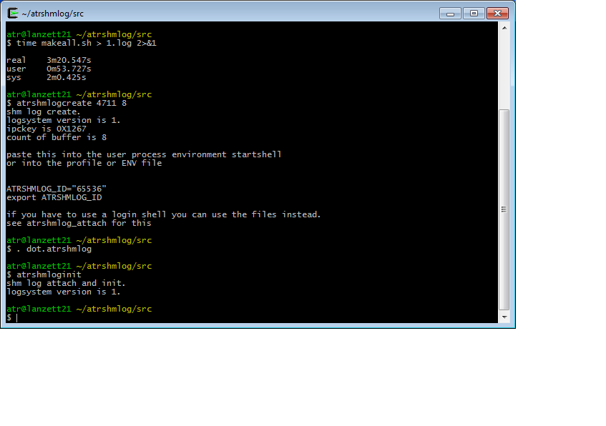
Illustration 89: And initialize the area
Its the same. We use the count already set by the dot file here.

First test with atrshmlogtest00

And here we go for the first test.

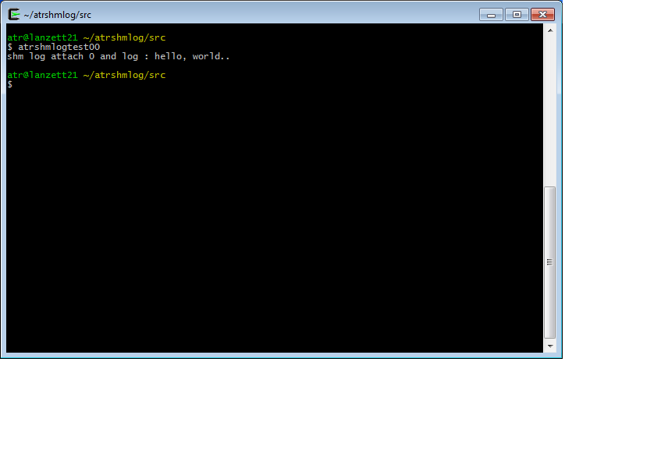
Illustration 90: Running the first test
So far, so good. Now we have to do the transfer into file system.

Reader for transfer

That's when the readerd comes in again.

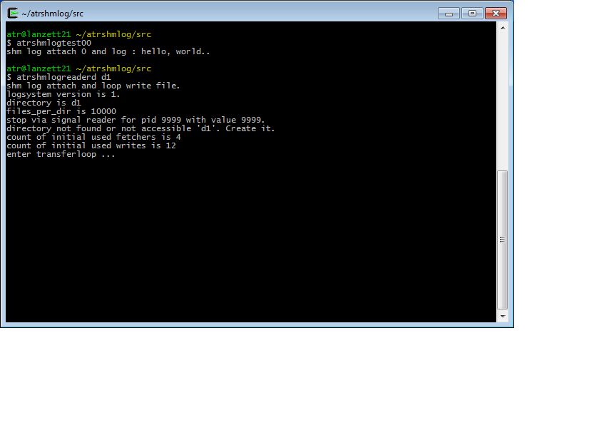
Illustration 91: Starting the reader to transfer the log
So we stop it after the connect is done and the transfer happened.

The second shell with the atrshmlogstopreader.
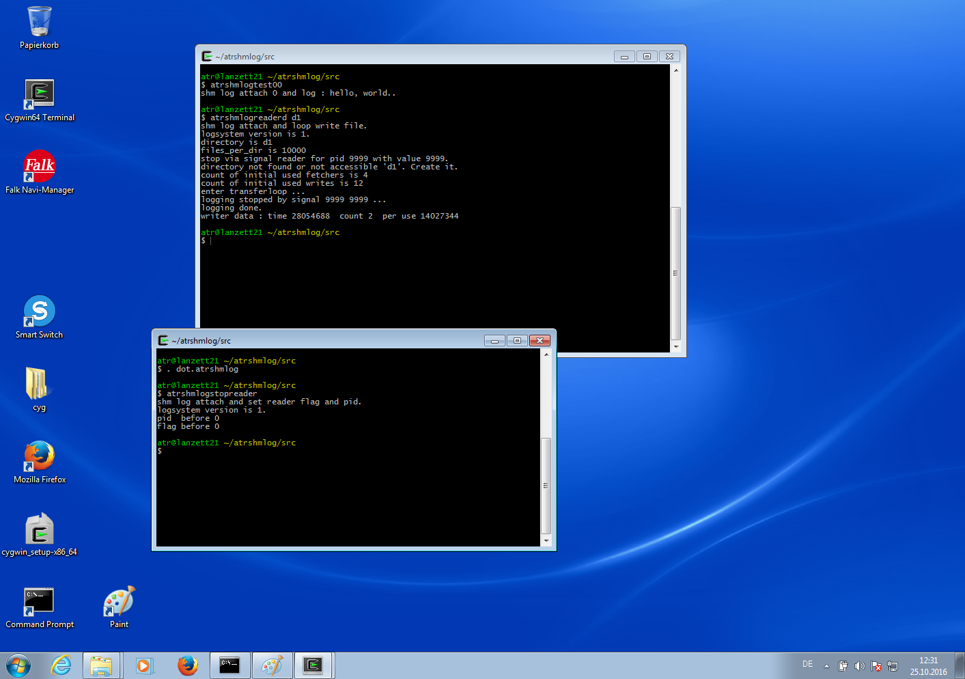
Illustration 92: Stopping the reader after its done.

OK. It stopped. Now we convert the log.

Conversion of the binary to human readable form

The convert with atrshmlogconv
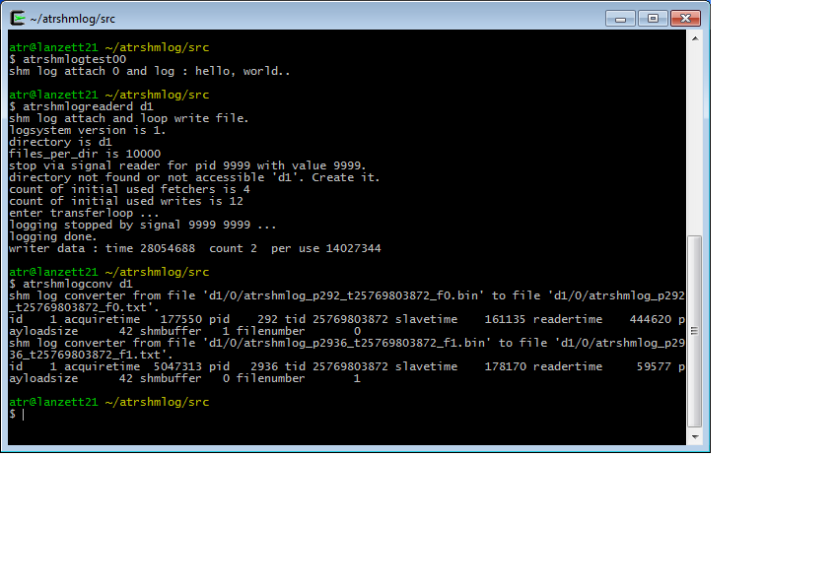
Illustration 93: Convert from binary to human readable text

So we have now the conversion done. Last thing is to check the resulting file .

Check the file ….

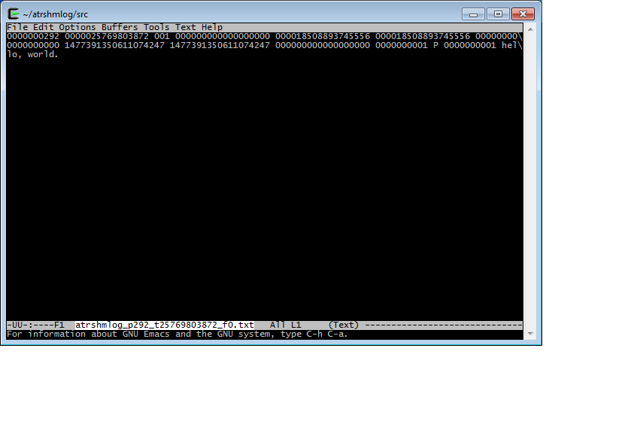
Illustration 94: The result log
OK. We have done it for cygwin, too.

Another platform : mingw

For the use of the module we don't need a C11 compiler – simply linking the library is enough. For example we can then use it for ANSI C or even worse thing.
So we can build it with the mingw cross compiler that is part of the cygwin system and use it in the C programs for the fenster;plural platform.
This has a big advantage – we don't have to adapt the scripts to another platform. We can simply use them as in posix or cygwin environment builds. Only the compiler and linker stuff is different. And so there is already a platform dot file for this.
One warning: If you have build a cygwin version you should NOT build in the same place the mingw version. Take another directory and start there. In this example I had killed the cygwin port and started for an empty directory from ground. So don't mix them.
The rest is still the 1.0.0 version – so much for my love for mingw. You simply have to use the cygwin dot file and no copy of headers any more. The rest is simply the same (ok, there is the tests now, but I hope you can figure that out by yourself).

Here is the basedir

Illustration 95: The mingw base directory in a cygwin system and setting the environment
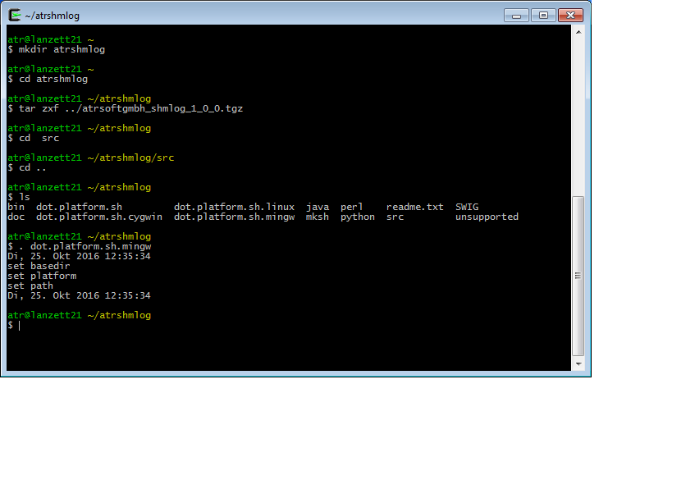
The setting of the environment variables done with
dot.platform.sh.mingw
as source file.

Copy the headers – NO MORE ...

We copy the already adapted headers from the alreadythere directory.
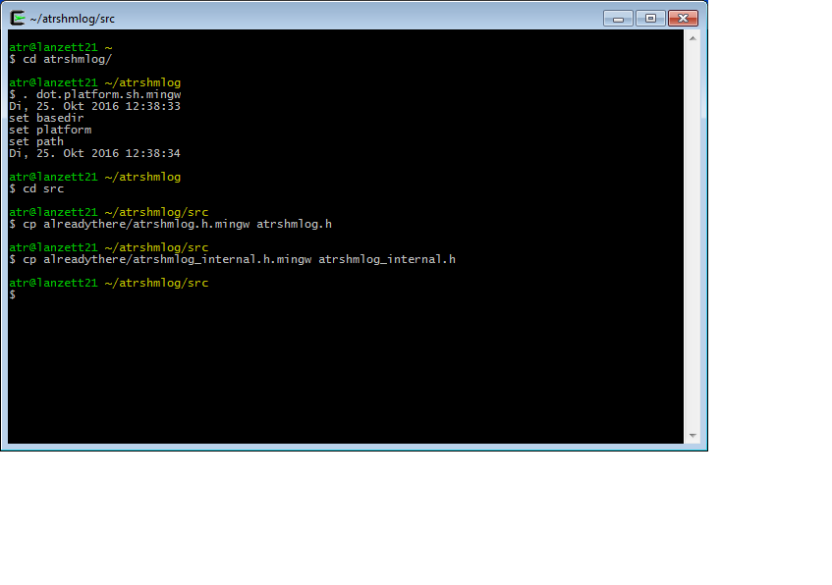
Illustration 96: Copy of the already adapted headers
OK. So we are ready for the makeall.sh now.
THATS NO LONGER NEEDED. We do this with the platform now.

Compile with makeall.sh

Nothing special. Simply as always the makeall.sh.
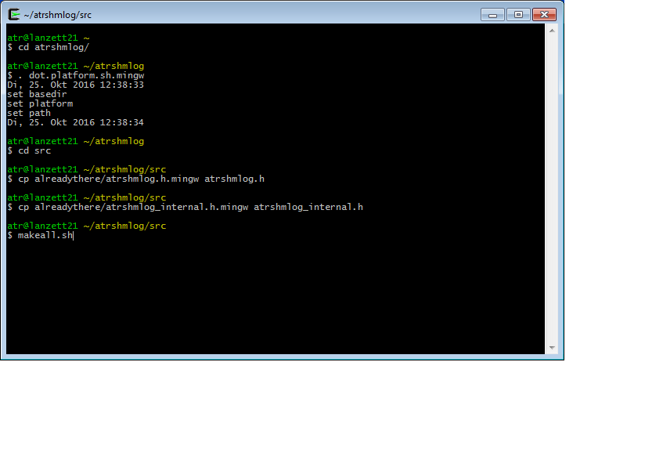
Illustration 97: Starting the build with makeall.sh
And this time after 9 minutes…. ( that was before we added the tests and t_test.sh ...)

End of compile

We crash land for the last program, its the C++ compiler problem with threads via pthread – we didn't turn that on because we use win threads. If you check the output all is normal till you hit the atrshmlogtest03.C.
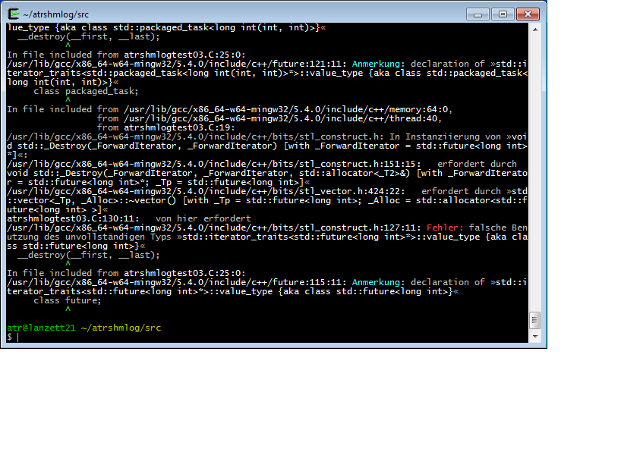
Illustration 98: A crash landing for test03 ....
There is a patched shmCPPfiles list file in case you don't like a crash landing at the end. You can copy it together with the includes and no 03 program will be build then .
Sad, but not a real problem. The rest is done. So we can start with testing.

Path handling for vanilla cmd

We use the programs directly from a fresh vanilla cmd – no shell this time. If you insist you can do this on another box where no cygwin is installed ( not quite right – you will still need the compiler stub dll for mingw, but that's a small price to pay).
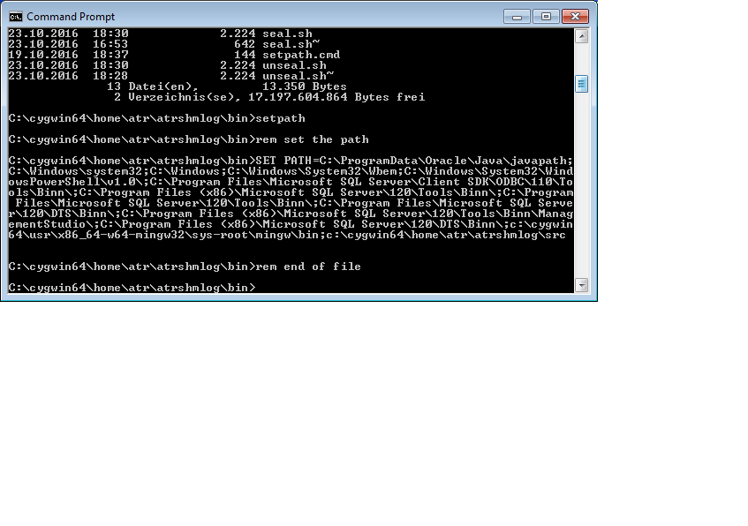
Illustration 99: Setting the path for a cmd
OK. Setting a path is after all not so dramatic. Simply check for your installation if the path is not the same. Now its time to start something.

Creating the buffer

We create the buffer as always with atrshmlogcreate. But this time its different for the parameters. We need here an internal info. The shared memory approach of fenster;plural is the same as a memory mapped file. So we need a file name for the thing and in theory a real file in the file system.
To make things more difficult there are so called Global and Local files. The Global files can be used from anybody, the Local only from sessions for the same User.
So if you try to understand the cygwin thing – bingo. A global file approach to cover the shared memory.
So I implemented 16 Local and Global file names in the module, and you get them via index. To make the 0 not a problem its indexed from 1 to 32. And the attach then uses that index via parameter - and if you are lucky you simply get the parameter back for the user programs.
So our first parameter is 1. The second is still the number of buffers. I use the 8 again.

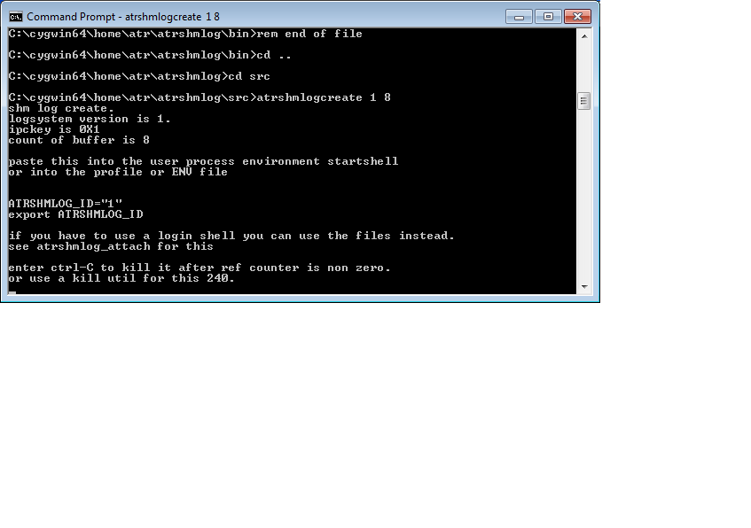
Illustration 100: Create of a shared mapped memory via pagefile.sys
Create done, but….
…. the program hangs. It will not end. And that has to do with the fact that we didn't used any real file here. So the mapping was done in fact for part of the page file. That's a bid wired, but it works for me, so I didn't made the other thing.
OK. So why it hangs ?
Well. The mapping for the page file is as all mappings done with reference counting. So if there is no process holding a reference – the kernel will simply delete the mapping and set free the memory.
So if we don't hang – we would likely end and the mapped memory freed before we had a chance to connect with other programs.
Bingo. That's why the cygwin uses a service for the cygrunsrv – its a permanent running program in the background, so it can map and then still hold the mapped file till someone is interested in it.
So in the end – without a backup file in the file system its simply the easiest thing to let the program not die after the create till at least another one has connected.

The init of the area

We now can use another cmd and init then the area as usual. We use the dot file – this time atrshmlog.cmd – to set the variables for the thing.

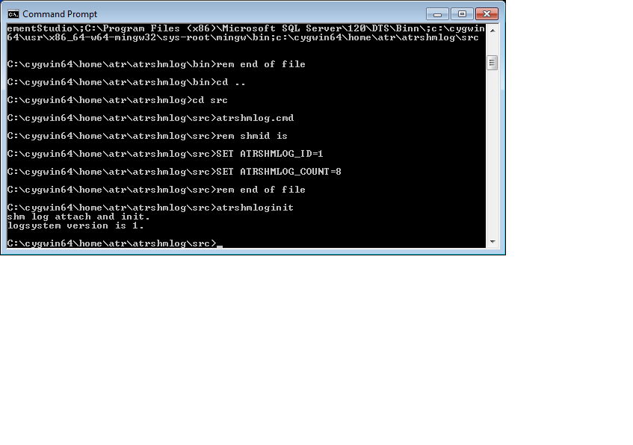
Illustration 101: Initialize or the area from a cmd
OK. This is more or less the usual now. Important is that we NOT kill our create process in this version of the game before we run the other programs.

First test with atrshmlogtest00

Its time now for our first logging test.
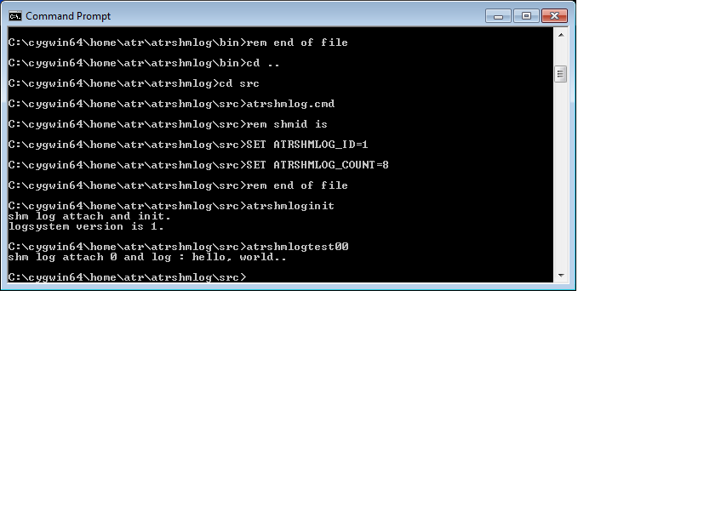
Illustration 102: Running a first test from a cmd
OK. This went as always, the program did at least tell us that. So we get the memory next.

Starting the reader for memory fetching

We prepare a new cmd and start the reader.

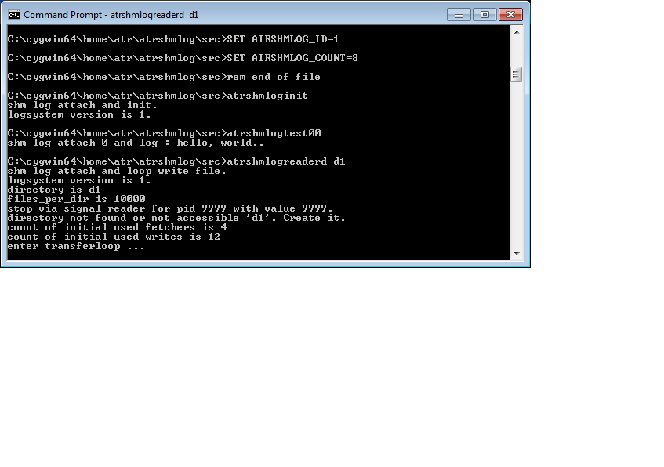
Illustration 103: Running the reader from a cmd
OK. Nothing dramatic different so far. In theory we could now get rid of the create – the reader is connected – but to make things not to complicated we leave the create where it is.

For the data we have now to stop the reader and then check for the file.

Stopping the reader with atrshmlogsignalreader.

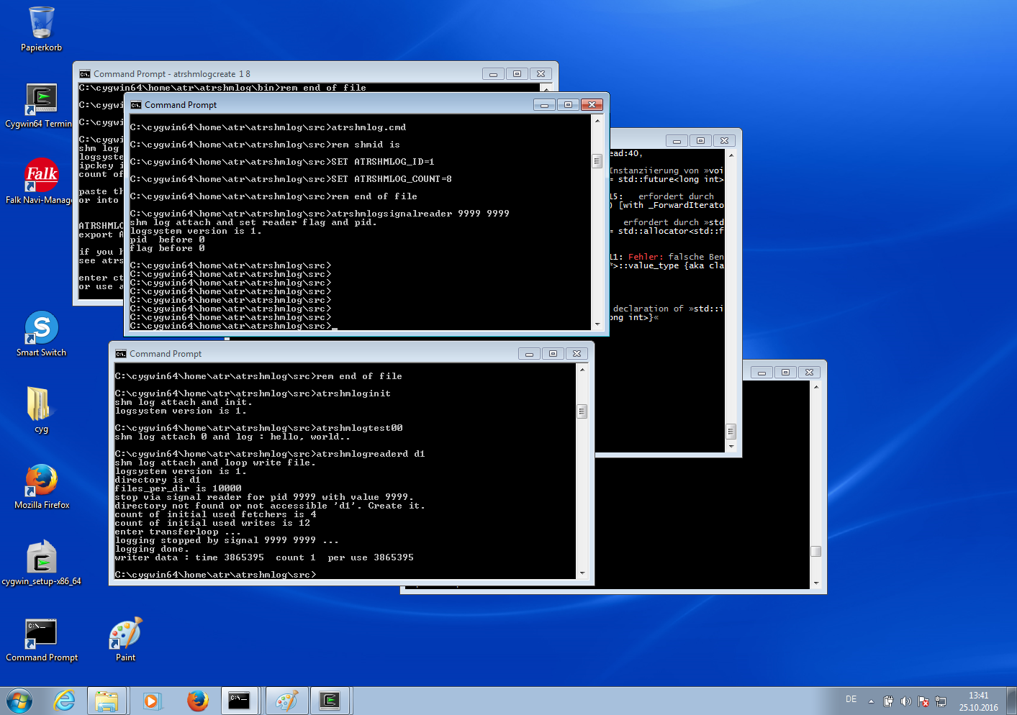
Illustration 104: Using signal reader to stop the reader - from a cmd
This worked. But I don't have made a cmd for it, so we had to use the raw signal reader instead of the atrshmlogstopreader script as it is for the other platform.
Try to adapt it and see for yourself how its done.

Conversion of the binary into human readable text

Again I don't have a cmd in place, so we have to use a raw program call here.

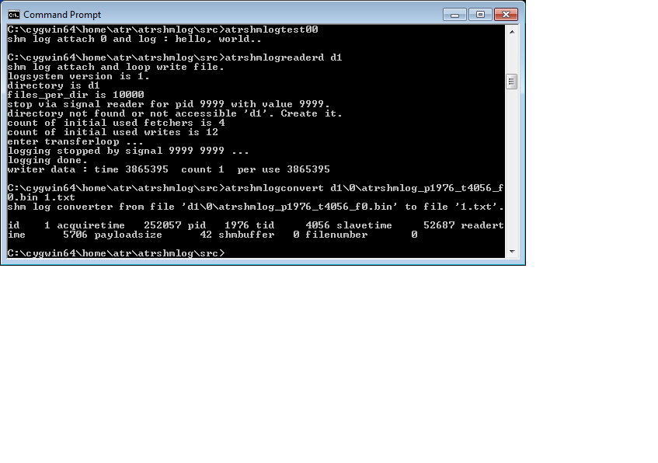
Illustration 105: Using the convert from a cmd to get human readable text
This time its in the directory src and its name is 1.txt. We check now.
Check with my favorite text editor. You can use of course yours if you want.

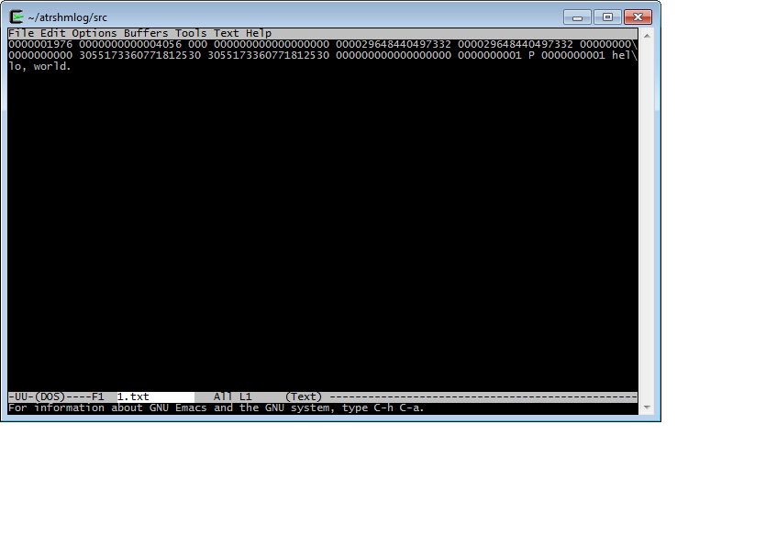
Illustration 106: The result log

OK. We could make the mingw platform so far. Now its time to add something vital.
The java layer.
This was also made with the cygwin, but the system didn't made it after starting the jvm for execution. It hang endless. So don't try the jni bridge with cygwin, its no use. Switch to mingw for that.

The jni layer for mingw

As with the other systems, you do this step by step as for the Linux. Change to the BASEDIR/java and get the library and headers in place with the getfrommain.sh.
Next go to the right vendor and jdk version, enter the src, source the dot.java.sh and then build it with the create_jni_lib.sh.
This is done on cygwin environment, but its for the mingw version, don't forget that !
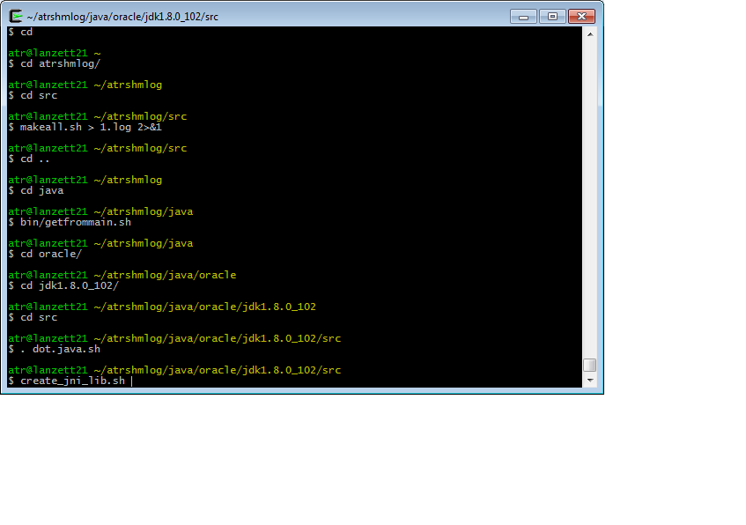
Illustration 107: Generation of the jni bridge with mingw for vanilla java
OK. We have the oracle and jdk1.8.0_102 in place now. So the build begins.

Building the class files, then the header and at last the new jni bridge dll.

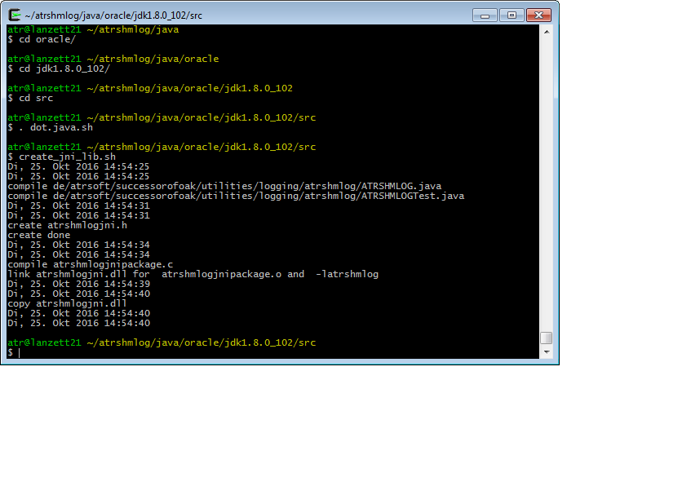
Illustration 108: Build of the jni bridge for mingw

OK. We have no abnormality here. Simply as the rest. Its only 15 seconds this time.
And you can see we have the atrshmlogjni.dll this time in the resulting copy.

Testing the jni bridge for mingw

So now its time for a cmd with both path settings, one for the mingw bin path and one for the load library. We have this in the start script, its this time a cmd.
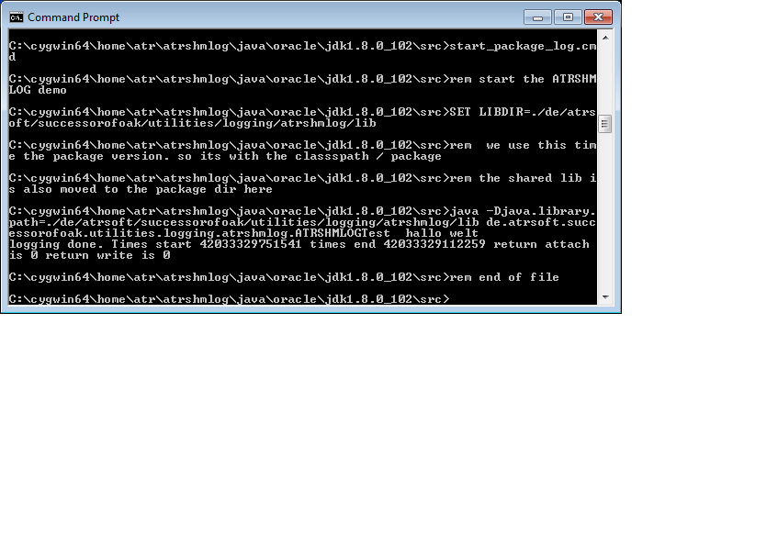
Illustration 109: Test of the jni bridge with vanilla java and cmd
OK. Seems it worked after all. No special things here.

As always, we check the converted result file. I leave the reader and convert stuff this time to the reader ( gag ! ) .

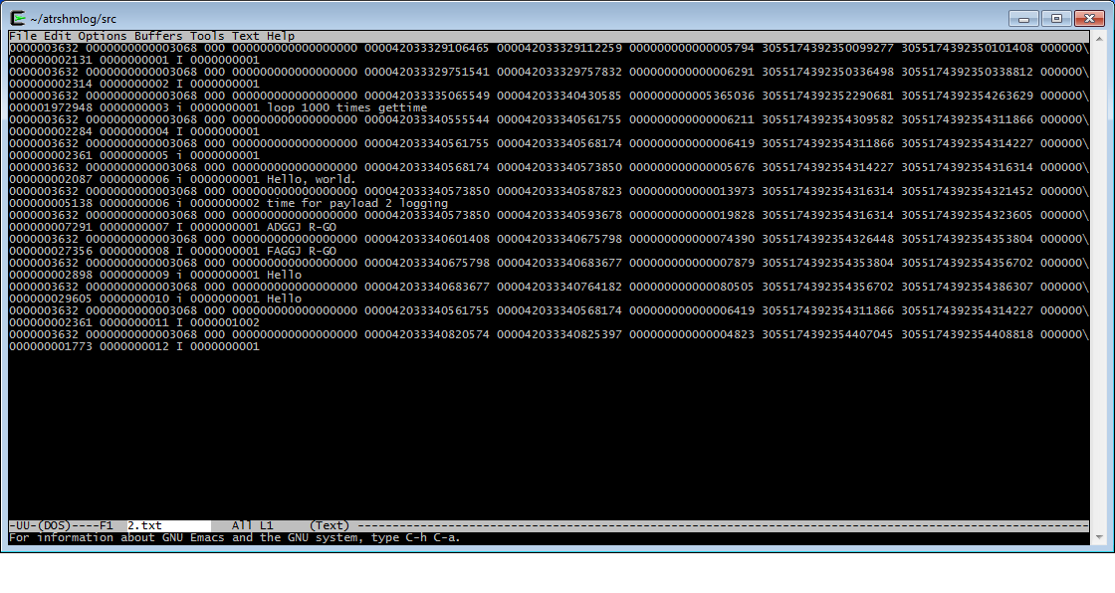
Illustration 110: The resulting log
OK. We have a logging jni implementation for mingw, and there is only the stuff in mingw bin that we need beside the created dll so far. I can live with that. If you need it different please contact me and I will see what I can do for you. But for now that's the thing I have for you.

What are those numbers for ? Adjustment process ?

The vanilla module should do the job at least if you are in a simple program scenario. If you have higher needs for performance, or you are simply in a high amount of threads or programs situation the things have to be adjusted to that.
This is called the adjustment process.
So here we try to find out if we can do make things better in this case.
First we see how to find out if there are any needs. Then we check for our options.

Now we need to know how fast it is

The module itself is a simple logging approach when it comes to measure the speed. Simply put an gettime in place, and then print out the clicks. Better the difference.
This way I found that the static (!) allocated memory buffers for the log were slow on fenster;plural if they were not accessed before – a simple log made 3000 to 5000 clicks. When I was inside the first memcopy got it and the second came with 10 clicks …
So what can we get ?
First of all you have some numbers when you get the timings right from the atrshmlogdefect.
You can see the time for 100 gettime calls. Raw made with 100 copied macro calls.
Next you get 100 low level logs with a small payload.
Last the argv write 2, but that is a different story.
So you have a rough first time for the gettime and log. And its in the region of 40 click on my box for the gettime ( If you check the code you will see that a simple C function takes rough here 20 operations itself for the stack thing, the prefix coed and the return suffix code. So its more 10 to 20 click for the time itself. Could make it inline directly in the writes one day …)
For the log a time of rough 100 clicks is OK.
The real cost come in for the transfers of the buffer. The problem is memcopy.
You can see the numbers when you convert a buffer.
Here for the sake of a proper discussion a run:

$ atrshmlogtest03 1 2048000 16
shm log check for c++ code and threads
start of threads.
dispatcher has count 1 and looptime 2048000
packages made
0 198423611
threads delivered futures 198423611 198423611
main 198467333
0.99978 1.00022
end of test.
I spare us for now snapshots.
Well, for starters.
The thing made 2048000 times a loop that makes a gettime, a loop of 16 times int++ for a volatile operations – the compiler could else evtl do something against it – and then the next gettime and the log.
Then the next iteration.
And it took 0,198 seconds (that's the German way, the , instead of a . …)
2 million logs in less than a blink of an eye, and still traffic on the process…

The reader did its job.

$ atrshmlogreaderd d1
shm log attach and loop write file.
logsystem version is 1.
directory is d1
files_per_dir is 10000
stop via signal reader for pid 9999 with value 9999.
directory not found or not accessible 'd1'. Create it.
count of initial used fetchers is 8
count of initial used writes is 24
enter transfer loop ...
logging stopped by signal 9999 9999 ...
logging done.
writer data : time 464597670 count 314 per use 1479610
That's a ssd below. An Intel 320 so we have good times for the 9 year old box with its sata II interface.
We have a time of 1479610 clicks per write. So if we have the transfer times for the buffers we can start some simple calculations.

The convert gives us the times:
shm log converter from file 'd1/0/atrshmlog_p25812_t25823_f0.bin' to file 'd1/0/atrshmlog_p25812_t25823_f0.t
xt'.
id 3 acquiretime 780 pid 25812 tid 25823 slavetime 2308860 readertime 1087060 payloadsize 5
24280 shmbuffer 0 filenumber 0
shm log converter from file 'd1/0/atrshmlog_p25812_t25823_f1.bin' to file 'd1/0/atrshmlog_p25812_t25823_f1.t
xt'.
id 4 acquiretime 300 pid 25812 tid 25823 slavetime 472620 readertime 780540 payloadsize 5
24280 shmbuffer 0 filenumber 1
shm log converter from file 'd1/0/atrshmlog_p25812_t25823_f2.bin' to file 'd1/0/atrshmlog_p25812_t25823_f2.t
xt'.
OK. Now we have some numbers.
First we get the acquiretime.
780 clicks. Well that's a slow one for static buffers. Next is 300, more in the right direction.
For an dynamic you can easy get a 50000 …
For the slavetime we get an awful 2308860 here. Bad. The next is 472620 , and this is still far from the 200000 I get when its right. So much for same thing same time. You are far from it. You are in the land of memcopy on real machines for half a MB buffers.
Next is the reader for its transfer – should be the same right ? Same thing and that stuff…
For the first its half the time (HM, better) but for the second its twice the time. OK, that's for our first two here… later we get better times, but still the reader has a problem. So we have to ask if its for having too many threads – after all the test03 did it only with one thread.
The payload size shows we use full buffers here. So we have to check for small transfer times if it it simply a empty one.
The shmbuffer is the index in the area. This helps to detect if we have concurrent use of them – numbers are changing – or only use one – numbers are the same for buffers.
Last is the file number, its also in the name but I have it separate.
Now let's see if we can make it better. We reduce the number of threads in the system.

$ export ATRSHMLOG_FETCH_COUNT=1
$ export ATRSHMLOG_WRITE_COUNT=2
$ atrshmlogreaderd d1
shm log attach and loop write file.
logsystem version is 1.
directory is d1
files_per_dir is 10000
stop via signal reader for pid 9999 with value 9999.
directory not found or not accessible 'd1'. Create it.
count of initial used fetchers is 1
count of initial used writes is 2
enter transferloop ...
logging stopped by signal 9999 9999 ...
logging done.
writer data : time 537103360 count 314 per use 1710520
So we got it this time with one fetcher and two writers – the write time is comparable.
Now the convert gives us
id 4 acquiretime 180 pid 27804 tid 27815 slavetime 168160 readertime 227460 payloadsize 5
24280 shmbuffer 0 filenumber 19
shm log converter from file 'd1/0/atrshmlog_p27804_t27815_f20.bin' to file 'd1/0/atrshmlog_p27804_t27815_f20
.txt'.
id 3 acquiretime 630 pid 27804 tid 27815 slavetime 159190 readertime 229290 payloadsize 5
24280 shmbuffer 0 filenumber 20
To be honest, it takes some buffers to come there, but now we are in the same league for the two.
So much for using too many threads.
On a box with only two real CPU cores its difficult to make such things. On a big one you can see that the mt thing is needed when you get a high load. That's right for the slaves and the reader. But for a two or four core box you can start with a one. That does the job.
If you have a permanent log and you need rough 200000 click per transfer the total time is 400000 click in the area. For the 16 buffers I use here that mean we can get through in 400000 click 16 buffers – a least in theory.
This would mean I have to write down in 2000000 clicks – that's the average for the reader to make it for one buffer to write down – we have 5 times 16 buffers – that would be a need for 80 writers – and they would have to do it nearly without interference for it or my reader would explode in some seconds – even if I have 1024 buffers in place – there were 314 in just 0,198 secs …
So much for the guys who want to log on a box with let's say 512 MB ram …. You are finished in just barely one second. BUMM.
Back to reality.
If you do the usual program logging it will be more than OK to have a simple setup.
If you have a real high log load – lets say an 20 GB application server with round about a thousand threads – that's different.
There is first the need for more buffers. Hopefully the thing makes good use of the turn off and stop for threads. Or if it is one of the start many threads in a short time then kill them things – you get it. You are out of memory for the thing in no time. And your box too.
For the reader its more a question to make it through the first seconds. If you have a reasonable fast file system you can expect an average write in about 1500000 clicks. That's about 0,5 milliseconds.
If you create an amount of buffers for let's say the load of the test03 in the first second it would mean to catch 1500 buffers in this second only. So you will likely need to raise the number of pre allocated buffers. There is an ALLOC ADVANCE thing in the reader for it. Give it a 5 – wups, that's alone 2.5 GB for the record – and make it real ram (it uses 1000 times the number of buffers ...). Using the swap space or page file is out of the question here.
So this is the way we can use it out of the box.

Now we know how fast it is – can we make it faster ?
So you have it up and running and you have problems still to come up. Or your program is crawling.
If you have control for your application and the module there are some options.
Before you start to do anything else you first have to find out what are your needs.
To do that a small statistic run can do the job. See below for the details.
After you have the statistics you can add info that is not known to the module for now.
How many threads do log at a time ?
Answer: NumberA.
How many threads do I start ?
Answer: NumberB.
How many of them need log buffers ?
Answer : NumberC.
How many buffers do I get back after the threads finish ?
Answer: NumberD.
With that info you can start.

A low throughput scenario
We start with a simple thing.
We have only partly logging. And its only a low traffic in the system.
When we check our program we see there is a small NumberA, perhaps only one . The mksh example is such a thing. The test00 to test02 are those things, also the defect.
So you have a low number of threads. And your NumberB is practical 0 – no additional threads.
You do logging for the thread, so the Number C is equal to Number A.
For the last number its none , zero, 0 . You simply end the program, the buffers are moved to the area by the cleanup. You do NOT give the buffers up after logging. Perhaps I should change that.
In this scenario we have no concern about the number of buffers in the active system. We start with the statics and we likely never need more than the buffers for one thread. This is 2 in the default. So we have 1 MB buffer memory in place for them. The rest is 31 MB and simply dead memory.
We do log, and we have for some of the programs that the run time is limited. So is the amount of log.
For the one program that does run in principle an undetermined time – the mksh – we have to accept the log can be undetermined too. For the others its limited to the amount of some entry's – best is about some hundred – and they are small.
This is a lot info, and we even have not started a statistical run.
So when we now try to make it better we have found that there are an bunch of programs that can live with the two log buffers completely.
OK. So we switch the slave off for them by setting the slave count to 0.
Next we can reduce the static allocated buffers. Set the define to 4 ,one reserve cannot hurt here , and change the static buffer initialization part.
This reduce start up time. And makes the memory footprint smaller. Less memory always ends up in faster, so we do it.
After this we have to start and run the thing with a reader – for now its reader d.
We know there is a bunch of threads to fetch buffers. But only a count of one or eventually two come in – so one thread would be enough. And a 0 is possible here . The reader make a final cleanup in the area, so if you insist you can wait till the program is done and then simply get the data from the area that's there in one final run.
Best is to simply do the program thing, and start the reader later. So there is no competition for the CPU and no lock contention in the area at all. We use the area as a buffer then the time we are not up with the reader.
Your program speed is now maximized. You get the log and this is done after the program has ended.
Not what you expected, but its for real. Try not to slow down a one shoot thing by making infinite loops in your mind.
Next is the mksh. Here we have an unlimited running.

A scenario for a long term running low throughput program
You have a long term runner.
Meaning you don't know how long it will take. But its a low through put one. Say less than a buffer per second.
OK. We reduce again for the process the footprint by reducing the static buffers. We then try to make it with one slave – that's the default. So we simply not set that in the environment.
We reduce the thread CPU load. Its save to slow it down in the loop in the wait part. Put 1000000 in there. Its a run of the slave every milli. Perhaps even more.
So do that what will disturb the client as less as possible.
For the reader we have one fetcher. And we have one writer. That should do the job.

A scenario with low throughput and multiple threads
This time the program starts threads.
Its still only a low throughput. So we have again only one slave. The adjustment of the static buffers cannot be done if you don't know the maximum thread number. So we leave this first. We have a reader with one fetcher and one writer.
Now comes the new part compared with the former scenario. The threads are started and stopped. So for logging threads its vital to make at the end an stop or you use the turn off.
If you don't do that you have a memory leak. And its a big one. One MB in default.
So your process should give up the logging in threads as soon as possible. And it should try to be sure of the stop or turn off for the threads. After the thread has been stopped its too late. No more access for the threads local possible, so no more cleanup for now.

A scenario with high throughput and small number of threads
This is a case for checking you have still enough buffers static. A statistic run should show no use of the buffer allocation with dynamic memory. Or you check the id numbers – if they exceed the number of static buffers its sure you have dynamic once in place. If you can do that adjust the static buffer to cover your maximum.
Next is to check if you encounter many buffer waits.
This indicates you have a transfer problem. Check how many slaves are running. This should be a reasonable number – about one slave for 16 threads is a good start if your threads log much.
You have to check how many buffers will be at the same time in the area.
If you have the numbers from the converter you can see the numbers of the used buffer in shared memory. This is changing if you need more than one buffer at a time. If its not changing from transfer to transfer you stay put. Not changing means that more or less one slave thread works at a time, so you can reduce them and spare CPU time.
If you have more than one buffer in the area at the same time its time to raise the number of fetcher in the reader. Start with two.
Same goes then for the writers. The ratio of time for a transfer to shared memory plus time for a transfer into reader to average write for a buffer to the file system comes in.
You need enough writers to come up with the number of buffers your fetchers put in. Or you get a bloating reader that can slow down and then your area is simply full – slaves encounter a wait till the transfer can be done. Because the reader has a 1024 buffer queue for buffers this can be undetected if you only do some logging, you need at least about some thousand till a shortage is here a problem.
So you have a complete transport chain now and you must honor that.
Still most vital is the thread cleanup. You need to maintain a stable number of buffers. This is the most important thing to do.

A scenario with very high throughput
You have high speed and high logging threads.
So you can get a throughput of number of area buffers in a time that is the sum of the time for copy to area and time to copy to reader.
This is the theoretical max. No way to do it faster. So you raise the number of buffers, but this will also raise the amount of memory used. And this is indeed a factor for the system speed – you have more memory than the second level caches of the CPU will cover, and likely more the third level cache support – so you slow down to conventional memory speed.
If you try to start more slaves be prepared it can only cost more CPU for you – they simply wait. So the max should be half the number of buffers in the area. Same for the fetchers. If the time is comparable to the time for the slaves use also half the number of buffers in the area – that's the default for the reader anyway.
For the writers you need to make the same number of buffers you get in from the area now to the file system. Take the average time for the write and you can calculate how many writes you have to make parallel. And check this before you start – some file systems simply do not like parallel. And some hardware don't like it too.
When you test realize that you do most things in the first time in memory – buffers for the file system are cached and even disks have their caches and he reader has at least 1024 buffers in place..
So you have to test at least for some time to be sure – a minute in high load should do the job, so in the second and third it should become realistic.
Raise the number of static buffers if you need it.
Now the statistics come in. Use them for at least some test runs – you will need that info.
If you encounter still high counts of buffer full waits – switch the most important for speed to the discard strategy – its better to have a thread doing its job than waiting for logging in that scenario.

Statistics

So you have it done but still not sure its right for the adjustments.
OK. We have some kind of statistics. The so called counters.
The thing is in now. The most is in the process done by atomics. For the stuff that would slow down the writes is in thread local. We can get them from a buffer with the converter. Add a third argument as filename. The number of the highest sequence is also now in on the output and filename. You get the best statistic from the one with the highest sequence.
What can we get ?
First of all we get simple counter numbers. No timings. So you have to accept there is no log of the log itself.
For the numbers most of them have to do with simple setting something – so you can check if you made that. There is no count for the getter things.
Can be quite interesting if you are in a big system, have multiple developers and somewhere someone decided to to a thing that kills you. And if you have not access to every bit of source – you get it. See the statistics for a test run and see if you were hit by someone.
For example a set strategy process. You simply use the default – its wait – and someone switches over to discard. That's it for you – you loose your log in a buffer full scenario.
See counter 75 and 76 ….
Other things are the counts of errors.
If you use the simple way of life you do most things with the log without checking return codes. That's OK for me. If you made it right it works and you don't have to check for every thing.
But from time to time you must be sure to be on the road, so you make a statistic run. See counters 25 or 26 for an example. If you encounter such things you can start to check for it. If you don't check return codes you simply don't know till the statistics show it. OR see the safeguard corrupted thing.
Have in mind that a log call can be faster than the java thing to make an enum from a return code – so checking codes can be more expensive than do logging here. So statistics it is.
And then there are the real things – log discard, waits and these things.
If you are in a high load scenario you have to know if your configuration is good. So you need those numbers.
The problem for now is to get them out. You need to call the get for it.
To analyze them I have a little helper. The script atrshmlogstat. You need the numbers in a special format to use it. See the test03 for this kind of stuff.
And check the appendix for the thing. Its the best info I have for you for now.

When I change it, what then ?
After you have changed the module and it fits you have a simple question to answer – is that enough for me in the future too ?
It can be that you never plan to update it, so then your answer is yes. No changes needed any more.
But if you have to live with updates – then this is at least a possibility you must take care of.

The Adjustment
We have the module in the vanilla version doing its job good. But if you need some different behavior it can be you have to do more than simply use the environment settings.
So we have to discuss here if you have to change the code.

Changes in the first place in atrshmlog.h
You can get some things here.
Use of a different platform with special needs for example. You add the define, then switch the others off.
You duplicate the codes and then set them different.
For example you use a clang on Linux, not the gcc.
So you have to adjust the inline stuff and the assembler. Most likely this is not the same.
Other things can be the use f a different threading. Switch from a posix pthread to a platform thing.
Plenty of things can be done in atrshmlog.h then.
There is:
- use of inline code
- the used thread model
- the use of get syscall if available
- the used real time clock time
- the nanosleep
- use of the tid model
- default timing function for the gettime
- some typedef stuff to cover system stuff like times
- helper types for pid, tid and such things
- all macro code – you can put something under cover in there if you need it
That is all in for the interface. So it makes a new module – even if you don't change the layout of the area its eventually worth a new one.

Changes for internals
So you came on a thing I have not in for now.
Let's say you work on a critical one and need best performance. And you have a real big iron. If this is an option – set a bigger buffer size and you minimize the overhead.
OK. You are now in the internals, its this time atrshmlog_internal.h.
You can change here a lot – and sometimes its not only here but also in the source then.
For a bigger buffer there is a define – simply use it.
If you have the opposite – for example your multiple core thing only support 256 k as second level cache – reduce it.
Recompile and that's it.
You can do a lot of things here.
For starters:
- change the buffer size
- change the number of prealloced buffers
- change the shared memory access rights – if they are used
- change the default times for slaves and waits
- change the number of buffers in an dynamic allocate
- change the number of events
- change the name prefix and suffixes for the module
- change the ratio of clicktime and nanoseconds
- change the head size for the logging entry
- change the structs (oha. But don't forget to know what you do in the first place…)
- change the number of buffers for a thread

So you have this with only doing it here – with the exception of the head size and the count of static buffers. For them you will need the code changes too.

Changes for the code
You have needs that go beyond the define stuff in the headers.
Well, this can happen.
Let's say you want to have the thread statistics before I can do it.
So you change the buffers and the thread local to hold them.
Then you add code to use them in the impls files.
You change the reader to transfer them – after all you have round about 300 bytes in the header left – or use a special stat buffer.
You change the converter and then you get the statistics. Or make it to the area and have some new dumper tool …
You have to change the code.
And yes, you can. Its all open source and you are free to do it. Simply fire up your favorite text editor, and then make it to your own module.
I am not against doing that.
It start to turn out that the trouble is if it not works or – worse – partly don't work.
This is the thing you have to keep in mind : we live in the world of atomics, fences and memory model order.
For the rest its plain C code, so you should have no problems if you have done some development. After all I have made some documentation about it, so you can dive in and check for it with this help.
Also a post card for me is an option. Pack your distro – please no more than 15 MB as zipped file – and sent it to me. If you can do – drop the doc and mksh stuff...
So in doubt split the tar and sent me the thing in multiple mails.
What would be first target – beside the stuff that must be maintained if you change the defines ?
First candidate is a converter that fits your needs.
Second a reader that transports different things.
Next is code to make something happen in the module you need there – for example a dynamic start of threads by a writer signal (that's on my list, but its not top priority …).
You can change the code. Add new files in the impls.

Local changes for your own system

Now you have made the changes – what's next ?
First there is a good change you have done it only for your own. So you do not to plan to give them to others for now.
Then you should prepare for the unthinkable – you have to upgrade some time to a new version.
Can happen – and yes, if worse you have simply got that changed bastard of hacks from your former colleague and now are confronted with it .
What to do ?
On most platforms you have a system that can make patches. That's a thing of a diff and the patch program (see a Linux system for that).
You build a patch file – this is easy.
Then you test it – run against the version that has been altered. Then check its identical to the version you have now to support.
Next is to run the patch against the new one.
I had only one file for the implementation in the beginning. Now you have a crowded impls directory. For the path tool this is ideal – no lot of hungs and mismatches – simply one or two lines here and there …
By the way : if you do this with diff and patch – don't make your life harder than you need – don't try to change things you don't have to like
- comments
- simple variable names
- indentations
This is simply counterproductive here. Use the original source and change it – yes, but only what you need.
Don't start to duplicate by having a commented former line in. That's a bad thing. Use your version control thing instead.
You should also try to make clean line changes – replace one, delete one and add one for one thing. Combining things only hurts when you have to change them again.
And one thing last : don't forget to change the version number if you change the layout in the area and buffers. Mixing multiple versions on a box should always lead to a run time error in attach at best.

Patches
Did I say patches in the former ?
Now its time for patches from me.
I have to make versions of it.
Its clear that sometimes its not the layout affected, so its perhaps only a glitch or a minor change for some new stuff.
Then it comes to a patch version.
You can get the new version – OK, that's the best – or a patch if your build environment supports it.
With a patch you can go to the new version. And if you have made patches then chances are you don't interfere with the patch and you have simply the patch in without doing yours work again.
So patches will be there.
You will get a patch number – so you can see it in the code and if you have to check from the compiled module too.
Making patches can involve a minor number switch. Then you have new functionality, but still the old interface and binary layout.
For the rest its a patch to go from one version to the next.

Wouldn't it be nice to get this, too ?

OK. So you have the shiny new thing and think you will have to put in in the light so others can use it too.
Then its time to make a distro – please no files with more than 15 MB size – split if needed to different mails.
And sent this to me.
I will see what I can do.
If you have a patch that's fine with me. I use the Linux diff and patch tool, so you should sent this or I need your patch tool too.
I have a little catalog here. Please be prepared to make the answers in your proposal – I need it at least in the mail.
Does it
- work ?
- have an impact for other functions – eventually a slow down ?
- need permanent maintenance ?

Stuff like that. A simple list is sufficient. And a can even accept the maintenance thing if its GOOD.

The glory details
OK. You now have made the module, tested it, used it, made even the layers, made the adjustments and have everything in place for the use.
Now you have the luxury of some spare time and you want to know how it works. And you are for real this time.
So I try to give some info about the how it is done and the why it is done here.
We will first use the theory approach.
Then comes some more or less understandable explenation for the non C guys.
At last we dive into the C module and see the things for yourself.

Theory of the module
We use here an analogy. It is far from perfect, but you will understand the most after that.
Imagine a house with a balcony at the first floor.
At the garden there is a small pool of water.
Its for some party thing and there are people in the garden and in the house.
Somebody screams, then something crashes. Again screams.
“Fire ! Fire !”.
There are some buckets around, and the guys in the garden run to the pool – there is plenty of space around and some guys start to put buckets in the pool, fill them up and then put them at a side of them.
Others take the full buckets and run to the balcony.
In between the guys at the pool grab the next empty bucket and fill again.
If you understood this – welcome to the client part of the log.
We use so called alternate buffers for the log. They are the buckets in the analogy. You fill them up with the log info.
The bucket has a maximum size. So when it is full you need to wait for it to return empty. Or use another one. If you are out of buckets – well you can ignore it, or wait….
The guys at the pool are your threads. They all use their own buckets. No one uses a bucket together with another one. So most of the time you work in logging in the thread and without any interaction with others.
Now to the guys that transport the buckets to the balcony.
This is the so called slave thing. Its realized a bit different, but you can think of it in this way. A thing to simply transport the full buffer to the shared memory. In the analogy the bucket to the balcony and then to the guy that stands there and grabs it.
Now we switch to the balcony thing.
There are standing some guys inside of it. They grab the bucket from the guy who takes it to them. Then they turn around and put it on the floor of the balcony entry. There is just enough space to do it with one bucket for each ( well, give it a try and think of big buckets here…).
Inside the house the people have to grab the bucket from the place, then move it to the fire and then do the thing.
In between the guys at the balcony move bucket for bucket in.
That's the transfer into the area. There is a limited number of buffers you make. The same thing for guys that can work on the balcony. If the place is limited you can only put a realistic number on it or the thing will slow down itself.
So far we have the second part of the slave thing here. It transports the buffer into one of the area buffers.
To do this the area buffer must be free – imagine in the analogy that there is place for one bucket behind the guy on the balcony, so he simply cannot put multiple buckets in without first having to wait the place is free again.
In reality we can put the buffer at any place in the area as far as its empty.
Now comes the last thing. The buckets are transported inside the house. That's the thing we call the reader in the system – we transport the buffers there from the shared memory into the reader address space and then do what we have to do with them. So we clean the buffer in the area after the transport is done the first part of the way – we do not wait for it to reach its destination, its enough to have the space free for the next buffer.
The guys who transport the buckets in the house to the fire are a bit slower then the guys that simply take the buckets at the balcony entry – which is a small door or so - and then give it to the inside guys.
So in our system we have the fetchers who grab a full buffer in the area and transfer them in the process address space on a list. Then they free the area buffer for the next transfer by setting them back on the free list in the area.
OK, sometimes an analogy does not match exactly, but for now it works.
Last thing is the guy who took the bucket and runs to the fire and puts it down.
These are the writers in the reader. They take the next available buffer from the readers list of full buffers and writes it down to the file system.
Here is where our analogy ends – the buckets simply dematerialize and after that rematerialize at the pool. So much for a computers way to copy data.
What happens when the fire is stopped ?
Well, first of all all guys at the pool stop – but they put the half full buckets at least behind them.
Next is that the guys start to clean up the place. Somebody will put any bucket to a place where it is needed and then the rest of the water is used.
In our system that is the job of the cleanup. It checks for all buffers and puts the not cleaned up in the area at last in program end. So nothing is lost in a regular shutdown of the program.
On the balcony the last buckets are moved inside, then the guys there stop. So again the things are moved in.
For the transport in the house the things are then moved where they are needed. Again in the shutdown of the program there is a cleanup so any already fetched buffer is then written down to the file system. So nothing is lost here, too.
OK. That was for the basics. Nothing so far from C or Java or anything for a programmer.
Still we can get some insides from the analogy.
First of all – there is no unlimited in this game. We have to accept limits.
First we have the fact that a bucket cannot be too big – no one could handle it then.
Our buffers are limited. And its a hard size limit in the code. I choose a thing that works nice for a small number of threads to do things. It fits at least in the second level cache of modern CPU's and so its fast to be moved. Anything bigger and you have to test it out.
Next is the number of guys at the balcony – the space is limited. So is the number of buffers in the area. If you think of a slave as a transfer of buffer from the list of full buffers you simply see that it makes no sense to have more slaves than buffers in the area – they simply will start to wait to do the job if the load is high.
Next is the fact that we accept only one bucket for every guy on the balcony inside. So there is a limit too, and its the number of buffers in the area again. Having more fetchers to get buffers from the area is simply not useful, so this is again a simple thing we have to accept.
If you think of it – if they both need the same time for their thing, the place for a bucket is somehow used half the time from the balcony guy and half from the guy that fetches the bucket – so in practice already half the number of slaves and fetchers will cover a 100 % use of the area – any more and one of them starts to blockade others.
Because the operations are similar, there is in theory a one to one for the two. In reality it depends on the speed of the system as a whole and the additional write stuff for the readers what timings you get.
Another thing. Everybody has to take care not to do one of two things: working without respect for the other or waiting too long if there is the change to do the thing.
So we have to synchronize the work at any place that the guys have to share a common thing.
This is done by using some internal handshaking protocols based on flags and by using some small time wait functions that use reasonable times for waiting. So the buffers cannot be used concurrently and the fact that one is using a common thing results in a short time wait for the others involved.
OK. If we have enough guys to do the thing – we have the maximum throughput of water.
Fill the bucket, transfer it to the balcony, put it through and in the end transfer its in the same time from the balcony inside the house. Of course the things in the house have to come up or we simply transport much more buckets than can be used in that time.
So in our system we have also to respect the time we need for the write down of the buffer into the file system. And we have to use as many writers as needed to come up with the fetchers and slaves.
That's for now with the programmer independent stuff. Now we get into more technical things.

The way to log in shared memory – or how to circumvent it
When we try to understand the way of logging that is implemented we have to start round about four months after the beginning.
That time I had a nice running logging for the single thread system mksh, but it was not the best in case of high speed nonsense things like a raw counter loop.
And I had already started some multi threading things because it was clear the thing would make it after to the shell to a java logging in application server environments.
HM. Bad thing. Even the single thread mksh told me I was wrong with all the knowledge of the past 25 years in UNIX ipc….
The timing was at best clumsy. Real time marks with about 500 NS to make them. The write of a log was fast, but I had those mutex things all around and when I tried to scale up – more or less a blockade from everyone against everyone else.
So I stopped twisting some simple C transfer things and made some bruit force experiments with the shared memory use – random, sequential, cross bar, interleaving ….
Nothing helped.
It was time to take a break.
Lean back, close your eyes, and start to think over.
Question: What is the best way to log the data ?
Answer: I put it with highest speed into a buffer that I control and nobody else.
Question: What happens when the thing is full ?
Answer: I put it on a full list and go on with my work.
Question: What when my buffer is on the full list and I need to log ?
Answer: Use two buffers alternatingly.
Well, that helped.
Make a small dummy and see how fast you can put log info in a local buffer.
Next, how to make a list for buffers so I could put these on the list when full and use the others.
The things began to work again. I could do rough 16000 log entries without interfering with anyone. Only the timing thing was bad.
I knew from my time at the University of Cologne how super computers did the timing – with a special register thing called a tick counter.
So I gave it a try, and bingo. The question of making time was reduced to 20 nanoseconds and I had no longer a system call.
Making a multithreaded logging with a support thread is not so tricky, if you do the list stuff by the book. So I took examples from the net for the posix way of live. My audience was in these days the posix and C99 community.
When I came to the atomics it was a bit too early – I had read about them in the working of ISO C11 and C++11 stuff, but I had no practice that days. So I switched on that things and started to replace the posix mutex and condition variable stuff.
After some weeks of more or less nice try's I realized that this was serious stuff – but there was no real help in place, no article on the net and worse no book about the C11 way.
I checked the PDF about multithreading in c from the Linux kernel guys, but that did things different.
So I made a move to Anthony Williams book for C++ and checked the stuff.
After having a rough time in making slow progress I could start to remove more and more of the not needed things – and I had a lot of them – and finally got the atomics things right in place.
Now the synchronization was smooth, and I had at least no longer the need for posix in that area. I began to make progress also for the area synchronization. Now the multithread reader began to make sense.
My calculations for throughput and parallelism came near the reality for my big boxes – two AMD Opteron Boxes with 24 and 32 cores and plenty of ram to be used for Oracle Databases and big application servers in development.
To have a scaling by more than 90 % was still tough, but possible as long as I had the number of CPU's in place. Sad to say that some operations simply took three times longer than my box – a P9600 at 2,6 GHz and 8 GB notebook from 2009. So much for AMD Servers today.
So to summarize this: doing logging into the area directly is the first thing, but it will end up in more or less heavy interaction of the threads via the synchronization stuff. Forget about this.
Next you have to accept is that logging in the program has to be made on thread base – no central logger stuff – same thing as for the area. Forget a central buffer system.
Next is that you will need fast timings – and I mean here for a log in nanosecond league no more than 50 nanos in the first place. That's already dangerous near the 70 nanos I need for the log entry to make with a 20 byte payload – if the buffer is not full.
And of course you need more than one buffer per thread. At best two. You have to accept that the buffer has to be moved by somebody else – not your working thread – and that takes easy 200000 to 700000 CPU ticks for the half MB I use. You can't wait that time or do it by the working thread itself. You NEED slave threads to do that move and the alternate buffer to log on in that time.
OK. So far we are now again on course, and that is exactly what this log is. We are still on course now for the theoretical best log possible. Any thing different needs at last a technological base for the memory transfers – perhaps I switch to transactional memory later on, but for now we use only the buffer and shared memory thing here. So we have to move the log buffer after it is full.
For the list stuff – its a lie. Today I use an adaptation of the stack atomics demo of Williams at all places. Its after all not of concern when a buffer arrives the file system, so I can live with an upside down order in writings and moves all over the place. Important is that the stuff works and is fast enough to come up with the 60 to 70 nanos a write takes – forget using condition variables or mutex's here. We need synchronizations in the 10 to 20 nanos region.
So after all I say, its clear that we MUST end up with this design. And for the details it can be made better, but for the design I have no alternative.
Points:
- We have to log in internal buffers only our thread uses.
- We have to log to multiple buffers in a way we are not stopped by full buffers.
- We need some background thread to do the real transfer from buffer to shared memory.
- We need a fast as possible timing function.
- We need as low as possible the cost of synchronization and if possible no blockade.

That's all for the moment. The rest will come clear if you check the implementations.
Next we have to clear our understanding of the atomics and the memory model.
So I use an analogy here, that will do the job and we don't have to check specs of a CPU vendor for the stuff.

Cindy's classroom
We enter Cindy classroom. She is a teacher at a school I have forgot the name for now.
There is her desk near the entrance, the table in her back, and then the rows of tables start and line up till its the end of the room.
Not very many, about 20 children or so.
The first row is desk by desk, the next have a small passage so the child's can reach the desk without having to go parallel. Only for the entrance to pass, go aside to the end, make it to the last row and go back between the desks in the column.
Well that's a bid odd first, but let it be for the time a fact. Its normally not the first row dense closed, but here it is.
First day of a new class, and so she puts some sheets on the desks.
The children arrive and the first thing after good morning is a simple task.
Write down ten numbers on the sheets for the first row guys. Put your name on it too. Number them from one to ten.
Last row get the task to ask for a desk and a number by the index and the thing is then copied on a sheet and the children have to put the sheet to the right desk in a shortest distance way through the lines. No crossing, no paper planes and no snowball things allowed.
After the things are back the first row has to announce the results and Cindy checks them.
Everything is OK, and for today the class closed.
Second day.
This time the game was changed by Cindy. All children in the last row asked one by one for the numbers, and the in between had to make as few transportation as possible, its now n time. So they started to combine desk and number combinations, and after the last row did the job the things came back.
This time there was a surprise.
Cindy : “Well, this is odd. Paul, can you explain the 56 here ?”
Paul took his notes about the numbers he had made and – it was right – he really got them.
Cindy: “HM, Mark, can you give me your numbers ?”
And so Cindy started to write down at the table the numbers and the flow of them.
After the third she came to Sally's notes.
Cindy: “I'm a bit puzzled – why did you gave Bob's 37 in here ?”
Sally: “I got Mikes result and there was the 37 .”
Cindy : “Oh, that was a bit unexpected by me – you didn't wait till it was given back to you from the second row ?”
Sally : “No, of course not. I gave him the number as fast as I could – this was after all what we was told to do !”
Cindy : “Ah, I see, for now its my problem then.”
And again the class was closed.
Afternoon this day:
Cindy went to Tom in the corner of the teachers room. Tom was the oldest of the teachers, and he had the most reputation when it came to giving support. She told him her problem with the class and the way they did the thing. Tom blinked once after his glasses and said : “ Come.”
He went with her to the second floor. In the teachers room they met Tony, the science guy.
Cindy told him the thing.
Tony: “ Oh, nice, seems you have a cache consistency problem.”
Cindy : “ A what ?”
Tony : “Same thing as for our today computers. You need rules that the children have to obey for the transport and the age of the calculated numbers or you will be lost.”
Cindy :“?”
Tony: “ Let's start by this. You name from the last two desks one time the first desk first number...”
Cindy: “ That's Tim's.”
Tony :” .. ah jepp, Tim. And then the second desk first one too.”
Cindy: “OK, Tim first and Mike first.”
Tony: “Good, then the second desk first again, and the third desk first.”
Cindy: “HM, can we make a picture ?”
Tony: “OK. I will do it.”
And the picture was made.
Tony: “So we start here with Tim first, a 12, Mike first a 23 and Bruce first a 7.”
Tony: “Now we make the sheets her and route them to the desks of Hilda and Marian.”
Tony : “Hilda calculates the new 35 for Mike, and for Tim.”
Tony: “And Marian does the 30 for Mike and Bruce.”
Tony: “So far so good – clear ?”
Cindy: “Sure. But what ...”
Tony : “Wait. For now we have made copies of the numbers, and there is nothing to give any number a preference over others, so they are made equal. Now we enter the caching game. We route them back and someone wants to calculate with Mike's number.”
Cindy: “But I never .. OH. There are now two of them...”
Tony: “Yes. You never told them to do it, but they simply routed the 35 and 30 directly back. And worse the original is still in place.”
Tony: “And now Denise and Theresa did the calculations and you got 42 and 68.”
Cindy: “So the problem was that they didn't wait for the numbers getting back to the first row.”
Tony : “Exactly. When they wait its a lot of speed they loose, so they tried to do the best to make it as fast as possible. And so you end up in calculations that are made on the intermediate results, not the originals in the first row. That's what we call the caching problem.”
Cindy: “OK, now I see that. What's the solution ?”
Tony: “To make a long story short : everything you like from an announcement to all to a grin and ignore it.”
Cindy : “WHAT ? Really ?”
Tony: “Yes. The computer vendors have made different solutions, and this is one of their keys in business to make it better then their competitors. Or at least they say so after making a test drive looking good for them.”
Cindy: “Any simple and not so simple example ?”
Tony: “For starters: the announcement. Every time a child needs a number it announces that and every child having it names the number and its time when it was made.”
Cindy: “So I need now the time too?”
Tony: “ Yes. No way without it. The youngest result wins. All have to replace their result with the youngest one and the show goes on.”
Cindy: “That will give a lot of noise ...”
Tony: “ Yes. And so it will do the job, but it will be a slow and rough approach. But it works. Next is the buddy's go alone thing. You have to calculate for the desk column only. So no numbers can go from column to column , only in the first row its allowed to change a column.”
Cindy:” Let's see …. ah, I see now.“
Tony: “That's right. Its a bit better and you do not have the same problem in the column.”
Cindy: “But still when I come to this column here and that there I go wrong.”
Tony: “ Yes, and you can still have another problem, that's the cache line buddy's. To make that you need to use a second number together with the first. Then you make some calculation for the second and ask after that in two different columns for it. After you have copied them also with calculations for the first number things get pretty rough.”
Cindy: “But that's again … wrong.”
Tony: “No, its two times right but from different points of view. So you have again a time and compare thing to help you, but this time its the whole group of numbers on a sheet. That's the cache line.”
Cindy: “OK. I see where this ends. I will never get the numbers right if I don't give strict orders how to handle the order of things.”
Tony: “Exactly. You need at least a time and a clear rule how to handle the thing for the desk itself. Then you can go down the desks in the room and solve it in one or the other way. At the end you come up with a bunch of rules and that will determine the results. “
Cindy: “OK, That's enough. I have to start in five minutes and must go now.”
On the way she began to make the rules for the third day.
Third day:
And the class got the correct results.
End of the analogy.

Back to work
So we need to have cache lines in mind. Having numbers in a block of memory that is moved from cache to cache inside the CPU. And for different levels of caches. And pages. Moved from third or even fourth level caches to others.
And cross bar and numa architectures. And store queues for delivering newest values ...
Oh boy.
Now we have to enter the multithread and multi processor game, and the only thing that helps it to make use of the new C11 and C++11 memory model thing.
Anything before is at best dependent for the platform in use and a black art of programming only told in classes that seemed never reached the light.
We start with the memory model.
Same for both worlds. There is a set of rules to handle that inside a program – and that means strictly that we have no ground if we leave the program and do the shared memory thing. But at least for my box it works and for my big once too. So I think its at least save on all posix systems with the Intel architecture.
We have to accept that the memory model has two ways to handle things.
First is to play safe. Use the consistency model and that its. Any intermediates inside the program memory will synchronize before you use them, and that's independent from your platform.
Second way it to use the release, acquire and consume relationships.
To make it short, the module does that second thing. All over the place you will find the acquire and release things. And some consumes.
All is tested. In the beginning I found the need for fences – the term is sometimes known as memory barrier – and did that too. But in the end I got the dependency's right and the release and acquire synchronized as expected after the things Williams told me. Good.
So I removed the fences, but then I realized that I could have at least problem on platforms not doing it like the Intels and AMD's. So I did make a compromise : having the fence still in but also a flag to ignore it in the default version of the module. Later on a getter and setter. So you can switch in theory on a power or sparc or alpha and check for the thing. If you need them you switch the fences on. When it works then change the default settings in the module and make this with a platform define depending on the platform – and sent me a post card with it, I will integrate it then.
The other thing was the atomics stuff.
After playing with the stack example and checking for the queue I switched to the stack. Its simple and if you do it by the book you end in a fast and simple construct for the pop and push operations. The rest is simply to decide how many of that things are needed and be happy if they work.
The queue has a bit better performance in case you have permanent concurrency, but this is normally not the case for the module – we simply do seldom the things that can hurt, and we have nano sleep all over the place, so chances are slim that we really hit another thread here – but its done and will work then. So much for the theory.
OK. So we have now atomics.
That gave an unseen draw back: In C and C++ the things work the same and the C implementation could have been the backbone here – but it didn't. So I had in my interface and its basic structure now a construct that had the same name and worked different for C and C++. Worse the signatures were different too. The C++ compile failed.
So I moved everything to the internal header. Cleared every use of an area struct and made void * intermediates.
Now the C++ does simply not know the layout of the C structs, and I can live with that.
Still plan a C++ version in one of the next versions to support those platforms not using C11….
OK.
You can check the internet, I suggest you take cppreference.com and see for the atomics yourself. For the fences its easier in practice if you use Williams. The way the committee tried to explain it is at least not very transparent.
After having done at least two versions where the things really went wrong even on Intel and AMD I can simply say its a good thing to have it work now. Don't spoil it if you try to use a new platform.
So after the basic architecture became working on real programs and even did it on the shared memory it was time to start the java layer.
This is perhaps a bit odd, but for the C module I see that we can use it in this way with our programs, but for the java module I suspect we will have still some changes here.
The thing is a full fletched layer, meaning I didn't left anything behind. Even added two helpers that you don't need in the C world to access the memory of the area manually.
OK. For this thing you have simply to check the documentation and you will find that it is a more or less one to one use of the C module function. So only the simplest thing that was needed from the java side was put in – the creation of new Strings for the returns of strings from the environment. All things else are made with the need of speed. No copy where I could come up with a different thing. In the end its a simple adaptation, and it took less than a week to become the version I have now.
There was some flow back of course. First the thing to circumvent jni calls at all cost.
The write became an internal fetch for the time. That covers most uses, the Point in Time and the Interval in time. Sometimes its needed to different timings and then decide, but if that is not the case you can now reduce the number of jni in Point in time to one and to two in Interval in time.
The other thing was the control over thread thing.
First I had only a few thread specific things and they were only internals. Now I had functions to inspect the thread for its internals and to stop, flush and turn off of them. And a bunch off functions to control that.
HM, makes the layer a bit more usable in the big run. So I accepted both and made the things in the C module and then in the layer.
After some silly playing I even did the things to make it a full fledged replacement – the create, the delete, the init and cleanup. Also the reads .
So now we have the java way to do things too – if somebody will do the coding for the support programs. At least a converter would be nice – the C version can handle the java string thing, but only partly, I would say at best its ill.
Back to the layer. Beside the flow back it gave me chance to check for the runtime dependancy and it was OK in Linux, but for fenster;plural things again got bad. Cygwin didn't make it, so the mingw port was needed. And I did it in three days. Its a bit more clumsy, and I doubt the timing will be nice with all that problems, but its at least the best we have – there is no other thing that works for now.
For a native port we still need first to switch to C++ - there is simply no support for C in the world of Redmond's thinking.
So for now I have set this on the list, but other things come first.

A word about fences – or should I say memory barriers ?
Life is a bitch.
You just got it through the compiler, then you make a simple test run and all is fine.
Then you take a test03 and make a simple single thread run. All OK.
Then a test for 4 to 8 threads.
The converter blows off. BANG.
Whats happening ?
The problem was persistent, so I had to check it.
First I ran into the fact that the converter was right. The careful made printf stuff gave me false numbers. Was the first part of a buffer. The rest was clean.
Next I checked the bin file – after all it was the first part – and bingo. The thing was corrupt.
Next was to check the reader. Again it was corrupt – from the moment I got it from the area.
That was bad. No magic sim sala bim to make it fixed. The thing happened inside the program that was logging.
At least from my point of view that day. Now I am not so sure, there is at least a synchronization issue possible for the fenster;plural if you play games with some flags . Its an OPTIMIZATION from the msdn web side to make the transfer from different program attached to an mapped file – well, inconsistent if you want … Never will understand what that optimization brings if your shared memory thing is inconsistent. But that's the way managers seem to think in Redmond. Sell shit and call it an optimization… should I next time transfer their bonus of the year by a system using an optimized but unrelayable mappe dfile thing and declaire ater it crashed the boni that I was only doing what the msdn claimed to be an optimiz…. Fired at best same second.
So I checked next the logging itself. No error. Correct data till the buffer was dispatched.
Next I checked the slave – still correct in the buffer …
And bang. A small check sum test made it clear, I had a different content.
This was a clear problem of the synchronization between threads.
As always I have buy'd the ISO PDF files. So I spent every three to five years about 600 bucks on the PDF files. I checked them carefully and found the fences for this kind of problem a solution. Strange was after I had read the thing that they had to be combined with a atomic operation. But that's the ISO committee thing. For Williams and his book things were different. Its possible to use them stand alone. Well, so much for committee work – did I already mention that Williams was the member for the whole multithread thing in the C++ 11 committee ?
OK. I tried it the ISO way and found it worked. So I had my first fence in place .
Now its time to say that the thing is better known as an memory barrier. It is some kind of fence too. It triggers in last consequence an synchronization for the memory you have written or will read.
So I still cannot follow the ISO way, but for now I will simply try to use them in the way both describe it – even if I don't have the atomic in place.
When the module evolved I could reduce that stuff. Careful reading for Williams and transforming the C++ view of things to C11 leaded to a fence free system.
That's the good news: On my Intel and AMD box it can be made - nearly – without them.
Nearly – if I try something special it could be needed even here – so much for the low level thing, the lfence and that stuff in the Intel mnemonics web side stuff….
OK. So I am lucky for now not to use the set of operations that need them even in Intel land.
This in mind I decided to check for others and found that they indeed need the stuff.
Bad news. When I switch to let's say Power the game is reset.
So I did not remove them. I made for every fence – sometimes for some of them that are used in correspondence – a flag switch.
So its possible to switch them on if you need the, and I honestly don't know if this will be the case. Have for now only the Intel and AMD stuff so I can't speak for MIPS, Alpha, Power, Sparc or ARM now.
So here you get the now 13 fences . I say were it is – you could grep of course – and which could be a symptom. Then its up to you to try it in case you have trouble.
Why not on in the first place ? Well, its easy. You will encounter heavy memory synchronization if you switch them on eventually. And this can slow down a system dramatically.
For an impression: If you synchronize numa regions in an AMD box by the bios for may servers and try to make a super big – more than the numa region size – Oracle DB instance and do heavy insert stuff the thing can slow down to rough 1 / 30 of a one CPU system on one region. So much for dumphead administrators with no clue of hardware…
Be warned. If you don't need them – switch them off.
And here it comes.

Fence 1
atrshmlog_dispatch_buffer
Symptom:
Your log buffer is inconsistent in the slave thread.
The list does not work.

Fence 2
atrshmlog_write0, 1 and 2
Symptom:
The log buffer is filled incorrect for some entries.

Fence 3
atrshmlog_read
Symptom:
The log is OK in the slave thread but your reader get a wrong check sum.

Fence 4
atrshmlog_read_fetch
Symptom:
The log is OK in the slave thread but your reader get a wrong check sum.

Fence 5
atrshmlog_transfer_mem_to_shm
Symptom:
The log is OK in the thread, the log in the area is corrupt.

Fence 6
atrshmlog_f_list_buffer_slave_proc
Symptom:
The buffer is OK in the thread, but corrupted in the slave.

Fence 7
atrshmlog_f_list_buffer_slave_proc
Symptom:
The buffer is not empty in the thread, but was emptied I the slave.

Fence 8
atrshmlog_alloc
Symptom:
Your allocated buffers seem not to be OK in the thread.

Fence 9
atrshmlog_init_thread_local
Symptom:
You area values are incorrect.

Fence 10
atrshmlog_exit_cleanup
Symptom:
The cleanup does not deliver all buffers.

Fence 11
atrshmlog_cleanup_locks
Symptom:
Your resources are not freed.

Fence 12
atrshmlog_init_shm_log
Symptom:
A fresh initialized area is still inconsistent in a following verify from another program.

Fence 13
atrshmlog_turn_logging_off
Symptom:
The tread you turned off still is running more than expected.

There are some fences in the readers. I simply leave them in.
For the 13 fences above its save to switch them on that are not in the logging functions. This will slow down, but if you have a sync every 5 to 10 thousand logs its not so dramatic. IF its in the write its different. Switch those on and make some tests if you really need them.
You have mno at least a helper for tests – the checksum. Its made in the client thread if you switch it on – and its slow and primitiv. Every transfer into a new thread it is recalculated and a counter hit if it is different. So you can identify a transfer problem at least this way. And check if the fence counters the thing. And sent me a postcard if it really works – on the x86 systems I got so far I did not need it any more.

And now for the gallery – the C module way
OK. Now we are alone and we can speak from C programmer to C programmer.
This means no more hold back.
We will inspect the thing and have my short info about it. So you can decide for yourself if you can use it this way.
We start with the header.
Switch to a BASEDIR/src and start the favorite editor. Load the atrshmlog.h and we simply move from thing to thing.
The usual comments things.
Then in line 51 ( ATRSHMLOG_PLATFORM_LINUX_X86_64_GCC) the start for the platform defines.
I use four things of info her. The OS, the major architecture, some minor stuff if there and the compiler.
So we can support multiple compilers. And indeed we have the cygwin and its cross compiler for mingw.
For now the number of platforms is small at best.
The important new thing in 1.1.0 is that you no longer set a define here. You support instead the one you need in the platform script parts as an define flag for the compilers. So no longer tons of headers for platforms. Simply tons of dot files for the platforms ...
Then in 133 (ATRSHMLOG_INLINE) we get the inlineing. That's a thing you have to think about. You use inlineing not only for the C but also for the C++ compiler. So if you are lucky you can use it here. If your C++ complains about it you have to switch off.
For now I inline the time getter functions. That's a bit of a start, but no big ones after all. So the effect is small, but you have still the choice.
The next in 154 ( ATRSHMLOG_USE_PTHREAD) is the threading. It is set up to use the platform as the major steering info, but you can set it there to the thing you need. Its possible a thing for the future, for now the things are simply set by the platform.
After 212 (ATRSHMLOG_SYSCALL) the Linux thing again for getting the syscall.
Then we have the clocks from 232 (ATRSHMLOG_USE_CLOCK_GETTIME) on.
For the real time clock its the best I can do. So the platform is again in lead here.
Next the nano sleep in 298 (ATRSHMLOG_USE_NANOSLEEP).
That's a disaster for the guys for fenster;plural. See the internet for the things. Only millisecond. Period.
Then the thread id in 336 ( ATRSHMLOG_USE_SYSCALL_TID) .
OK. Linux is lucky here to have at least the syscall. The rest is the usual, take the posix and be happy. Mingw has of course its own.
I don't know if that is a problem, at least for the logging the tid is used as additional info for the whole buffer, not the entry. Hope we have no thread id mutation anywhere.
The thread local and thread specifics follow from 408 ( ATRSHMLOG_THREAD_LOCAL).
We then have to decide if we use safer functions in 452 (ATRSHMLOG_USE_SAFER_COPY).
The next is the byte order we use – host has network or not – in 472 (ATRSHMLOG_H_ORDER_IS_N_ORDER). This is used for now in the readers and converters and in database layers.
So at last the timing functions, and some macro. If your platform supports a better one you can change it – line 510 (atrshmlog_get_clicktime).
First the idea to have it capsuled seems to be a good idea, but then the timing made it clear to have it more or less directly in a macro. So for now I have still the get_clocktime here, but it is on the list of not needed features for me.
So we hit now in 549 ( stdint ) he one and only include I need.
Stdint.h is for the basic types here. A 32 bit int, a 64 bit uint and perhaps a signed char or 8 bit signed int. I use the signed char for now.
That's all for it. All other things are expressed in int for the interface or a void*. All others are done in the int32 and the uint types.
What follows are the basic types. I use here some typedef's, could made defines but I think we can use the typedef's here. So its the bunch of types we need.
Not much :
- atrshmlog_time_seconds_t
The seconds of a time stamp.
- atrshmlog_time_nanoseconds_t
The nanoseconds.
- atrshmlog_internal_time_t
The real time helper.
- atrshmlog_time_t
The click time.
- atrshmlog_pid_t
The pid – and yes, the IBM has already made it in 64 bit land.
- atrshmlog_tid_t
The tid, also in 64 bit land.
- atrshmlog_int32_t
Our standard int type.
- atrshmlog_event_t
The event flag – 8 bits are enough for now.
- atrshmlog_ret_t
Our return type, again the int of the system.

Next we start to use them.
We have in 725 (atrshmlog_event_locks) the event lock pointer, that is used in macro stuff. So I have to know it here.
Then in 750 ( atrshmlog_logging_process) the logging for the process flag, again needed for the macro stuff.
One last time the clock id – perhaps we get rid of that soon.
Now we get some nice enum stuff.
In 802 ( atrshmlog_write_mode) the helpers for the write modes.
In 837 ( atrshmlog_counter) the statistics counter.
Then in 1040 ( atrshmlog_error) the error codes.
In 1360 ( atrshmlog_strategy) the strategy for a buffer full wait.
For the errors its easy to use enum's and so I did it with a scheme in mind. Having positive is minor, negative fatal and 0 is the OK. Tried to use a tenth range per function and it seems I could nearly make it.
Strategy is best when it comes to the write code, so we spare it here.
So we enter now the macros.
And yes, I know most people hate it. But for this thing the macros have two uses, one is to make the test for the events and logging flag not too bad in C and C++ .
And the other is to make at least some things possible that can be made with inline's, but then you have to expose code you have otherwise in the implementation header.
So I covered every function with a proper macro and played all the time the game of hide and seek.
At last for gettime it was worth it. For the rest its for now only some layer above. So I use the macros most of the time in the external source and not in the module itself – see for the program sources.
Only the gettime and the writes are of interest her – these use the macro for real and cover the event flag check with it. So the use of the macro is really with additional functionality here.
All other are for now only layers on top of the function.
And so in line 3294 ( atrshmlog_get_version) after the macros we get the functions.
And for the conventional functions that's it. So we can skip this too.
The un part starts with the inline functions at line 5267 (ATRSHMLOG_INLINE_TSC_CODE)
OK. Here we are back in the click time things.
The Wikipedia for tsc tick counter is the heart for the thing, so don't miss it. We have for now the only thing here for the gnu compiler and for the Intel way, but when the time is right I plan to do it at least for the alpha ( have one in my museum) the MIPS (also a sgi one here) the itanium 2 ( well, you know: there is a itanum2 here too), and a hppa 64 bit (also one of those in the museum).
Ahem, yes, of course also for real living ones.
The Power, the sparc and the ARM – don't know if the MIPS is a real living one, its after all an old school sgi workstation. Perhaps I have to buy a MIPS board…
So for the Power its possible to rent one at IBM, and its for free for a month, so I hope to make it.
For the sparc I don't know. That will come later. And Oracle is normally not for free...
For the ARM I guess a smartphone will do it today. Have to learn android then….
So this is the road after the big three missing Linux flavors and the BSD things. Perhaps I make a Solaris x86 too.
Leaves only the Mac OS X on Intel – have at least a 2005 two core machine here for Power 5, but that's a bit dead on the market now.
So the Intel macs will come about two months later..
So for now we have here only the gcc and Intel stuff. Later I hope to have the rest.
After the clock thing we are through.
Wasn't so bad after all. No big structs, no self reference pseudo OOP with function pointers and all that stuff you see all over the place now with tons of macros for pseudo names.
Lets switch now to the internal.h, its the only one left.
OK, here we are atrshmlog_internal.h
The first things as usual, the comment stuff and the includes.
Line 57 ( ATRSHMLOGVERSION) start versions.
Please follow my guideline and change at least the version if you make a change to the structure of area or log buffer. So this is more a safety for yourself not to run in a version problem for the tools. If you plan to have multiple in place.
Next comes the usual bunch of magic defines that makes the thing what it is. So we are entering the adjustment.
First is the maximum buffer size, line 94 (ATRSHMLOGBUFFER_INFOSIZE ).
If it comes to CPU s the second level cache is about in MB size, and the third level is – if existing – a some MB thing. Exceptions are the big ones, the VERY expensive big ones and so I use a size that fits for a simple process nice in the second and third level cache.
Make it bigger and you can slow down for the second level. Make it smaller and you spare perhaps enough to make it into two in. But I think that's at least a start.
Next in line 107 ( ATRSHMLOGBUFFER_PREALLOCED_COUNT) is a thing I need for several places. The number of buffers we have in advance. If you touch it you have to do some additional work in the module for the static buffers. See below.
And yes, its for 32 threads enough for now, so simple multithreaded things are happy with it.
The mincount and maxcount in the area. Use them simply if you need. But I doubt you have to change them.
Next are the rights to the shared memory and this is set for total access. Simply change if you need.
Now the time we wait in a slave when nothing to do. This is a bit in discussion now after the mingw disaster. Perhaps we have to set it in future for mingw to one million to get at least a millisecond sleep there. For now let it so.
Same for the next time constants.
Next interesting values are the preallocs. If you need a lot more threads buffer than the 64 from static you will need to alloc dynamic. And so this can reduce the number of real alloc's. We do it for that many buffers in one low level alloc.
Bad side: on cygwin and mingw this is memory we need to initialize for the time penalty of write. See below the attach for it.
Follows a bunch of things we have to use as limits in the initialization. We can reduce the buffer size, so there is a minimum.
We can set wait times. And we can set the number of slave threads to use to transfer to shared memory. And yes, even a 0 is allowed. See the adjustment for a scenario with that.
Next is clock stuff.
And now again an interesting one. The events max. We use a char buffer for the flags, but only one bit is used for now. So be sure if you make it bigger. You will need more memory then. Its helpful if you plan to instrumentalize a big system. Then you can definitely use a bigger one.
Next is the number of buffers a thread uses – to be honest I still have not checked if more buffers work better, so leave it for now to 2, but I think it will work with bigger numbers. You can try at least and if it does write me a post card…
The constants for the logging type. If you have an exotic environment with non ASCII you need to do the hard code thing like in the java layer.
Line 268 we leave the adjustment area (ATRSHMLOG_PLATFORM_LINUX_X86_64_GCC).
What follows in platform stuff – the includes and some basic defines we need in the code, also some typedef stuff.
From line 557 ( ATRSHMLOG_USE_PTHREAD ) the depending things for threads follow, so you can see what it needs for now to honor win and pthread and c11 here.
After the tid's things we reach the default c stuff includes in line 627 (stdio).
We need time and errno and ctype and stdlib and – ups- again stdint here.
Don't followed the development. Can be something is now no longer needed here…. Perhaps I spare some time on docs and try to reduce here…
For now we are through after the now needed atomics in line 654 (stdatomic).
OK. That's already 27 % of the thing. Defines, includes and the depending typedef stuff.
Now some defines that depend on the typedef's and structs are here. Mainly the head size of the log entry.
Next is the check part for the area – and a nice looking getter for it.
From there on we are in the area of initialization – the names for the environment and flag file lookup. We use a prefix and you can change it here. For the suffixes I say you should not do that, but its again up to you.
Last thing in defines are some hard code values and the Debugging flag – we have some printf stuff in place and you can switch it to on to see that when it comes to testings. But you have then also stdio.h in place and be sure not to corrupt your programs with it.
Next in 911 ( atrshmlog_base_ptr) is the one and only pointer for an area.
For now I don't plan to do a handle thing and use multiple. Its simply out of question for the needs of threads, could be done in about two weeks or so, but I doubt its worth the work for now.
Now we enter the real heart of the module.
The structs for the area, the internal log buffers and some thread local parts.
First in 918 (atrshmlog_buffer_states) a helper for states of a log buffer.
In 948 (atrshmlog_buffer_s) we have the first buffer thing. Now its time to do this one by one.

The log buffer
And here we are.

state
We have her the first time an atomic. Its her to make the synchronization for the thing work. We simply read and write it in a atomic way and so we synchronize also the access. See Williams for that stuff.
And that's already all for atomics here. The rest is conventional stuff.

shmsize
We use a size her. Its our buffers size.

next_append
Then we have some odd looking ints. In practice this is the shared memory analogous to pointers – to be precise to ptrdiff's.
We cannot use real pointers. That's a fact for all shared memory systems I came over in the last 25 years. Forget it. Use offset's. And if you can live with it ints do just fine. If you thing you need them you can use ptrdiff's. But for my little logging area the int is OK.
So we have here two lists. On is for the available buffers. They are free and you can use them next if you need a buffer.

next_full
The other is the full list. You have a buffer on one of them. And the module has them in shared memory – so be sure you understand the memory model and make clear this works for your platform.
If you have any doubt you have to add the fence support. For now I know it works on Linux. For cygwin and mingw I have no negative, but I also do not test these to rough. So perhaps we have here a to do. But for Linux I am pretty sure its OK now.

pid
After the lists we have the pid. Its OK to have it here – we support multi process logging so we need it.

tid
Next the tid. Same thing. We need it.

inittime
For the next three I have to explain a thing. We use click times in the module. So you can calculate the difference and its nice, but sometimes guys want to have human things like milli seconds and that stuff. So we have the need to calculate these. Doing it from the actual click time is possible if you know the basic of your OS vendor, but its tricky if the vendor does not like them – You got it. Its fenster;plural again.
See for the Wikipedia and the discussion about it for them…

inittimetsc_before inittimetsc_after
So back to that. We have in the attach a real time and two click times. One before and the other after. So we can build a 50 to 50 match and say that is our start click for that real time.

Lasttime lasttimetsc_before lasttimetsc_after
For the buffer we have again a triple, and so we can calculate a linear approximation for the real times – its a real easy thing if you can use a simple linear thing. Only problem is you need more than 64 bit to calculate it. But that's stuff for the converter. For the module and its buffer those six values are the backbone to calculate the real time.

starttransfer
The next time is the clicktime for the start of the transfer - together with the lasttimetsc_before we can calculate the clicks it needs to get a buffer from the main memory to shared memory – so if you remember the introduction of this chapter – we need it to have a clue about the time a shared memory area buffer is in use from one of the copy things, here the slave.

acquiretime
The next time is a bit simpler – its already the difference calculated by the reader for the other memcopy. So this is done in the reader and we save some bytes and have to do an subtraction in place for it.

id
Next is the buffer id. Every buffer gets one and its an atomic counter so here we have a unique id. This makes things easy in checks for buffer use.

chksum
Next a check sum. Its now not in use, but if you encounter problems and you assume a memory model problem you can make it and then try the fence for the transfer. This way I found my first two synchronization problems. If you need to check set the checksum flag and it is used.

safeguard
The safeguard. Every structure that is potential a target for an memcopy should have one – you never can trust a corrupted log, and this even spawns multiple processes. So this is the least I can do for checking.

number_dispatched
We have for the thread a counter and so we can see when a buffer was made. This helps to identify the last buffer – which contains the best thread statistic counters.

counter_write0 to counter_write2_adaptive_very_fast
These are the static counters for the thread when the buffer is made. So you can get them here – its not possible to make a process wide counter without introducing an interference between the threads. So we have the thread specifics that could easy interfere in thread local storage and every time a buffer is made we get them here.

info
The last we have here is the index to the real data for the log. Its again an int, so for the size I plan its big enough.
So this is the buffer control structure in the area – you will only need the info if you plan to do this by a new thing – or make the verify better. For now its used internal and for the tools, namely verify and defect.
Next is the area itself in line 1158 ( atrshmlog_area_s) .

The area
And here is is.

shmversion
We have first the version. So we can detect a mismatch for it. Helps a lot if you have different versions on your box.

shmid
Next is the id of the shared memory. This is used as an info, and as a check value.
While the version is something easy the shmid is normally a system given number and unique. So we can use that to check against the multiple init thing – simply set it in an int and if we do an init again we stop here.

shmsafeguard
Next a safeguard, as always.

Shma shmf
Now we have the two atomics that represent the anchors of the two lists for available and full buffers. Please note that I use here the index of the buffer, and so a 0 is NOT end of the list. Its a -1 this time

shmcount
Next we have the count of buffers from init. Note it can differ from the create – so you can play games with getting some more memory – but be sure to understand the full layout of the area or you will end up in memory overwrites in a shared memory buffer.

ich_habe_fertig
The next is the system wide log flag. See the source for its name and purpose.

Readerflag readerpid
Now we have two times an flag and a pid, one for readers and one for writers.
This is our little morse code approach to communicate with the area between programs. And for the readers its already in use.

Writerflag writerpid
For the writers is have no need for now, but its there and when I need it I have it here.

logbuffers
At last the descriptor array. The real buffers are after the descriptors. And yes, I use here a very dirty c trick.
See the init for how its done.
Now in 1331 ( atrshmlog_tbuff_s) we come to the one and only buffer in the client

The tbuff struct in client
This is the client and its local log buffer. Its used there and will not be used in the area. So the area is a different place. Keep this in mind.
First we have the three lists for the buffers.

next_cleanup
One to connect them all. So this is the cleanup list.
We call it also the s list – sequential.
We only do this one time, but we still use an atomic for it. So we are save for now its not corrupt – if you don't overwrite it.
The cleanup at exit uses the list to check all buffers for log that is not already at the shared memory. So this is a vital one. Most simple programs don't need a flush and so they simply exit and leave the transfer of the log to this mechanism. This is also the reason we cannot use for the buffers thread local storage – would be nice, but simply does not the trick when we exit the thing.
We also use it in the reuse check with a threads tid now.

next_full
The next list is the full list. We have a helper function to put a buffer on the list, and then its up to a slave thread to move it to shared memory. So this can be 0 in case we are not on the list – or we are the last buffer.

next_append
Next is the list for available buffers – meaning we are not in use for a thread if we are on that list.
Don't miss that - the buffer normally is on the list first and when a thread need one its given to the thread then. Don't confuse this with an empty buffer – that's a different thing.

safeguardfront
Next is the usual safeguard.

Pid tid
Then we have again the pid and the tid.

acquiretime
Now its time for a new time – or precise a clicktime difference. The acquire time is used to check for the time a buffer needs to be fetched from the available list . This can include the time to allocate it in case its a dynamic allocated one. So this is vital in getting info about the malloc or calloc overhead.

id
Next is the id. So we know that one and only buffer is it.

size
Now we have the size. A buffer can have a size from 0 to the max. And this can be smaller than the max define if you reduce the max size.

maxsize
So we have also the actual max in here.
Both are used to determine if the buffer is full – which does not mean that size and max is equal – we do not split log entry's, so we declare a buffer to be full if the actual payload is too much to fit in.
This has a big consequence – if you log big data its easy to fill buffers half or so. So be sure what you log.

dispose
Now we have a little but important flag. Its used to say goodbye for the thread to that buffer. If you finish logging for a thread this is set and then the slave does put it after the transfer to the area on the available list – so its a definitely goodbye. No way back.

dispatched
Next is the only atomic I need for the buffer. The dispatch flag. A full buffer becomes this set when it is moved on the full list. So the thread can now skip it if it check for a usable buffer. The slave resets the flag when the buffer content has been copied to shared memory. This means we use this also in the synchronization of the atomic to make the buffer for real in the slave thread – without synchronization we can easy end up corrupted. There is also some fence stuff here.

number_dispatched to counter_write2_adaptive_very_fast
These are set with the thread statistic counters from thread local when we dispatch the buffer. So the thread local gets out to the reader this way and the converter can use it then.

b
Last is the pointer to the real buffer for the log – there you have the stuff you write .

Next in line 1551 ( atrshmlog_g_tl_s) we start with the thread local and specific stuff.

The thread locals
This is the helper we need in the thread to get things together from log to log. Its a struct so we use only one lookup for thread local at all.
The struct is also used as a kind of identifier – its address is unique. And the tid inside is used if you inspect it from outside.

i
First we have the pointer to a slave local which is for slave threads. For normal threads its 0.

atrshmlog_idnotok
Next is the major flag to signal a vital logging. If you init a thread but have no vital logging its shut negative. If its 0 its OK. For the initial test its a -1. If you turn off the thread it is set to 1.
So this is a vital flag.

atrshmlog_targetbuffer_arr
Next are the pointers to the log buffers for the thread. We mean the in memory buffers here.

atrshmlog_targetbuffer_index
Next the index for the actual buffer.

atrshmlog_shm_count
Next the count in shared memory.

atrshmlog_buff
The pointer to the actual in use buffer. This is a speed up for two things. First we have the already used buffer in place, and as long it is not full we simply use it. So no check for the buffers state or flags any more till it is full. Second thing is that we use only the arr if we need to switch to a new buffer.

strategy
The next is the strategy flag . Again see the write for it. The basics: we can use different strategies for the threads to handle the all buffer full thing.

autoflush
The next is the autoflush. Check again the write code for this. Its basically for the post mortem debugging here – you can set it and the content is moved to shared memory every write. You can set it to move via slave or direct. And yes, it slows down a lot.

atrshmlog_thread_pid atrshmlog_thread_tid
Then we have the pid and the tid.

number_dispatched to counter_write2_adaptive_very_fast
Last the thread local statistics.
That's all for now.
Line 1716 ( atrshmlog_slave_s ) we have the slave list.

The slave local
And here it is.

next
We start with the link of the slave list. So we can iterate over the list by starting in tpslave and end up with 0. We have a function for that.

tid
We hold the tid. So we can do the iterate and find the slave and its tid in the C module notation. It can differ from the nottation the system uses for threads ( for example if we use pthread id and the system has a low level construct) or it can be different from your thread system id (for example if you use a own threading system and the tid of the system of yours is diferrent form an OS tid).
But for starters – you should be able to make a match and then use it for the slave thread in question.

g
Last is the thread locals adress. So we can navigate to the thing and set its flag.

Line 1746 we have the helpers for the reader and converter for io (atrshmlog_io_head_s).

The io head
The io head struct for reader, converter and database

order
The byte order indicator. A 2 char field. If its first byte is 0 its network order. We use it as a short target via pointer ….

version
The version of the module.

Tlen
The length of the total data inclusive the header info and optional the filler.

Pid
The pid of the process that wrote the info.

Tid
The tid of the thread that wrote the info.

Buffernumber
The number of the buffer the info was fetched from.

Filenumber
The number of the file the info was fetched from.

Inittime
The inittime of the rocess that wrote the info.

inittsc_before
The click time before the inittime.

inittsc_after
The clicktime after the inittime.

Lasttime
The time the process did tranfer the buffer to shm.

lasttsc_before
The clicktime before lasttime.

lasttsc_after
The clicktime after lasttime.

Difftimetransfer
The clicks the transfer took on read side in the reader process.

Starttransfer
The clicktime the transfer from process to shared memory starts. This defines with the lasttsc_before the time the memory transfer needs.

Acquiretime
The number of clicks the acquire for the buffer took for the thread.

Id
The buffer id – unique id in the process of the used buffer.

number_dispatched
Statistic counter of the thread. Number of buffer the thread dispatched.

counter_write0
Statistic counter of the thread for the number of write0 calls.

counter_write0_discard
Statistic counter of the thread for the number of write0 discards.

counter_write0_wait
Statistic counter of the thread for the number of write0 wait for buffer full in wait strategy.

counter_write0_adaptive
Statistic counter of the thread for the number of write0 wait in adaptive strategy.

counter_write0_adaptive_fast
Statistic counter of the thread for the number of write0 wait in adaptive fast strategy.

counter_write0_adaptive_very_fast
Statistic counter of the thread for the number of write0 wait in adaptive very fast strategy.

counter_write1
Statistic counter of the thread for the number of write1 calls.

counter_write1_discard
Statistic counter of the thread for the number of write1 discards.

counter_write1_wait
Statistic counter of the thread for the number of write1 wait for buffer full in wait strategy.

counter_write1_adaptive
Statistic counter of the thread for the number of write1 wait in adaptive strategy.

counter_write1_adaptive_fast
Statistic counter of the thread for the number of write1 wait in adaptive fast strategy.

counter_write1_adaptive_very_fast
Statistic counter of the thread for the number of write1 wait in adaptive very fast strategy.

counter_write2
Statistic counter of the thread for the number of write2 calls.

counter_write2_discard
Statistic counter of the thread for the number of write2 discards.

counter_write2_wait
Statistic counter of the thread for the number of write2 wait for buffer full in wait strategy.

counter_write2_adaptive
Statistic counter of the thread for the number of write2 wait in adaptive strategy.

counter_write2_adaptive_fast
Statistic counter of the thread for the number of write2 wait in adaptive fast strategy.

counter_write2_adaptive_very_fast
Statistic counter of the thread for the number of write2 wait in adaptive very fast strategy.

Line 1936 (atrshmlog_chunk_head_s) we have the single chunk of data helper for the converter.

starttime
The clicktime of the start of the log entry.

Endtime
The clicktime of the end of the log entry. Can be the same as start if point in time is used.

Deltatime
The clicks difference of starttime and endtime. Can be 0 for point in time.

Totallen
The total bytelen of the log entry. That is the len of the comprised head ( see the define ATRSHMLOGCONTROLDATASIZE for it) and the optional payload in case of the write1 and write2. It is the byte count, and it is comprised, so no filler bytes are in here.

Eventnumber
The event number of the log entry.

Userflag
The userflag of the log entry.

Eventflag
The event flag of the logentry ( see the defines and constants in the layers for the values we use in the log and be prepared to have your own values in case of binary logging).

Startreal
The calculated real start time in nanos.

Endreal
The calculated end start time in nanos.

Deltareal
The difference of real start and end.

Payload
The pointer to the start of the payload.
Meaningless if totallen is equal ATRSHMLOGCONTROLDATASIZE .

The externs
From line 2007 (atrshmlog_id) the extern definitions to make the impls follow. You are advised not to use them. You relay on internals of the module if you use them and they can change without waring evn between patches. Use the functions in the api header instead.
The need for the externs is simply technical – I have split the former atrshmlog.c into the base file – which only holds the thread local – and the impls. So there was the need to access now former static functions and variables from other source.
So they are now prototyped here for the access. This could have been also a third include then, but it seemed to be oversize to have one that time. So we simply have then in here.

The macros
Line 2104 (ATRSHMLOGSAFEGUARDVALUE) the macros start.
So for now the header contains also some macro stuff.
Some helpers first.
The statistics counter setter is easy.
The rest are the layers for create, delete, cleanup and init of area.
Use of these is normally only in the programs of the module – exceptions are the other layers here.
So I decided to put them here and not into the interface header – perhaps I will change it, as far as I can see its for the four OK to be there now.
Last in 2190 ( atrshmlog_create) are the functions, but you know that already …

Real code
Back to real code. The real C code. The one and only.
Former versions were implemented in one file. So I had a library, but all binary stuff contained the whole thing.
The library was and is a static one.
Linking dynamic would be easy. But I didn't do that in the first time. So for now no dynamic library.
If you need a dynamic its easy. Change the buddylib from using the ar into making a so or dll. That's all on most systems – at least for posix systems.
Because its a static thing having all code in one object would be more or less pointless.
That felt not right, and so I have split the thing into pieces. Most of it is now linked in if needed. So you find now most of it in the impls directory. This makes also patches easier.

atrshmlogc.c
Start with atrshmlogc.c now.
We have the usual comment stuff here.
Then the include – only one needed.
Next is the thread local struct. We always need it in the code so its here the definition.
You can see we initialize it with the array to 0 and the flag to -1.
Next is the getter for its address.
If we are on a platform that does not support thread local storage we use the pthread specific approach.
We have a global key and a key init flag here.
When the attach or the getter tries to get the thing it checks for a valid key with the flag.
If its needed the key is initialized.
In the getter we use the value and make a dynamic allocated struct for the thread if it has no value for the key.
If all fails we return 0 so the caller has to handle it.
For the sake of higher speed the three write functions follows. So I have access to the thread locals without the need to call a function.
It's a change for 2.0.0. Former versions had the three write functions in impls.

atrshmlog_write0, atrshmlog_write1, atrshmlog_write2
File : atrshmlogc.c
We write to the log.
We have three write functions. Beside the handling of payload they are equal. So this is for all three write functions.
We check the eventflag for a point in time logging.
In this case we check the starttime parameter. If its 0 we get a new starttime. Then we set the endtime with the starttime.
If we have not a point in time log we check the endtime parameter. If it is 0 we get an endtime.
This is the hidden mechanism to make less calls in the layers for other languages. In C and C++ it is no big advantage against the taking of times in advance.
We then get the thread local buffer.
If the thread local is not initialized we do initialize it.
So a thread only use to log – no other thing needed. Init is done inside the first log.
We check the parameters.
Next we do the argv array concatenation in case of write 2.
We then calculate the payload length.
We start the buffer checks.
If the size is too big for even an empty buffer we abort the write function.
If we have a enough free we switch to the data transfers.
If we have not enough free we dispatch this buffer as a full one and switch to the search for a free buffer.
We have to check for an not dispatched buffer first.
If we have no luck for our buffers we use the thread strategy to decide what to do.
We can discard the log. So we loose it but we have no penalty for a wait time. This can be used for threads that are critical to do the job fast but still should give info .
We can wait for the wait time flag value. This is the default and needs to work good a working nanosleep function at least. Don't know if we have luck on f…..
We can spin loop. This is CPU consuming but fast if we have only seldom a hit for it.
We can wait adaptive. This is done by using the last transfer time for a buffer and make a simple assumption about the average wait time. We use the count of buffers to break it down and then try to sleep that time.
So for a fast memory transfer the time is short, for a slow it is long. And its in regard of the last done time, so we have a kind of self adjustment here.
To work faster we have a version with a slash down to half and tenth the time.
You have to check for the times you have for the buffer transfers to decide if the thing is worth the use – in case of a relative stable time a simple wait with the proper time is better.
We check in the wait case also the final and logging flags every iteration, so we can be stopped by those flags.
After we got an not dispatched buffer we can synchronize with fence 2 if we encounter problems.
Then the buffer's max length is tested against the total size – it is possible to be exceeded in the case a reduction was done for the size and we have a dynamic allocated buffer at hand.
Next we check if we have the needed space free. This is done against the actual buffer sizes.
If the buffer has not the amount free we dispatch it and start over again with the dispatch loop.
This can mean you have with a big logging in short time all buffers dispatched and then to wait. For small payloads its rare to hit the size limit, rough 10000 logging's are needed to fill a buffer with a small payload.
If the buffer has sufficient memory left we calculate the actual position in the log buffer and transfer the parameters. This is done by memcopy for now, later I try to switch to a better – faster – way.
In case of write 1 and write 2 the payload and also the argv concatenated buffer is appended. The argv is limited to 64 K in this version, you can make that bigger but there is a buffer in place so don't overdue it.
In the layers the argv for write2 is not implemented. You have to concatenate the arguments there by yourself.
After the transfers the size is updated.
If we have the autoflush off we are through.
If autoflush is not zero we prepare the transfer to shm.
Then we dispatch the buffer to the slaves if the autoflush is set to 1.
If autoflush is set to 2 we do the checksum if needed and directly move the buffer to shared memory by ourself – this means we can be hit by a full shm area here and have to spin loop then.
At last we check the writer pid and flag and if we are in here we check the flags.
If the flags say we detach we do it.
If the flags say to change the number of slaves we do it.
After this we return.
In case of the write 2 we have then the concatenation of the argv array – its the classic C argv approach. We use a helper buffer here. Later I will switch back to a direct copy, its faster and we don't have the helper buffer any more. Still the thing will be limited to not hurt the size limits to early.

atrshmlog_attach
File : atrshmlogimpl_attach.c
We have to attach to a shared memory buffer.
We do this normally first in the programs. At least when we need a working area. Only the support programs and the create and delete don't use it.
So this is the first stop for us.
And its a big one. In fact the biggest C source at all for now.
The thing is simple.
Use the environment variables or the flag files and get it up. Try to connect to the area. Then initialize the rest inside the program – NOT INITIALIZE THE AREA.
So if this code is done we have one of two things. A connect to the area or a null pointer and the flags set to 0. No logging. No events set. No values of interest.
The thing starts with some helpers. Perhaps I give the putenv a try in the next version for the interface, but for now its off – crashed in the SWIG perl layer .… Made a hack to make it run again, but for now I leave the switch in here.
For the systems without thread local storage we have the pthread specific stuff in place.
Same for the init. Its a bastard to cover the two worlds of variable and files.
Next we have a helper struct. The real thing is then inside the attach function.
The attach should initialize the module. So we prepare for the worst and use atomics here to make multiple calls impossible.
This can lead to a busy wait but that's OK for me – you start your program and you call then attach – so if you encounter multiple instances running you have at least a strange sense of doing a module init….
Line 135 (atrshmlog_attach) the real thing starts.
After is has locked the once atomic it checks for its own helper once flag. That's also used from some of the functions. So don't spoil it.
If we are on a platform that needs the pthread specific we do that init now – if its needed.
Next is the time thing for the inittime – if we do not have a reattach here.
Then to the core function: get the shared memory id – this is also the check for the need to use flag files. Its a bit a slow down if you start a program without logging, but its no big deal. If you don't want to make file stuff simply set an invalid shmid for it. 0 is perfect….
Having the shmid is then the next thing. Now it starts the connect . And that's the place where we have the first time the platforms.
Needs a helper on mingw to get the memory mapped file connect. See then that helper code if you need it. For the others its the usual shmat call.
In line 380 (Ttrshmlog_base_ptr) the result determines if we are out – no area – or in.
After an mismatch we set the shmid to 0 and that's it.
For the rest we check at the end.
If its OK – we have a connected memory – things are as expected. Set the pointer and the id for the process.
We also set the env – seems a bid odd but for the flag file thing we better do it. So its a bid oversize for the env – its set after all – but OK for me.
Update: the putenv is for now only active if you set an define. The perl makes a core otherwise….
Update of update: I now use a malloc and the perl no longer makes a core, still you have to set the define to 1 to make the putenv work.
Now we use the helper array and set up all the things we want to know from the init things – variable or flag file does not matter, but we can use only one of them.
So then we use the suffixes, set the internal variables and that's it.
After the thing we initialize the buffers if this is needed – see the mingw for this.
Next we init the event lock buffer – if needed we make it bigger by using the dynamic memory.
The init is a bit bigger than you think, but its only a helper for the attach. For now its in a separate file, but I think I will change that. Its only needed here after all.
Next in line 734 (reattach) we set the atexit helper if we do not have reattach situation – then a former attach already did that. This is vital for us. So the result for the attach is set to the success of this.
Then we start the slaves. Default is one, but it can be 0 too. This is to cover some simple programs that don't log much and end simple and clean in the exit.
Back in all szenarios, after the slaves are up we check if we do logging from here on. If we don't its the program that can switch it on. If you have a tricky start up and want the thing initialized, but not running you start it off. Then you have the control and can switch on when its time.
The rest is to set the shmid.
And now we have a small trick to do here. We store the pid in this special variable. If we have a so called fork clone we can use this and the in place pid's for the old buffers to skip them – they are a relic of the former father.
Last things are the switch of the two initialized flags – the one for the others and our own.
After we are attached its possible to use the area. We have not initialized it – that's a separate thing here.
And we have not accessed it. Its only attached and we hope the best for the use of it.
Now we can check for the use of it. First we do the simple thing. Init it.

atrshmlog_reattach
File : atrshmlogimpl_attach.c
After the attach we have the reattach in place. I have started to combine things in the new versions in the same impls if they have a high chance of use together in a program.
The reattach first checks if an attach took place. Some things MUST be done in the first attach, so we are out if no attach took place.
Then the same lock is used for the thing as in attach to make it a single run without problems of parallel function calls.
We use a parameter array for the reattach – so no environment or flag files are in here. In return the parameter array must have value. No null pointer allowed here.
Then the parameters are used to decide what will be overwritten by the reattach. We have a flag value pair on the parameter array, and the flag decides if an overwrite is done.
First is the id of the shared memory – so you can now switch to another shared memory area if you need.
The rest is more or less a copy of the attach logic – only that we take values from the parameter array this time and if the flag is set. Is a flag not set is that value simply ignored and the old value for the thing is in place.
If we need it we can reinit the event flag array – but then we will use the environment settings here. So its possible but I doubt it is very halpful to reinit them.
After we successful attached again we set the shmid and clear the lock for parallel function calls.

atrshmlog_detach
File: atrshmlogimpl_detach.c
We check if we are attached. If not we leave.
We check a flag and loop if attach is in work.
We then set the base ptr to 0.
We detach for OS from the area.
We set the attach flag to no.
We set the logging flag to no.

atrshmlog_init_shm_log
File : atrshmlogimpl_init_shm_log.c
We have to init the area.
So you have an area but its only raw memory. You need to init it.
Yes, we could have done it in the create too – but then we would have combined two very different things – the creation and the use. So I have them still separate here.
Init uses a helper to do it for each buffer.
The thing is easy to read, but be careful for the parameters. We use the address of the area and then the index of the buffer. The rest is simple with the exception of the append.
We set it to the index plus one, so we point to the next buffer.
This is done with the design of the area in mind. So don't spoil it.
Back to the main function in line 78 ( atrshmlog_init_shm_log).
After the checks we have the fence 12 here. If you encounter problem on your platform for the access to the area set it on.
We check then for reinit – its forbidden.
Next we calculate the number of buffers ahead for the log buffers and use that as start for the log data buffers. There is some adjustment stuff to hit an aligned memory number – its a simple one and an alignment for 16 is good for all platforms I know.
Next we init the buffers with the helper.
When we have done it we correct a little mistake for the append list.
The rest is more or less simple. Only keep in mind we use a -1 as end of list here, not a 0 because that is a valid buffer index.
After setting the shmid the thing is official initialized.
At last we use a fence again here – if we need it for the access we also need it to announce our changes to the others.

atrshmlog_cleanup_locks
File : atrshmlogimpl_cleanup_locks.c
We cleanup all resources that we hold in the area.
This is needed in case we have OS resources here. This was the case with the mutex things, but now we only have atomics. To have the step is now an option. But if you plan to reinitialize the area this is a nice helper.
We change the states for the buffers. Then we switch the shmid and the safeguards.

atrshmlog_verify
File: atrshmlogimpl_verify.c
We have to check for consistency.
The verify has a fence to make sure you have it in your thread. Its off for now.
First we check the id in memory and in the area.
Next is the version.
It follows the check for every buffer.
For now we don't check the log buffer itself.

atrshmlog_create
File : atrshmlogimpl_create.c
We need the buffer from the OS.
First we check the parameters, and here we have a special for mingw. It uses a naming internal and the parameter is not an OS thing, but an index in a names array. Its made to work for index 1 to 32 for now.
We calculate a full buffer size, which is the area struct and the bunch of buffer structs. We have here to use the trick from the common c community of having a dummy array in the area and adding the rest of the array size to it for the buffer structs. After the structs the log buffers follow last.
After that we set the flags and do the low level call for the posix systems and cygwin. For mingw we do the file mapper.
Result is a positive number in case of success. Its the so called shared memory id.
We need it as the ID in the envirionment for the attach and reattach.

atrshmlog_delete
File : atrshmlogimpl_delete.c
We need to destroy that buffer.
For the posix and cygwin we use the OS call. For the mingw its a dummy. That system uses reference counting. So we have to detach from it or the end of process will do the thing. The last process that disconnects then also destroys indirect by getting the reference count to 0.
So no code here for mingw.

atrshmlog_get_area
File: atrshmlogimpl_get_area.c
We get the area address.
Simple getter for the pointer.

atrshmlog_get_area_count
File : atrshmlogimpl_get_area_count.c
We get the area count.
We check and get the area count here.
Note: It is rare used, so I didn't make a fence here, but if you need it sent me a post card and I do it.

atrshmlog_get_area_version
File : atrshmlogimpl_get_area_version.c
We get the area version.
We check and get the area version here.
Note: It is rare used, so I didn't make a fence here, but if you need it sent me a post card and I do it.

atrshmlog_get_area_ich_habe_fertig
File: atrshmlogimpl_get_ihf.c
We get the system wide logging flag.
We check the parameters and then get the flag.
This was an atomic, but from 2.0.0 on its a plain int.

atrshmlog_set_area_ich_habe_fertig
File : atrshmlogimpl_set_ihf.c
We set the system wide flag for logging.
After we have checked it we get the old value.
Then we set the new.
We return the old value.

atrshmlog_transfer_mem_to_shm
File: atrshmlogimpl_transfer_mem_to_shm.c
We transfer a buffer to the area.
After a lot of checks we take a time to calculate the transfer time.
In case you encounter problems you can then make a check sum. It slows down a lot, but in case you do have problems its the only way to do it right to detect.
We then loop till it is done.
We get the top of the available list in the area index.
If no buffer is available we sleep and try again.
To be sure we don't hang for ever we check in that sleep loop two of the flags, the system wide and the final.
After we got a valid index we do the pop from stack thing. Check Williams on the memory orders if you have a question for them , in doubt you can contact me .
After we got a valid and made the pop we can now safely use the buffer.
We cut of tthis one from he available list.
Then we set the values.
The transfer of the log can be made in a loop instead of memcopy if you are hunting a synchronization problem.
Last is the time stamps for the calculation. The before time is also used with the starttime to calculate the time for the transfer.
The time is then set in the atomic variable for the process to be used in the adaptive wait strategy in write. See below.
Then we can use a fence 5 if we encounter problems of synchronization.
Last is the state switch for the buffer, so it can be found with our read functions later.
Then we push it on the full list for the area for the read fetch.

atrshmlog_read_fetch
File: atrshmlogimpl_read_fetch.c
We transfer a buffer with log from the area into process space and clear the buffer in area for reuse.
First we set the length of transferred data to 0 – this is needed to make a return without error but also without log valid. We then simply skip that try.
If we have not done it we initialize our thread local buffer.
We check the valid flag – if we are not valid we leave.
Next we check the area safeguard. This is a bit risky, we don't have an atomic here, but the thing normally never changes, so its OK for me.
Then we fetch from the full list.
If we get a valid buffer we can use thread fence 4 for a full sync.
We then check the sizes to detect corruption of it.
We have a bit spare memory in place, but in theory the size has to be positive and best equal to the max size.
A 0 is possible here.
In case of a 0 we set the state to free and push it again on the available list.
If the size is not 0 we take the start of transfer time time stamp.
Then we transfer the log.
Again we can do the thing in a copy loop in case we encounter synchronization problems or with a memcopy.
Now we can make a checksum and compare to the delivered one – which means both writer and reader must make the checksum. So we can detect fence problems.
Next are the copy of the values and the end of transfer time stamp.
Again we switch the state to free and push the buffer in the area to the available list.

atrshmlog_read
File: atrshmlogimpl_read.c
We transfer a buffer from the area into process space , old version and no outdated.
This will be removed in a later version.
So in short its the read fetch, but not with the list stuff. We check for the state and that its.
The index is fix. So the check is done for one buffer and its up to the process to decide which it is.
Because we don't maintain the lists its only there to show the old days way.

atrshmlog_alloc
File: atrshmlogimpl_alloc.c
We get a new buffer for the threads for logging.
First we check the available list for a buffer.
If we get one we return its address.
If the available list is empty we check if allocation of dynamic memory is available.
If not we leave with 0 pointer.
We lock the atomics flag and recheck.
After that we unlock and leave if no alloc is possible.
In case we can alloc we get prealloc count buffers with one low level alloc.
If the alloc fails we set the no more alloc flag and leave with 0.
We init the buffer descriptors and connect the new buffers to the available list.
We leave the lock.
If we got the raw memory we can use thread fence 8 to make the memory available in case we have synchronization problems.
We try again to get a buffer from the available list .
This is a pathologic case here, in principal we could have a lot of threads waiting, and after we got the work still end up in eaten up all available buffers before we can pop from the available list. So its mandatory to start again with the initial check, even if its normally clear we have now buffers on the list.
After we got a valid buffer we leave.

atrshmlog_il_connect_buffers_list
File: atrshmlogimpl_connect_buffers_list.c
We initialize the buffer descriptors and connect the buffers to the lists.
We initialize the buffer structs and connect them for the append and cleanup list pointers.
Then we add them for the last buffer the anchors of the cleanup list and push the top on the stack - this is not a simple push, but a push of the whole bunch of buffers in one atomic operation.
Same thing then here for the append list.
Note that the thing can also do the connect to the log buffers if the parameter is set.
If a buffer is already initialized it can be simply pushed on the lists with the thing – no initialize then with the log buffer, no loop, only the two push's.

atrshmlog_acquire_buffer
File: atrshmlogimpl_acquire_buffer.c
We get a buffer from the alloc and initialize it for the thread.
First we take the time to make the acquire time in case we succeed.
Then we call atrshmlog_alloc to do the low level stuff.
After we got a buffer from alloc we set it initial.
Last thing is to take the end time and calculate the acquiretime.
In case of problems we leave with a 0.

atrshmlog_dispatch_buffer
File: atrshmlogimpl_dispatch_buffer.c
We push a buffer from a thread on the full list.
We check the buffer is for real and we have it not yet on the full list – this is done with the atomic dispatched flag.
If it is dispatched we leave.
Then we use in case of synchronization problems fence 1 to get the buffer in.
In case we need checksums we calc it here.
We set the dispatched flag now and then push the buffer on the full list.

atrshmlog_free
File: atrshmlogimpl_free.c
We give up ownership of a buffer.
The flags are set to reused and then the buffer is pushed on the available list.
No cleanup or transfer is done.
This a simple helper.

atrshmlog_flush
File: atrshmlogimpl_flush.c
We push our buffers to the full list.
We loop and push them with dispatch on the full list.
This is done with a non zero size buffer or a dispose buffer only .
In case the dispose flag was set the buffers are then no longer available for the thread. So this has to be done also even with an size 0 buffer.
After the call you have to wait for logging at least till the buffers made it to a slave proc and have been cleared for the dispatched flag. Or you have still non dispose and empty buffers in place.
The buffers that are disposed become a null ptr in the buffer array, so they never get used again.

atrshmlog_get_last_mem_to_shm
File: atrshmlogimpl_get_last_mem_to_shm.c
Simple getter.

atrshmlog_init_thread_local
File: atrshmlogimpl_init_thread_local.c
We initialize the thread local struct.
We check for already init.
If its init we deliver the flag .
If it is not init we clear the buffer pointers, then we check for a valid connect area.
In case of non connect or version problems we leave with flag set to no logging.
In case the area is OK we set pid , the tid , the strategy from process and autoflush from process and the thread statistics.

atrshmlog_init_in_write
File: atrshmlogimpl_init_in_write.c
We init in the write function.
We first init the thread local buffer.
We then lock an atomic lock flag.
We then check for a fork clone situation. This can happen in case your program forks but does no exec. A shell is an example for this thing to happen.
You then have to start the slaves for the forked process or you will not log till end of process happens with a cleanup.
So the memory contains in a fork clone the old pid of the father. We check that against our pid. If the pid is a mismatch we have a fork clone process. So we start the slaves and then reset the process pid.
After the fork clone check we clear the flag – if another thread was in, it will then only see the already new pid.
Then we get the buffers.
The actual number is determined by atrshmlog_transferbuffer_max. It can be from 2 - logical minimum for a switcher thing – to 16 ( a limit that you can raise by recompile with another define set to the new limit).
If we encounter a problem we give free the already allocated buffers and then leave nonlogging.

atrshmlog_stop
File: atrshmlogimpl_stop.c
We stop logging for this thread.
We switch the logging flag in the thread locals to off.
Then dispatch the buffers with a set dispose flag. So they will be moved to the available list after the transfer to the area.
To be sure we don't use the buffer any more we set our pointer to 0.

atrshmlog_turn_logging_off
File: atrshmlogimpl_turn_logging_off.c
We stop logging for possibly another thread.
We get the logging flag for the thread determined by the thread local struct.
We then can use fence 13 in case we have synchronization problems.
We switch logging off and we dispatch the buffers with the dispose flag set.
So the thread cannot log any more and its buffers are on the full list and will be pushed on the available list.
The thread can be a slave thread. Then there are simply no buffers. The flag is switched and the thread will end itself when it loops in the next iteration. So this is a graceful stop for the slave thread.
WARNING:
This will likely CRASH if the thread has ended – there is simply no more thread local then.
So you cannot use it after a thread has ended or you killed it.

atrshmlog_reuse_thread_buffers
File: atrshmlogimpl_reuse_thread_buffers.c
We have to reclaime dead buffers for killed threads or threads that ended and did not stop logging.
We get the head of the cleanup list.
Then we iterate the list.
For every buffer we check first the atomic, then we can use fence 10 if we encounter synchronization problems.
We skip if the safeguard is corrupt.
We skip if we have the wrong tid or pid – eventually a fork clone father in place.
We set the dispose and then dispatch the buffer, so its content is back to the area after.
We deliver at last the number of buffers we found.
This should never be used for a still living and logging thread. Use only if you kill threads – any other thing makes a clenup.
If you end threads without stop in the thread you should do this to reclaim the buffers after you are sure the thread is gone.
WARNING: Don't forget that the tid is the module tid here – your thread system can use a different id for it. So you need to have the tid for the thread from the local or from the thread call for get tid..

atrshmlog_exit_cleanup
File: atrshmlogimpl_exit_cleanup.c
We cleanup the buffers at end of program.
First we check if logging is on with a valid area.
Then we initialize our thread locals if needed.
We set the process wide logging to off.
We set the slave flag to exit to on, so slaves will in the next iteration leave the loop and exit.
If the wait for slaves is active we then loop till we find all slaves are down. This is off by default. It works only if the slave cont is accurate, so if you kill slaves you have to use the decrement slave count to balance the slave count, too.
We get the actual pid to detect a fork clone scenario.
We cut off the cleanup list and then iterate it.
We use fence 10 if we have synchronization problems.
The buffer is dispatched if it contains log and the fork clone test detects no father buffer. So only buffers of the actual process are transferred to the area.
Last we switch the final flag on so no more logging and slave activity takes place. This cannot be set back so its final.
We detach from the area at last.

atrshmlog_create_slave
File: atrshmlogimpl_create_slave.c
We create a new slave thread.
We get a piece of memory for the slave local.
We use the thread start function of the OS and start the new thread.
We deliver the result as a return value.
We deliver in case of c11 and pthread the thread id in the global variable
atrshmlog_f_list_buffer_slave.
This is not good enough, but for now its the thing you get. Will change this in a later version.

atrshmlog_f_list_buffer_slave_proc
File: atrshmlogimpl_buffer_slave_proc.c
We iterate the full list and transfer log buffers to the area.
First we init the thread locals buffer if needed.
Then we put our slave local on the slave list. So we are now part with our slave local on that list.
The slave local is made in the create, and we use it here – so we are responsible for setting it.
We maintain the slave counter.
We then enter the iteration loop. Its controlled by the flag
atrshmlog_f_list_buffer_slave_run, so you can stop all threads for the next iteration by it.
In the loop we check the thread local flag, if this is switched we leave.
We check for an buffer on the full list.
If we don't get one we sleep. In the check loop we leave if the final flag is set.
If we have a buffer we check the dispatched flag.
Then we synchronize if needed with fence 6 the buffer.
We check the size and transfer it if it is not 0 to the area.
After the transfer we synchronize if needed with fence 7.
We clear the dispatched flag. If the dispose is set we free the buffer.
So the thread that holds the buffer is responsible to no longer use it in that case.
After that the iteration starts again.
When we leave we maintain the slave list and the slave counter.

atrshmlog_decrement_slave_count
File: atrshmlogimpl_decrement_slave_count.c
We decrement the slave count.
We decrement till we hit a 0.
This is needed if you kill slaves. Then its up to you to maintain also the slave count and the slave list. You have to use this in this case. Don't use it elsewhere.

atrshmlog_remove_slave_via_local
File: atrshmlogimpl_remove_sl.c
We remove a slave from the slave list.
We need this if we kill slave threads to keep the slave list intact. The list is made for the slave locals. So you have to use this after you kill the thread.
First we make some checks and then we iterate the slave list till we hit a 0, a self or the former in the list.
If its a 0 the slave is already off and we leave.
If its a self we are the top of the list and we pop from it the pop then. No further check and we leave.
If we hit the former on the list we use our next member to set the former and so leave the list.
WARNING: This is not mt save code. You should only use it in a quit running part from a control thread so you be sure the list is not manipulated.

atrshmlog_get_next_slave_local
File: atrshmlogimpl_get_next_sl.c
We get the next slave local from the slave list.
If we call it with 0 it will get the top of the list.
Else it will deliver the next for the given slave local.
This works only if the list is intact. So don't use it parallel with turn off or with remove form list.
WARNING: This is not mt safe code. Use it only if you are sure no slave create or delete is done parallel.

atrshmlog_get_slave_tid
File: atrshmlogimpl_get_slave_tid.c
Simple getter.

atrshmlog_get_slave_to_shm_wait
File: atrshmlogimpl_get_slave_to_shm_wait.c
Simple getter.

atrshmlog_set_slave_to_shm_wait
File: atrshmlogimpl_set_slave_to_shm_wait.c
Simple setter with range check.

atrshmlog_turn_slave_off
File: atrshmlogimpl_turn_slave_off.c
We turn a slave off.
We set the ok flag to off and the rest is then done when the thread again hits the flag in the iteration loop.
So this is no kill, but it should stop the slave withing the next second.
It is the prefered way to stop a slave, do not use it together with a kill of threads.
If you kill you have to maintain the slave list and count by yourself.

atrshmlog_get_env
File: atrshmlogimpl_get_env.c
We get an environment variable value with prefix and the suffix.
We build the full name and then get the value.

atrshmlog_get_env_shmid
File: atrshmlogimpl_get_env_shmid.c
We get the shared memory ID from environment.

atrshmlog_get_env_id_suffix
File: atrshmlogimpl_get_env_id_suffix.c
We get the ENV SUFFIX value.

atrshmlog_get_env_prefix
File: atrshmlogimpl_get_env_prefix.c
We get the prefix.
If we are executed first time we use the default prefix to check if another is given as environment variable. So you can redefine the prefix by setting a variable with its name.
After the check for all further calls the prefix is fix.

atrshmlog_set_env_prefix
File: atrshmlogimpl_set_env_prefix.c
We set the prefix.
We check if the prefix buffer is already set. If yes we leave.
Else we move the parameter text to the buffer.
This is not mt save, but I think its OK for me. Simply do this only at one place and best with attach after it.

atrshmlog_buffers_prealloced
File: atrshmlogimpl_prealloc_buffers.c
This is not only code, more about the static buffers.
We use static buffers to speed up the logging for the used buffers. This is done by using the buffers as static array with connected entry's. Also the log buffers itself are done static.
The thing is initialized with the Macro
ATRSHMLOGBUFFERS_PRE
for the first buffers.
The last buffer is initialized with
ATRSHMLOGBUFFERS_PRE_LAST
Its mandatory that then buffers are initialized in the given order and with the correct index number.
The last must be also the ATRSHMLOGBUFFER_PREALLOCED_COUNT – 1 index.
Anything else and you will encounter buffer shortage at best, crash landing at program start or worse unpredictable program log run.
We use for now 64 buffers. That's enough for 32 threads for use of two per thread.
If you plan to use the log in a high number of threads environment you should raise the number to match at least your starting values.
If the static buffers are fetched by alloc from the available list an acquiretime withing 200 clicks is OK.
If you encounter much higher costs check your platform for problems with static variables and initialization.
Keep in mind that a big number of buffers always mean you need more memory. So this can cost time in the program. But for most platforms a static buffer has no run time cost. So this is preferable over the dynamic allocation.
There is one helper to init the chunks for the log buffers. This is switched on in cygwin and mingw. So the log buffers are not only static but also accessed. This cost some time at program start up. But it reduces access time for logging drastically in the write functions.
On Linux the helper is not needed, but you can switch it on if you need.
There is a helper atrshmloggenbuffers that create a proposal after you have run it for the actual setting in the internal header. You can then copy the proposal over the original file if you think its ok. So the last decission is yours. But I recommend to use it after you changed the define.

atrshmlog_il_get_raw_buffers
File: atrshmlogimpl_get_raw_buffers.c
We get new buffers from the dynamic memory.
The buffers are fetched with one low level alloc for the number of buffers and the size for the log buffer itself.
The total size is allocated for one low level call, its a malloc for normal and a calloc for init in advance case.
If there are new buffers the alloc count is maintained.

atrshmlog_get_logging
We get the logging state.
The first is to check for a connected area. If not connected we don't log and leave.
There is a fence 10 in case we encounter synchronization problems.
We check the system wide log flag in the area and leave if we are not logging.
We check the final flag and leave if we are not logging.
We check the process wide flag and leave if we are not logging.
Else we log and return that.

atrshmlog_get_realtime
File: atrshmlogimpl_get_realtime.c
We get a real time.
We use the best approximation for the platform we have for now.
We set the seconds and nanoseconds part then and return.
In case of mingw its the lifetime with a precision of 100 nanos. In case of the posix and cygwin its the clock_gettime.
If we don't have them we try gettimeofday and calculate the nanos from the microseconds.

atrshmlog_get_statistics
File: atrshmlogimpl_get_stats.c
We get the statistics counter array.
First we deliver the actual click time in low and high part for the field 0 and 1.
Then we deliver the statistics counters.
The array must be big enough or you overwrite memory. To make it right you use the atrshmlog_get_statistics_max_index and add at least one and then make the buffer.
For now there are 88 counters, so an array of 100 is doing fine.

atrshmlog_sleep_nanos
File: atrshmlogimpl_sleep_nanos.c
We sleep nanoseconds.
For the platforms with nano sleep its doing a loop for every 100000.
For the platform without it calculates the milliseconds and does that.
At least it calls a sleep 0 for it.
So you have to check your platform. In case of fenster;plural it simply cannot do better than milli. Don't try to use a busy wait here. This is not what you want in the end for the module.

atrshmlog_set_event_locks_max
File: atrshmlogimpl_set_event_locks.c
We set the event locks limit and adjust the buffer.
The new limit is checked and if its smaller nothing happens, only the limit is reduced.
If its bigger a new buffer is allocated from malloc and the old part is copied in. The rest is initialized with 0.

atrshmlog_init_events
File: atrshmlogimpl_init_events.c
We initialize the events in the event buffer.
We use environment variables to do it in the first way, files in the second.
First way.
We get EVENT NULL and EVENTONOFF.
Then we decide with EVENT NULL to do positive or to do negative logic.
Positive is to set the buffer with 1, negative to set it with 0.
In positive then we use onoff to switch the given events off. In negative we switch them on. If a number is out of bounds for the event lock array its ignored.
Second way.
We do the same but use the flag file for NULL and a file with event numbers in onoff.

atrshmlog_get_acquire_count
File: atrshmlogimpl_get_acquire_count.c
Simple getter.

atrshmlog_get_autoflush_process
File: atrshmlogimpl_get_autoflush_process.c
Simple getter.

atrshmlog_get_buffer_id
File: atrshmlogimpl_get_buffer_id.c
Simple getter.

atrshmlog_get_buffer_max_size
File: atrshmlogimpl_get_buffer_max.c
Simple getter.

atrshmlog_get_buffer_size
File: atrshmlogimpl_get_buffer_size.c
Simple getter.

atrshmlog_get_clock_id
File: atrshmlogimpl_get_clock_id.c
Simple getter.

atrshmlog_get_checksum
File: atrshmlogimpl_get_checksum.c
Simple getter.

atrshmlog_get_env_id_suffix
File: atrshmlogimpl_get_env_id_suffix.c
Simple getter.

atrshmlog_get_event
File: atrshmlogimpl_get_event.c
Simple getter with range check.

atrshmlog_get_event_locks_max
File: atrshmlogimpl_get_event_locks.c
Simple getter.

atrshmlog_get_thread_fence_1
File: atrshmlogimpl_get_fence_1.c
Simple getter.

atrshmlog_get_thread_fence_2
File: atrshmlogimpl_get_fence_2.c
Simple getter.

atrshmlog_get_thread_fence_3
File: atrshmlogimpl_get_fence_3.c
Simple getter.

atrshmlog_get_thread_fence_4
File: atrshmlogimpl_get_fence_4.c
Simple getter.

atrshmlog_get_thread_fence_5
File: atrshmlogimpl_get_fence_5.c
Simple getter.

atrshmlog_get_thread_fence_6
File: atrshmlogimpl_get_fence_6.c
Simple getter.

atrshmlog_get_thread_fence_7
File: atrshmlogimpl_get_fence_7.c
Simple getter.

atrshmlog_get_thread_fence_8
File: atrshmlogimpl_get_fence_8.c
Simple getter.

atrshmlog_get_thread_fence_9
File: atrshmlogimpl_get_fence_9.c
Simple getter.

atrshmlog_get_thread_fence_10
File: atrshmlogimpl_get_fence_10.c
Simple getter.

atrshmlog_get_thread_fence_11
File: atrshmlogimpl_get_fence_11.c
Simple getter.

atrshmlog_get_thread_fence_12
File: atrshmlogimpl_get_fence_12.c
Simple getter.

atrshmlog_get_thread_fence_13
File: atrshmlogimpl_get_fence_13.c
Simple getter.

atrshmlog_get_f_list_buffer_slave_count
File: atrshmlogimpl_get_f_list_buffer_slave_count.c
Simple getter.

atrshmlog_get_init_buffers_in_advance
File: atrshmlogimpl_get_init_buffers_in_advance.c
Simple getter.

atrshmlog_get_inittime
File: atrshmlogimpl_get_inittime.c
Simple getter.

atrshmlog_get_inittime_tsc_after
File: atrshmlogimpl_get_inittime_tsc_after.c
Simple getter.

atrshmlog_get_inittime_tsc_before
File: atrshmlogimpl_get_inittime_tsc_before.c
Simple getter.

atrshmlog_get_minor_version
File: atrshmlogimpl_get_minor.c
Simple getter.

atrshmlog_get_patch_version
File: atrshmlogimpl_get_patch.c
Simple getter.

atrshmlog_get_prealloc_buffer_count
File: atrshmlogimpl_get_prealloc_count.c
Simple getter.

atrshmlog_get_shmid
File: atrshmlogimpl_get_shmid.c
Simple getter.

atrshmlog_get_f_list_buffer_slave_wait
File: atrshmlogimpl_get_slave_wait.c
Simple getter.

atrshmlog_get_statistics_max_index
File: atrshmlogimpl_get_stats_max_index.c
Simple getter.

atrshmlog_get_strategy
File: atrshmlogimpl_get_strategy.c
Simple getter.

atrshmlog_get_strategy_process
File:atrshmlogimpl_get_strategy_process.c
Simple getter.

atrshmlog_get_targetbuffer_max
File: atrshmlogimpl_get_targetbuffer_max.c
Simple getter.

atrshmlog_get_tid
File: atrshmlogimpl_get_tid.c
Simple getter via OS function call.

atrshmlog_get_thread_local_tid
File: atrshmlogimpl_get_tl_tid.c
Simple getter.

atrshmlog_get_thread_local_pid
File: atrshmlogimpl_get_tl_tid.c
Simple getter.

atrshmlog_get_thread_local_index
File: atrshmlogimpl_get_tl_tid.c
Simple getter.

atrshmlog_get_thread_local_count
File: atrshmlogimpl_get_tl_count.c
Simple getter.

atrshmlog_get_thread_local_buffer
File: atrshmlogimpl_get_tl_tid.c
Simple getter in array of buffer pointers with range check.

atrshmlog_get_thread_buffer_next_cleanup
File: atrshmlogimpl_get_tl_tid.c
Simple getter.

atrshmlog_get_thread_buffer_next_full
File: atrshmlogimpl_get_tl_tid.c
Simple getter.

atrshmlog_get_thread_buffer_next_append
File: atrshmlogimpl_get_tl_tid.c
Simple getter.

atrshmlog_get_thread_buffer_safeguard
File: atrshmlogimpl_get_tl_tid.c
Simple getter.

atrshmlog_get_thread_buffer_pid
File: atrshmlogimpl_get_tl_tid.c
Simple getter.

atrshmlog_get_thread_buffer_tid
File: atrshmlogimpl_get_tl_tid.c
Simple getter.

atrshmlog_get_thread_buffer_acquiretime
File: atrshmlogimpl_get_tl_tid.c
Simple getter.

atrshmlog_get_thread_buffer_id
File: atrshmlogimpl_get_tl_tid.c
Simple getter.

atrshmlog_get_thread_buffer_chksum
File: atrshmlogimpl_get_tl_tid.c
Simple getter.

atrshmlog_get_thread_buffer_size
File: atrshmlogimpl_get_tl_tid.c
Simple getter.

atrshmlog_get_thread_buffer_maxsize
File: atrshmlogimpl_get_tl_tid.c
Simple getter.

atrshmlog_get_thread_buffer_dispose
File: atrshmlogimpl_get_tl_tid.c
Simple getter.

atrshmlog_get_thread_buffer_dispatched
File: atrshmlogimpl_get_tl_tid.c
Simple getter.

atrshmlog_get_thread_buffer_payload
File: atrshmlogimpl_get_tl_tid.c
Simple getter.

atrshmlog_fill_chunk_head
File: atrshmlogimpl_get_tl_tid.c
Simple transfer from head of chunk to struct.

atrshmlog_int32_change_order
File: atrshmlogimpl_get_tl_tid.c
Simple changer.

atrshmlog_int64_change_order
File: atrshmlogimpl_get_tl_tid.c
Simple changer.

atrshmlog_io_head_change_order
File: atrshmlogimpl_get_tl_tid.c
Simple changer.

atrshmlog_chunk_head_change_order
File: atrshmlogimpl_get_tl_tid.c
Simple changer.

atrshmlog_get_version
File: atrshmlogimpl_get_version.c
Simple getter.

atrshmlog_get_wait_for_slaves
File:atrshmlogimpl_get_wait_for_slaves.c
Simple getter.

atrshmlog_set_init_buffers_in_advance_off
File: atrshmlogimpl_set_advance_off.c
Simple setter.

atrshmlog_set_init_buffers_in_advance_on
Fie: atrshmlogimpl_set_advance_on.c
Simple setter.

atrshmlog_set_buffer_size
File: atrshmlogimpl_set_buffer_size.c
Simple setter that can only reduce.

atrshmlog_set_autoflush
File: atrshmlogimpl_set_autoflush.c
Simple setter.

atrshmlog_set_autoflush_process
File: atrshmlogimpl_set_autoflush_process.c
Simple setter.

atrshmlog_set_checksum
File: atrshmlogimpl_set_checksum.c
Simple setter.

atrshmlog_set_clock_id
File: atrshmlogimpl_set_clock_id.c
Simple setter with rangecheck.

atrshmlog_set_event
File: atrshmlogimpl_set_event.c
Simple setter with range check.

atrshmlog_set_event_on
File: atrshmlogimpl_set_event.c
Simple setter with range check.

atrshmlog_set_event_off
File: atrshmlogimpl_set_event.c
Simple setter with range check.

atrshmlog_set_thread_fence_1
File: atrshmlogimpl_set_fence_1.c
Simple setter.

atrshmlog_set_thread_fence_2
File: atrshmlogimpl_set_fence_2.c
Simple setter.

atrshmlog_set_thread_fence_3
File: atrshmlogimpl_set_fence_3.c
Simple setter.

atrshmlog_set_thread_fence_4
File: atrshmlogimpl_set_fence_4.c
Simple setter.

atrshmlog_set_thread_fence_5
File: atrshmlogimpl_set_fence_5.c
Simple setter.

atrshmlog_set_thread_fence_6
File: atrshmlogimpl_set_fence_6.c
Simple setter.

atrshmlog_set_thread_fence_7
File: atrshmlogimpl_set_fence_7.c
Simple setter.

atrshmlog_set_thread_fence_8
File: atrshmlogimpl_set_fence_8.c
Simple setter.

atrshmlog_set_thread_fence_9
File: atrshmlogimpl_set_fence_9.c
Simple setter.

atrshmlog_set_thread_fence_10
File: atrshmlogimpl_set_fence_10.c
Simple setter.

atrshmlog_set_thread_fence_11
File: atrshmlogimpl_set_fence_11.c
Simple setter.

atrshmlog_set_thread_fence_12
File: atrshmlogimpl_set_fence_12.c
Simple setter.

atrshmlog_set_thread_fence_13
File: atrshmlogimpl_set_fence_13.c
Simple setter.

atrshmlog_set_logging_process_off_final
File: atrshmlogimpl_set_final.c
Simple setter.

atrshmlog_set_f_list_buffer_slave_count
File: atrshmlogimpl_set_f_list_buffer_slave_count.c
Two modes.
Before attach or after detach:
Setter with range check.
After attach and before detach:
Set the new count.
Then raise if new value lower the number of threads till it reach the new number.
Reduce the number of threads if the number is lower than the old one.

atrshmlog_set_logging_process_off
File: atrshmlogimpl_set_logging_process_off.c
Simple setter.

atrshmlog_set_logging_process_on
File: atrshmlogimpl_set_logging_process_on.c
Simple setter.

atrshmlog_set_prealloc_buffer_count
File: atrshmlogimpl_set_prealloc_count.c
Simple setter with rangecheck.

atrshmlog_set_f_list_buffer_slave_wait
File: atrshmlogimpl_set_slave_wait_nanos.c
Simple setter with rangecheck.

atrshmlog_set_strategy
File: atrshmlogimpl_set_strategy.c
Simple setter with range check.

atrshmlog_set_strategy_process
File: atrshmlogimpl_set_strategy_process.c
Simple setter with range check.

atrshmlog_set_targetbuffer_max
File: atrshmlogimpl_set_targetbuffer_max.c
Simple setter with range check.

atrshmlog_set_thread_fence
File: atrshmlogimpl_set_thread_fence.c
Simple setter.

atrshmlog_set_wait_for_slaves_off
File: atrshmlogimpl_set_wait_for_slaves_off.c
Simple setter.

atrshmlog_set_wait_for_slaves_on
File: atrshmlogimpl_set_wait_for_slaves_on.c
Simple setter.

atrshmlog_set_f_list_buffer_slave_run_off
File: atrshmlogimpl_slave_run_off.c
Simple setter.

atrshmlog_init_via_env
File: atrshmlogimpl_init_via_env.c
Helper for init.

atrshmlog_init_via_file
File: atrshmlogimpl_init_via_file.c
Helper for init.

NON INLINE CODE
We need for the inline functions in case we switch inline off implementations.
So for every platform we have them here.
We use the defines to make the one and only visible for the compiler we need.
In the inline functions we do for now only two things.
Get the click time.
Get the clock time.
Get the clock time is for now a simple switcher for the clicktime you need. Default is to use the simple clicktime.
For the platforms on Intel architecture we have possible a clicktime with a fence to hinder optimizations to move it around.
And there is an advanced clicktime with the fence thing already in place internal.
The rest are the click time getter's. They use inline and assembler. They are for the Intel platform for now.

See this one:
/**
* \n Main code:
*
* The simple version, no check for fences

uint64_t atrshmlog_get_tsc_x86_64_gnu(void)
{
uint32_t hi, lo;

__asm volatile
("rdtsc" : "=a" (lo), "=d" (hi));

return ((uint64_t)hi << 32) | lo;
}
We have here the gcc inline assembler in place.
To make it you need the gcc compiler. Another compiler and you have to make it there, or use a mixed approach for linker compatible objects.

$ nm atrshmlogimpl_non_inline_code_linux_gcc.o
U atrshmlog_clock_id
0000000000000040 T atrshmlog_get_clicktime
0000000000000010 T atrshmlog_get_tsc_fence_x86_64_gnu
0000000000000030 T atrshmlog_get_tsc_null_x86_64_gnu
0000000000000000 T atrshmlog_get_tsc_par_x86_64_gnu
0000000000000020 T atrshmlog_get_tsc_x86_64_gnu
U _GLOBAL_OFFSET_TABLE_
as you can see there is not much inside the object code – so if you can't do it for your compiler you can use the gcc in place to make the thing and then link the non inline to the library.
So it is possible to use them even if the main compiler does not support inline assembler.
Last resort is to make a dummy function, make the assembler code with the magic compiler switch -S and patch the file. Then run the assembler to make the object.
For a simple dummy we get

.file "ass.c"
.text
.globl atrshmlog_get_tsc_x86_64_gnu
.type atrshmlog_get_tsc_x86_64_gnu, @function
atrshmlog_get_tsc_x86_64_gnu:
.LFB2:
.cfi_startproc
pushq %rbp
.cfi_def_cfa_offset 16
.cfi_offset 6, -16
movq %rsp, %rbp
.cfi_def_cfa_register 6
movl $4711, -4(%rbp)
movl $4812, -8(%rbp)
movl -4(%rbp), %eax
salq $32, %rax
movq %rax, %rdx
movl -8(%rbp), %eax
orq %rdx, %rax
popq %rbp
.cfi_def_cfa 7, 8
ret
.cfi_endproc
.LFE2:
.size atrshmlog_get_tsc_x86_64_gnu, .-atrshmlog_get_tsc_x86_64_gnu
.ident "GCC: (GNU) 5.3.1 20160406 (Red Hat 5.3.1-6)"
.section .note.GNU-stack,"",@progbits

All left is to replace the
movl $4711, -4(%rbp)
movl $4812, -8(%rbp)
with the
rdtsc
movl %eax, -4(%rbp)
movl %edx, -8(%rbp)
after a quick compare.
Then assemble the thing and you are there…. At least if your assembler is the build chain part of the compiler.
That's a thing I have not to do, my compiler supports so far the inline assembler in place.

All files with _flag.c
They hold the flag variables.

All files with _buffer.c
They hold a buffer.

All remaining files with _list.c
They hold a list anchor.

Best behavior
For most of the functions its easy. You use it only if you have to.
If you try something strange – lets say a atrshmlog_get_area_count(13); - you are on your own.
If you try to do something you really need and you are in trouble – let's say you DO have to kill slaves – then this is another story. I have made the functions so far that you can do the thing, but I am best against this. So you can do it. But if you miss it for one of the things that you have to encounter simply sent my your full code – and I mean here full, not the two lines you have with the problem call in place – and I am in. Any thing I can not see for my self and you are off…
So use the simple rule of best behavior: Leave the place always a bit more cleaned up and nice then you have found it.

Appendix
Here we have the usual lists.
The list of pictures.
The list of error codes.
The list of counter codes.
The list of environment variables.
The list of functions that can be called to change things before the attach.
The alphabetic index.
Stuff like that ….

Illustration Index
Illustration 1: The BASEDIR after unpacking the tar ball.... 41
Illustration 2: The bin directory with the build scripts 42
Illustration 3: The clean src directory 43
Illustration 4: Check for complete script start 44
Illustration 5: Result for the check complete script. 45
Illustration 6: Analyze the system with the check system script 46
Illustration 7: Setting the right environment 48
Illustration 8: After the makeall.sh finished 49
Illustration 9: Checking the build result with a ls 50
Illustration 10: A first test. We create a buffer for 8 log buffers with key 4711. 51
Illustration 11: Initialize the area 52
Illustration 12: Testing the log with the hello world demo program. 54
Illustration 13: Setting the area to no more logging and reading the data. 56
Illustration 14: The content of the directory tree d1 after transfer. 59
Illustration 15: Convert binary to human readable text. 61
Illustration 16: The resulting log in text form. 62
Illustration 17: Supported platforms in the atrshmlog.h header 63
Illustration 18: Detecting the OS and the architecture with uname 64
Illustration 19: Platform check for another system. 65
Illustration 20: Check for a conform compiler and the atomic header. 66
Illustration 21: Check for a C 11 feature, the _Thread_local 67
Illustration 22: Limits for the user 69
Illustration 23: A hello world program C source code 75
Illustration 24: A hello worlds internal stuff. 76
Illustration 25: The include added 78
Illustration 26: Attaching to the area. 80
Illustration 27: Adding the logging ( and correcting a nasty error too) 82
Illustration 28: The build and a first test. 83
Illustration 29: The output after a test against an active area (and some upses) 83
Illustration 30: The deep stuff 84
Illustration 31: The online documentation for ATRSHMLOG_WRITE 85
Illustration 32: Hello world with use of argv and timing the printf 89
Illustration 33: The test for hello world with argv use and printf timing 90
Illustration 34: The java ase directory 118
Illustration 35: The java bin with its scripts 119
Illustration 36: The vendor's directories 121
Illustration 37: Transfer from BASEDIR/src to the vendor's directories 122
Illustration 38: Inside a vendor dierctory... 123
Illustration 39: .. and more inside of it. 124
Illustration 40: Inside the package 126
Illustration 41: Setting up the build environment 128
Illustration 42: Create the jni library – former version 129
Illustration 43 And now from version 1.2.0 on the tests too. 130
Illustration 44: Test of the jni bridge 131
Illustration 45: The python basedir 142
Illustration 46: The python bin directory with the scripts 143
Illustration 47: The python source directory 144
Illustration 48: Transfer of lib and headers before build 145
Illustration 49: Inside the source directory ready for build 146
Illustration 50: Setting the build environment 148
Illustration 51: Create the python library 149
Illustration 52: Test of the python library 150
Illustration 53: The perl basedir 158
Illustration 54: The bin directory with the scripts 159
Illustration 55: The perl source directory 161
Illustration 56: Transfer of library and headers 162
Illustration 57: Inside the source ready for build 163
Illustration 58: Setting the environment for build 165
Illustration 59: Build the perl library 166
Illustration 60: Test of the perl library 167
Illustration 61: Test log output 168
Illustration 62: The SWIG base directory 175
Illustration 63: The bin directory with the scripts 176
Illustration 64: The source directory for SWIG 177
Illustration 65: Transfer of the library and the headers 179
Illustration 66: Inside the source ready for build 180
Illustration 67: Setting the build environment 182
Illustration 68: Create the tcl library with SWIG 183
Illustration 69: Test the new tcl library 184
Illustration 70: The log result 185
Illustration 71: The ruby base directory 196
Illustration 72: The bin directory with the scripts 197
Illustration 73: The source directory for ruby 198
Illustration 74: Transfer of the library and the headers 199
Illustration 75: Inside the atrshmlog 200
Illustration 76: The ruby subdirectories of the atrshmlog gem 202
Illustration 77: The atrshmlog gem extension directory 203
Illustration 78: Setting the environment CC 204
Illustration 79: The rake build 205
Illustration 80: building gem from the modue 206
Illustration 81: Test of the ruby module 207
Illustration 82: The cygwin base directory after unpack 229
Illustration 83: Copy for the adapted headers. 230
Illustration 84: Compile the module with makeall.sh 231
Illustration 85: Time for a compile in cygwin on my box 232
Illustration 86: Getting an administrator's shell 233
Illustration 87: Starting the cygrunsrv for the service cygserver 234
Illustration 88: Create the shared memory buffer 235
Illustration 89: And initialize the area 236
Illustration 90: Running the first test 237
Illustration 91: Starting the reader to transfer the log 238
Illustration 92: Stopping the reader after its done. 239
Illustration 93: Convert from binary to human readable text 240
Illustration 94: The result log 241
Illustration 95: The mingw base directory in a cygwin system and setting the environment 243
Illustration 96: Copy of the already adapted headers 244
Illustration 97: Starting the build with makeall.sh 245
Illustration 98: A crash landing for test03 .... 246
Illustration 99: Setting the path for a cmd 247
Illustration 100: Create of a shared mapped memory via pagefile.sys 248
Illustration 101: Initialize or the area from a cmd 250
Illustration 102: Running a first test from a cmd 251
Illustration 103: Running the reader from a cmd 252
Illustration 104: Using signal reader to stop the reader - from a cmd 253
Illustration 105: Using the convert from a cmd to get human readable text 254
Illustration 106: The result log 255
Illustration 107: Generation of the jni bridge with mingw for vanilla java 256
Illustration 108: Build of the jni bridge for mingw 257
Illustration 109: Test of the jni bridge with vanilla java and cmd 258
Illustration 110: The resulting log 259

Error codes
Technical the error codes are made with int. So we use enum's, but at the interface we get an int back.
This has the advantage that we don't have any problems to do this with the other languages, and even the applications in C and C++ don't have problems with it. It simply works.
When it comes to use of higher level constructs an enum is still preferable. So we have also the enum in place. Later in development I switched to use the enum's too.
In practice we have a no error code. Its 0 – an old UNIX and C tradition.
Then we have for every function a rage of ten or 20 numbers. All make a stop at the next full ten.
Positive is a minor error, sometimes simply as an all was OK but simply no data there thing.
Negative is serious. So this can only mean something went very wrong.
Best seems to use the raw int and first check for 0, then start any enum uses.
The enum is atrshmlog_error.
Now for the errors a short list. We give the enum, its value, its meaning and a rational with possible reasons. Can be more than one.

atrshmlog_error_ok
Value 0
The Operation was successful, no error. You can simply go on.

atrshmlog_error_error
Value -1
A generic error code. Will be replaced in the next version with specific.

atrshmlog_error_error2
Value -2
A generic error code. Will be replaced in the next version with specific.

atrshmlog_error_error3
Value -3
A generic error code. Will be replaced in the next version with specific.

atrshmlog_error_error4
Value -4
A generic error code. Will be replaced in the next version with specific.

atrshmlog_error_error5
Value -5
A generic error code. Will be replaced in the next version with specific.

atrshmlog_error_connect_1
Value -11
Buffer list is NULL in atrshmlog_il_connect_buffers_list.
Rational:
Parameter error, check your code.

atrshmlog_error_connect_2
Value -12
Buffer count is negative in atrshmlog_il_connect_buffers_list.
Rational:
Parameter error, check your code.

atrshmlog_error_init_thread_local_1
Value -21
The init was not successful in atrshmlog_init_thread_local.
Rational:
The init found a problem with the shared memory area.

atrshmlog_error_mem_to_shm_1
Value -31
The shared memory is not connected in atrshmlog_transfer_mem_to_shm.
Rational:
No valid connect was made – did you forget to attach ?
OR: Possible is an overwrite inside the process that nulled the pointer variable.
Set up a test to stabilize the overwrite then. Take a debugger check macro if possible and hit down the overwrite function.

atrshmlog_error_mem_to_shm_2
Value -32
The transfer buffer is NULL in atrshmlog_transfer_mem_to_shm.
Rational:
Parameter error. Check your program code.

atrshmlog_error_mem_to_shm_3
Value 31
The size is 0, no operation in atrshmlog_transfer_mem_to_shm.
Rational:
Your buffer contains no log info. This can happen when you flush buffers or stop logging for the thread.

atrshmlog_error_mem_to_shm_4
Value -33,
The maximum size is exceeded in atrshmlog_transfer_mem_to_shm for the buffer itself.
Rational:
Your size is bigger than the maxsize for the buffer. You have an corrupted buffer in your program. Set up a test to stabilize the overwrite then. Take a debugger check macro if possible and hit down the overwrite function.

atrshmlog_error_mem_to_shm_5
Value -34,
The logging was off for the thread in atrshmlog_transfer_mem_to_shm.
Rational:
The thread does not log. The init was not successful or someone has switched logging off after.

atrshmlog_error_mem_to_shm_6
Value -35,
The area safeguard was corrupt in atrshmlog_transfer_mem_to_shm.
Rational:
You have a memory overwrite for the area. Stop logging and shut down that area. At least reinit it.
Set up a test to stabilize the overwrite then. Take a debugger check macro if possible and hit down the overwrite function.
OR: It can mean you have a serious synchronization problem and need the fences.

atrshmlog_error_mem_to_shm_7
Value 32,
The logging was off for the system in area for atrshmlog_transfer_mem_to_shm.
Rational:
The system wide logging flag has been switched to off.

atrshmlog_error_mem_to_shm_8
Value 33,
The logging was final off in atrshmlog_transfer_mem_to_shm.
Rational:
The program shuts down so no more logging is allowed.
OR: Someone has overwritten the final flag, shut down the program. Set up a test to stabilize the overwrite then. Take a debugger check macro if possible and hit down the overwrite function.

atrshmlog_error_attach_1
Value 41,
The attach was already done in atrshmlog_attach.
Rational:
The attach found a concurrent operation already made it.
Check your program code. Only one attach should be made because we do not support multiple area.

atrshmlog_error_attach_2
Value -41,
Could not find a valid environment or file approach in atrshmlog_attach.
Rational:
You have no valid environment and no flag files set.

atrshmlog_error_attach_3
Value -42,
The cleanup could not successful made atexit in atrshmlog_attach.
Rational:
There was a problem to make the atexit for the cleanup. Check the number of functions that are used with atexit. If you reach the system limit you have to combine functions to reduce. The module needs at last one atexit slot.

atrshmlog_error_attach_4
Value -43,
The flag file seems to be corrupt in atrshmlog_attach.
Rational:
The flag file should contain numbers. Check this.

atrshmlog_error_attach_5
Value -44,
No flag file option for this level in atrshmlog_attach.
Rational:
You gave a flag file in a level where no flag file is allowed.

atrshmlog_error_attach_6
Value -45,
The cleanup could not successful made atexit in atrshmlog_attach.
Rational:
There was a problem to make the atexit for the cleanup. Check the number of functions that are used with atexit. If you reach the system limit you have to combine functions to reduce. The module needs at last one atexit slot.

atrshmlog_error_attach_7
Value -46,
Pthread specific buffer not available.
Rational:
We could not get the pthread specific key up. That means no logging. This can only happen for the platforms without thread local storage.

atrshmlog_error_init_in_write_1
Value -51,
Buffer allocation failure in atrshmlog_init_in_write.
Rational:
The initialization ended without getting a buffer. This means normally you have an out of memory situation.
Check for threads that do end but not give back the logging buffers to the module. You have two buffers per thread so you can easily get an out of memory if you do start many threads but end them without a stop or turn off.

atrshmlog_error_write0_1
Value -61,
Eventnumber negative in atrshmlog_write0.
Rational:
Parameter error, check your code.

atrshmlog_error_write0_2
Value -62,
Eventnumber too big in atrshmlog_write0.
Rational:
Your eventnumber is bigger than the max event locks.
The program needs bigger events and you didn't adjust the module or didn't set the max event locks high enough.
OR: Your environment is wrong and you miss the variable to set the max event locks.
OR: You overwrote the limit flag. Set up a test to stabilize the overwrite then. Take a debugger check macro if possible and hit down the overwrite function.

atrshmlog_error_write0_3
Value -63,
Logging off for the thread in atrshmlog_write0.
Rational:
Your eventnumber is bigger than the max event locks.
The program needs bigger events and you didn't adjust the module or didn't set the max event locks high enough.
OR: Your environment is wrong and you miss the variable to set the max event locks.
OR: You overwrote the limit flag. Set up a test to stabilize the overwrite then. Take a debugger check macro if possible and hit down the overwrite function.

atrshmlog_error_write0_4
Value 61,
Buffer full discard in atrshmlog_write0.
Rational:
You had a buffer full situation and your actual strategy is discard. So the log was aborted.

atrshmlog_error_write0_5
Value 62,
Logging off final in atrshmlog_write0.
Rational:
The program shuts down so no more logging is allowed.
OR: Someone has overwritten the final flag, shut down the program. Set up a test to stabilize the overwrite then. Take a debugger check macro if possible and hit down the overwrite function.

atrshmlog_error_write0_6
Value 63,
Logging off in area in atrshmlog_write0.
Rational:
The system wide logging flag has been switched to off.

atrshmlog_error_write0_7
Value -64,
The safeguard is corrupt in atrshmlog_write0.
Rational:
The buffer you use in the program is corrupt, shut down the program. Set up a test to stabilize the overwrite then. Take a debugger check macro if possible and hit down the overwrite function.

atrshmlog_error_write0_8
Value -65,
The area safeguard is corrupt in atrshmlog_write0.
Rational:
You have a memory overwrite for the area. Stop logging and shut down that area. At least reinit it.
Set up a test to stabilize the overwrite then. Take a debugger check macro if possible and hit down the overwrite function.
OR: It can mean you have a serious synchronization problem and need the fences.

atrshmlog_error_write0_9
Value 64,
Logging off in area atrshmlog_write0.
Rational:
The system wide logging flag has been switched to off.

atrshmlog_error_write0_10
Value -66,
Pthread specific buffer not available.
Rational:
We could not get the pthread specific key up. That means no logging. This can only happen for the platforms without thread local storage.

atrshmlog_error_write1_1
Value -71,
Size payload is negative in atrshmlog_write1.
Rational:
Parameter error, check your code.

atrshmlog_error_write1_2
Value -72,
Eventnumber negative in atrshmlog_write1.
Rational:
Parameter error, check your code.

atrshmlog_error_write1_3
Value -73,
Eventnumber too big in atrshmlog_write1.
Rational:
Your eventnumber is bigger than the max event locks.
The program needs bigger events and you didn't adjust the module or didn't set the max event locks high enough.
OR: Your environment is wrong and you miss the variable to set the max event locks.
OR: You overwrote the limit flag. Set up a test to stabilize the overwrite then. Take a debugger check macro if possible and hit down the overwrite function.

atrshmlog_error_write1_4
Value -74,
Payload too big for logging in atrshmlog_write1.
Rational:
Your payload is too big for the maximum possible size to log.

atrshmlog_error_write1_5
Value -75,
Logging off for the thread in atrshmlog_write1.
Rational:
The thread does not log. The init was not successful or someone has switched logging off after.

atrshmlog_error_write1_6
Value 71,
Buffer full discard in atrshmlog_write1.
Rational:
You had a buffer full situation and your actual strategy is discard. So the log was aborted.

atrshmlog_error_write1_7
Value 72,
Logging off final in atrshmlog_write1.
Rational:
The program shuts down so no more logging is allowed.
OR: Someone has overwritten the final flag, shut down the program. Set up a test to stabilize the overwrite then. Take a debugger check macro if possible and hit down the overwrite function.

atrshmlog_error_write1_8
Value 73,
Logging off in area in atrshmlog_write1.
Rational:
The system wide logging flag has been switched to off.

atrshmlog_error_write1_9
Value -76,
Payload too big for logging in atrshmlog_write1.
Rational:
You have hit the maximum size possible.

atrshmlog_error_write1_10
Value -77,
The safeguard is corrupt in atrshmlog_write1.
Rational:
The buffer you use in the program is corrupt, shut down the program. Set up a test to stabilize the overwrite then. Take a debugger check macro if possible and hit down the overwrite function.

atrshmlog_error_write1_11
Value -78,
The area safeguard is corrupt in atrshmlog_write1.
Rational:
You have a memory overwrite for the area. Stop logging and shut down that area. At least reinit it.
Set up a test to stabilize the overwrite then. Take a debugger check macro if possible and hit down the overwrite function.
OR: It can mean you have a serious synchronization problem and need the fences.

atrshmlog_error_write1_12
Value 74,
Logging off in area in atrshmlog_write1.
Rational:
The system wide logging flag has been switched to off.

atrshmlog_error_write1_13
Value -79,
Pthread specific buffer not available.
Rational:
We could not get the pthread specific key up. That means no logging. This can only happen for the platforms without thread local storage.

atrshmlog_error_write2_1
Value -81,
Size payload is negative in atrshmlog_write2.
Rational:
Parameter error, check your code.

atrshmlog_error_write2_2
Value -82,
Eventnumber negative in atrshmlog_write2.
Rational:
Parameter error, check your code.

atrshmlog_error_write2_3
Value -83,
Eventnumber too big in atrshmlog_write2.
Rational:
Your eventnumber is bigger than the max event locks.
The program needs bigger events and you didn't adjust the module or didn't set the max event locks high enough.
OR: Your environment is wrong and you miss the variable to set the max event locks.
OR: You overwrote the limit flag. Set up a test to stabilize the overwrite then. Take a debugger check macro if possible and hit down the overwrite function.

atrshmlog_error_write2_4
Value -84,
Payload too big for logging in atrshmlog_write2.
Rational:
Your payload is too big for the maximum possible size to log.

atrshmlog_error_write2_5
Value -85,
Logging off for the thread in atrshmlog_write2.
Rational:
The thread does not log. The init was not successful or someone has switched logging off after.

atrshmlog_error_write2_6
Value 81,
Buffer full discard in atrshmlog_write2.
Rational:
You had a buffer full situation and your actual strategy is discard. So the log was aborted.

atrshmlog_error_write2_7
Value 82,
Logging off final in atrshmlog_write2.
Rational:
The program shuts down so no more logging is allowed.
OR: Someone has overwritten the final flag, shut down the program. Set up a test to stabilize the overwrite then. Take a debugger check macro if possible and hit down the overwrite function.

atrshmlog_error_write2_8
Value 83,
Logging off in area in atrshmlog_write2.
Rational:
The system wide logging flag has been switched to off.

atrshmlog_error_write2_9
Value -86,
Payload too big for logging in atrshmlog_write2.
Rational:
You have hit the maximum size possible.

atrshmlog_error_write2_10
Value -87,
The safeguard is corrupt in atrshmlog_write2.
Rational:
The buffer you use in the program is corrupt, shut down the program. Set up a test to stabilize the overwrite then. Take a debugger check macro if possible and hit down the overwrite function.

atrshmlog_error_write2_11
Value -88,
The area safeguard is corrupt in atrshmlog_write2.
Rational:
You have a memory overwrite for the area. Stop logging and shut down that area. At least reinit it.
Set up a test to stabilize the overwrite then. Take a debugger check macro if possible and hit down the overwrite function.
OR: It can mean you have a serious synchronization problem and need the fences.

atrshmlog_error_write2_12
Value 84,
Logging is off in area in atrshmlog_write2.
Rational:
The system wide logging flag has been switched to off.

atrshmlog_error_write2_13
Value -89,
Pthread specific buffer not available.
Rational:
We could not get the pthread specific key up. That means no logging. This can only happen for the platforms without thread local storage.

atrshmlog_error_area_version_1
Value -91,
The area is not connected in atrshmlog_get_area_version.
Rational:
No valid connect was made – did you forget to attach ?
OR: Possible is an overwrite inside the process that nulled the pointer variable.
Set up a test to stabilize the overwrite then. Take a debugger check macro if possible and hit down the overwrite function.

atrshmlog_error_area_count_1
Value -101,
The area is not connected in atrshmlog_get_area_count.
Rational:
No valid connect was made – did you forget to attach ?
OR: Possible is an overwrite inside the process that nulled the pointer variable.
Set up a test to stabilize the overwrite then. Take a debugger check macro if possible and hit down the overwrite function.

atrshmlog_error_area_ich_habe_fertig_1
Value -111,
The area is not connected in atrshmlog_set_area_ich_habe_fertig.
Rational:
No valid connect was made – did you forget to attach ?
OR: Possible is an overwrite inside the process that nulled the pointer variable.
Set up a test to stabilize the overwrite then. Take a debugger check macro if possible and hit down the overwrite function.

atrshmlog_error_get_event_1
Value -121,
The index is out of range in atrshmlog_get_event.
Rational:
You have given an event false.
OR: The program needs bigger events and you didn't adjust the module or didn't set the max event locks high enough.
OR: Your environment is wrong and you miss the variable to set the max event locks.
OR: You overwrote the limit flag. Set up a test to stabilize the overwrite then. Take a debugger check macro if possible and hit down the overwrite function.

atrshmlog_error_get_logging_1
Value 131,
The area is not connected in atrshmlog_get_logging.
Rational:
No valid connect was made – did you forget to attach ?
OR: Possible is an overwrite inside the process that nulled the pointer variable.
Set up a test to stabilize the overwrite then. Take a debugger check macro if possible and hit down the overwrite function.

atrshmlog_error_get_logging_2
Value 132,
Area logging flag is off in atrshmlog_get_logging.
Rational:
That is OK. Someone hit the atrshmlogoff or did switch off. Some programs do that too.
OR: You have a memory overwrite in the area. Set up a test to stabilize the overwrite then. Take a debugger check macro if possible and hit down the overwrite function.
OR: It can mean you have a serious synchronization problem and need the fences.

atrshmlog_error_get_logging_3
Value 133,
Logging final is off in atrshmlog_get_logging.
Rational:
You have switched that flag on. So no more logging is possible.

atrshmlog_error_get_logging_4
Value 134,
Process logging is off in atrshmlog_get_logging.
Rational:
No error. Your process has switched the flag to off.

atrshmlog_error_create_1
Value -141,
The ipc key was out of range in atrshmlog_create.
Rational:
This can normally only be a parameter error – you cannot use negative numbers. Or you have made an error in the parameter handling in the program.
OR: For the mingw you tried less than 1 or more than 32.

atrshmlog_error_create_2
Value -142,
The buffer count is too low in atrshmlog_create.
Rational:
You tried to use a count lower then the limit. Is your parameter handling correct ?

atrshmlog_error_create_3
Value -143,
The buffer count is too high in atrshmlog_create.
Rational:
You tried to use a count higher then the limit. Is your parameter handling correct ?

atrshmlog_error_create_4
Value -144,
The connect failed in low level call in atrshmlog_create.
Rational:
The OS operation failed. Try a smaller area. Check for access rights. Check the errno value if your OS supports it.

atrshmlog_error_init_shm_1
Value -151,
The area is NULL in atrshmlog_init_shm_log.
Rational:
No valid connect was made – did you forget to attach ?
OR: Possible is an overwrite inside the process that nulled the pointer variable.
Set up a test to stabilize the overwrite then. Take a debugger check macro if possible and hit down the overwrite function.

atrshmlog_error_init_shm_2
Value -152,
The shared memory id is different for process and area in atrshmlog_init_shm_log.
Rational:
You have the wrong environment to use that area.
OR: It is not initialized at all.

atrshmlog_error_init_shm_3
Value -153,
The low level init failed in atrshmlog_init_shm_log.
Rational:
For a buffer an init failed. No further info.
OR: You have eventually a problem with the shared memory – can be a problem of wrong size calculations. Check the buffer counts used.

atrshmlog_error_read_1
Value -161,
The area is NULL in atrshmlog_read.
Rational:
No valid connect was made – did you forget to attach ?
OR: Possible is an overwrite inside the process that nulled the pointer variable.
Set up a test to stabilize the overwrite then. Take a debugger check macro if possible and hit down the overwrite function.

atrshmlog_error_read_2
Value -162,
Buffer index negative in atrshmlog_read.
Rational:
Parameter error in your program.

atrshmlog_error_read_3
Value -163,
The buffer index is too big in atrshmlog_read.
Rational:
The area has not that many buffers – did you get the area buffer count for the index limit or did you get it from somewhere else ?
OR: You connected to an area that was created earlier with another count of buffers.
OR: The count in the area has been overwritten. Set up a test to stabilize the overwrite then. Take a debugger check macro if possible and hit down the overwrite function.
OR: It can mean you have a serious synchronization problem and need the fences.

atrshmlog_error_read_4
Value -164,
The area safeguard was corrupt in atrshmlog_read.
Rational:
You have a memory overwrite for the area. Stop logging and shut down that area. At least reinit it.
Set up a test to stabilize the overwrite then. Take a debugger check macro if possible and hit down the overwrite function.
OR: It can mean you have a serious synchronization problem and need the fences.

atrshmlog_error_read_5
Value -165,
The buffer size in shared memory was too big in atrshmlog_read.
Rational:
That means you have the wrong maximum size. Stop logging. You have different version tools for logging and for the reader, so you work with different module versions – at least one was changed but not for the version.
OR: It can also mean you have a memory overwrite for the size in the area. Set up a test to stabilize the overwrite then. Take a debugger check macro if possible and hit down the overwrite function.
OR: It can mean you have a serious synchronization problem and need the fences.

atrshmlog_error_read_6
Value -166,
Pthread specific buffer not available.
Rational:
We could not get the pthread specific key up. That means no logging. This can only happen for the platforms without thread local storage.

atrshmlog_error_read_fetch_1
Value -171,
The area is NULL in atrshmlog_read_fetch.
Rational:
No valid connect was made – did you forget to attach ?
OR: Possible is an overwrite inside the process that nulled the pointer variable.
Set up a test to stabilize the overwrite then. Take a debugger check macro if possible and hit down the overwrite function.

atrshmlog_error_read_fetch_2
Value -172,
The area safeguard was corrupt in atrshmlog_read_fetch.
Rational:
You have a memory overwrite for the area. Stop logging and shut down that area. At least reinit it.
Set up a test to stabilize the overwrite then. Take a debugger check macro if possible and hit down the overwrite function.
OR: It can mean you have a serious synchronization problem and need the fences.

atrshmlog_error_read_fetch_3
Value 171,
No buffer to be processed in atrshmlog_read_fetch.
Rational:
This is OK. Most the time you will encounter in a low traffic scenario this fact. Simply skip the rest you plan for a buffer to do here and start next test.

atrshmlog_error_read_fetch_4
Value -173,
The buffer size in shared memory was too big in atrshmlog_read_fetch.
Rational:
That means you have the wrong maximum size. Stop logging. You have different version tools for logging and for the reader, so you work with different module versions – at least one was changed but not for the version.
OR: It can also mean you have a memory overwrite for the size in the area. Set up a test to stabilize the overwrite then. Take a debugger check macro if possible and hit down the overwrite function.
OR: It can mean you have a serious synchronization problem and need the fences.

atrshmlog_error_read_fetch_5
Value 172,
The fetch gave a buffer has size 0 in shared memory in atrshmlog_read_fetch.
Rational:
The operation simply didn't find a valid buffer to transfer. Could be an empty list or a size 0 buffer itself.
No major issue.

atrshmlog_error_read_fetch_6
Value -174,
Pthread specific buffer not available.
Rational:
We could not get the pthread specific key up. That means no logging. This can only happen for the platforms without thread local storage.

atrshmlog_error_verify_1
Value -181,
The check found that the Area was not attached in atrshmlog_verify.
Rational:
This can be a wrong ID in the environment.
Or: The access is not given for the process and the owner.

atrshmlog_error_verify_2
Value -182,
The check found the shared memory id differs to process shared memory id in atrshmlog_verify.
Rational:
You have the wrong environment to use that area.
OR: It is not initialized at all.

atrshmlog_error_verify_3
Value -183,
The check found an area safeguard was corrupted in atrshmlog_verify.
Rational:
Best is to stop logging. Shutdown that area, make a new or at least reinit it.
Set up a test to stabilize the overwrite then.
Take a debugger check macro if possible and hit down the overwrite function.

atrshmlog_error_verify_4
Value -184,
The check found a version mismatch for area and module code in atrshmlog_verify.
Rational:
That could mean you use different versions of the module.
OR: It could mean you have a serious memory synchronization problem between processes on the system. Switch the fences on and retry.

atrshmlog_error_verify_5
Value -185,
The check found a area buffer state was corrupt in atrshmlog_verify.
Rational:
Best is to stop logging. Shutdown that area, make a new or at least reinit it.
Set up a test to stabilize the overwrite then.
Take a debugger check macro if possible and hit down the overwrite function.

atrshmlog_error_verify_6
Value -186
The check found for a buffer that the safeguard was corrupted in atrshmlog_verify.
Rational:
Best is to stop logging. Shutdown that area, make a new or at least reinit it.
Set up a test to stabilize the overwrite then.
Take a debugger check macro if possible and hit down the overwrite function.

atrshmlog_error_buffer_slave_1
Value -190,
Pthread specific buffer not available.
Rational:
We could not get the pthread specific key up. That means no logging. This can only happen for the platforms without thread local storage.

atrshmlog_error_get_strategy_1
Value -191,
Pthread specific buffer not available.
Rational:
We could not get the pthread specific key up. That means no logging. This can only happen for the platforms without thread local storage.

atrshmlog_error_set_strategy_1
Value -192,
Pthread specific buffer not available.
Rational:
We could not get the pthread specific key up. That means no logging. This can only happen for the platforms without thread local storage.

atrshmlog_error_get_autoflush_1
Value -200
Pthread specific buffer not available.
Rational:
We could not get the pthread specific key up. That means no logging. This can only happen for the platforms without thread local storage.

atrshmlog_error_set_autoflush_1
Value -201
Pthread specific buffer not available.
Rational:
We could not get the pthread specific key up. That means no logging. This can only happen for the platforms without thread local storage.

atrshmlog_error_reattach_1
Value -210
No reattach possible without a successful attach first.
Rational:
You try to reattach but no attach was done before. The reattach relay on settings the attach do. So you have to attach first.

atrshmlog_error_reattach_2
Value -211
Reattach not successful for shm op
Rational:
The shared memory operation in the reattach failed.

atrshmlog_error_reattach_3
Value -212
Reattach or attach already done
Rational:
You are actually attached, so you have first to detach for making a reattach.

atrshmlog_error_reattach_4
Value -213
Parameter array null not allowed
Rational:
The parameter array pointer is NULL. This can not work, at least checks need the flags.

Statistics
The module has build in a counter array. Its made of atomics. So the counters are correct if you don't overwrite the thing. For the write the statistics is in thread local memory to circumvent interaction of threads when logging.
If you use them you can get an int array with them with the get statistics function.
There is a helper to comment them. It depends on a special format for the output. See atrshmlogstat.
We give here the enum for the counter positions and a small rational for its meaning.
The enum is atrshmlog_counter.

atrshmlog_counter_time_low
Value 0,
We deliver in the get function the actual click time low part.
Rational:
This is the 32 bit low part of the click time when we take the statistics.

atrshmlog_counter_time_high
Value 1,
We deliver in the get function the actual click time high part
Rational:
This is the 32 bit high part of the click time when we take the statistics.

atrshmlog_counter_attach
Value 2,
The number of calls to atrshmlog_attach()
Rational:
You should check this is only a 1.

atrshmlog_counter_get_raw
Value 3,
The number of calls to atrshmlog_il_get_raw_buffers()
Rational:
The number of allocs of dynamic memory. This should be small, best 0. Check if you have a high count the prealloc and the count so static buffers for the module and the number of threads. Check also if you do not give back buffers via turn of or stop.

atrshmlog_counter_free
Value 4,
The number of calls to atrshmlog_free()
Rational:
You should see her a high number if you start many threads and they are turned off or stop.

atrshmlog_counter_alloc
Value 5,
The number of calls to atrshmlog_alloc()
Rational:
The number of buffers you get from the available list. You can see if you start many non logging threads that this is much smaller than the number of threads times the number of buffers per thread.

atrshmlog_counter_dispatch
Value 6,
The number of calls to atrshmlog_dispatch_buffer()
Rational:
The number of buffers you put on the full list. This should be the number you see in mem to shm if you don't force empty buffers to be moved.

atrshmlog_counter_mem_to_shm
Value 7,
The number of calls to atrshmlog_transfer_mem_to_shm() Rational:
Rational:
The number of buffers you try to move.

atrshmlog_counter_mem_to_shm_doit
Value 8,
When atrshmlog_transfer_mem_to_shm() actually starts to transfer
Rational:
If you really do a transfer of a buffer. This should be for all clients the same number of buffers in the file system or you have a shared memory problem.

atrshmlog_counter_mem_to_shm_full
Value 9,
When atrshmlog_transfer_mem_to_shm() runs into a full shm buffer system and has to wait
Rational:
You have a slow reader or the system is busy.

atrshmlog_counter_create_slave
Value 10,
The number of calls to atrshmlog_create_slave()
Rational:
This can show you if you start slaves abnormal in another place.

atrshmlog_counter_stop
Value 11,
The number of calls to atrshmlog_stop()
Rational:
The number you stop logging for a thread. This and turn off should together be comparable to the number of threads you end or you loose log buffers.

atrshmlog_counter_write0
Value 12,
The number of calls to atrshmlog_write0()
Rational:
The number of write0 in your program.

atrshmlog_counter_write0_abort1
Value 13,
When atrshmlog_write0() exits because of error
Rational:
Parameter error negative eventnumber.

atrshmlog_counter_write0_abort2
Value 14,
When atrshmlog_write0() exits because of error
Rational:
Parameter error eventnumber too big.

atrshmlog_counter_write0_abort3
Value 15,
When atrshmlog_write0() exits because of error
Rational:
Logging was shut of for this thread or a init error.

atrshmlog_counter_write0_abort4
Value 16,
When atrshmlog_write0() exits because of error
Rational:
Error in init.

atrshmlog_counter_write0_discard
Value 17,
When atrshmlog_write0() exits because strategy discard
Rational:
Number of logs you lost in a buffer full situation because your strategy is discard.

atrshmlog_counter_write0_wait
Value 18,
When atrshmlog_write0() waits because strategy
Rational:
Number of buffer full waits you encounter. Should be as small as possible.

atrshmlog_counter_write0_adaptive
Value 19,
When atrshmlog_write0() waits because strategy
Rational:
Number of buffer full and adaptive waits. Should be as small as possible.

atrshmlog_counter_write0_adaptive_fast
Value 20,
When atrshmlog_write0() waits because strategy
Rational:
Number of buffer full and adaptive waits. Should be as small as possible.

atrshmlog_counter_write0_adaptive_very_fast
Value 21,
When atrshmlog_write0() waits because strategy
Rational:
Number of buffer full and adaptive waits. Should be as small as possible.

atrshmlog_counter_write_safeguard
Value 22,
When atrshmlog_write0() exits because safeguard error
Rational:
The number of corrupt buffers. Should be 0. Check program integrity else.

atrshmlog_counter_write_safeguard_shm
Value 23,
When atrshmlog_write0() exits because safeguard error
Rational:
Number of corrupt area. Should be 0 . Check synchronization problems and fences .

atrshmlog_counter_write1
Value 24,
The number of calls to atrshmlog_write1()
Rational:
The number of write1 for your program.

atrshmlog_counter_write1_abort1
Value 25,
When atrshmlog_write1() exits because of error
Rational:
Parameter error negative eventnumber.

atrshmlog_counter_write1_abort2
Value 26,
When atrshmlog_write1() exits because of error
Rational:
Parameter error eventnumber too big. Check code and max locks.

atrshmlog_counter_write1_abort3
Value 27,
When atrshmlog_write1() exits because of error
Rational:
Logging was shut of for this thread or a init error.

atrshmlog_counter_write1_abort4
Value 28,
When atrshmlog_write1() exits because of error
Rational:
Error in init.

atrshmlog_counter_write1_discard
Value 29,
When atrshmlog_write1() exits because strategy discard
Rational:
Number of logs you lost in a buffer full situation because your strategy is discard.

atrshmlog_counter_write1_wait
Value 30,
When atrshmlog_write1() waits because strategy
Rational:
Number of buffer full waits you encounter. Should be as small as possible.

atrshmlog_counter_write1_adaptive
Value 31,
When atrshmlog_write1() waits because strategy
Rational:
Number of buffer full and adaptive waits. Should be as small as possible.

atrshmlog_counter_write1_adaptive_fast
Value 32,
When atrshmlog_write1() waits because strategy
Rational:
Number of buffer full and adaptive waits. Should be as small as possible.

atrshmlog_counter_write1_adaptive_very_fast
Value 33,
When atrshmlog_write1() waits because strategy
Rational:
Number of buffer full and adaptive waits. Should be as small as possible.

atrshmlog_counter_write1_abort5
Value 34,
When atrshmlog_write1() exits because of error
Rational:
Parameter error, size of payload negative. Check program code.

atrshmlog_counter_write1_abort6
Value 35,
When atrshmlog_write1() exits because of error
Rational:
Payload too big, can never fit. Check program code.

atrshmlog_counter_write1_abort7
Value 36,
When atrshmlog_write1() exits because of error
Rational:
Payload too big for that buffer. Check your reduce of size and your need for log size.

atrshmlog_counter_write2
Value 37,
The number of calls to atrshmlog_write2()
Rational:
The number of write2 for your program.

atrshmlog_counter_write2_abort1
Value 38,
When atrshmlog_write2() exits because of error
Rational:
Parameter error negative eventnumber.

atrshmlog_counter_write2_abort2
Value 39,
When atrshmlog_write2() exits because of error
Rational:
Parameter error eventnumber too big. Check code and max locks.

atrshmlog_counter_write2_abort3
Value 40,
When atrshmlog_write2() exits because of error
Rational:
Logging was shut of for this thread or a init error.

atrshmlog_counter_write2_abort4
Value 41,
When atrshmlog_write2() exits because of error
Rational:
Error in init.

atrshmlog_counter_write2_discard
Value 42,
When atrshmlog_write2() exits because strategy discard
Rational:
Number of logs you lost in a buffer full situation because your strategy is discard.

atrshmlog_counter_write2_wait
Value 43,
When atrshmlog_write2() waits because strategy
Rational:
Number of buffer full waits you encounter. Should be as small as possible.

atrshmlog_counter_write2_adaptive
Value 44,
When atrshmlog_write2() waits because strategy
Rational:
Number of buffer full and adaptive waits. Should be as small as possible.

atrshmlog_counter_write2_adaptive_fast
Value 45,
When atrshmlog_write2() waits because strategy
Rational:
Number of buffer full and adaptive waits. Should be as small as possible.

atrshmlog_counter_write2_adaptive_very_fast
Value 46,
When atrshmlog_write2() waits because strategy
Rational:
Number of buffer full and adaptive waits. Should be as small as possible.

atrshmlog_counter_write2_abort5
Value 47,
When atrshmlog_write2() exits because of error
Rational:
Parameter error, size of payload negative. Check program code.

atrshmlog_counter_write2_abort6
Value 48,
When atrshmlog_write2() exits because of error
Rational:
Payload too big, can never fit. Check program code.

atrshmlog_counter_write2_abort7
Value 49,
When atrshmlog_write2() exits because of error
Rational:
Payload too big for that buffer. Check your reduce of size and your need for log size.

atrshmlog_counter_set_slave_count
Value 50,
The number of calls to atrshmlog_set_f_list_buffer_slave_count()
Rational:
IF you need more slaves you should see this is used.

atrshmlog_counter_set_clock_id
Value 51,
The number of calls to atrshmlog_set_clock_id()
Rational:
You should see if the clock is changed. Can be a problem with the op code on the CPU.

atrshmlog_counter_slave_off
Value 52,
The number of calls to atrshmlog_set_f_list_buffer_slave_run_off()
Rational:
If you get in buffer full situations you should check if the slaves were shut off.

atrshmlog_counter_set_event_locks
Value 53,
The number of calls to atrshmlog_set_event_locks_max()
Rational:
IF you need bigger event numbers and get errors for events you should check this is used.

atrshmlog_counter_set_buffer_size
Value 54,
The number of calls to atrshmlog_set_buffer_infosize()
Rational:
If you have too small buffers you should see if you have reduced them.

atrshmlog_counter_set_wait_slaves_on
Value 55,
The number of calls to atrshmlog_set_wait_for_slaves_on()
Rational:
If you hang in cleanup and you see this is not 0 you should check your slaves are all alive and if you kill them you have maintained the slave count.

atrshmlog_counter_set_wait_slaves_off
Value 56,
The number of calls to atrshmlog_set_wait_for_slaves_off()
Rational:
You should know if the wait as set off.

atrshmlog_counter_set_slave_wait
Value 57,
The number of calls to atrshmlog_set_f_list_buffer_slave_wait()
Rational:
IF you have a high CPU load for slaves you should see if you change the wait.

atrshmlog_counter_set_prealloc_count
Value 58,
The number of calls to atrshmlog_set_prealloc_buffer_count()
Rational:
IF you need another prealloc count you should know this.

atrshmlog_counter_set_thread_fence
Value 59,
The number of calls to atrshmlog_set_thread_fence()
Rational:
IF you need fences you should see here a small number.

atrshmlog_counter_create
Value 60,
The number of calls to atrshmlog_create()
Rational:
If you create buffers you should know this.

atrshmlog_counter_create_abort1
Value 61,
The atrshmlog_create() exits because of error
Rational:
Parameter error ipc key, check your code or environment.

atrshmlog_counter_create_abort2
Value 62,
The atrshmlog_create() exits because of error
Rational:
Parameter error for count, check your code or environment.

atrshmlog_counter_create_abort3
Value 63,
The atrshmlog_create() exits because of error
Rational:
Parameter error for your count, check your code or environment.

atrshmlog_counter_create_abort4
Value 64,
The atrshmlog_create() exits because of error
Rational:
OS error. Check the maximum available size and access rights.

atrshmlog_counter_delete
Value 65,
The number of calls to atrshmlog_delete()
Rational:
If you destroy the buffer you should know this.

atrshmlog_counter_cleanup_locks
Value 66,
The number of calls to atrshmlog_cleanup_locks()
Rational:
If you destroy the area you should know this.

atrshmlog_counter_init_shm
Value 67,
The number of calls to atrshmlog_init_shm_log()
Rational:
If you do the init internal you should be sure not to do it more than create.

atrshmlog_counter_read
Value 68,
The number of calls to atrshmlog_read()
Rational:
Old function, should not be used in normal cases.

atrshmlog_counter_read_doit
Value 69,
The atrshmlog_read() transfers a buffer
Rational:
Old function, should not be used in normal cases.

atrshmlog_counter_read_fetch
Value 70,
The number of calls to atrshmlog_read_fetch()
Rational:
The total number of read try's. If this is much more than the doit count you should give the reader a higher wait time. Its wasting CPU else.

atrshmlog_counter_read_fetch_doit
Value 71,
The atrshmlog_read_fetch() transfers a buffer
Rational:
Number of transferred buffers with a size greater 0 – should be identical to the count of bin files in the programs write file tree.

atrshmlog_counter_verify
Value 72,
The number of calls to atrshmlog_verify()
Rational:
IF you have a high verify count you should check if someone has made a sick joke and does always a verify before a log. That's a performance no go.

atrshmlog_counter_logging_process_on
Value 73,
The number of calls to atrshmlog_set_logging_process_on()
Rational:
IF you have less than off you should check why you shut off so much.

atrshmlog_counter_logging_process_off
Value 74,
The number of calls to atrshmlog_set_logging_process_off()
Rational:
If you have more than one you should check this if you loose valuable log.

atrshmlog_counter_set_strategy
Value 75,
The number of calls to atrshmlog_set_strategy()
Rational:
If you have a count here comparable to the number of threads you should consider to change the default instead for the program.

atrshmlog_counter_set_strategy_process
Value 76,
The number of calls to atrshmlog_set_strategy_process()
Rational:
IF you have here more than one you should consider to rethink what is your program wide default.

atrshmlog_counter_set_event
Value 77,
The number of calls to atrshmlog_set_event_on()
Rational:
IF you have a high count here check why you cannot live with the default init you have choose for the events.

atrshmlog_counter_set_env_prefix
Value 78,
The number of calls to atrshmlog_set_event_off()
Rational:
If you encounter problems with use of environment or flag files it could be you change the prefix.

atrshmlog_counter_exit_cleanup
Value 79,
The number of calls to atrshmlog_exit_cleanup()
Rational:
IF there are more than one its likely you have a problem with atexit functions.

atrshmlog_counter_flush
Value 80,
The number of calls to atrshmlog_flush()
Rational:
If you othen flush you slow down the logging and so the threads.

atrshmlog_counter_logging_process_off_final
Value 81,
The number of calls to atrshmlog_set_logging_process_off_final()
Rational:
IF you have logs not receiving its possible you have stopped logging else in your system.

atrshmlog_counter_turn_logging_off
Value 82,
The number of calls to atrshmlog_turn_logging_off()
Rational:
You switch threads off in your program. That's OK if the thread does not do itself a stop. So take the number of threads you create, and check the number of turn off you make. Should be comparable.
If not you could have memory problems if the threads log.

atrshmlog_counter_init_in_advance_on
Value 83,
The number of calls to atrshmlog_init_buffers_in_advance_on()
Rational:
If you switch the advance on you loose some time with memset and calloc instead of a malloc.

atrshmlog_counter_init_in_advance_off
Value 84,
The number of calls to atrshmlog_init_buffers_in_advance_off()
Rational:
If you switch the advance off you can encounter problems on mingw and also cygwin. So check why you switch it off.

atrshmlog_counter_reuse_thread_buffers
Value 85,
The number of calls to atrshmlog_ruswe_thread_buffers()
Rational:
If you reuse buffers you need to know how many are.

atrshmlog_counter_set_autoflush
Value 86,
The numbers you set the autoflush for process flag.
Rational:
If you switch the autoflush you need to know this.

atrshmlog_counter_fence_alarm_1
Value 87,
The numbers a checksum error is found in the slave.
Rational:
If you encounter consistency problems you need to know where they happen. So this is one spot you can defect them.

atrshmlog_counter_fence_alarm_2
Value 88,
The numbers a checksum error is found in the read_fetch.
Rational:
If you encounter consistency problems you need to know where they happen. So this is one spot you can defect them.

atrshmlog_counter_detach
Value 89,
The number of calls to atrshmlog_detach
Rational:
If you application makes a detach you loose log. You have to know that.

atrshmlog_counter_reattach
Value 90,
The number of calls to atrshmlog_reattach
Rational:
If your application makes reattach a log can end up in another area and reader converter chain. You need to know this.

Thread local statistics
To get the thread local statistic it was transferred with the log buffer via reader into conventional space. You have a sequence counter so the latest version with the highest sequence is the real thing. Check the output of the converter for it.
The conveter can deliver the statistics if you use three parameters. The third is then a file that the converter creates to get the statistics in text form.
You then can use the atrshmlogstat if you want to see for the meaning.
Its only the vital runtime dependent stuff. The error counts are still in the main statistics.

Strategy
There is no unlimited number of buffers for a thread. So we have to accept that it is possible that we have all buffers to log full when we enter the check for a free one.
So we have to wait.
OK, that is no perfect world, and so waiting is also a bad thing, but we simply have to.
When it comes down to this we have some options how to do this.
So we can set the default for the process, and then every thread gets that in its init and uses from then on the own value.
If you have a different behavior you need you can set the thread strategy. If you think the program is better served with it you can set a process strategy that differs too.
So here are the strategy values. Its an enum after all, but you can use the int instead.
The enum is atrshmlog_strategy

atrshmlog_strategy_discard
Value 0,
Rational :
If you have to do things very fast, but also need a log if possible, but cannot wait the rough 250000 up clicks in case you have a buffer full you can discard the log. This will cost only the time to find that you have to – rough 20 to 30 clicks – and that its.
So if you have for example a garbage collector and you need it to run but want have info if possible the discard would be a good strategy.

atrshmlog_strategy_spin_loop
Value 1,
Rational:
If you have a single or near single thread application, and you want to log at all cost, but need best response time – then the spin lock is an option. It will burn a CPU then. But you get a log – no discard – and you get the best response possible.

atrshmlog_strategy_wait
Value 2,
Rational:
This is a simple default. You estimate a wait time. And so you set this in here. There is a default and you can set it if you need different.

atrshmlog_strategy_adaptive
Value 3,
Rational:
This is using the last transfer time for a buffer. So you have the last for it in the module. You use a rough calculation to get it to nanoseconds. Then you scale it down with the number of buffers. So you get an average wait time this way – assuming its a more or less sequential thing.
This is a self adjusting thing, so it can be very good or get bad in case you have a peek time far from usual. But it is calculated always against the very last time you encounter. So its most up to date, and if you encounter heavy CPU loads its perhaps the best of all.

atrshmlog_strategy_adaptive_fast
Value 4,
Rational:
See the adaptive first. Now for this on the difference. You encounter peaks and want to reduce the effect. So this one make an additional cut down of factor 2. It comes faster back to the test this way.

atrshmlog_strategy_adaptive_very_fast
Value 5,
Rational:
See the adaptive first. Now for this on the difference. You encounter heavy peaks and want to reduce the effect. So this one make an additional cut down of factor 10. It comes much faster back to the test this way.

Environment setting
The module makes use of at least one environment variable at the initialization.
The name is determined by two things. The first is the prefix buffer content. The second is the define ATRSHMLOGENVSUFFIX.
The prefix is first an empty buffer. No content. Its max 128 chars. The content can be set in advance before first use with a setter. So there you are then with your own prefix. Next is to first try to read in a value. If not already set then the prefix is first default set with the define ATRSHMLOG_ENV_PREFIX.
Then a first lookup is made to find if there is an environment variable with that name. If there is one, its value is used to refill the prefix buffer.
This sounds a bit overdue.
You have a default and that can be set in the program before first use – so you are in for your name here.
OK. You can also change the define – its open source after all.
If you cannot do the setter – perhaps its not you that makes the attach, instead another company programmer in his code – or even a contractor – then you can also likely not change the define for the “ No changes to alien code “ policy ….
Then you can resort to the setting of the ATRSHMLOG variable and you are in with your naming.
So from this moment on all look ups are made with the prefix and the suffix is simply appended.
The prefix cannot be changed after this.
For the first lookup in the module its natural to be the lookup for the shared memory buffer's ID of the system. If its the mingw you have here the index in the hidden naming array, for the posix systems the shared memory id of the created buffer.
After that access is made you get a check for it. If its not there the thing tries to switch to the so called flag files. And that is then used for all accesses.
They have the same name as the environment variable – so all capital letters. And a suffix of “.TXT”. So you can set the values in case you cannot use the environment variables by using the flag files. The files are read in for most cases and the content is expected to be the first and othen only thing.
A plain number.
So what follows here is the list of environment variables that the module uses. The list is also spanning the reader. So you should be able to set the configuration of the module with it without trying to check the source code.
There are most the time simple settings, a flag thing with 0 and 1 or a simple number.
The exception is the event setting stuff. This uses a list approach. We use here the default names for the full variable. The prefix is ATRSHMLOG as you can see in the internal header.

ATRSHMLOG
Value : The new prefix.
Define : ATRSHMLOG_ENV_PREFIX
Rational:
You can redefine the prefix this way without changing the code. Set ATRSHMLOG=hugo for getting hugo to be the new prefix.
This works only for the first access to the prefix with atrshmlog_get_env.
After this access the resulting prefix is fix and cannot be changed.

ATRSHMLOG_ID
Value : A number that defines the used shared memory buffer for attach.
Define: ATRSHMLOGENVSUFFIX
Rational:
We use an environment here to get in the attach the ID of the shared memory buffer. In case of mingw the index for the name array.
The ID is on all systems I know a positive number. It can be small like 65536 in cygwin or something bigger in the rest of the posix systems.

ATRSHMLOG_COUNT
Value: A number.
Define : ATRSHMLOG_BUFFER_COUNT_SUFFIX
Rational:
The number of buffers you have in the area. We need this value only for mingw. Its an interim solution for now.
Some of the programs that use a parameter for the count of buffers have been altered to use it too. But not all. So check the program code in doubt.
Area buffers are rough half an MB in size. So on many systems you are limited for the total size of the area. Keep this in mind if you try bigger numbers.

ATRSHMLOG_INIT_IN_ADVANCE
Value: A flag 0 or 1.
Define : ATRSHMLOGINITINADVANCESUFFIX
Rational:
You can prepare the buffers in advance with a memset 0 and the dynamic allocated buffers with a calloc. This helps to shift the access time from logging to the initialization phase of the buffers. For the static buffers its done in attach. For the dynamic allocated buffers in the raw get.

ATRSHMLOG_STRATEGY
Value: A number from 0 to max for the enum's of atrshmlog_strategy.
Define: ATRSHMLOGSTRATEGYSUFFIX
Rational:
You can set the default strategy for the process in attach this way.
The strategy is then used in the thread local init to init the thread strategy.

ATRSHMLOG_STRATEGY_WAIT_TIME
Value : A number ( 100000 at best, more 250000 or even 750000).
Define : ATRSHMLOGSTRATEGYWAITTIMESUFFIX
Rational:
For the wait time in nanos you use this value as default. IF you use the wait strategy for the buffer full situation you can set it else.
If you use the adaptive the default click time is set to this, but normally the first real transfer wins over it – its only there to circumvent a possible 0 value…

ATRSHMLOG_DELIMITER_VALUE
Value : A number resulting in a new C char value from 0 to 255 at least.
Define: ATRSHMLOGDELIMITERSUFFIX
Rational:
You can set the delimiter char for the atrshmlog_write2 function for the concatenation of the argv strings.

ATRSHMLOG_EVENT_COUNT_MAX
Value : A number ( at least 10000 )
Define : ATRSHMLOGEVENTCOUNTSUFFIX
Rational:
You can set a new max size for the event flag buffer. This is also the maximum of the valid event values.
If you need a bigger event flag buffer and cannot change the default the this a thing you can use – do it as an interim. Your program will likely have problems when you forget to set it if you made bigger event numbers.

ATRSHMLOG_BUFFER_SIZE
Value: A number from 16 K up to the max value.
Define: ATRSHMLOGBUFFER_INFOSIZE_SUFFIX
Rational:
The buffer size for the payload log is a define and fix for the static buffers. For the dynamic buffers it can be reduced.
If you have a program need for dynamic allocated buffers and you don't need them to have big log entry's you can reduce this to spare memory. Your dynamic allocated buffers will be of this size for the payload.
So this is more an interim. Only if you cannot switch to static buffers its needed. And only to reduce.

ATRSHMLOG_PREALLOC_COUNT
Value: A number.
Define: ATRSHMLOG_INIT_PREALLOC_COUNT_SUFFIX
Rational:
The number of buffers to fetch in the low level allocation for the dynamic allocation call. So you only pay with one alloc for this many buffers.
But be sure you first tried the static buffer solution – that's always preferable.
And keep in mind that big allocs take time – you will have a wait for the first thread that has to do the thing.

ATRSHMLOG_SLAVE_WAIT_NANOS
Value: A number.
Define: ATRSHMLOG_INIT_BUFFER_SLAVE_WAIT_SUFFIX
Rational:
The number of nanos we wait if the slave finds no buffer on the full list. So for this time the process can put buffers on the list, but the slave is simply off.
This reduces CPU load in case you have a low throughput logging.
Times in order of a million could be too big, so try something in range of the memcopy times for the buffers. That should be OK.

ATRSHMLOG_SLAVE_COUNT
Value: A number.
Define : ATRSHMLOG_SLAVE_COUNT_SUFFIX
Rational:
We start in the attach and if we encounter a fork clone in the first write the slave threads. So we can set this to a reasonable number.
For a program that does only some logging and then ends normal in exit you can set it to 0 so no slave is active and the cleanup alone transfers the log – spares most CPU time.
The default is to set it to 1 for a low throughput program. It cost rough 1.5 million clicks to fill a log buffer with small payload logs – say 10 to 15 byte per log. So its about 8 to 10 threads when a slave can become to slow to do the transfer to memory for a fast system. For a higher number of threads or a slow system can be different.
So you can set the number that is used there – and only there. Setting it after has no effect. You have then to start them by yourself with the create slave function.

ATRSHMLOG_WAIT_FOR_SLAVES_ON
Value: A flag 0 or 1.
Define : ATRSHMLOG_WAIT_FOR_SLAVES_SUFFIX
Rational:
In the cleanup at exit of a normal ending program you can wait for the slaves to stop.
To do this the cleanup switches the slave run flag off. So the slaves – if active – will hit this in the next iteration. Most likely this is in some microseconds after you made the flag.
In case you want to wait for the cleanup then for the slaves to finish you can set this flag.
Then the cleanup waits till the number of slaves is 0 – but this has a caveat: the number is only maintained for regular ending slaves.
So if you play games with slaves, like kill the thread or similar , you have to maintain the number with a helper function.
If you set the flag but have not ending the threads or a false count the thing will hang here. And so you simply loose the log that is still in the buffers when you have to kill the program.
So consider be warned.

ATRSHMLOG_CLOCK_ID
Value: A number from 0 to max of clocks getter in atrshmlog_get_clocktime.
Define: ATRSHMLOG_CLOCK_ID_SUFFIX
Rational:
You can get one of the clock functions to deliver the time. If you try others it can be they are not working on the system in place – worse can be an illegal instruction trap.
So if you need a better clock getter its possible to check this in a test program.
For the module the simplest getter is used normally, but you can change this with a define if you have found a better.

ATRSHMLOG_CHECKSUM
Value: A flag 0 or 1.
Define: ATRSHMLOG_CHECKSUM_SUFFIX
Rational:
If you encounter consistency problems it might be needed to switch fences on. But they are also a performance issue. So we try to locate where we need them. To do so you have to check the problem in detail. And for the transfer you will need the checksum then. So you switch the time consuming and eventuelly misleading checksum calculation on with this.
This should raise the counter for checksum errors in case you need them.
If your consistence problem vanish you have indeed a problem – only the way the checksum was build now makes a synchronize the hard way – so you then have to switch the fences on and the checksum off. If your problem remains its time for the debugger.
This has to be off in production – solve your problem and dont try to use this a a workaround – then you will never make it to the holy grale of mt users that are worth the mt benefits – you simply exchange low transfer speed for not making your home work ….

ATRSHMLOG_FENCE_1 to 13
Value: A flag 0 or 1.
Define : ATRSHMLOG_FENCE_1_SUFFIX TO ATRSHMLOG_FENCE_13_SUFFIX
Rational:
We have in this version no fence active by default. The Intel and AMD systems that are covered simply don't need them as far as I have tested.
If you need fences – or so called memory barriers – then you can switch them on.
To see for the effect can be tricky, so be prepared you have to compile in some check stuff and then can see if it works.
For the fences see the chapter about the things.

ATRSHMLOG_LOGGING_IS_OFF_AT_START
Value: A flag 0 or 1.
Define: ATRSHMLOG_LOGGING_OFF_SUFFIX
Rational:
Sometimes you need to start with the log off. So this is the switch to do it. If you don't set it the module will start with logging on.
This is needed in tricky initialization situations when you simply don't know the correct order of execution. It is rare in C, but for C++ this can be very nasty. So if you decide to make the attach somewhere but cannot control otherwise its possible to hold logging till you are ready.

ATRSHMLOG_EVENT_NULL
Value : Not relevant: If set it switches on. If not set off. Same for the file : If exists its on, if not exists off.
Define: ATRSHMLOGEVENTNULLSUFFIX
Rational:
You can switch from positive logic for the event initialization to negative logic.
In positive logic the events are set to on – 1 – for default. In negative logic they are set to off -0 .
So you decide if you start with logging events or not at all.
This is only of small help if you not set the events then you need to on – or to off – individual.
To do this you can use the function or the initialize via environment.

ATRSHMLOG_EVENT_ONOFF
Value: A vector of event numbers.
Define: ATRSHMLOGEVENTONOFFSUFFIX
Rational:
You can set events different than the default with this. See also ATRSHMLOG_EVENT_NULL for this. In positive logic you switch the events off then. In negative logic you set them on.
The vector is in case of the file given by a serious of numbers. Every number is one event index and the number must be within range from 0 to max index.
For the environment we use a C sting with the numbers separated by ':' as in UNIX land. This is true also for mingw. Again a number has to be in range of 0 to max index.
So you can negate the logic, and then switch on only individual events. That's handy if you need only some logging's at all.
The other way you can switch of a group you actually don't need this time. Also handy.
Only one of the things is possible. So you can only do this one time. Switching has no effect after the attach made the event init.

ATRSHMLOG_TARGETBUFFER_MAX
Value: A number from 2 to defined limit 16.
Define: ATRSHMLOG_TARGETBUFFER_MAX_SUFFIX
Rational:
You can set the number of buffers that are used for threads. Having it small means you consume less memory with the log – which is a speedup for the process.
Having it bigger means it has a more smooth logging in case of a high load szenario.
You can set it as a default for the process.
So if you hav ehgh load szenario for the logging and your number of threads is not high its a simple thing to set the number per thread this way to a higher value. You will have more time for the thread then to log till a buffers are full situation appears. The down side is that you consume more memory.

ATRSHMLOG_FETCH_COUNT
Value: A number.
Define : -
Rational:
The number of threads the reader c and d start to fetch from the area.
This is per default half the number of buffers. This is in theory the high throughput scenario. In practice it can be reduced to the number of slaves in the programs writing.
Spare CPU this way.

ATRSHMLOG_WRITE_COUNT
Value: A number.
Define : -
Rational:
The number of writes the reader c and d start. This is for the number of fetchers a three times high count. So you get a bunch more writes than fetchers.
If you still encounter a blowing reader its time to check if you have a high amount of writes of buffers. Then you must raise the number of writes to keep up with the fetchers and slaves. Depends on the speed of write in last consequence, so I cannot give you a better default than make it three times bigger.

ATRSHMLOG_ALLOC_ADVANCED
Value: A number .
Define: -
Rational:
If you have a high amount of logging and you have trouble to keep up with the reader from the beginning on you can set this to allocate additional buffers for the reader in advance to make it till the first writers have done the job. You start in the reader d for now with 1024 buffers. You get 1024 next buffer for an loop with the alloc advanced. Not one, but 1024.
So if you have a thing that needs let say a short lifetime but about 3000 buffers you would need no write, but fetchers and at best 4000 buffers. No overhead and CPU for writers. Fetchers is another story. But enough buffers to catch the log.
Then when the reader stops it writes down all – after your test. So the system can make it without file system io at all (if it isn't for the paging …).
If you have the need for more buffers keep in mind this is a per 1024 switch or you can run out of memory easily.
Meaning: small numbers are GB ...

Functions to use before attach
The attach is also the initialization of the module. You can set the values for some flags and default values by environment. You can set some of the values alternative before you attach with the functions that follow. For the layer simply check the corresponding thing.
If you use a setter here you have to keep in mind the attach will have the last word for it – it simply ignores if you have a environment too the previous value.
If a thing is initialized more complex you can only change after the attach. This is true for the events. So don't set them before attach. The settings will not make it.

atrshmlog_set_env_prefix
You can set another prefix. This MUST be done before attach – after it simply is not used.

atrshmlog_set_event_locks_max
You can set the new size of the event flag buffer to use bigger events. Still init is done in attach, so you can not set events in advance.

atrshmlog_set_buffer_size
You can reduce the size for buffers for the dynamically allocated buffers here.

atrshmlog_set_f_list_buffer_slave_count
You can set the number of slaves to start.

atrshmlog_set_clock_id
You can set the id for the clock function to use in the atrshmlog_get_clocktime.

atrshmlog_set_wait_for_slaves_on
You can set the flag to on.

atrshmlog_set_wait_for_slaves_off
You can set the flag to off.

atrshmlog_set_f_list_buffer_slave_wait
You can set the wait time for the slaves .

atrshmlog_set_prealloc_buffer_count
You can set the number of buffers to alloc in one low level alloc here.

atrshmlog_set_strategy_process
You can set the buffer full strategy default of the process here.

atrshmlog_set_autoflush_process
You can set the autoflush flag in advance.

atrshmlog_set_strategy_wait_wait_time
You can set the wait strategy wait time in advance.

atrshmlog_set_slave_to_shm_wait
You can set the time a slave waits for the memcpy in advance.

atrshmlog_set_thread_fence_1 to atrshmlog_set_thread_fence_13
You can set the flag for use of the fence here.

atrshmlog_set_init_buffers_in_advance_on
You can set the init in advance to on here

atrshmlog_set_init_buffers_in_advance_off
You can set the init in advance to off here.

atrshmlog_set_targetbuffer_max
You can set the default number of buffers a thread will use for logging before you attach.

For other functions you can call them too, but this makes only partly sense to me.
Of course you can call the getter's if you need.
The exception is the get event. This makes only sense after the init which is done in the attach.

Alphabetical Index
Adjustment 260
area 17f., 27ff., 37, 52f., 55, 59, 79, 83, 91, 96, 131, 133ff., 150, 167, 184, 236, 250, 262, 264ff., 272, 274f., 279ff., 283, 290, 292, 294f., 300ff., 314, 317ff., 328ff., 335, 352, 358, 360f., 364f., 367f., 370ff., 388, 397, 407, 414
Area 373, 379, 407
AREA 37
atrshmlog 27, 29, 38, 52, 63, 70ff., 77f., 84, 250, 262f., 272f., 293ff., 314f., 317, 320ff., 357ff., 383ff., 404f., 407f., 411, 416f.
ATRSHMLOG 36, 38f., 46, 64, 81, 117, 126, 132, 212f., 263, 406ff.
atrshmlog_acquire_buffer 326
atrshmlog_alloc 325
ATRSHMLOG_ALLOC_ADVANCED 414
atrshmlog_attach 317
ATRSHMLOG_BUFFER_SIZE 409
atrshmlog_buffers_prealloced 334
ATRSHMLOG_CHECKSUM 411
atrshmlog_chunk_head_change_order 344
atrshmlog_cleanup_locks 321
ATRSHMLOG_CLOCK_ID 411
ATRSHMLOG_COUNT 407
atrshmlog_create 321
atrshmlog_create_slave 330
atrshmlog_decrement_slave_count 331
atrshmlog_delete 322
ATRSHMLOG_DELIMITER_VALUE 408
atrshmlog_detach 320
atrshmlog_dispatch_buffer 326
atrshmlog_error_area_count_1 372
atrshmlog_error_area_ich_habe_fertig_1 372
atrshmlog_error_area_version_1 371
atrshmlog_error_attach_1 361
atrshmlog_error_attach_2 361
atrshmlog_error_attach_3 361
atrshmlog_error_attach_4 361
atrshmlog_error_attach_5 361
atrshmlog_error_attach_6 362
atrshmlog_error_attach_7 362
atrshmlog_error_buffer_slave_1 380
atrshmlog_error_connect_1 358
atrshmlog_error_connect_2 358
atrshmlog_error_create_1 374
atrshmlog_error_create_2 374
atrshmlog_error_create_3 374
atrshmlog_error_create_4 374
atrshmlog_error_error 357
atrshmlog_error_error2 357
atrshmlog_error_error3 358
atrshmlog_error_error4 358
atrshmlog_error_error5 358
atrshmlog_error_get_autoflush_1 381
atrshmlog_error_get_event_1 372
atrshmlog_error_get_logging_1 373
atrshmlog_error_get_logging_2 373
atrshmlog_error_get_logging_3 373
atrshmlog_error_get_logging_4 373
atrshmlog_error_get_strategy_1 380
atrshmlog_error_init_in_write_1 362
atrshmlog_error_init_shm_1 374
atrshmlog_error_init_shm_2 375
atrshmlog_error_init_shm_3 375
atrshmlog_error_init_thread_local_1 358
atrshmlog_error_mem_to_shm_1 359
atrshmlog_error_mem_to_shm_2 359
atrshmlog_error_mem_to_shm_3 359
atrshmlog_error_mem_to_shm_4 359
atrshmlog_error_mem_to_shm_5 360
atrshmlog_error_mem_to_shm_6 360
atrshmlog_error_mem_to_shm_7 360
atrshmlog_error_mem_to_shm_8 360
atrshmlog_error_ok 357
atrshmlog_error_read_1 375
atrshmlog_error_read_2 376
atrshmlog_error_read_3 376
atrshmlog_error_read_4 376
atrshmlog_error_read_5 376
atrshmlog_error_read_6 377
atrshmlog_error_read_fetch_1 377
atrshmlog_error_read_fetch_2 377
atrshmlog_error_read_fetch_3 378
atrshmlog_error_read_fetch_4 378
atrshmlog_error_read_fetch_5 378
atrshmlog_error_read_fetch_6 378
atrshmlog_error_set_autoflush_1 381
atrshmlog_error_set_strategy_1 381
atrshmlog_error_verify_1 379
atrshmlog_error_verify_2 379
atrshmlog_error_verify_3 379
atrshmlog_error_verify_4 379
atrshmlog_error_verify_5 380
atrshmlog_error_verify_6 380
atrshmlog_error_write0_1 363
atrshmlog_error_write0_10 365
atrshmlog_error_write0_2 363
atrshmlog_error_write0_3 363
atrshmlog_error_write0_4 363
atrshmlog_error_write0_5 364
atrshmlog_error_write0_6 364
atrshmlog_error_write0_7 364
atrshmlog_error_write0_8 364
atrshmlog_error_write0_9 365
atrshmlog_error_write1_1 365
atrshmlog_error_write1_10 367
atrshmlog_error_write1_11 367
atrshmlog_error_write1_12 368
atrshmlog_error_write1_13 368
atrshmlog_error_write1_2 365
atrshmlog_error_write1_3 366
atrshmlog_error_write1_4 366
atrshmlog_error_write1_5 366
atrshmlog_error_write1_6 366
atrshmlog_error_write1_7 367
atrshmlog_error_write1_8 367
atrshmlog_error_write1_9 367
atrshmlog_error_write2_1 368
atrshmlog_error_write2_10 370
atrshmlog_error_write2_11 371
atrshmlog_error_write2_12 371
atrshmlog_error_write2_13 371
atrshmlog_error_write2_2 368
atrshmlog_error_write2_3 369
atrshmlog_error_write2_4 369
atrshmlog_error_write2_5 369
atrshmlog_error_write2_6 369
atrshmlog_error_write2_7 370
atrshmlog_error_write2_8 370
atrshmlog_error_write2_9 370
ATRSHMLOG_EVENT_COUNT_MAX 409
ATRSHMLOG_EVENT_NULL 412
ATRSHMLOG_EVENT_ONOFF 413
atrshmlog_event_t 298
atrshmlog_exit_cleanup 330
atrshmlog_f_list_buffer_slave_proc 331
ATRSHMLOG_FENCE_1 412
ATRSHMLOG_FETCH_COUNT 414
atrshmlog_fill_chunk_head 343
atrshmlog_flush 327
atrshmlog_free 327
atrshmlog_get_acquire_count 337
atrshmlog_get_area 322
atrshmlog_get_area_count 322
atrshmlog_get_area_ich_habe_fertig 323
atrshmlog_get_area_version 323
atrshmlog_get_autoflush_process 337
atrshmlog_get_buffer_id 337
atrshmlog_get_buffer_max_size 337
atrshmlog_get_buffer_size 338
atrshmlog_get_checksum 338
atrshmlog_get_clock_id 338
atrshmlog_get_env 333
atrshmlog_get_env_id_suffix 333, 338
atrshmlog_get_env_prefix 333
atrshmlog_get_env_shmid 333
atrshmlog_get_event 338
atrshmlog_get_event_locks_max 338
atrshmlog_get_f_list_buffer_slave_count 340
atrshmlog_get_f_list_buffer_slave_wait 341
atrshmlog_get_init_buffers_in_advance 340
atrshmlog_get_inittime 340
atrshmlog_get_inittime_tsc_after 340
atrshmlog_get_inittime_tsc_before 340
atrshmlog_get_last_mem_to_shm 327
atrshmlog_get_logging 335
atrshmlog_get_minor_version 340
atrshmlog_get_next_slave_local 332
atrshmlog_get_patch_version 340
atrshmlog_get_prealloc_buffer_count 340
atrshmlog_get_realtime 336
atrshmlog_get_shmid 341
atrshmlog_get_slave_tid 332
atrshmlog_get_slave_to_shm_wait 332
atrshmlog_get_statistics 336
atrshmlog_get_statistics_max_index 341
atrshmlog_get_strategy 341
atrshmlog_get_strategy_process 341
atrshmlog_get_targetbuffer_max 341
atrshmlog_get_thread_buffer_acquiretime 343
atrshmlog_get_thread_buffer_chksum 343
atrshmlog_get_thread_buffer_dispatched 343
atrshmlog_get_thread_buffer_dispose 343
atrshmlog_get_thread_buffer_id 343
atrshmlog_get_thread_buffer_maxsize 343
atrshmlog_get_thread_buffer_next_append 342
atrshmlog_get_thread_buffer_next_cleanup 342
atrshmlog_get_thread_buffer_next_full 342
atrshmlog_get_thread_buffer_payload 343
atrshmlog_get_thread_buffer_pid 342
atrshmlog_get_thread_buffer_safeguard 342
atrshmlog_get_thread_buffer_size 343
atrshmlog_get_thread_buffer_tid 342
atrshmlog_get_thread_fence_1 338
atrshmlog_get_thread_fence_10 339
atrshmlog_get_thread_fence_11 339
atrshmlog_get_thread_fence_12 339
atrshmlog_get_thread_fence_13 340
atrshmlog_get_thread_fence_2 338
atrshmlog_get_thread_fence_3 338
atrshmlog_get_thread_fence_4 339
atrshmlog_get_thread_fence_5 339
atrshmlog_get_thread_fence_6 339
atrshmlog_get_thread_fence_7 339
atrshmlog_get_thread_fence_8 339
atrshmlog_get_thread_fence_9 339
atrshmlog_get_thread_local_buffer 342
atrshmlog_get_thread_local_count 342
atrshmlog_get_thread_local_index 342
atrshmlog_get_thread_local_pid 341
atrshmlog_get_thread_local_tid 341
atrshmlog_get_tid 341
atrshmlog_get_version 344
atrshmlog_get_wait_for_slaves 344
ATRSHMLOG_ID 407
atrshmlog_il_connect_buffers_list 326
atrshmlog_il_get_raw_buffers 335
atrshmlog_init_buffers_in_advance 70
atrshmlog_init_events 337
ATRSHMLOG_INIT_IN_ADVANCE 408
atrshmlog_init_in_write 328
atrshmlog_init_shm_log 320
atrshmlog_init_thread_local 328
atrshmlog_init_via_env 348
atrshmlog_init_via_file 349
atrshmlog_int32_change_order 344
atrshmlog_int32_t 298
atrshmlog_int64_change_order 344
atrshmlog_internal_time_t 297
atrshmlog_internal.h 29, 72, 273, 299
atrshmlog_io_head_change_order 344
ATRSHMLOG_LOGGING_IS_OFF_AT_START 412
atrshmlog_perlwrapper.c 156f.
atrshmlog_pid_t 297
ATRSHMLOG_PREALLOC_COUNT 409
atrshmlog_read 325
atrshmlog_read_fetch 324
atrshmlog_reattach 319
atrshmlog_remove_slave_via_local 332
atrshmlog_ret_t 298
atrshmlog_reuse_thread_buffers 329
atrshmlog_set_area_ich_habe_fertig 323
atrshmlog_set_autoflush 345
atrshmlog_set_autoflush_process 345
atrshmlog_set_buffer_size 344
atrshmlog_set_checksum 345
atrshmlog_set_clock_id 345
atrshmlog_set_env_prefix 334
atrshmlog_set_event 345
atrshmlog_set_event_locks_max 336
atrshmlog_set_event_off 345
atrshmlog_set_event_on 345
atrshmlog_set_f_list_buffer_slave_count 347
atrshmlog_set_f_list_buffer_slave_run_off 348
atrshmlog_set_f_list_buffer_slave_wait 348
atrshmlog_set_init_buffers_in_advance_off 344
atrshmlog_set_init_buffers_in_advance_on 344
atrshmlog_set_logging_process_off 347
atrshmlog_set_logging_process_off_final 347
atrshmlog_set_logging_process_on 347
atrshmlog_set_prealloc_buffer_count 347
atrshmlog_set_slave_to_shm_wait 333
atrshmlog_set_strategy 348
atrshmlog_set_strategy_process 348
atrshmlog_set_targetbuffer_max 348
atrshmlog_set_thread_fence 348
atrshmlog_set_thread_fence_1 345
atrshmlog_set_thread_fence_10 346
atrshmlog_set_thread_fence_11 346
atrshmlog_set_thread_fence_12 347
atrshmlog_set_thread_fence_13 347
atrshmlog_set_thread_fence_2 345
atrshmlog_set_thread_fence_3 346
atrshmlog_set_thread_fence_4 346
atrshmlog_set_thread_fence_5 346
atrshmlog_set_thread_fence_6 346
atrshmlog_set_thread_fence_7 346
atrshmlog_set_thread_fence_8 346
atrshmlog_set_thread_fence_9 346
atrshmlog_set_wait_for_slaves_off 348
atrshmlog_set_wait_for_slaves_on 348
ATRSHMLOG_SLAVE_COUNT 410
ATRSHMLOG_SLAVE_WAIT_NANOS 410
atrshmlog_sleep_nanos 336
atrshmlog_stop 328
ATRSHMLOG_STRATEGY 408
atrshmlog_strategy_adaptive 405
atrshmlog_strategy_adaptive_fast 405
atrshmlog_strategy_adaptive_very_fast 405
atrshmlog_strategy_discard 404
atrshmlog_strategy_spin_loop 404
atrshmlog_strategy_wait 70, 404
ATRSHMLOG_STRATEGY_WAIT 408
ATRSHMLOG_STRATEGY_WAIT_TIME 408
atrshmlog_swigwrapper.c 173f.
atrshmlog_tid_t 298
atrshmlog_time_nanoseconds_t 297
atrshmlog_time_seconds_t 297
atrshmlog_time_t 297
atrshmlog_transfer_mem_to_shm 323
atrshmlog_turn_logging_off 329
atrshmlog_turn_slave_off 333
atrshmlog_verify 321
ATRSHMLOG_WAIT_FOR_SLAVES_ON 410
ATRSHMLOG_WRITE_COUNT 414
atrshmlog_write0 315
atrshmlog_write1 315
atrshmlog_write2 315
atrshmlog.h 27, 29, 36, 38f., 46, 52, 63f., 70ff., 77f., 81, 84, 117, 126, 132, 212f., 250, 262f., 272f., 293ff., 314f., 317, 320ff., 326ff., 357ff., 383ff., 404ff., 416f.
Atrshmlog.i 155
ATRSHMLOG.java 117, 126, 132
atrshmlogcalc 27
atrshmlogcheckcomplete 27, 44
Atrshmlogcheckcomplete 32
atrshmlogchecksystem 27, 46, 64
Atrshmlogchecksystem 32
atrshmlogconv 27, 59, 240
atrshmlogconv 61
atrshmlogconvert 27
atrshmlogcreate 27, 51, 131, 133, 150, 167, 184, 235, 248
atrshmlogdefect 28, 260
atrshmlogdump 28
atrshmlogerror 28
atrshmlogfinish 28
atrshmloginit 28, 52, 133
atrshmlogjnipackage.c 27, 35, 116f.
atrshmlogmodule.c 140f.
atrshmlogoff 28, 373
atrshmlogon 28
atrshmlogreaderd 28f., 55, 261, 263
atrshmlogreset 28
atrshmlogruby.c 193
atrshmlogruby.c. 194
atrshmlogsignalreader 28, 253
atrshmlogsignalwriter 28
atrshmlogsort 28
atrshmlogstat 28, 134, 269, 383
atrshmlogstopreader 29, 55, 239, 253
atrshmlogtest.pl 164
atrshmlogtest.py 147
atrshmlogtest.tcl 181
atrshmlogtest00 29, 53, 237, 251
atrshmlogtest01 29
atrshmlogtest03 246, 260
atrshmlogverify 29
basedir 212f., 243
BASEDIR 26, 30, 34, 40, 47, 50, 92f., 118, 125, 142, 147, 158, 164, 175, 181, 196, 212f., 229, 256, 296
buddydoc.sh 31
buddylib.sh 29, 31
centos 212
CentOS 67, 210, 215
Cleanall.sh 32
compile_jni_stub.sh 35, 119, 124
compile_perl_stub.sh 159, 163
compile_python_stub.sh 143, 146
compile_swig_stub.sh 176, 180
compile_to_class_package_tests.sh 119, 124
compile_to_class_package_version.sh 35, 119, 124
create_header_package_version.sh 35f., 120, 125
create_jni_lib.sh 35, 120, 125, 127, 129, 256
create_perl_lib.sh 159, 163, 166
create_python_lib.sh 143, 146, 149
create_swig_lib.sh 176, 180, 183
cygwin 26, 30, 32, 34, 213, 227ff., 241f., 247ff., 255f., 296, 300, 302, 322, 335f., 401, 407
Cygwin 227, 291
dot.java.sh 35, 120, 125, 127f., 256
dot.perl.sh 163, 165
dot.platfom.sh 30
dot.python.sh 146, 148
dot.swig.sh 180, 182
ell.sh 31f., 212
environment 25, 30, 33ff., 38f., 47, 51f., 74, 76, 79, 91, 93, 116, 120, 125, 128, 132ff., 138, 140, 146, 148, 156, 163, 165, 173, 180, 182, 193, 227, 235, 242f., 256, 266, 272, 276, 290, 301, 317, 333f., 337, 361, 363, 366, 369, 372, 375, 379, 396f., 400, 406f., 413, 416
Environment 406
Error codes 357
event 37f., 71, 81, 84f., 87, 93, 134f., 298f., 319, 336ff., 345, 363, 366, 369, 372, 394f., 400, 407, 409, 413, 416, 418
EVENT 337, 409, 412f.
event_off 345
event_on 345
fences 292
fenster;plural 17, 26, 32, 74, 118, 134, 136f., 227, 242, 248, 260, 291f., 296, 303, 336
g++14w.sh 31f., 213
g99.sh 30, 32, 212
getfrommain.sh 120f., 127, 143f., 159ff., 176ff., 197f., 256
java 20, 24, 27, 34ff., 41, 73, 116ff., 125ff., 130, 132f., 137, 255f., 269, 282, 290f., 301
Java 36, 281
JAVA 35, 127
jni 27, 34ff., 73, 116f., 119f., 124ff., 129, 131ff., 255ff., 290
JNI 34
korn 16, 19, 24, 91f.
Korn 92
libatrshmlog.a 29, 117, 125, 140, 147, 157, 164, 174, 181, 194
makeall.sh 30ff., 49, 64, 72, 119, 143, 159, 176, 213f., 231, 244f.
memory barriers 292
mingw 26, 34, 117, 120, 137, 140, 157, 174, 194, 213, 227, 242f., 247, 255f., 258f., 291, 296, 300, 302, 318f., 322, 335f., 374, 401, 406f., 413
Mingw 297
NON INLINE CODE 349
Packdistro.sh 33
perl 20, 27, 32ff., 36, 41, 155, 228
posix 32, 242, 272, 283, 289, 297, 322, 336, 406f.
python 20, 32, 34, 36, 41, 139
seal.sh 33
SWIG 34, 37, 41, 173
tbuff 305
The helper to build the test package classes. 119
The heper for byte code generation for test classes. 124
thread 329
thread locals 307
Unseal.sh 33
You can set the init of buffers before use with memset. 70
362
.sh 29

