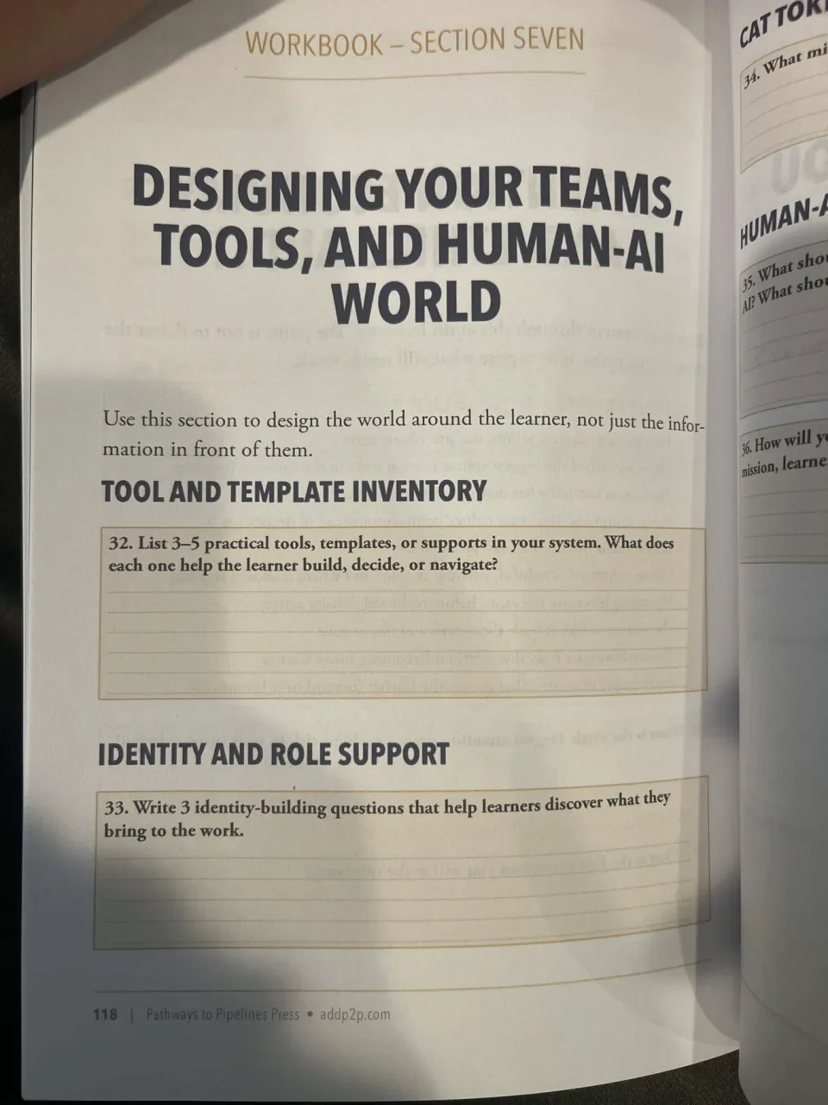

Prompt 32: Tool and Template Inventory
- Elias’ engineering expertise are a support that can help interpret the data about what went technically wrong with the rogue command and robot in the QA cell.
- The night-shift operator’s account of the checks that were performed on the cell’s operations could help us track any potential human errors in the system.
- Various logs in the records terminal can be used to establish a timeline of events surrounding the QA cell incident.

Prompt 33: Identity Building Questions
- What information have you acquired and need to present?
- How does your department’s expertise play into the operations in the QA cell?
- Based on your expertise, what part of the QA cell operations could be improved to avoid another rogue command and robot incident?

