Student name: Karan Raj Chaudhari Roll no:21 div:A batch:1` date:31.10.2025
Practical no2:Hyperlink Implemention:Add internal and external links to an HTML Document

<!DOCTYPE html>
<html>

<body>

<h1>Internal link<h1>
<p><a heref="about.html"> Go to about page</a></p>

<h1>External Link</h1>
<p><a herf="htps;//www.w3schools.com/">visit w3schools.com!</a></p>

</body>
<html>

OutPut:
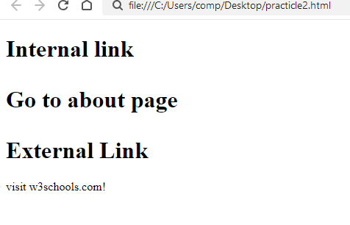
About.Html

<!DOCTYPE HTML>
<html>
<head>
<title> About page</title>
</head>

<body>

<h1>About our website</h1>
<p>this is our about page</p>

<p><a href="practical2.html"> Back to home page</a></p>

</body>
</html>

OUTPUT:
