# Cournot’s Model of Oligopoly

A single good is produced by n firms. The cost to firm i to produce qi units is Ci(qi) where C is an increasing function. The selling price is determined by the demand and production, and is given by P(Q) where P is an inverse demand function and Q is the total output of all firms.

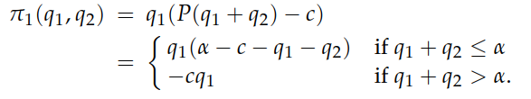For a Nash Equilibrium, see a specific case, 2 firms, same cost price c per unit and the inverse demand function is just linear. P(Q) = α – Q if Q <= α, else 0. The preference of each firm is to maximise the profit π = P(Q)qi – cqi . So in this case,

Symmetrically thinking about Firm 2, we can see that, if q2 = 0, the best response is (α-c)*0.5

As q2 increases, the profit that 1 can make decreases as price decreases. The profit function is quadratic, and using symmetry we can tell that the maximising value of q1 = 0.5*(α-c-q2) but if q2 is too big, the best response becomes 0. The game is symmetric hence firm 2 has the same BRF. Their intersection point gives the Nash Equilibrium which is q1* = q2* = (α-c)/3

While in this simple case we can’t observe it, but it is often the case that there exist non-equilibrium outputs which can further increase the profit of the firm if they had colluded with each other. One can also extend this game to various other situations involving use of a common resource. Such resources end up being overused in equilibrium condition.

# Bertrand’s Model of Oligopoly

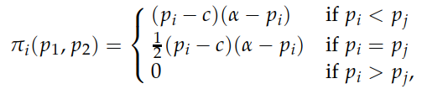Here, the firm decides the price before hand and then satisfies whatever demand it receives. Multiple firms with same lowest price share demand equally, whereas the ones who didn’t choose the lowest price get no demand. All demand has to be satisfied, even at a loss. Taking demand function as D(p) = α – p, constant unit cost c and 2 firms, the profit function is given by –

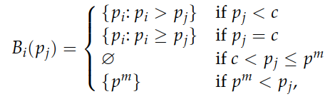Note that we assumed price to be a continuous value, unlike the real world. The BRF in this case comes out to be –

The Nash Equilibrium in this case is when both firms sell at the price c. Observe how while both models try to answer the same question, the answer they come up with is quite different.

# Electoral Competition – Hotelling’s Model

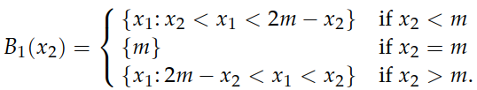The players are candidates, and the position/policy of each of them is mapped onto the number line. Citizens vote for the policy they are closest to. Each candidate prefers to win than tie, and would rather tie with few people. Distribution of voters is arbitrary, and candidates sharing a position share the voters they pull equally. The BRF comes out as –

The Nash Equilibrium is hence when both candidates pick m. Either party picking a different position would lose. And for any other pair of values, the party that loses/ties can do better by picking a position closer to m.