PATENT DESIGN AND DOCUMENTATION PACKAGE
Multimodal Physical-State Inference Platform for Tabletop Interaction,
Passive Encoded Game Objects, and Self-Configuring Modular Play Surfaces
Purpose of this package
This document is an engineering and patent-drafting work product intended to help a licensed patent attorney prepare filings. It contains (i) a confidential portfolio and monetization strategy, (ii) a broad provisional-style technical disclosure, (iii) illustrative claims, (iv) schematic figures, and (v) inventor and filing worksheets. It is not a legal opinion, freedom-to-operate opinion, patentability opinion, or guarantee that any claim will issue or be enforceable.

Field | Entry
Inventor(s) | [INSERT ALL HUMAN INVENTORS WHO CONTRIBUTED TO THE CLAIMED SUBJECT MATTER]
Assignee / applicant | [INSERT PERSON OR ENTITY]
Project / docket | Physical Tabletop State Engine / [INSERT DOCKET]
Draft date | August 22, 2026
Priority target | [INSERT INTENDED FILING DATE]
Confidentiality | Do not publicly distribute before counsel determines filing strategy.

Prepared as an editable working draft. Bracketed text must be completed or removed before filing.
AI-assisted drafting does not change inventorship law: only natural persons who actually conceived claimed subject matter should be named as inventors.

CONTENTS
PART I — CONFIDENTIAL PATENT AND PROFIT STRATEGY
1. Executive conclusion
2. Protectable center and prior-art constraints
3. Recommended patent-family architecture
4. Claim design and fallback positions
5. Product and licensing architecture
6. Trade-secret, trademark, design-patent, and copyright layers
7. Filing sequence and evidence plan
PART II — DRAFT PROVISIONAL PATENT SPECIFICATION
Title; technical field; background; summary; definitions
Brief description of drawings
Detailed description of embodiments
Use cases and implementation examples
Illustrative claims
Abstract
APPENDICES — Prior-art map, inventor worksheet, test matrix, filing checklist, and sources

PART I — CONFIDENTIAL PATENT AND PROFIT STRATEGY
This section is a strategy memo and should not automatically be included in a patent filing.

1. EXECUTIVE CONCLUSION
The commercially valuable invention is not merely “an iPhone reads dice with LiDAR” and not merely “a smart game board.” Those broad categories already contain substantial prior art. The strongest protectable position is an integrated physical-state platform that: (a) combines heterogeneous sensing from a play surface, rim, and/or mobile device in a common coordinate frame; (b) recognizes passive or active physical objects and their time-varying pose; (c) distinguishes meaningful physical events from incidental motion; (d) converts validated events into game-agnostic rule transactions; and (e) optionally self-configures across modular tiles and survives optical occlusion through sensor fusion.
The recommended commercial strategy is therefore a portfolio, not a single narrow patent. File one enabling omnibus provisional disclosure before public demonstration, then split the nonprovisional/PCT stage into separate claim families directed to the platform, passive encoded dice and objects, modular self-topologizing surfaces, and physical-event/rule-transaction processing. Preserve calibration methods, training data, manufacturing tolerances, and anti-cheat models as trade secrets where they cannot be reverse-engineered easily.
Primary defensible thesis
A game-agnostic system maintains a probabilistic digital twin of a physical play environment by dynamically fusing spatially and temporally registered sensor streams, then emits validated semantic transactions only when a physical interaction satisfies defined event criteria. Passive encoded objects and modular surface topology are interoperable embodiments of that same architecture.

2. PROTECTABLE CENTER AND PRIOR-ART CONSTRAINTS
A preliminary, non-exhaustive patent landscape shows earlier disclosures covering visual-marker tracking of miniatures, arrays of RFID or Hall-effect sensors in boards, projector-enhanced game surfaces, marked play pieces, modular connected game boards, active electronic dice, flatbed optical dice readers, RFID dice readers, and camera-based physical/virtual games. A claim that merely recites a board, a sensor, a die, a phone, and a processor is therefore likely to face serious novelty or obviousness challenges.
Reference | Relevant disclosure | Design-around direction
US 8,602,857; US 10,456,675 | Visual-marker identification and tracking of board-game objects; dynamic object characteristics. | Avoid relying on unique markers plus camera tracking as the inventive center.
US 10,953,314 family / US 2010/0004062 | Sensor arrays, RFID/Hall/opto detection, projector, game state, remote systems. | Generic sensorized tabletop claims are crowded.
US 2016/0287979 | Modular connected board interfacing with smart devices and tagged objects. | Claim self-topology, seam calibration, and common-frame fusion rather than modularity alone.
US 9,168,455 | Computer-aided tabletop play using machine-readable play pieces. | Markers alone are not enough.
US 10,828,556; US 11,565,171 | Flatbed dice scanning, motion/standstill detection, verification sensors, trajectory checks. | Avoid claiming generic optical dice recognition or generic roll validation alone.
US 9,694,275 | Battery-powered electronic die with accelerometer and wireless reporting. | Emphasize passive/no-battery encoding and board-side inference.
US 8,998,698; US 10,688,382 | RFID dice detection and array-based determination of upward face. | Use distinct multimodal signatures, distributed encoding, confidence fusion, and tabletop integration.
US 8,734,245 | Physical game pieces sensed over virtual layouts. | Tie software effects to a specific technical state-estimation pipeline.

2.1 Candidate inventive combinations
- Common-frame multimodal fusion: board-embedded or rim sensors and an external mobile depth/RGB/IMU sensor are registered into one coordinate system, with dynamic confidence weighting based on occlusion, glare, magnetic interference, radio collisions, field-of-view, or object geometry.
- Semantic physical-event generation: the system converts a temporal sequence of uncertain object states into a discrete transaction such as roll, pickup, placement, movement, rotation, stack, collision, line-of-sight change, zone crossing, or area-of-effect intersection.
- Passive error-corrected object encoding: a die or game object uses distributed non-powered magnetic, optical, resonant, geometric, or RF elements whose combined signature identifies object identity, orientation, and/or upward face and can be cross-validated by a second physical modality.
- Self-topologizing modular surface: connected tiles determine adjacency, orientation, scale, seam position, and sensor overlap automatically, then transform local measurements into a global play coordinate frame.
- Confidence-aware rules integration: the rules engine accepts, rejects, defers, or requests confirmation based on measurement confidence and preserves a signed replayable event log rather than treating every sensor detection as authoritative.
- Local-first privacy and remote play: raw imagery can remain local while signed object-state or event transactions are synchronized across remote tables.

2.2 What not to make the sole independent-claim limitation
- “LiDAR” by itself. Use the broader terms depth sensor, range sensor, or spatial sensor and disclose LiDAR, time-of-flight, structured light, stereo vision, radar, and ultrasonic alternatives.
- “Dungeons & Dragons” or any single game. Use tabletop role-playing game, miniature game, board game, wagering game, educational simulation, training system, or physical-computer interface.
- A single die shape or dot pattern. Cover polyhedra, spinners, coins, cards, randomizers, and arbitrary physical objects.
- A camera-only reader, RFID-only board, or Hall-sensor-only array. The valuable claim should survive substitution of sensing technology.
- A processor merely “applying game rules.” Tie processing to measured physical states, event confidence, spatial geometry, and a technical output.

3. RECOMMENDED PATENT-FAMILY ARCHITECTURE
Family | Claim focus | Commercial role
Family A — Core platform | Multimodal common-frame sensing, probabilistic object-state model, semantic event engine, rules transactions, confidence handling. | Highest licensing leverage; platform claim against board, accessory, and software vendors.
Family B — Passive encoded objects | Battery-free dice, miniatures, bases, cards, tokens, terrain, magnetic/optical/resonant codes, error correction, identity-plus-pose decoding. | Consumables and accessory royalties; recurring revenue.
Family C — Modular surface | Tile discovery, adjacency/orientation identification, overlapping sensor zones, seam transforms, distributed power/data, fault isolation. | Scalable hardware platform and expansion-tile sales.
Family D — Roll and interaction validation | Temporal state machine, manipulation rejection, quality thresholds, signed result transaction, remote verification. | Dice tray, casino, online tournament, accessibility, and anti-cheat licensing.
Family E — Spatial gameplay engine | Line of sight, cover, movement, elevation, area-of-effect, fog of war, and physical-to-virtual geometry tied to sensed states. | Software subscriptions and publisher integrations; may be pursued as continuation claims.
Family F — Remote mirrored play | Local event abstraction, synchronization, conflict resolution, privacy-preserving transmission, replay. | Network service and competitive-play monetization.

The first provisional should describe all families in one integrated disclosure so that later U.S. continuations, divisionals, or PCT/national-stage applications can seek different claim scope while preserving the earliest supported filing date. This only works for subject matter actually described and enabled in the original filing; broad aspirations without implementation detail do not create reliable priority support.

4. CLAIM DESIGN AND FALLBACK POSITIONS
Layer | Core limitations | Purpose
Broad commercial claim | Surface or interaction region; heterogeneous sensing; common coordinate frame; object-state estimate; temporal event classification; rule transaction. | Potentially valuable but vulnerable to combinations of known smart-board and sensor-fusion art.
Medium fallback | Board/rim sensor plus mobile depth sensor; dynamic source weighting based on quality; state covariance/confidence; event accepted only after temporal and physical criteria. | More technical and easier to distinguish.
Hardware fallback | Passive polyhedral object with distributed magnetic elements producing face-dependent field pattern at planar array, plus independent optical verification. | Concrete, licensable accessory claim.
Modular fallback | Each tile reports connector identity/orientation; overlapping sensor measurements estimate seam transform; global frame persists after tile substitution. | Strong implementation-specific claim.
Transaction fallback | Validated event packet includes object IDs, pose/result, confidence, timestamp, source provenance, and cryptographic integrity value. | Useful for remote and tournament products.

4.1 Drafting rules for prosecution flexibility
- Use “comprising” and describe components as optional or combinable unless an embodiment requires otherwise.
- Define a “physical interaction surface” broadly enough to include a board, mat, tray, table, floor, wall, foldable panel, projected surface, or modular assembly.
- Describe both continuous free-space tracking and discrete cell/grid tracking.
- Support both local processing and distributed processing across the board, phone, console, edge server, or cloud.
- Describe deterministic, probabilistic, machine-learning, model-based, and hybrid classifiers.
- Include calibration, failure, ambiguity, and human-confirmation modes; these often become useful claim limitations.
- Disclose manufacturing variations, object dimensions, sensor spacing, sampling rates, and example algorithms without making them mandatory.

5. PRODUCT AND LICENSING ARCHITECTURE
Layer | Implementation | Profit mechanism
Starter product | Passive dice + phone stand/overhead accessory + app; no full board. | Lowest hardware risk; validates recognition and event engine.
Premium board | 24–36 inch surface with rim depth sensors, optional under-board magnetic/RF sensing, LEDs, and phone/tablet compute. | Higher margin; centerpiece ecosystem product.
Modular tiles | Snap-connected tiles sold in sets and expansions. | Expandable average order value; lower replacement cost.
Peripheral marketplace | Encoded dice, miniature bases, terrain, cards, templates, condition rings, rulers, and spell tools. | Recurring physical revenue and partner licensing.
Publisher SDK | Game-definition schema, event API, geometry engine, content tools, certification tests. | B2B integration and royalties without manufacturing every title.
Hosted services | Campaign persistence, remote play, tournament verification, replay, analytics, marketplace entitlements. | Subscription and transaction revenue.

5.1 Preserve platform neutrality
The patent and core product should not depend on a license from a single game publisher. The hardware and event schema should expose generic primitives—object, owner, pose, zone, movement, random result, effect volume, visibility, state change—and allow publishers or community developers to map those primitives to particular rules. Licensed branded content can then sit above the protected platform rather than define it.

5.2 Potential license structures
- Per-unit royalty on compatible boards, dice, bases, tiles, or sensors.
- SDK license plus annual certification fee for publisher integrations.
- Revenue share on downloadable rule packs, campaigns, object profiles, and digital assets.
- Reference-design license to electronics or toy manufacturers.
- Field-of-use licenses, for example tabletop entertainment, casino verification, education, rehabilitation, training, or industrial spatial interfaces.
- White-label hardware with protected compatibility mark and accessory ecosystem.

6. OTHER IP LAYERS
Layer | Protect | Action
Utility patents | Functional architecture, sensing, encoding, topology, event inference, synchronization. | File before disclosure; maintain continuation options.
Design patents / registered designs | Distinct board rim, tile connector appearance, dice ornamentation, bases, and UI hardware. | File separate applications when industrial design is stable.
Trademarks | Platform name, certification mark, accessory compatibility mark, app/service names. | Clear marks before launch; avoid descriptive names as the sole brand.
Copyright | Software source, artwork, rule-pack text, 3D models, documentation, audiovisual assets. | Use contributor agreements and clean ownership chain.
Trade secrets | Calibration datasets, sensor-fusion weights, manufacturing tolerances, test fixtures, training data, anti-cheat thresholds, supplier knowledge. | Restrict access; use NDAs and security controls; do not unnecessarily publish in patents.
Contracts | Publisher SDK terms, accessory certification, data rights, update obligations, audit rights, exclusivity limits. | Often determines practical profit more than claim breadth alone.

7. FILING SEQUENCE AND EVIDENCE PLAN
- Freeze public disclosure. Do not publish detailed schematics, source code, demonstration videos, crowdfunding pages, sales offers, or unrestricted investor decks before filing strategy is set. U.S. law has a limited inventor-originated grace period, but many foreign jurisdictions can treat pre-filing disclosure as novelty-destroying.
- Complete the inventor worksheet. Name every human who conceived at least one claimed feature; do not name a person solely for funding, supervision, coding to instructions, or routine testing. Do not name an AI system as an inventor.
- Add actual implementation detail. Record the preferred sensor arrangement, object encoding, algorithms, dimensions, calibration steps, and best known embodiment. A provisional supports later priority only for subject matter adequately described and enabled.
- File the omnibus provisional with specification, figures, cover sheet, inventor names, and fee through USPTO Patent Center. Claims are not required, but including draft claims helps expose missing support.
- Within the following months, build and document at least one proof of concept, perform a focused patent search, and revise claim strategy based on measured performance and discovered prior art.
- Before the 12-month deadline, file one or more U.S. nonprovisional applications and, if international coverage is commercially justified, a PCT application claiming priority to the provisional.
- Keep continuation rights alive when economically justified so claim scope can be adapted to competitors, licensees, and product evolution.

7.1 Evidence to collect before nonprovisional filing
- Dated architecture diagrams and source-control history.
- Who conceived each feature and when; contemporaneous notes signed or witnessed where practical.
- Prototype photos, videos, bills of materials, PCB revisions, CAD files, and test logs.
- Confusion matrices for object identity/face recognition, accuracy under occlusion, latency, multi-object capacity, and false-event rate.
- Calibration and seam-registration procedures for modular tiles.
- Comparative tests showing why multimodal fusion outperforms a single camera or single sensor array.
- Commercial records, NDA history, and dates of any disclosure, sale, offer, public use, or demonstration.

7.2 Current U.S. provisional filing notes
As of the USPTO fee schedule updated August 14, 2026, the basic provisional filing fee is listed as $325 for a large entity, $130 for a small entity, and $65 for a micro entity, subject to eligibility and change. A provisional application is not examined and ordinarily must be followed by a corresponding nonprovisional application within 12 months to preserve its benefit. The provisional must name all inventors. Claims are not required, but the written description and any drawings must support and enable later-claimed subject matter. Verify the current fee, form, and Patent Center instructions immediately before filing.
Critical limitation
This document cannot establish patentability or freedom to operate. A professional search and claim chart are still required, especially because several active patent families broadly cover intelligent tabletop tracking and dice recognition.

PART II — DRAFT PROVISIONAL PATENT SPECIFICATION
The following section is structured for attorney conversion into a U.S. provisional or nonprovisional specification.

TITLE OF THE INVENTION
MULTIMODAL PHYSICAL-STATE INFERENCE PLATFORM FOR TABLETOP INTERACTION, PASSIVE ENCODED GAME OBJECTS, AND SELF-CONFIGURING MODULAR PLAY SURFACES

INVENTOR INFORMATION
Required item | Information
Inventor legal name(s) | [INSERT]
Residence / mailing information | [INSERT AS REQUIRED BY FILING FORM]
Applicant / assignee | [INSERT]
Correspondence address | [INSERT]

CROSS-REFERENCE TO RELATED APPLICATIONS
[0001] This application claims no priority in its present draft form. Before filing, insert any applicable priority claim and verify that each named inventor and each disclosed subject matter family is correctly supported.

STATEMENT REGARDING FEDERALLY SPONSORED RESEARCH OR DEVELOPMENT
[0002] Not applicable unless completed otherwise before filing.

FIELD OF THE DISCLOSURE
[0003] The present disclosure relates generally to human-computer interfaces, interactive physical environments, object tracking, electronic tabletop systems, spatial computing, and game systems. More particularly, the disclosure relates to sensing and interpreting physical objects and user interactions on or near an interaction surface, maintaining a digital representation of the physical environment, and applying software-defined rules or other processing to validated physical events.

BACKGROUND
[0004] Tabletop games and other physical simulations provide tactile, social, and spatial interaction that is difficult to reproduce on a conventional screen. However, physical play commonly requires manual entry of dice results, movement, object identity, status, range, line of sight, area effects, scoring, and state changes. This interrupts play and limits remote participation, accessibility, persistence, analytics, and automation.
[0005] Prior electronic game boards have used discrete switches, RFID readers, Hall-effect sensors, cameras, printed markers, touch screens, projectors, or instrumented game pieces. Prior dice systems have used cameras, scanner plates, RFID tags, accelerometers, batteries, wireless transmitters, or dedicated casino mechanisms. These approaches can be limited by occlusion, lighting, grid resolution, tag collisions, battery maintenance, cost, calibration, lack of interoperability, or an inability to distinguish an intentional game event from incidental handling.
[0006] A need remains for a platform that preserves unconstrained physical play while reliably inferring object identity, pose, motion, and interaction; combines different sensing modalities without requiring every object to contain powered electronics; adapts to different board dimensions and modular configurations; and converts uncertain continuous measurements into validated, game-meaningful transactions.

SUMMARY
[0007] In one aspect, a physical-interaction system includes an interaction surface, at least one first sensor associated with the surface, an optional second sensor associated with a mobile device or a rim assembly, and one or more processors configured to register sensor data into a common spatial and temporal frame. The processors estimate a state of one or more physical objects, including one or more of identity, class, position, orientation, upward face, velocity, trajectory, ownership, status, elevation, or confidence.
[0008] The processors may dynamically weight or select measurements according to sensor quality, including occlusion, illumination, reflectivity, radio interference, magnetic interference, multipath effects, field of view, sampling rate, object density, or prior state consistency. The system thereby maintains a probabilistic or deterministic digital twin of the physical play environment.
[0009] In another aspect, the system recognizes a semantic physical event from a temporal sequence of object states. Example events include a die roll, coin toss, spinner result, pickup, placement, translation, rotation, stack, unstack, collision, exchange, zone crossing, card play, terrain placement, gesture, measurement, line-of-sight change, or area-of-effect intersection. An event can be accepted, rejected, deferred, or presented for human confirmation according to confidence and validation criteria.
[0010] In another aspect, an accepted event is converted into a rule transaction defined by a game-agnostic rules description. The transaction may update a game state, trigger a display or illumination effect, generate audio, control augmented-reality content, calculate geometry, synchronize a remote system, create a replay record, or invoke a third-party application programming interface.
[0011] In another aspect, a passive physical object includes a body and a plurality of non-powered encoding elements arranged so that different positions or orientations of the object generate distinguishable signatures at one or more readers. The elements may include magnets, magnetically permeable materials, resonant circuits, RFID or NFC structures, conductive or capacitive features, optical marks, fluorescent features, retroreflective features, acoustic features, geometric features, or combinations thereof.
[0012] The passive object may be a polyhedral die. A distributed encoding arrangement may cause each stable die face, die identity, and/or rotational orientation to produce a code detectable by a planar sensor array. A second modality may verify the decoded result. The code may incorporate redundancy or error correction so that a result remains decodable when part of the object is occluded, a sensor is unavailable, or multiple objects are present.
[0013] In another aspect, the interaction surface includes modular tiles. Each tile may determine or communicate its identity, orientation, adjacency, scale, connector state, and local sensor coordinate frame. Overlapping or shared measurements near a seam may be used to estimate a transformation between tiles, enabling a global coordinate frame that automatically updates when tiles are added, removed, rotated, or replaced.
[0014] In another aspect, the system validates a physical randomizing event by detecting release, motion, collision or tumbling, settling, and stable pose. The system may reject or flag a result when handling occurs after settling, the surface is tilted beyond a threshold, a trajectory fails a physical criterion, the object leaves a permitted region, or sensor confidence is insufficient. A validated event record may include source provenance, timestamp, object identifiers, result, trajectory summary, confidence, and an integrity value.
[0015] The disclosed concepts are not limited to games. Embodiments may be used in education, simulation, training, rehabilitation, accessibility, logistics, industrial spatial interfaces, retail demonstrations, museums, entertainment venues, wagering systems where legally permitted, and any application in which physical objects are interpreted as structured digital input.

DEFINITIONS AND INTERPRETIVE PRINCIPLES
[0016] “interaction surface” means any physical or projected region on, above, below, or adjacent to which one or more objects or users interact, including a board, mat, tray, table, panel, wall, floor, foldable assembly, modular assembly, transparent surface, display, or unbounded tabletop region.
[0017] “sensor” means any device or subsystem that provides information concerning presence, identity, position, orientation, motion, force, distance, field, image, sound, radio response, or another property. Examples include RGB, infrared, ultraviolet, event, stereo, structured-light, time-of-flight, LiDAR, radar, ultrasonic, acoustic, capacitive, resistive, inductive, Hall-effect, magnetometer, RFID, NFC, UWB, BLE, load-cell, piezoelectric, inertial, pressure, switch, and conductive sensors.
[0018] “physical object” means a die, coin, spinner, miniature, base, card, tile, token, terrain item, ruler, template, wand, figurine, pawn, chip, book, container, hand-held controller, or other article.
[0019] “object state” means one or more estimates relating to an object, such as identity, class, location, orientation, face, elevation, velocity, acceleration, trajectory, occupancy, ownership, status, contact, confidence, covariance, or source provenance.
[0020] “physical event” means a temporally delimited interpretation of one or more object states or user actions, rather than a single raw sensor sample.
[0021] “rule transaction” means a structured message or operation that maps a physical event to one or more application-defined consequences.
[0022] “passive” means not requiring an onboard battery or continuously powered processor to provide the relevant identifying or orienting signature, although a passive object may include optional powered features.
[0023] “common coordinate frame” means a shared spatial representation into which measurements from different sensors, tiles, or devices are transformed.
[0024] “confidence” means any quantitative or categorical representation of uncertainty, reliability, consistency, or quality, including a probability, score, covariance, interval, rank, flag, or state.
[0025] The terms “including,” “comprising,” and “having” are intended to be open-ended. Singular forms include plural forms unless context clearly requires otherwise. Features described in connection with one embodiment may be combined with features of another embodiment. Numerical ranges include endpoints and intermediate values unless stated otherwise.

BRIEF DESCRIPTION OF THE DRAWINGS
[0026] FIG. 1 illustrates an overall physical tabletop state engine combining a sensor-equipped interaction surface, passive or active physical objects, an optional mobile sensing device, a controller, and one or more outputs.
[0027] FIG. 2 illustrates an example layered construction of a play surface and a rim-mounted sensing module.
[0028] FIG. 3 illustrates registration of heterogeneous sensor streams into a common coordinate frame and dynamic weighting according to measurement quality.
[0029] FIG. 4 illustrates a passive polyhedral object having distributed, non-powered encoding elements and an optional optical code.
[0030] FIG. 5 illustrates a state machine that distinguishes a physical roll from placement or manipulation and produces a validated result transaction.
[0031] FIG. 6 illustrates modular tiles that discover their adjacency and orientation and are transformed into a global coordinate frame.
[0032] FIG. 7 illustrates conversion of raw measurements into object states, physical events, and game-rule transactions.
[0033] FIG. 8 illustrates evaluation of line of sight, range, cover, elevation, and area-of-effect geometry from sensed object states.
[0034] FIG. 9 illustrates local processing and synchronization of abstract events between remote play sites.
[0035] FIG. 10 illustrates embodiment families supported by the same physical-state and event architecture.

DRAWINGS
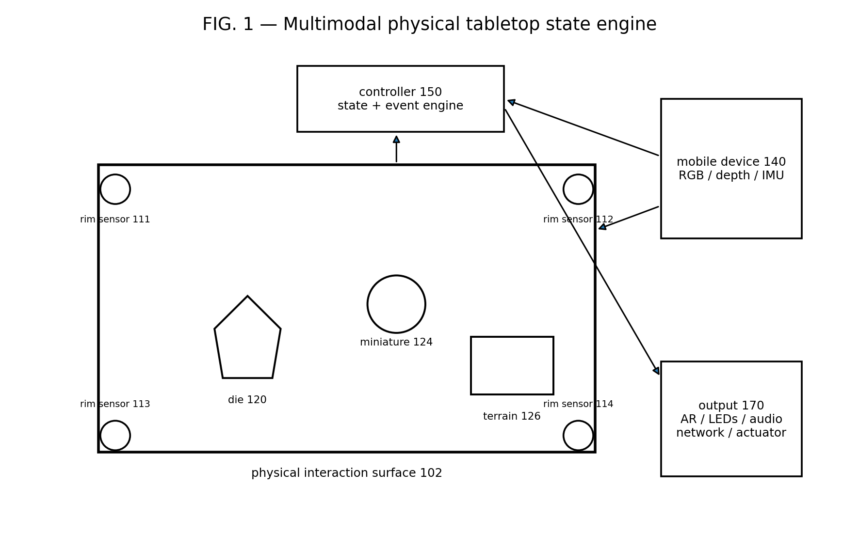
FIG. 1 illustrates an overall physical tabletop state engine combining a sensor-equipped interaction surface, passive or active physical objects, an optional mobile sensing device, a controller, and one or more outputs.

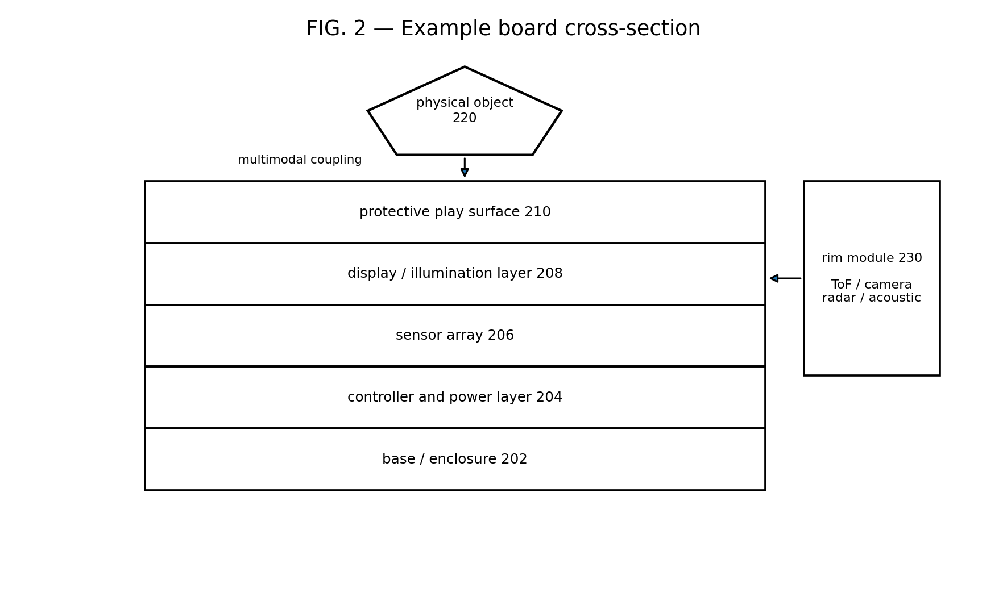
FIG. 2 illustrates an example layered construction of a play surface and a rim-mounted sensing module.

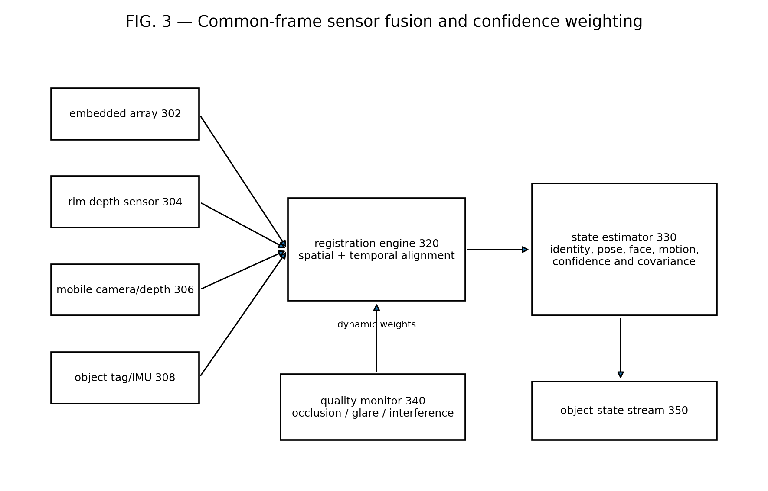
FIG. 3 illustrates registration of heterogeneous sensor streams into a common coordinate frame and dynamic weighting according to measurement quality.

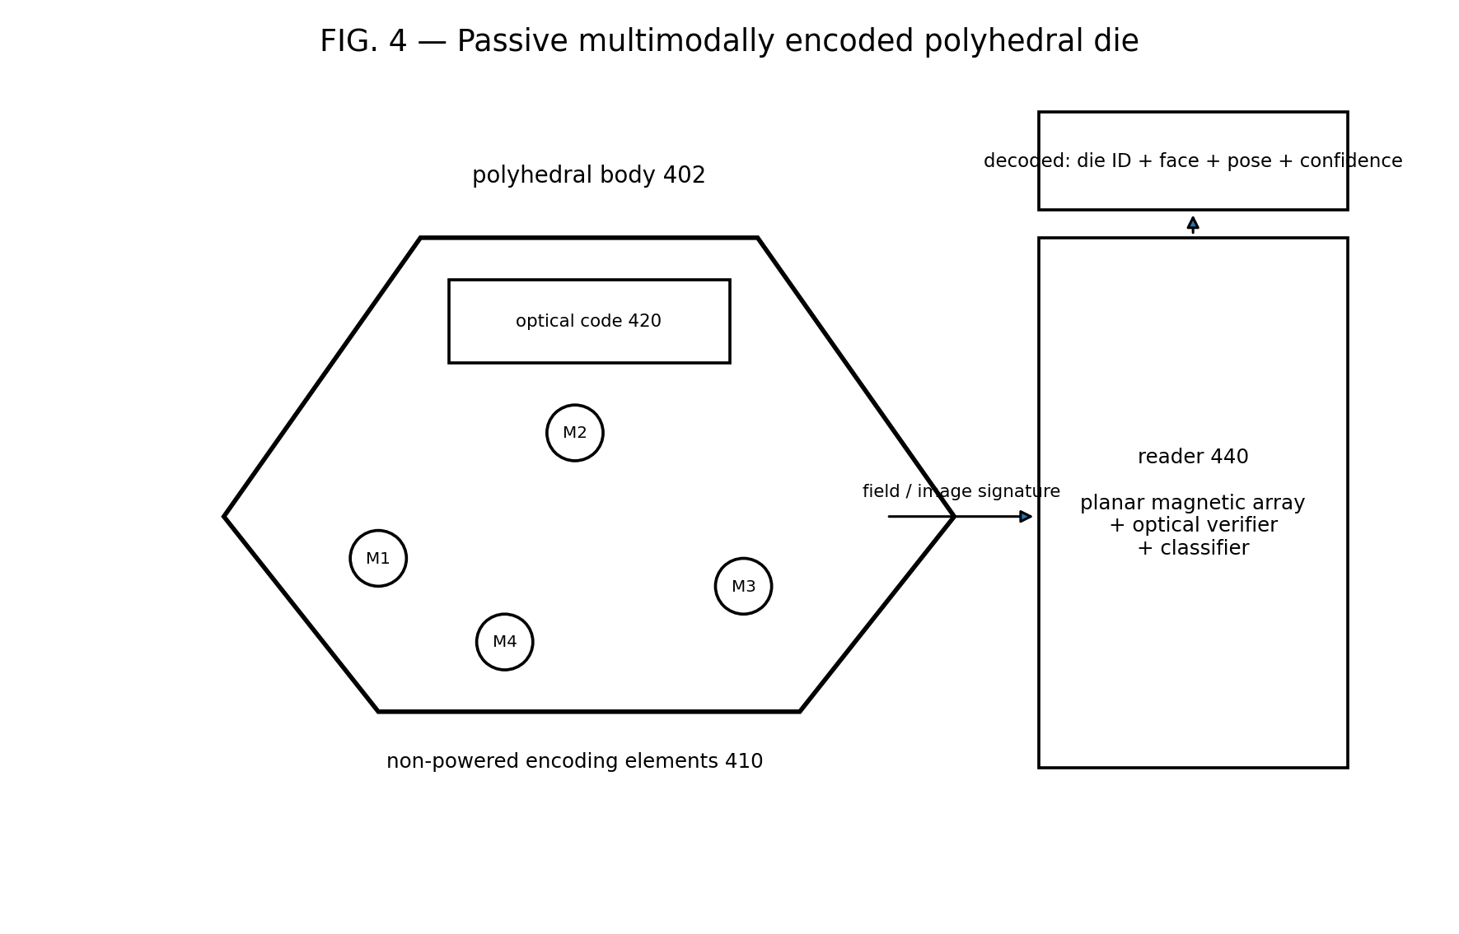
FIG. 4 illustrates a passive polyhedral object having distributed, non-powered encoding elements and an optional optical code.

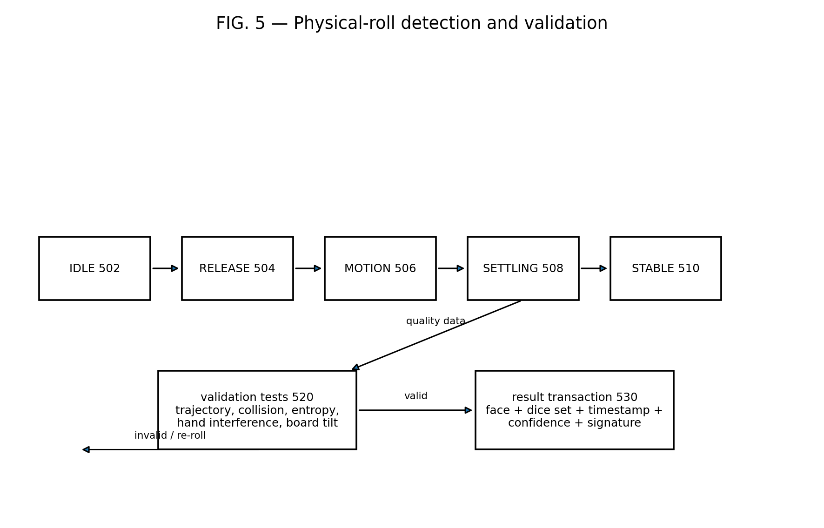
FIG. 5 illustrates a state machine that distinguishes a physical roll from placement or manipulation and produces a validated result transaction.

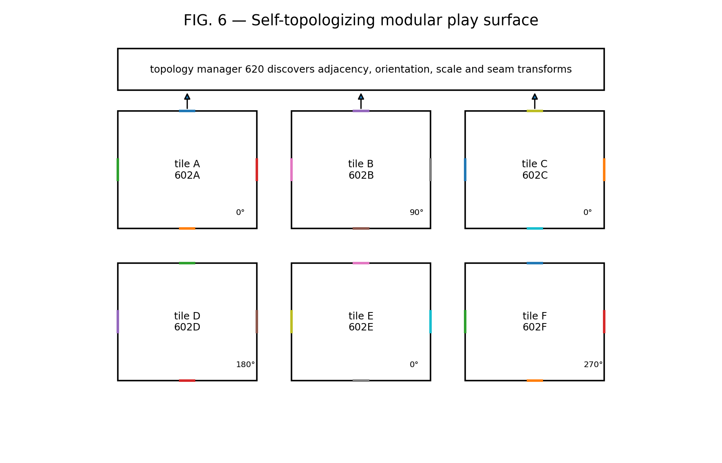
FIG. 6 illustrates modular tiles that discover their adjacency and orientation and are transformed into a global coordinate frame.

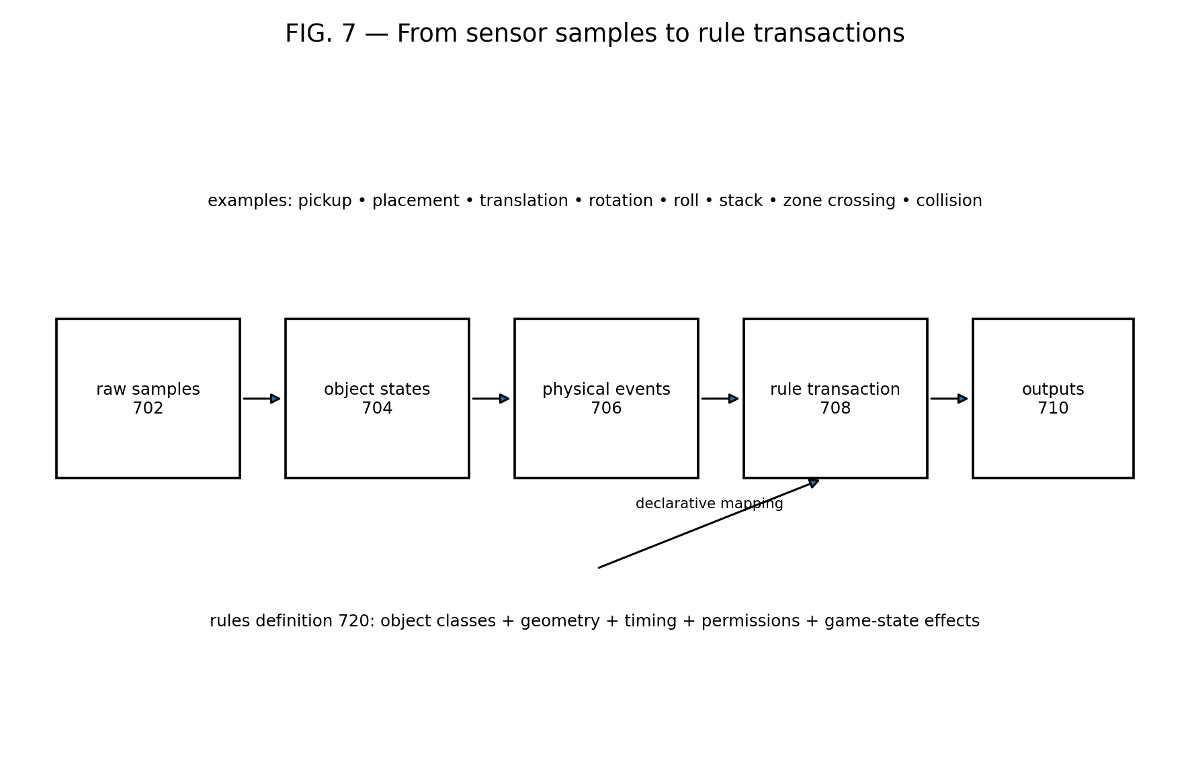
FIG. 7 illustrates conversion of raw measurements into object states, physical events, and game-rule transactions.

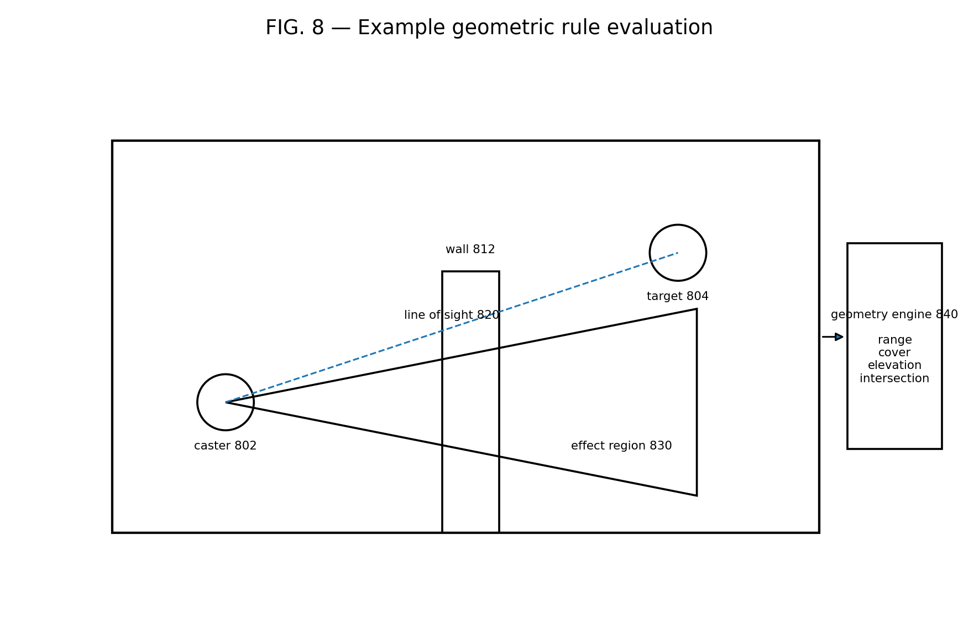
FIG. 8 illustrates evaluation of line of sight, range, cover, elevation, and area-of-effect geometry from sensed object states.

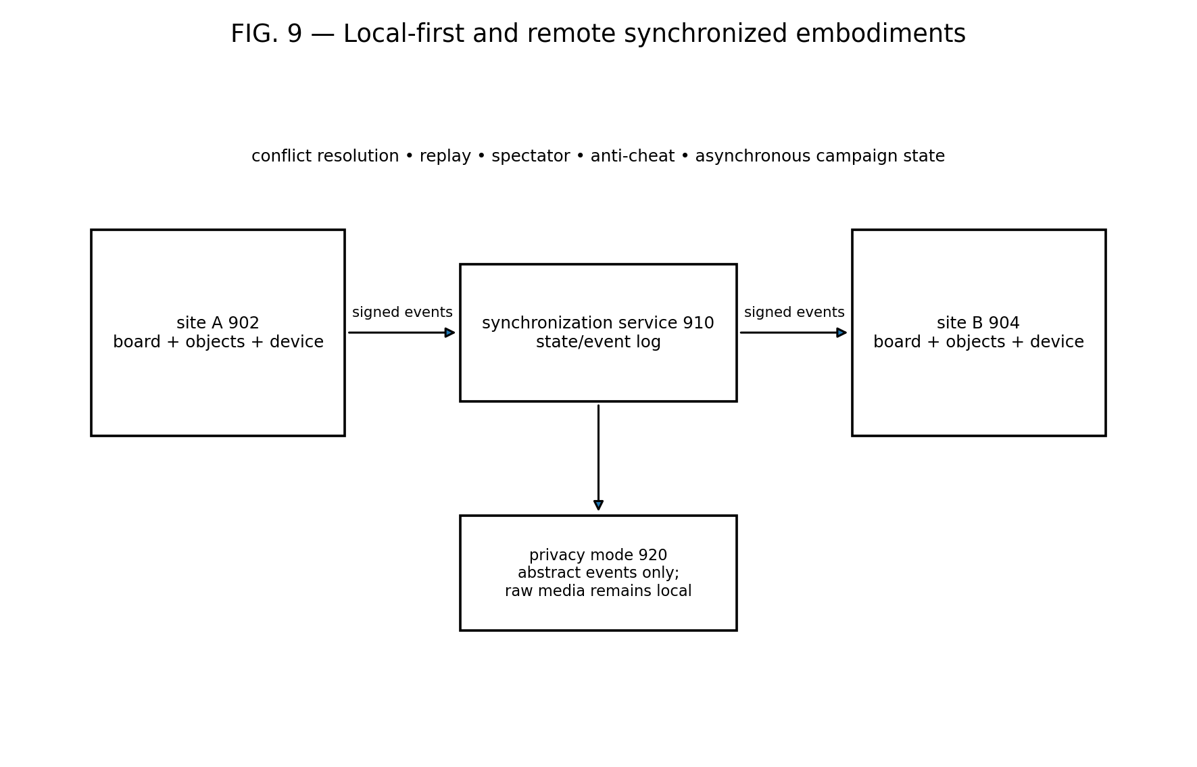
FIG. 9 illustrates local processing and synchronization of abstract events between remote play sites.

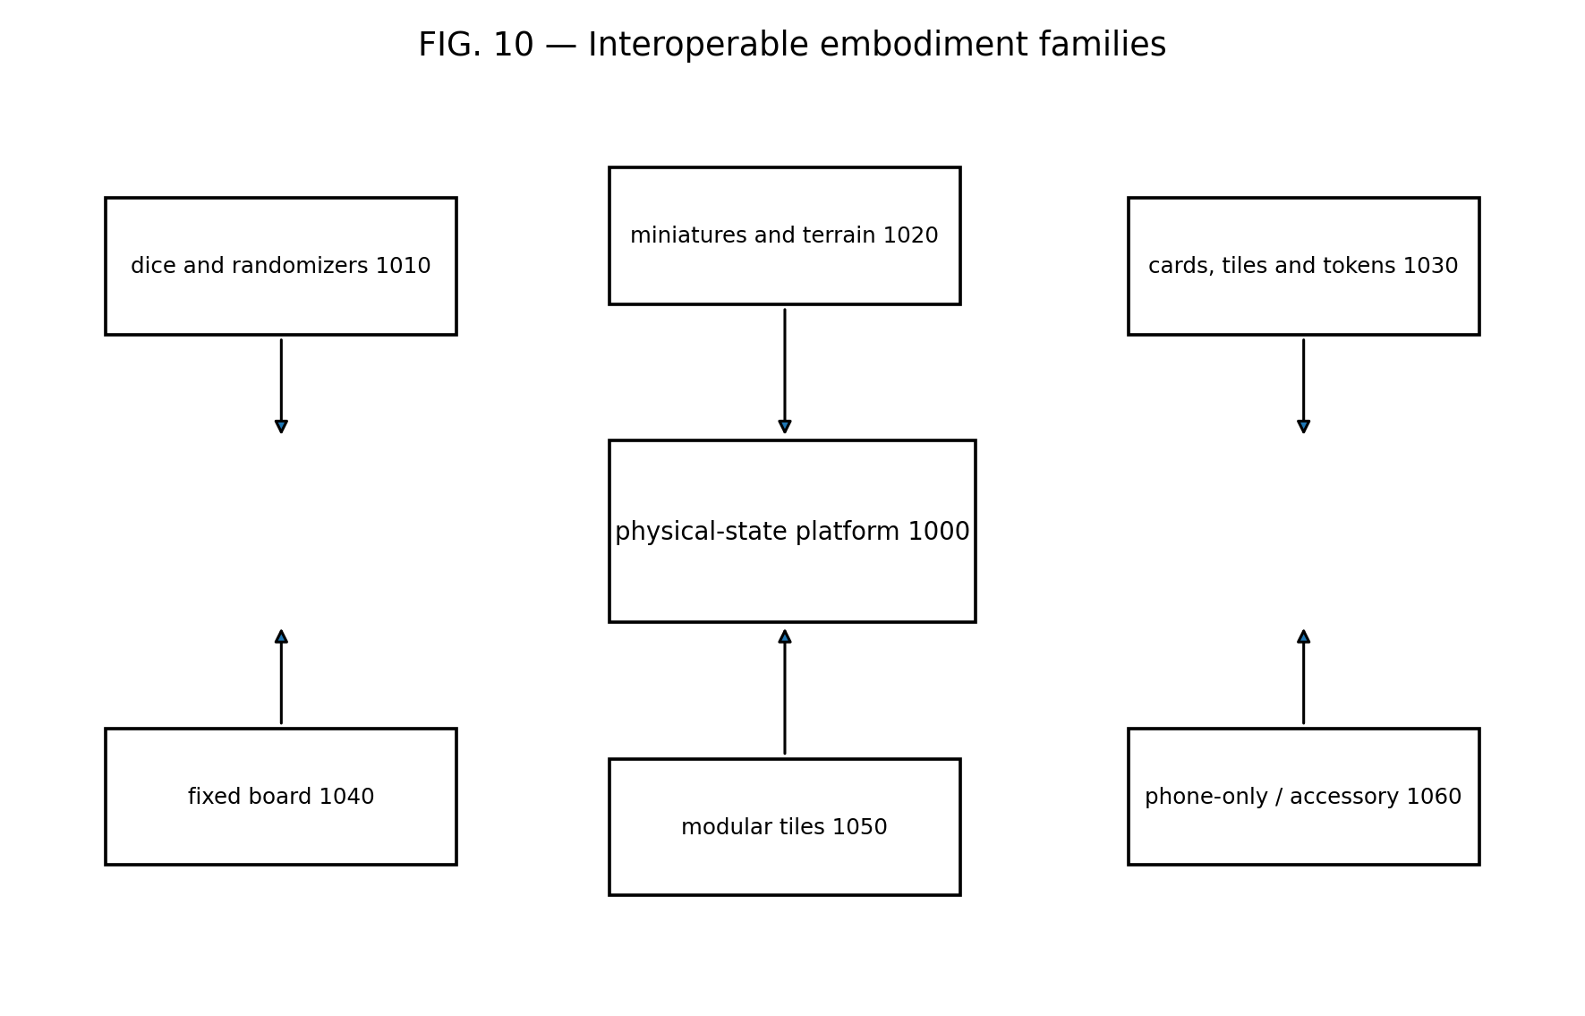
FIG. 10 illustrates embodiment families supported by the same physical-state and event architecture.

DETAILED DESCRIPTION

A. System Architecture
[0036] Referring to FIG. 1, a system 100 may include a physical interaction surface 102, one or more surface-associated sensors 110–116, one or more physical objects 120–126, an optional mobile device 140, one or more controllers 150, and one or more outputs 170. Components may be integrated into a single enclosure or distributed across multiple devices.
[0037] The surface 102 may be continuous or divided into cells. The surface may be rigid, flexible, rollable, foldable, transparent, translucent, opaque, flat, curved, or three-dimensional. A system may recognize object coordinates continuously, relative to a grid, relative to another object, or relative to a dynamically generated map.
[0038] A controller 150 may include one or more microcontrollers, processors, graphics processors, neural processors, programmable logic devices, application-specific integrated circuits, edge computers, mobile devices, consoles, personal computers, or servers. Processing may occur locally, remotely, or in a distributed pipeline. A low-power board controller may perform sampling and preprocessing while a phone or tablet performs object inference, rule processing, rendering, speech, networking, or machine learning.
[0039] Outputs 170 may include LEDs, addressable light guides, a display, projector, e-paper layer, haptic actuator, speaker, headset, augmented-reality display, virtual-reality system, phone, tablet, television, network message, accessory actuator, or external application. Outputs may be positioned in the surface, rim, object, room, or remote site.

B. Sensor Arrangements
[0040] Referring to FIG. 2, sensors may be positioned below the surface, within a rim, above the surface, in a mobile device, in an object, or in the environment. A layered board may include a structural base 202, controller and power layer 204, sensor array 206, display or illumination layer 208, and protective surface 210. One or more layers may be omitted, combined, printed on flexible substrates, or distributed among modular tiles.
[0041] Under-surface sensing may include a matrix of Hall-effect sensors or magnetometers, RFID/NFC antennas, capacitive electrodes, inductive coils, load cells, pressure sensors, acoustic sensors, optical detectors, or switches. The array may be regular, irregular, sparse, adaptive, multiplexed, or formed from overlapping zones. Spatial resolution may be improved through interpolation, model fitting, coded excitation, time multiplexing, or fusion with another sensor.
[0042] Rim or overhead sensing may include time-of-flight sensors, LiDAR, structured-light emitters and cameras, stereo cameras, RGB/IR cameras, radar, ultrasonic transducers, event cameras, or light curtains. Sensors may view horizontally across the surface, obliquely downward, vertically downward, upward through a transparent surface, or from multiple angles.
[0043] The mobile device 140 may be removably mounted to the board, held by a user, placed on a stand, or moved around the play environment. The mobile device may contribute depth, RGB, inertial, audio, ultra-wideband, location, or orientation data. The system may estimate the mobile device pose relative to the board from fiducials, surface geometry, connector data, simultaneous localization and mapping, known sensor locations, or shared object observations.
[0044] A system need not include LiDAR. Any range or spatial sensing modality may be substituted. A low-cost embodiment may use only RGB imaging and printed markers. Another embodiment may use only under-surface magnetic and RF sensing. A preferred high-reliability embodiment uses at least two physically independent modalities so that the failure modes of one modality can be detected or compensated by another.

C. Calibration and Common Coordinate Frame
[0045] Referring to FIG. 3, measurements from sensors 302–308 may be spatially and temporally registered by a registration engine 320. A transform may include translation, rotation, scale, perspective, lens distortion, surface deformation, tile seam, clock offset, clock drift, or latency compensation. Calibration may be performed at manufacture, installation, startup, during play, or continuously.
[0046] Calibration references may include fixed fiducials, light emitters, magnetic references, RF anchors, known board corners, known tile connectors, a calibration object, a known die, surface texture, or shared observations of a moving object. The system may request that a user move a calibration object through one or more locations. The system may also infer calibration opportunistically from ordinary gameplay.
[0047] Temporal registration may use timestamps, hardware synchronization, network time, cross-correlation of motion signals, detected impacts, acoustic events, or shared transitions. Latency estimates may be updated according to processor load, sensor frame rate, radio conditions, or network conditions.
[0048] The state estimator 330 may use triangulation, multilateration, template matching, pose estimation, Bayesian filtering, Kalman filtering, particle filtering, factor graphs, hidden Markov models, neural networks, nearest-neighbor classification, support vector machines, decision trees, physical simulation, or combinations thereof.
[0049] The quality monitor 340 may calculate a confidence for each measurement or state estimate. The monitor may reduce the weight of a camera when a hand occludes an object, reduce the weight of a magnetic array near a ferromagnetic terrain item, reduce the weight of an RFID channel during tag collision, or increase the weight of a mobile depth sensor when an object is elevated above the board. A sensor may be disabled, recalibrated, or used only to verify another sensor.
[0050] The object-state stream 350 may report a point estimate, distribution, covariance, alternatives, source provenance, and confidence. When identity and pose are ambiguous, the system may maintain multiple hypotheses until later motion or an independent modality resolves the ambiguity.

D. Physical Objects and Encodings
[0051] Objects may be unmodified, visually marked, magnetically encoded, RF-tagged, geometrically distinctive, instrumented, or multimodally encoded. An object profile may define physical dimensions, mass, face geometry, marker locations, magnetic arrangement, RF identifier, expected reflectance, game class, ownership, and permitted interactions.
[0052] Optical encoding may use visible marks, infrared marks, ultraviolet-fluorescent marks, retroreflective regions, polarization, microtext, color, texture, concentric rings, fiducials, bar codes, matrix codes, edge patterns, face symbols, or combinations thereof. Markings may be decorative and machine-readable simultaneously. A code may be placed on a top face, bottom face, side, base, removable ring, insert, sticker, coating, or embedded transparent layer.
[0053] Magnetic encoding may use one or more permanent magnets, magnetic particles, magnetically permeable inserts, or shaped flux guides. Elements may differ in position, orientation, polarity, moment, depth, material, or geometry. The resulting spatial field pattern may encode an object identifier, object class, orientation, face, status, or error-checking information.
[0054] RF or resonant encoding may use passive RFID, NFC, resonant LC circuits, frequency-selective elements, backscatter, chipless RFID, or multiple resonances. Antennas may be distributed among faces or regions so that coupling changes with orientation. A reader may sequentially energize overlapping zones, measure phase or strength, and infer location or face.
[0055] Conductive or capacitive encoding may use patterned electrodes, conductive inks, impedance networks, or contact pads. Acoustic encoding may use cavities, resonators, impact signatures, or surface textures. Geometric encoding may use shape, relief, holes, recesses, edge chamfers, base footprints, or internal density distribution.
[0056] Encoding may be redundant. For example, a magnetic code may provide identity and coarse pose while an optical code verifies the upward face. A passive RF code may provide identity while a depth sensor provides position and height. A code can include parity, a cyclic redundancy check, Hamming-distance separation, or another error-detecting or error-correcting structure.

E. Passive Polyhedral Dice and Randomizers
[0057] Referring to FIG. 4, a passive die 400 includes a polyhedral body 402 and non-powered encoding elements 410. The body may be a d4, d6, d8, d10, d12, d20, d100 component, custom polyhedron, irregular randomizer, coin, spinner, top, or another object having multiple stable or detectable outcomes.
[0058] The encoding elements 410 may be placed in a three-dimensional pattern so that each stable face generates a distinguishable magnetic or electromagnetic signature at a reader 440. In one embodiment, at least three magnets with non-collinear positions and selected polarities create a vector-field pattern. The pattern is decoded by fitting candidate object models to measurements from a planar magnetometer array. The fit yields die identity, upward face, rotational orientation, position, height, and confidence.
[0059] The object may include an optical code 420 on one or more faces. The optical code may identify the face directly, identify the die while geometry determines the face, or provide an independent check. An underside optical reader may view a lower face through a transparent or translucent surface, and the opposite-face relationship may determine the upward result. An overhead or mobile camera may read the upward face.
[0060] The encoding may be designed so that the total mass distribution remains balanced within a manufacturing tolerance. Magnets or inserts may be paired, counterweighted, symmetrically distributed, or selected for equal mass. Calibration data may compensate for residual bias. A verification procedure may estimate fairness by analyzing repeated trajectories and outcome frequencies.
[0061] Multiple dice may be decoded simultaneously. The reader may separate overlapping signatures using sparse reconstruction, iterative subtraction, multi-hypothesis tracking, spatial clustering, coded excitation, or optical localization followed by magnetic model fitting. Each die may have a unique identity or class code so that a game can distinguish a damage die from an attack die even when the dice are rolled together.
[0062] A die may include no electronics. Alternatively, a hybrid die may include an optional inertial sensor, energy harvester, near-field-powered circuit, LED, haptic element, memory, or wireless transceiver. The system may use board-side inference as the primary result and the onboard system as a verification source, or vice versa.

F. Roll and Randomizer Event Validation
[0063] Referring to FIG. 5, a roll detector may transition through idle 502, release 504, motion 506, settling 508, and stable 510 states. Release may be inferred from hand separation, loss of surface contact, acceleration, vertical displacement, acoustic onset, light-curtain crossing, or a user command. Motion may be characterized by translation, rotation, collisions, impacts, or changing face observations.
[0064] The system may distinguish a roll from deliberate placement by requiring one or more physical criteria, such as minimum travel distance, minimum number of face transitions, minimum angular displacement, one or more impacts, time above the surface, velocity range, entropy estimate, collision with a wall, or a trajectory inconsistent with simple placement. Criteria may vary by die type, game, accessibility mode, or user preference.
[0065] Settling may be detected when velocity, angular velocity, position variance, acoustic energy, or face estimate change falls below a threshold for a dwell period. The stable result may be read immediately or after a verification interval. The system may preserve sensor samples around the event to support replay or dispute resolution.
[0066] Validation tests 520 may detect post-settlement manipulation, hand occlusion, board tilt, removal of a die, replacement of a die, an out-of-bounds result, insufficient sensor quality, impossible dynamics, or conflict between modalities. The system may automatically accept, reject, request a reroll, ask a user to confirm, or send the event for remote adjudication.
[0067] A result transaction 530 may include one or more die identifiers, result values, roll-set identity, timestamp, duration, trajectory summary, validation status, confidence, source modalities, board identifier, session identifier, player identifier, and cryptographic integrity data. The transaction may be signed by a secure element in the board or mobile device.

G. Miniatures, Bases, Terrain, Cards, and Tokens
[0068] A miniature or base may be identified by a code in the base, top, side, or removable ring. The state estimator may determine position, facing, footprint, elevation, tilt, articulated pose, or attached accessories. A base may contain a passive tag and distributed magnetic or optical orientation features. Different rings or inserts may represent conditions, teams, owners, status, or equipment.
[0069] Terrain may be recognized by shape, tags, markers, or scanned geometry. The system may build a height map or volumetric model of walls, doors, trees, platforms, stairs, bridges, buildings, and other obstructions. Terrain can be static, movable, destructible, or stateful. A door object may transition between open and closed states based on orientation.
[0070] Cards and tiles may be recognized when placed in zones, stacked, flipped, rotated, tapped, or passed between players. A card may include an optical code, NFC tag, conductive pattern, thickness profile, or edge code. Hidden-information embodiments may identify a card from below or by tag while preventing other players from seeing its face.
[0071] Tokens, rulers, templates, and condition rings may act as physical commands. For example, placing a ring around a miniature may create a status event; placing a cone template may define an effect volume; moving a ruler between objects may request a distance; arranging rune tiles may define a command or spell grammar.

H. Self-Topologizing Modular Surface
[0072] Referring to FIG. 6, a modular surface may include tiles 602A–602F. Each tile may have mechanical connectors, electrical contacts, optical links, wireless links, magnets, alignment features, or combinations thereof. A connector can encode side identity, polarity, orientation, or neighbor identity.
[0073] A topology manager 620 may determine which tile edge is connected to which other tile edge. The manager may infer orientation from asymmetric connectors, electrical pin order, magnetic polarity, inertial sensing, optical marks, or relative observations. Each tile may report a unique identifier and local coordinate system.
[0074] The system may estimate seam transforms by comparing overlapping sensor observations, detecting a calibration object across the seam, measuring connector geometry, or using factory calibration. A transform may compensate for gap, overlap, rotation, scale, height offset, flexure, or manufacturing tolerance.
[0075] Tiles may communicate through a wired bus, daisy chain, mesh network, optical link, power-line communication, or wireless network. Power may be distributed through connectors or supplied locally. A tile may be hot-swapped, and the global coordinate frame may update without restarting a session. A faulty tile may be isolated while neighboring sensors bridge its region.
[0076] Tiles may have different functions, including sensing, illumination, display, dice rolling, terrain elevation, charging, audio, storage, or control. A low-cost tile may provide only passive fiducials and a surface; a premium tile may provide dense sensor and display arrays. The topology manager may expose a capability map to the application.

I. Object State, Event Grammar, and Rule Transactions
[0077] Referring to FIG. 7, raw sensor samples 702 are transformed into object states 704. Object states are transformed into physical events 706 using an event grammar or classifier. Physical events are transformed into rule transactions 708 according to a rules definition 720. Outputs 710 present or transmit the resulting effect.
[0078] An event definition may specify participating object classes, start conditions, end conditions, spatial relationships, timing, velocity, confidence, required modalities, forbidden interference, ownership, permissions, and resulting parameters. Event definitions may be declarative, scripted, compiled, learned, or supplied by an external game engine.
[0079] For example, a movement event may begin when a miniature is lifted or translated beyond a threshold and end when it remains stable. The transaction may include the start pose, path length, end pose, zones crossed, terrain intersections, and confidence. A game can then decide whether the movement is legal and how much movement allowance remains.
[0080] A pickup and transfer event may identify a card or token leaving one player zone and entering another. A stack event may determine order from height, timing, or tag response. A collision event may use acoustic and motion data. A gesture event may include a hand path, wand path, object arrangement, or sequence of placements.
[0081] A transaction interface may be game agnostic. A transaction schema may include event type, participant object IDs, before-state, after-state, geometry, random result, confidence, provenance, timestamp, and application payload. A publisher or third-party developer can map the schema to game-specific rules without modifying low-level sensing.
[0082] The system may use an uncertainty policy. Above a first threshold, an event may be accepted automatically. Between first and second thresholds, the system may request confirmation or collect additional data. Below the second threshold, the system may reject the event. Thresholds may depend on consequence severity, tournament mode, accessibility mode, or user preference.

J. Spatial Geometry and Augmented Reality
[0083] Referring to FIG. 8, a geometry engine 840 may evaluate movement distance, adjacency, range, line of sight 820, cover, elevation, reach, visibility, and effect regions 830. Geometry may be evaluated in two or three dimensions using object footprints, meshes, height maps, bounding volumes, signed-distance fields, voxels, polygons, or simplified rule geometry.
[0084] An area effect may be a sphere, cylinder, cone, line, wall, polygon, custom volume, or time-varying region. The system may project the region onto the surface, illuminate affected objects, display it in augmented reality, or report intersections. A user may define the region by selecting a physical object, placing a template, pointing a mobile device, moving a wand, speaking a command, or selecting an application control.
[0085] Fog of war or hidden information may be generated for each player according to character position, terrain, sensor model, and game rules. Different mobile devices or headsets may display different virtual content over the same physical surface. The board may emit only shared public information while private information remains on a player device.
[0086] The physical environment may extend above or below the board. Elevated stands, flying objects, stacked tiles, projected levels, or virtual floors may be incorporated into the common coordinate frame. A physical object can act as an anchor for virtual geometry that is larger, smaller, or differently shaped than the object itself.

K. Remote, Persistent, and Secure Play
[0087] Referring to FIG. 9, a first site 902 and second site 904 may synchronize through a service 910. Each site may maintain a local physical state while sharing selected object states, events, rule transactions, or rendered outcomes. A remote site may reproduce an event virtually or prompt a local player to move a corresponding physical object.
[0088] Privacy mode 920 may keep raw camera or audio data local and transmit only abstract events. Users may select which object identities, positions, or private zones are disclosed. The system may redact hands, faces, room imagery, or speech before storage or transmission.
[0089] A persistent campaign state may survive disassembly of the board. The system may save topology, terrain, object identities, statuses, destroyed elements, doors, traps, inventory, and unexplored regions. On later setup, the system may recognize a partially reconstructed environment and align it with the saved state.
[0090] An event log may be append-only, signed, hash-chained, redundantly stored, or otherwise protected against undetected alteration. The system may support replay, spectator mode, adjudication, tournament auditing, anti-cheat analysis, and recovery after connectivity loss. Cryptographic protection is optional and is not limited to blockchain implementations.

L. Failure Handling, Accessibility, and Safety
[0091] The system may detect sensor failure, obstruction, board tilt, connector failure, low power, thermal condition, excessive RF field, magnetic saturation, or calibration drift. It may degrade gracefully to a subset of sensors, reduce spatial resolution, request repositioning of a mobile device, or ask for manual confirmation.
[0092] Accessibility modes may permit reduced-motion rolls, assisted placement, voice commands, enlarged objects, haptic feedback, audio descriptions, high-contrast illumination, remote object handling, or alternative event criteria. A random result may be generated physically, virtually, or through a verified assisted mechanism according to user needs and game policy.
[0093] Safety features may limit optical emission, radio power, magnetic field strength, surface temperature, pinch hazards, and small-part risks according to applicable product requirements. The system may detect incompatible objects or warn when strong magnets could affect medical devices or electronics.

M. Manufacturing Embodiments
[0094] A board may use one or more rigid printed circuit boards, flexible printed circuits, printed conductive films, injection-molded structures, laminated sheets, textiles, glass, wood, polymer, foam, or composite materials. Sensors may be placed only in high-value regions and combined with interpolation to reduce cost.
[0095] A magnetic array may use three-axis magnetometers, single-axis Hall sensors with different orientations, multiplexed analog Hall elements, or printed magnetic sensors. Sensor spacing may be uniform or nonuniform. Reference sensors may measure ambient magnetic field. Calibration may compensate for component offsets, board materials, nearby electronics, and Earth's magnetic field.
[0096] A depth rim may use one sensor per corner, multiple sensors per side, a moving sensor, mirrors, light guides, or a removable arch. A phone mount may provide known pose and charging. The play surface may be replaceable so different graphics can be used without replacing the electronics.
[0097] Passive objects may be injection molded around inserts, assembled from shells, 3D printed with cavities, overmolded, laminated, or fitted with removable bases. Encoding elements may be inserted after fairness testing. Each manufactured object may be characterized and assigned a calibration profile stored locally or remotely.

N. Alternative Embodiments and Markets
[0098] Referring to FIG. 10, the same platform may support dice and randomizers 1010, miniatures and terrain 1020, cards and tokens 1030, a fixed board 1040, modular tiles 1050, or a phone-only accessory 1060. A system may begin as a low-cost dice reader and later add board sensing without changing the event API.
[0099] Role-playing embodiments may automate initiative, movement, range, damage, conditions, inventory, line of sight, fog of war, and persistent campaigns. Miniature-wargame embodiments may track squads, facing, templates, terrain, and objective zones. Board-game embodiments may automate setup, scoring, hidden information, tutorials, and adaptive difficulty.
[0100] Educational embodiments may interpret manipulatives, geometry constructions, molecular models, circuits, language tiles, or physics experiments. Training embodiments may monitor tabletop command simulations, logistics, emergency response, or equipment layouts. Rehabilitation embodiments may score reach, dexterity, sequencing, and object placement.
[0101] Wagering or tournament embodiments may use validated random events, signed logs, tamper detection, and remote verification, subject to applicable laws and approvals. Museum and entertainment embodiments may activate effects when visitors arrange or manipulate physical artifacts.
[0102] Industrial embodiments may use the same architecture for workbench guidance, assembly verification, inventory placement, collaborative planning, or spatial configuration. Accordingly, the term “game” is illustrative and does not limit the disclosed physical-state platform.

O. Example Implementations
[0103] Example 1 — Phone-assisted dice tray. A tray has four passive visual fiducials that define a coordinate frame and a removable phone mount. Custom passive dice have face-specific optical patterns and internal magnetic elements. The phone provides RGB/depth data while a low-cost magnetometer strip in the tray verifies identity and stable face. The app emits a roll transaction only after release, tumbling, and stable-pose criteria are met.
[0104] Example 2 — Premium role-playing board. A 30-inch board includes corner time-of-flight sensors, under-surface Hall-sensor zones, addressable LEDs, and a tablet mount. Miniature bases include passive tags and orientation magnets. The board tracks movement, terrain, line of sight, spell volumes, condition rings, and physical dice while the tablet performs rules and rendering.
[0105] Example 3 — Modular convention surface. Twelve-inch tiles connect magnetically and electrically. Each edge has an asymmetric connector code. Tiles discover topology through the bus, then refine seam transforms by observing a calibration token moved across boundaries. A failed tile is bypassed and neighboring depth sensors maintain coarse tracking.
[0106] Example 4 — Remote campaign. Each table transmits signed event transactions rather than video. A die roll at one site appears as a verified result at another. Miniature movement is rendered on the remote table as LEDs or augmented reality. Private card identities remain local until a rule transaction reveals them.
[0107] Example 5 — Rune grammar. Passive tiles encode symbols and orientation. The event engine recognizes a spatial and temporal arrangement of tiles as a command. The rules engine verifies syntax and generates an effect. The same mechanism can implement crafting recipes, programming education, escape-room puzzles, or accessibility controls.

P. Implementation Detail for Enablement
[0108] An example magnetic die classifier may store a forward model B_i(p, R, c) for the magnetic field measured at sensor i for candidate die class c, position p, and rotation R. Given measurements y_i, the controller may estimate the candidate state by minimizing a weighted residual sum Σ_i w_i ||y_i − B_i(p, R, c)||² plus temporal regularization. Weights w_i may reflect sensor calibration, saturation, distance, interference, or occlusion. Candidate face and identity are derived from the fitted rotation and class. A second optical measurement may be incorporated as an additional likelihood term or independent verification rule.
[0109] An example common-frame estimator may represent each sensor pose by a transform T_s from sensor coordinates to board coordinates. A mobile-device transform can be initialized from fiducials and updated from simultaneous localization and mapping. Object observations z_{s,t} are transformed by T_s and fused in a filter that maintains state x_t and covariance P_t. Sensor quality modifies measurement covariance. The event engine evaluates a window x_{t-k:t} against event-specific state-transition criteria.
[0110] An example modular topology protocol may assign each tile a unique identifier and each edge a local edge number. Upon connection, neighboring edge controllers exchange identifiers and orientation codes. The topology manager builds a graph whose nodes are tiles and whose edges include a nominal rigid transform. Shared observations near seams are used to optimize transforms by minimizing disagreement between tile-local object coordinates. The resulting transforms map all tile-local states into the global board frame.
[0111] An example rule transaction may be encoded as a structured object containing: session ID; event ID; event type; object IDs; actor or owner; start and end timestamps; start and end poses; geometric path or region; random result; confidence; sensor provenance; validation flags; game payload; and integrity value. The physical-state engine may remain unchanged while different games consume the same transaction type differently.
[0112] The foregoing algorithms are examples. A person of ordinary skill may implement equivalent deterministic, probabilistic, optimization-based, or learned methods without departing from the disclosed architecture.

ILLUSTRATIVE CLAIMS
The following claims are included to identify intended protection and disclosure support. They require professional claim drafting and prior-art analysis before use in a nonprovisional application.
1. A physical-interaction system comprising: an interaction surface configured to support or receive one or more physical objects; a first sensing subsystem associated with the interaction surface and configured to generate a first sensor stream concerning the one or more physical objects; a second sensing subsystem physically distinct from the first sensing subsystem and configured to generate a second sensor stream concerning the one or more physical objects; and one or more processors configured to: spatially and temporally register the first sensor stream and the second sensor stream in a common coordinate frame; estimate, from the registered sensor streams, a time-varying object state including at least identity or class and pose of a physical object; determine a measurement quality associated with at least one of the sensor streams; identify, from a temporal sequence of the object state and according to the measurement quality, a semantic physical event involving the physical object; and generate a rule transaction responsive to the semantic physical event.
2. The system of claim 1, wherein the first sensing subsystem is embedded in, positioned below, or positioned in a rim of the interaction surface, and the second sensing subsystem is included in a mobile computing device.
3. The system of claim 1, wherein the second sensing subsystem includes a depth sensor selected from a time-of-flight sensor, LiDAR sensor, structured-light sensor, stereo camera, radar sensor, or ultrasonic sensor.
4. The system of claim 1, wherein the first sensing subsystem includes at least one of a magnetic sensor array, RFID reader array, capacitive sensor array, pressure sensor array, optical detector array, acoustic sensor array, or load-cell array.
5. The system of claim 1, wherein the one or more processors dynamically change a relative weight of the first sensor stream and the second sensor stream in response to occlusion, illumination, magnetic interference, radio interference, multipath, field of view, object density, or consistency with a prior object state.
6. The system of claim 1, wherein the object state further includes at least one of an upward face, elevation, velocity, angular velocity, trajectory, ownership, status, confidence, covariance, or source provenance.
7. The system of claim 1, wherein the semantic physical event is selected from a roll, toss, spin, pickup, placement, translation, rotation, stack, unstack, collision, transfer, zone crossing, card play, terrain change, gesture, line-of-sight change, or area-of-effect intersection.
8. The system of claim 1, wherein the one or more processors accept, reject, defer, or request user confirmation of the semantic physical event according to a confidence threshold.
9. The system of claim 1, further comprising a game-agnostic rules definition that maps the semantic physical event to the rule transaction.
10. The system of claim 9, wherein the rule transaction includes an event type, one or more object identifiers, a before-state, an after-state, geometric information, a confidence value, a timestamp, and sensor-source provenance.
11. The system of claim 1, further comprising an output subsystem configured to provide at least one of illumination, projection, display content, augmented-reality content, audio, haptic output, a network message, or actuation responsive to the rule transaction.
12. The system of claim 1, wherein raw imagery is processed locally and the system transmits the rule transaction without transmitting the raw imagery.
13. The system of claim 1, wherein the interaction surface is assembled from a plurality of modular tiles and the common coordinate frame includes respective transforms for the plurality of modular tiles.
14. The system of claim 1, wherein the physical object includes a passive machine-readable encoding detected by at least one of the sensing subsystems.
15. The system of claim 14, wherein the passive machine-readable encoding includes at least two physically independent encoding modalities.
16. A passive polyhedral gaming object comprising: a body having a plurality of outcome-associated faces; and a plurality of non-powered encoding elements distributed in three dimensions within or on the body, the plurality of non-powered encoding elements being arranged such that respective stable orientations of the body produce respective distinguishable spatial signatures at a reader external to the body, the respective distinguishable spatial signatures encoding at least an identity of the gaming object and an outcome-associated face.
17. The passive polyhedral gaming object of claim 16, wherein the non-powered encoding elements include a plurality of permanent magnets having selected positions, polarities, moments, depths, or orientations.
18. The passive polyhedral gaming object of claim 17, wherein the spatial signatures are configured for detection by a planar array of Hall-effect sensors or magnetometers.
19. The passive polyhedral gaming object of claim 16, further comprising an optical encoding on one or more faces, the optical encoding providing an independent verification of the outcome-associated face or identity.
20. The passive polyhedral gaming object of claim 16, wherein the plurality of non-powered encoding elements encode error-detecting or error-correcting information.
21. The passive polyhedral gaming object of claim 16, wherein masses of the encoding elements are counterbalanced to maintain outcome fairness within a manufacturing tolerance.
22. The passive polyhedral gaming object of claim 16, wherein the body is selected from a d4, d6, d8, d10, d12, d20, d100 component, coin, spinner, or custom randomizer.
23. The passive polyhedral gaming object of claim 16, wherein the identity distinguishes the gaming object from a second gaming object simultaneously present at the reader.
24. The passive polyhedral gaming object of claim 16, further comprising a passive resonant or radio-frequency encoding structure.
25. A set comprising a plurality of the passive polyhedral gaming objects of claim 16 and a reading surface configured to determine respective identities and results of the plurality of gaming objects after a common roll.
26. A modular physical-interaction surface comprising: a plurality of removably connectable tiles, each tile having a local coordinate frame, at least one sensing capability, and a plurality of edge interfaces; and a topology manager configured to: determine an adjacency and an orientation of each connected tile from information associated with the edge interfaces; determine a transform from each local coordinate frame to a global coordinate frame; and combine object observations from the connected tiles in the global coordinate frame.
27. The modular physical-interaction surface of claim 26, wherein an edge interface includes an asymmetric mechanical connector, electrical contact arrangement, optical code, magnetic code, or wireless exchange that identifies a tile edge or orientation.
28. The modular physical-interaction surface of claim 26, wherein the topology manager refines a transform across a seam by comparing observations of a common physical object made by neighboring tiles.
29. The modular physical-interaction surface of claim 26, wherein at least two neighboring tiles have overlapping sensor regions.
30. The modular physical-interaction surface of claim 26, wherein the global coordinate frame is updated in response to addition, removal, rotation, replacement, or failure of a tile without restarting a play session.
31. The modular physical-interaction surface of claim 26, wherein different tiles report different capability sets selected from sensing, illumination, display, audio, charging, dice reading, terrain elevation, storage, or control.
32. The modular physical-interaction surface of claim 26, wherein power and data are distributed between tiles through the edge interfaces.
33. The modular physical-interaction surface of claim 26, wherein a neighboring tile or an external depth sensor provides reduced-resolution tracking across a failed tile.
34. The modular physical-interaction surface of claim 26, further comprising a mobile computing device whose sensor data is registered to the global coordinate frame.
35. A computer-implemented method of validating a physical randomizing event, the method comprising: detecting release of a physical randomizer; tracking motion of the physical randomizer after release; determining that the physical randomizer has entered a stable pose; decoding an outcome and an identity of the physical randomizer from at least one passive signature; evaluating the tracked motion and the stable pose against one or more validation criteria that distinguish a randomizing event from placement or post-result manipulation; and, responsive to satisfaction of the validation criteria, generating a validated result transaction.
36. The method of claim 35, wherein the validation criteria include at least one of travel distance, angular displacement, number of observed face transitions, impact count, velocity, time above a surface, collision with a boundary, entropy, surface tilt, hand interference, or post-settlement movement.
37. The method of claim 35, further comprising rejecting or flagging the event when independent sensing modalities produce inconsistent outcomes.
38. The method of claim 35, wherein the validated result transaction includes a timestamp, randomizer identifier, result, confidence, source provenance, and integrity value.
39. The method of claim 35, further comprising determining respective outcomes and identities for a plurality of physical randomizers rolled together.
40. The method of claim 35, wherein decoding includes fitting a candidate magnetic-field model to measurements from a planar sensor array.
41. The method of claim 40, further comprising verifying the decoded outcome using an optical observation.
42. The method of claim 35, wherein a reduced-motion accessibility mode applies a different set of validation criteria while preserving a physical outcome.
43. The method of claim 35, further comprising cryptographically signing the validated result transaction and transmitting it to a remote game session.
44. A non-transitory computer-readable medium storing instructions that, when executed by one or more processors of a physical-interaction system, cause the one or more processors to maintain a time-varying digital representation of physical objects in a common coordinate frame, classify semantic physical events from temporal object states and confidence data, and expose the semantic physical events through a game-agnostic transaction interface.
45. The non-transitory computer-readable medium of claim 44, wherein the instructions cause the one or more processors to evaluate line of sight, cover, range, elevation, movement distance, or intersection with a three-dimensional effect region using the digital representation.
46. The non-transitory computer-readable medium of claim 44, wherein event definitions specify participating object classes, spatial relationships, start conditions, end conditions, timing, confidence, permissions, and transaction parameters.
47. The non-transitory computer-readable medium of claim 44, wherein the instructions maintain multiple object-state hypotheses when identity or pose is ambiguous and resolve the ambiguity using later motion or an independent sensing modality.
48. The non-transitory computer-readable medium of claim 44, wherein the instructions synchronize abstract event transactions between remote sites while retaining raw sensor data locally.
49. The non-transitory computer-readable medium of claim 44, wherein the instructions restore a persistent virtual state by aligning a newly observed physical tabletop configuration with a previously stored configuration.
50. A kit comprising: an interaction-surface accessory; a plurality of passive encoded dice or game objects; and software configured to register sensor data from the interaction-surface accessory and a mobile computing device, determine validated physical events, and provide the validated physical events to a plurality of different game applications through a common transaction interface.

ABSTRACT
A physical-interaction platform senses dice, miniatures, cards, terrain, tokens, and other objects on or near an interaction surface. Sensor streams from a board, rim, mobile device, or object are registered in a common coordinate frame and fused according to measurement quality to estimate object identity, pose, motion, and confidence. A temporal event engine distinguishes semantic interactions, including rolls, placements, movement, stacking, transfers, gestures, and spatial-rule changes, from incidental handling and converts validated events into game-agnostic rule transactions. Passive objects may include distributed magnetic, optical, resonant, conductive, geometric, or radio-frequency encodings that identify object identity, orientation, and outcome without an onboard battery. Modular tiles may discover adjacency and orientation and combine local observations into a global play surface. The platform can provide augmented reality, illumination, geometry evaluation, remote synchronization, privacy-preserving event exchange, persistent campaign state, accessibility modes, and anti-tamper records.

APPENDICES

APPENDIX A — INVENTORSHIP AND OWNERSHIP WORKSHEET
Complete this worksheet with counsel. Inventorship is claim-specific and can change as claims change.
Feature / conception | Human contributor(s) | Approx. date | Evidence / file | Assignment status
Common-frame board + mobile sensor fusion
Dynamic confidence weighting / occlusion handoff
Semantic physical-event transaction engine
Passive magnetic/optical die encoding
Roll-validation state machine
Self-topologizing modular tiles / seam calibration
Game-agnostic SDK / transaction schema
Remote privacy-preserving synchronization
Other

APPENDIX B — PROTOTYPE VALIDATION MATRIX
Test | Target | Method / metric | Result
Single d20 result accuracy | ≥99.5% stable-face accuracy in controlled lighting | Phone RGB/depth; optional magnetic verification
Mixed dice set | Decode ≥8 dice of different types in one roll | Identity, face, position, confidence
Occlusion | Maintain or recover state after hand/terrain occlusion | Cross-modal handoff latency and error
False event rejection | Separate roll, placement, pickup, bump, and post-settlement manipulation | Precision/recall by event class
Miniature tracking | Position and facing within selected tabletop tolerance | Static and dynamic error
Line of sight / AoE | Agreement with geometric ground truth | Intersection and cover tests
Modular topology | Correctly detect tile layout, rotations, additions, removals | Topology accuracy and recalibration time
Remote transaction | Signed event delivered and replayed after network interruption | Integrity and conflict recovery
Fairness | No statistically or mechanically material die bias from encoding elements | Mass, center-of-gravity, roll study
EMI / environment | Operate near phones, speakers, metal terrain, bright light | Degradation and fallback behavior

APPENDIX C — FILING CHECKLIST
☐ Replace all bracketed placeholders and verify title.
☐ Confirm every human inventor and obtain assignments/confidentiality agreements.
☐ Document dates of any disclosure, public use, sale, offer for sale, crowdfunding, investor pitch, or demonstration.
☐ Have counsel perform a focused patentability and freedom-to-operate search.
☐ Add the actual best-known hardware architecture, algorithms, dimensions, and prototype results.
☐ Review drawings for support of every planned claim family.
☐ Confirm small-entity or micro-entity eligibility before asserting status.
☐ Prepare USPTO provisional cover sheet or Patent Center application data.
☐ File specification and drawings in accepted format and pay the current fee.
☐ Calendar the 12-month nonprovisional/PCT deadline and intermediate review dates.
☐ Before the 12-month deadline, decide U.S.-only versus PCT/international strategy.
☐ Preserve source files, filing receipt, confirmation number, and exact filed version.

APPENDIX D — PRELIMINARY PRIOR-ART SEARCH TERMS
- intelligent board game sensor array miniature tracking
- tabletop game object tracking common coordinate frame
- dice recognition scanner camera trajectory standstill
- RFID die upward face reader array
- passive magnetic object position orientation Hall array
- modular connected game board smart device RFID
- self-configuring modular sensor surface topology
- tabletop game sensor fusion depth camera occlusion
- physical event detection rule transaction tabletop
- augmented reality tabletop miniatures line of sight area effect

APPENDIX E — SOURCE AND LEGAL-PROCESS NOTES
[1] USPTO, “Provisional Application for Patent” and MPEP guidance: a provisional must name all inventors; a corresponding nonprovisional ordinarily must be filed within 12 months to obtain the benefit of the provisional filing date.
[2] USPTO MPEP §§ 211, 2163, and 2164: claims are not required in a provisional, but later claims receive the provisional date only to the extent the original disclosure provides adequate written description and enablement.
[3] USPTO fee schedule updated August 14, 2026: listed basic provisional fees were $325 large entity, $130 small entity, and $65 micro entity; fees and eligibility must be rechecked at filing.
[4] USPTO revised inventorship guidance for AI-assisted inventions: the ordinary inventorship standard applies, and only natural persons may be named as inventors.
[5] USPTO MPEP §§ 2152–2153: U.S. law contains limited exceptions for certain inventor-originated disclosures made one year or less before the effective filing date.
[6] WIPO patent and PCT guidance: many jurisdictions apply strict novelty rules to pre-filing public disclosure, and a PCT application may generally be filed within 12 months of the first priority application.
[7] Non-exhaustive patent references reviewed for this draft include US 8,602,857; US 10,456,675; US 10,953,314 and related publications; US 2016/0287979; US 9,168,455; US 10,828,556; US 11,565,171; US 9,694,275; US 8,998,698; US 10,688,382; and US 8,734,245.

APPENDIX F — COUNSEL BRIEFING QUESTIONS
- Which of the six proposed families appears to have the strongest novelty after a professional search?
- Should the first filing be one omnibus provisional, multiple provisionals, or an immediate nonprovisional?
- Which features should remain trade secrets rather than be disclosed?
- Is any prior public disclosure, offer for sale, or use relevant to U.S. or foreign rights?
- Who are the correct inventors for each planned claim family?
- Should passive dice, modular tiles, and the core platform be separate nonprovisional applications at 12 months?
- Which jurisdictions are commercially justified, and is a PCT filing warranted?
- Which active patent families create freedom-to-operate concerns even if the new claims are patentable?
- What continuation strategy best preserves claims against future board, accessory, and software competitors?
- What assignment, licensing, certification-mark, and SDK terms are needed before approaching partners?
End of draft
Before filing, replace placeholders, add inventor-specific conception facts and actual best-mode implementation detail, conduct a professional search, and have a registered patent practitioner revise the specification and claims.

