Emma Christman
ATSA Spring 2025
Project Proposal –18 April 2025

Introduction
Lack of long data records currently impedes our understanding of how aquatic populations and ecosystems respond to ongoing climate change. An additional challenge is to understand how geographic context controls ecological responses to changing environmental drivers. Sockeye salmon in Bristol Bay, Alaska have become increasingly abundant over the last century as nursery lakes have warmed and become more productive. However, population responses are widely variable among the watersheds across the region. For example, the Nushagak River jumped from producing 5% of the Bristol Bay sockeye to nearly 20% in 2022, while sockeye populations in the nearby Wood River began increasing gradually in the 1980s. We hypothesize that the differences between these two river systems is a function of local watershed control on climate forcing and local ecological responses to warming lakes. The large, cold lakes that feed the Nushagak and Wood Rivers are oriented in a N-S pattern, with the Nushagak lakes located north of the Wood River lakes, and nearly 100km farther from the ocean. We analyzed a century-long (1917-2023) archive of sockeye salmon scales to reconstruct juvenile growth in fresh water to assess the lake-specific responses to warming climate. Preliminary analysis support the hypothesis that the sequential population response is attributed to landscape-filtered climate shifts that have positively affected salmon growth: that the natal lakes closer to the coast (Wood lakes) experienced a climate shift, while the inland lakes (Nushagak lakes), have not yet. Additionally, early analysis suggests that high return years in the Nushagak demonstrate density dependent effects on freshwater growth the following year, a well-documented effect in the Wood lakes, but completely undocumented in the Nushagak lakes due to the historically low production from the watershed.
In addition to reconstructing the juvenile-phase growth in the freshwater portion of the sockeye life cycle, we also reconstructed ocean-phase growth for the same time span. Saltwater scale growth of sockeye, like freshwater scale growth, is indicative of climate and growing conditions, and thus can be used to investigate shifts in the somatic growth of sockeye at sea over the length of the time series. Specifically, the effects of climate indices, such as PDO, as well as food web shifts, such as the introduction of large-scale pink salmon production, may be elucidated in this 106 year time series.

Hypotheses (Freshwater Growth):
- The sequential population growth response of the sockeye returning to the Wood and Nushagak lakes can be attributed to landscape-filtered climate shifts that positively affected freshwater sockeye salmon growth over time
- Density dependent effects on juvenile sockeye growth in the lakes are magnified in years with a warmer climate signal
Hypotheses (Saltwater Growth):
- Saltwater scale growth of sockeye at sea is larger when the PDO index/ Ocean Heat Content trends indicate warmer-phase years
- Saltwater scale growth of sockeye at sea is reduced during periods of high competition (density dependence) when there are many other competing salmonids present, either large amounts of sockeye or pink salmon
- The effect of density dependence at sea is magnified during warm growth years at sea
Questions (Freshwater Growth):
- What climate index works best for my freshwater data? Is it Ice out on Lake Aleknagik or should I use a historical reconstruction like SNAP, which can be traced through my entire data series?
- What is the best way to fit a line through the FW growth through time? Is it to split up into four groups (N vs W, 1.x vs 2.x), or to group by river (N vs W) or just by age group (1.x vs 2.x)
- Is there any effect of climate on growth of juvenile Nushagak fish in recent years?
- Are density dependent effects magnified in warmer years in the Wood Lakes and Nushagak lakes equally?
- What effect does freshwater growth, (and subsequently freshwater density dependence and freshwater climate) have on the number of returning fish from that freshwater cohort? i.e. Do years with large freshwater growth produce more fish returning to spawn?
Questions (Saltwater Growth):
- What climate index works best for my saltwater data? Options include PDO, Ocean Heat Content, ColdPool Data from AFSC
- Are marine heat wave effects visible in the saltwater growth of sockeye scales?
- How is density dependence affecting growth at sea during years of high pink salmon and sockeye salmon abundance?
- Does density dependence at sea vary in effect sizes between the first year and second year of sockeye growth at sea?
- Are density dependent effects magnified during warmer years?
- Are the growth patterns of scales during SW growth stock specific or is combining Nushagak and Wood fish adequate to understand the open-ocean growth dynamics?

The Data
The data here are a time series of sockeye scale measurements from two rivers in Bristol Bay, Alaska, from 1917-2023. Scales were collected during the peak of the spawning migration and thus Scale measurements capture the growth of individual somatic growth during all scale-bearing phases of the fish’s life, beginning during first scale growth when the fish is 25-30mm in length (citation). Scales are measured in millimeters, and this dataset includes the measurements of individual circuli within a zone as well as the total zone distance. Similar to the methodology of tree ring chronology, scale measurements can be used to infer growth of the fish during specific portion of the life span (Figure 1). Using collections from the Alaska Department of Fish and Game and the Department of Commerce, I compiled measurements from the Wood and Nushagak rivers during this time span. I am using both the freshwater and the saltwater growth zones of the fish to investigate changes in growth over time and the interrelatedness of climate, density dependence, and subsequently juvenile rearing conditions. The data is largely consistent from 1961 to 2023, however there are sparse records from 1917-1961. Although analyzing a 106 year-span of data is appealing due to the power of early records, and our sparse knowledge of the state of juvenile salmon growth in the early 1900s, applying analysis here to just the span from 1961-2023 will ensure the greatest span of non-sparse data. However, I aim to also include the early records for some analysis because it can provide insight into the rearing conditions in the rivers and lakes, as well as the open-ocean feeding and growth in the early 1900s.
Data are represented in millimeter growth, often interpreted as a rate because it is assumed to be for an entire year’s worth of growth. In addition to the whole-zone growth for each year of growth, millimeter measurements of individual circuli have also been collected. Circuli are the smaller rings that make up the inter-annual growth patterns.
Data are categorized yearly and split between the two rivers, Nushagak, and Wood. Scales were collected during the peak of the summer return run as fish were returning to spawn in the rivers. Scales were collected in-river, which was used for assignment of river here. All of the scales were aged during the measurement process, and thus the scales are also divided into age classes. For this analysis, I will be using only the common age classes for these rivers; 1.2, 1.3, 2.2, and 2.3 fish. In this notation, the first digit represents the number of winters the fish spent in freshwater after hatching, and the second digit represents the number of winters the fish spent in salt water before returning home to spawn.

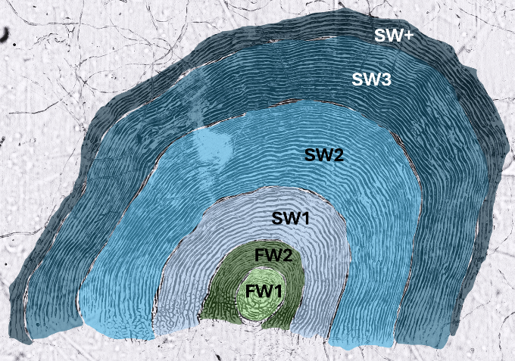
Figure 1. An age 2.3 sockeye scale (Left), and the annotated scale showing the growth zones that were measured (Right).

Preliminary Results and Plots
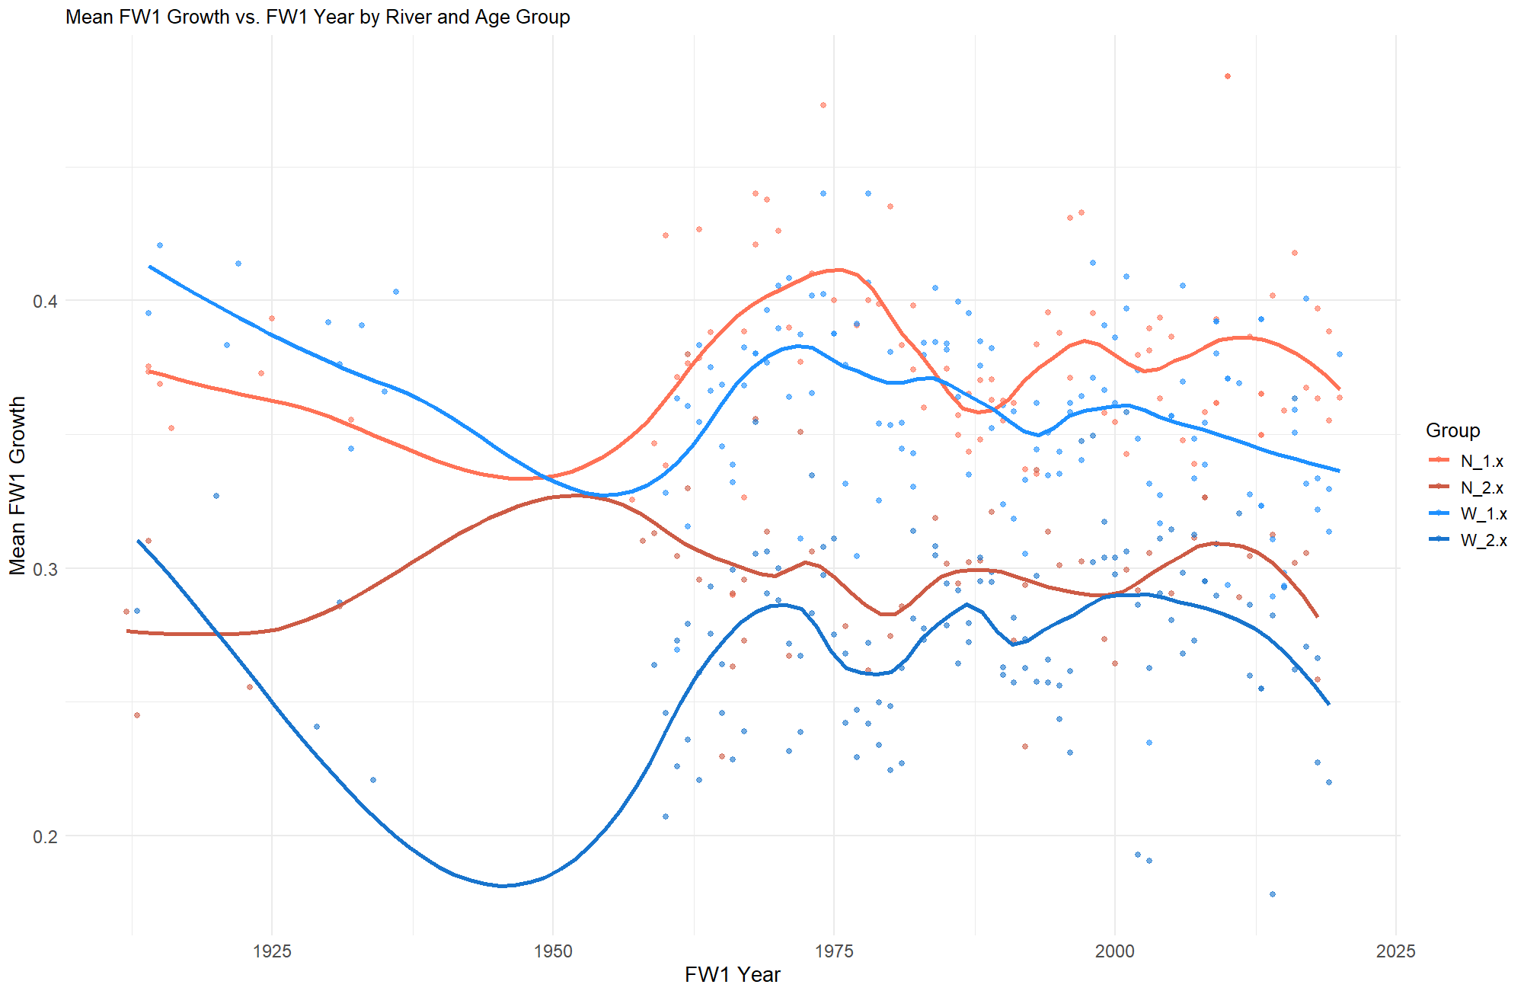
Figure 2. Mean freshwater growth of scales from the Nushagak (N) and (W) during the first year of scale growth, FW1, from the focus to the first annulus in fish with one year of freshwater residency (1.x) and in fish with two years of freshwater residency (2.x), fitted with a Loess model.
Freshwater growth of sockeye varied between the rivers and also between the residency times. Fish that spent only one year in freshwater before out-migrating had larger growth increments in year one than fish that stayed in freshwater for two years during the same growth period. This trend is consistent with the rivers as well with Wood fish having lower overall FW1 scale growth than Nushagak fish. Growth during the first year of ocean growth varied by river, but not by age class, and seems to vary throughout time.

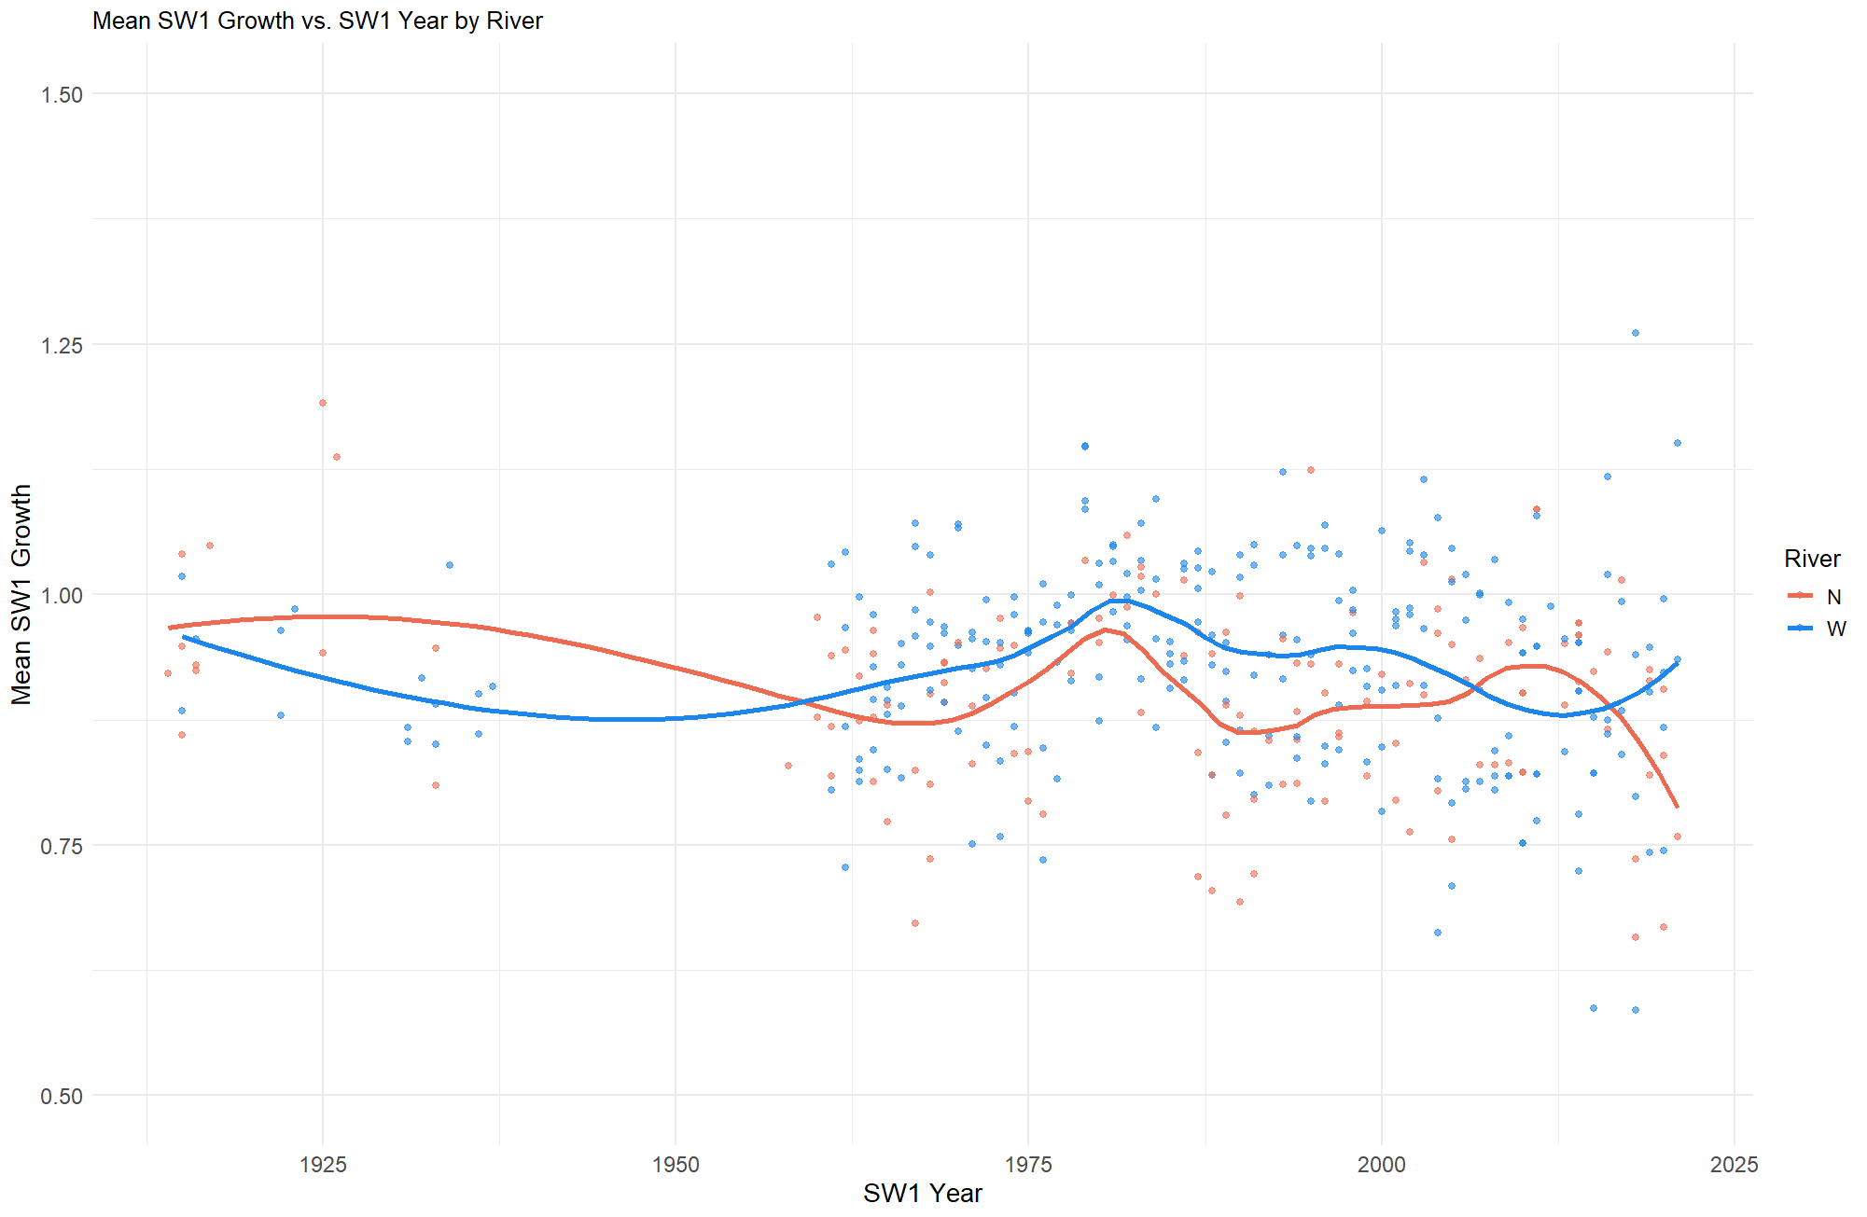
Figure 3. Mean saltwater growth of scales from the Nushagak (N) and Wood (W) during the first year of ocean growth, SW1, from the last freshwater annulus to the fist ocean annulus, in all four major age groups, fitted with a Loess model.

Preliminary Analysis on Freshwater Growth
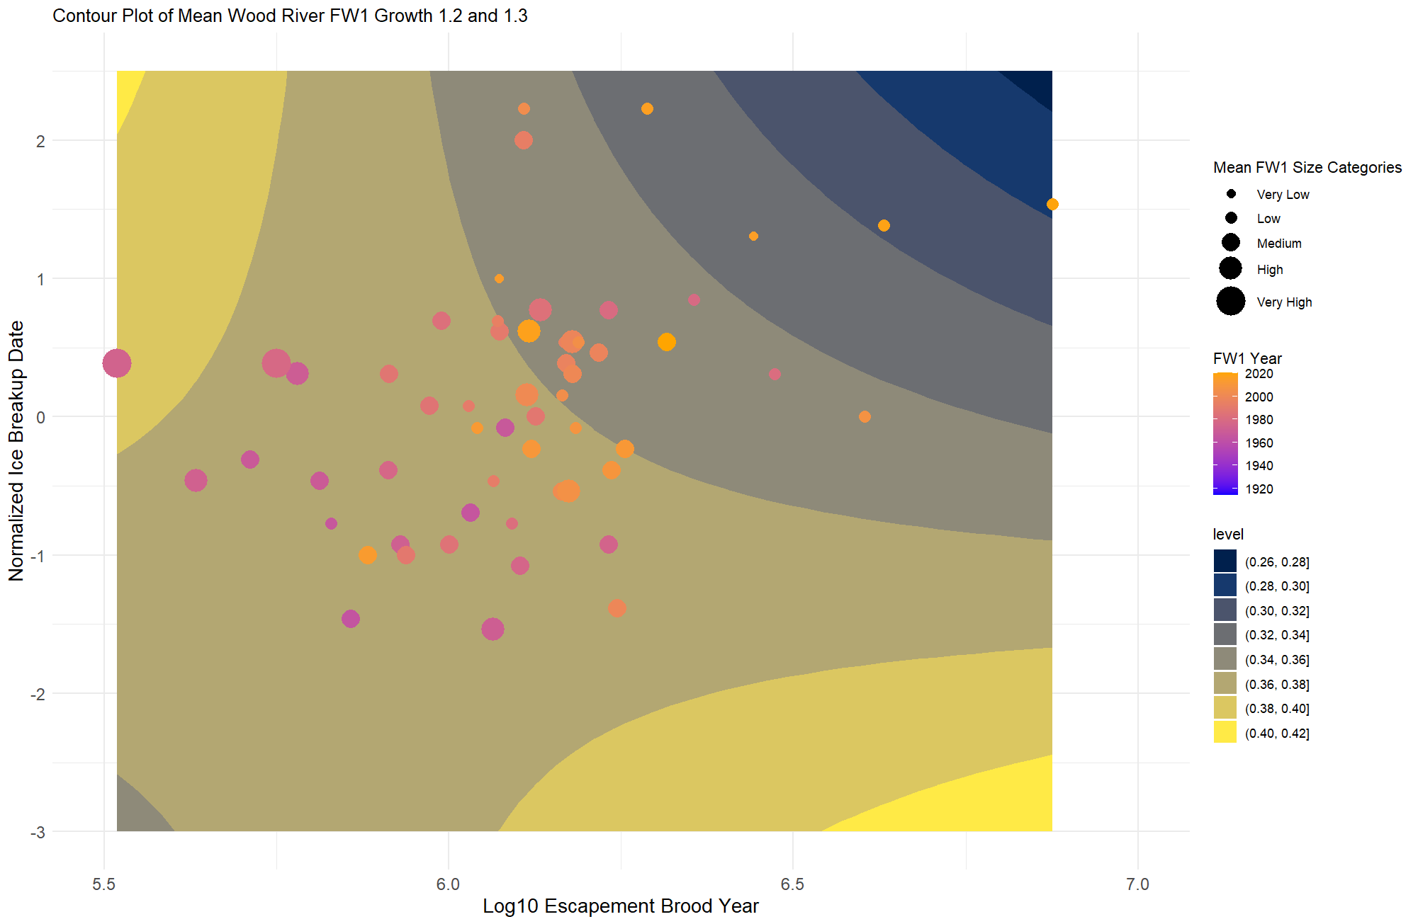
Figure 4. A contour plot and FW1 growth from scales of age 1.2 and 1.3 sockeye from the Wood river. The color of the point indicates the year, (recent = yellow, older = pink), the size of the point indicates the relative FW1 growth level, and the background contour plot indicates the predicted FW1 growth from the model with yellow = larger FW1 growth and blue = lower FW1 growth.

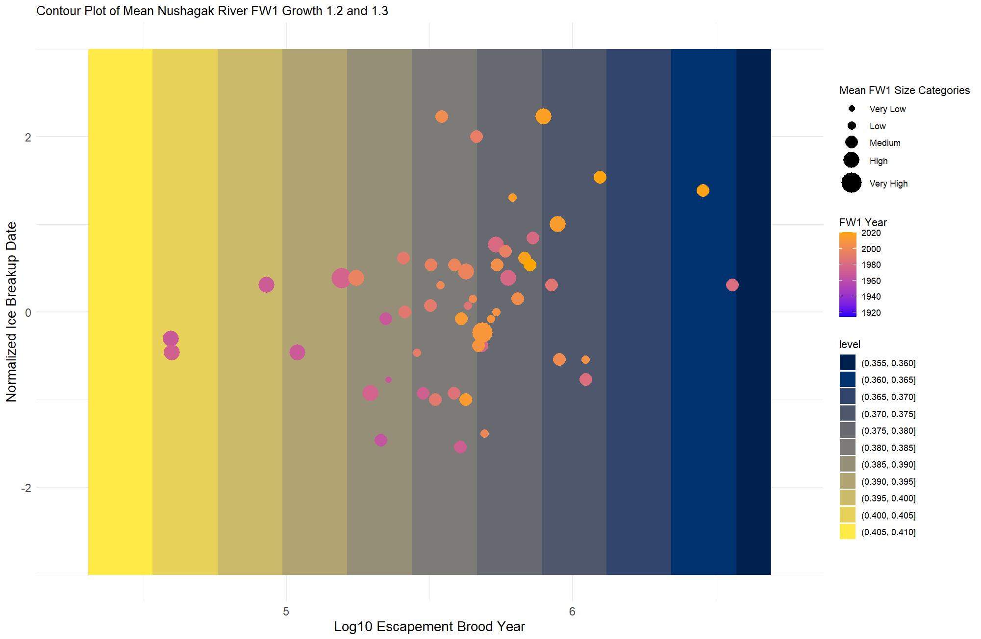
Figure 5. A contour plot and FW1 growth from scales of age 1.2 and 1.3 sockeye from the Nushagak river. The color of the point indicates the year, (recent = yellow, older = pink), the size of the point indicates the relative FW1 growth level, and the background contour plot indicates the predicted FW1 growth from the model with yellow = larger FW1 growth and blue = lower FW1 growth.

For the Wood river samples, I fit a linear model that took the escapement of sockeye salmon to the Wood river for the Brood year of the FW1 growth samples (a 1 – year lag), to account for density dependence during the FW1 growth period, p < 0.05, and the normalized Ice Breakup date from Lake Aleknagik, p = 0.06). Both the density dependence and the climate had significant or nearly significant effects on FW1 growth over the entire time series (Figure 4). In the Nushagak samples, Ice Breakup date did not have a significant effect on the FW1 growth, while escapement in the Brood Year did (P <0.05). Thus, the predictive contour plot does not include Ice Breakup as a component (Figure 5).

Proposed methods
Freshwater growth Methods
I will use variations of a Dynamic Linear Model to answer my questions about freshwater growth and include 2 variables and their effect sizes. My two variables are climate and density dependence, and I will test both the Ice Breakup on Lake Aleknagik dataset as well as the SNAP CRU dataset which reconstructs surface air temperature at 3m for the entire dataset, and has been extrapolated to have separate time series for the Nushagak lakes vs the Wood lakes, which would allow for watershed-specific responses in the model.
Using the freshwater growth data from the first year of residence, I will split the data into four groups based on the river (N or W), and the residence time (1.x or 2.x). Fish that stay for 2 years in the lakes before out migrating typically have smaller growth zones in the first year compared to fish that are able to growth enough in the first year to then out migrate the following year.
I will allow the effect size of density dependence and climate to vary through time, and test the assumption that both are affecting the fish through time, but that the effect size is changing between the lakes over time. I will use escapement from the broody year as a density dependence variable. Using this multivariate approach, I will be able to fully consider the breadth of Freshwater Hypotheses #1 and #2, and will be shaped by my approach to Freshwater Questions #1, 3 and 4. I will alter the below equations to test the two potential climate variable options, Ice Breakup and SNAP.
In order to consider Freshwater Question #5, which investigates the effect of FW1 growth size on fish return in that cohort year, I will also use a multivariate DLM to that takes three variables: Freshwater 1 growth, an ocean climate variable, and an ocean density variable, as this would potentially show any influences of FW1 growth on return size. I am less clear about how this would work, and if it would be better not to build a new stock recruit model for this and rather use the above questions to anecdotally assess the effect of FW1 growth and return years.
Example Equations:
H1: Both Nushagak and Wood 1.x growth (g) is affected by the escapement (V₁) and the climate variables (V₂), and the effect size is the same;
$${\overline{g}}_{\begin{aligned}1,t \\ \end{aligned}}= V_{1,t} × β_{t }+ V_{2,t} × α_{t }+ e_{t}$$
$${\overline{g}}_{\begin{aligned}2,t \\ \end{aligned}}= V_{1,t} × β_{t }+ V_{2,t} × α_{t }+ e_{2,t}$$
$$β_{t }= β_{t-1 }+ e_{β,t}$$
$$α_{t }= α_{t-1 }+ e_{α,t}$$
H2: Both Nushagak and Wood 1.x growth (g) is affected by the escapement (V₁) and the climate variable(V₂), but at different effect sizes;
$${\overline{g}}_{\begin{aligned}1,t \\ \end{aligned}}= V_{1,t} × β_{t }+ V_{2,t} × α_{t }+ e_{t}$$
$${\overline{g}}_{\begin{aligned}2,t \\ \end{aligned}}= V_{1,t} × β_{2,t }+ V_{2,t} × α_{2,t }+ e_{2,t}$$
$$β_{t }= β_{t-1 }+ e_{β,t}$$
$$α_{t }= α_{t-1 }+ e_{α,t}$$
Saltwater Growth Methods
Similar to the Freshwater Growth Methods, I will also use a multivariate DLM to investigate the Saltwater growth hypotheses and questions. It is understood that sockeye may change their feeding behavior during their second year at sea, and as such I will separate the SW1 year from the SW2 growth (Ruggerone et al.,2023). This will allow me to investigate Saltwater Question #4. I will also separate the stocks by river to answer Saltwater Growth Question #5. I will use the multivariate DLM model to compare the fit of using the PDO index vs the Ocean Heat Content index (or Alaska ColdPool data). I will use data from Dr. Ruggerone’s work on Pink Salmon abundance and ocean density dependence as an open-ocean density dependence variable.
To investigate the influence of marine heat waves or “blob” years on sockeye growth at sea, I will use the circuli width measurements (the inter-annual line formation on scales) during calendar years where a marine heatwave or blob was present in the North Pacific/Bering Sea. Circuli width is associated with somatic growth of the fish, and tightly-spaced circuli are associated with periods of slower growth. This formation of circuli is what scale readers use to distinguish winter growth from summer growth. However, in times of slower growth, such as during a stressful period, I hypothesize there will be a mid-summer formation of tightly packed circuli in what is known as a “false check” (Figure 6). I will compare the growth of the SW1 zone during the heatwave years to non-heatwave years, and I will also compare the individual circuli measurements during the marine heatwave years verses the “typical” years. Overall conclusions from my multivariate DLM will elucidate the connection between temperature and open-ocean growth, however, I will investigate the direct effect of anomaly events on sockeye growth.
The multivariate DLM will follow the same structure as the one above in the freshwater methods section, however I will have the following groups for the first hypothesis that saltwater growth responses are stock specific:
Nushagak SW1
Wood SW1
Nushagak SW2
Wood SW2
Nushagak and Wood SW1
Nushagak and Wood SW2

Starting by separating the stocks will allow me to understand how to approach the larger questions in the saltwater growth, and whether the stock specific-effects need to be included as a variable in the model.

Example Equations (if the stocks can be combined):
SW1 growth (g) is affected by the pink/sockeye abundance (V₁) and the climate variable (V₂), and SW2 growth (g2) is affected by pink/sockeye abundance (V1) and the climate variable (V2), but the effect sizes for both are different;
$${\overline{g}}_{\begin{aligned}1,t \\ \end{aligned}}= V_{1,t} × β_{t }+ V_{2,t} × α_{t }+ e_{t}$$
$${\overline{g}}_{\begin{aligned}2,t \\ \end{aligned}}= V_{1,t} × β_{2,t }+ V_{2,t} × α_{2,t }+ e_{2,t}$$
$$β_{t }= β_{t-1 }+ e_{β,t}$$
$$α_{t }= α_{t-1 }+ e_{α,t}$$

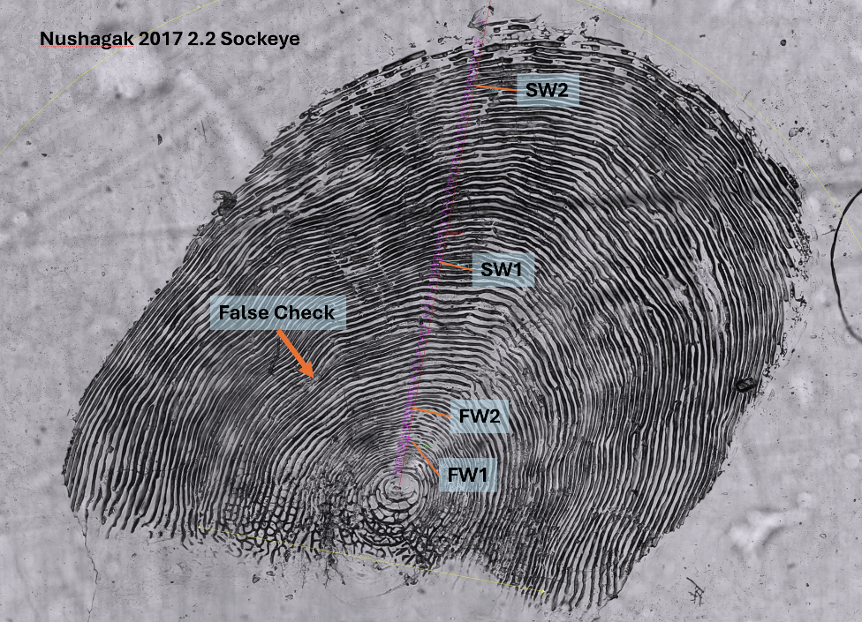
Figure 6. An annotated Nushagak 2.2 sockeye scale from 2017, showing the annuli marking and the false check, which in this scale would be associated with Summer 2015, during the first “Blob” marine heatwave.

