Image Encryption by RSA Algorithm upon Image Compression by DCT and Huffman Coding

(July - 19 -2022)

Albert Tsang Chun Ching, MSc Student in INFORMATION TECHNOLOGY

**Abstract**— Image Encryption and Image Compression are important for Image Transmission from Senders to Receivers (I will use Verifiers equivalent to Receivers in the context of this paper.) Image Encryption can guarantee the transmission security while Image Compression can reduce the bandwidth required for the transmission. This individual assignment will study the feasibility of Image Encryption by RSA Algorithm upon Image Compression by DCT and Huffman Coding.

**Index Terms** — # Image Encryption. # Image Compression. #Huffman Coding. # RSA Algorithm

THE HONG KONG POLYTECHNIC UNIVERSITY

————————————————

—————————— ◆ ——————————

# 1 Introduction

T

HIS individual assignment was inspired by COMP5422 LAB#3 hosted by Mr. Chengdong Dong in 2022 Semister 3. In LAB#3 , a simple key value is applied to the water-marked image for securing a particular image and also validating the image ownership by a embedded watermarks. In this individual assignment, I propose to use RSA Algorithm to validing the ownership of a particular 256x256 image and, at the same time, DCT and Huffman Coding will also be applied for Image Compression.

# 2 Proposed Workflow

## 2.1 RSA Key Pairs Generatioin

RSA Key Pairs Genenation starts from randomly chosing two different prime numbers; and then by the following mathematics, we can have a pair of private key and public key generated from the sender’s side.

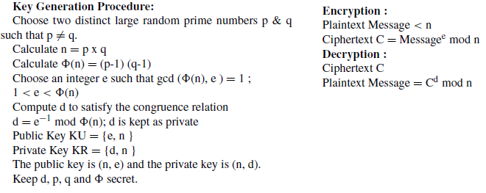

Fig. 1. RSA Key Pair Generation Mathematics [1]

## 2.2 Sender’s Side Compression and Encryption

The following flowchart depicts how the Sender compresses and encrypts a particular 256x256 image.

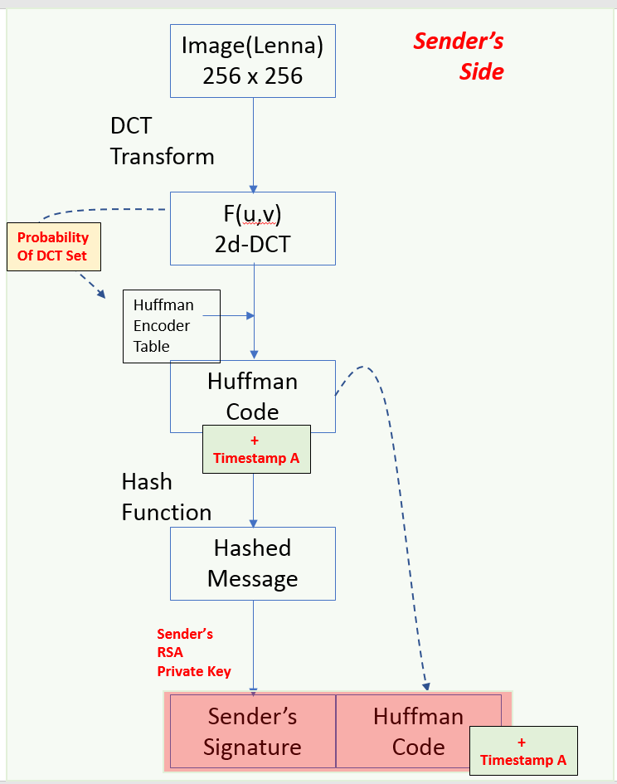

Fig. 2. Sender’s Side Compression and Encryption

Assuming the Sender has an 256x256 color image, before he sends out the image, he will first conduct DCT Transform towards the original image and then have an 2d-DCT image. We will then compute a probability set from the DCT image which it will also act as the Huffman Encoder Table for us encoding the DCT matrix into the Huffman Code. And then the timestamp at ther moment will be embedded in the Huffman code and then the whole object will be hashed. After that, the sender will use his RSA Private key to sign on this hashed message (i.e. Huffman code+timestamp) to produce a One-Time Sender Digital Signature. This One-Time Sender Digital Signature will be sent together with the Huffman code to the Receiver’s side (i.e. the verifier’s side).

## 2.3 Verifier’s Side Decryption and Decompression

The following flowchart depicts how the Receiver’s side (i.e. the verifier’s side) decrypts and decompresses the received pakage.

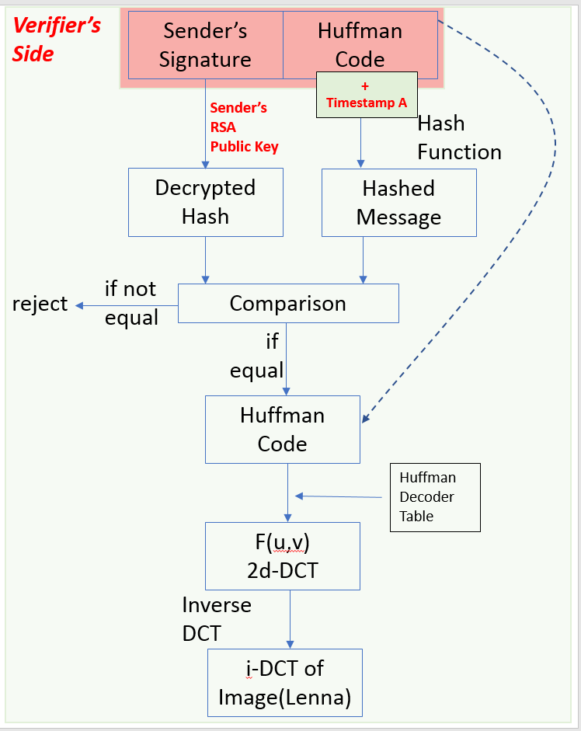

Fig. 3. Verifier Side Decryption and Decompression

When the verifier gets the sender’s one time digital signature with the Huffman code. The verifier will use the sender’s publiuc key to decrypt sender’s one time digital signature and get back the hash value. Then , comparision will be conducted between the hash value of decrypted signature and the hash value of the “Huffman code+timestamp”. If they are the same, Huffman decoding and inverse DCT will be conducted accordingly to recover ther image in gray level. If such verification fails, decoding process will stop (i.e. rejected).

# 3 Implementation

In this individual assignment, PYTHON will be used for implementing the ideas proposed in Section#2.

## 3.1 Folder Structure of my Individual assignment

There will be two python files simulating the Sender Application and the Verifier Application.

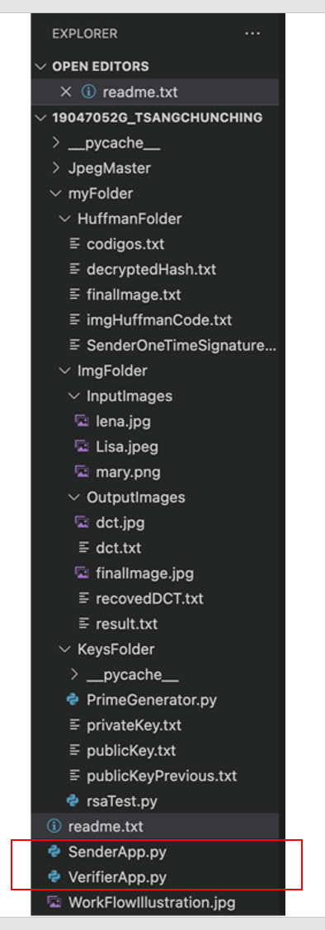

Fig. 4. Folder Structure containing SenderApp.py and VerifierApp.py

SenderApp.py will execute the workflow proposed in Fig2 while VerifierApp.py will execute the workflow proposed in Fig3. Commands for running the applications will be:

* python SenderApp.py ; and
* python VerifierApp.py .

Results from these two executions will be discussed in Section#4

## 3.2 RSA Key Pairs Generatioin Libray

The rsaTest.py is modified from a github library created by ErbaAitbayev[3]. Instead of two fixed primary number values, I advance the ErbaAitbayev’s library to rsaTest.py where two random prime numbers will be used. So that the key pairs alternate every time for a new image.

## 3.3 DCT and Huffman Coding

“Jpeg-master” with four python files is also a github library ; it was created by Edgard Diaz[2]. I only choose to use some of the methods from “Jpeg-master” which are in my concerns of this project. Overall, “Jpeg-master” can well address the the solution for Huffman encoding and decoding ; while it also provides methods towards DCT Transform and inverse DCT Transform. However, thereare two limitations that “Jpeg-master” is only able to handle 256x256 images and the recoved images are in gray level after decoding and decompressing. My individual assignemt is also inherited with the limitations of the “Jpeg-master” library. But it is enough to verify my hypoithesis proposed in Section#2.

# 4 Results

## 4.1 Overall Results

TABLE 1  
Lena vs Lisa vs Mary

|  |  |  |
| --- | --- | --- |
| Original Lena | Original Liza | Original Mary |
| Lena’s DCT | Liza’s DCT | Mary’s DCT |
| Recovered Img | Recovered Img | Recovered Img |

Table 1 shows the results of three 256x256 rgb images being converted to their corresponding DCT images and recovered back to gray-level images if verifications are successful.

## 4.2 Huffman Encoder Table

The following screencapture shows a selected portion of the Huffman Encoder Table of the Lena’s DCT which is used for Huffman coding:

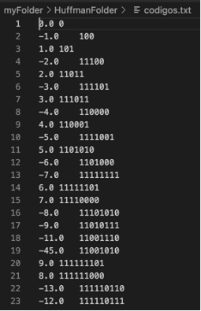

Fig. 5. Huffman Encoder Table of the Lena’s DCT

## 4.3 Signature Verification

The following screencapture shows successful verifications if the hash value of decrypted signature are equal the hash value of the “Huffman code+timestamp”:

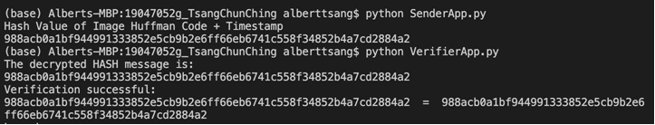

Fig. 6. Successful Verifications

If the verifier mistakenly uses an outdated public-key file(e.g. publicKeyPrevious.txt), he will fail to verify the identity and the decoding process will also stop. The following picture illustrates such a situation.

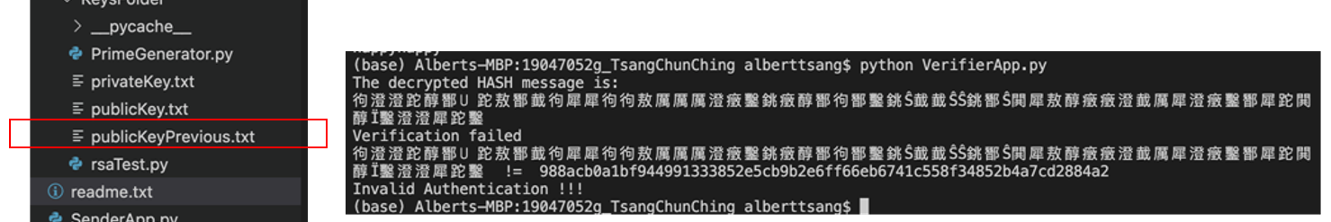

Fig. 7. Verifications fails due to Outdated Public Key File

# 5 Conclusion

Overall , the python works in this individual assignemt can primarily verify my ideas of Image Encryption by RSA Algorithm upon Image Compression by DCT and Huffman Coding. In the future, I may spend time on modifying the “Jpeg-master” libray such that it can also handle images in a wide range of resultions not only limited to 256x256. And this individual assignment may also base my personal interests in NFT by which we can manage the artwork ownership by using decentralized cryptographic techniologies.

**Acknowledgment**

This individual assignment was inspired by COMP5422 LAB#3 hosted by Mr. Chengdong Dong.

**References**

1. O. F. A. Wahab, A. A. M. Khalaf, A. I. Hussein and H. F. A. Hamed, "Hiding Data Using Efficient Combination of RSA Cryptography, and Compression Steganography Techniques," in IEEE Access, vol. 9, pp. 31805-31815, 2021, doi: 10.1109/ACCESS.2021.3060317.
2. Compression of images with JPEG algorithm using python and Huffman codes https://github.com/josgard94/JPEG
3. Simple Python RSA for digital signature with hashing implementationn https://gist.github.com/ErbaAitbyev/8f491c04af5fc1874e2b0744965a732b
4. COMP5422 Lecturer’s Notes : [Fundamentals of Data Compression] + [Image Compression Part 1] by Prof. Ajay Kumar
5. COMP5422 LAB#3 : [Watermaks on Image] by Mr. Chengdong Dong
6. THE HONG KONG POLYTECHNIC UNIVERSITY COMP 5521 Lecturer’s Notes : [Digital Signatures] by Prof. Bin Xiao