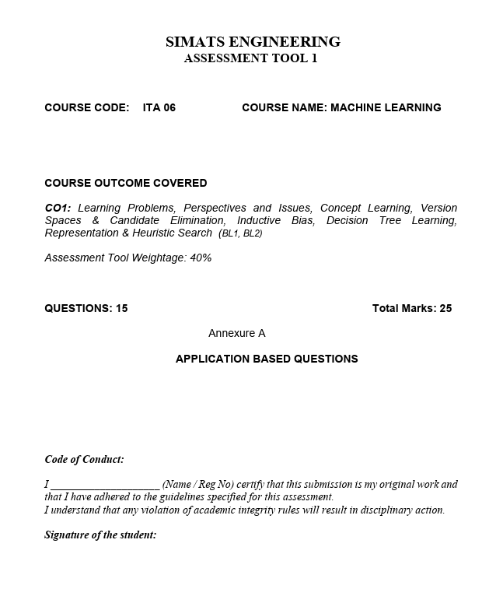

SIMATS ENGINEERING

Atsayaa .R
(192412024)

CO1-AT1
Short answer questions

ITA0606-
Machine learning

Date of submission :23.7.2026

1. Probability that the selected box was Box C (Bayes' Theorem)

Step 1: Prior Probabilities

Box B is twice as likely as A and C.

Let:
- P(A) = x
- P(B) = 2x
- P(C) = x

x + 2x + x = 1

4x = 1

x = 1/4

Therefore:
- P(A) = 1/4
- P(B) = 1/2
- P(C) = 1/4

Step 2: Probability of drawing a blue ball

P(Blue|A) = 4/12 = 1/3

P(Blue|B) = 7/15

P(Blue|C) = 2/15

Step 3: Total probability of drawing a blue ball

P(Blue) = P(A)P(Blue|A) + P(B)P(Blue|B) + P(C)P(Blue|C)

= (1/4)(1/3) + (1/2)(7/15) + (1/4)(2/15)

= 1/12 + 7/30 + 1/30

= 21/60

= 7/20

Step 4: Apply Bayes' Theorem

P(C|Blue) = [P(C)P(Blue|C)] / P(Blue)

= [(1/4)(2/15)] / (7/20)

= (1/30) × (20/7)

= 2/21

Answer:

Probability that the selected box was Box C = 2/21 ≈ 0.0952 (9.52%)

2. Probability that the blue car came from Section C

Step 1: Prior Probabilities

P(A) = 1/4

P(B) = 1/2

P(C) = 1/4

Step 2: Probability of selecting a blue car

P(Blue|A) = 3/10

P(Blue|B) = 6/15 = 2/5

P(Blue|C) = 2/15

Step 3: Total probability of blue car

P(Blue)

= (1/4)(3/10) + (1/2)(2/5) + (1/4)(2/15)

= 3/40 + 1/5 + 1/30

= 37/120

Step 4: Bayes' Theorem

P(C|Blue)

= [(1/4)(2/15)] / (37/120)

= (1/30)(120/37)

= 4/37

Answer:

Probability that the blue car came from Section C = 4/37 ≈ 0.1081 (10.81%)

3. Medical Image Classification Performance

Step 1: Test samples

Total dataset = 1800 + 1800 = 3600

Testing data = 20%

= 0.20 × 3600

= 720 samples

Step 2: Find FN

TP + TN + FP + FN = 720

210 + 190 + 30 + FN = 720

430 + FN = 720

FN = 290

Step 3: Accuracy

Accuracy

= (TP + TN)/(TP + TN + FP + FN)

= (210 + 190)/720

= 400/720

= 55.56%

Step 4: Precision

Precision

= TP/(TP + FP)

= 210/(210 + 30)

= 210/240

= 87.5%

Step 5: Sensitivity (Recall)

Recall

= TP/(TP + FN)

= 210/(210 + 290)

= 210/500

= 42%

Step 6: Specificity

Specificity

= TN/(TN + FP)

= 190/(190 + 30)

= 190/220

= 86.36%

Results
Metric | Value
FN | 290
Accuracy | 55.56%
Precision | 87.50%
Recall | 42.00%
Specificity | 86.36%

4. Training and Validation Loss Analysis

i) Epoch where overfitting begins
Epoch | Training Loss | Validation Loss
1 | 2.8 | 2.4
2 | 2.5 | 2.2
3 | 2.2 | 2.0
4 | 2.0 | 2.1
5 | 1.8 | 2.3
6 | 1.6 | 2.6
7 | 1.5 | 2.9
8 | 1.3 | 3.2

Validation loss starts increasing after Epoch 3 while training loss continues decreasing.

Answer:

Model begins overfitting at Epoch 4.

ii) Two techniques to reduce overfitting

Early Stopping

Stop training when validation loss begins increasing.

Dropout / Regularization

Randomly deactivate neurons or apply L1/L2 regularization.

iii) Effect on Generalization

Model memorizes training data.

Performs well on training data but poorly on unseen data.

Prediction accuracy decreases for new samples.

Conclusion:

Overfitting reduces the model's ability to generalize to real-world data.

5. Training and Validation Accuracy Analysis

i) Epoch where overfitting starts
Epoch | Train Accuracy | Validation Accuracy
1 | 60% | 58%
2 | 65% | 63%
3 | 70% | 68%
4 | 75% | 72%
5 | 80% | 73%
6 | 85% | 72%
7 | 88% | 70%
8 | 92% | 68%

Validation accuracy reaches maximum at Epoch 5 (73%) and decreases afterward.

Answer:

Overfitting starts at Epoch 6.

ii) Why does validation accuracy decrease?

The model begins memorizing training data.

It learns noise and irrelevant patterns.

Therefore, performance on unseen validation data drops.

iii) Two methods to improve validation performance

Data Augmentation

Increase diversity of training samples.

Regularization / Dropout

Prevent the model from becoming too complex.

Conclusion:

The model achieves the best balance at Epoch 5. Training beyond this point causes overfitting and reduces validation performance.

