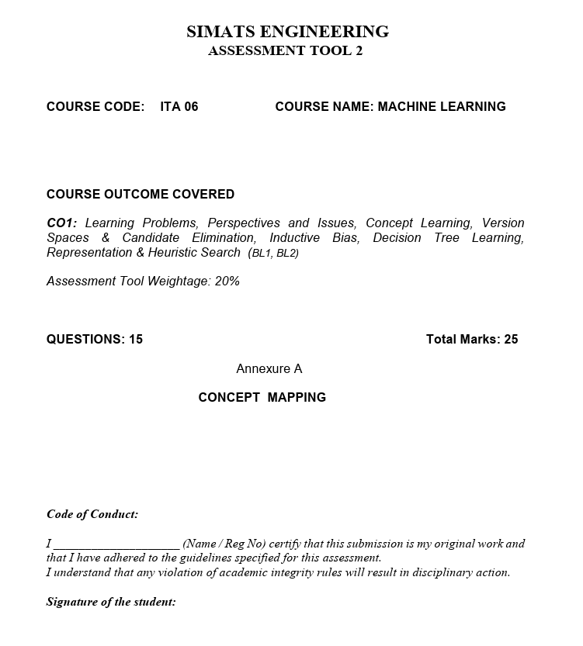

SIMATS ENGINEERING

Atsayaa.R
(192412024)

CO1-AT2
Concept Mapping

ITA0606-
Machine learning

Date of submission :23.7.2026

Question 1: Machine Learning System Blocks

Block Diagram

Data Collection

↓

Data Preprocessing

(Cleaning, Normalization)

↓

Feature Selection/Extraction

↓

Training Dataset

↓

Machine Learning Model

↓

Model Training

↓

Testing/Validation

↓

Prediction / Decision Making

↓

Performance Evaluation

Explanation of Blocks
- Data Collection – Gather data from sensors, databases, websites, etc.
- Data Preprocessing – Remove missing values and noise.
- Feature Selection – Select important attributes.
- Model Training – Train the ML algorithm.
- Testing/Validation – Check model performance.
- Prediction – Predict future outcomes.
- Evaluation – Measure accuracy, precision, recall, etc.

Supervised Learning Example

House Price Prediction

Input: House size, location, rooms

Output: House price

Known input-output pairs are used for training.

Unsupervised Learning Example

Customer Segmentation

Input: Customer purchase records

Output: Groups of similar customers

No target/output labels are provided.

Question 2: Disaster Management Prediction System

System Design

Historical Data + Real-Time Sensor Data

↓

Data Preprocessing

↓

Feature Selection

↓

ML Prediction Model

↓

Flood/Earthquake Prediction

↓

Early Warning System

Choice of Model

Random Forest for flood prediction

Neural Networks for earthquake prediction

Data Preprocessing

Remove missing values

Normalize data

Remove noise

Feature Selection

Flood:

Rainfall

River level

Soil moisture

Earthquake:

Seismic activity

Ground vibration

Magnitude history

(a) Training, Validation and Evaluation

Collect data

Split into training and testing sets

Train model

Validate model

Evaluate using Accuracy, Precision, Recall

(b) Early Warning and Emergency Response

Predict disasters before occurrence

Send alerts to authorities

Assist evacuation planning

Reduce property and human loss

Question 3: Find-S Algorithm – Tennis Dataset

Positive Examples Only
Example | Outlook | Temp | Humidity | Wind
3 | Overcast | Hot | High | Weak
4 | Rainy | Mild | High | Weak
5 | Rainy | Cool | Normal | Weak
7 | Overcast | Mild | Normal | Strong

Step 1

H₁ = <Overcast, Hot, High, Weak>

Step 2 (Example 4)

Compare with H₁

H₂ = <?, ?, High, Weak>

Step 3 (Example 5)

H₃ = <?, ?, ?, Weak>

Step 4 (Example 7)

H₄ = <?, ?, ?, ?>

Final Hypothesis

H = <?, ?, ?, ?>

(All attributes become generalized)

Question 4: Candidate Elimination Algorithm
Initial Boundaries
Specific Boundary:
S₀ = <Ø, Ø, Ø, Ø>
General Boundary:
G₀ = <?, ?, ?, ?>

Example 1 (Sunny, Warm, Normal, Weak) → Yes
S₁ = <Sunny, Warm, Normal, Weak>
G₁ = <?, ?, ?, ?>

Example 2 (Sunny, Warm, High, Strong) → Yes
S₂ = <Sunny, Warm, ?, ?>
G₂ = <?, ?, ?, ?>

Example 3 (Rainy, Cold, High, Weak) → No
Specialize G
G₃ = {
<Sunny, ?, ?, ?>,
<?, Warm, ?, ?>
}

Example 4 (Sunny, Cold, Normal, Weak) → Yes
S₄ = <Sunny, ?, ?, ?>
Remove inconsistent hypotheses
G₄ = {<Sunny, ?, ?, ?>}

Example 5 (Rainy, Warm, Normal, Strong) → No
No change required
Final Boundaries
Specific Boundary (S):
<Sunny, ?, ?, ?>
General Boundary (G):
{<Sunny, ?, ?, ?>}

Question 5: Find-S Algorithm – Product Purchase Dataset
Positive Examples
Example | Age | Income | Student | Credit Rating
3 | Middle | High | No | Fair
4 | Senior | Medium | No | Fair
Step 1
H₁ = <Middle, High, No, Fair>
Step 2
Compare Example 4
- Middle ≠ Senior → ?
- High ≠ Medium → ?
- No = No → No
- Fair = Fair → Fair
H₂ = <?, ?, No, Fair>
Final Hypothesis
H = <?, ?, No, Fair>
Interpretation
A customer is likely to buy the product if:
- Student = No
- Credit Rating = Fair
- Age and Income can be any value.

