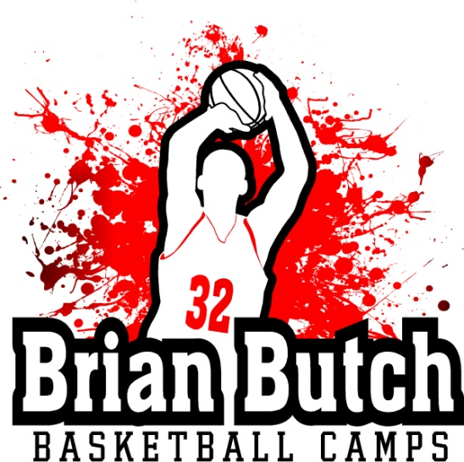

**PRESEASON BASKETBALL TRAINING**

Brian Butch Basketball Camps is offering a preseason workout program to get you primed and ready for the upcoming basketball season. This 2 day a week program will be held in the field house at Hortonville High school and will feature skill development in ball handling, shooting,as well as, conditioning and some scrimmaging. Former Denver Nugget and Wisconsin Badger Brian Butch along with Hortonville Head Varsity Coach Craig Hawley will be the primary instructors. Program will run for 3 weeks starting on October 11th with workouts each Tuesday and Thursday going from 7pm-830pm. The program is offered for boys and girls in grades 5 thru 8. Cost is $50 per player.

Please make checks payable to Brian Butch Basketball Camps 1532 Remington Rd Neenah WI 54956. For more information email Rich Kuranda at [rjkuranda@aol.com](mailto:rjkuranda@aol.com)

______________________________________________________________________________

Name_________________________________Phone_____________________________

Address_________________________________________________________________

Phone_________________ Email____________________________________________

School next fall_____________________________________ Grade next fall__________