CaRT Demonstration

JAS

null

## Demonstration of Classification and Regression Trees (CaRT) using R

This demonstration of classification and regression trees (CaRT) will utilize the 2019 County Health Rankings. The rankings provide data on a number of demographic, social and environmental health characteristics for counties in the United States. We will be using this dataset to address two research questions.

1. What are the predictors of life expectacy on a county-level?
2. Imagine a scenario where the maintainers of the CHR were concerned that the data on firearm fatalities would no longer be made public. This information has been use by a number of foundations to target population-based interventions at reducing gun violence. They are wondering if the counties with higher proportions of firearm fatalities would still be able to be identified, based on the other data within the CHR. That is, can the other data in the CHR be used to classify counties according to having higher or lower firearm_fatalities?

The first question will be addressed with a regression tree, while the second will be addressed with a classification tree.

### Step 1: Load needed packages

We will be using two different packages: rpart and caret. Both of these packages allow us to construct classification and regression trees, but they have different levels of functionality. Also loading tidyverse for some data wrangling and rpart.plot which makes cleaner looking plots of the trees.

library(tidyverse)

## ── Attaching packages ──────────────────────────────────────────────────────────────── tidyverse 1.2.1 ──

## ✓ ggplot2 3.2.1 ✓ purrr 0.3.2  
## ✓ tibble 2.1.3 ✓ dplyr 0.8.3  
## ✓ tidyr 1.0.0 ✓ stringr 1.4.0  
## ✓ readr 1.3.1 ✓ forcats 0.4.0

## ── Conflicts ─────────────────────────────────────────────────────────────────── tidyverse_conflicts() ──  
## x dplyr::filter() masks stats::filter()  
## x dplyr::lag() masks stats::lag()

library(rpart)  
library(caret)

## Loading required package: lattice

##   
## Attaching package: 'caret'

## The following object is masked from 'package:purrr':  
##   
## lift

library(rpart.plot)  
library(pROC)

## Type 'citation("pROC")' for a citation.

##   
## Attaching package: 'pROC'

## The following objects are masked from 'package:stats':  
##   
## cov, smooth, var

### Step 2: Load and check data

Variable names in the original dataset were not informative, so we need to append our own as column names. We also need to strip off the Id variable for easier processing. We’re also going to look at some basic descriptives of the data to determine if it needs cleaning, imputation of missing data, etc.

chr = read.csv("/Users/ashleytseng/OneDrive - cumc.columbia.edu/MPH/Spring 2020/EPID P8451_Machine Learning/Sessions/Session 5/p8451_session5/chr.csv")  
  
chr = chr[,2:68]  
  
var.names = c("pre_death", "poorhealth", "poorphyshealth_days", "poormenthealth_days", "low_bwt", "ad_smoking", "ad_obesity", "foodenv_index", "phys_inactivity", "exer_access", "excess_drink", "alc_drivdeaths", "sti", "teen_birth", "uninsured", "primcareproviders", "dentists", "menthealthproviders", "prevhosp", "mammo_screen", "flu_vacc", "hsgrad", "somecollege", "unemployed", "child_poverty", "income_ineq", "sing_parent", "social_assoc", "violent_crime", "injury_deaths", "pm_air", "water_viol", "housing_prob", "driving_alone", "long_commute", "life_exp", "age_adj_premortality", "freq_physdistress", "freq_mentdistress", "diabetes", "hiv", "food_insecure", "ltd_access_healthyfood", "mvcrash_deaths", "insuff_sleep", "uninsured_adults", "uninsured_child", "other_pcp", "medhhinc", "freelunch_child", "res_seg_bw", "res_seg_nw", "firearm_fatalities", "homeownership", "hous_cost_burden", "population", "bw18", "gte65", "nonhisp_afam", "AmerInd_AlasNative", "Asian", "OPacIslander", "Hisp", "nonhisp_white", "nonprof_english", "female", "rural")  
  
colnames(chr) = var.names  
  
# The following two variables are too close as proxies for the life expectancy outcomes. If we don't think we should be using them in the future, then we shouldn't use them now.  
chr$age_adj_premortality = NULL   
chr$pre_death = NULL  
  
  
#Will idenitify any rows that do not have complete cases (i.e. have missing data)  
miss.rows = chr[!complete.cases(chr),]  
  
summary(chr)

## poorhealth poorphyshealth_days poormenthealth_days  
## Min. :0.08289 Min. :2.324 Min. :2.440   
## 1st Qu.:0.13948 1st Qu.:3.393 1st Qu.:3.493   
## Median :0.16687 Median :3.869 Median :3.932   
## Mean :0.17468 Mean :3.920 Mean :3.932   
## 3rd Qu.:0.20432 3rd Qu.:4.409 3rd Qu.:4.348   
## Max. :0.40732 Max. :7.231 Max. :5.964   
## low_bwt ad_smoking ad_obesity foodenv_index   
## Min. :0.02646 Min. :0.06735 Min. :0.1360 Min. : 0.000   
## 1st Qu.:0.06794 1st Qu.:0.15234 1st Qu.:0.2930 1st Qu.: 6.900   
## Median :0.07877 Median :0.17316 Median :0.3230 Median : 7.700   
## Mean :0.08112 Mean :0.17867 Mean :0.3203 Mean : 7.465   
## 3rd Qu.:0.09029 3rd Qu.:0.20275 3rd Qu.:0.3500 3rd Qu.: 8.200   
## Max. :0.26136 Max. :0.42754 Max. :0.4950 Max. :10.000   
## phys_inactivity exer_access excess_drink alc_drivdeaths   
## Min. :0.0840 Min. :0.0000 Min. :0.09265 Min. :0.0000   
## 1st Qu.:0.2220 1st Qu.:0.4928 1st Qu.:0.15102 1st Qu.:0.2033   
## Median :0.2560 Median :0.6671 Median :0.17403 Median :0.2857   
## Mean :0.2564 Mean :0.6319 Mean :0.17431 Mean :0.2927   
## 3rd Qu.:0.2910 3rd Qu.:0.8028 3rd Qu.:0.19678 3rd Qu.:0.3600   
## Max. :0.4510 Max. :1.0000 Max. :0.29440 Max. :1.0000   
## sti teen_birth uninsured primcareproviders   
## Min. : 40.1 Min. : 2.395 Min. :0.02068 Min. :0.0000000   
## 1st Qu.: 224.0 1st Qu.: 21.339 1st Qu.:0.07156 1st Qu.:0.0003311   
## Median : 336.8 Median : 31.432 Median :0.10364 Median :0.0005104   
## Mean : 385.2 Mean : 31.983 Mean :0.11108 Mean :0.0005494   
## 3rd Qu.: 469.2 3rd Qu.: 40.934 3rd Qu.:0.13987 3rd Qu.:0.0007067   
## Max. :3543.9 Max. :110.236 Max. :0.33454 Max. :0.0047722   
## dentists menthealthproviders prevhosp mammo_screen   
## Min. :0.0000000 Min. :0.0000000 Min. : 471 Min. :0.0700   
## 1st Qu.:0.0002661 1st Qu.:0.0004945 1st Qu.: 3680 1st Qu.:0.3500   
## Median :0.0004211 Median :0.0011861 Median : 4668 Median :0.4000   
## Mean :0.0004571 Mean :0.0015167 Mean : 4820 Mean :0.3999   
## 3rd Qu.:0.0006041 3rd Qu.:0.0019290 3rd Qu.: 5721 3rd Qu.:0.4500   
## Max. :0.0072513 Max. :0.0200266 Max. :33333 Max. :0.6200   
## flu_vacc hsgrad somecollege unemployed   
## Min. :0.0300 Min. :0.2564 Min. :0.1676 Min. :0.01624   
## 1st Qu.:0.3500 1st Qu.:0.8471 1st Qu.:0.4953 1st Qu.:0.03522   
## Median :0.4200 Median :0.8918 Median :0.5791 Median :0.04362   
## Mean :0.4055 Mean :0.8825 Mean :0.5774 Mean :0.04612   
## 3rd Qu.:0.4800 3rd Qu.:0.9333 3rd Qu.:0.6622 3rd Qu.:0.05339   
## Max. :0.6500 Max. :1.0000 Max. :0.9367 Max. :0.20071   
## child_poverty income_ineq sing_parent social_assoc   
## Min. :0.0270 Min. : 2.556 Min. :0.0000 Min. : 0.000   
## 1st Qu.:0.1470 1st Qu.: 4.018 1st Qu.:0.2569 1st Qu.: 9.337   
## Median :0.2040 Median : 4.421 Median :0.3183 Median :12.531   
## Mean :0.2149 Mean : 4.519 Mean :0.3240 Mean :13.736   
## 3rd Qu.:0.2660 3rd Qu.: 4.868 3rd Qu.:0.3773 3rd Qu.:16.427   
## Max. :0.7470 Max. :10.100 Max. :1.0000 Max. :70.621   
## violent_crime injury_deaths pm_air water_viol   
## Min. : 0.0 Min. : 25.59 Min. : 3.000 Min. :0.0000   
## 1st Qu.: 124.4 1st Qu.: 68.98 1st Qu.: 7.700 1st Qu.:0.0000   
## Median : 221.2 Median : 82.21 Median : 9.300 Median :0.0000   
## Mean : 254.1 Mean : 84.80 Mean : 9.011 Mean :0.3867   
## 3rd Qu.: 328.7 3rd Qu.: 96.41 3rd Qu.:10.400 3rd Qu.:1.0000   
## Max. :1819.5 Max. :284.96 Max. :19.700 Max. :1.0000   
## housing_prob driving_alone long_commute life_exp   
## Min. :0.03038 Min. :0.04585 Min. :0.0000 Min. :62.44   
## 1st Qu.:0.11340 1st Qu.:0.77180 1st Qu.:0.2160 1st Qu.:75.59   
## Median :0.13846 Median :0.80944 Median :0.3050 Median :77.48   
## Mean :0.14276 Mean :0.79489 Mean :0.3096 Mean :77.46   
## 3rd Qu.:0.16461 3rd Qu.:0.83953 3rd Qu.:0.3940 3rd Qu.:79.27   
## Max. :0.71217 Max. :0.97207 Max. :0.8450 Max. :97.97   
## freq_physdistress freq_mentdistress diabetes hiv   
## Min. :0.06937 Min. :0.08035 Min. :0.033 Min. : 10.4   
## 1st Qu.:0.10205 1st Qu.:0.10793 1st Qu.:0.097 1st Qu.: 85.2   
## Median :0.11714 Median :0.12090 Median :0.114 Median : 173.4   
## Mean :0.11984 Mean :0.12209 Mean :0.116 Mean : 190.8   
## 3rd Qu.:0.13527 3rd Qu.:0.13463 3rd Qu.:0.133 3rd Qu.: 190.8   
## Max. :0.24618 Max. :0.22206 Max. :0.209 Max. :2590.2   
## food_insecure ltd_access_healthyfood mvcrash_deaths insuff_sleep   
## Min. :0.0370 Min. :0.00000 Min. : 2.807 Min. :0.2303   
## 1st Qu.:0.1100 1st Qu.:0.03652 1st Qu.:12.758 1st Qu.:0.3004   
## Median :0.1310 Median :0.06559 Median :18.843 Median :0.3299   
## Mean :0.1369 Mean :0.08615 Mean :18.843 Mean :0.3306   
## 3rd Qu.:0.1570 3rd Qu.:0.10583 3rd Qu.:22.543 3rd Qu.:0.3613   
## Max. :0.3610 Max. :0.71844 Max. :92.162 Max. :0.4671   
## uninsured_adults uninsured_child other_pcp medhhinc   
## Min. :0.02543 Min. :0.007647 Min. :0.0000000 Min. : 22679   
## 1st Qu.:0.08259 1st Qu.:0.036064 1st Qu.:0.0004475 1st Qu.: 42437   
## Median :0.12309 Median :0.050010 Median :0.0006747 Median : 49070   
## Mean :0.13253 Mean :0.058402 Mean :0.0007743 Mean : 51237   
## 3rd Qu.:0.17021 3rd Qu.:0.072005 3rd Qu.:0.0009653 3rd Qu.: 56965   
## Max. :0.40679 Max. :0.232258 Max. :0.0143389 Max. :136191   
## freelunch_child res_seg_bw res_seg_nw firearm_fatalities  
## Min. :0.0000 Min. : 0.6328 Min. : 0.04508 Min. : 1.7   
## 1st Qu.:0.4146 1st Qu.:40.8522 1st Qu.:23.67956 1st Qu.:12.1   
## Median :0.5269 Median :45.7702 Median :31.28347 Median :15.1   
## Mean :0.5347 Mean :45.7702 Mean :31.28347 Mean :15.1   
## 3rd Qu.:0.6304 3rd Qu.:51.3547 3rd Qu.:38.15045 3rd Qu.:16.6   
## Max. :1.0000 Max. :91.1238 Max. :91.09909 Max. :76.8   
## homeownership hous_cost_burden population bw18   
## Min. :0.03774 Min. :0.00463 Min. : 88 Min. :0.0000   
## 1st Qu.:0.67354 1st Qu.:0.09048 1st Qu.: 11134 1st Qu.:0.2021   
## Median :0.72456 Median :0.11096 Median : 26484 Median :0.2223   
## Mean :0.71244 Mean :0.11534 Mean : 204021 Mean :0.2224   
## 3rd Qu.:0.76826 3rd Qu.:0.13548 3rd Qu.: 72564 3rd Qu.:0.2399   
## Max. :0.93452 Max. :0.31641 Max. :39536653 Max. :0.4124   
## gte65 nonhisp_afam AmerInd_AlasNative  
## Min. :0.04767 Min. :0.000000 Min. :0.000000   
## 1st Qu.:0.15813 1st Qu.:0.006941 1st Qu.:0.003731   
## Median :0.18386 Median :0.022409 Median :0.006340   
## Mean :0.18768 Mean :0.090019 Mean :0.023246   
## 3rd Qu.:0.21224 3rd Qu.:0.102937 3rd Qu.:0.013103   
## Max. :0.56944 Max. :0.853296 Max. :0.926969   
## Asian OPacIslander Hisp   
## Min. :0.000000 Min. :0.0000000 Min. :0.005151   
## 1st Qu.:0.004507 1st Qu.:0.0003040 1st Qu.:0.023124   
## Median :0.007159 Median :0.0005972 Median :0.043213   
## Mean :0.015739 Mean :0.0014095 Mean :0.095168   
## 3rd Qu.:0.014429 3rd Qu.:0.0011427 3rd Qu.:0.098455   
## Max. :0.430067 Max. :0.4772727 Max. :0.963230   
## nonhisp_white nonprof_english female rural   
## Min. :0.0276 Min. :0.000000 Min. :0.2657 Min. :0.0000   
## 1st Qu.:0.6428 1st Qu.:0.002801 1st Qu.:0.4942 1st Qu.:0.3260   
## Median :0.8346 Median :0.007502 Median :0.5032 Median :0.5876   
## Mean :0.7616 Mean :0.017475 Mean :0.4990 Mean :0.5806   
## 3rd Qu.:0.9247 3rd Qu.:0.018927 3rd Qu.:0.5103 3rd Qu.:0.8590   
## Max. :0.9792 Max. :0.353053 Max. :0.5700 Max. :1.0000

#variables have very different distributions, but tree-based methods do not require scaling.  
  
#Create the variable for Question 2, an indicator of having fire-arm fatalities above the median  
  
chr$firearm.class = as.factor(ifelse(chr$firearm_fatalities>median(chr$firearm_fatalities),1,0))  
summary(chr$firearm.class)

## 0 1   
## 2210 983

#Data are slightly unbalanced. This is important to note because the model will have good accuracy even if it classifies as all observations as "firearm.class = 0" because there are more observations under that category.

### Step 3: Partition data into training and testing sets.

set.seed(100)  
#To address Question 1   
training.data.q1 = chr$life_exp %>% createDataPartition(p = 0.7, list = F)  
train.data.q1 = chr[training.data.q1, ]  
test.data.q1 = chr[-training.data.q1, ]  
  
train.data.q1$firearm.class = NULL  
test.data.q1$firearm.class = NULL  
  
#To address Question 2  
training.data.q2 = chr$firearm.class%>% createDataPartition(p = 0.7, list = F)  
train.data.q2 = chr[training.data.q2, ]  
test.data.q2 = chr[-training.data.q2, ]  
  
train.data.q2$firearm_fatalities = NULL  
test.data.q2$firearm_fatalities = NULL

### Step 4: PART 1: REGRESSION TREES

We will create a number of regression trees to predict life expectancy. First, we will use the default values of rpart. Then, we will vary some of the control parameters.

From the rpart documentation, this lists the defaults of rpart.control rpart.control(minsplit = 20, minbucket = round(minsplit/3), cp = 0.01, maxcompete = 4, maxsurrogate = 5, usesurrogate = 2, xval = 10, surrogatestyle = 0, maxdepth = 30, …)

Variable Importance: “An overall measure of variable importance is the sum of the goodness of split measures for each split for which it was the primary variable.”

Trees prefer continuous variables since there are more options to split at (vs. categorical variables).

#Regression Tree 1-default values of rpart  
tree.lifexp = rpart(life_exp ~ ., data = train.data.q1, method = "anova") # method would be different for binary outcome  
plot(tree.lifexp, uniform = TRUE)  
text(tree.lifexp, use.n = TRUE, all = TRUE, cex = 0.8)

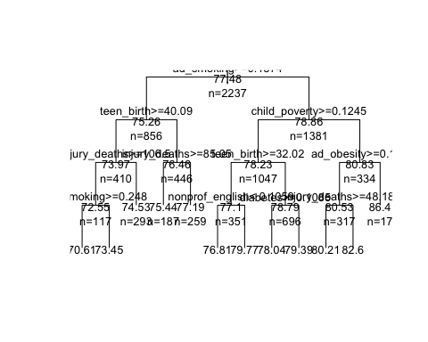

printcp(tree.lifexp)

##   
## Regression tree:  
## rpart(formula = life_exp ~ ., data = train.data.q1, method = "anova")  
##   
## Variables actually used in tree construction:  
## [1] ad_obesity ad_smoking child_poverty diabetes   
## [5] injury_deaths nonprof_english teen_birth   
##   
## Root node error: 19796/2237 = 8.8495  
##   
## n= 2237   
##   
## CP nsplit rel error xerror xstd  
## 1 0.344323 0 1.00000 1.00067 0.047147  
## 2 0.086887 1 0.65568 0.68582 0.038907  
## 3 0.066718 2 0.56879 0.59557 0.034166  
## 4 0.034003 3 0.50207 0.53514 0.031953  
## 5 0.028010 4 0.46807 0.51420 0.031871  
## 6 0.016851 5 0.44006 0.48018 0.027061  
## 7 0.016568 6 0.42321 0.45828 0.026198  
## 8 0.015758 7 0.40664 0.45475 0.026135  
## 9 0.013551 8 0.39088 0.44235 0.025764  
## 10 0.010715 9 0.37733 0.43436 0.025526  
## 11 0.010283 10 0.36661 0.43210 0.025664  
## 12 0.010000 11 0.35633 0.42920 0.025816

plotcp(tree.lifexp)

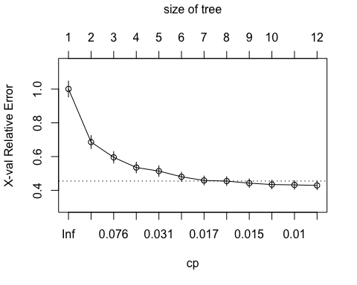

print(tree.lifexp)

## n= 2237   
##   
## node), split, n, deviance, yval  
## * denotes terminal node  
##   
## 1) root 2237 19796.3300 77.48154   
## 2) ad_smoking>=0.1873709 856 4299.5740 75.26436   
## 4) teen_birth>=40.08801 410 1678.0850 73.96882   
## 8) injury_deaths>=106.5088 117 615.8804 72.55341   
## 16) ad_smoking>=0.2480356 37 186.2220 70.61382 *  
## 17) ad_smoking< 0.2480356 80 226.0859 73.45048 *  
## 9) injury_deaths< 106.5088 293 734.2144 74.53401 *  
## 5) teen_birth< 40.08801 446 1300.7260 76.45532   
## 10) injury_deaths>=85.04951 187 404.6919 75.43752 *  
## 11) injury_deaths< 85.04951 259 562.4472 77.19019 *  
## 3) ad_smoking< 0.1873709 1381 8680.4270 78.85585   
## 6) child_poverty>=0.1245 1047 4837.1390 78.22551   
## 12) teen_birth>=32.02208 351 1722.3570 77.09641   
## 24) nonprof_english< 0.1059455 317 1066.2170 76.81010 *  
## 25) nonprof_english>=0.1059455 34 387.8794 79.76582 *  
## 13) teen_birth< 32.02208 696 2441.6410 78.79492   
## 26) diabetes>=0.1085 306 927.2700 78.03912 *  
## 27) diabetes< 0.1085 390 1202.4230 79.38794 *  
## 7) child_poverty< 0.1245 334 2123.2340 80.83179   
## 14) ad_obesity>=0.197 317 1215.2650 80.53341   
## 28) injury_deaths>=48.17918 274 867.4213 80.20935 *  
## 29) injury_deaths< 48.17918 43 135.7168 82.59836 *  
## 15) ad_obesity< 0.197 17 353.4709 86.39573 *

rpart.plot(tree.lifexp) # Pretty tree plot!

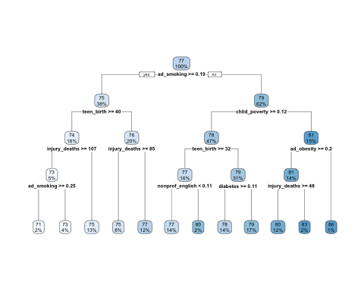

#Regression Tree 2- varying values in rpart.control, specifically going to cp = 0.001, to find minimum cv-error  
tree.lifexp.2 = rpart(life_exp ~ ., data = train.data.q1, method = "anova", control = rpart.control(cp = 0.001))  
plotcp(tree.lifexp.2)

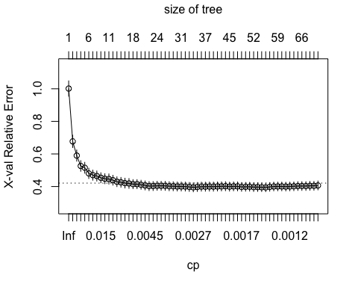

rpart.plot(tree.lifexp.2)

## Warning: labs do not fit even at cex 0.15, there may be some overplotting

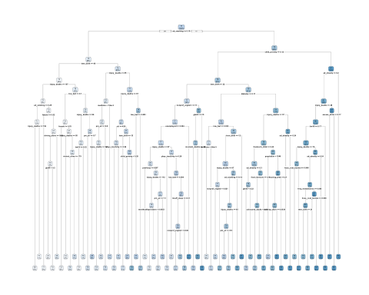

printcp(tree.lifexp.2)

##   
## Regression tree:  
## rpart(formula = life_exp ~ ., data = train.data.q1, method = "anova",   
## control = rpart.control(cp = 0.001))  
##   
## Variables actually used in tree construction:  
## [1] ad_obesity ad_smoking bw18   
## [4] child_poverty diabetes driving_alone   
## [7] excess_drink female food_insecure   
## [10] freelunch_child freq_mentdistress gte65   
## [13] hous_cost_burden housing_prob injury_deaths   
## [16] insuff_sleep low_bwt medhhinc   
## [19] menthealthproviders mvcrash_deaths nonhisp_afam   
## [22] nonprof_english phys_inactivity pm_air   
## [25] population prevhosp sti   
## [28] teen_birth unemployed uninsured_adults   
## [31] violent_crime   
##   
## Root node error: 19796/2237 = 8.8495  
##   
## n= 2237   
##   
## CP nsplit rel error xerror xstd  
## 1 0.3443230 0 1.00000 1.00147 0.047195  
## 2 0.0868875 1 0.65568 0.67724 0.037852  
## 3 0.0667175 2 0.56879 0.59012 0.034530  
## 4 0.0340033 3 0.50207 0.52624 0.032712  
## 5 0.0280102 4 0.46807 0.51513 0.033445  
## 6 0.0168509 5 0.44006 0.48058 0.031416  
## 7 0.0165682 6 0.42321 0.46992 0.031014  
## 8 0.0157579 7 0.40664 0.46462 0.031003  
## 9 0.0135510 8 0.39088 0.45384 0.030757  
## 10 0.0107155 9 0.37733 0.44798 0.030867  
## 11 0.0102833 10 0.36661 0.44627 0.031288  
## 12 0.0066655 11 0.35633 0.43891 0.030433  
## 13 0.0066621 13 0.34300 0.42946 0.030186  
## 14 0.0059904 14 0.33634 0.42596 0.030091  
## 15 0.0057831 15 0.33035 0.42100 0.030109  
## 16 0.0053705 16 0.32456 0.41903 0.030137  
## 17 0.0053556 17 0.31919 0.41470 0.027890  
## 18 0.0050223 18 0.31384 0.41461 0.027898  
## 19 0.0045486 19 0.30882 0.41091 0.027748  
## 20 0.0045181 20 0.30427 0.40679 0.027483  
## 21 0.0035628 21 0.29975 0.40270 0.027610  
## 22 0.0035239 22 0.29619 0.40296 0.027629  
## 23 0.0034553 23 0.29266 0.40440 0.027662  
## 24 0.0033420 24 0.28921 0.40440 0.027662  
## 25 0.0032896 25 0.28587 0.40406 0.027668  
## 26 0.0031506 26 0.28258 0.40184 0.027603  
## 27 0.0031394 28 0.27627 0.40160 0.027602  
## 28 0.0030584 29 0.27314 0.40022 0.027600  
## 29 0.0030200 30 0.27008 0.40026 0.027593  
## 30 0.0029577 31 0.26706 0.39982 0.027553  
## 31 0.0027817 32 0.26410 0.39772 0.027520  
## 32 0.0026399 33 0.26132 0.39526 0.027507  
## 33 0.0022544 34 0.25868 0.39724 0.027456  
## 34 0.0021690 35 0.25642 0.39933 0.027532  
## 35 0.0021397 36 0.25425 0.39906 0.027705  
## 36 0.0021360 37 0.25211 0.39974 0.027741  
## 37 0.0021343 38 0.24998 0.39943 0.027742  
## 38 0.0020675 39 0.24784 0.40038 0.027744  
## 39 0.0020062 41 0.24371 0.40087 0.027764  
## 40 0.0019848 43 0.23970 0.40188 0.027808  
## 41 0.0018453 44 0.23771 0.39932 0.027302  
## 42 0.0017367 45 0.23587 0.40096 0.027286  
## 43 0.0017147 46 0.23413 0.40091 0.027293  
## 44 0.0017001 48 0.23070 0.39774 0.026737  
## 45 0.0015584 49 0.22900 0.39843 0.026786  
## 46 0.0014679 50 0.22744 0.39869 0.026798  
## 47 0.0014282 51 0.22597 0.39650 0.026666  
## 48 0.0014213 52 0.22455 0.39677 0.026699  
## 49 0.0013904 53 0.22312 0.39568 0.026373  
## 50 0.0012881 54 0.22173 0.39463 0.026297  
## 51 0.0012548 55 0.22045 0.39784 0.026441  
## 52 0.0012521 56 0.21919 0.40017 0.026556  
## 53 0.0012399 58 0.21669 0.40051 0.026616  
## 54 0.0012399 59 0.21545 0.40051 0.026616  
## 55 0.0012178 60 0.21421 0.39956 0.026615  
## 56 0.0011924 61 0.21299 0.40029 0.026686  
## 57 0.0011568 62 0.21180 0.40143 0.026713  
## 58 0.0011410 63 0.21064 0.40293 0.026821  
## 59 0.0011378 65 0.20836 0.40301 0.026821  
## 60 0.0011162 66 0.20722 0.40300 0.026812  
## 61 0.0010942 67 0.20610 0.40433 0.027094  
## 62 0.0010098 68 0.20501 0.40450 0.027077  
## 63 0.0010000 69 0.20400 0.40661 0.027120

selected.cp = tree.lifexp.2$cptable[which.min(tree.lifexp.2$cptable[,"xerror"]), "CP"]  
  
tree.lifexp.pruned = prune(tree.lifexp.2, cp = selected.cp)  
rpart.plot(tree.lifexp.pruned)

## Warning: labs do not fit even at cex 0.15, there may be some overplotting

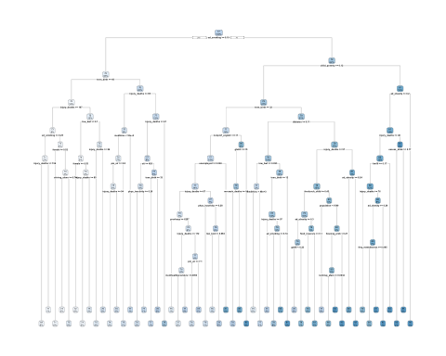

#Regression Tree 3-manually setting cp to 1SD greater error than minimum value  
tree.lifexp.3 = rpart(life_exp ~ ., data = train.data.q1, method = "anova", control = rpart.control(cp = 0.006665509))  
rpart.plot(tree.lifexp.3)



print(tree.lifexp.3)

## n= 2237   
##   
## node), split, n, deviance, yval  
## * denotes terminal node  
##   
## 1) root 2237 19796.3300 77.48154   
## 2) ad_smoking>=0.1873709 856 4299.5740 75.26436   
## 4) teen_birth>=40.08801 410 1678.0850 73.96882   
## 8) injury_deaths>=106.5088 117 615.8804 72.55341   
## 16) ad_smoking>=0.2480356 37 186.2220 70.61382 *  
## 17) ad_smoking< 0.2480356 80 226.0859 73.45048 *  
## 9) injury_deaths< 106.5088 293 734.2144 74.53401 *  
## 5) teen_birth< 40.08801 446 1300.7260 76.45532   
## 10) injury_deaths>=85.04951 187 404.6919 75.43752 *  
## 11) injury_deaths< 85.04951 259 562.4472 77.19019 *  
## 3) ad_smoking< 0.1873709 1381 8680.4270 78.85585   
## 6) child_poverty>=0.1245 1047 4837.1390 78.22551   
## 12) teen_birth>=32.02208 351 1722.3570 77.09641   
## 24) nonprof_english< 0.1059455 317 1066.2170 76.81010 *  
## 25) nonprof_english>=0.1059455 34 387.8794 79.76582 *  
## 13) teen_birth< 32.02208 696 2441.6410 78.79492   
## 26) diabetes>=0.1085 306 927.2700 78.03912 *  
## 27) diabetes< 0.1085 390 1202.4230 79.38794 *  
## 7) child_poverty< 0.1245 334 2123.2340 80.83179   
## 14) ad_obesity>=0.197 317 1215.2650 80.53341   
## 28) injury_deaths>=48.17918 274 867.4213 80.20935 *  
## 29) injury_deaths< 48.17918 43 135.7168 82.59836 *  
## 15) ad_obesity< 0.197 17 353.4709 86.39573 *

#Fit model to test data and calculate R-squared and MSE  
pred.intest = predict(tree.lifexp.3, newdata = test.data.q1)  
r.square.test = cor(test.data.q1$life_exp, pred.intest)^2  
r.square.test

## [1] 0.5451525

pred.mse = mean((pred.intest-test.data.q1$life_exp)^2)  
  
#Plot distribution of error (not squared error)  
test = data.frame(pred.intest-test.data.q1$life_exp)  
histogram(test$pred.intest...test.data.q1.life_exp)

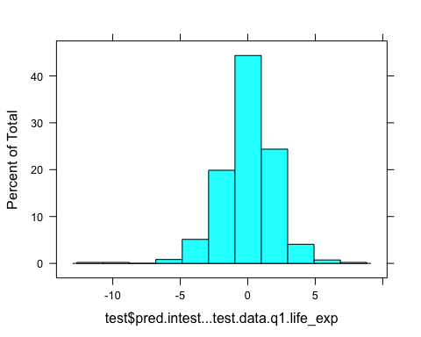

# We can see the distribution of the observations. Tells you what's happening to the people who aren't the same.   
  
tree.lifexp.3$variable.importance

## ad_smoking freq_physdistress freq_mentdistress   
## 7067.56306 5105.66368 4444.91382   
## poorphyshealth_days poormenthealth_days insuff_sleep   
## 4159.58888 4058.08158 3384.27790   
## teen_birth child_poverty medhhinc   
## 2452.24199 2296.67954 1356.79728   
## poorhealth freelunch_child phys_inactivity   
## 1333.04873 969.08531 953.76999   
## injury_deaths diabetes ad_obesity   
## 921.04408 696.99162 616.68421   
## uninsured_adults uninsured nonprof_english   
## 331.39075 304.32290 268.26076   
## mvcrash_deaths Hisp pm_air   
## 206.13376 201.36710 163.08781   
## AmerInd_AlasNative firearm_fatalities excess_drink   
## 149.80948 137.36110 126.15111   
## low_bwt prevhosp unemployed   
## 97.85269 97.85269 82.52939   
## Asian driving_alone bw18   
## 73.98235 66.26341 47.65674   
## housing_prob exer_access   
## 39.45011 19.73271

# Frequency of physical distress and frequency of mental distress are likely surrogates for smoking based on the variable importance rankings, but these two variables do not show up in our tree because they are surrogates and not actually in our tree.

### Step 5: Compare results using caret package.

set.seed(100)  
train.control = trainControl(method = "cv", number = 10)  
tree.lifexp.4 = train(life_exp~ . , data = train.data.q1, method = "rpart",trControl = train.control)

## Warning in nominalTrainWorkflow(x = x, y = y, wts = weights, info =  
## trainInfo, : There were missing values in resampled performance measures.

tree.lifexp.4$bestTune

## cp  
## 1 0.06671755

rpart.plot(tree.lifexp.4$finalModel)

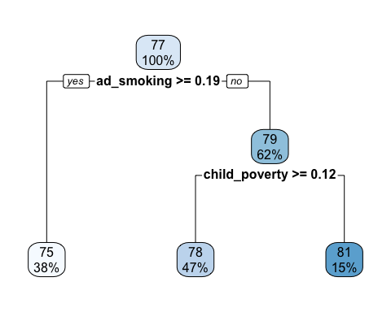

pred.intest.temp = predict(tree.lifexp.4, newdata = test.data.q1)  
r.square.test.temp = cor(test.data.q1$life_exp, pred.intest.temp)^2  
r.square.test.temp

## [1] 0.3540709

#Specify tuneGrid so caret explores wider variety of cp-values  
grid = expand.grid(cp = seq(0.001,0.1, by = 0.001))  
tree.lifexp.5 = train(life_exp ~ ., data = train.data.q1, method = "rpart", trControl = train.control, tuneGrid = grid)  
rpart.plot(tree.lifexp.5$finalModel)

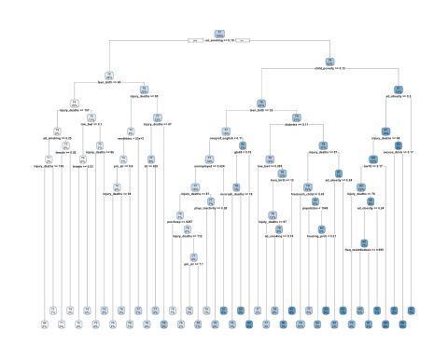

tree.lifexp.5$bestTune

## cp  
## 2 0.002

grid = expand.grid(.cp = 0.0067)  
tree.lifexp.6 = train(life_exp ~ ., data = train.data.q1, method = "rpart", trControl = train.control, tuneGrid = grid)  
rpart.plot(tree.lifexp.6$finalModel)



pred.intest.2 = predict(tree.lifexp.6, newdata = test.data.q1)  
  
r.square.test.2 = cor(test.data.q1$life_exp, pred.intest.2)^2  
r.square.test.2

## [1] 0.5451525

pred.mse.2 = mean((pred.intest.2-test.data.q1$life_exp)^2)  
  
varImp(tree.lifexp.6)

## rpart variable importance  
##   
## only 20 most important variables shown (out of 64)  
##   
## Overall  
## teen_birth 100.00  
## injury_deaths 98.79  
## ad_smoking 79.71  
## poorhealth 77.30  
## freq_mentdistress 52.93  
## bw18 47.32  
## phys_inactivity 36.38  
## diabetes 34.98  
## AmerInd_AlasNative 31.87  
## ad_obesity 28.84  
## medhhinc 28.64  
## freq_physdistress 24.85  
## nonprof_english 20.53  
## gte65 18.61  
## prevhosp 15.47  
## child_poverty 15.14  
## excess_drink 13.69  
## freelunch_child 13.45  
## low_bwt 13.21  
## Asian 13.00

### Step 6: PART 2 CLASSIFICATION TREES

#Using caret - use for categorical outcomes. Use caret to run CV and to get the best tuning parameters.  
  
train.control = trainControl(method = "cv", number = 10)  
grid.2 = expand.grid(cp = seq(0.001, 0.3, by = 0.01))  
tree.firearm = train(firearm.class~., data = train.data.q2, method = "rpart", trControl = train.control, tuneGrid = grid.2)  
tree.firearm$bestTune

## cp  
## 2 0.011

grid.3 = expand.grid(cp = seq(0.0005, 0.02, by = 0.001))  
tree.firearm = train(firearm.class~., data = train.data.q2, method = "rpart", trControl = train.control, tuneGrid = grid.3)  
tree.firearm$bestTune

## cp  
## 8 0.0075

tree.firearm

## CART   
##   
## 2236 samples  
## 64 predictor  
## 2 classes: '0', '1'   
##   
## No pre-processing  
## Resampling: Cross-Validated (10 fold)   
## Summary of sample sizes: 2012, 2013, 2012, 2013, 2012, 2012, ...   
## Resampling results across tuning parameters:  
##   
## cp Accuracy Kappa   
## 0.0005 0.7660754 0.4428216  
## 0.0015 0.7678652 0.4455335  
## 0.0025 0.7723354 0.4537681  
## 0.0035 0.7839726 0.4787952  
## 0.0045 0.7955938 0.5078320  
## 0.0055 0.7964966 0.5111469  
## 0.0065 0.7991792 0.5197305  
## 0.0075 0.8009689 0.5249378  
## 0.0085 0.7956118 0.5121768  
## 0.0095 0.7960602 0.5113268  
## 0.0105 0.7920324 0.5033719  
## 0.0115 0.7942685 0.5099865  
## 0.0125 0.7947169 0.5122347  
## 0.0135 0.7947169 0.5129963  
## 0.0145 0.7947169 0.5144734  
## 0.0155 0.7942725 0.5156278  
## 0.0165 0.7929272 0.5137669  
## 0.0175 0.7812920 0.4664872  
## 0.0185 0.7795063 0.4603142  
## 0.0195 0.7799548 0.4635666  
##   
## Accuracy was used to select the optimal model using the largest value.  
## The final value used for the model was cp = 0.0075.

varImp(tree.firearm)

## rpart variable importance  
##   
## only 20 most important variables shown (out of 64)  
##   
## Overall  
## injury_deaths 100.000  
## life_exp 91.283  
## food_insecure 83.444  
## freq_mentdistress 55.284  
## poormenthealth_days 50.846  
## population 41.144  
## uninsured 17.705  
## foodenv_index 17.199  
## uninsured_adults 16.301  
## child_poverty 15.520  
## rural 14.951  
## poorphyshealth_days 13.009  
## phys_inactivity 10.311  
## bw18 9.293  
## AmerInd_AlasNative 8.452  
## social_assoc 8.300  
## hiv 7.986  
## ltd_access_healthyfood 7.735  
## nonhisp_afam 7.172  
## hsgrad 7.108

rpart.plot(tree.firearm$finalModel)

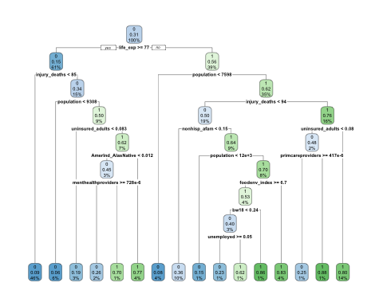

pred.firearm = predict(tree.firearm, test.data.q2)  
pred.firearm.prob = predict(tree.firearm, test.data.q2, type = "prob")  
  
eval.results = confusionMatrix(pred.firearm, test.data.q2$firearm.class, positive = "1")  
print(eval.results)

## Confusion Matrix and Statistics  
##   
## Reference  
## Prediction 0 1  
## 0 591 121  
## 1 72 173  
##   
## Accuracy : 0.7983   
## 95% CI : (0.7715, 0.8233)  
## No Information Rate : 0.6928   
## P-Value [Acc > NIR] : 1.256e-13   
##   
## Kappa : 0.5032   
##   
## Mcnemar's Test P-Value : 0.0005501   
##   
## Sensitivity : 0.5884   
## Specificity : 0.8914   
## Pos Pred Value : 0.7061   
## Neg Pred Value : 0.8301   
## Prevalence : 0.3072   
## Detection Rate : 0.1808   
## Detection Prevalence : 0.2560   
## Balanced Accuracy : 0.7399   
##   
## 'Positive' Class : 1   
##

analysis = roc(response = test.data.q2$firearm.class, predictor = pred.firearm.prob[,2])

## Setting levels: control = 0, case = 1

## Setting direction: controls < cases

plot(1-analysis$specificities, analysis$sensitivities, type = "l",  
ylab = "Sensitiviy", xlab = "1-Specificity", col = "black", lwd = 2,  
main = "ROC Curve for Greater Firearm Fatalities")  
abline(a = 0, b = 1)

