User Documentation

Step 1: Login to your WordPress admin Panel

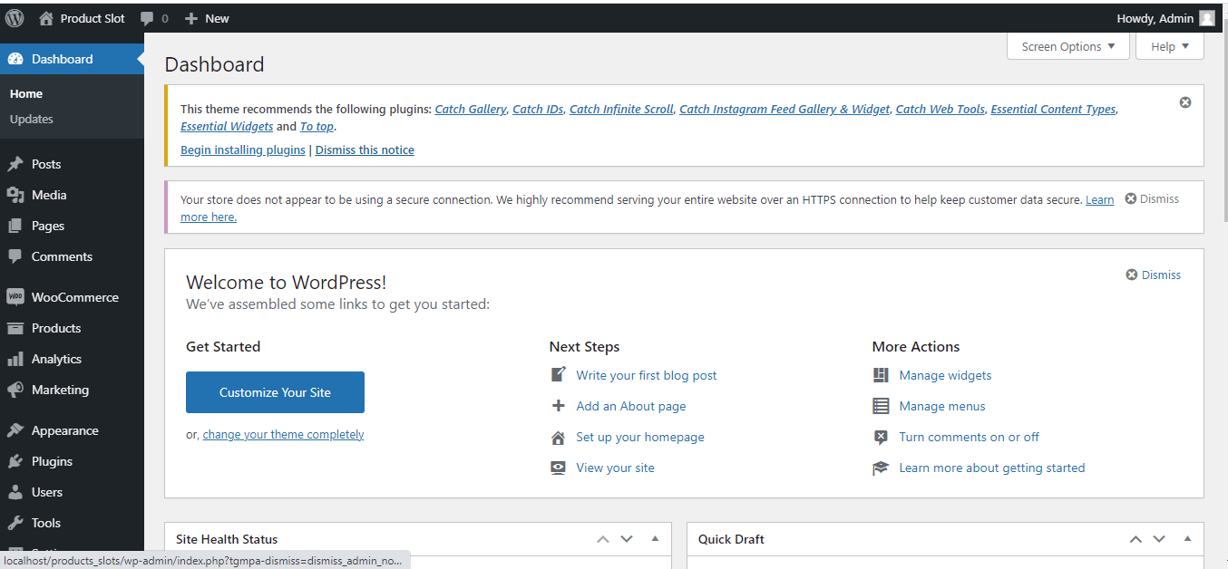

Step 2: Navigate to 🡪 Plugins 🡪 Add New 🡪 Upload Plugin

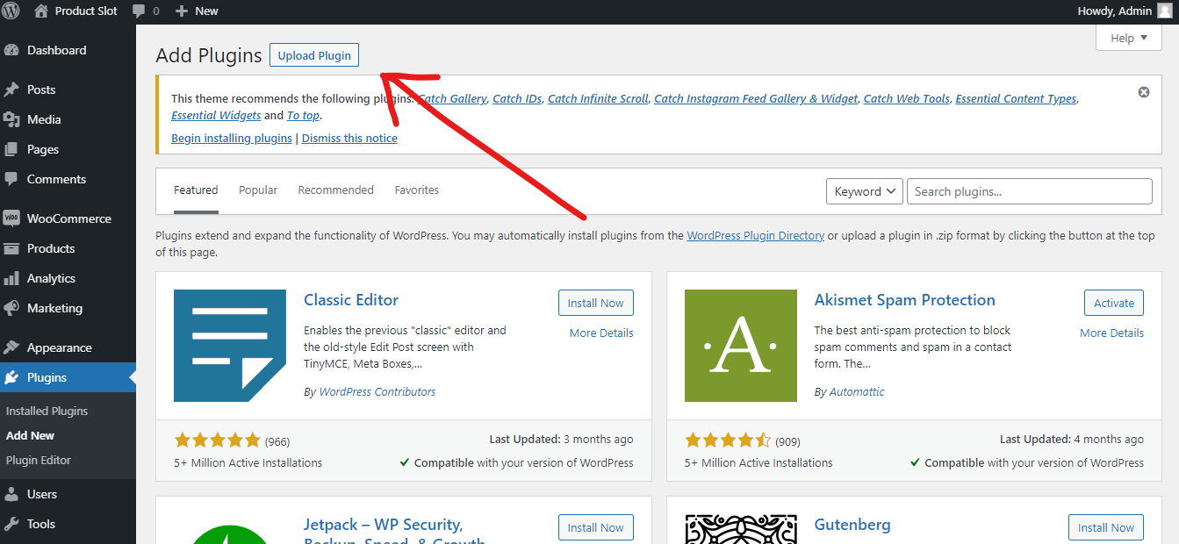

Upload plugin zip file, then click on Install Now

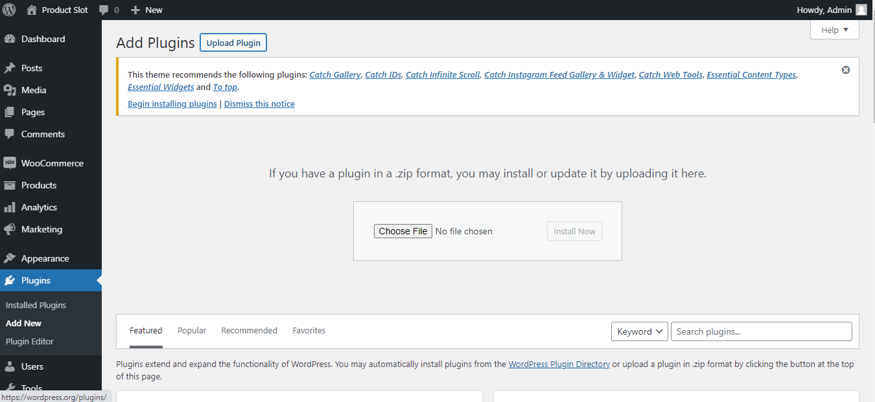

Step 3: Then, Click on Activate Plugin

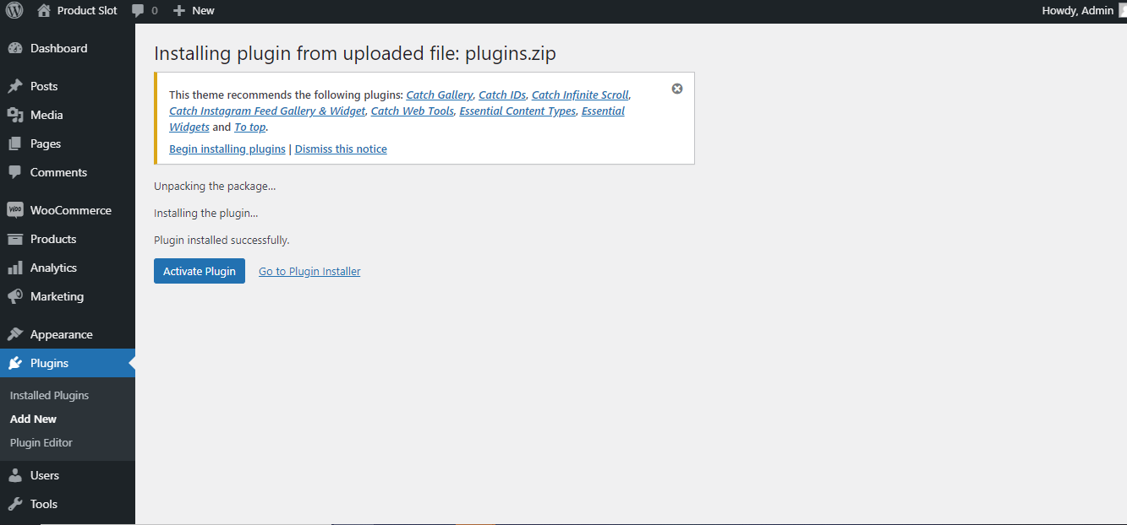

Step 4: After activating the plugin, you will see our plugin (ResProVis Lite) under installed plugin

Step6: After the successful installation & activation of ResProVis Plugin, you will automatically see checkboxes(Weekdays Slots) under WooCommerce add new products page

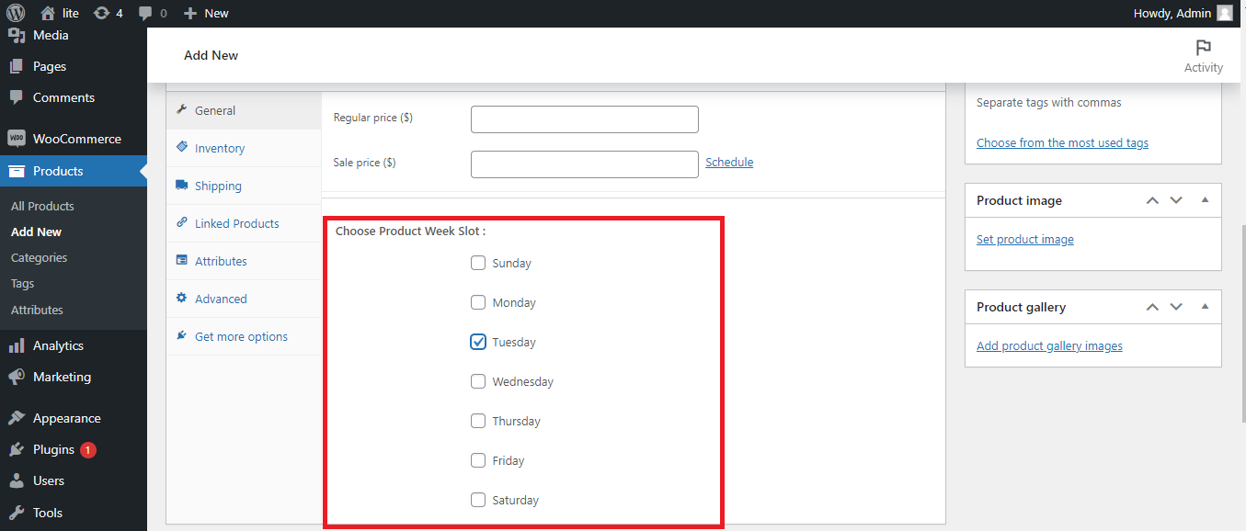

Step 14: If you want to delete the plugin, firstly you have to deactivate the plugin.

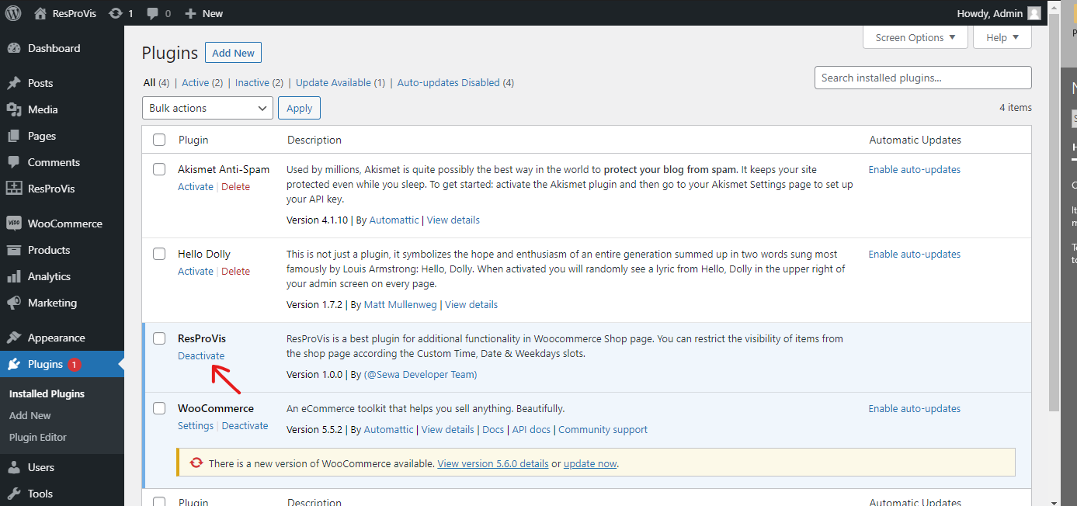

Step15: To delete the plugin, Click on delete

