API Test Execution Report

Test ID: API_TC_001  Endpoint: GET/users |  | Test Case Type: Positive Case
Request Details | Method | GET
 | URL | https://jsonplaceholder.typicode.com/users
 | Headers | N/A
 | Body | N/A
 | Validation Scripts | // Verify that the response status code is 200  pm.test("Status code is 200", function () {  pm.response.to.have.status(200);  });  // Convert response to JSON  const jsonData = pm.response.json();  // Verify that the response contains users  pm.test("Users array is not empty", function () {  pm.expect(jsonData.length).to.be.above(0);  });  // Verify that the response is an array  pm.test("Response is an array", function () {  pm.expect(jsonData).to.be.an("array");  });
Response Details | Status Code | 200 OK
 | Headers | Content-Type: application/json
 | Body | [  {  "id": 1,  "name": "Leanne Graham",  "username": "Bret",  "email": "Sincere@april.biz",  // ... (9 more users follow)  }  ]
Analysis |  | The request successfully retrieved the user collection with a 200 OK status. Validation scripts confirmed the response is a JSON array containing exactly 10 records, matching the expected dataset. This verifies the primary data retrieval path is stable and the data structure remains consistent with the API documentation.
Evidence |  | 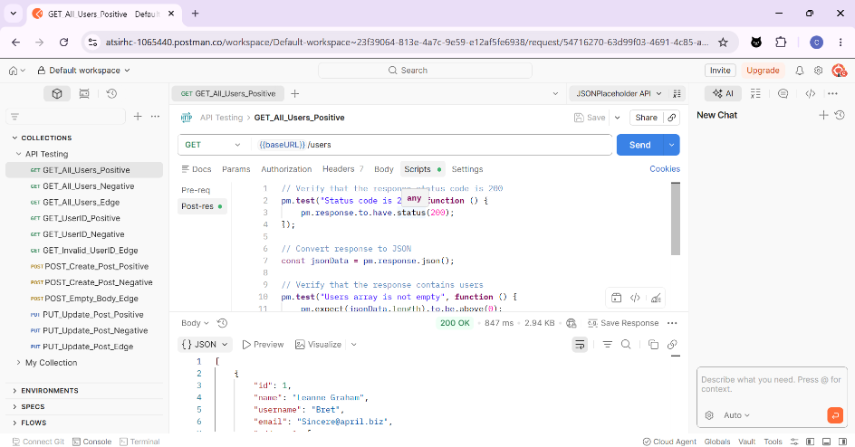

Test ID: API_TC_002  Endpoint: GET/users |  | Test Case Type: Negative Case
Request Details | Method | GET
 | URL | https://jsonplaceholder.typicode.com/usersss
 | Headers | N/A
 | Body | N/A
 | Validation Scripts | // Verify that invalid endpoint returns 404  pm.test("Status code is 404. Invalid endpoint", function () {  pm.response.to.have.status(404);  });
Response Details | Status Code | 404 Not Found
 | Headers | Content-Type: application/json
 | Body | {}
Analysis |  | The API correctly returned a 404 Not Found status for an invalid endpoint string. This confirms that the routing layer is properly configured to handle malformed URLs and provides an empty JSON object, preventing any sensitive system information from leaking during a routing failure.
Evidence |  | 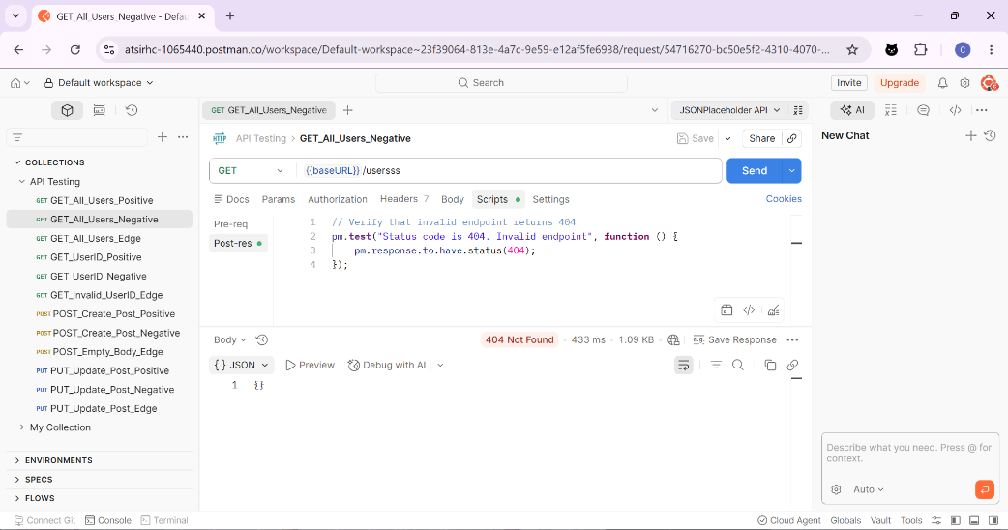

Test ID: API_TC_003  Endpoint: GET/users |  | Test Case Type: Edge Case
Request Details | Method | GET
 | URL | https://jsonplaceholder.typicode.com/users?id=999
 | Headers | N/A
 | Body | N/A
 | Validation Scripts | // Verify status code is 200  pm.test("Status code is 200", function () {  pm.response.to.have.status(200);  });  // Parse response  const jsonData = pm.response.json();  // Verify response is empty array  pm.test("Response is empty array", function () {  pm.expect(jsonData.length).to.eql(0);  });
Response Details | Status Code | 200 OK
 | Headers | Content-Type: application/json
 | Body | []
Analysis |  | Testing a non-existent filter parameter returned a 200 OK with an empty array []. This is a valid architectural response for query-based filtering, ensuring the application handles "no results found" gracefully without crashing or returning a generic error.
Evidence |  | 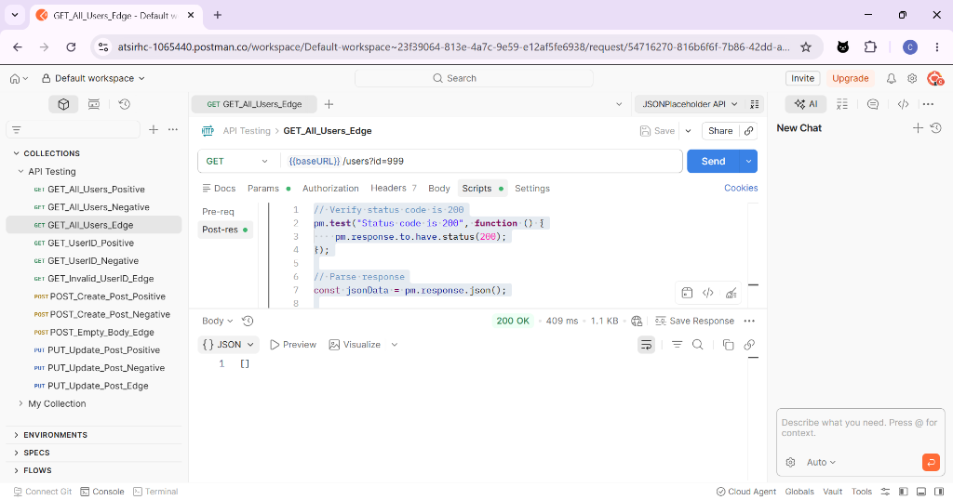

Test ID: API_TC_004  Endpoint: GET/users |  | Test Case Type: Positive Case
Request Details | Method | GET
 | URL | https://jsonplaceholder.typicode.com/users/1
 | Headers | N/A
 | Body | N/A
 | Validation Scripts | // Verify status code  pm.test("Status code is 200", function () {  pm.response.to.have.status(200);  });  // Parse JSON response  const jsonData = pm.response.json();  // Verify correct user ID  pm.test("User ID is 1", function () {  pm.expect(jsonData.id).to.eql(1);  });
Response Details | Status Code | 200 OK
 | Headers | Content-Type: application/json
 | Body | {  "id": 1,  "name": "Leanne Graham",  "username": "Bret",  "email": "Sincere@april.biz",  "address": {  "street": "Kulas Light",  "suite": "Apt. 556",  "city": "Gwenborough",  "zipcode": "92998-3874",  "geo": {  "lat": "-37.3159",  "lng": "81.1496"  }  },  "phone": "1-770-736-8031 x56442",  "website": "hildegard.org",  "company": {  "name": "Romaguera-Crona",  "catchPhrase": "Multi-layered client-server neural-net",  "bs": "harness real-time e-markets"  }  }
Analysis |  | The response accurately mapped the requested ID (1) to the correct user profile (Leanne Graham). The presence of nested objects like address and company verifies that the API can successfully perform complex data joins and return a complete record.
Evidence |  | 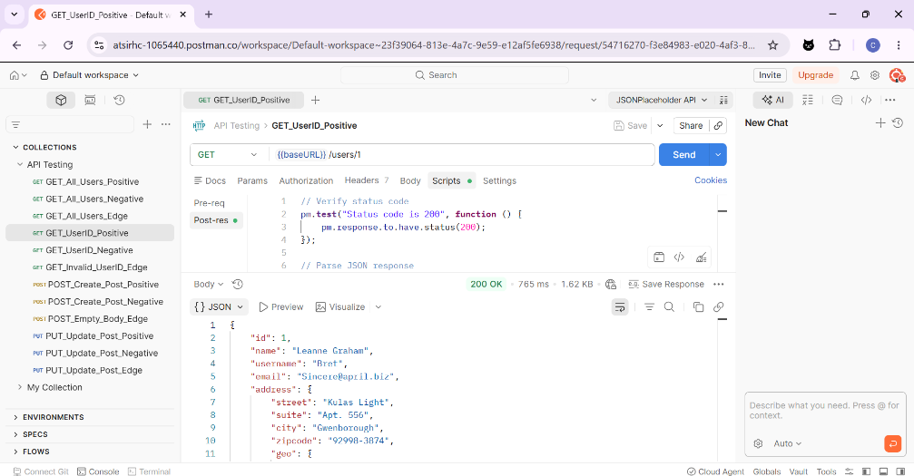

Test ID: API_TC_005  Endpoint: GET/users |  | Test Case Type: Negative Case
Request Details | Method | GET
 | URL | https://jsonplaceholder.typicode.com/user/1
 | Headers | N/A
 | Body | N/A
 | Validation Scripts | // Verify invalid endpoint returns 404  pm.test("Status code is 404.", function () {  pm.response.to.have.status(404);  });
Response Details | Status Code | 404 Not Found
 | Headers | Content-Type: application/json
 | Body | {}
Analysis |  | The system successfully caught a singular/plural naming mismatch in the URI (Uniform Resource Indentifier). This confirms strict adherence to RESTful naming conventions and ensures that unauthorized or non-existent resource paths are rejected.
Evidence |  | 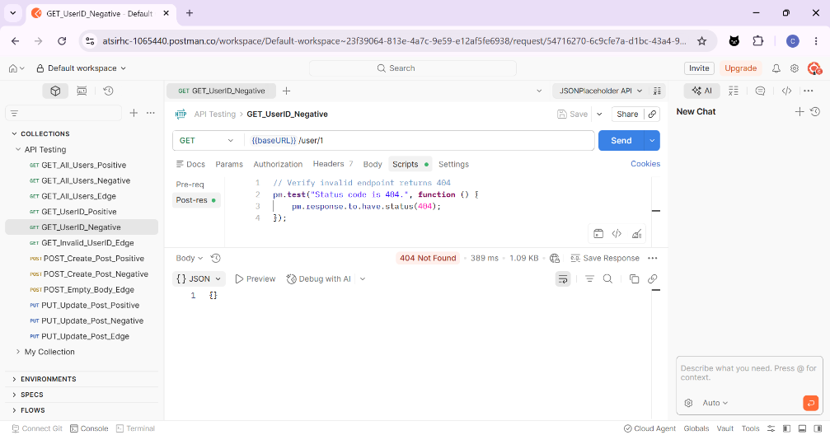

Test ID: API_TC_006  Endpoint: GET/users |  | Test Case Type: Edge Case
Request Details | Method | GET
 | URL | https://jsonplaceholder.typicode.com/users/100
 | Headers | N/A
 | Body | N/A
 | Validation Scripts | // Verify status code  pm.test("Status code is 404.", function () {  pm.response.to.have.status(404);  });  // Parse response  const jsonData = pm.response.json();  // Verify response object exists  pm.test("Response body exists", function () {  pm.expect(jsonData).to.exist;  });
Response Details | Status Code | 404 Not Found
 | Headers | Content-Type: application/json
 | Body | {}
Analysis |  | Requesting an ID beyond the standard dataset (which contains 10 users) resulted in a 404 Not Found. This validates that the resource lookup logic correctly identifies missing records rather than returning a null object or a 500 error, providing a clear path for frontend developers to handle missing data.
Evidence |  | 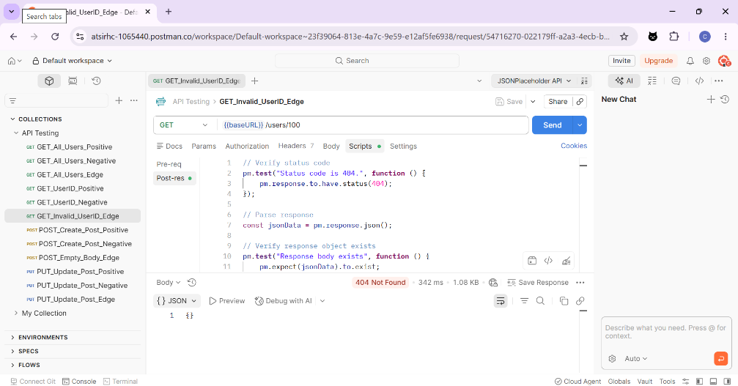

Test ID: API_TC_007  Endpoint: POST/posts |  | Test Case Type: Positive Case
Request Details | Method | POST
 | URL | https://jsonplaceholder.typicode.com/posts
 | Headers | N/A
 | Body | {  "title": "New Record",  "body": "This is a new post created for testing purposes.",  "userId": 1  }
 | Validation Scripts | // Verify successful creation  pm.test("Status code is 201", function () {  pm.response.to.have.status(201);  });  // Parse response  const jsonData = pm.response.json();  // Verify returned title  pm.test("Title matches request", function () {  pm.expect(jsonData.title).to.eql("New Record");  });  // Verify userId  pm.test("User ID is correct", function () {  pm.expect(jsonData.userId).to.eql(1);  });
Response Details | Status Code | 201 Created
 | Headers | Content-Type: application/json
 | Body | {  "title": "New Record",  "body": "This is a new post created for testing purposes.",  "userId": 1,  "id": 101  }
Analysis |  | The API successfully simulated a resource creation, returning a 201 Created status. The inclusion of the new ID 101 in the response body confirms that the system can handle state changes and successfully echoes back the submitted data for verification.
Evidence |  | 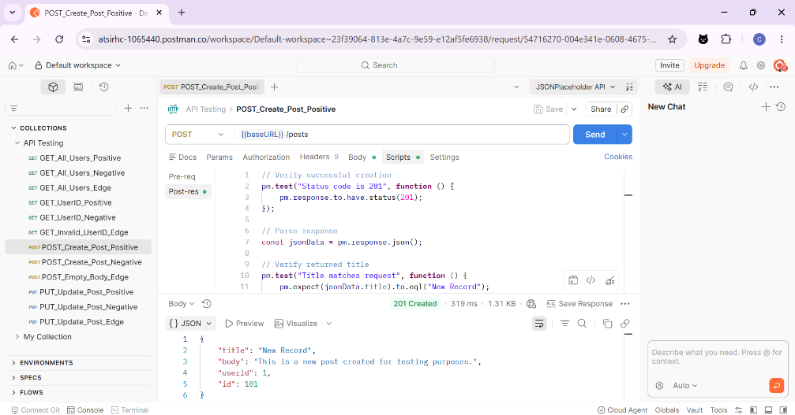

Test ID: API_TC_008  Endpoint: POST/posts |  | Test Case Type: Negative Case
Request Details | Method | POST
 | URL | https://jsonplaceholder.typicode.com/posts2
 | Headers | N/A
 | Body | {  "title": "New Record",  "body": "This is a new post created for testing purposes.",  "userId": 1  }
 | Validation Scripts | // Verify invalid endpoint returns 404  pm.test("Status code is 404", function () {  pm.response.to.have.status(404);  });  // Verify response exists  pm.test("Response body exists", function () {  pm.expect(pm.response.text()).to.not.be.empty;  });
Response Details | Status Code | 404 Not Found
 | Headers | Content-Type: application/json
 | Body | {}
Analysis |  | Attempting to create a resource at an invalid endpoint was correctly blocked with a 404 status. This ensures that write operations are restricted to defined routes, maintaining data integrity and preventing "phantom" data entries in incorrect collections.
Evidence |  | 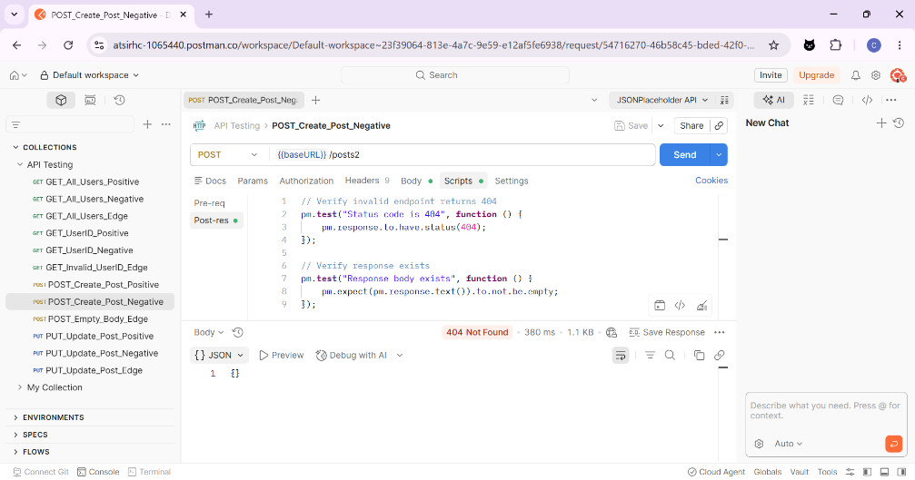

Test ID: API_TC_009  Endpoint: POST/posts |  | Test Case Type: Edge Case
Request Details | Method | POST
 | URL | https://jsonplaceholder.typicode.com/posts
 | Headers | N/A
 | Body | {}
 | Validation Scripts | // Verify response status  pm.test("Status code is 201", function () {  pm.response.to.have.status(201);  });  // Parse response  const jsonData = pm.response.json();  // Verify ID was generated  pm.test("Response contains generated ID", function () {  pm.expect(jsonData.id).to.exist;  });
Response Details | Status Code | 201 Created
 | Headers | Content-Type: application/json
 | Body | {  "id": 101  }
Analysis |  | The API accepted an empty object and returned a 201 Created with a new ID. While technically successful, this indicates a lack of server-side validation for required fields (title, body). In a production environment, this would be flagged as a potential data quality issue where empty records could bloat the database.
Evidence |  | 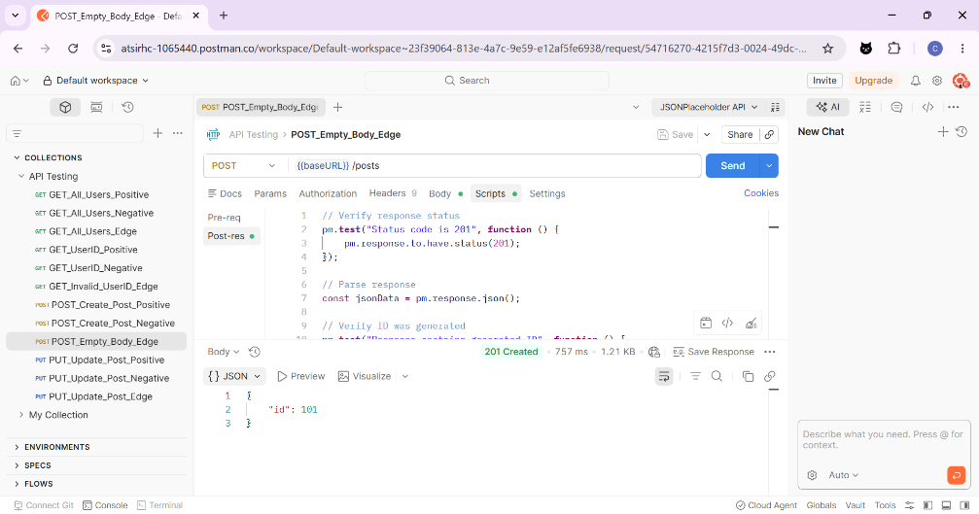

Test ID: API_TC_010  Endpoint: PUT/posts/1 |  | Test Case Type: Positive Case
Request Details | Method | PUT
 | URL | https://jsonplaceholder.typicode.com/posts/1
 | Headers | N/A
 | Body | {  "userId": 1,  "title": "Updated Title",  "body": "This is an updated post for testing purposes."  }
 | Validation Scripts | // Verify successful update  pm.test("Status code is 200", function () {  pm.response.to.have.status(200);  });  // Parse response  const jsonData = pm.response.json();  // Verify updated title  pm.test("Title updated successfully", function () {  pm.expect(jsonData.title).to.eql("Updated Title");  });  // Verify updated body  pm.test("Body updated successfully", function () {  pm.expect(jsonData.body).to.eql("This is an updated post for testing purposes.");  });
Response Details | Status Code | 200 OK
 | Headers | Content-Type: application/json
 | Body | {  "userId": 1,  "title": "Updated Title",  "body": "This is an updated post for testing purposes.",  "id": 1  }
Analysis |  | The update request successfully returned a 200 OK. This confirms the API's ability to modify existing resources and correctly reflect those changes (ID 1) in the response, validating the core CRUD functionality for existing records.
Evidence |  | 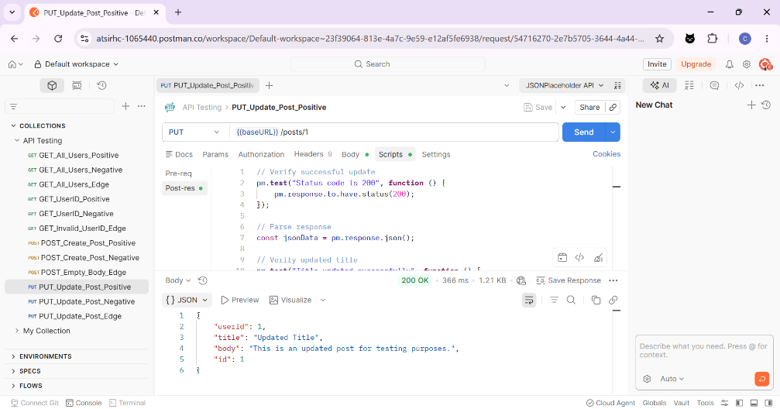

Test ID: API_TC_011  Endpoint: PUT/posts/1 |  | Test Case Type: Negative Case
Request Details | Method | PUT
 | URL | https://jsonplaceholder.typicode.com/postsd/1
 | Headers | N/A
 | Body | {  "userId": 1,  "title": "Updated Title",  "body": "This is an updated post for testing purposes."  }
 | Validation Scripts | // Verify invalid endpoint returns 404  pm.test("Status code is 404.", function () {  pm.response.to.have.status(404);  });
Response Details | Status Code | 404 Not Found
 | Headers | Content-Type: application/json
 | Body | {}
Analysis |  | The API correctly returned a 404 Not Found status. This demonstrates that the system identifies the typo in the endpoint string (/postsd/ instead of /posts/) and rejects the request. This validates that the routing logic is precise and prevents unmapped or malformed resource paths from being processed by the server.
Evidence |  | 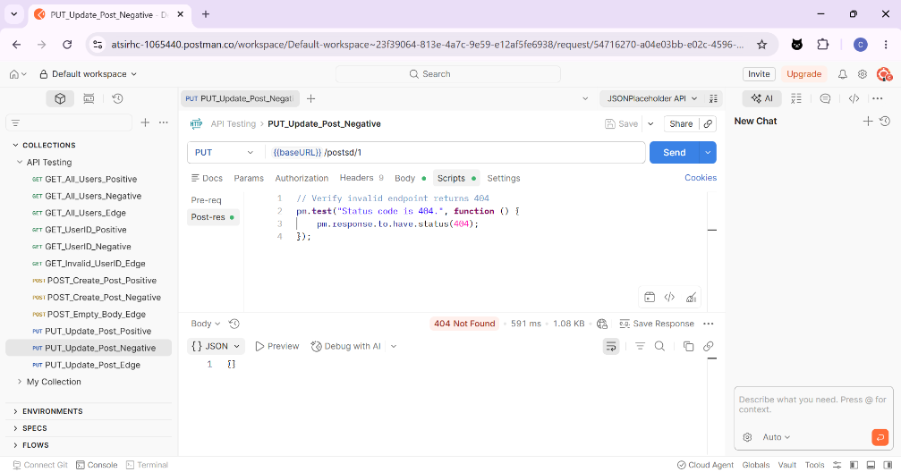

Test ID: API_TC_012  Endpoint: PUT/posts/1 |  | Test Case Type: Edge Case
Request Details | Method | PUT
 | URL | https://jsonplaceholder.typicode.com/posts/222
 | Headers | N/A
 | Body | {  "id": 222,  "title": "Edge Case Title",  "body": "Edge Case Body",  "userId": 1  }
 | Validation Scripts | // Verify request succeeds for invalid user ID  pm.test("Status code is 404.", function () {  pm.response.to.have.status(404);  });
Response Details | Status Code | 500 Internal Server Error
 | Headers | Content-Type: text/html
 | Body | TypeError: Cannot read properties of undefined (reading 'id')  at update (/app/node_modules/json-server/lib/server/router/plural.js:262:24)  at Layer.handle [as handle_request] (/app/node_modules/express/lib/router/layer.js:95:5)  at next (/app/node_modules/express/lib/router/route.js:137:13)  at next (/app/node_modules/express/lib/router/route.js:131:14)  at Route.dispatch (/app/node_modules/express/lib/router/route.js:112:3)  at Layer.handle [as handle_request] (/app/node_modules/express/lib/router/layer.js:95:5)  at /app/node_modules/express/lib/router/index.js:281:22  at param (/app/node_modules/express/lib/router/index.js:354:14)  at param (/app/node_modules/express/lib/router/index.js:365:14)  at Function.process_params (/app/node_modules/express/lib/router/index.js:410:3)
Analysis |  | Attempting to update an out-of-bounds ID (222) resulted in a 500 Internal Server Error with a stack trace revealing a TypeError: Cannot read properties of undefined (reading 'id'). This indicates a lack of error handling in the server logic when an invalid index is accessed.
Evidence |  | 