**Code first migration**

Create a new new application in Visual Studio(ConsoleApp1 used for example)

Add the latest version of EntityFramework NuGet package:  
 Tools -> NuGet Package Manager -> Package Manager Console   
 Enter “Install-Package EntityFramework”

Add a new class, for example Employee.cs, use the code below:  
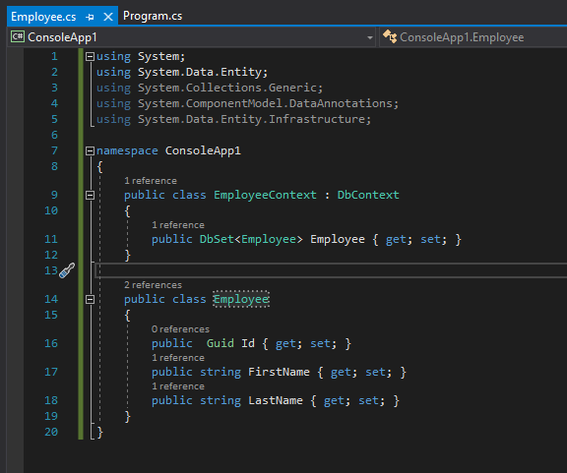

Update the Program.cs accordingly:  
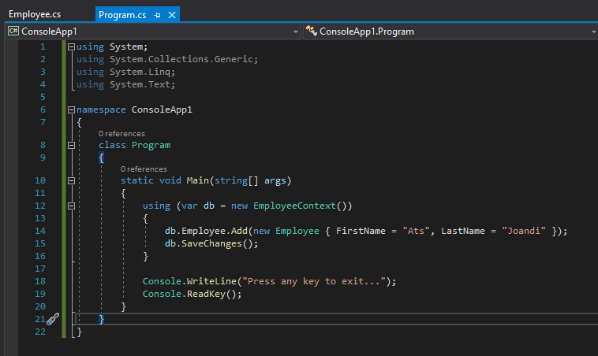

Run the application and you will see that the database has been added:  
  
