**Database first migration**

Open MS SQL Server Management Studio and copy the “Server name” according to your computer:

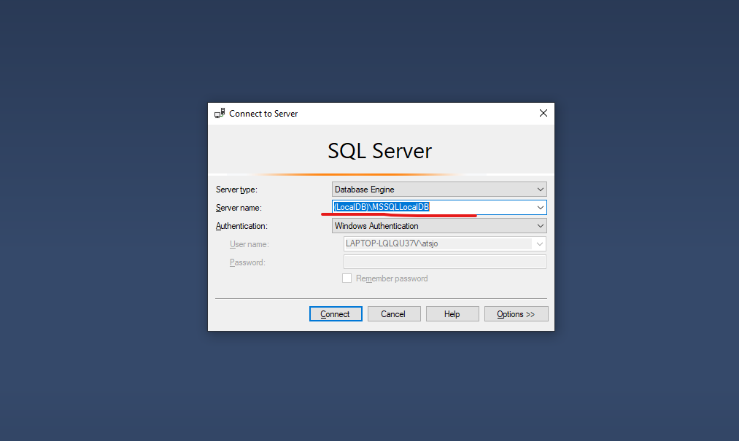  
Create new databse  
Add table named Employee

Using the teachers github “example” open appsettings.json file to change DefaultConnection using your own SQL Server Name:

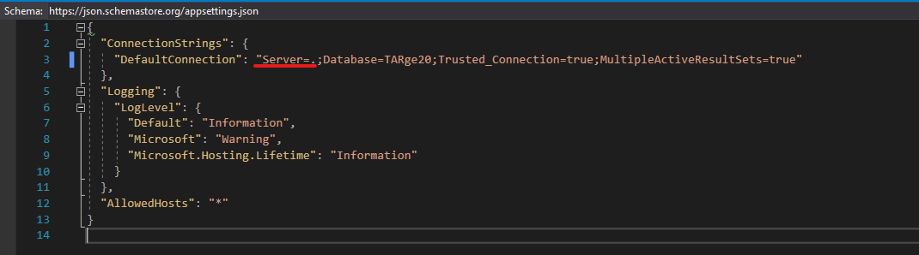

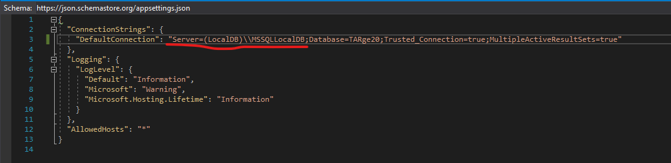

Open Packet Manager Console:

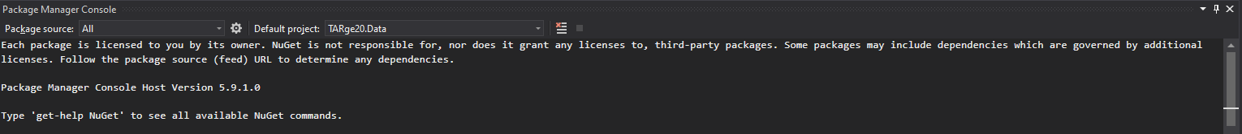

Type “Add-Migration init”:

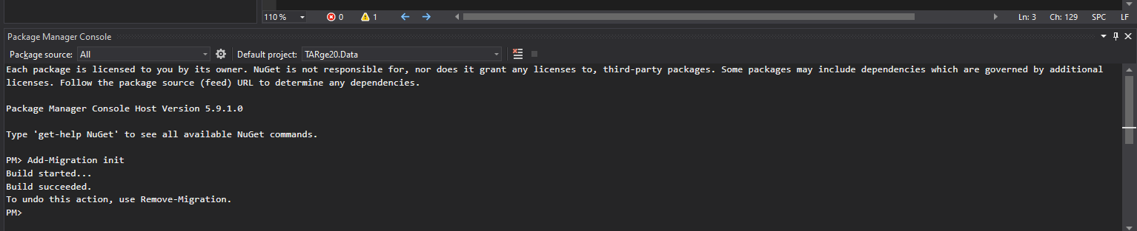

End product code:

