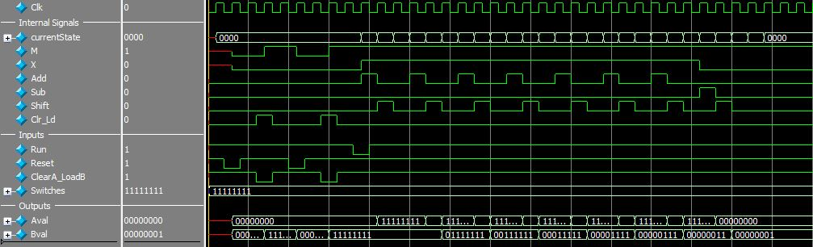 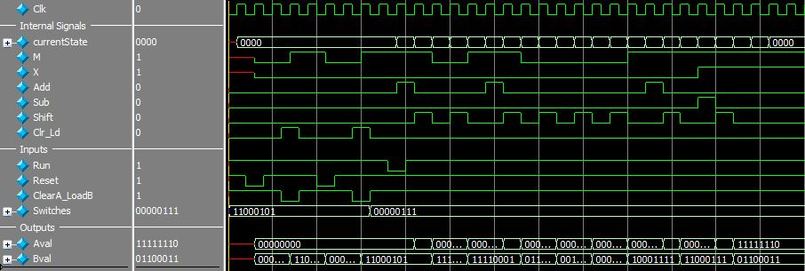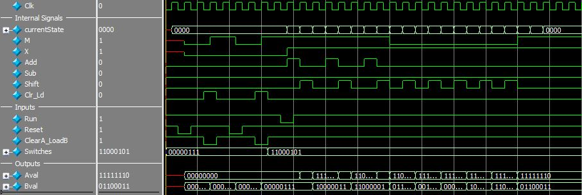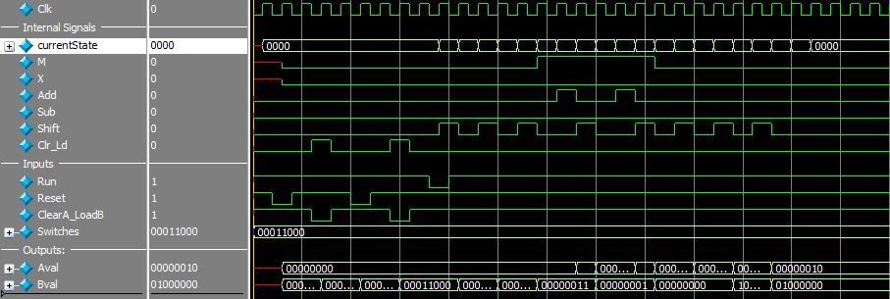

Run is pressed

The number ‘576’ stored in AB

‘24’, ‘24’ loaded into B and switches respectively

Run is pressed

The number ‘-413’ stored in AB

‘7’ , ‘-59’ loaded into B and switches respectively

‘-59’ , ‘7’ loaded into B and switches respectively

The number ‘-413’ stored in AB

Run is pressed

Run is pressed

The number ‘1’ stored in B

‘-1’ , ‘-1’ loaded into B and switches