From “Stalling” to Coordinated Preparation–Content Control in Gemma 3 270M

Summary
This project began with a practical question: can a small language model’s tendency to emit a bridge or “stall” token be causally reduced, allowing it to commit earlier to an answer it already represents? We used Gemma 3 270M because it can be studied on a 16 GB Apple M1 with Circuit Tracer. Our standard was deliberately high. Moving one desired output logit on one prompt would only validate the intervention tool. A meaningful result would require a reusable intervention that transfers across prompts without injecting a specific answer or broadly damaging language behavior.
The work proceeded in three phases.
First, country–city prompts tested the original stalling idea. On The city people most strongly associate with France is, Gemma ranked the first and Paris second. Interventions could reverse that ordering, but the effect was not clean: direct suppression of features supporting the failed on the source prompt, successful combinations included Paris-associated features, and related interventions moved wrong-country answers and syntax controls. Shared suppression features later produced small cross-country movements, but no combination met the specificity standard. This phase validated the mechanics of feature intervention and exposed the central confound: changing an output token is not the same as isolating a reusable “commitment” mechanism.
Second, we adopted the preparation–content task from Latent Planning Emerges with Scale. That paper asks whether a model represents a future content word early enough to choose a preceding grammatical token such as a versus an. Gemma strongly favored the majority article a. On the key prompt Someone who treats eye diseases is, it generated the ungrammatical continuation a ophthalmologist. Circuit tracing showed that features carrying information about the future word ophthalmologist were active before article generation. More importantly, suppressing a separately selected pair of features changed the continuation to an ophthalmologist on the source prompt.
The decisive held-out test changed the interpretation. The same fixed pair repaired 10 expected-an cases, but it also changed 22 expected-a controls to an and changed the first content word on 37 of 107 held-out prompts. Examples included a pilot becoming an aviator, and a lawyer becoming an attorney. There were zero cases where the article alone repaired a realized grammatical mismatch while the content word remained fixed. The intervention therefore did not behave like a clean grammar or anti-stalling control. It behaved like a switch between coordinated response classes—compiled trajectories (chunks): a plus a consonant-initial noun versus an plus a vowel-initial noun.
Third, after Stage VII we planned mainly to confirm that chunking story with twin occupations and controls. Collaborator discussion then raised the bar: Latent Planning treats article movement under sparse intervention as evidence of content-specific planning, but that reading is only secure if content identity can be locked while the article moves. We therefore ran a stricter causal program on pretrained Gemma 3 270M with an affine Gemma Scope 2 transcoder (chosen over instruction-tuned + non-affine after comparing the two stacks; see Section 10). Across selection-criterion ablation, dose–response, forced content-lock / dual intervention, a causal tetrad on twin families, and slim domain transfer, no held-out condition produced reliable wrapper-like repair. Dual-effect gain-of-function remained trajectory-like (chunking)—for example amplifying frozen features turned Someone who flies airplanes is from a pilot into an aviator, and simultaneously amplifying “content-lock” features did not preserve pilot while flipping only the article. Illicit mismatches such as an + consonant-initial nouns stayed near zero.
Our current claim is therefore:
In Gemma 3 270M (pretrained), sparse features that look like “planning” features under article-only metrics causally select coherent multi-token packages—compiled trajectories (chunks)—rather than acting as editable wrappers around a fixed latent noun. Article movement alone is not evidence of content-preserving latent planning unless content identity is locked and reported.
This is a publishable mechanistic claim relative to the Latent Planning task family on this model, not a claim about all scales or all architectures. The early stages remain the path by which the claim was earned: stalling failed specificity; ophthalmologist looked like planning on one prompt; held-out transfer forced the chunking reading; the later causal suite stress-tested that reading against a modular alternative.

A plain-language guide to the methods
This report uses several terms from language modeling and mechanistic interpretability:
- Token: a unit of text processed or generated by the model. A token may be a whole word, such as Paris, or part of a word, such as ophthalm.
- Next-token prediction: given all text so far, the model assigns a score to every token that could come next. Generation normally selects or samples from this distribution, then repeats the process.
- Logit: the model’s unnormalized score for a possible next token. A larger logit means a token is favored more strongly. Probabilities are obtained by applying a softmax transformation to all logits.
- Logit margin: the difference between two logits. For example, Paris - the is positive when Paris is favored over the and negative when the is favored.
- Baseline: the model’s logits or generated continuation with no internal intervention. Every intervention result is interpreted relative to this unchanged run.
- Transcoder: the auxiliary sparse model used by Circuit Tracer to decompose the original neural-network activation at each layer into individually addressable features plus reconstruction error. The transcoder does not replace Gemma; it provides the feature coordinates used for attribution and intervention.
- Feature: Circuit Tracer represents activity inside a model layer using learned sparse components. A feature is one such component. A label such as L13/F10304 means feature 10,304 in the transcoder attached to model layer 13. A feature is not assumed to have one human-readable meaning merely because it affects a token.
- Attribution graph: a directed graph estimating how input tokens, internal features, and error terms contribute to later features and output logits for one model run. It suggests candidate causal pathways, but attribution alone does not establish causality.
- Intervention: a second forward pass in which selected internal feature activations are deliberately changed. In this project, suppression sets an activation to zero. We then compare the intervened logits or generated continuation with the unchanged baseline.
- Final prompt position: the internal state produced after the model reads the last token of the prompt and immediately before it predicts the next token. Intervening there changes the computation used to select that next token.
- Demonstration: a completed example placed before the target prompt to show the desired task format. The model weights are not updated; this is one-shot prompting.
- Held-out prompt: a prompt that was not used to discover or select the intervention. Held-out evaluation tests whether one fixed intervention transfers rather than being tailored to its source example.
- Preselected criterion or intervention: a rule or feature combination fixed before examining the final aggregate test result. This reduces the risk of presenting whichever choice happened to work by chance.
- Wrapper-like effect: an intervention that changes the preparatory article while preserving the later content word (or its identity). This is what a content-preserving latent-planning repair would look like.
- Trajectory-like / compiled-trajectory effect (chunking): an intervention that switches a coordinated multi-token package—typically article plus noun-initial sound class—together (for example a pilot to an aviator). In this report we use “compiled trajectory,” “response class,” and “chunk” as near-synonyms for that package structure.
- Gain-of-function (amplify): raising a feature’s activation above its natural value on a prompt, used to test sufficiency.
- Loss-of-function (zero / suppress): setting a feature’s activation to zero, used to test necessity.
Whenever this report says that a token was “predicted,” it means that the token had the highest next-token logit unless stated otherwise. Whenever it says that behavior “changed,” it refers to a comparison between the unchanged baseline run and a run with the specified feature activations suppressed.

1. Research question and standard of evidence
Autoregressive language models generate one token at a time, but coherent language often requires information about words that have not yet been emitted. An article is a simple example: choosing a or an depends on the sound at the beginning of the next noun. A model can solve this either by representing the future noun before selecting the article, or by selecting the article first and allowing that choice to constrain the noun.
Our initial “stalling” hypothesis was broader. We proposed that small models may possess answer-relevant representations that are partially concealed by circuits favoring generic bridge tokens such as the. If those circuits could be down-regulated, the model might commit directly to the contextually appropriate answer.
We required three properties before treating an intervention as scientifically meaningful:
- Causality: changing the feature must change model behavior.
- Transfer: a fixed intervention must work on prompts not used to select it.
- Specificity: it must improve the intended behavior without injecting a particular answer, changing unrelated prompts, or merely exchanging one coherent answer for another.
The third requirement is crucial. If a “Paris” feature raises Paris for both France and Germany prompts, the intervention controls content but does not reveal a general commitment mechanism. Likewise, if an article intervention changes both a pilot and an aviator, it may be controlling a larger response class rather than repairing preparation for a fixed answer.

2. Stage I: Can a high-probability bridge token be suppressed?

Motivation
The first experiments established whether Circuit Tracer could identify and causally manipulate features contributing to competing next-token outputs. The source example was:
The city people most strongly associate with France is
Gemma’s top two next-token candidates were:
Rank | Token | Probability | Logit
1 | the | 0.248 | 18.743
2 | Paris | 0.186 | 18.458
The baseline commitment margin was:
$$m=ℓ_{Paris}−ℓ_{the}=−0.284$$
Because Paris was already strongly available, the was treated as a possible bridge into a longer phrase such as “the city of Paris.” The experiment asked whether suppressing features that positively contributed to the would allow Paris to win.

Experiment and result
We built attribution graphs for the and Paris, then tested three intervention families at the final prompt position:
- suppress features supporting the;
- amplify features supporting Paris;
- combine both operations.
For each family, candidates were selected from features with positive attribution to the relevant output token in the source graph. “Top eight” therefore means the eight highest-ranked candidate features under that graph-based selection rule, not eight features chosen after observing which intervention worked. For every intervention, we reran the same prompt, recorded the new Paris and the logits, and subtracted the baseline values. This produced the reported change in each logit and in the Paris - the margin.
The best combination changed the margin by +1.175, making Paris rank first. Most of this movement came from reducing the the logit by 1.340, while the Paris logit itself fell slightly by 0.166.
This demonstrated causal control of the output competition, but not the hypothesized mechanism. Pure suppression of the-supporting features did not work: suppressing the top eight made the margin worse by 0.672. The successful intervention also used Paris-associated features, creating an obvious answer-injection confound.

Why the next stage was necessary
An intervention selected on France and evaluated only on France cannot distinguish a reusable commitment feature from a Paris-specific feature or a broad change in answer format. We therefore moved to multiple countries and explicit controls.

3. Stage II: Cross-country transfer and the specificity problem

Motivation
The next experiments used prompts for France, Germany, Spain, and Italy, with expected answers such as Paris, Berlin, Madrid, and Rome. Prompt families included direct capitals, near matches, and country-specific association prompts. We compared each expected city with the competing token the.
The core test was asymmetric:
- A useful commitment intervention should increase the correct city relative to the across countries.
- A Paris-inducing intervention should fail because it would also raise Paris on Germany, Spain, or Italy prompts.
- A broad syntax intervention should fail because it would move non-geographic controls.

Experiment and result
Country-specific interventions often produced strong movement on the prompt used to select them. When transferred, however, they also produced wrong-city movement. This “cross-country pollution” prevented the strong claim that the features were disentangled from city semantics.
“Wrong-city movement” means that an intervention increased, or insufficiently separated itself from, the logit of a city that was not the correct answer for that prompt. For example, a France-derived intervention that favors Paris on a Germany prompt is not evidence of general commitment, even if it also lowers the.
We then searched for feature identifiers appearing among the the-supporting candidates in attribution graphs from multiple countries. Two individual candidates, L7/F89 and L10/F9037, showed weak directional promise when suppressed. Each was first tested alone. We then suppressed both activations in the same forward pass to test whether their effects combined. This pair experiment did not mean that one feature was applied to France and the other to Germany; the identical pair was applied to every evaluated prompt.
The pair was interesting because it was fixed across cases and used suppression only. Nevertheless, the aggregate result did not meet the success criteria set before reviewing the combined results: effects were small or inconsistent, some expected-city logits fell, wrong-city logits moved, and syntax controls were not cleanly separated. The country stage therefore ended as a negative mechanistic result.

What this stage established
It established a reusable experimental discipline:
$$\text{specificity}=Δℓ_{expected}−max(Δℓ_{wrong answer}$$
#0)
A next-token margin can improve even when the expected answer becomes less likely, provided the competitor falls faster. We therefore stopped treating margin improvement alone as evidence of useful commitment. This lesson directly shaped the later held-out tests.

4. Connection to Latent Planning Emerges with Scale

The nearest experiment in the paper
Latent Planning Emerges with Scale studies cases where an earlier “preparatory” token depends on later content. Its a/an occupation task uses prompts of the form:
Someone who treats eye diseases is
The model must choose an article before emitting an occupation. If it plans ophthalmologist, the grammatically appropriate preparation is an.
The paper reports that latent planning becomes more evident with scale: larger models more reliably encode and use future-content information when selecting earlier functional tokens, while smaller models often default to a majority-class preparation. The paper’s core mechanistic question is whether future content is represented before it is generated and whether that representation contributes to the preparatory token.

Our extension
Our hardware prevents a scale study, but Circuit Tracer gives us a complementary causal question on one small model:
When a small model represents the future answer but nevertheless emits the wrong preparation, is the plan absent, ignored, or overridden by another pathway that can be causally suppressed?
This contrasts with a simple scale conclusion. Rather than asking only whether planning strength increases with model size, we ask whether an apparently unsuccessful small-model plan can be exposed by intervention.

5. Stage III: Behavioral replication of the article imbalance

Motivation
Before tracing circuits, we needed to verify that Gemma 3 270M occupies a behaviorally relevant regime. If it always used correct grammar, there would be no failure to explain. If it selected a but then changed to a consonant-initial noun, the behavior could reflect coherent article-led generation rather than a concealed plan.
Each target was evaluated after two one-shot demonstrations:
- a demonstration: Someone who studies living organisms is a biologist.
- an demonstration: Someone who studies ancient objects and sites is an archaeologist.
For example:
Someone who studies living organisms is a biologist. Someone who handles financial records is
and
Someone who studies ancient objects and sites is an archaeologist. Someone who handles financial records is
The immediate next-token probabilities of a and an were measured.

Result
The pilot contained 32 target prompts: 20 whose listed occupation required a and 12 whose listed occupation required an. Every target was run twice, once after each demonstration. This produced 20 × 2 = 40 expected-a evaluations and 12 × 2 = 24 expected-an evaluations.
Here article recall means:
$$\text{article recall}=\frac{\text{number of evaluations where the highest-logit article was the expected article}}{\text{number of evaluations requiring that article}}$$
For all 40 expected-a evaluations, a had the higher next-token logit, so expected-a recall was 40/40, or 100%. For only 3 of the 24 expected-an evaluations, an had the higher logit, so expected-an recall was 3/24, or 12.5%. No third token outranked both articles in these evaluations.
Separating the expected-an cases by preceding demonstration shows that the example had only a modest effect. After the a demonstration, an won 1 of 12 cases, or 8.3%. After the an demonstration, it won 2 of 12, or 16.7%. Gemma therefore showed a substantial majority-class bias, although not complete collapse.
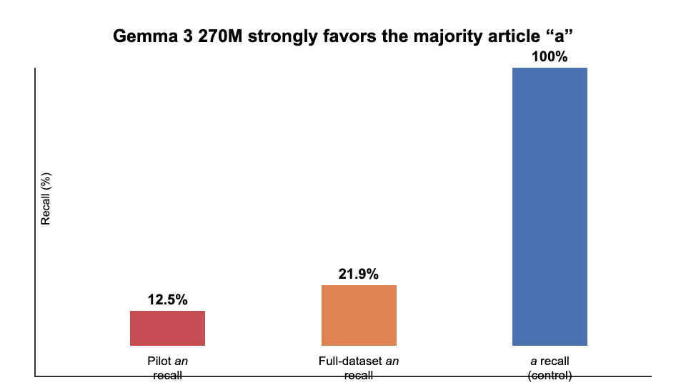
Figure 1. Immediate article recall. The model reliably selects the majority article a but rarely selects an when required by the listed target.
This was only a behavioral prerequisite. It did not show that Gemma intended the listed word. For example, after Someone who handles financial records is, Gemma generated a financial analyst, not a accountant. The article and chosen noun were grammatically coherent.

Why continuation screening was necessary
To motivate a concealed-plan analysis, we needed cases where the model selected the wrong article and nevertheless continued with a vowel-initial noun. We therefore generated the continuation rather than inferring the future answer from the dataset label.

6. Stage IV: Finding genuine preparation–content mismatches

Pilot continuation result
Across 24 expected-an pilot evaluations, only one unique target produced a mismatch under both demonstrations:
Prompt | Demonstration | Generated continuation
Someone who examines eyes and prescribes corrective lenses is | a example | a ophthalmologist.
same prompt | an example | a ophthalmologist.
The model did not generate the listed target optometrist; it generated the semantically appropriate alternative ophthalmologist. This distinction matters. The future content used for mechanistic analysis must be the model’s actual continuation, not the dataset’s expected label.
A mismatch was counted only when the model’s own generated article was a and the first generated lexical word began with a vowel sound, making the realized phrase ungrammatical. Merely predicting a for a dataset row labeled with a vowel-initial occupation did not count if the model then chose a different, consonant-initial occupation. For example, a financial analyst is grammatical and was not counted as a mismatch even when the dataset listed accountant.

Full released-dataset screen
We then screened all 105 an targets from the paper’s released a_an_examples.csv, evaluating each after both demonstrations. This produced 105 × 2 = 210 evaluations. In 46 of those 210 evaluations, an had the higher next-token logit, giving an recall of 46/210, or 21.9%. We generated a continuation for every case rather than stopping at the article. We found three mismatch rows representing two unique targets:
- Someone who treats eye diseases is → a ophthalmologist. under both demonstrations;
- Someone who studies stars and planets is → a astronomer. under the an demonstration.
Before running the full screen, we set a threshold of ten distinct mismatch concepts as the minimum needed to justify a broad multi-example mechanistic study. The two observed concepts fell below that threshold. The scarcity is itself important: Gemma usually preserves grammatical coherence by changing the noun after choosing a. We therefore narrowed the mechanistic pilot to the reproducible ophthalmologist case instead of generalizing from a large behavioral set that did not exist.

7. Stage V: Does future-answer information exist before the wrong article?

Motivation
The string a ophthalmologist does not by itself prove planning. The model might select a first and only later choose ophthalmologist. To establish a latent plan, information associated with the future content must be present before article generation and must causally contribute to both the article decision and the eventual noun. In this report, “future-answer information” therefore does not mean that a feature has been given the semantic label “ophthalmologist.” It means that the feature is active before the article and has measured attribution to the later ophthalm output, followed by a causal suppression test.
The mechanistic prompt was:
Someone who studies living organisms is a biologist. Someone who treats eye diseases is
At baseline, the article logits were:
$$ℓ_{an}−ℓ_{a}=−1.000$$
After forcing a, the token ophthalm was the top continuation, with probability 0.1459. “Forcing a” means appending the token a to the prompt regardless of which article the model preferred, then measuring the distribution for the following token. This lets us ask what content the model would emit along the observed a branch.

Experiment
We first built an attribution graph ending at the article decision and identified features active at the final prompt position. We also evaluated their relationship to the later ophthalm token. We screened for features that contributed to:
- the future token ophthalm;
- the preparatory article logits;
- the eventual ophthalm token after the article.
For each candidate, suppression set that one activation to zero at the final prompt position while leaving all other feature activations unchanged. We then recomputed the article logits. In a corresponding continuation run, we measured the effect on ophthalm after the article. Comparing these runs with baseline tests whether the candidate is causally relevant; the attribution graph alone only nominated the candidate.

Result
Four features showed a dual effect: when each feature was suppressed independently, both the losing an preparation and the future ophthalm token became less favored. The strongest, L13/F10231, changed the an logit by −1.125 and the ophthalm logit by −0.250, while leaving the a logit unchanged. Negative values mean that suppression lowered the named token’s logit relative to its unchanged baseline.
This is evidence that future-answer information was present before article generation and contributed to the correct article pathway, even though that pathway lost at baseline. It supports the “latent plan exists” premise. It does not improve behavior; suppressing this feature makes the correct preparation weaker.

Next we needed to suppress the competing pathway
To correct behavior, we needed features supporting the competing incorrect pathway rather than features carrying the future answer. We therefore selected features that favored a over an but had low direct attribution to ophthalm. This separation was designed to avoid simply suppressing the answer itself.

8. Stage VI: Correcting the source prompt by suppressing a competing pathway

Experiment
Candidate features were ranked by how strongly the attribution graph indicated that they favored the incorrect article a over an. We excluded candidates with a large direct attribution to ophthalm, because suppressing such a feature could simply erase the answer. No future-answer feature was amplified. The strongest remaining individual candidate was L13/F10304.
Suppressing L13/F10304 alone improved the article margin from −1.000 to −0.125: a still won, but only narrowly. We then tested combinations selected from the five strongest screened candidates. The key preselected two-feature intervention combined L13/F10304 with L14/F1949. “Suppressing the pair” means setting both feature activations to zero simultaneously in the same forward pass. Suppressing both:
- reduced the a logit by 0.125;
- increased the an logit by 1.000;
- improved the margin by 1.125, from −1.000 to +0.125;
- left the ophthalm logit unchanged;
- changed greedy generation from a ophthalmologist. to an ophthalmologist.
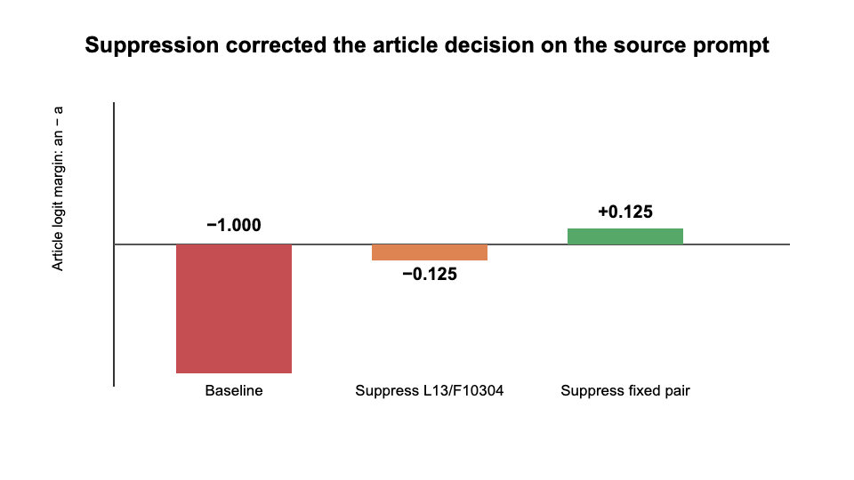
Figure 2. On the source prompt, suppression of the fixed pair crossed the decision boundary from a to an while preserving ophthalmologist.
This was the strongest source-prompt result in the project. It matched the expected signature of removing a competing grammatical pathway while preserving the represented future answer. However, selection and evaluation on one prompt cannot establish that interpretation.

9. Stage VII: The held-out test that changed the hypothesis

Motivation
The decisive question was whether the exact same intervention could be handed to another researcher and applied without rediscovering features for each prompt. We froze the pair L13/F10304 + L14/F1949, excluded the source ophthalmologist sentence, and applied it at the final prompt position to 107 other occupation prompts from the released dataset. There was no per-prompt feature selection or adjustment after seeing an output. Of these held-out prompts, 21 had listed answers requiring an, while 86 required a.
The intended result was content-preserving transfer:
$$\text{wrong article + same noun}→\text{correct article + same noun}$$
Expected-a prompts served as controls. A clean anti-stalling or grammar intervention should not broadly turn them into an responses.

Result
For this table, an expected-an repair means that the generated article changed from baseline a to intervened an. An expected-a control change means that a prompt whose baseline generated article was a generated an after intervention. A content-word change means that the first lexical word after the article differed between baseline and intervention. A grammar-only repair requires the article to become grammatical while that content word remains unchanged.
The fixed pair caused:
Outcome | Count
Expected-an prompts repaired | 10
Expected-an regressions | 0
Expected-a controls changed to generated an | 22
First content word changed | 37
Realized grammar-only repairs with content preserved | 0
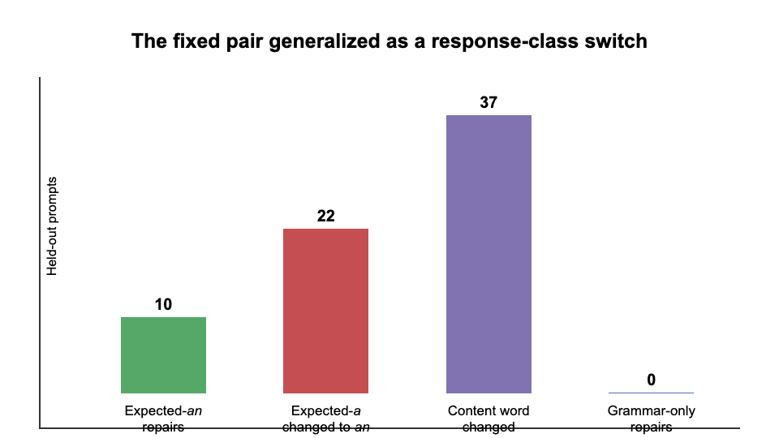
Figure 3. Held-out outcomes. Apparent article repairs were accompanied by broad article and content changes, so the intervention did not generalize as a content-preserving grammar repair.
Concrete examples make the mechanism clearer:
Prompt meaning | Baseline | Fixed-pair suppression
flies airplanes | a pilot | an aviator
represents clients in legal matters | a lawyer | an attorney
studies matter and energy | a physicist | an astronomer
The 10 expected-an repairs are therefore not sufficient evidence of success. The same intervention changed 22 of 86 expected-a controls to an, and it changed the first content word in 37 of all 107 prompts. These outputs remain locally grammatical because article and noun move together. The intervention does not simply raise an; it shifts the lexical continuation toward a vowel-initial alternative compatible with an. Exact listed-word completions, meaning continuations whose first content word matched the occupation supplied by the dataset, fell from 53 before intervention to 44 after intervention.

Interpretation - we found an <‘an’-noun> feature pair
The source correction was real, but its original interpretation did not generalize. We did not isolate a feature pair that reveals a fixed hidden answer by suppressing grammar or stalling. We found a pair that causally influences a coordinated preparation–content choice.
There are alternative interpretations: we tried to find an ‘an’-article-specific set of features to correct a mismatched grammatical construction, <‘a’-noun>, whereby the article did not match the noun. Instead we found a feature pair that encodes ‘chunking’ of the article and noun together. Increasing its contribution corrects the grammatically incorrect example with a correct <‘an’-noun> chunk, and it changes output of grammatically correct <‘a’-noun> examples to grammatically correct <‘an’-noun>.
In the terminology of Sections 10–11, this is a compiled-trajectory (chunking) effect rather than a wrapper effect. A wrapper would mean: keep the same later noun, change only the article. A compiled trajectory (chunk) means: article and noun-initial class move together as one selectable package—for example a pilot ↔ an aviator.
This result runs alongside, rather than directly contradicting, Latent Planning Emerges with Scale. The paper shows that future content can influence earlier preparation and that this behavior changes with scale. Our result suggests that, in a very small model, the causal organization may not decompose into a stable future answer plus an independently adjustable preparation. Instead, sparse features can select between coupled response trajectories—that is, they can chunk together future tokens. Sections 10–11 ask whether that reading survives a stricter causal test.

10. What we planned next, how the question sharpened, and what we then ran
Section 9 left us with a concrete mechanism: the frozen pair did not generalize as content-preserving grammar repair. It generalized as coordinated preparation–content control—compiled trajectories (chunking). This section records what we planned immediately after that result, how collaborator discussion changed the question we needed to answer, which model stack we used, and the causal experiments that followed (Stages VIII–XIV).

10.1 What we planned after Stage VII
At that time, the working hypothesis was already close to today’s language, but framed mainly as a confirmation agenda:
In Gemma 3 270M, a/an preparation and the initial-sound class of the following occupation are partly controlled by shared sparse features. These features select from grammatically correct chunks, rather than independently controlling grammar around a fixed semantic plan.
The planned next checks were:
- Had we over-indexed on ophthalmologist when choosing L13/F10304 + L14/F1949?
- Was one feature enough for article choice, with the other binding article to noun?
- Would the pair shift probability toward vowel-initial nouns across paraphrases?
- Would semantically matched twins such as pilot/aviator show class switching while preserving occupation meaning?
- Would activation-matched random features fail to reproduce the effect?
The minimum publishable study we sketched was: preregister twin occupation pairs, freeze the intervention, measure class-shift probability under intervention versus baseline, and report article change, semantic preservation, and controls separately.
That plan was reasonable. It was also incomplete. It treated chunking as something mainly to demonstrate more carefully. It did not yet ask the harder question that Latent Planning’s own claims force: when sparse features move the article, is the later noun still an editable, content-locked plan, or only a package that travels with the article?

10.2 How the question sharpened
Latent Planning Emerges with Scale shows that future content can influence earlier grammatical choices and that this improves with scale. Their causal evidence is largely: identify features with dual effects on preparation and future content, then ablate or upweight them and watch the article (and sometimes continuations) move.
After Stage VII we already suspected that article movement can be misleading. Collaborator discussion made the missing criterion explicit. In biological terms, it is not enough to show necessity- or sufficiency-like effects on one readout. For modular planning you also need specificity of the content identity:
Reading | What success looks like
Wrapper / modular planning | Change a↔an while the later noun (or its planned identity) stays put.
Compiled trajectory (chunking) | Article and noun-initial class move together as one package (a pilot ↔ an aviator).
Stage VII already favored the second row under loss-of-function of one fixed pair. The new program asked whether any reasonable feature selection rule, including Latent-Planning-style dual-effect gain-of-function, could recover the first row—especially if we amplified content-supporting features or tried to lock content while pushing the article.
We also adopted a clearer causality checklist for later stages: loss-of-function (necessity), gain-of-function (sufficiency), rescue/reversibility where feasible, activation-matched controls, and joint scoring of article and content on every trial.

10.3 Model and transcoder stack: PT+affine versus IT+non-affine
Before the full suite, we compared two workable Circuit Tracer stacks for Gemma 3 270M:
Stack | Pros | Cons
Pretrained LM + affine CLT (gemma-3-270m + width_262k_l0_medium_affine) | Matches the model that produced the Stage VI–VII results; Latent Planning’s Appendix J found base models slightly better than instruction-tuned models on a/an; affine skip can improve MLP reconstruction fidelity. | Affine skip means some MLP computation bypasses sparse features, so interventions may leave residual pathways.
Instruction-tuned LM + non-affine CLT (gemma-3-270m-it + width_262k_l0_medium) | Closer to Latent Planning’s main-text use of instruction-tuned models; non-affine forces more of the MLP path through intervenable features. | Hub’s IT medium_affine layer-0 file was empty/corrupt, so affine IT was unavailable; IT is a weaker a/an instrument per Appendix J; would require re-deriving all feature IDs.
We chose pretrained + affine as the primary stack for hypothesis testing: the scientific question lives on the a/an task, where base is at least as appropriate as IT, and Stage VII already gave a clean trajectory-like (chunking) signal there. IT was treated as a conceptual alternative, not the main evidence path. All Stage VIII–XIV numbers below are from the pretrained + affine stack.

10.4 Stage VIII: Planning-style gain-of-function clincher
Instead of only suppressing the ophthalmologist pair, we asked what happens if we do what Latent Planning-style analyses suggest: freeze features that support both an and a future content token on a selection set, then amplify them on held-out prompts.
On held-out occupations, amplification did not yield wrapper-like repairs. It yielded compiled trajectories (chunks). Concrete examples:
Prompt | Baseline | Dual-effect amplify ($5×$)
Someone who flies airplanes is | a pilot | an aviator
Someone who represents clients in legal matters is | a lawyer | an attorney
Someone who studies matter and energy is | a physicist | an astronomer
This clincher was enough to justify a full suite: if Latent-Planning-style gain-of-function already class-switches, the modular reading is in trouble before any dual-lock test.

10.5 Stage IX: Selection-criterion ablation (E1)
Question. Does how we pick features determine whether interventions look like wrappers or like compiled trajectories (chunks)?
We built article and future-content attribution graphs on eight selection occupations disjoint from the test set, then froze four feature sets ($k=4$):
Set | Selection rule
S1 Dual-effect | Positive direct effect on an and on the future noun token
S2 Article-only | Positive on an, near-zero on future content
S3 Content-only | Positive on future content, near-zero on an
S4 Competing / a-favoring | Favors a over an, near-zero on future content
Each set was amplified $5×$ on 20 held-out prompts and compared with activation-matched random controls.
Set | Wrapper-like rate | Trajectory-like (chunking) rate | Mean $Δ(\text{an}−\text{a})$
S1 Dual-effect | 0.00 | 0.95 | +3.31
S2 Article-only | 0.00 | 0.05 | +1.03
S3 Content-only | 0.00 | 0.05 | +0.11
S4 Competing a | 0.00 | 0.00 | −5.11
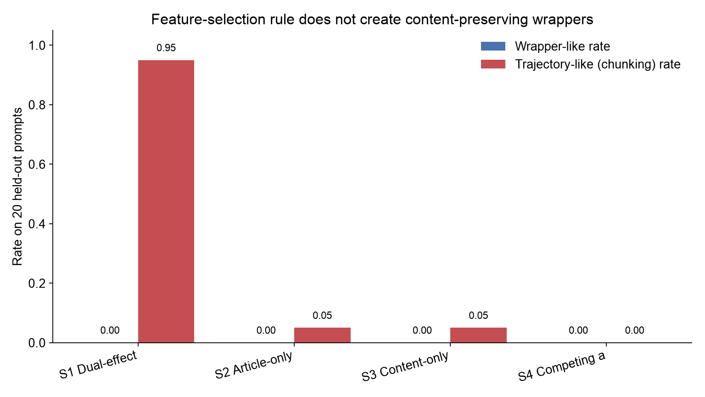
Figure 4. No selection rule produced held-out wrapper-like repair; dual-effect features were almost purely trajectory-like (chunking).
S1 recovered the same dual-effect family as the clincher (including L12/F6229, L10/F2930, L13/F10231, L11/F793). S4 recovered the original ophthalmologist competing pair (L13/F10304, L14/F1949) among its top features—useful later—but under amplification it pushed toward a packages rather than creating wrappers. No set cleared a wrapper-like bar. Changing the selection rule did not rescue modular planning.

10.6 Stage X: Dose–response (E2)
Question. Is there a low-dose window where dual-effect features move only the article, with content preserved?
We swept amplify factors $\{1.5,2,3,5,8\}$ on S1 (and the other E1 sets that showed article movement).
Factor | Trajectory-like (chunking) | Content preserved | Wrapper-like
$1.5×$ | 0.10 | 0.90 | 0.00
$2×$ | 0.50 | 0.50 | 0.00
$3×$ | 0.85 | 0.15 | 0.00
$5×$ | 0.95 | 0.05 | 0.00
$8×$ | 0.95 | 0.05 | 0.00
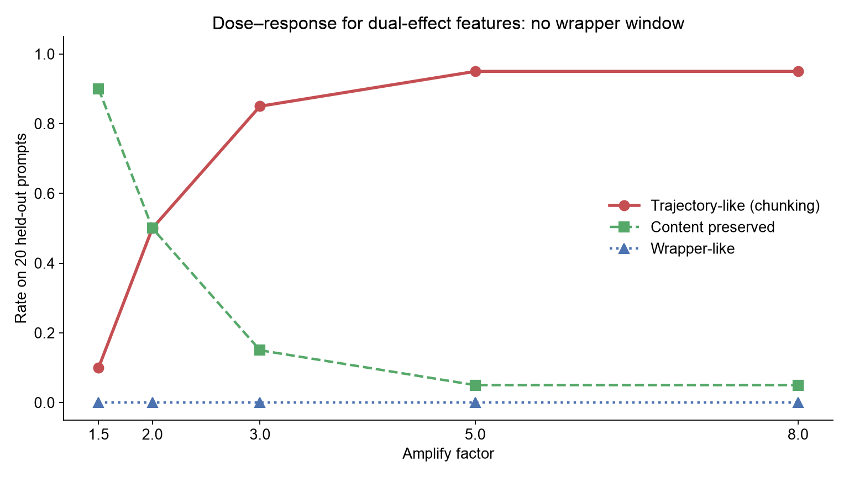
Figure 5. As gain increases, content preservation falls and trajectory-like (chunking) rate rises. Wrapper-like rate stays at zero.
There is no wrapper window. Mild doses mostly do little; stronger doses buy package switches, not grammar-only edits.

10.7 Stage XI: Forced content-lock / dual intervention (E3)
This is the decisive improved-logic experiment. If modular planning exists, pushing the article while locking content-supporting features should raise wrapper-like success above article-push alone.
Condition | Intervention
C0 | Baseline
C1 | Amplify article-moving set (S1)
C2 | Amplify content-only set (S3)
C3 | Dual: C1 + C2 together
C5 | Activation-matched random controls

Condition | Trajectory-like (chunking) | Content preserved | Wrapper-like | Illicit mismatch
C1 Article-push | 0.95 | 0.05 | 0.00 | 0.00
C2 Content-lock | 0.05 | 0.95 | 0.00 | 0.00
C3 Dual | 0.95 | 0.05 | 0.00 | 0.00
Control | 0.00 | 1.00 | 0.00 | 0.00
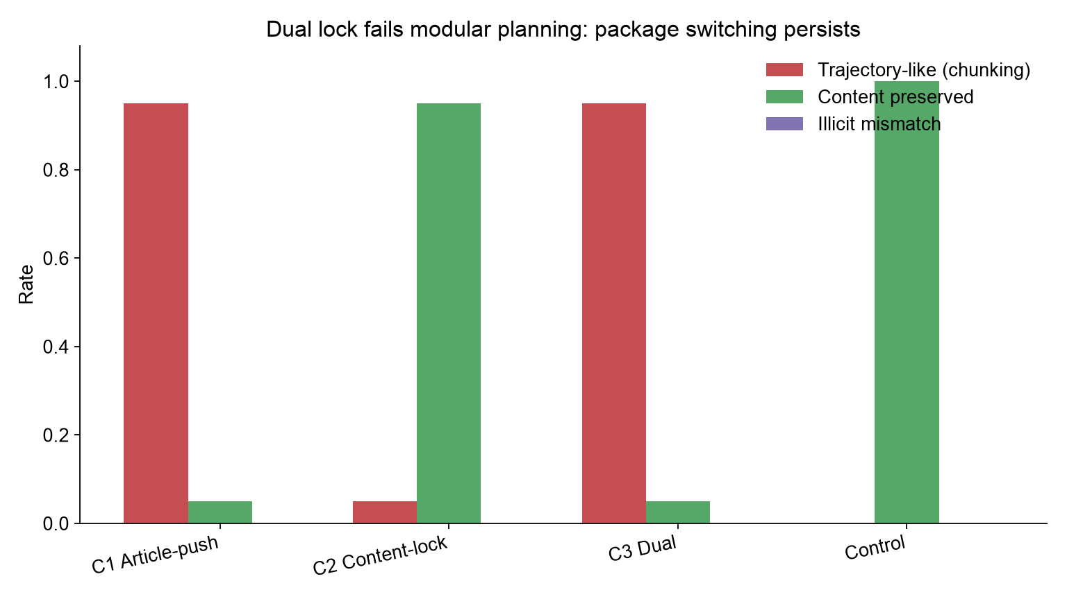
Figure 6. Content-lock alone preserves nouns but barely moves articles. Dual intervention still class-switches; illicit article–noun mismatches stay near zero.
Examples under C1 and C3 were the same kind of package switch:
- Someone who flies airplanes is → baseline a pilot → intervention an aviator
- Someone who represents clients in legal matters is → a lawyer → an attorney
C2 largely kept the baseline noun. C3 did not combine the best of both: it did not produce an pilot-style illicit repairs, and it did not produce an with pilot preserved. The system re-bundled into legal packages. That is compiled-trajectory (chunking) control, not an editable wrapper around a fixed latent goal.

10.8 Stage XII: Causal tetrad on twin families (E4)
On pilot/aviator and lawyer/attorney prompts we compared baseline, loss-of-function (zero S1), gain-of-function (amplify S1), and activation-matched control amplify.
Family | Baseline | LoF (zero) | GoF (amplify) | Control amplify
pilot / aviator | a pilot | a pilot | an aviator | a pilot
lawyer / attorney | a lawyer | a lawyer | an attorney | a lawyer
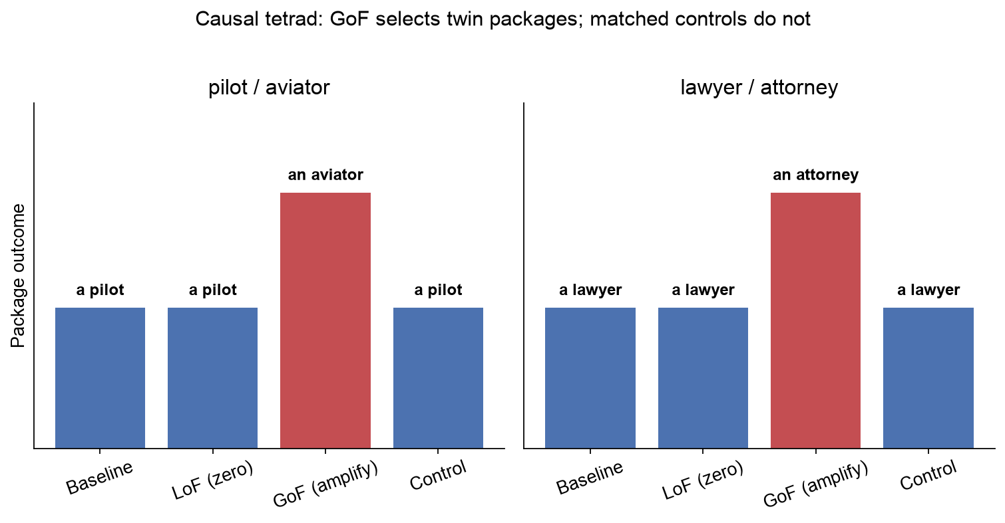
Figure 7. Gain-of-function selects the vowel-initial twin package; matched random amplifications do not.
Sufficiency and specificity for package control are strong. Simple zeroing of the same set did not flip these baselines—necessity is incomplete for that readout—but the positive causal role of the frozen features in selecting the twin chunk is clear relative to controls.

10.9 Stage XIII: Reclassifying the ophthalmologist source case (E6)
We returned to Someone who treats eye diseases is with the E3-style toolkit. Under the current pretrained baseline and demonstration, the model often began from a doctor rather than the historical a ophthalmologist mismatch. Loss-of-function of the original pair, gain-of-function of S1, and dual intervention could all move the continuation to an ophthalmologist.
Read with Stage VII–XI language, that is still package selection toward an ophthalmologist-compatible chunk, not proof that a fixed latent ophthalmologist plan was waiting behind a wrapper. Stage VI remains historically important—the mismatch and pair discovery happened—but it is no longer the foundation of the claim.

10.10 Stage XIV: Slim domain transfer (E5)
Freezing occupation-derived S1 features and testing non-occupation prompts (animals, instruments, nationalities) showed that the trajectory-like (chunking) effect still moved behavior above activation-matched controls. Content-only features did not export a clean grammar tool. We interpret this as locality of a packaging mechanism that is not confined to one prompt template, not as discovery of a universal a/an module.

10.11 Current hypothesis (after Stages VIII–XIV)
Relating old and new terms:
Earlier Stage VII language | Current causal language
Coordinated preparation–content classes | Compiled trajectories (chunks)
Content-preserving grammar repair | Wrapper-like / modular planning success
Fixed-pair suppression switches a pilot→an aviator | Loss- or gain-of-function selects packages
“Not yet publishable; need twin study” | Twin + dual-lock + dose suite now completed
Current hypothesis.
In pretrained Gemma 3 270M with Gemma Scope 2 affine features, sparse features that jointly affect article logits and future-content attributions causally implement compiled trajectories (chunking): they select coherent article–noun packages. They do not behave as wrappers that edit preparation around a locked latent noun under held-out gain-of-function, dose sweeps, or dual content-lock tests.
Rejected alternative (for this model/task).
Dual-effect “planning” features can be used to flip a/an while preserving content identity above controls.
Article $Δ$ without content locking remains an insufficient metric for claiming content-preserving latent planning.

11. What has and has not been achieved
We have achieved:
- a reproducible, memory-safe Circuit Tracer workflow for Gemma 3 270M on constrained hardware;
- behavioral replication of a strong minority-class an disadvantage as found in Latent Planning Emerges with Scale;
- direct evidence that future-answer information is active before an incorrect article in the ophthalmologist discovery case;
- a suppression-only intervention that corrected that source continuation without directly ablating the future noun token in the original mismatch setting;
- a held-out fixed-pair test showing coordinated article and lexical choice—compiled trajectories (chunking), not grammar-only repair;
- a Latent-Planning-style gain-of-function clincher that class-switches on held-out occupations (a pilot→an aviator, and analogues);
- a selection-criterion ablation showing that dual-effect, article-only, content-only, and competing-a rules do not yield wrapper-like held-out success;
- a dose–response with no content-preserving wrapper window;
- a dual content-lock test in which article-push and dual conditions remain trajectory-like (chunking) while illicit mismatches stay near zero;
- a twin-family causal tetrad in which gain-of-function selects an aviator / an attorney above matched controls;
- an explicit stack decision for pretrained + affine over IT + non-affine for this hypothesis test.
We have not achieved:
- a general tool for reducing stalling behavior on country–city prompts;
- a content-preserving grammar correction that transfers across prompts;
- evidence that the country–city the token reflects one reusable stalling circuit;
- proof that compiled trajectories (chunking) are the story at larger scales or in other model families—the Latent Planning scale axis is outside our hardware envelope;
- a complete necessity story from zero-ablation alone on twin baselines (GoF/specificity carry more of the causal weight here).
The main scientific progress is therefore twofold. First, increasingly stringent transfer and specificity tests rejected the simplest stalling and wrapper readings. Second, the same tests—extended with Latent Planning-style gain-of-function, dose, dual lock, and twin controls—support a precise positive claim: in this small model, sparse “planning-looking” features causally select preparation–content packages (chunks), so article interventions must not be scored as content-preserving latent planning unless content identity is locked.

Reproducibility map
The reports and machine-readable outputs are organized by experiment:
Stage | Repository directory
France the versus Paris source screen | experiments/stall_commitment_sprint/
Country transfer and wrong-city controls | experiments/cross_country_commitment_screen/
Shared-feature and pair screens | experiments/shared_stall_suppression/, experiments/paired_shared_feature_suppression/
Article majority baseline | experiments/a_an_majority_baseline/
Continuation mismatch pilot | experiments/a_an_continuation_check/
Full released-dataset screen | experiments/a_an_full_dataset_screen/
Future-answer planning pilot | experiments/ophthalmologist_planning_pilot/
Competing-pathway source correction | experiments/ophthalmologist_competing_pathway_screen/
Frozen-pair held-out generalization | experiments/fixed_pair_generalization/
Planning-style GoF clincher | experiments/planning_gain_content_clincher/
Selection-criterion ablation (E1) | experiments/selection_criterion_ablation/
Dose–response (E2) | experiments/planning_dose_response/
Forced content-lock / dual (E3) | experiments/forced_content_lock/
Twin causal tetrad (E4) | experiments/trajectory_causal_tetrad/
Ophthalmologist reclassify (E6) | experiments/ophthalmologist_it_reclassify/
Domain transfer (E5) | experiments/domain_transfer_aan/
Paper execution contract | experiments/PAPER_EXPERIMENTS.md
Each experiment directory contains a human-readable results/report.md, machine-readable results/summary.json, and a README.md describing regeneration. Feature IDs, prompts, and intervention positions are preserved in those artifacts. This collaborator document is rebuilt from docs/collaborator-report/research-narrative.md via docs/collaborator-report/build_docx.py (Pandoc path).

