From “Stalling” to Coordinated Preparation–Content Control in Gemma 3 270M

Executive summary
This project began with a practical question: can a small language model’s tendency to emit a bridge or “stall” token be causally reduced, allowing it to commit earlier to an answer it already represents? We used Gemma 3 270M because it can be studied on a 16 GB Apple M1 with Circuit Tracer. Our standard was deliberately high. Moving one desired output logit on one prompt would only validate the intervention tool. A meaningful result would require a reusable intervention that transfers across prompts without injecting a specific answer or broadly damaging language behavior.
The work proceeded in two phases.
First, country–city prompts tested the original stalling idea. On The city people most strongly associate with France is, Gemma ranked the first and Paris second. Interventions could reverse that ordering, but the effect was not clean: direct suppression of features supporting the failed on the source prompt, successful combinations included Paris-associated features, and related interventions moved wrong-country answers and syntax controls. Shared suppression features later produced small cross-country movements, but no combination met the specificity standard. This phase validated the mechanics of feature intervention and exposed the central confound: changing an output token is not the same as isolating a reusable “commitment” mechanism.
Second, we adopted the preparation–content task from Latent Planning Emerges with Scale. That paper asks whether a model represents a future content word early enough to choose a preceding grammatical token such as a versus an. Gemma strongly favored the majority article a. On the key prompt Someone who treats eye diseases is, it generated the ungrammatical continuation a ophthalmologist. Circuit tracing showed that features carrying information about the future word ophthalmologist were active before article generation. More importantly, suppressing a separately selected pair of features changed the continuation to an ophthalmologist. on the source prompt.
The decisive held-out test changed the interpretation. The same fixed pair repaired 10 expected-an cases, but it also changed 22 expected-a controls to an and changed the first content word on 37 of 107 held-out prompts. Examples included a pilot becoming an aviator, and a lawyer becoming an attorney. There were zero cases where the article alone repaired a realized grammatical mismatch while the content word remained fixed. The intervention therefore did not behave like a clean grammar or anti-stalling control. It behaved like a switch between coordinated response classes: a plus a consonant-initial noun versus an plus a vowel-initial noun.
Our current hypothesis is consequently narrower and more defensible:
In Gemma 3 270M, some sparse features causally coordinate an early functional token with the lexical class of a later content token. Suppressing those features can switch both preparation and content together, rather than merely correcting grammar around a fixed latent answer.
This does not yet constitute a publishable result. It is a concrete, falsifiable mechanism that contrasts with the content-preserving planning interpretation we initially sought, and it now has a clear replication and validation path.

1. Research question and standard of evidence
Autoregressive language models generate one token at a time, but coherent language often requires information about words that have not yet been emitted. An article is a simple example: choosing a or an depends on the sound at the beginning of the next noun. A model can solve this either by representing the future noun before selecting the article, or by selecting the article first and allowing that choice to constrain the noun.
Our initial “stalling” hypothesis was broader. We proposed that small models may possess answer-relevant representations that are partially concealed by circuits favoring generic bridge tokens such as the. If those circuits could be down-regulated, the model might commit directly to the contextually appropriate answer.
We required three properties before treating an intervention as scientifically meaningful:
- Causality: changing the feature must change model behavior.
- Transfer: a fixed intervention must work on prompts not used to select it.
- Specificity: it must improve the intended behavior without injecting a particular answer, changing unrelated prompts, or merely exchanging one coherent answer for another.
The third requirement is crucial. If a “Paris” feature raises Paris for both France and Germany prompts, the intervention controls content but does not reveal a general commitment mechanism. Likewise, if an article intervention changes both a pilot and an aviator, it may be controlling a larger response class rather than repairing preparation for a fixed answer.

2. Stage I: Can a high-probability bridge token be suppressed?

Motivation
The first experiments established whether Circuit Tracer could identify and causally manipulate features contributing to competing next-token outputs. The source example was:
The city people most strongly associate with France is
Gemma’s top two next-token candidates were:
Rank | Token | Probability | Logit
1 | the | 0.248 | 18.743
2 | Paris | 0.186 | 18.458

The baseline commitment margin was:
$$m = \ell_{\mathrm{Paris}} - \ell_{\mathrm{the}} = -0.284$$
Because Paris was already strongly available, the was treated as a possible bridge into a longer phrase such as “the city of Paris.” The experiment asked whether suppressing features that positively contributed to the would allow Paris to win.

Experiment and result
We built attribution graphs for the and Paris, then tested three intervention families at the final prompt position:
- suppress features supporting the;
- amplify features supporting Paris;
- combine both operations.
The best combination changed the margin by \(+1.175\), making Paris rank first. Most of this movement came from reducing the the logit by \(1.340\), while the Paris logit itself fell slightly by \(0.166\).
This demonstrated causal control of the output competition, but not the hypothesized mechanism. Pure suppression of the-supporting features did not work: suppressing the top eight made the margin worse by \(0.672\). The successful intervention also used Paris-associated features, creating an obvious answer-injection confound.

Why the next stage was necessary
An intervention selected on France and evaluated only on France cannot distinguish a reusable commitment feature from a Paris-specific feature or a broad change in answer format. We therefore moved to multiple countries and explicit controls.

3. Stage II: Cross-country transfer and the specificity problem

Motivation
The next experiments used prompts for France, Germany, Spain, and Italy, with expected answers such as Paris, Berlin, Madrid, and Rome. Prompt families included direct capitals, near matches, and country-specific association prompts. We compared each expected city with the competing token the.
The core test was asymmetric:
- A useful commitment intervention should increase the correct city relative to the across countries.
- A Paris-inducing intervention should fail because it would also raise Paris on Germany, Spain, or Italy prompts.
- A broad syntax intervention should fail because it would move non-geographic controls.

Experiment and result
Country-specific interventions often produced strong movement on the prompt used to select them. When transferred, however, they also produced wrong-city movement. This “cross-country pollution” prevented the strong claim that the features were disentangled from city semantics.
We then searched for features shared among the attribution graphs for the across multiple countries. Two individual candidates, L7/F89 and L10/F9037, showed weak directional promise when suppressed. Here L7/F89 means feature 89 in the transcoder attached to model layer 7; L10/F9037 means feature 9037 at layer 10. Each was first tested alone, then the pair was suppressed simultaneously.
The pair was interesting because it was fixed across cases and used suppression only. Nevertheless, the aggregate result did not meet the preregistered success criteria: effects were small or inconsistent, some expected-city logits fell, wrong-city logits moved, and syntax controls were not cleanly separated. The country stage therefore ended as a negative mechanistic result.

What this stage established
It established a reusable experimental discipline:
$$\text{specificity} = \Delta \ell_{\mathrm{expected}} - \max(\Delta \ell_{\mathrm{wrong\ answer}})$$
A next-token margin can improve even when the expected answer becomes less likely, provided the competitor falls faster. We therefore stopped treating margin improvement alone as evidence of useful commitment. This lesson directly shaped the later held-out tests.

4. Connection to Latent Planning Emerges with Scale

The nearest experiment in the paper
Latent Planning Emerges with Scale studies cases where an earlier “preparatory” token depends on later content. Its a/an occupation task uses prompts of the form:
Someone who treats eye diseases is
The model must choose an article before emitting an occupation. If it plans ophthalmologist, the grammatically appropriate preparation is an.
The paper reports that latent planning becomes more evident with scale: larger models more reliably encode and use future-content information when selecting earlier functional tokens, while smaller models often default to a majority-class preparation. The paper’s core mechanistic question is whether future content is represented before it is generated and whether that representation contributes to the preparatory token.

Our extension
Our hardware prevents a scale study, but Circuit Tracer gives us a complementary causal question on one small model:
When a small model represents the future answer but nevertheless emits the wrong preparation, is the plan absent, ignored, or overridden by another pathway that can be causally suppressed?
This contrasts with a simple scale conclusion. Rather than asking only whether planning strength increases with model size, we ask whether an apparently unsuccessful small-model plan can be exposed by intervention.

5. Stage III: Behavioral replication of the article imbalance

Motivation
Before tracing circuits, we needed to verify that Gemma 3 270M occupies a behaviorally relevant regime. If it always used correct grammar, there would be no failure to explain. If it selected a but then changed to a consonant-initial noun, the behavior could reflect coherent article-led generation rather than a concealed plan.
Each target was evaluated after two one-shot demonstrations:
- a demonstration: Someone who studies living organisms is a biologist.
- an demonstration: Someone who studies ancient objects and sites is an archaeologist.
For example:
Someone who studies living organisms is a biologist. Someone who handles financial records is
and
Someone who studies ancient objects and sites is an archaeologist. Someone who handles financial records is
The immediate next-token probabilities of a and an were measured.

Result
In the 32-target pilot, expected-a recall was 100% across 40 evaluations, while expected-an recall was only 12.5% across 24 evaluations. Changing the demonstration from a to an improved an recall only from 8.3% to 16.7%. Gemma therefore showed a substantial majority-class bias, although not complete collapse.
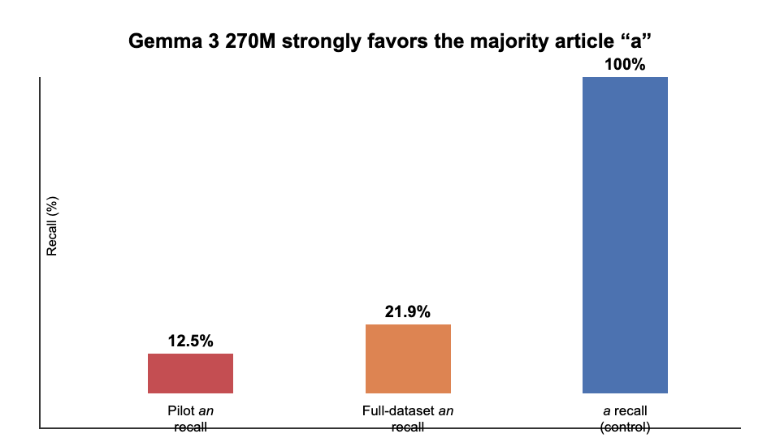
Figure 1. Immediate article recall. The model reliably selects the majority article a but rarely selects an when required by the listed target.
This was only a behavioral prerequisite. It did not show that Gemma intended the listed word. For example, after Someone who handles financial records is, Gemma generated a financial analyst, not a accountant. The article and chosen noun were grammatically coherent.

Why continuation screening was necessary
To motivate a concealed-plan analysis, we needed cases where the model selected the wrong article and nevertheless continued with a vowel-initial noun. We therefore generated the continuation rather than inferring the future answer from the dataset label.

6. Stage IV: Finding genuine preparation–content mismatches

Pilot continuation result
Across 24 expected-an pilot evaluations, only one unique target produced a mismatch under both demonstrations:
Prompt | Demonstration | Generated continuation
Someone who examines eyes and prescribes corrective lenses is | a example | a ophthalmologist.
same prompt | an example | a ophthalmologist.

The model did not generate the listed target optometrist; it generated the semantically appropriate alternative ophthalmologist. This distinction matters. The future content used for mechanistic analysis must be the model’s actual continuation, not the dataset’s expected label.

Full released-dataset screen
We then screened all 105 an targets from the paper’s released a_an_examples.csv, evaluating each after both demonstrations. Across 210 evaluations, an recall was 21.9%. We found three mismatch rows representing two unique targets:
- Someone who treats eye diseases is → a ophthalmologist. under both demonstrations;
- Someone who studies stars and planets is → a astronomer. under the an demonstration.
This was below our preregistered threshold of ten distinct concepts for a broad mechanistic study. The scarcity is itself important: Gemma usually preserves grammatical coherence by changing the noun after choosing a. We therefore narrowed the mechanistic pilot to the reproducible ophthalmologist case instead of generalizing from a large behavioral set that did not exist.

7. Stage V: Does future-answer information exist before the wrong article?

Motivation
The string a ophthalmologist does not by itself prove planning. The model might select a first and only later choose ophthalmologist. To establish a latent plan, information associated with the future content must be present before article generation and must causally contribute to both the article decision and the eventual noun.
The mechanistic prompt was:
Someone who studies living organisms is a biologist. Someone who treats eye diseases is
At baseline, the article logits were:
$$\ell_{\mathrm{an}} - \ell_{\mathrm{a}} = -1.000$$
After forcing a, the token ophthalm was the top continuation, with probability \(0.1459\).

Experiment
We identified features active at the final prompt position before the article was generated. We screened for features that contributed to:
- the future token ophthalm;
- the preparatory article logits;
- the eventual ophthalm token after the article.
Suppression means setting the selected transcoder feature activation to zero during the forward pass at that token position, then recomputing logits. This is a causal ablation, not merely inspection of an attribution edge.

Result
Four features showed a dual effect: suppressing each weakened both the losing an preparation and the future ophthalm token. The strongest, L13/F10231, changed the an logit by \(-1.125\) and the ophthalm logit by \(-0.250\), while leaving the a logit unchanged.
This is evidence that future-answer information was present before article generation and contributed to the correct article pathway, even though that pathway lost at baseline. It supports the “latent plan exists” premise. It does not improve behavior; suppressing this feature makes the correct preparation weaker.

Why another selection method was necessary
To correct behavior, we needed features supporting the competing incorrect pathway rather than features carrying the future answer. We therefore selected features that favored a over an but had low direct attribution to ophthalm. This separation was designed to avoid simply suppressing the answer itself.

8. Stage VI: Correcting the source prompt by suppressing a competing pathway

Experiment
Candidate features were ranked by their contribution to the incorrect article margin while screening out strong direct effects on ophthalm. No future-answer feature was amplified. The strongest individual candidate was L13/F10304.
Suppressing L13/F10304 improved the article margin from \(-1.000\) to \(-0.125\). A preselected two-feature intervention combined L13/F10304 with L14/F1949. Suppressing both:
- reduced the a logit by \(0.125\);
- increased the an logit by \(1.000\);
- improved the margin by \(1.125\), from \(-1.000\) to \(+0.125\);
- left the ophthalm logit unchanged;
- changed greedy generation from a ophthalmologist. to an ophthalmologist.
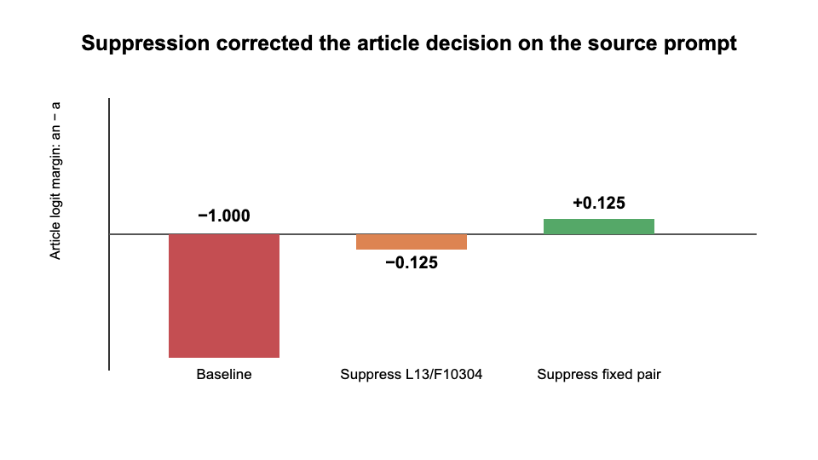
Figure 2. On the source prompt, suppression of the fixed pair crossed the decision boundary from a to an while preserving ophthalmologist.
This was the strongest source-prompt result in the project. It matched the expected signature of removing a competing grammatical pathway while preserving the represented future answer. However, selection and evaluation on one prompt cannot establish that interpretation.

9. Stage VII: The held-out test that changed the hypothesis

Motivation
The decisive question was whether the exact same intervention could be handed to another researcher and applied without rediscovering features for each prompt. We froze the pair L13/F10304 + L14/F1949, excluded the source ophthalmologist sentence, and applied it at the final prompt position to 107 other occupation prompts from the released dataset. There was no per-prompt feature selection.
The intended result was content-preserving transfer:
$$\text{wrong article + same noun} \rightarrow \text{correct article + same noun}$$
Expected-a prompts served as controls. A clean anti-stalling or grammar intervention should not broadly turn them into an responses.

Result
The fixed pair caused:
Outcome | Count
Expected-an prompts repaired | 10
Expected-an regressions | 0
Expected-a controls changed to generated an | 22
First content word changed | 37
Realized grammar-only repairs with content preserved | 0

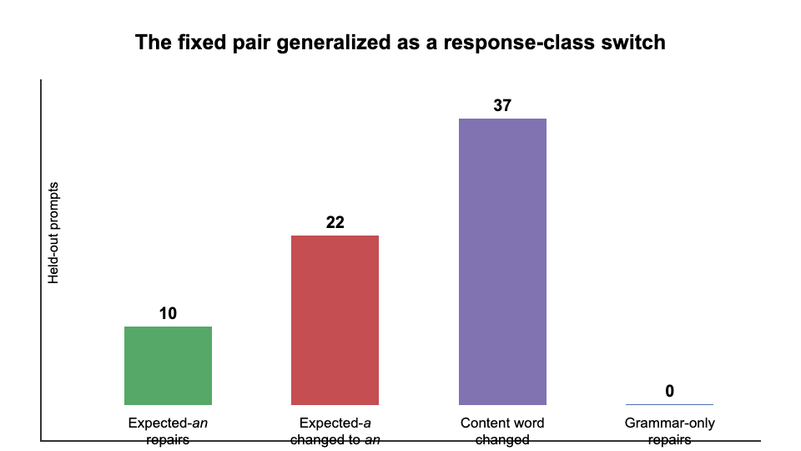
Figure 3. Held-out outcomes. Apparent article repairs were accompanied by broad article and content changes, so the intervention did not generalize as a content-preserving grammar repair.
Concrete examples make the mechanism clearer:
Prompt meaning | Baseline | Fixed-pair suppression
flies airplanes | a pilot | an aviator
represents clients in legal matters | a lawyer | an attorney
studies matter and energy | a physicist | an astronomer

These outputs remain locally grammatical because article and noun move together. The intervention does not simply raise an; it shifts the lexical continuation toward a vowel-initial alternative compatible with an. Exact listed-word completions fell from 53 to 44.

Interpretation
The source correction was real, but its original interpretation did not generalize. We did not isolate a feature pair that reveals a fixed hidden answer by suppressing grammar or stalling. We found a pair that causally influences a coordinated preparation–content choice.
This result runs alongside, rather than directly contradicting, Latent Planning Emerges with Scale. The paper shows that future content can influence earlier preparation and that this behavior changes with scale. Our result suggests that, in a very small model, the causal organization may not decompose into a stable future answer plus an independently adjustable preparation. Instead, sparse features can select between coupled response trajectories.

10. Current hypothesis and required next experiment

Revised hypothesis
In Gemma 3 270M, a/an preparation and the phonological class of the following occupation are partly controlled by shared sparse features. These features choose among coordinated response classes rather than independently controlling grammar around a fixed semantic plan.

Predictions
A positive result should satisfy all of the following:
- The fixed pair should shift probability mass from consonant-initial to vowel-initial noun continuations even when no single article token is forced.
- The same direction should appear across paraphrases and demonstrations.
- Causal mediation should show that the feature pair affects the article partly through future-content-class representations, or affects both through a common downstream pathway.
- Semantically matched noun pairs should reveal class switching while preserving occupation meaning, as in pilot versus aviator.
- Random features, activation-matched controls, alternative token positions, and unrelated syntactic tasks should not reproduce the effect.
A negative result would also be informative. If the pair’s effect disappears under paraphrase, it is prompt-template-specific. If many activation-matched pairs produce the same behavior, it is nonspecific disruption. If the article changes without systematic movement in noun-initial class under controlled decoding, the current response-class interpretation is wrong.

Minimum publishable study
The next study should preregister a held-out dataset of occupation concepts with semantically comparable consonant- and vowel-initial alternatives, run the frozen intervention and controls, and measure:
$$\Delta_{\mathrm{class}} =
P(\text{vowel-initial content}\mid\mathrm{do}(f=0))
- P(\text{vowel-initial content})$$
It should separately report article change, semantic preservation, first-content-word change, grammaticality, and exact-answer retention. Mechanistically, it should trace whether the pair connects to a distributed vowel/consonant content-class representation before the article, rather than relying only on output logits.

11. What has and has not been achieved
We have achieved:
- a reproducible, memory-safe Circuit Tracer workflow for Gemma 3 270M on constrained hardware;
- behavioral replication of a strong minority-class an disadvantage;
- direct evidence that future-answer information is active before an incorrect article in the ophthalmologist case;
- a suppression-only intervention that corrects that source continuation without directly reducing ophthalm;
- a held-out test showing that the same intervention broadly coordinates article and lexical choice.
We have not achieved:
- a general tool for reducing stalling behavior;
- a content-preserving grammar correction that transfers across prompts;
- evidence that the country–city the token reflects one reusable stalling circuit;
- enough independent feature pairs, prompt families, seeds, and controls for publication.
The main scientific progress is not that we proved the original hypothesis. It is that increasingly stringent transfer and specificity tests rejected its simplest form and exposed a more precise causal phenomenon: coordinated control of preparation and future-content class in a very small language model.

Reproducibility map
The reports and machine-readable outputs are organized by experiment:
Stage | Repository directory
France the versus Paris source screen | experiments/stall_commitment_sprint/
Country transfer and wrong-city controls | experiments/cross_country_commitment_screen/
Shared-feature and pair screens | experiments/shared_stall_suppression/, experiments/paired_shared_feature_suppression/
Article majority baseline | experiments/a_an_majority_baseline/
Continuation mismatch pilot | experiments/a_an_continuation_check/
Full released-dataset screen | experiments/a_an_full_dataset_screen/
Future-answer planning pilot | experiments/ophthalmologist_planning_pilot/
Competing-pathway source correction | experiments/ophthalmologist_competing_pathway_screen/
Frozen-pair held-out generalization | experiments/fixed_pair_generalization/

Each directory contains a human-readable results/report.md, machine-readable results/summary.json, and a README.md describing regeneration. The paper-aligned dataset provenance, source commit, prompts, feature IDs, and intervention positions are preserved in those artifacts.

