**HTML TAGS**

**Exercise 01**

Write an HTML code for the below table.

Student Records

|  |  |  |
| --- | --- | --- |
| Student ID | Student Name | Degree |
| 1002323 | Nimesh Fernando | BSc in IT |
| 1002424 | Lasadun Bandara | BSc in Computer Science |

**Exercise 02**

Write a html code to get the output.

Programming languages

1. C
2. C#
3. C++
4. JAVA
5. PYTHON

**Exercise 03**

Write an HTML program to create a form as the following

Name

Index Number

ANSWERS

Exercise 01

<html>

<head>

Lab01

</head>

<body>

<table border="1">

<tr>

<th>Student ID</th>

<th>Student Name</th>

<th>Degree</th>

</tr>

<tr>

<td>1002323</td>

<td>Nimesh Fernando</td>

<td>BSc in IT</td>

</tr>

<tr>

<td>1002424</td>

<td>Lasadun Bandara</td>

<td>BSc in Computer Science</td>

</tr>

</table>

</body>

</html>

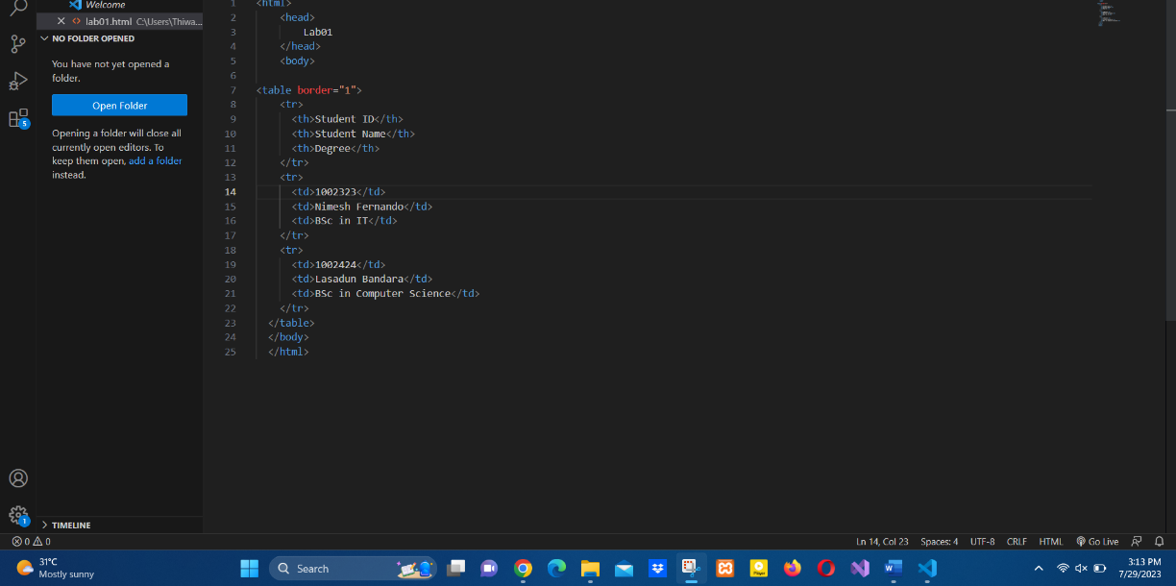

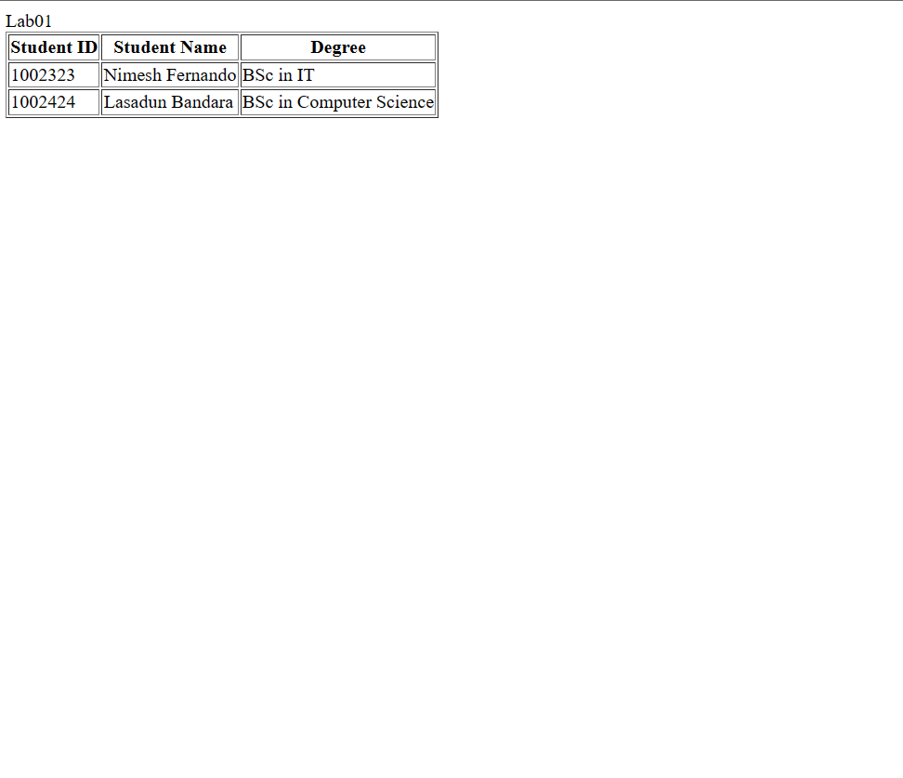

Exercise 02

<html>

<head>

<title>Programming Languages</title>

</head>

<body>

<h1>Programming languages</h1>

<ol type="I">

<li>C</li>

<li>C#</li>

<li>C++</li>

<li>JAVA</li>

<li>PYTHON</li>

</ol>

</body>

</html>

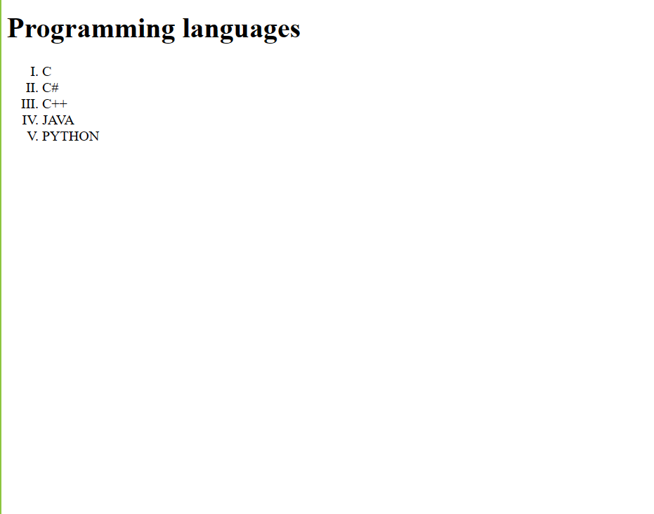

Exercise 3

<!DOCTYPE html>

<html>

<head>

<title>Student Information Form</title>

</head>

<body>

<h1>Student Information Form</h1>

<form>

<label for="name">Name:</label>

<input type="text" id="name" name="name" required><br><br>

<label for="indexNumber">Index Number:</label>

<input type="text" id="indexNumber" name="indexNumber" required><br><br>

<input type="submit" value="Submit">

</form>

</body>

</html>

