Austin Stephens

Lab 02

1/24/17

1. I successfully wrote a program that converts miles to yards. When one is used as an input the program outputs the right conversion factor of 1760 yards. When zero is used as an input then zero yards is returned and when eighteen miles is used as an input then the program successfully outputs 31680 yards.

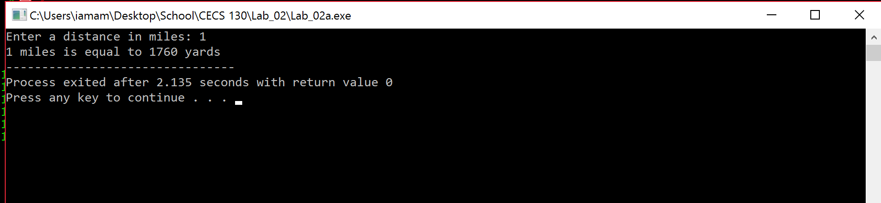

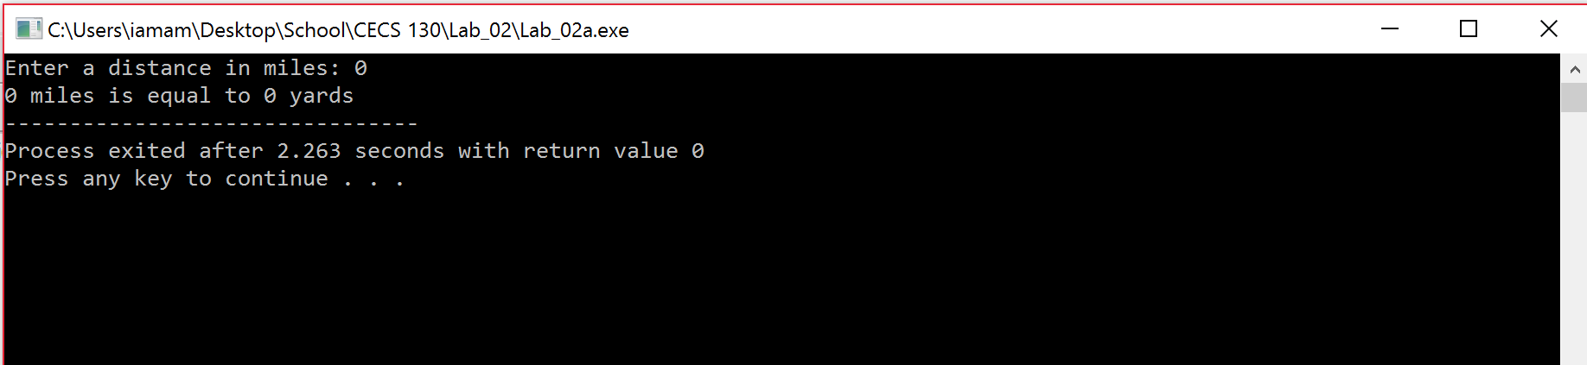

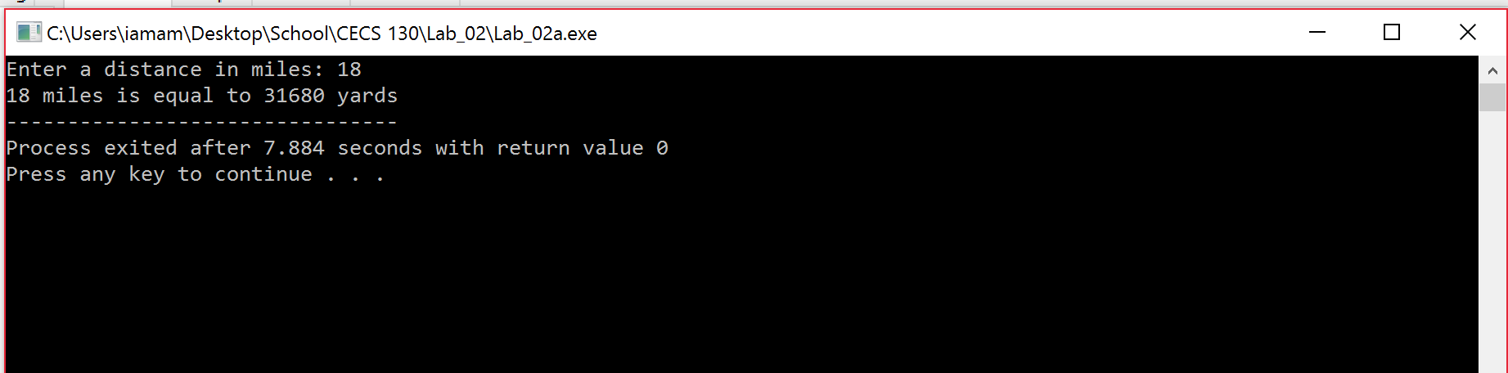

1. I successfully wrote a program that shows that a double long takes up 16 bytes of memory.

