Austin Stephens

Lab 03

1/31/16

1. My code takes two integers separated by a comma and then tells which quadrant that ordered pair is in. Below are screenshots of the program successfully placing an ordered pair in each quadrant.

First

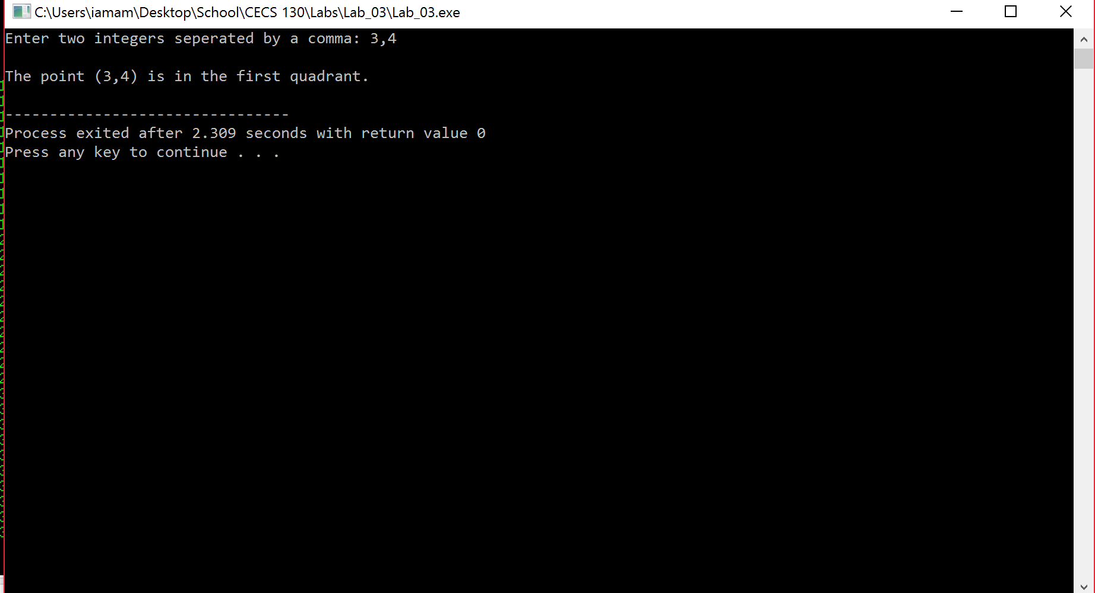

Second

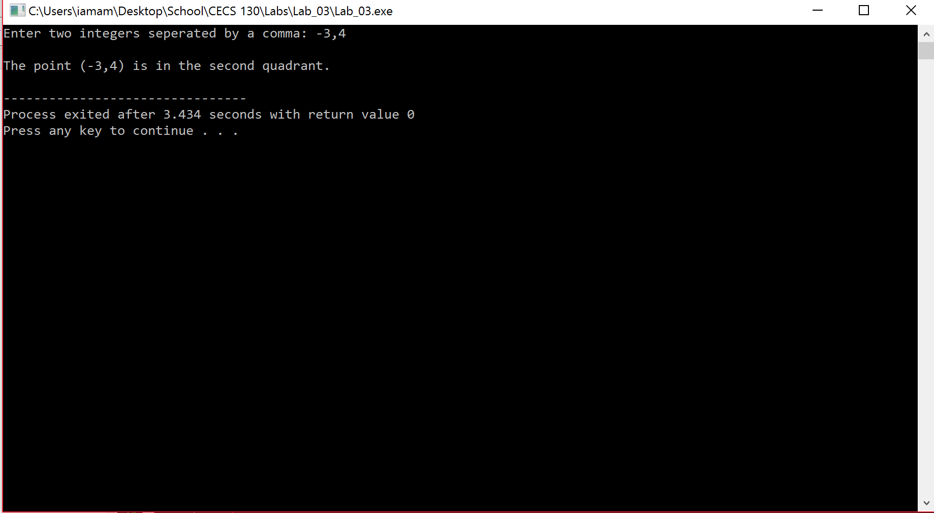

Third

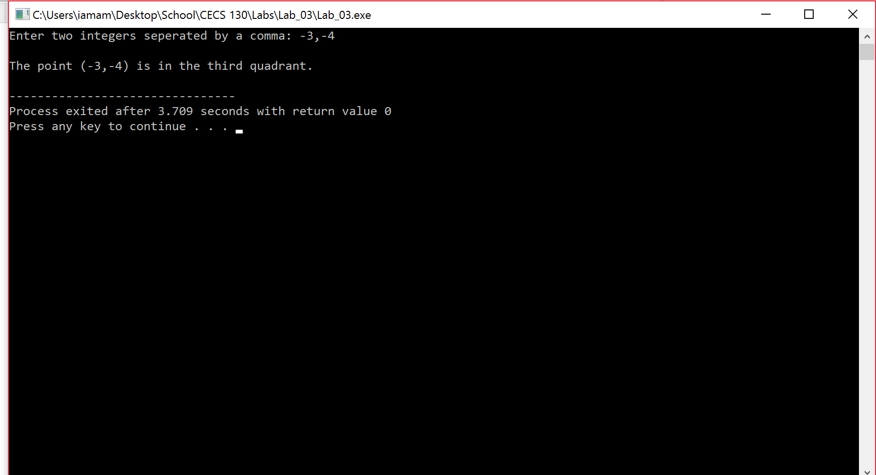

Fourth

