Austin Stephens

Lab 04

2/7/16

1. My code successfully calculates the factorial of a user chosen integer using a for loop.

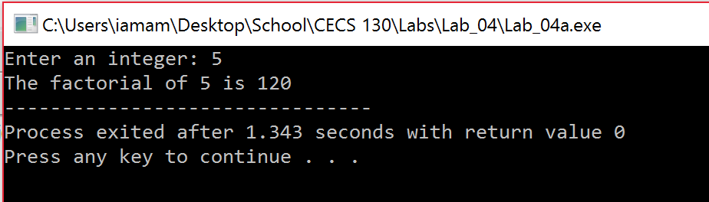

1. My code successfully calculates the factorial of a user chosen integer using a while loop. I chose the same number for consistency’s sake.

